**WEEK 6**

**REACT**

1. ReactJS-HOL  
  
**app.js**  
import React from 'react';

function App() {

return (

<div>

<h1>Welcome to the first session of React</h1>

</div>

);

}

export default App;

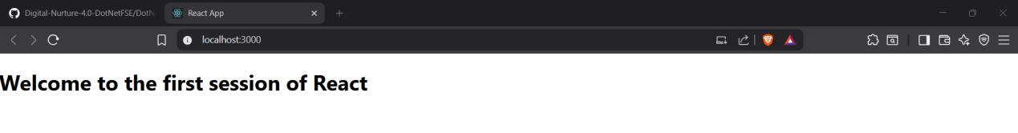

2. ReactJS-HOL

**App.js**

import React from 'react';

import Home from './Components/Home';

import About from './Components/About';

import Contact from './Components/Contact';

function App() {

return (

<div>

<Home />

<About />

<Contact />

</div>

);

}

export default App;

**Home.js**

import React, { Component } from 'react';

class Home extends Component {

render() {

return (

<div>

<h2>Welcome to the Home page of Student Management Portal</h2>

</div>

);

}

}

export default Home;

**About.js**

import React, { Component } from 'react';

class About extends Component {

render() {

return (

<div>

<h2>Welcome to the About page of the Student Management Portal</h2>

</div>

);

}

}

export default About;

**Contact.js**

import React, { Component } from 'react';

class Contact extends Component {

render() {

return (

<div>

<h2>Welcome to the Contact page of the Student Management Portal</h2>

</div>

);

}

}

export default Contact;

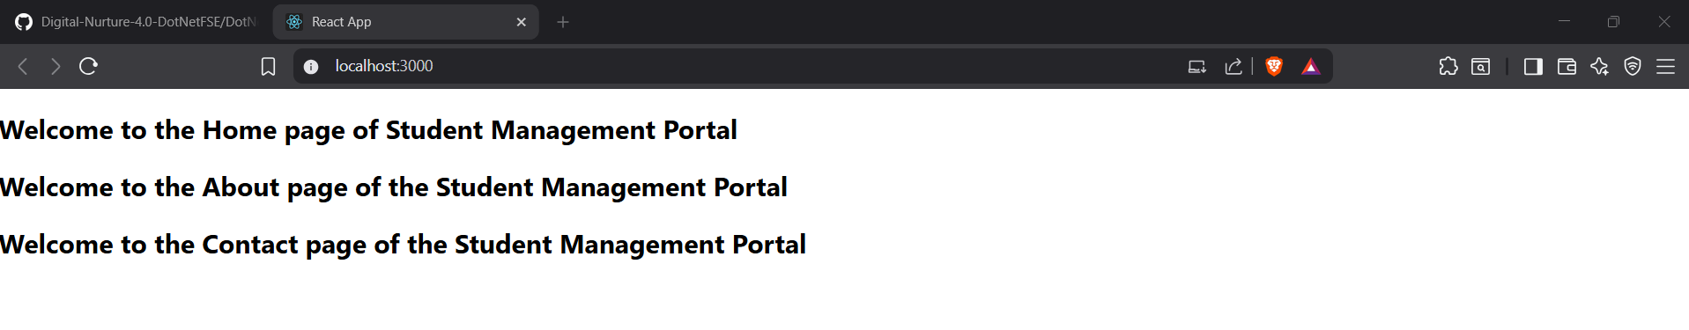

3. ReactJS-HOL

CalculateScore.js  
  
import React from 'react';

import '../Stylesheets/mystyle.css';

function CalculateScore(props) {

const average = props.total / 5;

return (

<div className="score-container">

<h2>Student Score Details</h2>

<p><strong>Name:</strong> {props.name}</p>

<p><strong>School:</strong> {props.school}</p>

<p><strong>Total Marks:</strong> {props.total}</p>

<p><strong>Goal:</strong> {props.goal}</p>

<p><strong>Average Score:</strong> {average}</p>

</div>

);

}

export default CalculateScore;

mystyle.css

.score-container {

border: 2px solid #4CAF50;

border-radius: 8px;

padding: 20px;

margin: 30px;

background-color: #f9f9f9;

font-family: Arial, sans-serif;

}

.score-container h2 {

color: #4CAF50;

}

.score-container p {

font-size: 16px;

line-height: 1.5;

}

App.js

import React from 'react';

import CalculateScore from './Components/CalculateScore';

function App() {

return (

<div>

<CalculateScore

name="Sristi Srivastava"

school="KIIT University"

total={450}

goal="Become a Software Engineer"

/>

</div>

);

}

export default App;

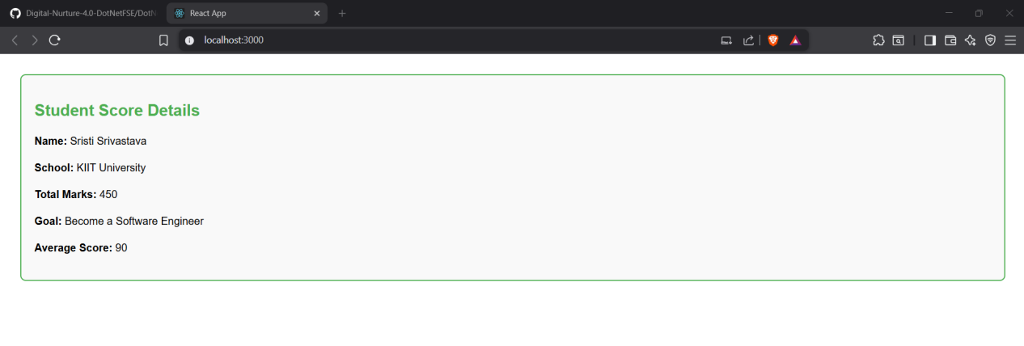

1. ReactJS-HOL

Post.js

import React from 'react';

function Post(props) {

return (

<div style={{ border: '1px solid #ccc', margin: '10px', padding: '15px' }}>

<h3>{props.title}</h3>

<p>{props.body}</p>

</div>

);

}

export default Post;

Posts.js

import React, { Component } from 'react';

import Post from './Post';

class Posts extends Component {

constructor(props) {

super(props);

this.state = {

posts: [],

hasError: false

};

}

componentDidMount() {

this.loadPosts();

}

loadPosts() {

fetch('https://jsonplaceholder.typicode.com/posts')

.then(res => res.json())

.then(data => {

this.setState({ posts: data });

})

.catch(error => {

console.error('Error fetching posts:', error);

this.setState({ hasError: true });

});

}

componentDidCatch(error, info) {

alert("An error occurred while rendering posts.");

console.error("Error:", error, info);

}

render() {

if (this.state.hasError) {

return <h2>Something went wrong!</h2>;

}

return (

<div>

<h1>Blog Posts</h1>

{this.state.posts.map(post => (

<Post key={post.id} title={post.title} body={post.body} />

))}

</div>

);

}

}

export default Posts;

App.js

import React from 'react';

import Posts from './Posts';

function App() {

return (

<div className="App">

<Posts />

</div>

);

}

export default App;

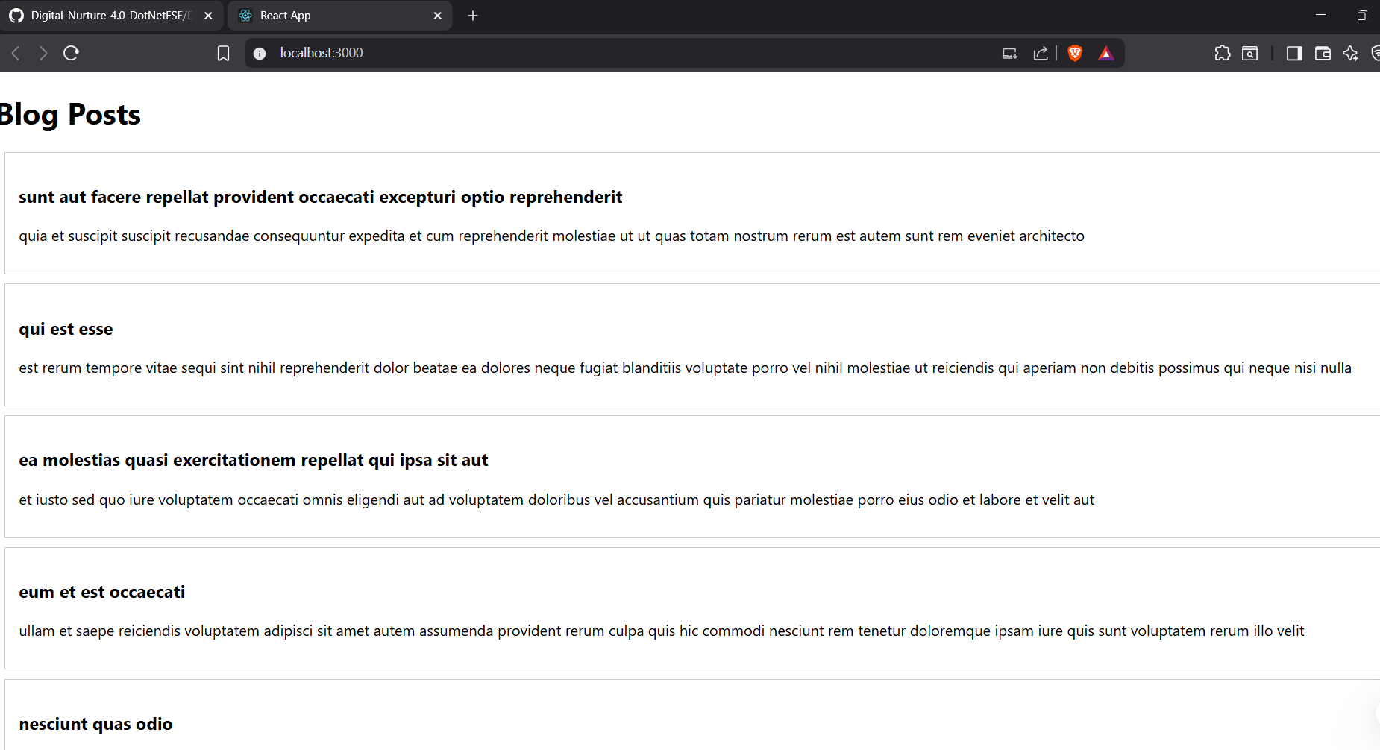

1. ReactJS-HOL

**CohortDetails.js**

import React from 'react';

import styles from './CohortDetails.module.css';

function CohortDetails(props) {

const { name, duration, status } = props;

const headingStyle = {

color: status.toLowerCase() === "ongoing" ? "green" : "blue"

};

return (

<div className={styles.box}>

<h3 style={headingStyle}>{name}</h3>

<dl>

<dt>Duration:</dt>

<dd>{duration}</dd>

<dt>Status:</dt>

<dd>{status}</dd>

</dl>

</div>

);

}

export default CohortDetails;

**CohortDetails.module.css**

.box {

width: 300px;

display: inline-block;

margin: 10px;

padding: 10px 20px;

border: 1px solid black;

border-radius: 10px;

}

dt {

font-weight: 500;

}

**App.js**

import React from 'react';

import CohortDetails from './CohortDetails';

function App() {

return (

<div className="App">

<h2>My Academy Cohorts</h2>

<CohortDetails name="Frontend Bootcamp" duration="8 weeks" status="Ongoing" />

<CohortDetails name="Backend Bootcamp" duration="6 weeks" status="Completed" />

</div>

);

}

export default App;

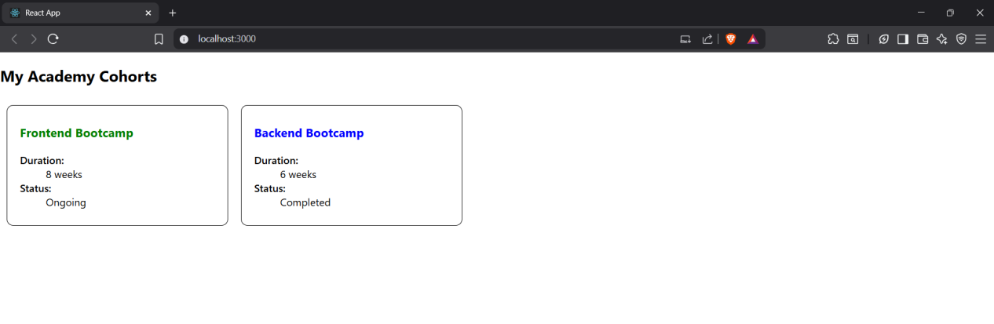

1. ReactJS-HOL

KafkaWebAPI.csproj

<Project Sdk="Microsoft.NET.Sdk.Web">

<PropertyGroup>

<TargetFramework>net6.0</TargetFramework> <!-- or net7.0/net8.0 if you installed those -->

</PropertyGroup>

<ItemGroup>

<!-- Kafka-related NuGet packages -->

<PackageReference Include="Confluent.Kafka" Version="1.9.3" />

</ItemGroup>

</Project>

Program.cs

using Microsoft.AspNetCore.Builder;

using Microsoft.AspNetCore.Hosting;

using Microsoft.Extensions.DependencyInjection;

using Microsoft.Extensions.Hosting;

var builder = WebApplication.CreateBuilder(args);

// Add services to the container

builder.Services.AddControllers();

var app = builder.Build();

// Configure the HTTP request pipeline

if (app.Environment.IsDevelopment())

{

app.UseDeveloperExceptionPage();

}

app.UseHttpsRedirection();

app.UseAuthorization();

app.MapControllers();

app.Run();

