Lab 6 openMP

This code iterative to sum matrix A and B and use pragma omp parallel for to divide in parallel openMP use in single line.

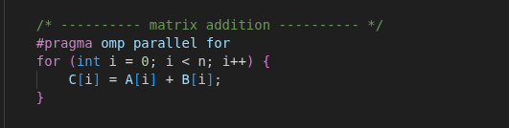

Experiment 100 round per N thread and average time. Besides Plot result.

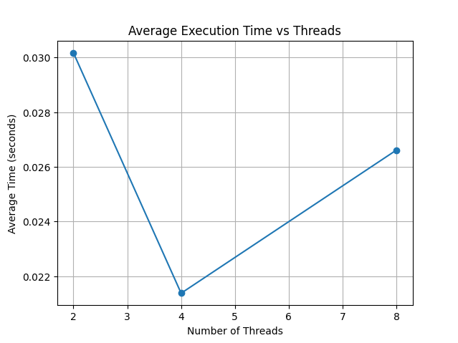

The graph show average execution time (include computational time) vs threads. At x-axis is number of threads and average time y-axis. The time decrease from 0.03 at 2 thread to less than 0.022 at 4 thread after than time are increase. This experiment ran on Intel I5-9300H 4 Core 8 Threads. In my perspective at 4 thread is equal to number of core the result may be best in this case and if use 8 thread is maximum of system the time might increase but batter than 2 threads.

