Temperature Control of Halogen Lamp using PID Controller, Arduino UNO and MATLAB Analysis

Ali Zaman (47)

Syed Shaftain Ali Kazmi (08)
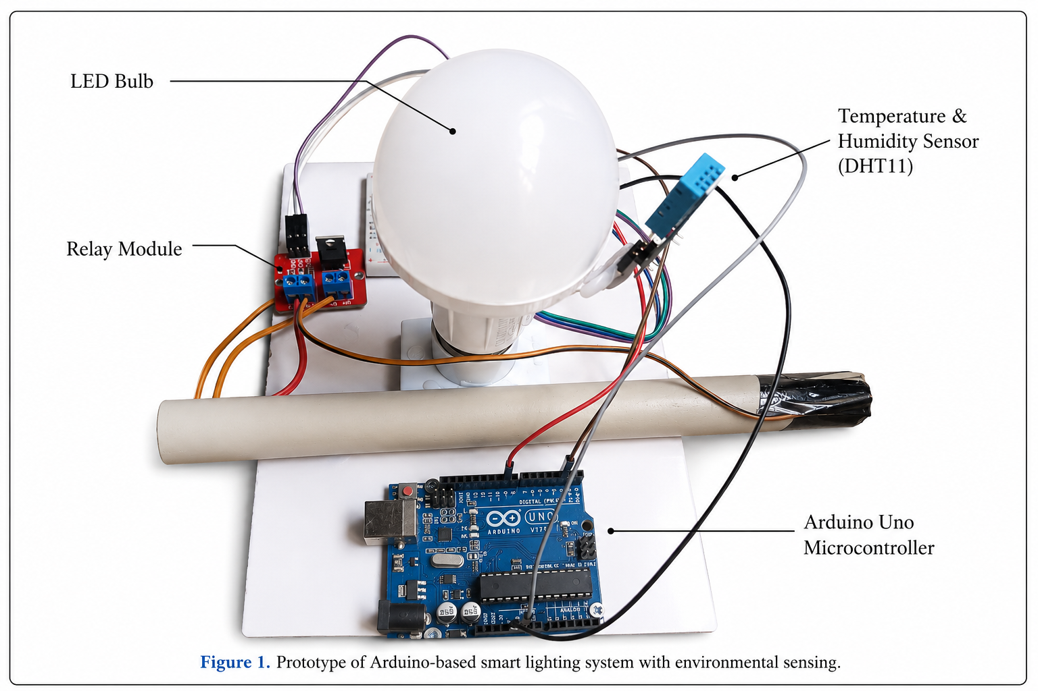

Keywords
PID Controller, Arduino UNO, DHT11 Sensor, MATLAB, Temperature Control System, PWM, Halogen Lamp
Abstract
This paper presents the design and implementation of a temperature control system for a 12V DC halogen lamp using an Arduino UNO and a PID controller. The system employs a DHT11 temperature sensor to continuously monitor the temperature generated by the lamp. The measured temperature is compared with a predefined setpoint of 32°C. Based on the error value, the Arduino executes a PID algorithm and generates a PWM signal that drives an IRF520N MOSFET module to regulate the power supplied to the lamp. MATLAB was used to analyze the system performance under Open Loop, Closed Loop, P, PD, and PID control configurations. The obtained results demonstrate that the PID controller significantly improves response speed, stability, and temperature regulation accuracy.

1. Introduction
Temperature control systems are widely used in industrial automation, environmental monitoring, heating systems, and process control applications. Maintaining the desired temperature is essential for achieving stability, efficiency, and safety in many engineering systems.
Traditional open-loop temperature control methods often suffer from slow response and poor regulation. To overcome these limitations, feedback control techniques such as Proportional-Integral-Derivative (PID) control are commonly used.
In this project, a PID-based temperature control system is developed using an Arduino UNO microcontroller. A DHT11 temperature sensor measures the temperature generated by a 12V halogen lamp. The Arduino processes sensor data and calculates the PID control action. The resulting PWM signal is applied to an IRF520N MOSFET module, which adjusts the power delivered to the lamp.
MATLAB is used to model and analyze the dynamic performance of the control system under different controller configuration

2. System Components
The hardware components used in the project are listed below:
Component | Quantity
Arduino UNO | 1
DHT11 Temperature Sensor | 1
IRF520N MOSFET Module | 1
12V DC Halogen Bulb | 1
Breadboard | 1
Li-ion Batteries (3.7V) | 4

2. Circuit Diagram
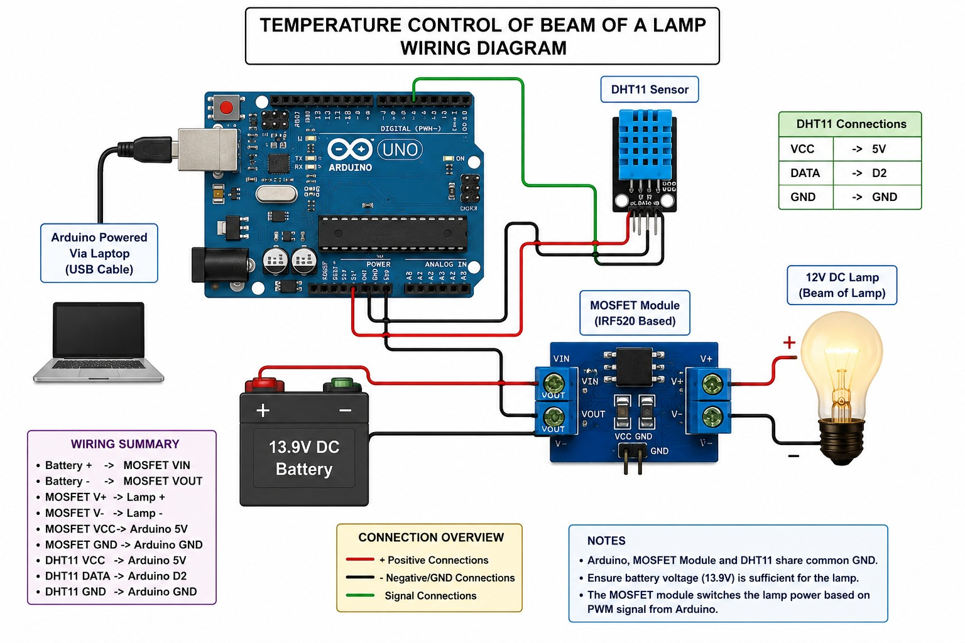

3. Working Principle
The temperature generated by the halogen lamp is continuously monitored by the DHT11 sensor. The measured temperature is transmitted to the Arduino UNO.
The Arduino compares the measured temperature with the desired setpoint temperature of 32°C and computes the error.
Error = Setpoint − Measured Temperature
The PID controller calculates the control output according to:
$$PID=K_{p}e(t)+K_{i}∫e(t)dt+K_{d}\frac{de(t)}{dt}$$
where:
- $K_{p}$= Proportional Gain
- $K_{i}$= Integral Gain
- $K_{d}$= Derivative Gain
The PID output is converted into a PWM signal and applied to the IRF520N MOSFET module. The MOSFET controls the power supplied to the halogen lamp, thereby regulating its temperature.
The control loop executes every second until the temperature stabilizes around the desired setpoint.
4. Arduino PID Parameters
The PID parameters used in the controller are:
Parameter | Value
Setpoint | 32°C
Kp | 20
Ki | 0.3
Kd | 5

These parameters were experimentally tuned to obtain a stable response with minimum error and acceptable settling time.
5. MATLAB Analysis
The system was analyzed using MATLAB Transfer Function models.
Open Loop Transfer Function:
$$G(s)=\frac{1}{10s+1}$$
Closed Loop Transfer Function:
$$T(s)=\frac{1}{10s+2}$$
Different controller configurations were evaluated:
- Open Loop
- Closed Loop
- P Controller
- PD Controller
- PID Controller
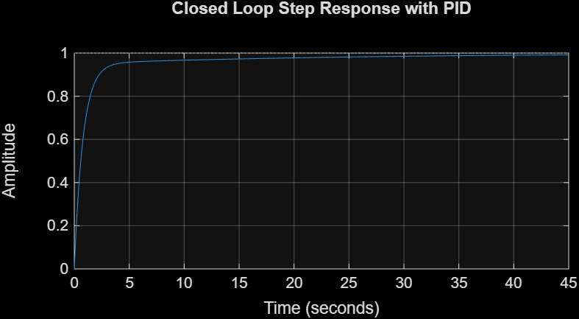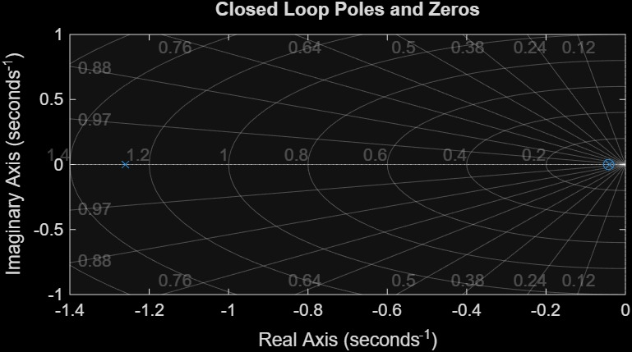

6. Project Simulink
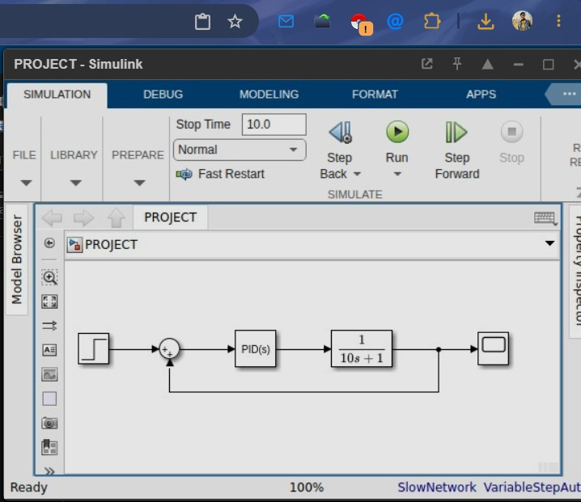

7. Performance Comparison
Parameter | Open Loop | Closed Loop | P Controller | PD Controller | PID Controller
Rise Time | 21.97 s | 10.98 s | 3.19 s | 4.39 s | 3.38 s
Settling Time | 39.12 s | 19.56 s | 15.27 s | 7.82 s | 15.55 s
Overshoot | 0% | 0% | 6.70% | 0% | 6.63%
Peak Time | 73.22 s | 36.61 s | 7.83 s | 14.64 s | 8.06 s
Stability | Stable | Stable | Stable | Stable | Stable
Poles | $$-0.1$$ | -0.2 | -0.3 ± 0.1i | -0.5, -0.1 | -0.2857 ± 0.1166i

8. Results and Discussion
The Open Loop system exhibited a slow response and a large settling time. Introducing feedback in the Closed Loop system improved the response speed and stability. The P Controller reduced the rise time significantly but introduced a small overshoot. The PD Controller provided the best settling performance with zero overshoot overshooting stability. The PID Controller achieved balanced performance by providing a fast response, acceptable overshoot, and improved temperature regulation accuracy. Experimental testing showed that the DHT11 sensor successfully monitored the lamp temperature and the PID controller maintained the temperature close to the desired setpoint of 32°C. The PWM output varied dynamically according to the temperature error, allowing smooth regulation of lamp heating power.
9. Acknowledgements
The authors would like to express their sincere gratitude to their supervisor, teachers, and the Department of Electrical/Computer Engineering for their valuable guidance and support throughout this project. Special thanks are extended to the laboratory staff for providing the necessary resources and facilities required for the successful completion of this work. The authors also acknowledge the use of MATLAB software and Arduino development tools that assisted in the design, simulation, and implementation of the temperature control system.

10. Conclusion
A PID-based temperature control system for a 12V DC halogen lamp was successfully designed and implemented using an Arduino UNO, DHT11 sensor, and IRF520N MOSFET module.
MATLAB analysis confirmed that feedback control significantly improves system performance compared to the open-loop configuration. Among all tested controllers, the PD controller achieved the best settling time with zero overshoot, while the PID controller provided the best overall balance between speed, stability, and accuracy.
The developed system effectively maintained the temperature around the desired setpoint of 32°C and demonstrated the practical application of PID control in embedded temperature regulation systems.

References
[1] K. Ogata, Modern Control Engineering, 5th ed. Upper Saddle River, NJ, USA: Pearson, 2010.
[2] R. C. Dorf and R. H. Bishop, Modern Control Systems, 13th ed. Boston, MA, USA: Pearson, 2017.
[3] M. A. Johnson and M. H. Moradi, PID Control: New Identification and Design Methods. London, U.K.: Springer, 2005.
[4] MathWorks, “Control System Toolbox User's Guide,” MathWorks Inc., Natick, MA, USA, 2024.
[5] MathWorks, “MATLAB and Simulink Documentation,” MathWorks Inc., 2024.
[6] Arduino, “Arduino UNO Rev3 Technical Specifications,” Arduino Documentation, 2024.
[7] Aosong Electronics, “DHT11 Temperature and Humidity Sensor Datasheet,” 2023.
[8] International Rectifier, “IRF520N Power MOSFET Datasheet,” 2023.
[9] M. Rashid, Power Electronics: Circuits, Devices, and Applications, 4th ed. Pearson Education, 2013.
[10] N. Nise, Control Systems Engineering, 8th ed. Wiley, 2020.
[11] G. F. Franklin, J. D. Powell, and A. Emami-Naeini, Feedback Control of Dynamic Systems, 8th ed. Pearson, 2019.
[12] C. L. Phillips and H. T. Nagle, Digital Control System Analysis and Design, 4th ed. Pearson, 2014.
[13] F. Baskoro, M. Rohman, D. Arya S. F., and A. Putra, “Temperature Control of Focused Beam Lamp: PID-Controlled Pulse Width Modulation using MATLAB Simulink and Arduino,” Jurnal Teknik Elektro, vol. 9, no. 2, pp. 97–109, 2024.
[14] D. Amine, “An Arduino-Based Low-Cost Hardware for Temperature Control,” WSEAS Transactions on Systems, pp. 54–66, 2021.
[15] N. Seiichi, “Arduino-Based PID Control of Temperature in Closed Space by Pulse Width Modulation of AC Voltage,” International Journal of Computer and Systems Engineering, 2021.

