|  |  |
| --- | --- |
| **Web Technology Curricular Activity: Personal Website** | |
| **Name: Sritam Roy Chowdhury** | **PRN: 122M1H059** |
| **Roll No: FYMCA59** | **Date: 26/06/23** |

|  |  |
| --- | --- |
|  | **Pimpri Chinchwad Education Trust’s**  **Pimpri Chinchwad College of Engineering** |

**Screenshots:**

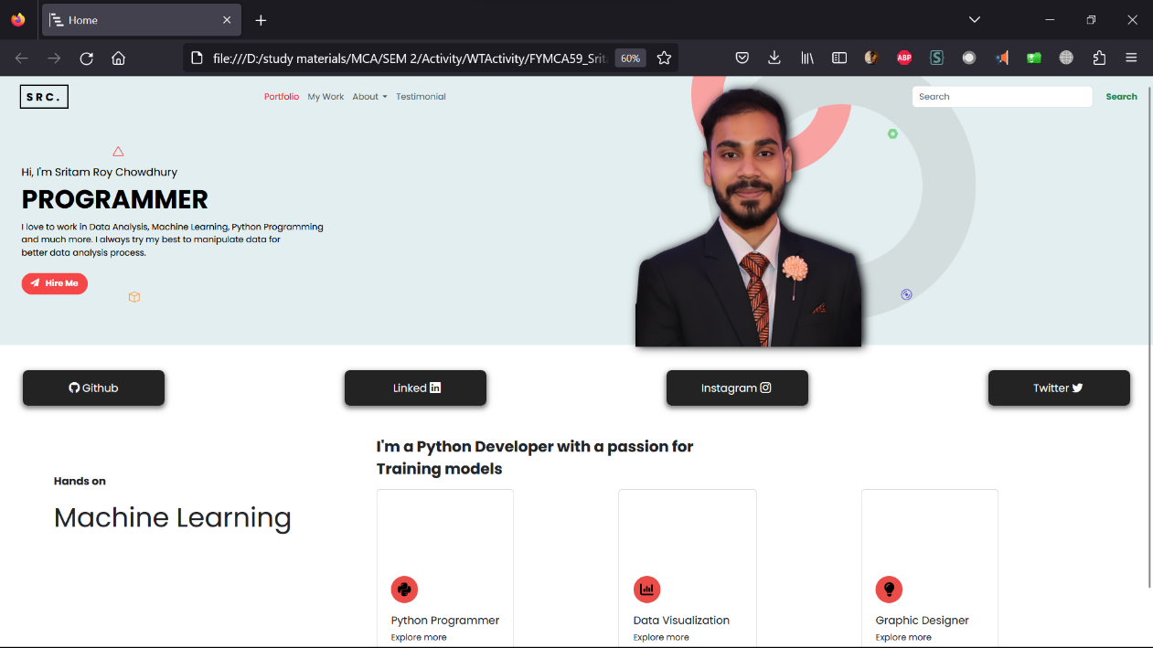

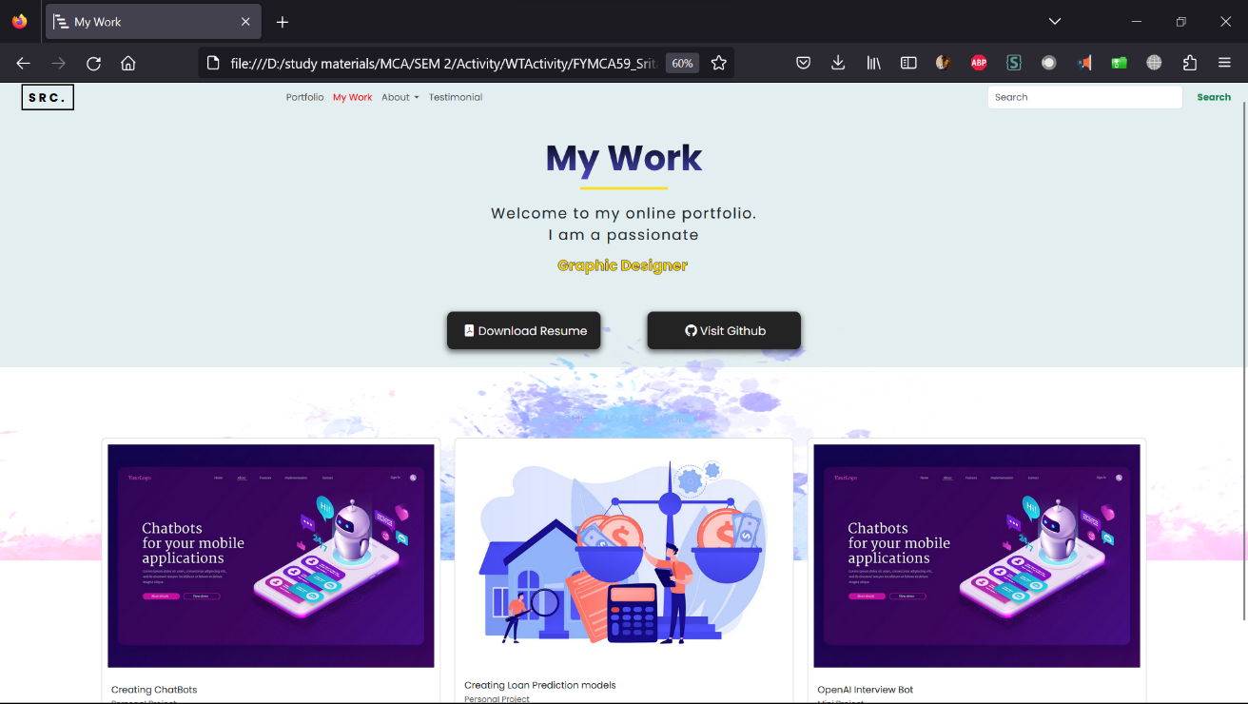

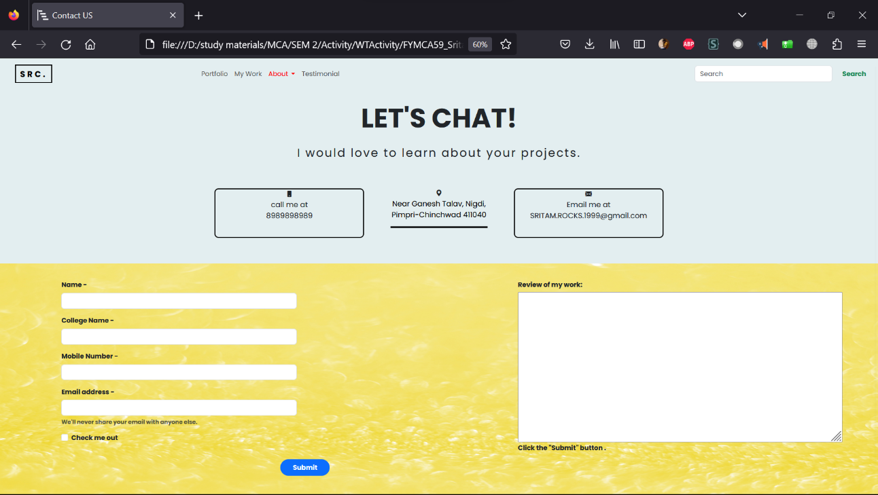

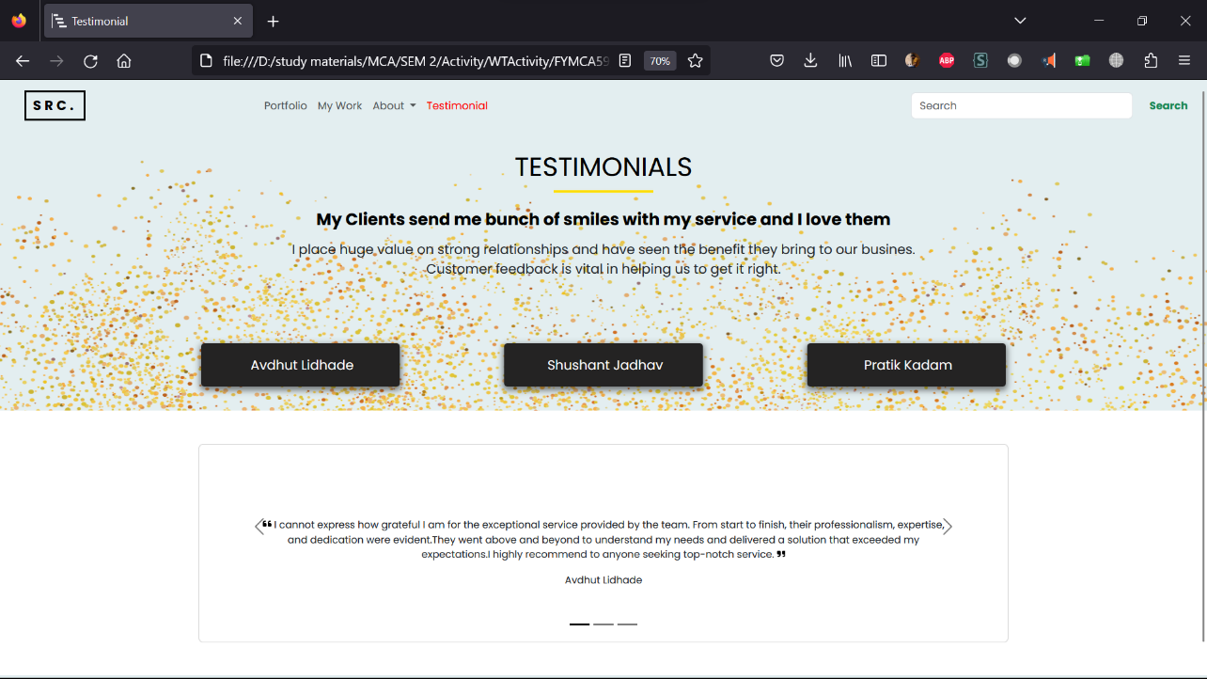

**Main Page Source Code Example:**

<!DOCTYPE html>

<html lang="en">

<head>

.........

.........

<style>

body {

font-family: 'Poppins', sans-serif;

scroll-behavior: smooth;

overflow-x: hidden;

}

.container1 {

background-color: #e3eef0;

padding: 0px;

padding-top: 0px;

height: 500px;

}

.navbar {

padding: px;

}

transition: color 0.15s ease-in-out, background-color 0.15s ease-in-out;

}

bottom: 12px;

font-size: 20px;

font-weight: bold;

/* transform: rotate(180deg); */

}

.box1 {

position: relative;

padding-left: 200px;

color: #fe9d3e;

bottom: 10px;

font-size: 20px;

font-weight: bold;

/* transform: rotate(50deg); */

}

.nut1 {

position: relative;

right: 50px;

color: #7dd48d;

bottom: 180px;

font-size: 20px;

font-weight: bold;

}

.middle-bar {

padding-top: 30px;

}

a.l1 {

width: 264px;

height: 65px;

border-radius: 10px;

color: #fff;

background-color: #242323;

transition: background-color 0.5s;

align-content: center;

justify-content: center;

margin-left: 30px;

margin-right: 30px;

box-shadow: 0px 4px 10px 2px rgba(0, 0, 0, .5);

.........

.........

</style>

</head>

<body>

<div class="container-fluid container1">

<!-- this is the starting navbar and 1st row -->

<div class="navbar navbar-1">

<nav class="navbar navbar-expand-lg navbar-light shadow-5-strong" style="width: 100%; padding-left: 25px;">

<!-- <nav class="navbar navbar-expand-lg navbar-dark" style="background-color: #2d2d39; width: 100%;"> -->

<div class="container-fluid">

<a class="navbar-brand" href="#"

style="font-weight: bold; padding-left: 10px; padding-right: 10px; border: #000000 solid; ;letter-spacing: 5px;">

SRC.

</a>

<div class="col-5">

<ul class="navbar-nav">

<li class="nav-item home-link">

<a class="nav-link port-link" href="01mainpage.html">

Portfolio

</a>

</li>

<li class="nav-item">

<a class="nav-link" href="02myportfolio.html">My Work</a>

</li>

<li class="nav-item dropdown">

<a class="nav-link dropdown-toggle" href="#" id="navbarDropdown" role="button"

data-bs-toggle="dropdown" aria-expanded="false">

About

</a>

<ul class="dropdown-menu" aria-labelledby="navbarDropdown">

<li><a class="dropdown-item" href="03contactuspage.html">Contact Us</a></li>

<li>

<hr class="dropdown-divider">

</li>

<li><a class="dropdown-item" href="#">Something else here</a></li>

</ul>

</li>

<li class="nav-item">

<a class="nav-link" href="04testimonialpage.html">Testimonial</a>

</li>

</ul>

</div>

<!-- <a class="navbar-brand" href="https://www.linkedin.com/in/sahil-mudhale-600b571aa/ "

target="_blank">

<i class="bi bi-linkedin"></i>

</a> -->

<form class="d-flex">

<input class="form-control me-2" type="search" placeholder="Search" aria-label="Search">

<button class="btn btn-outline-success" type="submit">

Search

</button>

</form>

</div>

</nav>

</div>

.........

.........

.........

<div class="footer" style="margin-top: 50px;">

<p style="padding: 10px; margin: 0px;font-size: 14px;">

&#169; Sritam Roy Chowdhury

</p>

</div>

</body>

</html>