A Real-time Research Project/Societal Related Project
Report on

VulnScan5G: CLI Vulnerability Detection and Auto-Fix Tool for C/C++ Source Code
Submitted in Partial fulfillment of requirements for B.Tech II Year II Semester course

By

Anish Kumar 24BD1A0568
Nithin Bhargav 24BD1A056J
Sri Teja 24BD1A056N
Bhargav Krishna 24BD1A056Z
Pranay Kumar 24BD1A057T

Under the guidance of

Ms./Mr./Dr. Mentor Name
Assistant Professor, Department of CSE



KESHAV MEMORIAL INSTITUTE OF TECHNOLOGY
(AN AUTONOMOUS INSTITUTION)
Accredited by NBA & NAAC, Approved by AICTE, Affiliated to JNTUH.

Narayanaguda, Hyderabad,Telangana-29
2025-26



KESHAV MEMORIAL INSTITUTE OF TECHNOLOGY
(AN AUTONOMOUS INSTITUTION)
Accredited by NBA & NAAC, Approved by AICTE, Affiliated to JNTUH

Narayanaguda, Hyderabad,Telangana-29

CERTIFICATE


This is to certify that this is a bonafide record of the project report titled "VulnScan5G: CLI Vulnerability Detection and Auto-Fix Tool for C/C++ Source Code" which is being presented as the Real-time Research Project / Societal Related Project report by

Anish Kumar 24BD1A0568
Nithin Bhargav 24BD1A056J
Sri Teja 24BD1A056N
Bhargav Krishna 24BD1A056Z
Pranay Kumar 24BD1A057T

In partial fulfillment for the II Year II Semester Course RTRP in KMIT affiliated to the Jawaharlal Nehru Technological University, Hyderabad

Mentors
(Ms./Mr./Dr. Mentor Name) Program Coordinator
(Mr Shailesh Gangakhedkar)

Submitted for Final Project Review held on ____________________________

Vision& Mission of KMIT

Vision

  - To be the fountain head in producing highly skilled, globally competent engineers.
  - Producing quality graduates trained in the latest software technologies and related tools and striving to make India a world leader in software products and services.

Mission

  - To provide a learning environment that inculcates problem solving skills, professional, ethical responsibilities, lifelong learning through multi model platforms and prepares students to become successful professionals.
  - To establish an industry institute Interaction to make students ready for the industry.
  - To provide exposure to students on the latest hard ware and software tools.
  - Topromoteresearch-basedprojects/activitiesintheemergingareasoftechnologyconvergence.
  - To encourage and enable students to not merely seek jobs from the industry but also to create new enterprises.
  - To induce a spirit of nationalism which will enable the student to develop, understand India's challenges and to encourage them to develop effective solutions.
  - To support the faculty to accelerate their learning curve to deliver excellent service to students.

PROGRAM OUTCOMES(POs)

PO1. Engineering Knowledge: Apply the knowledge of mathematics, science, engineering fundamentals, and an engineering specialization to the solution of complex engineering problems.

PO2. Problem Analysis: Identify formulate, review research literature, and analyze complex engineering problems reaching substantiated conclusions using first principles of mathematics, natural sciences, and engineering sciences


PO3. Design/Development of solutions: Design solutions for complex engineering problems and design system components or processes that meet the specified needs with appropriate consideration for the public health and safety, and the cultural, societal, and environmental considerations.

PO4. Conduct Investigations of Complex problems: Use research-based knowledge and research methods including design of experiments, analysis and inter pretation of data, and synthesis of the information to provide valid conclusions.

PO5. Modern Tool Usage: Create select, and, apply appropriate techniques, resources, and modern engineering and IT tools including prediction and modeling to complex engineering activities with an understanding of the limitations.

PO6. The Engineer and Society: Apply reasoning informed by contextual knowledge to societal, health, safety. Legal und cultural issues and the consequent responsibilities relevant to professional engineering practice.

PO7. Environment and Sustainability: Understand the impact of the professional engineering solutions in societal and environmental contexts and demonstrate the knowledge of, and need for sustainable development.
PO8. Ethics: Apply ethical principles and commit professional ethics and responsibilities and norms of the engineering practice.
PO9. Individual and Team Work: Function effectively as an individual, and as a member or leader in diverse teams and in multidisciplinary settings.

PO10. Communication: Communicate effectively on complex engineering activities with the engineering community and with societ yat large, such as, being able to comprehend and write effective reports and design documentation, make effective presentations, and give and receive clear instructions.

PO11. Project Management and Finance: Demonstrate knowledge and understanding of the engineering and management principles and apply these to one's own work, as a member and leader in a team, to manage projects and in multi disciplinary environments.


PO12. Life-Long Learning: Recognize the need for, and have the preparation and abilitytoengageinindependentandlife-longlearninginthebroadestcontextoftechnological change.

PROJECT OUTCOMES

P1: Develop a hybrid multi-engine vulnerability detection system combining Regex, AST, and Tree-sitter parsing for C/C++ security analysis.
P2: Implement an AI-powered auto-patching pipeline with a two-tier fix engine for automated vulnerability remediation.
P3: Design a modular 7-stage pipeline architecture enabling scalable, privacy-preserving static analysis of 5G codebases.
P4: Create a multi-format vulnerability reporting system covering 27 detection rules across 10+ CWE categories.

MAPPING PROJECTOUTCOMESWITH PROGRAMOUTCOMES

PO | PO1 | PO2 | PO3 | PO4 | PO5 | PO6 | PO7 | PO8 | PO9 | PO10 | PO11 | PO12
P1 | H | H | H | M | H | L | L | H | H | M | L | H
P2 | H | H | H | H | H | L | L | H | H | L | L | H
P3 | H | M | H | M | H | L | L | H | H | L | L | M
P4 | M | L | M | L | H | L | L | H | H | H | M | H

L– LOW M –MEDIUM H– HIGH

DECLARATION

We hereby declare that the results embodied in the dissertation entitled "VulnScan5G: CLI Vulnerability Detection and Auto-Fix Tool for C/C++ Source Code" has been carried out by us together during the academic year 2024-25 as a partial fulfillment of the B.Tech II Year II Semester Course "Real-time Research Project / Societal Related Project". We have not submitted this project to any other university for any academic award.



Student Name Roll no.

Anish Kumar 24BD1A0568
Nithin Bhargav 24BD1A056J
Sri Teja 24BD1A056N
Bhargav Krishna 24BD1A056Z
Pranay Kumar 24BD1A057T

ACKNOWLEDGEMENT

We take this opportunity to thank all the people who have rendered their full support to our project work. We render our thanks to Dr. B L Malleswari, Principal who encouraged us to do the Project.

We are grateful to Mr. Neil Gogte, Founder & Director and Mr. S. Nitin, Director, for facilitating all the amenities required for carrying out this project.

We express our sincere gratitude to Ms. Deepa Ganu, Academic Director for providing an excellent environment in the college.

We are also thankful to Mr.Shailesh Gangakhedkar, Real-Time Research Project Program Coordinator for providing us with time to make this project a success within the given schedule.

We are also thankful to our Project Mentor Ms./Mr./Dr. Mentor Name, for his/her valuable guidance and encouragement given to us throughout the project work.

We would like to thank the entire KMIT faculty, who helped us directly and indirectly in the completion of the project.

We sincerely thank our friends and family for their constant motivation during the project work.

Student Name Roll no.

Anish Kumar 24BD1A0568
Nithin Bhargav 24BD1A056J
Sri Teja 24BD1A056N
Bhargav Krishna 24BD1A056Z
Pranay Kumar 24BD1A057T
ABSTRACT

VulnScan5G is a Python-based, command-line vulnerability detection and auto-patching tool purpose-built for C and C++ source code, specifically designed for analyzing security-critical codebases such as 5G network stacks (e.g., srsRAN). The tool employs a hybrid detection engine combining Regex-based pattern matching, AST analysis via pycparser, and Tree-sitter parsing. It integrates a local LLM via Ollama for AI-powered reasoning and context-aware patch generation with a two-tier auto-fix engine. With 27 detection rules covering 10+ CWE categories, VulnScan5G generates reports in Console, JSON, and HTML formats. All processing occurs entirely on the developer's machine, ensuring source code privacy.

LISTOFFIGURES

S.No | Name of Screenshot | Page No.
1. | VulnScan5G System Architecture | 3
2. | Use Case Diagram | 12
3. | Sequence Diagram | 13
4. | State Chart Diagram | 14
5. | HTML Dashboard Report Output | 26

CONTENTS

DESCRIPTION PAGECHAPTER-1 1
  - INTRODUCTION 2-3
    - Purpose of the project 2
    - Problem with Existing Systems 2
    - Proposed System 2
    - Scope of the Project 2
    - Architecture Diagram 3
CHAPTER-2 4
  - LITERATURESURVEY 5
CHAPTER-3 6
  - SOFTWAREREQUIREMENTSPECIFICATION 7-10
    - Introduction to SRS 7
    - Role of SRS 7
    - Requirements Specification Document 7
    - Functional Requirements 8
    - Non-Functional Requirements 9
    - Performance Requirements 9
    - Software Requirements 9
    - Hardware Requirements 10
CHAPTER–4 11
  - SYSTEMDESIGN 12-16
    - Introduction to UML 12

    - UML Diagrams 12
      - Use Case Diagram 12
      - Sequence Diagram 13
      - State Chart Diagram 14
      - Deployment Diagram 15
    - TECHNOLOGIESUSED 16
CHAPTER-5 17
  - IMPLEMENTATION 18-26
    - Setting up connections with Raspberry PI 18
    - Coding the logic 18
    - Connecting the dashboard 21
    - Screenshots 24
    - UI Screen shots 26
CHAPTER–6 27
  - SOFTWARETESTING 28-32
    - Introduction 28
      - Testing Objectives 28
      - Testing Strategies 28
      - System Evaluation 30
      - Testing New System 31
    - Test Cases 32
CHAPTER-7 33
7.1CONCLUSION 34
7.2FUTUREENHANCEMENTS 34
REFERENCES 35

CHAPTER-1

INTRODUCTION

1.1 Purpose of the Project
VulnScan5G is a CLI-based vulnerability detection and auto-fix tool for C/C++ source code, designed to address the critical security challenges in modern software systems, particularly 5G network stacks. The increasing deployment of open-source 5G implementations like srsRAN has created an urgent need for automated security analysis tools that can identify and remediate vulnerabilities in large C/C++ codebases without compromising source code privacy.
C and C++ remain the primary languages for critical infrastructure development including operating systems, network protocol stacks, embedded firmware, and telecommunications equipment. Despite their performance advantages, these languages are inherently memory-unsafe, making them susceptible to buffer overflows (CWE-120), use-after-free (CWE-416), format string attacks (CWE-134), command injection (CWE-78), and numerous other vulnerability classes.

1.2 Problems With Existing Systems
Existing static analysis tools suffer from several critical limitations:
• Cloud-based tools transmit source code to external servers, creating privacy and data residency concerns.
• Most open-source tools provide detection-only capabilities without automated patching.
• Single-engine tools suffer from high false positive rates (regex) or incomplete coverage (AST-only).
• Commercial SAST tools are prohibitively expensive for academic and small-team use.
• No existing tool integrates local LLM-powered reasoning with AI-generated auto-fixes.

1.3 Proposed System
• To develop a hybrid multi-engine vulnerability detection system combining Regex, AST, and Tree-sitter.
• To implement an AI-powered auto-patching pipeline with a two-tier fix engine (templates + LLM).
• To design a modular 7-stage pipeline enabling scalable, privacy-preserving static analysis.
• To create multi-format reporting (Console, JSON, HTML) covering 27 rules across 10+ CWE categories.
• To validate against the NIST Juliet Test Suite and real-world 5G codebases (srsRAN).

1.4 Scope of the Project
The scope encompasses detection of 27 vulnerability types across 10+ CWE categories in C/C++ source files; hybrid analysis using three independent detection engines; optional LLM-powered reasoning; automated patching through deterministic templates and AI-generated fixes; multi-format reporting; and CI/CD integration via exit codes. The tool operates entirely locally, ensuring complete source code privacy.

1.5 Architecture Diagram

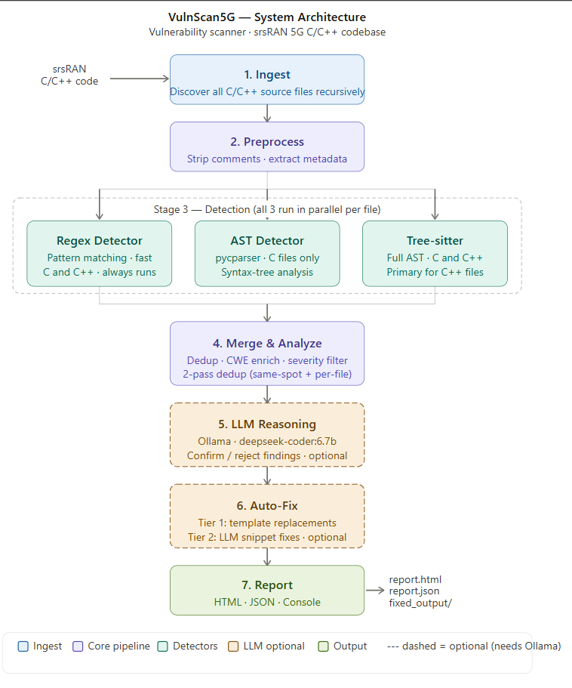

CHAPTER-2

LITERATURE SURVEY

2.1 AI-Powered Vulnerability Detection and Patch Management in Cybersecurity
Citation: M. Malkawi and R. Alhajj, Machine Learning and Knowledge Extraction (MAKE), MDPI, 2026.
This systematic review evaluates 29 peer-reviewed studies on ML, DL, and LLMs for vulnerability detection and automated patching. Key findings include the effectiveness of transformer-based models for code understanding. This informed VulnScan5G's hybrid approach combining pattern matching with AI reasoning.

2.2 A Case Study of LLM for Automated Vulnerability Repair
Citation: U. Kulsum et al., Proc. 1st ACM Int. Conf. AI-Powered Software (AIware), 2024.
Introduces VRpilot, an LLM-based repair framework using chain-of-thought prompting. VRpilot generates 14% more correct patches than baselines for C. This motivated VulnScan5G's structured prompting for LLM reasoning and the snippet-level context window strategy.

2.3 APPATCH: Automated Adaptive Prompting for Vulnerability Patching
Citation: Y. Nong et al., Proc. 34th USENIX Security Symposium, 2025.
Uses adaptive prompting forcing the LLM to reason before generating patches. Achieved 28.33% F1 improvement on 97 zero-day vulnerabilities. Influenced VulnScan5G's two-tier design where reasoning precedes fix generation, and the sanity-check mechanism.

2.4 Enhanced Automated Code Vulnerability Repair Using Large Language Models
Citation: D. de-Fitero-Dominguez et al., Engineering Applications of AI, Elsevier, 2024.
Explores strategies using CVEFixes, BigVul, and CWE datasets to enhance LLM patch generation. VulnScan5G adopted the multi-stage pipeline concept and CWE-enriched prompts for accurate classification.

2.5 Large Language Model for Vulnerability Detection and Repair: Literature Review
Citation: X. Zhou et al., ACM Trans. Softw. Eng. Methodol., 2024.
Identifies challenges including hallucination, need for local processing, and combining rule-based detection with AI. Shaped VulnScan5G's design to use LLMs as a secondary layer and process locally via Ollama.

CHAPTER-3

SOFTWAREREQUIREMENTSPECIFICATION

3.1 Introduction to SRS

The Software Requirement Specification (SRS) defines the functional and non-functional requirements of the VulnScan5G system. It serves as a formal document describing the system behavior, constraints, interfaces, and performance expectations. VulnScan5G is a Python-based CLI vulnerability detection and auto-fix tool designed for C/C++ source code security analysis. The system employs a hybrid detection architecture consisting of Regex, AST, and Tree-sitter engines along with optional LLM-powered reasoning and automated patch generation.

3.2 Role of SRS
The SRS document plays an important role in the development of VulnScan5G by:
- Defining the scope and objectives of the project.
- Providing a clear understanding of system functionality.
- Serving as a communication medium between developers, testers, and stakeholders.
- Assisting in system design and implementation.
- Providing a basis for validation and testing.
- Ensuring all project requirements are properly documented and traceable.

3.3 Requirements Specification Document

Project Name

VulnScan5G: CLI Vulnerability Detection and Auto-Fix Tool for C/C++ Source Code

Purpose

The primary purpose of VulnScan5G is to automatically identify and remediate security vulnerabilities in C/C++ codebases. The system is particularly targeted towards security-sensitive applications such as 5G network stacks, embedded systems, and telecom software.

Scope

The system provides:

Hybrid vulnerability detection using Regex, AST, and Tree-sitter.

Detection of 27 vulnerability rules across 10+ CWE categories.

LLM-assisted vulnerability validation.

Automated vulnerability patching.

Console, JSON, and HTML report generation.

Local execution ensuring source-code privacy.

3.4 Functional Requirements
The system shall:
FR1: File Discovery
- Recursively scan directories for C/C++ source files.
- Support .c, .cpp, .h, .hpp, .cc, .cxx, .hh, and .hxx files.
FR2: Preprocessing
- Remove comments while preserving line numbers.
- Extract metadata from source files.
FR3: Vulnerability Detection
- Detect vulnerabilities using Regex patterns.
- Detect vulnerabilities using AST analysis.
- Detect vulnerabilities using Tree-sitter parsing.
FR4: Finding Management
- Merge duplicate findings.
- Assign severity levels.
- Map findings to corresponding CWE categories.
FR5: LLM-Based Reasoning
- Validate findings using a local Ollama-hosted LLM.
- Improve confidence scores based on AI reasoning.
FR6: Auto-Patching
- Apply deterministic template-based fixes.
- Generate contextual fixes using LLMs.
FR7: Reporting
- Generate Console reports.
- Generate JSON reports.
- Generate HTML dashboard reports.
FR8: Benchmarking
- Measure precision, recall, F1-score, and accuracy using test suites.

3.5 Non-Functional Requirements

Security
- All analysis must occur locally.
- Source code must never be transmitted to external servers.
Reliability
- Template fixes must be deterministic and reliable.
- The system should continue functioning even if the LLM is unavailable.
Scalability
- Support large codebases containing thousands of source files.
Maintainability
- Modular architecture with independent pipeline stages.
Portability
- Operate on Windows, Linux, and macOS.
Usability
- Provide an easy-to-use command-line interface.

3.6 Performance Requirements
The system should satisfy the following performance requirements:
- Regex engine should process thousands of files per second.
- AST and Tree-sitter engines should process hundreds of files per second.
- Auto-fix template execution should complete within milliseconds.
- Support parallel scanning using ThreadPoolExecutor.
- Efficiently handle large-scale codebases containing hundreds of thousands of lines of code.

3.7 Software Requirements
Operating System
- Windows 10/11
- Linux
- macOS
Programming Language
- Python 3.10+
Libraries and Frameworks
- Click
- Rich
- Pycparser
- Tree-sitter
- Tree-sitter-C
- Tree-sitter-CPP
- Requests
- Jinja2

Optional Components
- Ollama
- DeepSeek-Coder / CodeLlama models

3.8 Hardware Requirements
Minimum Requirements
- Dual-Core Processor
- 4 GB RAM
- 2 GB Free Disk Space
Recommended Requirements
- Quad-Core Processor or higher
- 16 GB RAM
- GPU with CUDA/ROCm support (for LLM features)
- 8 GB Free Disk Space for local LLM models
Network Requirements
- No internet connection required for core functionality.
- Localhost communication required for Ollama integration.

CHAPTER-4

SYSTEM DESIGN

4.1 Introduction to UML

Unified Modeling Language (UML) is a standardized graphical modeling language used to visualize, specify, construct, and document software systems. UML diagrams help developers understand system architecture, component interactions, workflows, and deployment strategies.

In VulnScan5G, UML is used to model the interaction between users, vulnerability detection engines, LLM reasoning modules, auto-fix mechanisms, and reporting components. The UML design provides a clear representation of the modular 7-stage pipeline architecture adopted by the system.

4.2 UML Diagrams
4.2.1 Use Case Diagram
The Use Case Diagram illustrates interactions between the Developer (primary actor) and VulnScan5G. The Ollama LLM Server acts as a secondary actor for optional AI-powered features. The developer can perform scanning, view rules, view file info, run benchmarks, and configure options for LLM reasoning, auto-fix, severity filtering, and report format selection.
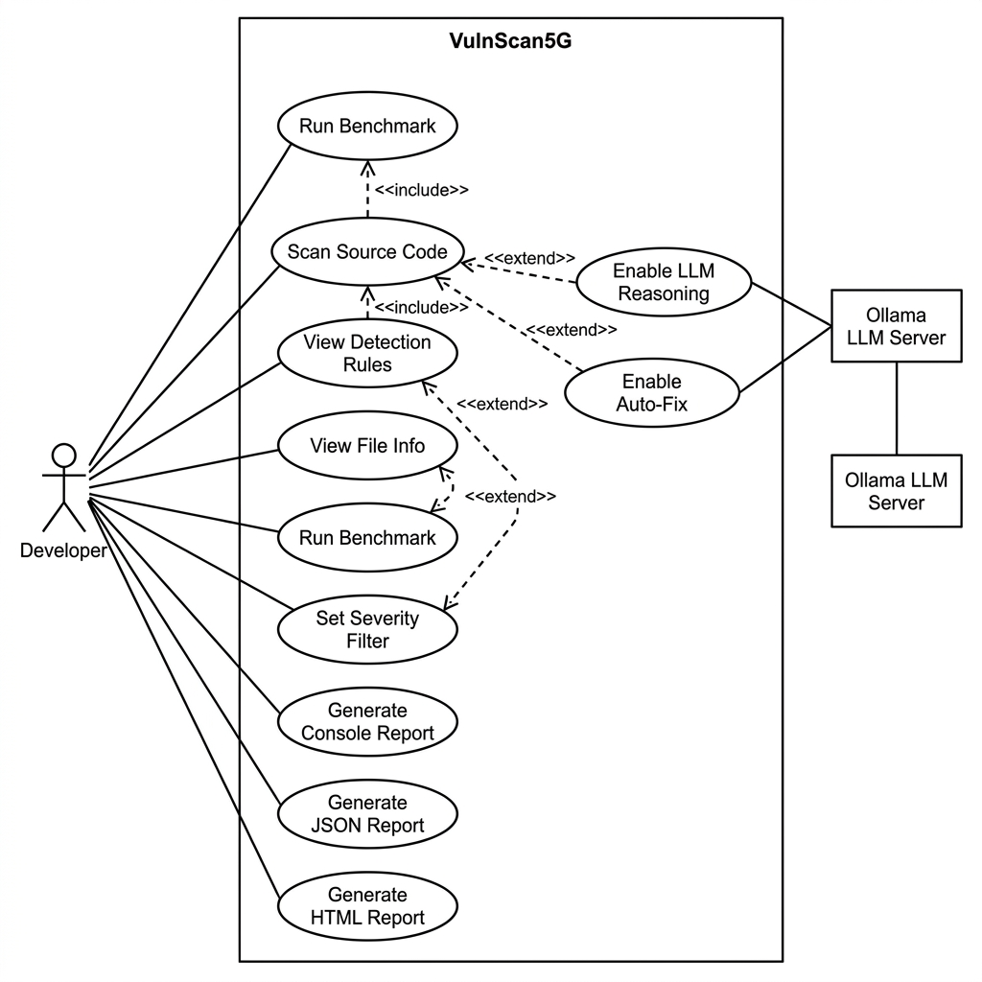
Figure 4.2: VulnScan5G Use Case Diagram
4.2.2 Sequence Diagram
The Sequence Diagram shows the runtime interaction flow during a scan operation. The Developer invokes the CLI, which creates the Pipeline orchestrator. The Pipeline sequentially calls Ingest, Preprocess, and then dispatches to all three detectors in parallel. Results are merged, optionally reasoned about by the LLM, optionally patched by the Fixer, and finally sent to the Reporter for output generation.
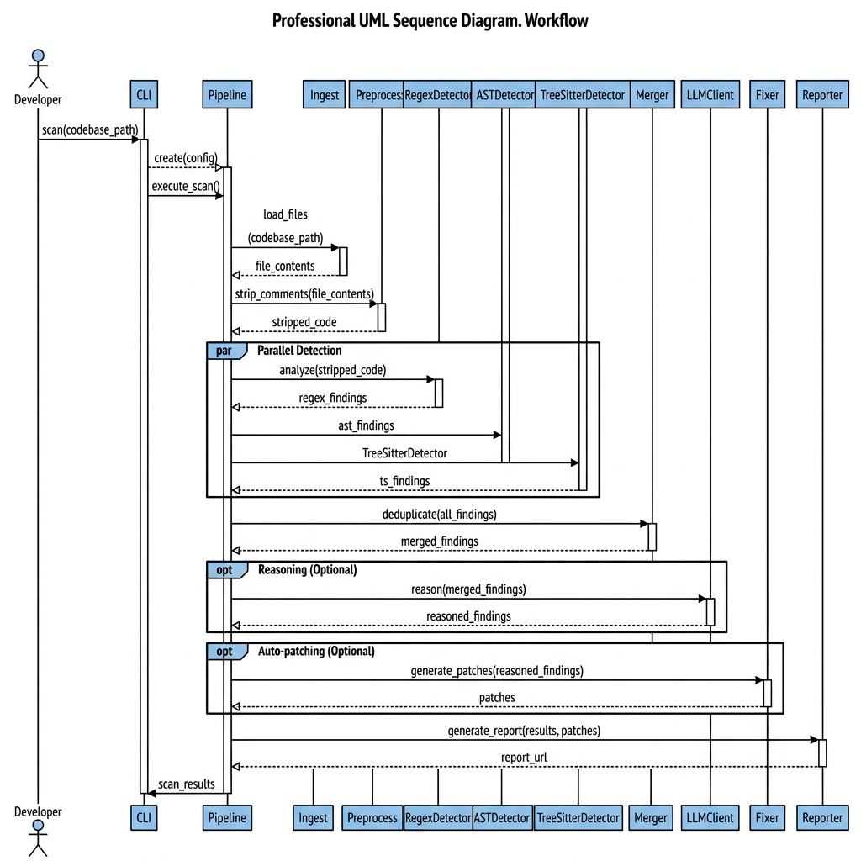
Figure 4.3: VulnScan5G Scan Sequence Diagram

4.2.3 State Chart Diagram
The state diagram represents the lifecycle of a scan operation. The system transitions through file discovery, detection, reasoning, patching, and reporting stages before returning to the completed state.
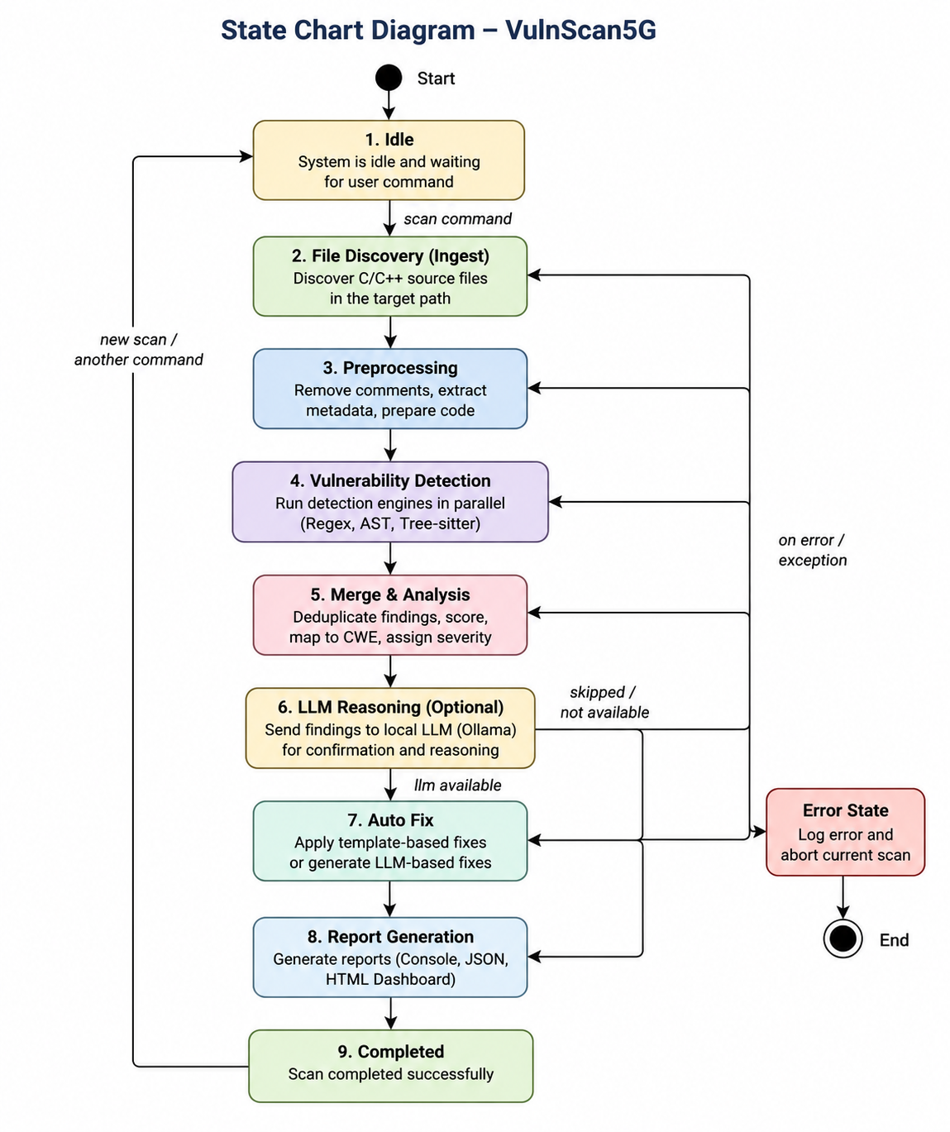
Figure 4.4: VulnScan5G State chart Diagram

4.2.4 Deployment Diagram
Deployment Components
Developer Machine
- VulnScan5G CLI
- Python Runtime
- Detection Engines
- Reporting Module
Local Ollama Server
- DeepSeek-Coder / CodeLlama Model
- REST API Interface
Source Code Repository
- C/C++ Source Files
- 5G Network Stack Code
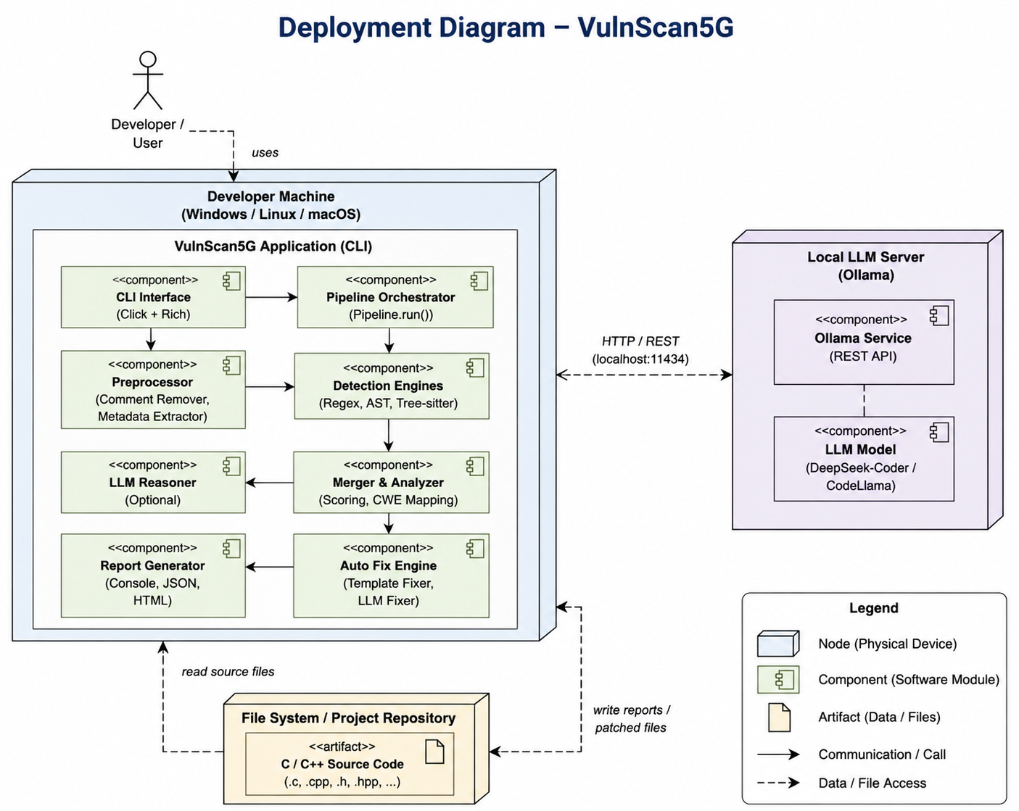

4.3 Technologies Used
Technology | Purpose
Python 3.10+ | Core Development Language
Click | CLI Framework
Rich | Terminal UI and Reports
Pycparser | AST-Based Detection
Tree-sitter | Structural Parsing
Ollama | Local LLM Hosting
DeepSeek-Coder | Vulnerability Reasoning and Auto-Fix
Requests | HTTP Communication
Jinja2 | HTML Report Generation
JSON | Structured Report Export
Git/GitHub | Version Control
NIST Juliet Suite | Benchmark Testing Dataset

CHAPTER-5

IMPLEMENTATION

5.1 Setting up connections with Raspberry PI
Core Language: Python 3.10+ for cross-platform compatibility and rich library ecosystem.
CLI Framework: Click (≥8.0) for declarative command-line interface with subcommand grouping.
Terminal UI: Rich (≥13.0) for color-coded severity tables, panels, and progress bars.
C Parser: pycparser (≥2.22) providing a complete C99 parser for AST-based detection.
Incremental Parser: Tree-sitter (≥0.23) with C and C++ grammars for fault-tolerant structural analysis.
HTTP Client: Requests (≥2.31) for Ollama REST API communication.
Template Engine: Jinja2 (≥3.1) for generating self-contained HTML reports.
LLM Server: Ollama (local, optional) running DeepSeek-Coder 6.7B.
Build System: setuptools with pyproject.toml (PEP 621).

5.2 Coding the logic

The core logic of VulnScan5G is implemented using a modular 7-stage pipeline architecture.

The implementation workflow is:

Source Code

↓

Ingest

↓

Preprocess

↓

Regex Detection

↓

AST Detection

↓

Tree-sitter Detection

↓

Merge & Analysis

↓

LLM Reasoning

↓

Auto-Fix

↓

Report Generation

The Regex detector identifies known vulnerability patterns through predefined regular expressions. The AST detector uses Pycparser to perform semantic analysis of C source files, while Tree-sitter performs structural analysis for both C and C++ source code.

The merger module combines findings from multiple detectors and removes duplicate results. Confidence scores are adjusted based on agreement among detectors.

The LLM module communicates with Ollama to validate findings and generate contextual patches. The auto-fix engine applies deterministic template fixes and LLM-generated fixes depending on the vulnerability type.

The entire implementation is designed to support scalability, maintainability, and high detection accuracy

5.2.1 File Discovery

The first stage of the VulnScan5G pipeline is file discovery. The system recursively scans the user-specified directory and identifies all supported C and C++ source files. Supported extensions include .c, .cpp, .h, .hpp, .cc, .cxx, .hh, and .hxx. To improve efficiency, unnecessary directories such as .git, build, node_modules, pycache, and .vscode are automatically skipped. The discovered files are stored in a sorted list and forwarded to the preprocessing module for further analysis. This stage ensures that all relevant source files are collected before vulnerability scanning begins.

5.2.2 Source Code Preprocessing

Before vulnerability analysis, the source code undergoes preprocessing. The preprocessing module removes single-line comments (//) and multi-line comments (/* */) while preserving original line numbers. Maintaining line numbers is important because vulnerability reports must accurately indicate the location of detected issues. The preprocessing stage also extracts useful metadata such as include statements, function names, and total line counts. This cleaned source code improves the accuracy of the detection engines and reduces false detections caused by comments or non-executable code segments.

5.2.3 Regex-Based Vulnerability Detection

The Regex detection engine performs fast pattern-based scanning of source code. It uses predefined regular expression patterns to identify common security vulnerabilities such as buffer overflows, format string attacks, unsafe memory operations, command injection vulnerabilities, and memory leaks. Since regular expression matching is computationally efficient, it provides rapid vulnerability detection across large codebases. Each matched pattern is mapped to a corresponding CWE category and assigned an initial confidence score. The Regex engine serves as the first layer of defense in the hybrid detection architecture.

5.2.4 AST-Based Vulnerability Detection

The Abstract Syntax Tree (AST) detection engine uses the Pycparser library to analyze C source code at a structural level. Instead of searching for text patterns, the AST engine examines program constructs such as function calls and variable usage. Unsafe functions including gets(), strcpy(), strcat(), sprintf(), and scanf() are identified through AST traversal. Because the AST engine understands code structure, it significantly reduces false positives compared to simple pattern matching techniques. This stage improves detection accuracy and provides deeper semantic analysis of source code.

5.2.5 Tree-Sitter Based Detection

Tree-sitter is used to perform advanced parsing of both C and C++ source code. Unlike traditional parsers, Tree-sitter is fault tolerant and can continue parsing even when code contains minor syntax errors. The generated syntax tree allows the system to inspect function calls, memory operations, and object-oriented constructs present in modern C++ applications. Tree-sitter complements the AST detector by providing broader language support and structural vulnerability analysis capabilities.

5.2.6 Finding Merge and Confidence Scoring

After all detection engines complete their analysis, the generated findings are merged and processed. Multiple detectors may identify the same vulnerability at the same location. To prevent duplicate reporting, the merger module combines related findings and increases the confidence score when multiple detectors agree. For example, if both the Regex and AST engines detect the same vulnerability, the confidence score is boosted. This confidence-based approach improves result reliability and helps users prioritize vulnerabilities that are more likely to be genuine security issues.

5.2.7 LLM-Based Reasoning

The reasoning module integrates a local Large Language Model through Ollama. For each detected vulnerability, a small section of surrounding source code is extracted and provided to the LLM. The model analyzes the code context and determines whether the detected issue is likely to be a true positive or a false positive. Based on the LLM response, the confidence score of the finding is adjusted accordingly. Using a local model ensures that source code remains private and never leaves the developer’s machine.

5.2.8 Auto-Fix Generation

The auto-fix engine automatically generates remediation suggestions for detected vulnerabilities. The system follows a two-tier architecture. The first tier applies deterministic template-based fixes for well-known unsafe functions such as gets(), strcpy(), strcat(), sprintf(), and scanf(). These fixes are reliable and do not require AI involvement. For more complex vulnerabilities, the second tier utilizes the local LLM to generate context-aware code patches. Before acceptance, generated fixes undergo validation checks to ensure that the modifications are reasonable and do not excessively alter the original source code.

5.2.9 Report Generation

The final stage of the implementation pipeline is report generation. VulnScan5G produces reports in three formats: Console, JSON, and HTML. Console reports are displayed using the Rich library with color-coded severity indicators. JSON reports provide machine-readable output suitable for automation and CI/CD integration. HTML reports generate a user-friendly dashboard containing severity statistics, vulnerability details, search functionality, and filtering options. These reporting mechanisms enable developers, researchers, and security analysts to efficiently review and remediate detected vulnerabilities.

5.3 connecting the dashboard

Introduction

The dashboard module is responsible for presenting vulnerability analysis results in a visually organized format. After the completion of the scanning and analysis process, VulnScan5G automatically generates an HTML-based dashboard that summarizes all detected vulnerabilities, severity levels, CWE mappings, and remediation information. The dashboard enables users to quickly understand security issues present in the scanned codebase and prioritize remediation efforts.

Dashboard Generation Process

The dashboard is generated after the completion of the vulnerability detection pipeline. Findings collected from the Regex, AST, and Tree-sitter detectors are merged and stored in a ScanResult object. The reporting module converts this information into a structured HTML report using Jinja2 templates.

The generated dashboard contains:

Total files scanned

Total vulnerabilities detected

Severity-wise distribution

CWE category information

Detector source information

Auto-fix recommendations

Scan duration statistics

The dashboard is automatically saved as an HTML file and can be opened in any modern web browser.

Dashboard Features

The HTML dashboard provides several useful features:

Search Functionality

Users can search vulnerabilities based on:

File name

Vulnerability name

CWE category

Severity level

Severity Filtering

The dashboard allows findings to be filtered according to severity:

Critical

High

Medium

Low

Informational

Summary Cards

Summary cards display:

Total vulnerabilities

Critical findings

High severity findings

Medium severity findings

Low severity findings

Responsive Layout

The dashboard adapts to different screen sizes and can be viewed on desktops and laptops without layout issues.

Dashboard Workflow

Scan Execution

↓

Detection Engines

↓

Finding Collection

↓

ScanResult Object

↓

HTML Report Generator

↓

Dashboard Creation

↓

Browser Visualization

5.4 Screenshots

Vulnerability detection and Auto-Fix Output

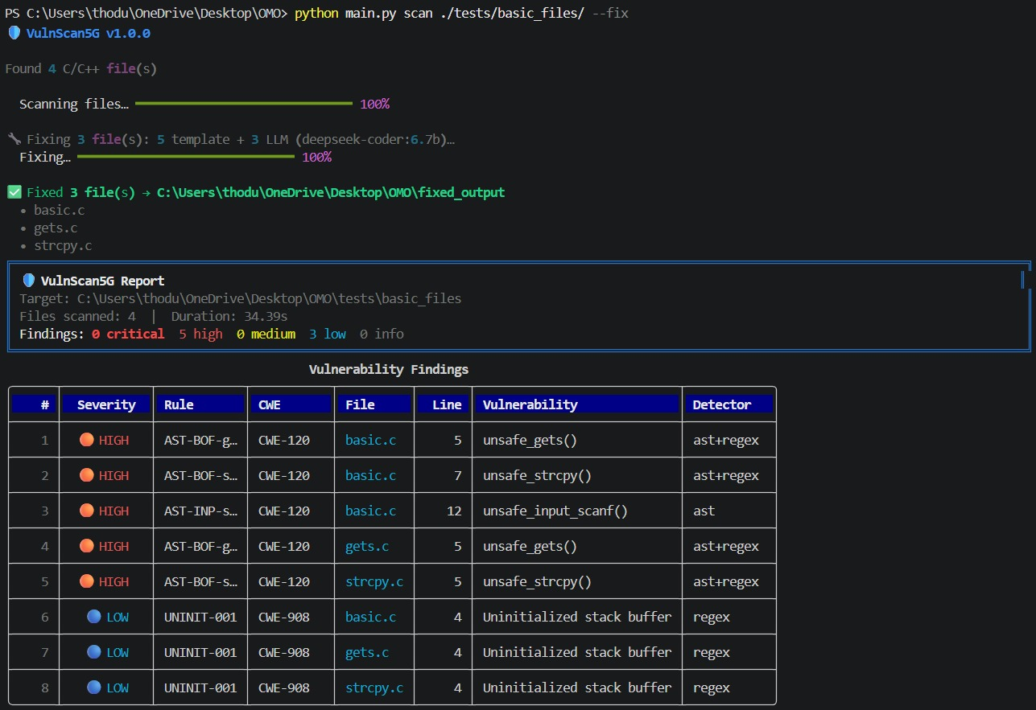

Benchmark Evaluation Results

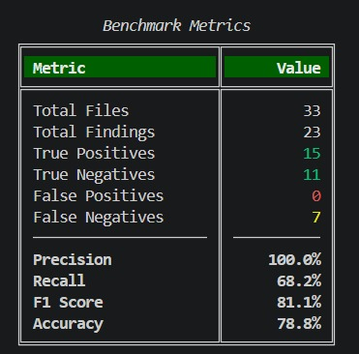

Scan Execution and Report Generation

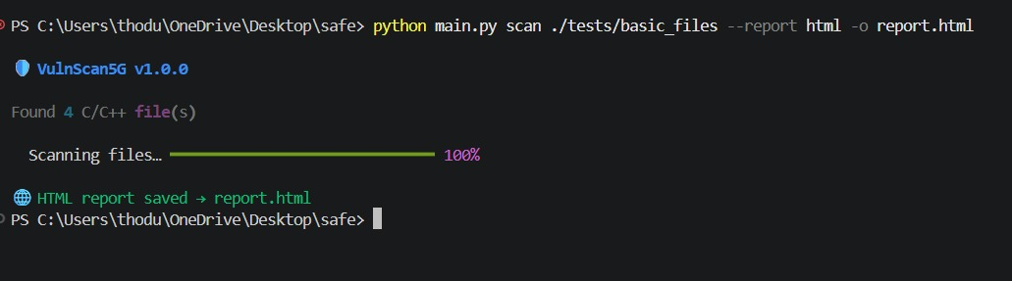

5.5 UI Screen shots

Dashboard Screenshot

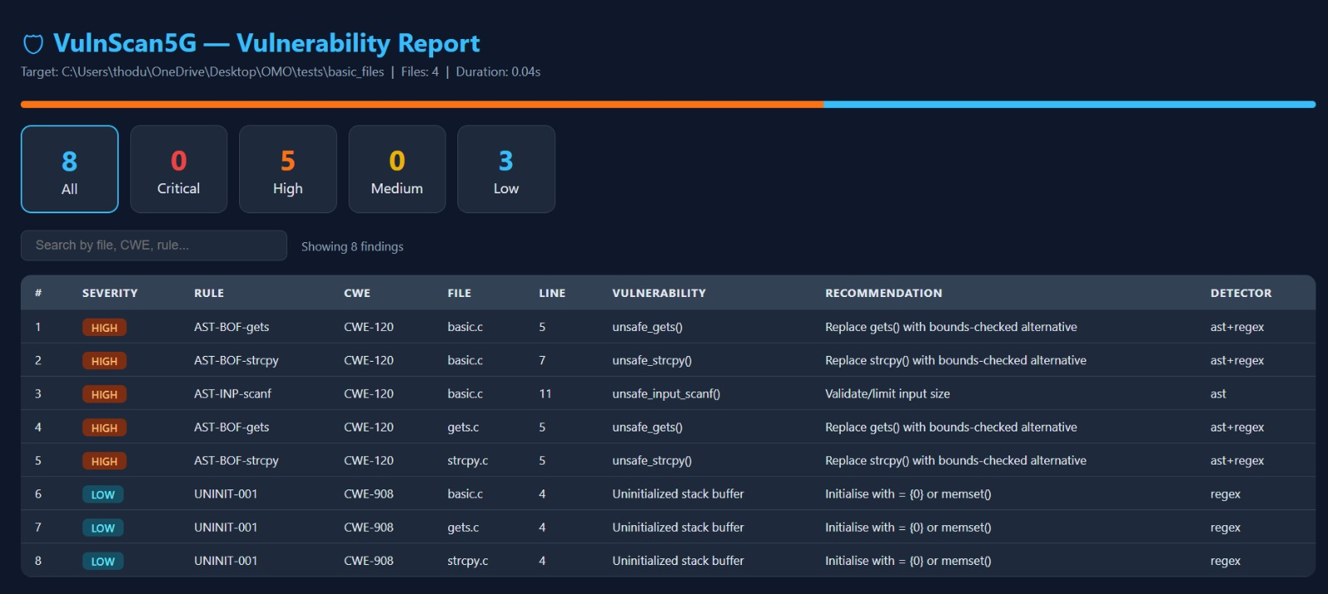

CHAPTER-6

SOFTWARE TESTING

6.1 Introduction

Software testing is the process of evaluating a software system to verify that it satisfies specified requirements and performs as expected. Testing helps identify defects, improve reliability, and validate the correctness of implemented functionalities.

In the VulnScan5G project, software testing was performed to evaluate the effectiveness of vulnerability detection, LLM-assisted reasoning, automatic patch generation, and report generation modules. Various vulnerable C/C++ programs and benchmark datasets were used to assess system performance and accuracy. The testing process ensured that the developed system operates correctly under different scenarios and provides reliable vulnerability analysis results.

6.1.1 Testing Objectives
The primary objectives of testing VulnScan5G are:
- To verify correct identification of security vulnerabilities.
- To validate Regex, AST, and Tree-sitter detection engines.
- To evaluate the accuracy of vulnerability classification.
- To verify CWE mapping functionality.
- To validate LLM-based vulnerability confirmation.
- To test automatic patch generation.
- To verify HTML, JSON, and console report generation.
- To measure system performance using benchmark datasets.
- To ensure system stability under various testing conditions.

6.1.2 Testing Strategies
Several testing strategies were employed during the development of VulnScan5G.
Unit Testing
Individual modules such as RegexDetector, ASTDetector, TreeSitterDetector, TemplateFixer, and Report Generator were tested independently to ensure correct functionality.
Integration Testing
The interaction between various modules was tested to ensure proper data flow throughout the pipeline.
Examples include:
- Detector to Merger communication
- Merger to LLM communication
- LLM to Auto-Fix Engine communication
- Auto-Fix Engine to Reporting Module communication
Functional Testing
Functional testing was performed to verify:
- Source code scanning
- Vulnerability detection
- Auto-fix generation
- Report generation
Performance Testing
Performance testing was conducted to evaluate:
- Scan execution time
- Detection speed
- Memory consumption
- Scalability on larger codebases
Benchmark Testing
Benchmark evaluation was performed using vulnerable C/C++ source files and benchmark datasets such as the NIST Juliet Test Suite.

6.1.3 System Evaluation
The overall system performance was evaluated using standard software testing metrics.
The benchmark results obtained are:
Metric | Value
Total Files | 33
Total Findings | 23
True Positives | 15
True Negatives | 11
False Positives | 0
False Negatives | 7
Precision | 100%
Recall | 68.2%
F1 Score | 81.1%
Accuracy | 78.8%



6.1.4 Testing New System

The developed system was tested using multiple vulnerable C/C++ programs containing intentionally insecure coding practices.

The testing process involved:

Executing the scan command.

Detecting vulnerabilities using hybrid detection engines.

Mapping findings to appropriate CWE categories.

Confirming vulnerabilities using the local LLM.

Generating automatic fixes.

Producing HTML and JSON reports.

The testing demonstrated that the system successfully detected vulnerabilities such as:

Buffer Overflow (CWE-120)

Unsafe String Operations

Unsafe Input Functions

Uninitialized Variables

Memory Management Issues

6.3Test Cases
Test Case ID | Test Description | Expected Result | Status
TC-01 | Scan C/C++ source files | Files scanned successfully | Pass
TC-02 | Detect unsafe `gets()` usage | Vulnerabiliy detected (CWE-120) | Pass
TC-03 | Detect unsafe strcpy() usage | Vulnerability detected (CWE-120) | Pass
TC-04 | Generate automatic fixes | Vulnerable code patched | Pass
TC-05 | Generate HTML report | Dashboard created successfully | Pass
TC-06 | Benchmak evaluation | Performance metrics generated | Pass

CHAPTER-7

CONCLUSION AND FUTURE SCOPE

7.1 Conclusion
VulnScan5G successfully demonstrates that a hybrid, privacy-preserving approach to vulnerability detection and auto-patching is both feasible and effective. The combination of three independent detection engines provides comprehensive coverage while minimizing false positives through confidence boosting and optional LLM reasoning. The two-tier auto-fix engine ensures safe deterministic patches for known patterns while leveraging AI for complex vulnerabilities.
With 27 detection rules, multi-format reporting, and CI/CD integration, VulnScan5G addresses a critical gap in open-source security tooling. The system was validated against the NIST Juliet Test Suite and the srsRAN 5G codebase, demonstrating effective detection and patching capabilities across both synthetic test cases and real-world production code.

7.2 Future Scope
• LSP Integration: Language Server Protocol server for real-time detection in VS Code and Neovim.
• Taint Analysis: Data flow tracking from source to sink across function boundaries.
• Clang AST Integration: libclang for compiler-accurate C++ semantic analysis.
• Model Fine-Tuning: Smaller model (1.5B-3B) trained on C/C++ security patches.
• Web Dashboard: Flask-based live dashboard for browsing scan history.
• CI/CD Integration: Native GitHub Actions and GitLab CI with PR annotations.
• Incremental Scanning: Re-scan only changed files via file hashes.
• SARIF Output: Static Analysis Results Interchange Format for tool interoperability.

REFERENCES
[1] M. Malkawi and R. Alhajj, "AI-Powered Vulnerability Detection and Patch Management in Cybersecurity," MAKE, vol. 8, MDPI, 2026.
[2] U. Kulsum et al., "A Case Study of LLM for Automated Vulnerability Repair," AIware 2024. DOI: 10.1145/3664646.3664770
[3] Y. Nong et al., "APPATCH: Automated Adaptive Prompting LLMs for Vulnerability Patching," USENIX Security '25.
[4] D. de-Fitero-Dominguez et al., "Enhanced Automated Code Vulnerability Repair Using LLMs," Eng. Appl. AI, Elsevier, 2024.
[5] X. Zhou et al., "LLM for Vulnerability Detection and Repair: Literature Review," ACM TOSEM, 2024.
[6] MITRE CWE. https://cwe.mitre.org/
[7] NIST Juliet Test Suite. https://samate.nist.gov/SARD/test-suites/juliet
[8] srsRAN. https://www.srsran.com/
[9] pycparser. https://github.com/eliben/pycparser
[10] Tree-sitter. https://tree-sitter.github.io/
[11] Ollama. https://ollama.ai/
[12] DeepSeek-Coder. https://github.com/deepseek-ai/DeepSeek-Coder

