Assignment 02 | Technical Analysis using R
PRELIMINARY STAGE • SETUP, FUNCTIONS, OUTPUTS & EVIDENCE
Student | Sriteja Kokkula | 664429563
Course | BDA400 – Data Science Tools and Techniques
Repository | https://github.com/Sriteja490/TechnicalAnalysis (to be created / confirmed)
Assignment directory | TechnicalAnalysis/Assignment2/
Report date | October 26, 2026

1. Project purpose
This project is the preliminary stage of a three-assignment technical analysis workflow. It configures the development environment and demonstrates reproducible stock-data acquisition, five basic statistics, console displays and closing-price visualizations. Historical data are retrieved on demand from Yahoo Finance using quantmod.

2. Deliverable inventory
Requirement | Location / evidence
GitHub repository | TechnicalAnalysis; an Assignment2 subdirectory for this stage
Portfolio config | Assignment2/portfolio.txt — one stock symbol per line
Import/statistics functions | Assignment2/R/technical_analysis.R
Display and chart utilities | Assignment2/R/display_results.R
Execution script | Assignment2/R/run_analysis.R
Screenshots and report | Assignment2/docs/; capture missing run/repository evidence locally
Evidence transparency: The next three images are genuine photos previously supplied by the student showing earlier installation activities. They are not represented as a new Assignment 2 run. Repository creation and live output screenshots have not yet been captured for this report.

3. GitHub account and repository setup
The existing GitHub account username is Sriteja490. Create a separate public repository named TechnicalAnalysis at https://github.com/new. This repo is distinct from the previously created Assignment 1 and Assignment 6 repositories. Upload the contents of the supplied TechnicalAnalysis folder so that Assignment2/portfolio.txt and Assignment2/R/run_analysis.R are visible at the correct paths.
Repository: TechnicalAnalysis
Course assignment folder: Assignment2
Expected URL: https://github.com/Sriteja490/TechnicalAnalysis
SCREENSHOT TO ADD — GitHub repository home page
After creating and uploading the repository, paste an actual screenshot showing the repository name, Public status and Assignment2 folder.
SCREENSHOT TO ADD — GitHub Assignment2 folder
Paste an actual screenshot showing portfolio.txt, R/, docs/, and outputs/ under Assignment2.

4. Install R and RStudio on Windows
Step 1: Download R for Windows from CRAN, run the installer, accept the license and choose an appropriate installation folder. Step 2: Download RStudio Desktop from Posit, run the installer and complete setup. Step 3: Launch RStudio and confirm that the Console displays the R version.
Figure 1. R 4.6.1 installation completion window previously shared by the student.
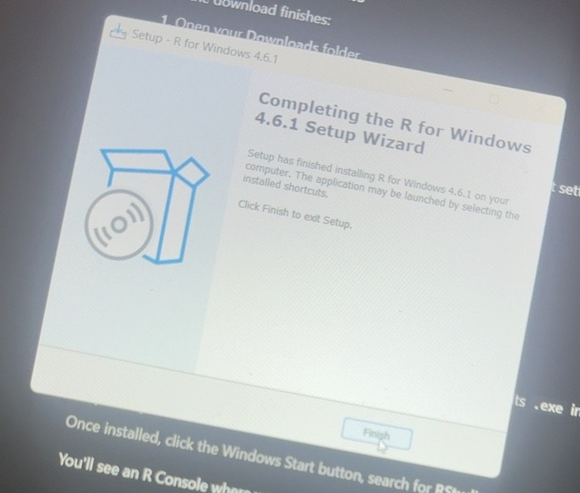

Figure 2. RStudio setup window previously shared by the student.
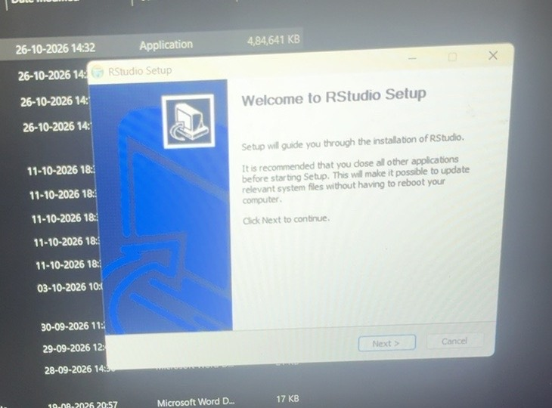
This photo records the RStudio installer. The next image shows RStudio running with its R Console, corroborating a functioning installation.

5. Install and verify R packages
Step 1: Open RStudio Console. Step 2: Install quantmod, TTR, ggplot2 and zoo using install.packages(). Step 3: Verify the libraries load without errors. Capture the Console output if a fresh screenshot is needed.
install.packages(c("quantmod", "TTR", "ggplot2", "zoo"))
library(quantmod)
library(TTR)
library(ggplot2)
packageVersion("quantmod")
packageVersion("TTR")
Figure 3. Earlier RStudio Console screen showing successful unpacking of quantmod, TTR and ggplot2 among other packages.
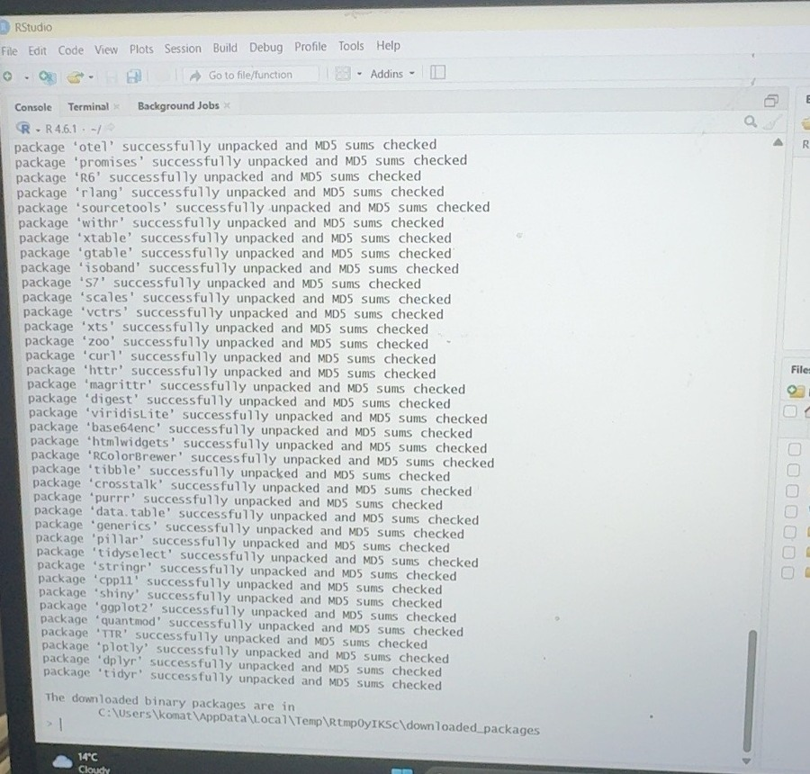

6. Project configuration and initialization
Step 1: In TechnicalAnalysis/Assignment2, create portfolio.txt. Step 2: Write one stock ticker per line. Step 3: Open the file and verify that there are no commas, quotation marks or extra characters.
AAPL
MSFT
GOOGL
These are sample US-listed tickers. Replace with a personal selection if your instructor requests individual portfolio choices. All market-data rows used by the code will come from Yahoo Finance at execution time.

7. Function to import stock data
The read_portfolio() function reads portfolio.txt, removes duplicate or blank symbols, and checks symbol format. The load_stock_data() function calls quantmod::getSymbols with src="yahoo" and auto.assign=FALSE for each ticker. It converts the resulting xts series into a separate data frame containing Date, Open, High, Low, Close, Volume, Adjusted and Symbol. The result is a named list, one separate data frame per symbol.
source("R/technical_analysis.R")
stocks <- load_stock_data("portfolio.txt",
from = Sys.Date() - 365, to = Sys.Date())
names(stocks)
head(stocks[["AAPL"]])
SCREENSHOT TO ADD — Yahoo download and imported data frames
After running R/run_analysis.R, paste a screenshot of the Console displaying symbols and their first/last rows. Prices must come from the actual live download.

8. Function to compute basic statistics
The calculate_statistics() function receives a stock data frame and produces a structured result with observations, latest closing price, mean, mode, median, sample standard deviation and the latest simple moving average. The calculate_portfolio_statistics() function runs it for every successfully downloaded stock.
Statistic | Method / interpretation
Mean | mean(Close) — arithmetic average over the selected dates
Mode | Most frequently repeated Close rounded to cents; NA if none repeats
Median | median(Close) — middle ordered closing price
Standard deviation | sd(Close) — sample standard deviation in USD
Moving average | TTR::SMA(Close, n=20) — 20-trading-day rolling mean
The first 19 entries of the 20-day SMA are undefined because there are not yet 20 prior observations. When no daily price repeats to the nearest cent, a unique modal stock close does not exist, and the report outputs NA. This is intentional and documented rather than inventing a mode.
results <- calculate_portfolio_statistics(stocks, ma_period = 20)
print(results$summary)
SCREENSHOT TO ADD — Summary statistics table
After running the script, paste a screenshot of the Console summary or outputs/stock_statistics.csv. Do not type unverified prices into the report.

9. Utilities to display stocks and visualizations
The display_stock_data() function prints the first and last observations of each downloaded stock. The display_statistics() function shows the summary table. The plot_stock_data() function draws a ggplot2 line chart of closing prices and the 20-day moving average for each ticker. The save_stock_charts() function exports a PNG chart for each ticker.
source("R/display_results.R")
display_stock_data(stocks)
display_statistics(results$summary)
save_stock_charts(results$by_stock, output_dir="outputs")
After executing source("R/run_analysis.R") from the Assignment2 working directory, expected local output names include outputs/stock_statistics.csv, outputs/AAPL_daily.csv and outputs/AAPL_price_and_SMA.png (assuming AAPL data downloads successfully).
SCREENSHOT TO ADD — Stock price chart — AAPL
Paste an actual exported PNG chart from outputs/AAPL_price_and_SMA.png, or a screenshot showing it in the RStudio Plots/Viewer panel.
SCREENSHOT TO ADD — Stock price chart — MSFT or GOOGL
Paste an actual second ticker plot so that the report demonstrates separate data visualizations.

10. Execution steps and validation
Run the package installation once if necessary. Then set the working directory to TechnicalAnalysis/Assignment2 using Session > Set Working Directory > Choose Directory in RStudio. In the Console, type the single command below.
source("R/run_analysis.R")
Test | What to verify | Status
Portfolio | read_portfolio("portfolio.txt") returns the intended symbols | Needs local check
Download | Every downloaded symbol appears in names(stock_data) | Needs live Yahoo check
Data frames | head(stock_data[["AAPL"]]) includes OHLCV and Date | Needs live check
Statistics | Mean, median, sd and SMA calculated per ticker | Needs live check
Charts | At least two actual chart PNGs produced in outputs/ | Needs local check
GitHub | Public TechnicalAnalysis repo with Assignment2 folder | Needs upload check
Possible errors: (a) "Cannot find portfolio.txt" means the working directory is not Assignment2; (b) missing package errors require install.packages(); (c) Yahoo Finance may block requests or reject a ticker; verify internet and symbols, then retry. Live numbers may change with date and price revisions.

11. Submission checklist
- Create GitHub repository named TechnicalAnalysis; upload the Assignment2 project folder.
- Run R/run_analysis.R from RStudio, check output CSVs and PNGs, and capture real screenshots.
- Add screenshots of the new GitHub repo, downloaded data, statistical table, and actual plots to this Word report.
- Save the completed report in Assignment2/docs/ and upload it to GitHub.
- Confirm the repository URL is public and opens without logging in.
- Submit MS Word cover page with GitHub link through the LMS, plus any other file requested.

12. Repository URL
https://github.com/Sriteja490/TechnicalAnalysis
URL not verified as created at the time of this report generation. Confirm it after uploading. No stock prices or statistical results have been invented in this report.

