**JAVA :**

**public** **class** Class1 {

**public** **static** **void** main(String[] args) {

// Arrays

**int** a[]=**new** **int**[5];//declaration and instantiation

a[0]=10;//initialization

a[1]=20;

a[2]=70;

a[3]=40;

a[4]=50;

//printing array

**for**(**int** i=0;i<a.length;i++)//length is the property of array

System.***out***.println(a[i]);

}

}

2) **package** JavaBasics;

**public** **class** Class1 {

//methods

**int** i;

**public** **void** display()

{

/*

*

* all definitions goes here!!!

*/

}

**public** **static** **void** main(String[] args) {

// **TODO** Auto-generated method stub

System.***out***.println("Divya");

}

}

3) import java.util.NoSuchElementException;

import org.openqa.selenium.By;

import org.openqa.selenium.WebElement;

public class MyClass {

public static void main(String[] args) {

// TODO Auto-generated method stub

System.setProperty("webdriver.gecko.driver", "C:\\Users\\Divya Juloori\\Downloads\\geckodriver-v0.13.0-win64\\geckodriver.exe");

WebElement txtbox_username = driver.findElement(By.id("username"));

try{

if(txtbox_username.isEnabled()){

txtbox_username.sendKeys("tutorial");

}

}

catch(NoSuchElementException nsee){

System.out.println(nsee.toString());

}

}

}

**public** **class** MyClass {

// **TODO** Auto-generated method stub

**private** **int** var;

**public** MyClass()

{

//code for default one

var = 1000;

}

**public** MyClass(**int** num)

{

//code for parameterized one

var = num;

}

**public** **int** getValue()

{

**return** var;

}

**public** **static** **void** main(String args[])

{

MyClass obj2 = **new** MyClass();

System.***out***.println("var is: "+obj2.getValue());

}

}

**Loops:**

**public** **class** Class1 {

**public** **static** **void** main(String[] args) {

// **TODO** Auto-generated method stub

**int** a = 0;

**while** (a <=10)

{

System.***out***.println(a);

a++;

}

// using do while

**int** b = 0;

**do** {

System.***out***.println(b);

b++;

} **while** (b <=10);

}

}

**public** **class** Class2 {

**public** **static** **void** main(String[] args) {

// while loop

**int** a =0;

**while** (a<10)

{

System.***out***.println(a);

a++;

}

}

}

**public** **class** Class3 {

**public** **static** **void** main(String[] args) {

**int**[] myintarray = {20,30,55,80,76};

// For loop

**for**(**int** index=0; index < 5 ; index++)

{

System.***out***.println(myintarray[index]);

}

}

}

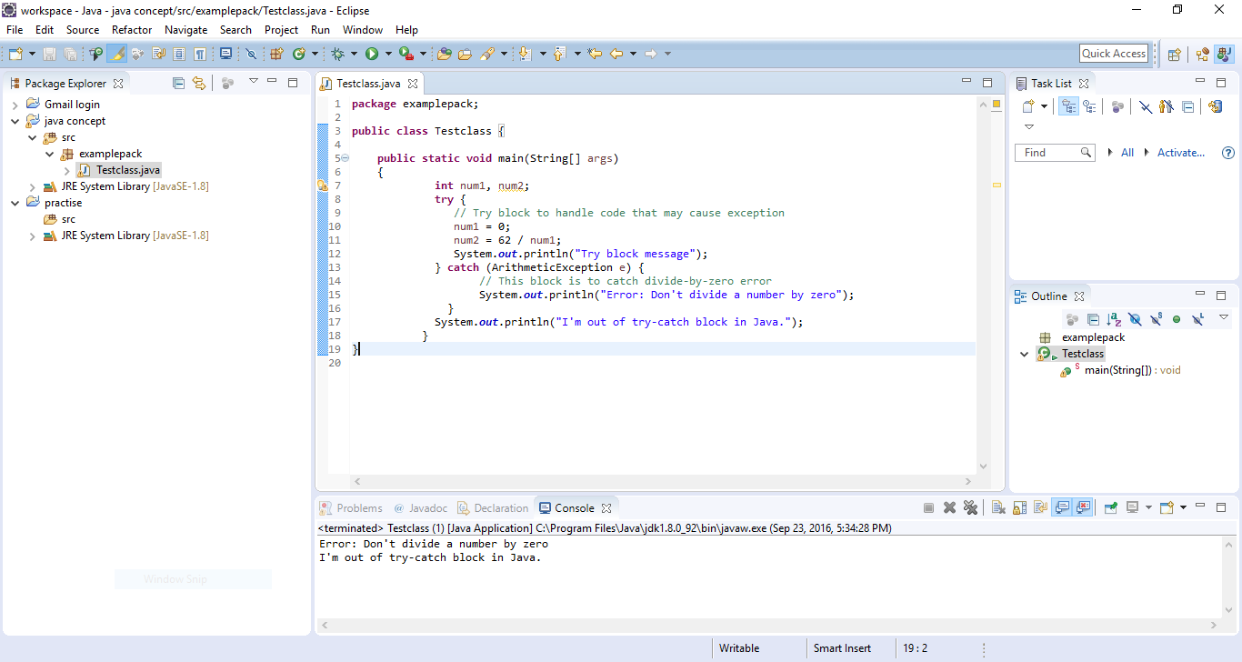

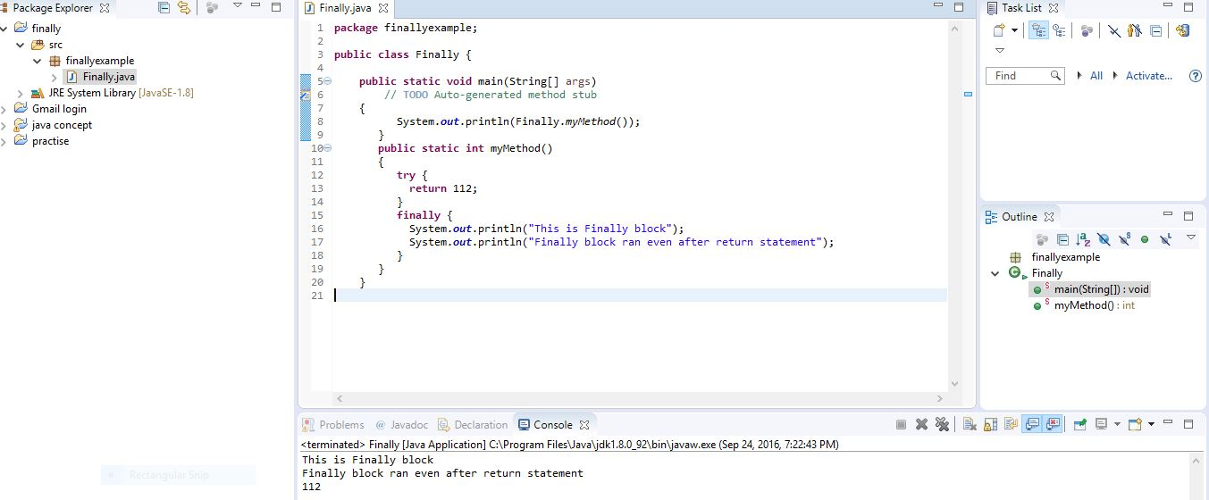

**interface** MyInterface

{

**public** **void** method1();

**public** **void** method2();

}

**class** XYZ **implements** MyInterface

{

**public** **void** method1()

{

System.***out***.println("implementation of method1");

}

**public** **void** method2()

{

System.***out***.println("implementation of method2");

}

**public** **static** **void** main(String arg[])

{

{

MyInterface obj = **new** XYZ();

obj. method1();

}

}

**class** Calculation{

**void** sum(**int** a,**int** b){System.out.println(a+b);}

**void** sum(**int** a,**int** b,**int** c){System.out.println(a+b+c);}

**public** **static** **void** main(String args[]){

  Calculation obj=**new** Calculation();

  obj.sum(20,10,5);

  obj.sum(20,10);

  }

}

**class** Human{

**public** **void** eat()

{

System.***out***.println("Human is eating");

}

}

**class** Boy **extends** Human{

**public** **void** eat(){

System.***out***.println("Boy is eating");

}

**public** **static** **void** main( String args[]) {

Boy obj = **new** Boy();

obj.eat();

}

}