**PREDICTION ALGORITHM FOR DISASTER MANAGEMENT WITH INTERNET OF THINGS**

**A PROJECT REPORT**

***Submitted by***

**OMMI TANMAI KRISHNA (314506408044)**

**SRITHA DARBHA (314506408058)**

**SWETHA KONDUR (314506408060)**

***In partial fulfilment for the award of the degree***

***OF***

**BACHELOR OF TECHNOLOGY**

***IN***

**COMPUTER SCIENCE AND ENGINEERING**

***Under the guidance of***

***Dr. G. Prassana Lakshmi***

**Professor and women scientist (DST)**

**DEPARTMENT OF COMPUTER SCIENCE AND SYSTEMS ENGINEERING**



**ANDHRA UNIVERSITY COLLEGE OF ENGINEERING (A)**

**ANDHRA UNIVERSITY: VISAKHAPATNAM-530 003**

**MAY 2018**

**ANDHRA UNIVERSITY COLLEGE OF ENGINEERING (A)**

**DEPARTMENT OF COMPUTER SCIENCE AND SYSTEMS ENGINEERING**

**ANDHRA UNIVERSITY, VISAKHAPATNAM -530003**



**CERTIFICATE**

This is to certify that this project entitled **“Prediction Algorithm for Disaster Management with Internet of Things** “has been submitted by ***OMMI TANMAI KRISHNA (314506408044), SRITHA DARBHA (314506408058), SWETHA KONDUR (314506408060)*** during the year 2014-2018 in partial fulfilment of the requirements for the aware of **“BACHELOR OF TECHNOLOGY”** in Computer Science and Engineering from Andhra University, Visakhapatnam is a record of bonafide work carried out under my guidance and supervision.

**PROF, P.V.G.D PRASAD REDDY DR. G. PRASANNA LAKSHMI**

**HEAD OF DEPARTMENT PROJECT GUIDE**

**DEPARTMENT OF CS &SE WOS- A PROGRAMME (DST)**

**DECLARATION**

We hereby declare that the project entitled **“Prediction Algorithm for Disaster Management with Internet of Things”** is an original and authentic work done in the Department of Computer Science & Systems Engineering, Andhra University College of Engineering (A), Andhra University, Visakhapatnam, submitted in partial fulfillment of the requirements for the degree of Bachelor of Technology.

**Sincerely,**

**OMMI TANMAI KRISHNA**

**SRITHA DARBHA**

**SWETHA KONDUR**

**ACKNOWLEDGEMENT**

We have immense pleasure in expressing our earnest gratitude to my Project Supervisor **Dr. G. PRASANNA LAKSHMI**, Department of CS&SE, AUCE, Andhra University for her inspiring and scholarly guidance. Despite her pre-occupation with several assignments, he has been kind enough to spare her valuable time and gave me the necessary counsel and guidance. We received at every stage of planning and constitution of this work.

I express sincere gratitude to **Prof. P. V. G. D. Prasad Reddy**, Head of the Department, Computer Science and Systems Engineering, for having accorded us permission to take up this Project work and for helping us graciously throughout the execution of this work.

We extend our sincere thanks to our academic teaching staff and non-teaching staff for their affection and help throughout our study.

With sincere regards

**OMMI TANMAI KRISHNA**

**SRITHA DARBHA**

**SWETHA KONDUR**

**ABSTRACT**

The proposed Fire alarm system is a real-time monitoring system that detects the presence of smoke in the air due to fire and captures images via a camera installed inside a room when a fire occurs. The embedded systems used to develop this fire alarm system are Raspberry Pi and Arduino Uno. The key feature of the system is the ability to remotely send an alert when a fire is detected. When the presence of smoke is detected, the system will display an image of the room state in a webpage. The system will need the user confirmation to report the event to the Firefighter using Short Message Service (SMS). The advantage of using this system is it will reduce the possibility of false alert reported to the Firefighter. The camera will only capture an image, so this system will consume a little storage and power.

The smart fire management requires significant surveillance systems to detect and control the fire and fire causing agents automatically. This requirement has been accomplished in this proposed system by employing fire detection system and fire controlling system using Raspberry pi. The fire detection system entails flame detectors along with temperature sensors which reduces the false fire detection rate. The system also notifies the user by emailing the video of fire affected area and gives the updates of room temperature from time to time. A gas leakage sensor has been employed to detect various types of gases like ethane, methane, LPG etc. The proposed fire controlling system performs various functions on detection of fire or gas, which includes switching off the main power supply, switching on the exhaust fan and finally dousing the fire. The water sprinklers have been employed which will be activated on the detection of fire by the employed fire sensors in the system. If temperature rises above the set threshold temperature, then the proposed system will also drop the mail to fire brigade along with the video and notify the user to inform the fire brigade manually. This proposed system can be installed in a hall of maximum area 126ft × 21ft employing one Raspberry pi module.

**LIST OF SYMBOLS**

IOTA INTERNET OF THINGS

DEP DEVELOPER ENGAGEMENT PLATFORM

API APPLICATION PROGRAM INTERFACE

RPi RASPBERRY PI

FEMA FOREIGN EXCHANGE MANAGEMENT ACT

MIMD MULTIPLE INPUT MULTIPLE OUTPUT

D2D DEVICE TO DEVICE

USB UNIVERSAL SERIAL BUS

**TABLE OF CONTENTS**

ABSTRACT

LIST OF SYMBOLS

INTRODUCTION

* IOT SERVICE OFFERINGS
* IOT SOLUTIONS
  + Anomaly Detection
  + Developer Engagement Platform
  + VOLANSYS

LITERATURE REVIEW

SOFTWARE AND HARDWARE REQUIREMENTS

* RASPBERRY PI
  + Different Types Of Rpi Models
  + Comparison Table
  + Advantages Of Different Rpi Models
  + Applications Of Rpi
* ARDUINO UNO
  + Different Types Of Arduino Block
  + Applications
* VOLTAGE DIVIDER

SYSTEM ARCHITECTURE

METHODOLOGIES AND TOOLS

* PROPOSED TECHNOLOGY AND THEIR ADVANATGES
* PROCESS MODEL
* FUNCTIONALITIES OF THE PROCESS MODEL
* ALGORITHM OF THE SMOKE DETECTOR

LIMITATIONS

FEASIBILITY

FUTURE SCOPE AND CONCLUSION

* FUTURE SCOPE
* CONCLUSION

CASE STUDIES

* CASE STUDY 1
* CASE STUDY 2
* CASE STUDY 3

REFERENCE

BIBLOGRAPHY

**INTRODUCTION**

Internet of Things (IoT) is an ecosystem of connected physical objects that are accessible through the internet. The ‘thing’ in IoT could be a person with a heart monitor or an automobile with built-in-sensors, i.e. objects that have been assigned an IP address and have the ability to collect and transfer data over a network without manual assistance or intervention. The embedded technology in the objects helps them to interact with internal states or the external environment, which in turn affects the decisions taken.

Education domain has always been reluctant in adopting technology in comparison to any other domains like Industrial Automation, Home Automation etc. Even when the new technological paradigm the Internet of Things is conquering the entire world, Education domain once again is falling back in utilizing the advantages of it. IoT is the network of networks that is connecting the physical objects for collecting and exchanging data and deriving relevant insights which in return will create unprecedented opportunities for an enterprise. This White paper touches the various aspects on how the Education Domain can take advantage of Internet of Things and benefit from it. The Internet of Things can play major role in equipping three Areas of the Educational Domain:

1) Security

2) Increasing overall Efficiency

3) Making Technology Accessible to students

From homes and industries to enterprises, Internet of Things have become commonplace in all walks of life. Connecting everything and everyone, IoT is making the world smarter and better than ever before. However, this is just the beginning. Unlocking the full potential of Internet of Things requires that businesses understand the opportunities for value creation and systematically address the underlying challenges.

1. SECURITY

It is very difficult to monitor the activities and whereabouts of the students in any Educational Institution because the person per unit area is high. For example, around 40 students might be in a classroom which might be of the size of 20 by 20 feet. This kind of high density is usually not seen in other types of building, be it factory or an office. Moreover, students at an Educational Institution are more vulnerable to risk and need smart security as compared to any adult population in any other workspace. IoT comes to the rescue here and can add tremendous value in terms of increasing the security of the Schools or any Educational Institutions. Technologies such as 3D positioning can monitor the students all the time and report their presence at any point in time. This technology can also provide an option of distress buttons in order to raise an alarm if needed. Intelligent Camera Vision can be employed in the campus to monitor the behaviour of the students. Currently, Computer Vision Technologies have improved tremendously and can track any signature movements etc. which can prevent any untoward incidents automatically

2. INCREASING OVERALL EFFICIENCY

In Schools and Educational Institutions, a huge amount of time is spent on activities which do not add value to the central aim of their existence. For example taking attendance is a huge drain on the resources and time. This activity needs to be repeated eight or nine times a day. If a class has 30 students, then each student’s name has to be called and the student has to answer to the attendance while the teacher has to mark the presence in a register. This process might take 10 seconds for each student. Therefor the total time spent on taking attendance is about 30 X 10 = 300 seconds which is about 5 minutes. If the total duration of the class is 40 minutes, then 12.5% of the class time is wasted in taking attendance, which is a huge loss. Given an entire day which has about 8 periods, the total time wasted is a whopping number of (8 X 5 =) 40 minutes that is wasted in only taking attendance. If a school has 100 class rooms then the total loss of time per day is a huge 40 * 100 = 4000 minutes or 66 hours. In addition to that the data has to be collectively sent to the central office for various purposes, which is another set of task all together. Internet of Things can come to the rescue of this inefficient system. IoT end-devices can collect these data and then can automatically send those data to the central office server without any human intervention. This revolutionary shift towards IoT technology can relieve the teacher and the students of the tedious task and concentrate more towards studies and innovation which is the central function of any Educational Institute

3. MAKING TECHNOLOGY ACCESSIBLE TO STUDENTS

In some cases there are children or students with special needs in the class and every time the student needs some help, he or she has to call the teacher for help or someone else has to do the same on their behalf. Connected devices of IoT can automatically detect their needs by gauging their behaviour and need based on any situation. For example, a special needs student in a computer lab can have the screen font size increased automatically using his or her connected device instead of calling for help. This will empower the special needs students and the institution as well.

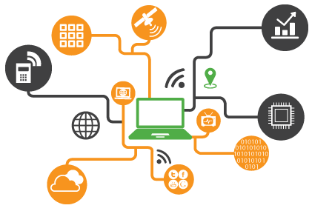

Internet of Things service enables organizations to transform business needs into competitive differentiators by delivering innovative IoT powered solutions. From integrating the right sensors and deriving inspired insights to choosing the best-fit platform, we provide comprehensive IoT services to our clients. We empower organizations to:

* Connect and scale with efficiency.
* Analyze and Act on new data.
* Integrate and transform business processes.
* Improve decision making with augmented intelligence.
* Design, develop, integrate, deploy and manage end to end IoT processes.
* Seamlessly integrate IoT solutions with existing enterprise architecture.

With 30+ IoT customers, 300+ SMES, 50+ partners and 20+ analyst mentions, we are uniquely positioned to help you improve business value, enhance efficiency, and reduce operations and maintenance cost. Our partnerships with leading innovators like Microsoft Azure, PTC ThingWorx, AWS IoT, MongoDB, WindRiver, Intel and Host of Device and Sensor Partnerships along with industry memberships with TSDSI and Industrial Internet Consortium enable us to deliver best-of-class solutions for all your IoT requirements.

**Focus Areas**

Our end-to-end IoT solutions empower smart industries, smart living and smart enterprises and deliver connected experiences by connecting assets, operations/logistics, and services. While we have expertise across all stages of IoT adoption to provide you with a seamless single vendor experience to maximize efficiencies, we focus predominantly on the segments mentioned below:

* Smart Industries – Manufacturing, Energy, Utilities. Re-imagine processes to unlock the true potential of your industry while facilitating sustainable development.
* Smart Living – Wearables, Healthcare, Security. Enhance the quality of life by embracing emerging technologies designed to foster healthier, happier and safe environment.
* Smart Enterprises – Smart homes/ Buildings/ Offices, Retail. Connect people, machines and information using Big Data to enhance business efficiency in a secured ecosystem.

**What we Offer**

|  |  |  |
| --- | --- | --- |
| Enabling IoT Adoption across All Stages | | |
| Proof of Concept   * Bring in connectivity to already deployed devices * Quick prototyping with the cloud based IoT platform * Demonstrate possible business value | Productization   * Creation of next generation connected devices * Identify the right partner for IoT platform * Combine data with existing enterprise systems * Create business applications | Operationalization   * On-board groups and users * On-board devices * Create operations center * Monitor and manage devices and business |

**IOT SERVICE OFFERINGS**

**[Consulting and Solution Development](https://www.happiestminds.com/services/internet-of-things/" \o ")**

* Requirement elicitation and analysis
* Business process modelling with technology and process consulting
* Defining the problem statement along with recommendation on solution blueprint
* Thought leadership and repository of business-ready use cases
* Product and service enhancement

**Intelligent Platforms**

* Open platform architecture with end-to-end connectivity
* Multi-tenant architecture to support IoT resources cost efficiently and securely
* Big data support with mashup builder and business intelligence
* Device vendor agnostic and device virtualization
* Secure, reliable, scalable and OTA firmware updates

**Connected Device**

* Hardware product design (PCB, Firmware) to deliver end-to-end solutions and accelerate time to market
* Design flow implementation and PCB fabrication support
* Device IoT framework and enablement
* Customized form-factor design and prototyping as per requirement
* Feature enhancements and certifications

**Vertical Applications**

* End-device application development with multiple protocols and cross-platform support
* Native, mobile application development
* Application management with easy data import/export
* Vertical domain expertise
* Re-engineering and optimization with iterative refinement and customer-driven design

**End to End System Integration**

* CRM and other web content
* ERP system integration
* SMS and email gateway integration
* Map and billing engine integration
* Integrating multiple Internet of Things assets with different functionalities, departments and stages in product lifecycle

**Testing**

* Device lab testing (manual/automated)
* Device field testing
* Platform testing
* Mobile application testing
* Application automated testing

**Managed Services and Support**

* Application management
* Cloud hosting
* L1/L2/L3 support
* Remote infrastructure management
* Incident management
* Command centre: SoC/NoC

**What is the scope of IoT?**

Internet of Things can connect devices embedded in various systems to the internet. When devices/objects can represent themselves digitally, they can be controlled from anywhere. The connectivity then helps us capture more data from more places, ensuring more ways of increasing efficiency and improving safety and IoT security.

IoT is a transformational force that can help companies improve performance through IoT analytics and **IoT Security** to deliver better results. Businesses in the utilities, oil & gas, insurance, manufacturing, transportation, infrastructure and retail sectors can reap the benefits of IoT by making more informed decisions, aided by the torrent of interactional and transactional data at their disposal.

**How can IoT help?**

IoT platforms can help organizations reduce cost through improved process efficiency, asset utilization and productivity. With improved tracking of devices/objects using sensors and connectivity, they can benefit from real-time insights and analytics, which would help them make smarter decisions. The growth and convergence of data, processes and things on the internet would make such connections more relevant and important, creating more opportunities for people, businesses and industries.

**IOT SOLUTION**

1. **Anomaly Detection**

The digital world has changed dramatically in last few years. Data Production is expected to be 44 times more by 2020 than it was in 2009. Although every business is a race to harness the power of the digital universe, with this speed and the variety of information it is difficult to count on the existing process and institutes for useful insights.

Our digital universe is spinning faster than ever before and there is no chance that it will slow down. Running rule-based engines to detect Security threats, predict device failure, predict fraud, highlighting discount glitches will not be able to give the required insights to the business.

Our Anomaly Detection Solution is a feedback based ‘Domain Agnostic’ solution which runs a variety of Algorithms to check data anomalies and also learns with time, based on the Algorithm’s efficient.

**1. Anomaly Detection:**

Anomaly Detection is the process of identifying non-complying patterns called outliers. This Domain Agnostic Anomaly detection solution uses statistical, supervised and Artificially Intelligent algorithms to automate the process of finding outliers. It is a Plug and Play solution, flexible enough to deal with variety of categorical and numerical data and that too on high velocity. Its feedback based engine makes it capable to learn with time and adapt to change in patterns over time.

As every domain has different data patterns and variations, the Anomaly Detection is a tedious task which demands rich Domain Knowledge, Data Science and Engineering expertise and various iterations to conclude on efficient Algorithms.

With this solution, we have automated the entire iterative process of customizing and finding efficient algorithms and have helped Businesses to quickly figure out outliers. It’s as simple as pumping the domain data, configuring and running different algorithms and at the same time judging the efficiency of each algorithm for their Business advancement.

**Features**

* Domain Agnostic: Domain independent real time solution that can run on any variety of data set (Categorical/Numerical)
* Multiple Algorithm: No ‘one-size-fits-all’ solution for outliers. Right blend of statistic based and Machine Learning Algorithms.
* Feedback Based: Captures the feedback on correctness from the users. Trains accordingly perform effectively on new data sets.
* 3V’s of Big Data: Embodies Velocity for running algorithms for large online streaming data, Volume for handling [Big Data](https://www.happiestminds.com/services/big-data/) needs and Variety for supporting data from heterogeneous sources.
* Simple UI: User friendly

**Benefits**

* Domain Agnostic- anyone can implement this irrespective of their domain. Solution is well suited for.
* Security Intrusion Identification.
* Price Glitches Identification on an e-commerce site.
* Discount Malpractices by Sales team
* Device Failure Prediction
* The solution is self-evolving it continuously learns and adapts changing patterns with time
* Automated Algorithm selection and ranking for a given domain
* Plug and play solution
* Cuts down the dependency on Data Scientist and Big Data Engineers and bridges the gap between all parties

1. **Developer Engagement Platform (DEP)**

The Developer Engagement Platform is an innovative solution from Happiest Minds that gives API providers a method to socialize APIs, educate, communicate and contribute with the developer community innovatively. This solution enables them to build an engaging developer community with faster user adoption fostering learning, development, and collaboration.

**Why DEP**

With more and more organizations exposing services through APIs, the real challenge remains with enabling the developers to quickly understand and learn the APIs. Quicker learning and understanding of the APIs will enable developers to leverage the services and functionalities. The sooner the learning process, the better it is for the company and the developers. An API provider, therefore, needs a platform that makes APIs available to developers and provides a medium for them to learn, and develop applications.

**[Features](https://www.happiestminds.com/solutions/developer-engagement-platform/)**

* Intuitive API testing console for REST APIs
* API Key management
* Track API usage
* Easy integration with API management platform
* Showcase applications
* Collaboration through Blogs & Forums

**[Benefits](https://www.happiestminds.com/solutions/developer-engagement-platform/)**

* Frictionless learning experience
* Centralized repository for all development tools and learning needs
* Reliable and secured infrastructure for code repository
* An open environment for developers to quickly test APIs
* A social collaboration platform
* Competitive developer and partner relationship
* Customizable and seamless integration with different API management products

1. **VOLANSYS**

The Internet of Things (IoT) & wearable devices are changing & impacting each aspect of our lives. VOLANSYS provides services & solutions for IoT & wearable devices in all industries & domains including healthcare, smart appliances for home & office, smart energy devices, automotive, Industrial IoT (IIoT), transportation & logistics and smart consumer devices, to name a few. As enterprises, connected products & utility providers have deployed cloud solutions, it is essential for these businesses to integrate & collaborate their cloud services for the next level of growth. VOLANSYS also provides cloud collaboration solutions and multiple cloud integration services to serve cloud-ready IoT solutions to various industries including consumer electronics, healthcare, oil & gas, transportation, automotive, home automation & industrial processes.

**What Is Unique About Us?**

We are among the few companies that excel at all Connected Product solution components, with expertise on Embedded Devices, Cloud, and Mobile under a single roof. We provide IoT solutions featuring rich architecture with the in-built capability and hooks to automate more than 90% of validation efforts.

**Technologies & Standards That Matter**

With our proven track record in the IoT domain over several years, we have deep expertise in various technologies & standards. We have also partnered with companies who provide the basic building blocks of IoT to speed up development – whether cloud, database, semiconductor or apps. Some areas of our technical expertise are as follows:

* **Connectivity:** Wi-Fi, Wi-Fi Direct, ZigBee & profiles, Zwave, Bluetooth & profiles, IR, NFC
* **Semiconductor:** NXP, Marvell, Atmel, TI, Microchip & many more
* **Cloud Platforms:** AWS, Windows Azure, Google, ThingWorx
* **Web Services:** RestFul service, OAuth Authorization services, and SOAP services
* **Databases:** Cassandra, MongoDB, Raven DB, MySQL, Oracle, MS-SQL
* **Mobile:** Android, iOS, Windows 10
* **Standards:** OPENIoT, HomeKit, Thread, Nest, Alljoyn, Brillo & Weave
* **Communication & Queuing Protocols:** CoAP, MQTT, RabbitMQ, ZeroMQ

**LITERATURE REVIEW**

**Embedded IoT Systems: Network, Platform, and Software by Jeongyeup Paek,1 Om prakash Gnawali,2 Marcos A. M. Vieira,3 and Shuai Hao4**

1Chung-Ang University, Seoul, Republic of Korea

2University of Houston, Houston, TX, USA

3Universidade Federal de Minas Gerais, Belo Horizonte, MG, Brazil

4AT&T Labs Research, Bedminster, NJ, USA

Received 19 April 2017; Accepted 19 April 2017; Published 24 May 2017

This is an open access article distributed under the Creative Commons Attribution License, which permits unrestricted use, distribution, and reproduction in any medium, provided the original work is properly cited. With the rapid development of connected embedded devices being placed everywhere in our everyday life, the vision of the Internet of Things (IoT) is coming close to reality where billions of physical world devices have a digital presence on the Internet. However, despite the importance of IoT, there are still several technical challenges remaining before the next Internet revolution. This special issue has focused on technical challenges that can enable IoT. We call for manuscripts presenting and discussing the most recent advances in embedded systems for IoT. Until the deadline of the special issue, 17 manuscripts have been received worldwide. After the review process, 7 manuscripts have been accepted by this special issue. The accepted research manuscripts have focused on the energy efficiency and power transfer for IoT devices, device-to-device communication, multithreading for multicore IoT platforms, and topology construction and scalability of IoT networks. Accepted manuscripts present the important research findings and these advances will contribute to the development of IoT. Evaluation of power efficiency is important for low power wireless personal area network (LoWPAN) devices and applications in IoT. Conventional methods to evaluate the power efficiency of LoWPAN devices rely deeply on the accuracy of the testing equipment, which trades off high cost with limited accuracy. To tackle this challenge, a low cost, real-time power measurement platform called PTone is proposed, which can be used to detect the real-time power usage of LoWPAN devices and be able to determine the state of each module of device under test. Based on PTone, an abnormal status diagnosis mechanism is developed which can not only judge abnormal status, but also classify the abnormal status and locate the abnormality causing module accurately.

Power transfer wirelessly is another promising technology that can enable a massive number of wireless devices in IoT. For this purpose, destination-aided simultaneous wireless information and power transfer (SWIPT) is proposed for a decode-and-forward relay network, in which massive multiple-input multiple-output (MIMO) antennas are deployed at relay to assist communications among multiple source-destination pairs. During relaying, energy signals are emitted from multiple destinations when multiple sources are sending their information signals to relay. Analysis reveals that asymptotic harvested energy is independent of the fast fading effect of wireless channels; meanwhile, transmission powers of each source and destination can be scaled down inversely proportional to the number of relay antennas. To reduce energy leakage interference and multi pair interference, zero-forcing processing and maximum ratio transmission are employed at relays. Fundamental trade-off between harvested energy and achievable sum rate is quantified, and it is shown that asymptotic sum rate is neither convex nor concave with respect to power splitting and destination transmission power. Thus, a one-dimensional embedded bisection algorithm can be used to jointly determine the optimal power splitting and destination transmission power, which shows that destination-aided SWIPT are beneficial for harvesting energy and increasing the sum rate. For the past decade, wireless sensor networks have focused primarily on data collection. As a result, the network topology for these systems was usually heavily centralized. However, for these networks to form a full IoT system, the introduction of proper actuation units and decision-making intelligence is inevitable. To that end, a new distributed wireless sensor and actuator network (DWSAN) system has been proposed. The DWSAN system architecture effectively combines both sensor and actuation hardware devices to a single network and manages this network so that the actuation decisions are made in a distributed manner and the topology of the network maintains a multitier architecture. Intensive sets of evaluations reveal that, compared to the centralized approaches that have been used in most wireless sensor network systems until now, when actuation units are introduced to the system, the DWSAN architecture reduces the transmission load of the network and the actuation decision-making latency by close to twofold and threefold, respectively. Furthermore, this benefit naturally leads to better scalability of the system, making it suitable for various sensing applications in different environments.

Device heterogeneity and device-to-device (D2D) communication are another important enabler for the Internet of Things. For the D2D communication, transmit and receive beam forming with the channel state information for virtual MIMO enabled by D2D receive cooperation can be used. Analysis on the sum rate achieved by a device pair has been made, and a distributed algorithm for device pairing to maximize the throughput of the multi device network has been developed in this special issue. Furthermore, for heterogeneous multicore IoT systems, efficient thread mapping and scheduling mechanism primed for heterogeneously configured multicore systems had been proposed which considers CPU utilization for mapping running threads with the appropriate core that can potentially deliver the actual needed capacity.

Finally, topology management for IoT has been studied analytically. For successful realization of IoT, challenges such as heterogeneous connectivity, ubiquitous coverage, reduced network and device complexity, enhanced power saving, and enhanced resource management have to be solved, and all these challenges are heavily impacted by the IoT network topology consisting of a massive number of connected devices. Small-world networks and scale-free networks are important complex network models with a massive number of nodes and have been actively used to study the network topology of brain networks, social networks, and wireless networks. These models, also, have been applied to IoT networks to enhance synchronization, error tolerance, and more. However, due to the interdisciplinary nature of the network science, with heavy emphasis on graph theory, it is not easy to study the various tools provided by complex network models. Therefore, the concept of basic graph theory has to be used, including small-world networks and scale free networks, to provide system models that can be easily implemented to be used as a powerful tool in solving various research problems related to IoT.

**SOFTWARE AND HARDWARE REQUIREMENTS**

**RASPBERRY Pi**

The Raspberry Pi is a series of small single-board computers developed in the United Kingdom by the Raspberry Pi Foundation to promote the teaching of basic computer science in schools and in developing countries .The original model became far more popular than anticipated, selling outside its target market for uses such as robotics. It does not include peripherals (such as keyboards, mice and cases). However, some accessories have been included in several official and unofficial bundles.

According to the Raspberry Pi Foundation, over 5 million Raspberry Pi’s were sold by February 2015, making it the best-selling British computer. By November 2016 they had sold 11 million units and 12.5m by March 2017, making it the third best-selling "general purpose computer". In July 2017, sales reached nearly 15 million. In March 2018, sales reached 19 million

The Raspberry Pi is a credit-card sized and low-cost device. It plugs into a TV or computer monitor and uses a mouse and keyboard. This device allows all the students and aged people to learn how to write a program in a language like Python and Scratch. This Raspberry Pi is mainly used for browsing the internet, playing HD video, word pressing, playing games and to make spreadsheets. The applications of Raspberry Pi mainly involve in digital projects, music machines, weather stations, IR cameras and raspberry pi projects.

**Different Types of Raspberry Pi Models**

The different types of raspberry pi models are following

* Raspberry Pi 1 model B
* Raspberry Pi 1 model A
* Raspberry Pi 1 model B+
* Raspberry Pi 1model A+
* Raspberry Pi Zero
* Raspberry Pi 2
* Raspberry Pi 3 model B
* Raspberry Pi Zero W

**Raspberry Pi 1 model B+**

This model B+ is replaced in the place of raspberry pi model B in the year 2014. Model B+ Rpi is compared with the model B it has.

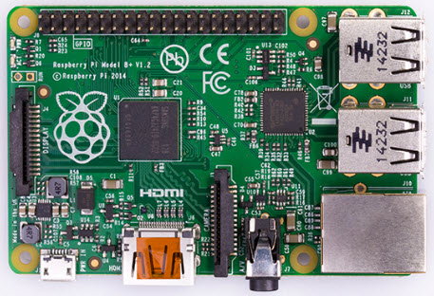

**More GPIO:** The GPIO model B+ has 40 pins while retaining the same pinout for the first 26 pins as the Model A and B.

**More USB:** It has 4 USB 2.0 ports, compared to 2 on the Model B, and better hotplug and overcurrent behavior.

**Micro SD:** The old friction-fit SD card socket has been replaced with a much nicer push-push micro SD version.

**Lower Power Consumption:** In the low power consumption the linear regulators are replaced by switching one and it will reduce the power consumption by between 0.5W and 1W.

**Better Audio:** The audio circuit has a dedicated low-noise power supply.

**Neater Form Factor:** With the broad edges the USB connections are arranged and the video is moved composite with the 3.5mm jack. There are four squarely-placed maintaining holes.

**Raspberry Pi Zero**

It is a half size of the model A+ with twice a utility and for any project, it has the same specification like 1GHz, Single-core CPU, 512MB RAM, Mini-HDMI port, Micro-USB OTG port, Micro-USB power, HAT-compatible 40-pin header, Composite video and reset headers, CSI camera connector (v1.3 only). The following image shows the raspberry pi zero.

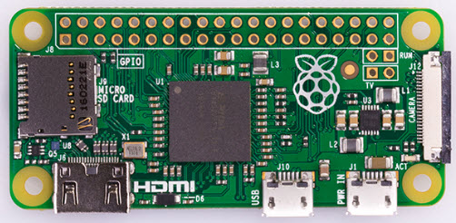

**Raspberry Pi 2**

The basic image of the raspberry pi 2 is following and the features of the raspberry pi 2 are it has quad-core ARM cortex-A7 processor with a 900MHz, the SDRAM is about the 1GB. It is completely compatible with the raspberry pi 1.

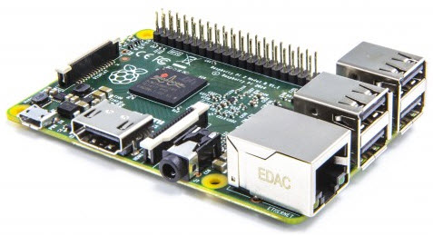

**Raspberry Pi Model B**

It is a higher-spec variant of raspberry pi. After this design of this raspberry pi, it has extended to the next model i.e raspberry pi 2. The specifications of the raspberry pi model B are following, the raspberry pi model B has two USB ports, having a RAM of 512MB and its Ethernet port is 100mb. The basic image of the raspberry pi model is shown in the following. 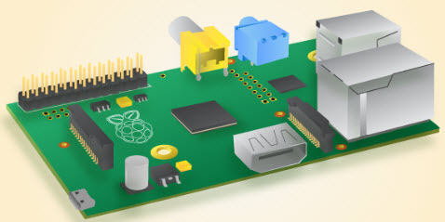

**Comparison Table**

The following table shows the comparison between four different types of raspberry pi models.

|  |  |  |  |  |
| --- | --- | --- | --- | --- |
|  | **Raspberry pi 3 model B** | **Raspberry pi 2 model B** | **Raspberry pi  model B+** | **Raspberry pi  model A+** |
| Ethernet Port | Yes | Yes | Yes | No |
| GPU | Videocore IV | Videocore IV | Videocore IV | Videocore IV |
| Processor Speed | 1.2GHz Quad-core processor | 900MHz Quad core processor | 700MHz Single core processor | 700MHz Single core processor |
| Wi-Fi | Built-in | No | No | No |
| Bluetooth LE | Built in | No | No | No |
| Storage | Micro SD | Micro SD | Micro SD | Micro SD |
| Processor Chipset |  |  |  |  |
| RAM | 1 GB SDRAM of 400MHz | 1 GB SDRAM of 400MHz | 512 MB SDRAM of 400MHz | 256 MB SDRAM of 400MHz |
| GPIO | 40 Pin | 40 Pin | 40 Pin | 40 Pin |
| USB 2.0 | 4 x USB Port | 4 x USB Port | 4 x USB Port | 1 x USB Port |
| Maximum power draw/voltage | The maximum power is about 2.5A and voltage is 5V | The maximum power is 1.8A and voltage is about 5V. | The maximum power is 1.8A and voltage is about 5V. | The maximum power is 1.8A and voltage is about 5V. |

**Advantages of Different Raspberry Pi Models**

* The size of the raspberry pi is in small of credit card
* The price of the raspberry pi is low
* Gathering a set of raspberry pi to work as a server is more effective than the normal server.

**Applications of Raspberry pi**

The different applications of the raspberry pi model are

* Media steamer
* Tablet computer
* Home automation
* Internet radio
* Controlling robots
* Cosmic Computer
* Arcade machines
* Raspberry pi based projects

**ARUDINO UNO**

Arduino is an open source computer hardware and software company, project, and user community that designs and manufactures single-board microcontrollers and microcontroller kits for building digital devices and interactive objects that can sense and control objects in the physical and digital world. The project's products are distributed as open-source hardware and software, which are licensed under the GNU Lesser General Public License (LGPL) or the GNU General Public License (GPL), permitting the manufacture of Arduino boards and software distribution by anyone. Arduino boards are available commercially in preassembled form, or as do-it-yourself (DIY) kits.

Arduino board designs use a variety of microprocessors and controllers. The boards are equipped with sets of digital and analog input/output (I/O) pins that may be interfaced to various expansion boards or Breadboards (shields) and other circuits. The boards feature serial communications interfaces, including Universal Serial Bus (USB) on some models, which are also used for loading programs from personal computers. The microcontrollers are typically programmed using a dialect of features from the programming languages C and C++. In addition to using traditional compiler tool chains, the Arduino project provides an integrated development environment (IDE) based on the Processing language project.

The Arduino project started in 2003 as a program for students at the Interaction Design Institute Ivrea in Ivrea, Italy, aiming to provide a low-cost and easy way for novices and professionals to create devices that interact with their environment using sensors and actuators. Common examples of such devices intended for beginner hobbyists include simple robots, thermostats, and motion detectors.

The name Arduino comes from a bar in Ivrea, Italy, where some of the founders of the project used to meet. The bar was named after Arduin of Ivrea, who was the margrave of the March of Ivrea and King of Italy from 1002 to 1014.

**Different Types of Arduino Boards**

The list of Arduino boards includes the following such as

* Arduino Uno (R3)
* LilyPad Arduino
* Red Board
* Arduino Mega (R3)
* Arduino Leonardo

**Arduino Uno (R3)**

The Uno is a huge option for your initial Arduino. It consists of 14-digital I/O pins, where 6-pins can be used as PWM ([pulse width modulation](https://www.elprocus.com/pulse-width-modulation-pwm/) outputs), 6-analog inputs, a reset button, a power jack, a USB connection and more. It includes everything required to hold up the microcontroller; simply attach it to a PC with the help of a USB cable and give the supply to get started with a A-to-DC adapter or battery

.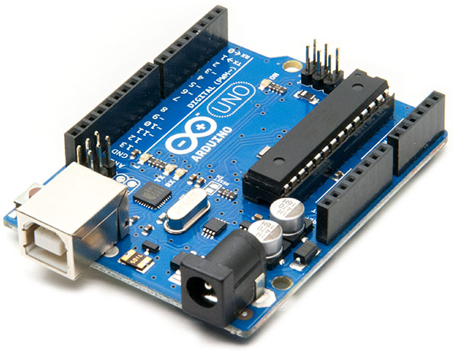

**LilyPad Arduino Board**

The Lily Pad Arduino board is a wearable e-textile technology expanded by Leah “ Buechley”and considerately designed by “Leah and SparkFun”. Each board was imaginatively designed with huge connecting pads & a smooth back to let them to be sewn into clothing using conductive thread. This Arduino also comprises of I/O, power, and also sensor boards which are built especially for e-textiles. These are even washable!

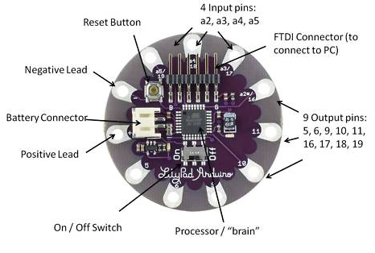

**RedBoard Arduino Board**

The RedBoard aAduino board can be programmed using a Mini-B USB cable using the Arduino IDE. It will work on Windows 8 without having to modify your security settings.It is more constant due to the USB or FTDI chip we used and also it is entirely flat on the back. Creating it is very simple to utilize in the project design. Just plug the board, select the menu option to choose an Arduino UNO and you are ready to upload the program. You can control the RedBoard over USB cable using the barrel jack.

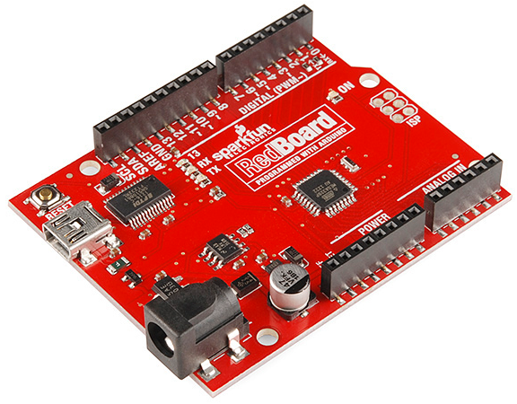

**Arduino Mega (R3) Board**

The Arduino Mega is similar to the UNO’s big brother. It includes lots of digital I/O pins (from that, 14-pins can be used as PWM o/ps), 6-analog inputs, a reset button, a power jack, a USB connection and a reset button. It includes everything required to hold up the microcontroller; simply attach it to a PC with the help of a USB cable and give the supply to get started with a AC-to-DC adapter or battery.The huge number of pins make this Arduino board very helpful for designing the projects that need a bunch of digital i/ps or o/ps like lots buttons.

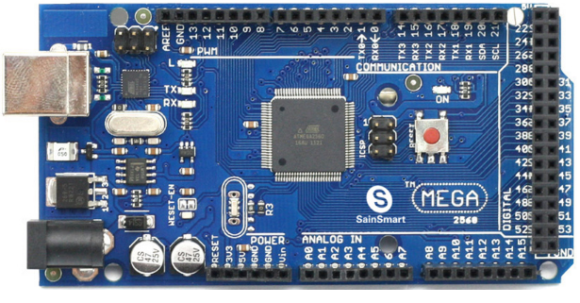

**Arduino Leonardo Board**

The first development board of an Arduino is the Leonardo board. This board uses one microcontroller along with the USB. That means, it can be very simple and cheap also. Because this board handles USB directly, program libraries are obtainable which let the Arduino board to follow a keyboard of the computer, mouse, etc.

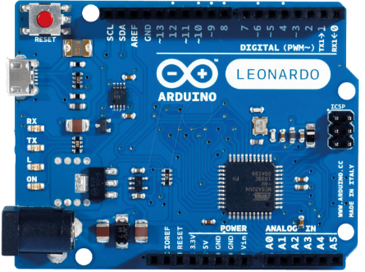

**The Arduino Shields**

Additionally, Arduino shields are pre built circuit boards used to connect to a number of Arduino boards. These shields fit on the top of the Arduino compatible boards to provide an additional capabilities like connecting to the internet, motor controlling, providing [wireless communication](http://www.elprocus.com/how-does-wifi-work/), LCD screen controlling, etc..The different types of an Arduino shields are

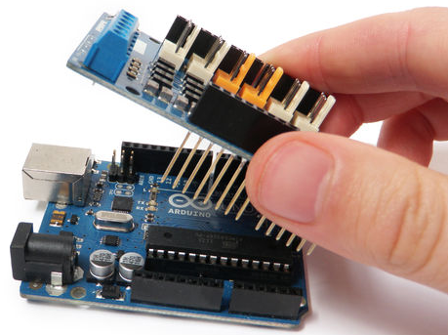

* Wireless Shields
* The GSM Shield
* The Ethernet Shield
* The Proto Shields

**Applications**

* Arduboy, a handheld game console based on Arduino
* Arduino Motion Control Rig
* Arduinome, a MIDI controller device that mimics the Monome
* ArduinoPhone, a do-it-yourself cellphone
* Ardupilot, drone software and hardware
* ArduSat, a cubesat based on Arduino.
* Automatic titration system based on Arduino and stepper motor
* C-STEM Studio, a platform for hands-on integrated learning of computing, science, technology, engineering, and mathematics (C-STEM) with robotics.
* DC motor control using Arduino and H-Bridge
* Data loggers for scientific research
* Gameduino, an Arduino shield to create retro 2D video games
* Homemade CNC using Arduino and DC motors with close loop control by Homofaciens
* Impedance sensor system to detect bovine milk adulteration
* Low cost data glove for virtual reality applications
* OBDuino, a trip computer that uses the on-board diagnostics interface found in most modern cars
* Water quality testing platform
* Xoscillo, an open-source oscilloscope

**VOLTAGE DIVIDER**

A voltage divider is a simple circuit which turns a large voltage into a smaller one. Using just two series resistors and an input voltage, we can create an output voltage that is a fraction of the input. Voltage dividers are one of the most fundamental circuits in electronics. If learning Ohm’s law was like being introduced to the ABC’s, learning about voltage dividers would be like learning how to spell cat.

**The Circuit**

A voltage divider involves applying a voltage source across a series of two resistors. You may see it drawn a few different ways, but they should always essentially be the same circuit.

[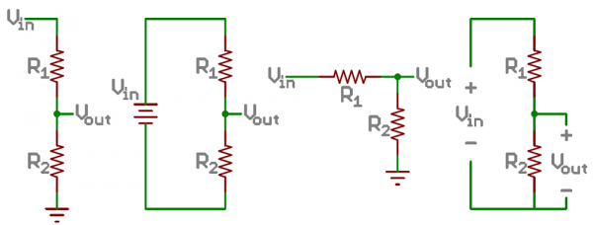](https://cdn.sparkfun.com/assets/4/0/3/a/e/511948ffce395f7f47000000.png)

*Examples of voltage divider schematics. Shorthand, longhand, resistors at same/different angles, etc.*

We’ll call the resistor closest to the input voltage (Vin) R1, and the resistor closest to ground R2. The voltage drop across R2 is called Vout, that’s the divided voltage our circuit exists to make.

That’s all there is to the circuit! Vout is our divided voltage. That’s what’ll end up being a fraction of the input voltage.

The Equation

The voltage divider equation assumes that you know three values of the above circuit: the input voltage (Vin), and both resistor values (R1 and R2). Given those values, we can use this equation to find the output voltage (Vout):

[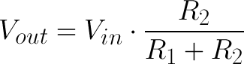](https://cdn.sparkfun.com/assets/e/7/6/3/c/511968d9ce395f7c54000000.png)

*Memorize that equation!*

This equation states that the output voltage is **directly proportional** to the **input voltage** and the **ratio of R1 and R2**.

**Calculator**

Have some fun experimenting with inputs and outputs to the voltage divider equation! Below, you can plug in numbers for Vin and both resistors and see what kind of output voltage they produce.

Top of Form

Vin =  V  
R1 =  Ω  
R2 =  Ω  
Vout=  V

Bottom of Form

Or, if you adjust Vout, you’ll see what resistance value at R2 is required (given a Vin and R1).

**Simplifications**

There are a few generalizations that are good to keep in mind when using voltage dividers. These are simplifications that make evaluating a voltage dividing circuit just a little easier.

[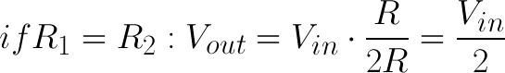](https://cdn.sparkfun.com/assets/8/6/0/3/2/51197073ce395f5d6d000000.png)

First, **if R2 and R1 are equal** then the output voltage is **half** that of the input. This is true regardless of the resistors' values.

[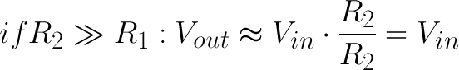](https://cdn.sparkfun.com/assets/3/4/f/4/6/5119730dce395f2353000000.png)

If R2 is *much* larger (at least an order of magnitude) than R1, then the output voltage will be very close to the input. There will be very little voltage across R1.

[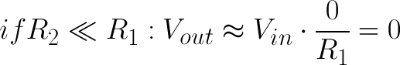](https://cdn.sparkfun.com/assets/0/1/c/9/0/5119730dce395f7153000001.png)

Conversely, if R2 is much smaller than R1, the output voltage will be tiny compared to the input. Most of the input voltage will be across R1

**SYSTEM ARCHITECTURE**

**Selecting a Template**

Figure below shows the system architecture. The structure of this fire alarm system is composed of five components, which are Raspberry Pi Model-B single-board computer, Arduino Uno single-board microcontroller, gas sensor and webcam. Raspberry Pi was selected due to its good technical specifications, high performance for data processing and is cheaper than other single board computers available in the market. The Arduino Uno is used to reduce the tasks of the Raspberry Pi by processing the analog signal from sensor and send SMS using the GSM shield. The web cam is used to capture the image of the environment when the sensor detects any abnormality in the air.

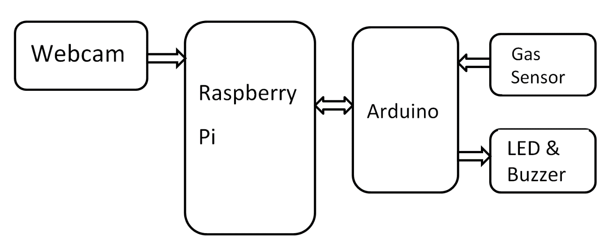

Block diagram of the fire alarm system

**Sensor**

The sensor used in this system is gas sensor QM-NG 1 to detect the presence of smoke. It can be placed at any locations inside the room, but it is best placed at the center of room. The selection of the sensor was made due to its high sensitivity for poisonous gas, long inductive time and long life span.

**Hardware connections**

The USB webcam is connected to the Raspberry Pi by using an USB cable and the GSM shield was attached to the Arduino Uno. A Local Area Connection cable is plugged in to the Ethernet port of Raspberry Pi to allow a connection to the internet. The ports of Raspberry Pi used to connect with the Arduino Uno are shown in Fig. 2a including the pins of the Arduino Uno. Port 24 of Raspberry Pi is connected to Pin 13 of Arduino Uno, Port 25 is connected to Pin 12, and Port 23 is connected to Pin 11. Port 24 is used by the Raspberry Pi to get warnings from Arduino Uno if any events occur. Port 25 is used to inform the Arduino Uno if the user confumed the alert, while Port 23 is used to inform the Arduino Uno if the user cancelled the alert.

**METHODOLOGIES AND TOOLS**

**PROPOSED TECHNOLOGY AND THEIR ADVANTAGES**

**Proposed Technology**

Fire is an undesirable event that could bring a great loss of social wealth and human life. To prevent this losses, various alarm systems have been developed such as smoke detectors, temperature sensor based systems etc. As technologies evolved and instruments such as temperature sensors, camera etc., becomes affordable, various automated fire alarm systems are now available. In conjunction with the cheaper instruments, internet based and wireless broadband technologies, have also improved and there are now various systems that enables cheap, high rate data transmission and wireless networking. The availability of cheap credit card sized single board computer such as the Raspberry Pi has enabled the creation of numerous automated and monitoring system that has low power consumption, faster processing ability at a lower cost. The fire alarm system proposed in this paper integrates the use of affordable instruments, connectivity and wireless communication.

The technology developed by the help of IoT is based on how one can prevent major calamities to happen. A smoke detector is being developed which can be step up in all apartments, buildings, offices etc., this certain smoke detector helps us out.

The purpose of this smoke detector is that when a fire or any smoke is detected in a building. The detector which is connected to IoT will sense the smoke or fire with the help of a gas sensor. The gas sensor will then send signals to the Arduion Uno microcomputer which then sends the signals to the Raspberry pi which is a microprocessor. This informs the user that there is some sort of smoke or fire in the building (this is usually helpful when the owner is away from the house and there is some short circuit) when the image is sent to the owner. They will send a confirmation back to the board and the buzzer would start ringing and also a message will be sent to the other owners in that building as well. So they may help out in the emergency and stop the fire from spreading.

The use of this project is to aware people on how to react when there is a fire and how what all precaution to take. How to avoid traps and how to main the smoke detector.

**Precautions to be taken towards Fire Safety in your Apartment Complex**

1. Get your property and valuables insured  
   Consider getting insurance against fire and other calamities. There are insurance policies which provides complete protection for property and contents. These insurance provides cover against loss from fire, burglary, theft, earthquakes and other natural calamities.
2. Be aware of emergency contacts around your apartment complex  
   Have emergency contacts like fire department, hospitals (specially ambulance service) handy. Save them in your mobile and tag them properly, so that you can easily find these numbers during an emergency.
3. Add all your family members to ADDA  
   In case any emergency situation arises in your apartment complex, your management committee would send cautionary notifications and safety tips to all residents. As ADDA is the place where all information about the residents would be present, important notifications are usually sent through ADDA. Add details of all your family members, or your tenants against your flat to[ensure that they receive all notifications during emergencies](https://apartmentadda.com/home/apartment-communication-software.php)and can take appropriate precautionary measures.
4. Install and Maintain Proper Fire Detection Systems in your Apartment Complex  
   Fire detection systems like smoke alarms should be installed on every floor of the apartment building. Smoke alarms should be tested at least twice a year. The smoke alarm should be tested using the test device located on the smoke alarm or any other test method recommended by the manufacturer. Do a visual check to ensure that the smoke alarm is securely fastened to the ceiling or wall and it is not obstructed in any manner. Check that the batteries are not leaking and are securely fastened. The batteries should anyways be changed once or twice a year. It should be cleaned by a regular household vacuum cleaner in regular intervals. Check the users manual for details on after how many years you should look for a replacing the device.
5. Make sure that a clear Building Evacuation Plan is in place and the residents are aware of it  
   Each floor should have clearly marked fire escape route. The fire exits should be marked clearly. Its always a good practice to have more than one fire exit route which residents can take in case the primary route is blocked. Evacuation plans are best placed in lobbies, beside lifts, around notice boards, where usually there is high footfall. Also, have the safe assembly areas clearly marked so that it makes it easy to spot during emergencies.
6. Maintain Fire Fighting devices in each floor and lobby  
   As a best practice, at least one resident from each apartment should know how to handle fire fighting devices used in the apartment complex like fire extinguishers. The association and manager can setup these assets in ADDA Asset Tracker module for maintaining all fire systems related documents in one place.
7. Have regular Fire Safety Sessions and Fire Drills  
   Fire systems familiarisation sessions and fire drills should be held once every six months so that residents know how to use the fire fighting devices and are also aware of the fire safety rules, evacuation plans and safety processes which are implemented in your apartment complex.

**Fire Safety Do’s**

* When evacuating the building, be sure to feel doors for heat before opening them to be sure there is no fire danger on the other side.
* DO remain in your room if you are unable to exit the building safely because of smoke or fire. Keep the door closed and await assistance from the fire department. If smoke is entering under or around the door, stuff damp sheets or blankets in the spaces to help keep smoke out. If possible, open a window and waive or hang a brightly colored towel or garment to notify rescue personnel of your location.
* DO close the doors behind you if it is safe to leave your room.
* DO become aware of your neighbors and note if they have not evacuated and tell authorities they are missing and may need assistance**.**
* If there is smoke in the air, stay low to the ground, especially your head, to reduce inhalation exposure. Keep one hand on the wall to prevent disorientation and crawl to the nearest exit.
* When evacuating the building, be sure to feel doors for heat before opening them to be sure there is no fire danger on the other side.
* Alert all family members and quickly move them towards the fire exit
* If you catch fire on your clothes then stop, do panic or run. It will make fire burn faster and lead to more injuries or burn. Dropping on the ground and rolling can help extinguish the fire.

**Don’t During a Fire Related Emergency**

* Do not use lift.
* If you are trapped in your room or building during fire try to stop smoke and fire getting into your room by using towels, blankets or spare cloths to block the gaps in the door.
* Never store flammable materials in your room or apartment.
* Do not tamper with any fire system equipment such as smoke detectors, pull stations or fire extinguishers. Doing so is a criminal offense.
* Raising a false alarm is a criminal offense. It endangers the lives of the occupants and emergency personnel.
* Don’t hide in the washrooms as you can suffocate

**The 7 Ways to Prepare for a Home Fire**

* Install the right number of smoke alarms. Test them once a month and replace the batteries at least once a year.
* Teach children what smoke alarms sound like and what to do when they hear one.
* Ensure that all household members know two ways to escape from every room of your home and know the family meeting spot outside of your home.
* Establish a family emergency communications plan and ensure that all household members know who to contact if they cannot find one another.
* Practice escaping from your home at least twice a year. Press the smoke alarm test button or yell “Fire“to alert everyone that they must get out.
* Make sure everyone knows how to call 9-1-1.
* Teach household members to STOP, DROP and ROLL if their clothes should catch on fire.

**10 Fire Safety Rules**

**1.)** Don't play with matches and lighters. If you see matches or a lighter where you can reach them, don't touch them. Go tell a grown up right away.

**2.)** Ask your parents to install smoke detectors on every floor and in the sleeping areas of your home. Smoke detectors can save lives. Ask your parents to show you where each one is located.

**3.)** Remind your parents to test your smoke detectors every month. Make sure everyone in your family is familiar with its piercing sound. Teach them that this sound means danger, and they must escape quickly.

**4.)** When your parents change the time on your clocks for Daylight Savings, ask them to change your smoke alarm batteries. Give it fresh batteries and your smoke alarm will stay awake and watch for fire while you are sleeping.

**5.)** In case of fire: **DON'T HIDE, GO OUTSIDE!** Fires are scary, but you should **NEVER** hide in closets or under beds when there is a fire.

**6.)** To escape during a fire; **Fall & Crawl**. It is easier to breath in a fire if you stay low while getting out. Use the back of your hand to test if a door is hot before you open it. If it is hot, try to use another way out.

**7.)** If your clothes are on fire; **Stop, Drop, and Roll** until the fire is out. Shout for help, but don't run. Running makes fire burn faster.

**8.)** Have an escape plan and practice it with your family. Find two ways out of every room in case one way is blocked by fire or smoke. Practice escaping by both routes to be sure windows are not stuck and screens can be taken out quickly.

**9.)** Choose a meeting place outside, such as a big tree or the end of the driveway, so you will know that everyone has gotten out safely. **NEVER** go back into a burning building for any reason. If someone is missing, tell the fire fighters. They have the clothing and equipment to safely rescue people.

**10.)** Know your local emergency number. Put stickers and magnets with emergency numbers on your refrigerator and every telephone in the house. If there is a fire at your house, choose one family member to leave your meeting place and call the fire department from a neighbour’s phone.

**How Home Fire Spreads**

To know how to best escape a fire, you need to think like a fire. You need to know what a fire needs to survive, grow and spread throughout a structure in order to maximize your chances of successful escape.

For a fire to start, three elements must be present: a heat source to provide the initial catalytic energy, such as spark or cinder; plenty of oxygen; and any sort of combustible as a fuel source. In the US, cooking remains the primary source of home fires, and the primary source of fire-related injury. Dropped cigarettes, on the other hand, have been the number one source of fire-related deaths since 2005. *Fun Fact*: Men started 64 percent of the fires in 2010 and caused nearly double the property damage ($4.8 billion vs $2.7 billion caused by women).

Once ignition occurs, a fire will continue to burn and spread as long as it has a continuous supply of fuel and oxygen. It will always spread into cooler areas following the flow of heat, and it doesn't take long for heat to spread. On average, a house fire can raise the interior temperature to over 1100-degrees F in just 3.5 minutes—note that your goose is cooked, quite literally, at 350 F. And in five minutes, the air in a room can get so hot that everything in it spontaneously combusts, a phenomenon known as flashover, even if actual flames are not present. That means you and yours are working with roughly a 210 second window of opportunity.

**Be Prepared**

When it comes to home fire response, live by the Boy Scouts of America motto. Taking the proper preventative measures and knowing what to do if a fire does break out can help minimize damage and maximize your chances of survival.

Prevention is as easy as being aware of your surroundings. Don't place open candles near fuel sources like drapes or waste paper baskets. Certainly don't leave them unattended. Don't leave newspapers near space heaters or other heat sources, and don't smoke in bed, or anywhere in your house, for that matter.

If a fire does break out, you'll want to know as soon as possible so you can hopefully knock it out before it gets out of hand. To do so, install fire and carbon monoxide alarms in every bedroom, as well as the kitchen, the attic, and the basement. Check these alarms annually and replace the individual units every few years. Also keep a couple of fire extinguishers stashed around the house—in the kitchen, garage, and bedroom—*and know how to use them*. These need to be checked annually and serviced by trained professionals.

However, if a fire starts when your family is asleep, it may burn out of control before you become aware of it. In case this occurs, every family member should learn and memorize at least two potential exits from every room in the house—the normal route for entering and exiting (typically through the front door) as the primary route as well as an alternative door or window. Study each escape route for potential hazards such as sticky window, security bars that require tools to open, or heavy furniture, and adjust these routes accordingly. And remember, even with every light in the house on, a structure fire can create blackout conditions within the home in just four minutes. So make the outside routes as direct as possible.

Also be sure to assign which able bodies will be in charge of helping the very young, the elderly, and pets to escape. In addition, stick a pet rescue alert on any clean glass surface near the front door to alert first responders to your pets' existence. If you have children, you must impress upon them the importance of using an alternate escape route if the primary is blocked and not hiding in a closet or under the bed. Explain that this will make it much harder for firefighters to find them. And once you've created a plan, practice it with your kids.

Another helpful habit is for everyone to shut their bedroom doors at night. This not only gives you more privacy, but can also delay the spread of fire and smoke into the room by as much as twenty minutes. What's more, fire alarms will still detect smoke with the door closed.

**You Have to Keep Your Head on a Swivel**

Fires and people compete for the same vital resource: oxygen. But people are at a disadvantage because a lack of oxygen makes us dumb and sleepy—two qualities you really don't need when escaping the flames. The official FEMA fire safety manual explains the effects of a low oxygen environment:

21% Oxygen Level— Normal atmospheric level.  
19.5% Oxygen Level — Minimum healthful level.  
15-19% Oxygen Level — Decreased stamina and coordination.  
12-14% Oxygen Level — Breathing rate increases with exertion, increase in heart rate, impaired coordination, perception, and judgment.  
10-12% Oxygen Level — Breathing further increases in rate and depth, lips turn blue. Poor judgment.  
8-10% Oxygen Level — Mental failure, fainting, unconsciousness, nausea, and vomiting.  
6-8% Oxygen Level — Fatal after 6 to 8 minutes.  
4-6% Oxygen Level — Coma in 40 seconds, convulsions, respiration ceases, and death occurs.

The lack of oxygen isn't the only gaseous danger you'll face. As fires expand, they generate thick plumes of acrid, toxic black smoke that obscures your vision and wreaks havoc on your lungs. Carbon monoxide, for example, is an odorless and highly-stupefying gas, causing mental impairment on par with alcohol intoxication when inhaled in even modest amounts. If you're already asleep when a fire breaks out, spreading CO gas can drop you into such a deep slumber that not even the intense heat of approaching flames will be enough to rouse you (a fire alarm, however, will). In fact, more people die each year from smoke inhalation than do from the actual flames.

**Get Down**

There's a silver lining to these clouds of noxious gasses—the heat of the fire forces them all to rise, which clears a low area of relatively clean air to breathe near the floor. So, as Arnold Schwarzenegger put it, "[GET DOWN](http://www.youtube.com/watch?v=L-9ACi6-nww)." If you're in bed when the fire alarm sounds, roll out of bed and onto the floor before crawling quickly to your primary exit option. If that option is your bedroom door (which should be closed), check it before you open it by placing the back of your hand against the door itself, the knob, and the crack on the hinged side next to the frame. If any of those points feel warm, bail on that exit strategy and immediately move on to your secondary option. And even if they're cool, brace your shoulder against the door before you twist the handle to prevent the door from blowing open due to air pressure differences on either side.

If you need to travel through a smoke-filled room to reach safety, you can further protect yourself from damaging gasses by wrapping a piece of cloth around your mouth and nose to help filter larger smoke and soot particulates. Wetting the wrap will add further protection.

If you find both your primary and secondary routes cut off, look for a window. If you have to break the pane to open it, smash out the lower corners with a blunt, heavy object, then cover the exposed edges with clothing, bedding or cushions before going through. If you're on the ground floor, toss a few cushions out to help break your landing. If you need to get your family out of a second story window, lower your kids as far as possible before dropping them to a waiting adult below.

**Get Out and Stay Out**

All your hard work and planning will be for naught if someone is left behind and no one realizes that they are still in danger. That's why you need a designated meeting spot outside the house. It should be safely away from danger but close enough for everyone to reach quickly.

If you do realize that someone is missing, *do not reenter the home to look for them*. You are not a firefighter. Do not try to do a firefighter's job without a firefighter's equipment, training, or solid steel balls. If you do, the real firefighters will more than likely be pulling two bodies from the ashes.

Once everyone is accounted for, get medical attention for anyone that needs its. Look for signs of oxygen deprivation—ie, your eight-year-old is stumbling around like a wee drunkard. Once the fire is under control, ask the fire firefighters or a neighbor for help notifying your insurance company, emergency contacts, or the Red Cross for emergency lodging.

**PROCESS MODEL**

The proposed fire alarm system that used Raspberry Pi as a master device and Arduino Uno as a slave device was implemented. The sensor was placed at the center of the room.

It is sensitive to the ionization of the surrounding air, resulting in the changes of its resistivity. The value of the output voltage from the sensor circuitry varies linearly with the resistivity of the sensor, so any changes in the sensor resistivity will result in the changes of the output voltage. The output voltage of the sensor circuitry is read in 1024 bit resolution by the Arduino Uno. At start, the Arduino Uno read the fust reading from the sensor and set the threshold value. The calculation of the threshold value is shown below:

Threshold = 2.5 x sample readi1􀀡 [J

As for the ports configurations of the Raspberry Pi, Port 24 was defmed as the input port to receive any alert from Arduino

Uno, Port 25 was defined as the output port and it is used to inform the Arduino Uno if the user has already confirmed the alert, while Port 23 was defined as the output port and is used to inform the Arduino Uno if the user cancelled the alert. While for the pins configurations of the Arduino Uno, Pin 13 was defmed as the output pin for sending the alert to Raspberry Pi, Pin 12 and Pin 11 were defined as the input pin for receiving the information from the Raspberry Pi whether the user confumed or cancelled the alert.

The Raspberry Pi waits for any input from the Arduino Uno on its Port 24. Upon detecting the event, the Arduino Uno will send a HIGH output which is 5V from its Pin 13 to the Ports 24of the Raspberry Pi and the voltage will be reduced as the current flows through the voltage divider circuit. An image will be captured using the webcam. The image will be displayed on the webpage and the Raspberry Pi will wait for the user confirmation on the validity of the alert. The user can do the confirmation by clicking a submit button on the webpage. At the moment the user click, the PHP programming of the webpage will automatically open a text ftle named Logger ftle and log a command data. The Python programming will open the text ftle, and write a word "send" in the Logger_ftle. Then the Raspberry Pi will send a HIGH output which is 3.3V through Port 25 to Pin 12 of the Arduino Uno. The Arduino Uno will then generate an SMS alert and send it using the GSM shield.

If the user cancels the alert, the PHP programming of the webpage write a word "cancel" in the Logger_fIle. The Python programming read the content of the Logger_ftle, then the image will be deleted and the Raspberry Pi will send a HIGH output through Port 23 to Pin 11 of the Arduino Uno. The Arduino Uno will continue to read the analog signal from the sensor and the Raspberry Pi wait for other alert from the Arduino Uno.

**False warning**

A false warning test was made to show what happened when any error occurs during the operation of the system. The source of error can vary. It could be due to sensor failure or gas leakage. However, in this project, gas leakage detection was not covered, so if the sensor detects the increase of methane gas or cigarette smoke or any kind of misleads in the kitchen, it will be assumed as device error. It is dangerous to leak the methane gas in the room, so the sensitivity of the sensor was changed after a sample reading to determine the threshold value was taken. After the values of the measurements exceed the threshold value, an image was captured. The image was displayed in the mail. After the cancel button was clicked, the PHP programming modified the content of the Logger_file by writing a word "cancel" in it. The user will be redirected to the cancel webpage named cancel.php The Python programming read the content of the Logger_file and a HIGH output was sent through Port 23 of the Raspberry Pi. The Python programming deleted the image and the content in the Logger_file. The Arduino Uno reads the signal from the Raspberry Pi as a cancellation and continued to monitor the measurements from the gas sensor. After the NO command, the user will be reset.

**FUNCTIONALITIES OF THE PROCESS MODEL**

The fire alarm system consists of Raspberry pi and Arduino and a voltage convertor along with the gas sensor.

The role of the arduino is to sense a signal from the gas sensor when there is a fire or any smoke present and captures a picture and then that signal along with the picture will be sent to the raspberry pi which will send the registered user a message to their mail which shows a message as follows:

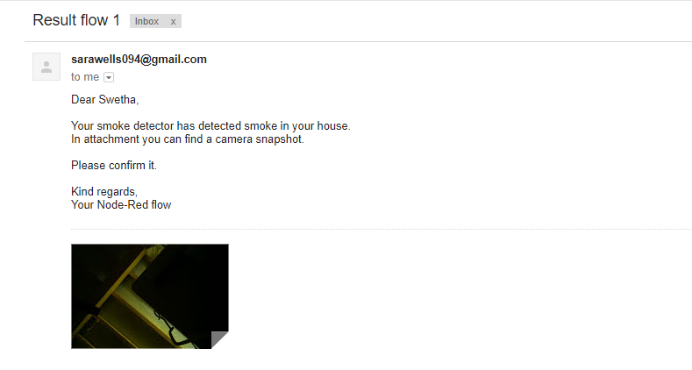

After a message appears like this. The user is supposed to reply back with a “YES or NO”.

If the reply is NO. Then the message will be sent to the smoke detector and it will detected as a false alarm.

If the reply is YES. Then the message will be sent to the smoke detector and it will start buzzing and the message will be sent to all the registered contacts. The alarm will keep on buzzing until it is RESET.

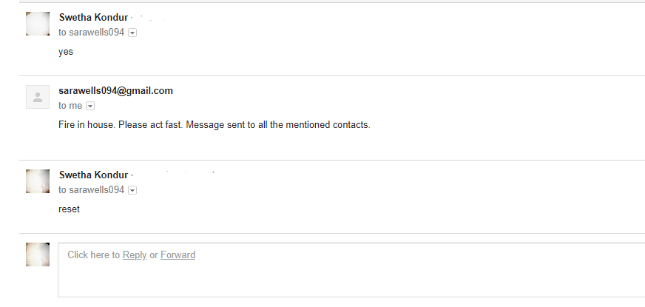

**The programs used in the circuit**

**Arduino Node Board Program**

int onboard = 13;

int torpi = 12;

int buzzer = 11;

int led = 10;

int fromrpi=A1;

int smokeA0 = A0;

// Your threshold value

int sensorThres = 400;

int rpithreshold = 700;

void setup() {

pinMode(torpi, OUTPUT);

pinMode(onboard, OUTPUT);

pinMode(buzzer, OUTPUT);

pinMode(led, OUTPUT);

pinMode(smokeA0, INPUT);

pinMode(fromrpi, INPUT);

Serial.begin(9600);

}

void loop() {

int analogSensor = analogRead(smokeA0);

int rpiout = analogRead(fromrpi);

Serial.print("Pin A1: ");

Serial.println(rpiout);

// Checks if it has reached the threshold value

if (analogSensor > sensorThres)

{

digitalWrite(torpi, HIGH);

digitalWrite(onboard, HIGH);

}

else

{

digitalWrite(torpi, LOW);

digitalWrite(onboard, LOW);

}

if( rpiout > rpithreshold)

{

digitalWrite(led, HIGH);

tone(buzzer, 1000);

delay(1000);

digitalWrite(led, LOW);

noTone(buzzer);

delay(1000);

}

else

{

digitalWrite(led, LOW);

noTone(buzzer);

delay(1000);

}

delay(100);

}

**Program For The Camera:**

import picamera

print("About to take a picture")

with picamera.PiCamera() as camera:

camera.resolution = (1280,720)

camera.capture("/home/pi/Desktop/picam/newimage.jpg")

print("Picture Taken.")

**Comparator Block Program**

if(msg.payload=="yes\n")

{

msg.payload="yes";

}

else if(msg.payload=="no\n")

{

msg.payload="no";

}

else if(msg.payload=="reset\n")

{

msg.payload="reset";

}

return msg;

**Attachment Of Picture And Message**

msg.topic = "Fire Alarm";

msg.payload = "Dear Swetha,<br><br>Your smoke detector has detected smoke in your house.<br>In attachment you can find a camera snapshot.<br><br>Please confirm it.<br><br>Kind regards,<br>Your Node-Red flow";

msg.attachments = [{

filename: 'newimage.jpg',

path: '/home/pi/Desktop/picam/newimage.jpg',

content: msg.payload

}];

return msg;

**If False Alarm**

msg.payload = "Confirmation received. False alarm . Message sent to all the mentioned contacts.";

return msg;

**If Fire Present**

msg.payload = "Fire in house. Please act fast. Message sent to all the mentioned contacts.";

return msg;

**To Reset The Program**

msg.payload = "Fire in house. Please act fast. Message sent to all the mentioned contacts.";

return msg;

**ALGORITHM ON HOW THE SMOKE DETECTOR WORKS**

*First of all, we need to install the smoke detector and input all the required contacts in the database.*

Step 1: Is there any fire emergency detected. If Yes, go to Step 3 else go to Step2.

Step 2: Detect new fire emergency.

Step 3: Once the fire is detected, the picture of the detected area will be sent to the entered mail using Node-Red service

Step 4: The user has to confirm is it a fire emergency or not.

Step 5: If it is a fire emergency, reply Yes and go to Step 7. If it is not, reply No and go to Step 6.

Step 6: Detect new fire emergency.

Step 7: The buzzer which is installed with the fire detector will buzz after it is confirmed with yes to alarm people in and around the house.

Step 8: Send the fire detected confirmation mail to the previously listed contacts.

Step 9: After the fire is extinguished, reset

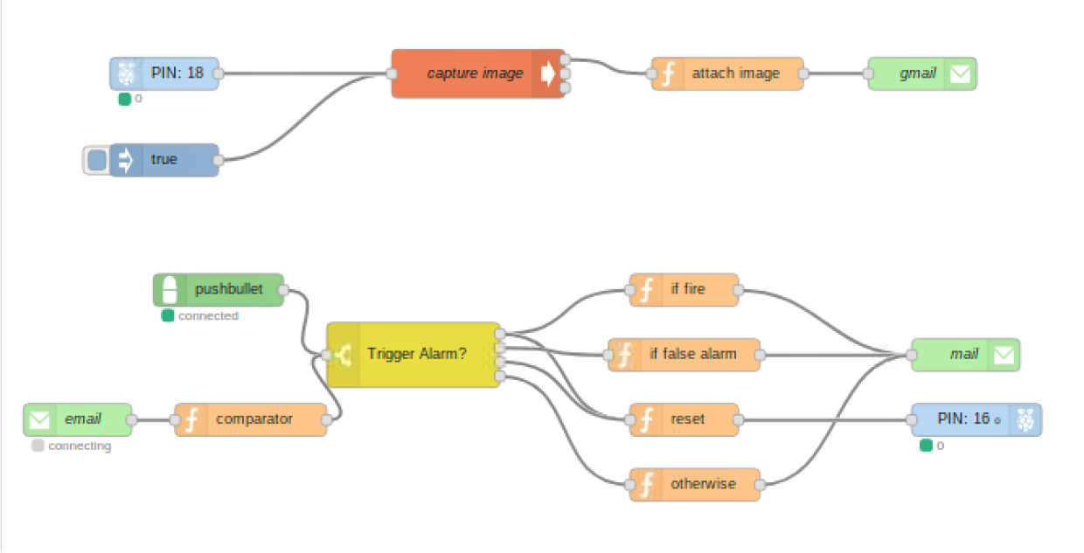

**LIMITATIONS**

**FEASIBILITY**

The feasibility of the smoke detector is that it can detect smoke and fire within the range it is present. It captures the image and sends it to the user for confirmation. The quality of the image is low as higher the resolution, longer is the upload time and lower the resolution shorter the upload time. Hence, we use low resolution camera for preventing the delay in upload time as fire emergency should be attended as soon as possible.

The fire alarm is a small portable device that can be fixed on the roof of the rooms .The Raspberry pi can be connected to multiple Arduion Uno making it affordable to use for multiple rooms.

The components of the smoke detector are easily available at any given hardware store. The service charges can be minimal to none and the parts can be replaced easily.

**FUTURE SCOPE AND CONCLUSION**

**FUTURE SCOPE**

Have you noted any significant changes in how fire-alarm systems are set up in buildings since the events of 9/11? HEIN: Many people are beginning to recognize the importance of fire-alarm systems as part of a comprehensive security system. We've also seen a keen interest in emergency-evacuation systems.

Many people are beginning to recognize the importance of fire-alarm systems as part of a comprehensive security system. We've also seen a keen interest in emergency-evacuation systems. Since the fire system supervises all audio system functions, its place in the mind of security personnel has become paramount.

Another trend since 9/11 is the increased use of CCTV equipment. Obviously, having a camera pan-tilt-and-zoom based on a specific fire detector input provides a visual indication of the location, and could give responders insight into what to expect.

The most significant changes we've noted are those related to survivability. More often than not, we find requirements for redundant circuits, especially in voice-evacuation systems for high-rise buildings. There is also increased demand for better intelligibility or clarity in voice-messaging systems.

Fortunately, there's been a lot of technological advances facilitating these changes. For example, audio signals can now be transmitted digitally throughout the building, but converted back to an analog signal close to the speakers. This eliminates electrical noise typical of lighting ballasts and other high-voltage circuits. It also permits multiple messages—up to eight—that can be sent over a single pair of wires.

This also allows unique voice messages to be broadcast simultaneously providing area-specific instructions based on the initiating event.

Of course, there's also been a lot of human factor interface improvements including large multi-line LCD displays, color graphic maps and closed-circuit television pictures based on alarm-specific information.

On the subject of communications, many fire devices are now intelligent and therefore have the capacity to interface with other building systems. Has the need for more comprehensive control systems pushed greater levels of system integration?

Since 9/11, the integration of security and fire-alarm systems is becoming more common, as well as the connection of fire-alarm systems to the building automation system. It's basically owner-driven because it cuts costs, eliminating an entire cable and conduit loop since both systems are monitored and controlled over the same cables. Also by allowing fire-alarm systems to be monitored off site, the building owner does not need a separate security person monitoring at odd hours of the day.

And in the not too distant future, users will be able to receive e-mails of alarm and trouble events on wireless devices.

Another factor contributing to the need for greater system integration is the increasing popularity of green building design, which often incorporates large quantities of natural light. Since glass atriums are an ideal way to do so, the integration of fire-alarm systems and HVAC smoke-control systems becomes necessary. For example, beam-type detectors can be equipped with addressable control modules that are integrated into the smoke-control fans. Should the beam detectors sense any type of smoke in the atrium, they signal for the HVAC smoke control system to start up.

There's definitely a demand for centralized command and control, especially in larger buildings. More and more, we find that the specification of the BACnet protocol is finally taking hold. Owners seem to want one-line responsibility for service of all of their building systems including HVAC, security/CCTV, card access and fire. This requirement is pushing manufacturers toward complete integration. Sometimes this is proprietary, depending on the manufacturer, and sometimes it is an open architecture using published building communication protocol standards such as BACnet or Echelon's LonWorks.

Some of the limiting factors revolve around standards issues. While customers may want to integrate their systems, the local authority having jurisdiction usually requires UL-listed components. As an example, if the fire-alarm system manufacturer offers a UL-listed BACnet gateway that permits fire signals to be transmitted to another manufacturer's HVAC system, it is only UL-listed with the fire system, not the HVAC system. Therefore, the entire system may not meet UL requirements since the dampers and fans are not cross-listed as UL-864 devices with the fire system. It is possible that the only answer is for the HVAC manufacturer is to submit their devices to UL for cross-listing with the fire manufacturer's HVAC system. But this is an expensive proposition.

I agree that integration is the buzzword floating about the industry, and it is indeed occurring, but it should be noted that system complexities and attendant costs that result from complete building systems integration seem to be dampening the desire to "totally" integrate all building systems.

Total building systems integration will be driven primarily by perceived cost savings, but the fear of putting all of the eggs in one basket—without assurance that a single fault won't take down critical systems—will continue to slow total building systems integration.

It takes education, including the authority having jurisdiction. The major system providers are now all offering some level of integration, and by educating the AHJs, who have traditionally resisted integrating these functions, we have seen a mind change. Moreover, many AHJs have expressed an unforeseen benefit to integrating fire systems since most security systems are active, rather than passive, making maintenance a high priority.

On the subject of education, what are some common pitfalls engineers and building owners encounter when it comes to designing and utilizing fire alarm systems?

Not understanding the limitations of the detection portion of the system. Second, not informing owners that the building codes traditionally require only partial detection, and that required limited detection—in other words, just meeting the code—may not meet the owner's fire-protection goals.

Finally, a common engineering error is assuming the equipment can make up for mistakes in the design process.

Owners, on the other hand, often make the assumption that the AHJ will ensure that the fire-alarm system will be installed properly. The AHJ is not responsible for monitoring the quality of the installation, nor is he or she responsible to enforce the specifications of the design engineer.

In our experience, most problems occur when the project is design-build, rather than driven from a specification. Having said that, we have also seen projects where the specification called out Class A wiring, but the electrical designer never provided a return conduit path. It is truly amazing how weekly progress and informational meetings can make or break the project.

Sometimes problems can come out of left field, when the architect objects to the color or design of a device that may destroy the aesthetics.

Back to the notion of codes. In some states there can be contradictions. For example, in Pennsylvania, the ANSI/BOCA code indicates that sprinklers must be installed in the elevator shafts of all buildings that are "fully sprinklered." However, the Pennsylvania Elevator Code does not allow anything in the elevator shafts. To resolve this issue, a variance must be obtained from the state in order to install the system per ANSI codes.

Another common pitfall is inadequate quantities of audible indicating devices. The NFPA and ADA requires that the audible level of fire-alarm signals be 15 dB above the ambient level for the area. Many times, designers do not show enough audible horn devices to produce this output in higher ambient sound areas such as manufacturing facilities. In facilities requiring voice evacuation systems, engineers often install an inadequate number of speaker devices which creates inaudible voice evacuation messages.

**Alarm Advances**

Fire-alarm control panels, which are now fully addressable, have advanced to become an intelligent system that allows individual addresses for each device. The front-end control panel can narrow the location of an alarm down to the very spot that the respective detector alarmed. New technology also enables the panel to poll up to five times faster than before. Further, the addressable fire-alarm control panels can digitally adjust the sensitivity of detectors to compensate for any dust or debris that may accumulate on them.

Specific advances include the following:

*Multisensor technology.* This type of sensors can distinguish between a legitimate change of state and a non-threatening situation that would otherwise lead to false alarms. Each sensor is equipped with an on-board microprocessor and is capable of performing many basic digital computing operations reducing the cost of cable installation.

*Harsh environment type detectors.* Similar to air-sampling type detectors, these detectors, employing a laser, can provide very early warning of slow smoldering fires at lower installed costs. The harsh environment detectors have a small, built-in intake fan that draws air across a filter into a photoelectric sensing chamber to provide active smoke detection. These types of detectors reduce the number of nuisance alarms common in harsh environments.

*Visual strobe technology.* Now featuring self-synchronization, this innovation allows all devices in an open area to flash in sync in the event of an alarm. This is a requirement of the Americans with Disabilities Act.

*Field-adjustable candela (cd) level dipswitch.* An offshoot of visual strobe technology, these devices help meet NFPA and ADA strobe standards for devices installed in areas ranging from 15 to 75 cd. The field-adjustable dipswitch allows the designer to specify one type of strobe device with the contractor setting the proper cd output for the proper field application.

**Performance-Based Design & the Code**

Perhaps the most significant change affecting fire alarm specifications that ripples through the codebook are the references to performance-based design. New guidelines have been added to the 2002 NFPA code that call for applying this design approach. Each performance objective must be documented in an approved format together with calculations, modeling or other technical issues that can be used to establish fire and life-safety performance. The code also directs approval of such designs to the local authority having jurisdiction.

Areas related to performance-based design include:

Audibility. Use of analysis and design to permit audible signaling to comply with masked threshold requirements in lieu of the prescriptive requirements (7.4.5).

Performance-based visibility. Language was added for a performance-based alternative for visible signaling design (7.5.4.3).

**Other significant code changes that affect specifications are:**

Requirements for survivability of circuits (6.9.4.1) are now applicable to both audible and visible notification appliance circuits. As stated above, the local AHJ can approve performance alternatives to stated requirements.

The new audible notification appliances in stairwells (6.9.7.3) section requires separate speaker circuits to stairwells and permits only manual selective paging.

Sleeping area minimum sound levels have been raised to 75 dBA at pillow (7.4.4).

Other parts of chapter 6 include new requirements for integrated systems, including devices found on modern networks such as routers and servers. The new code addresses recent advances in computerized fire-alarm systems and other combined systems.

**Fire Alarm Design Software, A Vision**

One noted trend in the world of fire-alarm system design is the number of software packages that have begun to hit the market. Some are as simple as basic quote packages with manufacturer's data filled in, while others are very sophisticated programs that provide smart front-end to high-end CAD systems.

The ultimate scenario would be for the fire system designer to lay down the NFPA symbols on a CAD layer called "fire." The manufacturer's branch or distributor accepts the CAD format and then modifies each symbol with either a smart block (AutoCad) or a Visio SmartShape. The benefit of a data attribute is that a complete list of data fields can be supported. This means that programs can automatically generate bills of material, based on the graphic element of a detector or fire device. If the device is a horn or strobe, the candela and current draw can be automatically computed and the power supply sized appropriately. Eventually, programs will be smart enough to automatically calculate the wire footage, type required, conduit lengths, address of the device and so on. Sales proposals can automatically collate and include complete submittal items such as the manufacturer's data sheets and accurate pricing.

In the scenario described above, the fire designer, architect or engineer would receive back the "fire" layer with all the smart blocks loaded with the attributes. If the proposal is accepted, the fire alarm supplier could even print off "as-builts" based on the final accepted drawings.

What does this all mean to manufacturers and specifiers? It permits the bidding entity to design systems more efficiently and provide more accurate bids with faster turnaround on proposals and the opportunity to bid on more projects. While design systems exist for audio and lighting packages, and while some larger bidding contractors have developed their own proprietary systems already, we should see completely automated fire design quoting and proposal packaging systems within three years.

**​ CONCLUSION**

This study presented the development of a fire alarm system using the Raspberry Pi and Arduino Uno micro controller. The developed prototype offered a feature that enabled verification that a fire actually occurred. The fire alarm system warns the user by first sending an alert and asks for confirmation before submitting a report/alert to the "Firefighter". This system used low cost, reliable instruments that were suitable to develop a fire alarm and affordable as a final year project that enabled students to apply knowledge acquired during the engineering program.

The features and functions discussed herein will bring new value to the fire service and to building owners. Benefits to the fire service relate to the provision of real time information that enhances operational effectiveness and safety. Benefits to the owner involve enhanced reliability and reduced costs of maintaining safety systems. The building alarm system is the best candidate for the performance of these functions since they have the needed infrastructure, reliability, and survivability needed to accomplish the objectives.

**CASE STUDIES**

Let us see a few examples of how fire has effected lives due to lack of fire alarms or proper maintenance.

**CASE STUDY 1:**

AMRI Hospital building fire accident. Date: 9 December 2011.Place:Kolkata.State: West Bengal. Lives losses = 94

**Ignition of fire:** The basement floor used as storage area of diesel, motor oil and wooden furniture store room. Fire started here.

**Fire feeding materials:** All the floors accommodated with hospital needed common hazard materials

**Fire spread:** The building having basement, ground + six floors. All doors, windows, exterior finishes are constructed by glass materials. The exterior glasses are not opening or breakable. The fire sprinkler, fire smokers, vent opening on the top are not provided. As soon as the fire started due to combustible materials in all floors thick density of dark coloured smoke, fumes and toxic substances produced, it starts to move basement to upward direction along with the fire flame. Chucking out of smoke from building to outside took four hours after breaking the glasses by the fire professionals. The fire spread was very high in the building.

**Reasons for major lives losses:** The cubical shape of building without ventilation the fire flame makes the building inside very hot and the smoke covered the entire building and blocked all escape routes. As a patient they cannot make their way out due to suffocation, breathing difficulty, vision obscurity.

**Failure aspects:** Provision of minimum requirements of fire fighting appurtenances, housekeeping, security arrangement, disaster management by the management and evacuations procedure.

**Solution:** If the building might have been provided with proper vent opening and the required fire fighting appurtenances, can reduce the volume of fire and smoke. Or extinguish and chuck out the smoke quickly, can save the lives of patients especially in the upper floors. Information reached the fire professionals after two hours of burning; the reaching of building took another two hours due to morning traffic. If the information is on time, they might have reached on time; extinguishment of fire, large number of lives saving might have been done so early.

**CASE STUDY 2:**

**Mumbai rooftop pub fire kills 14, including woman celebrating birthday**

Fourteen people were killed and at least 16 injured after a fire broke out in a rooftop restaurant and engulfed a four-storey building in Mumbai’s thriving Kamala Mills complex late on Thursday night, raising concerns over fire-safety norms in the city’s commercial hubs.

Eleven of the victims were women, many of whom had come to a pub, 1Above, to celebrate the birthday of 29-year-old Khushboo Mehta Bansali, who was among the dead. Two of those who died were US-based men who went back in to try and rescue their aunt from the blaze.

All 14 victims killed in the fire died due to suffocation from not being able to find an exit, officials said.

The exact cause of the fire, which started at 12.27am and was doused by eight fire tenders and five tankers about six hours later, is not yet known. But officials said the flames spread quickly because of bamboo and other flammable material on the rooftops of 1Above and the adjacent Mojo Bistro. Both restaurants had been served three notices each for safety violations in recent months.

Jayant Lalani (C), father of Dhairya and Vishwa Lalani who lost their lives in a fire accident, sits at a crematorium in Mumbai on December 29, 2017. At least 14 people were killed when a blaze tore through a popular restaurant in Mumbai early December 29. (AFP)

In a video that was posted on social media, Bansali, dressed in a black top, is seen blowing out candles on her birthday cake to the chorus of “Happy Birthday”. The video is believed to have been recorded minutes before the fire broke out.

On Friday, chief minister Devendra Fadnavis directed Mumbai’s municipal commissioner Ajoy Mehta to conduct an inquiry and determine who was responsible for the incident.

Mehta suspended five Brihanmumbai Municipal Corporation (BMC) officials, and transferred assistant municipal commissioner Prashant Sapkale hours after the incident. The police lodged an FIR against the owners of 1Above — Hitesh Sanghvi, Jigar Sanghvi and Abhijit Manka.

In an official statement, the management of 1 Above said it was not to blame: “All our premises are well inspected and we have all requisite permissions.”

According to the Mumbai Fire Brigade (MFB) officials, however, both restaurants did not have emergency exits, which led to over 200 people getting trapped inside. The pubs did not have working fire safety equipment, and flammable material such as tarpaulin sheets and artificial flowers for decoration aggravated the fire, said deputy chief fire officer R Chaudhary.

Mojo Bistro and 1 Above had made extensive alterations to the structure of the building, and illegally occupied the large balcony area of the top floor, the officials said. “Both had licences only to use one-third of the area of the floor. The remaining two-thirds was supposed to an open balcony.”

In August, the BMC had demolished part of the balcony extension common to Mojo Bistro and 1 Above. In September, the BMC found the space was being used again, and in October, it raided and confiscated the furniture placed in the balcony. 1Above was taken to court on three occasions between May and September.

But the BMC failed to answer questions about why it did not cancel their licences, and why the restaurants were allowed to continue serving customers.

“Five officers from the civic body have already been suspended. If they are found guilty of giving permissions illegally, they too will be booked for criminal offence. The owner-directors of the rooftop restaurant are being booked under various sections of the IPC and are facing the charge of culpable homicide,” Fadnavis said after visiting the site.

Survivors from the fire said the staff, rather than pointing them to an exit, advised them to stay in the bathrooms. “We had rushed into the bathroom, and the staff wouldn’t let us come out. That’s how many people suffocated,” said Pratik Thakur, 28, who was at 1Above. Some of the victims were found outside a restroom that had no windows.

Mahesh Narvekar, the head of the BMC’s disaster management cell, added: “The first rule during a fire is not to haul up in enclosed spaces, especially small rooms that get clouded with smoke. Restaurant staff did the exact opposite (of what they should have done).”

**CASE STUDY 3:**

**This is a case study on an actual fire accident that happened in July 2008, in a small office premise in Chennai.**

 The fire occurred at about 10:30 PM. The duty staff comprised only two security guards and a security supervisor. This was in view of the cost reduction drive. It is doubtful whether a larger duty staff would have helped in this case.

The building consisted of:

* A basement housing some meeting rooms, storage spaces, the utility controls and the security control room with fire panel, CCTV etc.
* A raised ground floor with offices, customer service counter and kiosks.
* First floor with offices, meeting rooms and server room.

The fire was attributed to a short-circuit in the Fan Coil Unit (FCU) of a split air-conditioning unit located within a kiosk in the front end of the building.

The FCU was mounted on to the partition wall made of commercial marine plywood.  The fire from the FCU spread onto the wooden partitions, that accelerated the burning and helped in spreading the fire further.

[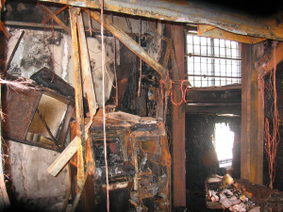](https://maintrain.wordpress.com/2010/08/25/a-fire-accident-case-study/123-192/)

Kiosk wall and equipment after the fire

The other views of the worst affected areas in the vicinity of the fire indicates the intensity of the heat generated.

[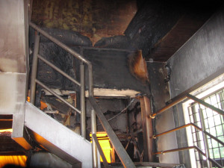](https://maintrain.wordpress.com/2010/08/25/a-fire-accident-case-study/123-203-2/)[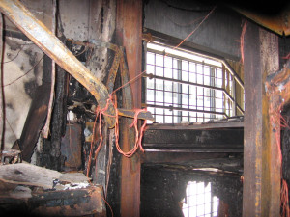](https://maintrain.wordpress.com/2010/08/25/a-fire-accident-case-study/123-193/)

[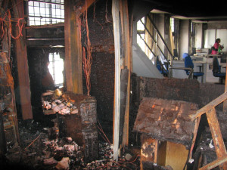](https://maintrain.wordpress.com/2010/08/25/a-fire-accident-case-study/123-195/)

The actual burning down of the most affected area took less than 15 minutes. The local fire brigade reached the scene within 12 minutes of the fire alert and started the fire-fighting.

[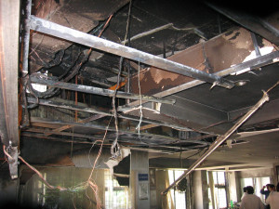](https://maintrain.wordpress.com/2010/08/25/fire-accident-a-case-study/123-197/)

The fire then spread above the false ceiling, through cable trays and the ventilation ducts. Some of the damages above the false ceiling and soot stains near ventilation louvers are shown in the images given below.

The customer service areas were totally devastated by the fire and could not be used till they were re-built. The other areas were also affected due to smoke stains, water logging, doubt on integrity of the electrical circuits, no data connectivity etc.

The interiors were rebuilt in 12 weeks time and put back in use. The ground floor cabling was completely renewed, all the ducts were internally cleaned, and all the affected furniture replaced. In the other areas, everything was inspected for damage and only essential items were replaced or repaired.

**Consequential Damages**

* Large number of structural glazing panels had cracked due to the intense heat and were replaced.
* Water sprayed into the electrical room during the fire fighting phase had entered the UPS. The two UPSs had to be shipped to the OEM for testing and overhaul.
* All the carpets had to be written off due to water logging and soot staining.
* Many computers and peripherals in the ground floor were damaged due to extreme heat and water ingress.
* About 25% of the furniture had to replaced and the balance had to be repaired.
* One staircase, in the vicinity of the fire had to be tested for structural integrity since a steel channel was found to have distorted due to extreme heat. The affected steel channel was replaced.
* 100% data cables were replaced due to partial burning of a few bunches.
* The server room went through a deep cleaning due to water logging under the false floor and some ingress of water into the racks during the fire fighting.

**Business Continuity Plan (BCP)**

The robust BCP helped the premise user in shifting their operations almost seamlessly to their alternative locations within 24 hours. The client servicing was also not very badly affected.

**Insurance Cover**

The premise had a comprehensive insurance cover and helped in recovering the cost of refurbishing the premise to its original state.

Fires can happen from very minor faults and cause much damage to assets and property. We need to take precaution against the occurrence of fire rather than regretting later. Proper inspection and maintenance of all electrical installations, cleaning of electrical contacts, premises cleanliness, pest control (particularly rodent control), and a disciplined work force will all go a long way in avoiding fire accidents.

**REFERENCES**

[1] Y. Qiongfang, Z. Dezhong, F. Yongli and D. Aihua, "Intelligent Fire Alarm System Based on Fuzzy Neural Network," 2009 International Workshop on Intelligent Systems and Applications, p. 1, May 2009.

[2] C. Shunxia and C. Yanda, "Design Of Wireless Intelligent Home Alarm System," Industrial Control and Electronics Engineering (ICICEE), 2012 International Conference on, p. 1511, August 2012.

[3] J. Hou, C. Wu, Z. Yuan, J. Tan, Q. Wang and Y. Zhou, "Research of Intelligent Home Security Surveillance System Based on ZigBee," International Symposium on Intelligent Information Technology Application Workshops, pp. 554-557, 2008.

[4] V. Rakesh, P. Sreesh and S. N. George, "Improved real-time surveillance system for home security system using Beagleboard SBC, Zigbee and FTP Webserver," 2012 Annual IEEE India Conference (INDICON), pp. 1240 - 1244,2012.

[5] Price, Peter (3 June 2011). ["Can a £15 computer solve the programming gap?"](http://news.bbc.co.uk/2/hi/programmes/click_online/9504208.stm). [BBC Click](https://en.wikipedia.org/wiki/Click_(TV_programme)). Retrieved 2 July 2011.

[6] Bush, Steve (25 May 2011). ["Dongle computer lets kids discover programming on a TV"](http://www.electronicsweekly.com/Articles/2011/05/25/51129/Dongle-computer-lets-kids-discover-programming-on-a.htm). [Electronics Weekly](https://en.wikipedia.org/wiki/Electronics_Weekly). Retrieved 11 July 2011.

[7] ["Ten millionth Raspberry Pi, and a new kit – Raspberry Pi"](https://www.raspberrypi.org/blog/ten-millionth-raspberry-pi-new-kit/). 8 September 2016. Retrieved 9 September 2016. We’ve beaten our wildest dreams by three orders of magnitude

[8] Gibbs, Samuel (18 February 2015). ["Raspberry Pi becomes bestselling British computer"](https://www.theguardian.com/technology/2015/feb/18/raspberry-pi-becomes-best-selling-british-computer). The Guardian. Retrieved 28 December 2016.

[9] [The Mag Pi Magazine issue 53, Page 10](https://www.raspberrypi.org/magpi/issues/53/), Raspberry Pi Foundation, On 25 November, it was confirmed that total sales of the Raspberry Pi have now topped 11 million.

[10] S. Monk, Programming Arduino Getting Start With Sketches, McGraw-Hill,2011.

[11] Ningbo Hi-Tech Park SKKY Science Technology Co. Ltd., QMNGl, Zhejiang, 2010.

[12] Shawn and M. Richardson, Getting Started With Raspberry Pi, Sebastopol: O'Reilly Media, Inc, 2012.

[13] H. Schildt, C++: The Complete Reference, Mcgraw-Hill Osborne Media, 2003.

[14] L. Chun-yuan, "Design of intelligent fire alarm system based on GSM network," 2011 International Conference on Electronics and Optoelectronics (ICEOE), vol. 1, pp. VI-393, July 2011.

[15] B. Lee and J. Jeon, "An Embedded Router for Internet Communication Among Private Networks," ICIT 2006. IEEE International Conference on Industrial Technology, 2006., p.688,2006.

**https://pimylifeup.com/raspberry-pi-gpio/**

**BIBLOGRAPHY**

<http://www.ijettjournal.org/volume-11/number-4/IJETT-V11P236.pdf>

<https://ieeexplore.ieee.org/document/6895040/>

<https://www.happiestminds.com/services/internet-of-things/>

<https://www.happiestminds.com/Insights/internet-of-things/>

<https://volansys.com/iot-solution-and-wearable-devices/>

<https://www.happiestminds.com/wp-content/uploads/2016/05/The-Role-of-IoT-in-Providing-Security-Efficiency-and-Accessibility-in-Education.pdf>

<https://en.wikipedia.org/wiki/Raspberry_Pi>

<https://pdfs.semanticscholar.org/2006/d0fca0546bdeb7c3f0527ffd299cff7c7ea7.pdf>

<https://www.efxkits.us/different-types-of-raspberry-pi-boards-its-application/>

<https://learn.sparkfun.com/tutorials/voltage-dividers>

<http://ualr.edu/safety/home/campus-safety-links/fire-safety/what-to-do-in-case-of-a-fire/>

<http://www.redcross.org/get-help/how-to-prepare-for-emergencies/types-of-emergencies/fire>

<https://www.foxbusiness.com/features/five-signs-your-house-is-a-firetrap>

<http://www.firesafetyforkids.org/fire-safety-rules.html>

<https://gizmodo.com/5941196/how-to-escape-a-burning-building>

<https://www.wikihow.com/Keep-Safe-During-a-House-Fire>

<https://www.hindustantimes.com/mumbai-news/14-killed-in-fire-at-mumbai-building-survivor-says-people-were-running-over-him/story-oiSHXbTMCUVXzI5P1Ow4gP.html>

<https://www.ready.gov/home-fires>

<https://www.researchgate.net/figure/The-flowchart-of-the-Python-programming-in-Raspberry-Pi_fig3_280829016>

https://maintrain.wordpress.com/2010/08/25/fire-accident-a-case-study/