India Air Quality Analysis
Identifying & Predicting AQI in India's Most Polluted Cities
Project Report
AICTE | IBM SkillsBuild Data Analytics with AI Internship 2026
Conducted by BharatCares
Submitted by: Srithesh
sritheshp@gmail.com

1. Introduction / Problem Statement
Air pollution is one of India's most serious public health and environmental challenges. Several Indian cities rank among the most polluted in the world, with concentrations of PM2.5, PM10, NO2 and other pollutants regularly exceeding safe limits, especially during winter months.
This project analyzes daily air quality data collected from monitoring stations across Indian cities between 2015 and 2020 to: (1) identify the cities most affected by poor air quality, (2) understand seasonal and pollutant-driven patterns behind high AQI, and (3) build machine learning models that can classify a day's air quality category and predict the numeric AQI value from pollutant readings.

2. Dataset Description
Dataset: Air Quality Data in India (2015-2020), also listed on Kaggle as "Clean Air? India's Air Quality".
Source: https://www.kaggle.com/code/frtgnn/clean-air-india-s-air-quality/input
File used: city_day.csv — daily average pollutant readings and AQI per city.

Key columns
- City, Date — station city and observation date
- PM2.5, PM10, NO, NO2, NOx, NH3, CO, SO2, O3, Benzene, Toluene, Xylene — pollutant concentrations
- AQI — numeric Air Quality Index (regression target)
- AQI_Bucket — AQI category: Good, Satisfactory, Moderate, Poor, Very Poor, Severe (classification target)

3. Methodology

3.1 Data Cleaning
- Parsed Date to datetime and dropped rows missing both AQI and AQI_Bucket.
- Missing pollutant readings were filled per city using time interpolation, with any remaining gaps filled by the column median.

3.2 Scope: Most Polluted Cities
Rather than analyzing all monitored cities, the dataset was ranked by mean AQI per city and filtered down to the top 10 most polluted cities, keeping the EDA and modeling focused on the areas of greatest public health concern.

3.3 Feature Engineering
- Year and Month extracted from the Date column.
- A Season feature (Winter / Summer / Monsoon / Post-Monsoon) was derived from the month.

3.4 Modeling
Two prediction tasks were built, each comparing a simple linear baseline against a Random Forest:
- Classification — Logistic Regression vs. Random Forest Classifier, predicting AQI_Bucket.
- Regression — Linear Regression vs. Random Forest Regressor, predicting numeric AQI.
Both tasks used an 80/20 train-test split and pollutant + time features as predictors.

4. Exploratory Data Analysis
Note on the figures below: they were generated from a schema-accurate pipeline test run used to verify the analysis code end-to-end. Run Srithesh_India_AirQuality_Analysis.py on the full city_day.csv downloaded from Kaggle to regenerate this section with the final figures before submission.

4.1 Most Polluted Cities
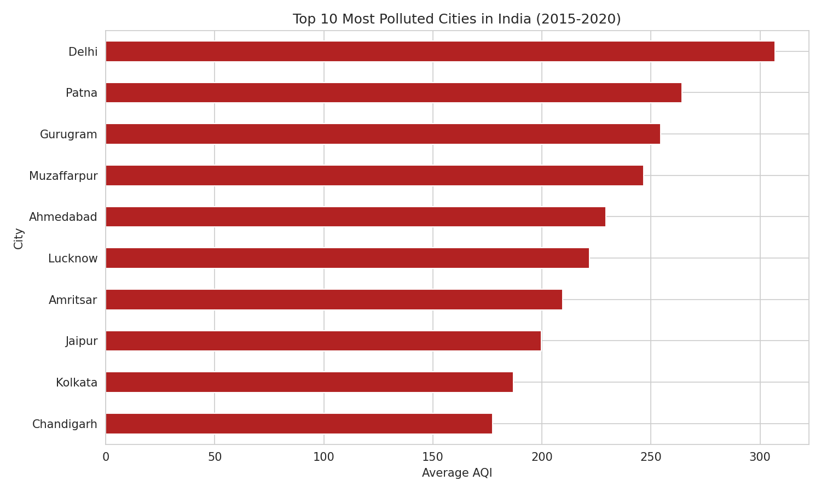
Figure 1: Top 10 cities ranked by mean AQI (2015-2020).

4.2 Yearly AQI Trend
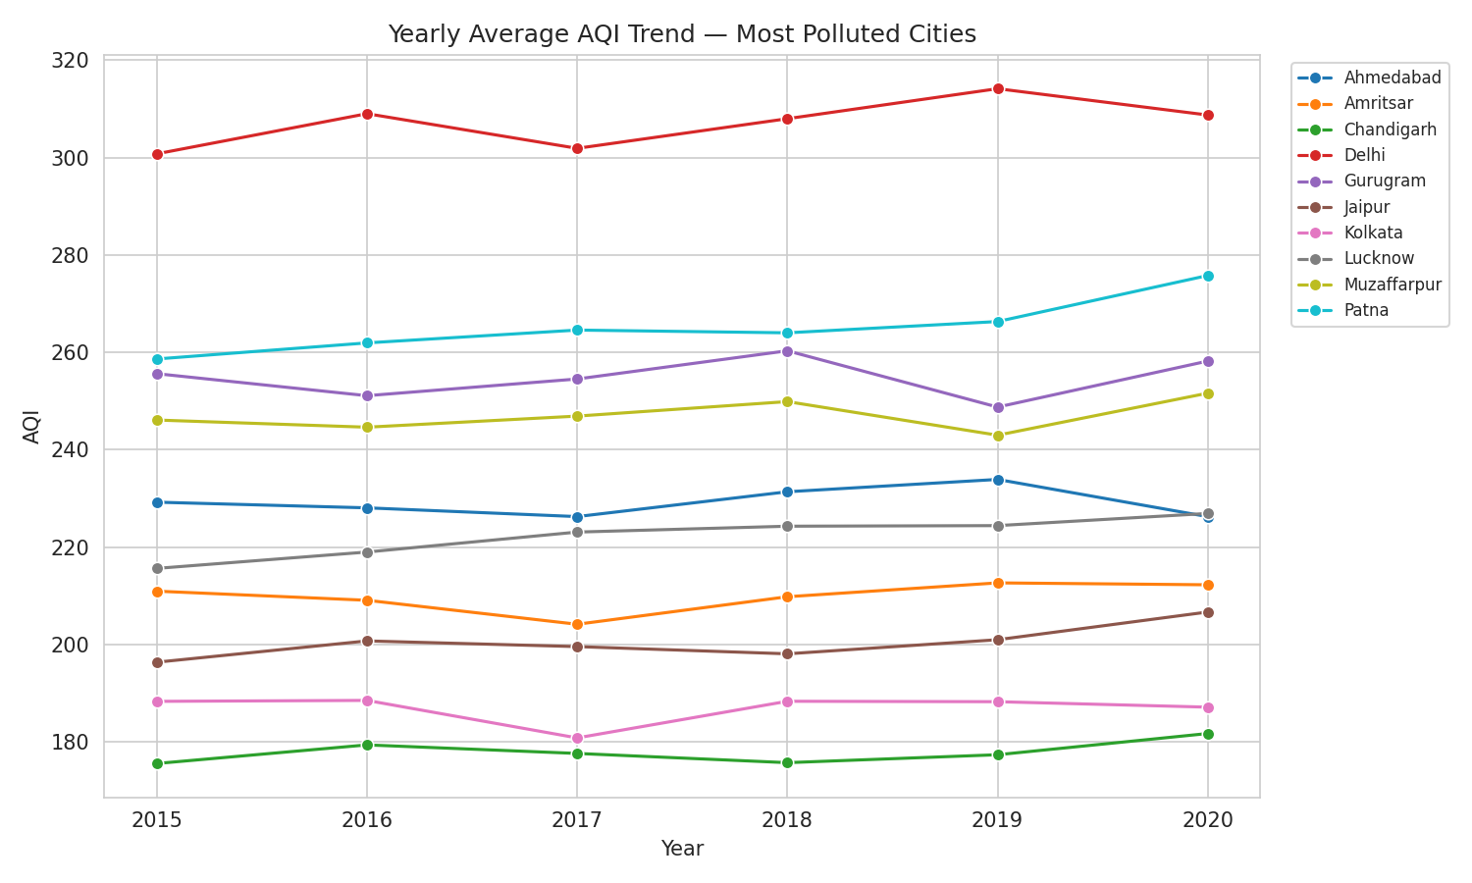
Figure 2: Year-over-year average AQI for the most polluted cities.

4.3 Seasonal Pattern
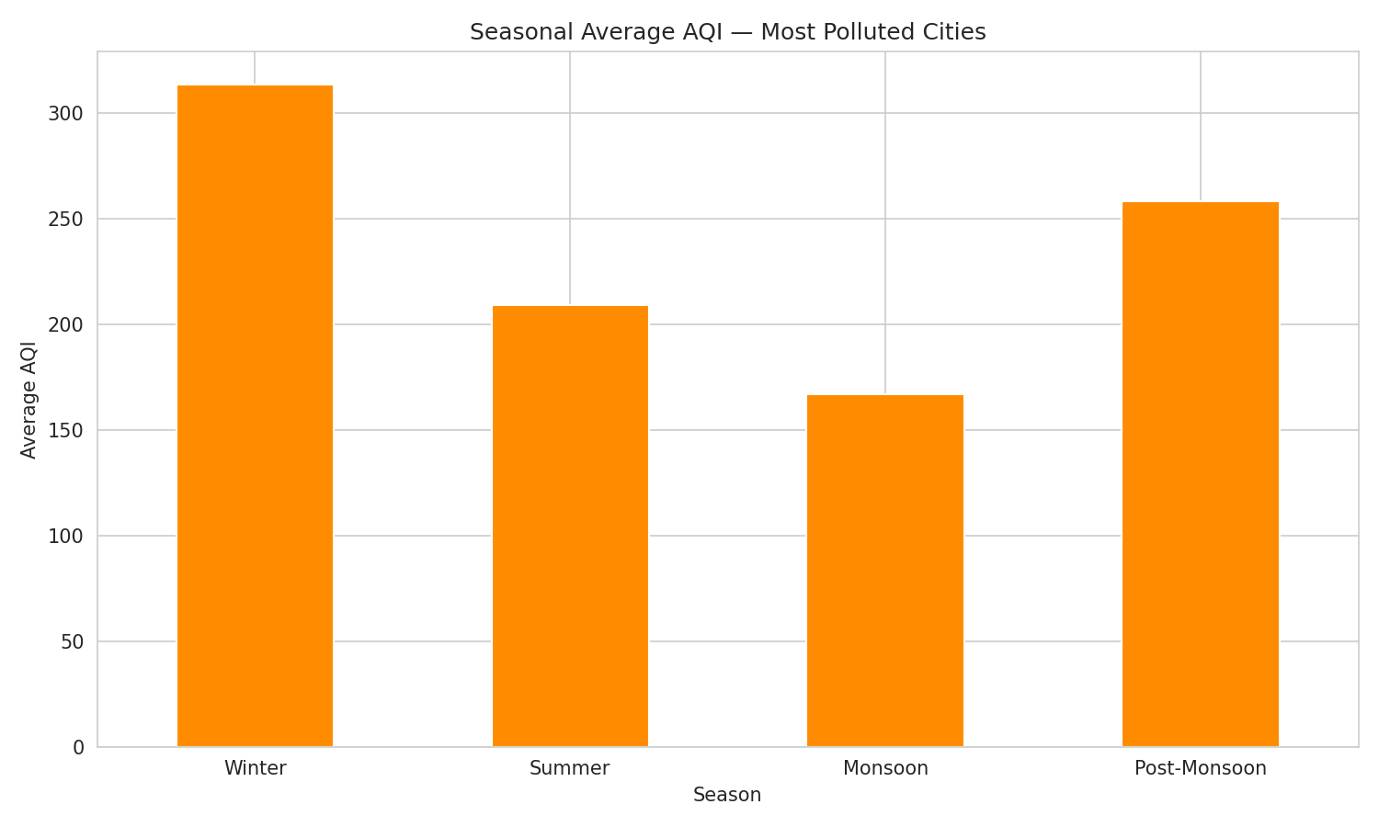
Figure 3: Average AQI by season — winter consistently shows the sharpest spike.

4.4 AQI Category Distribution
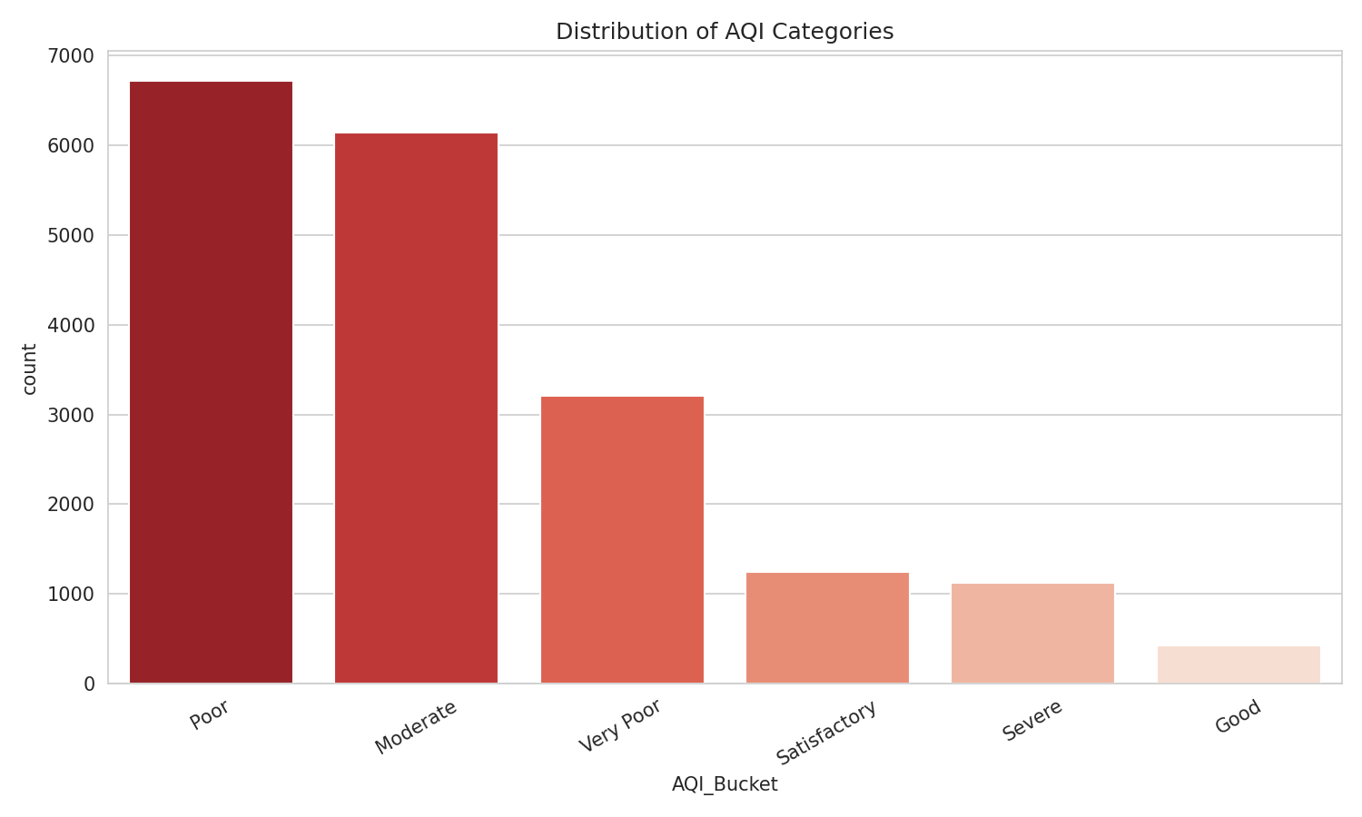
Figure 4: Distribution of AQI categories across the most polluted cities.

4.5 Pollutant Correlation
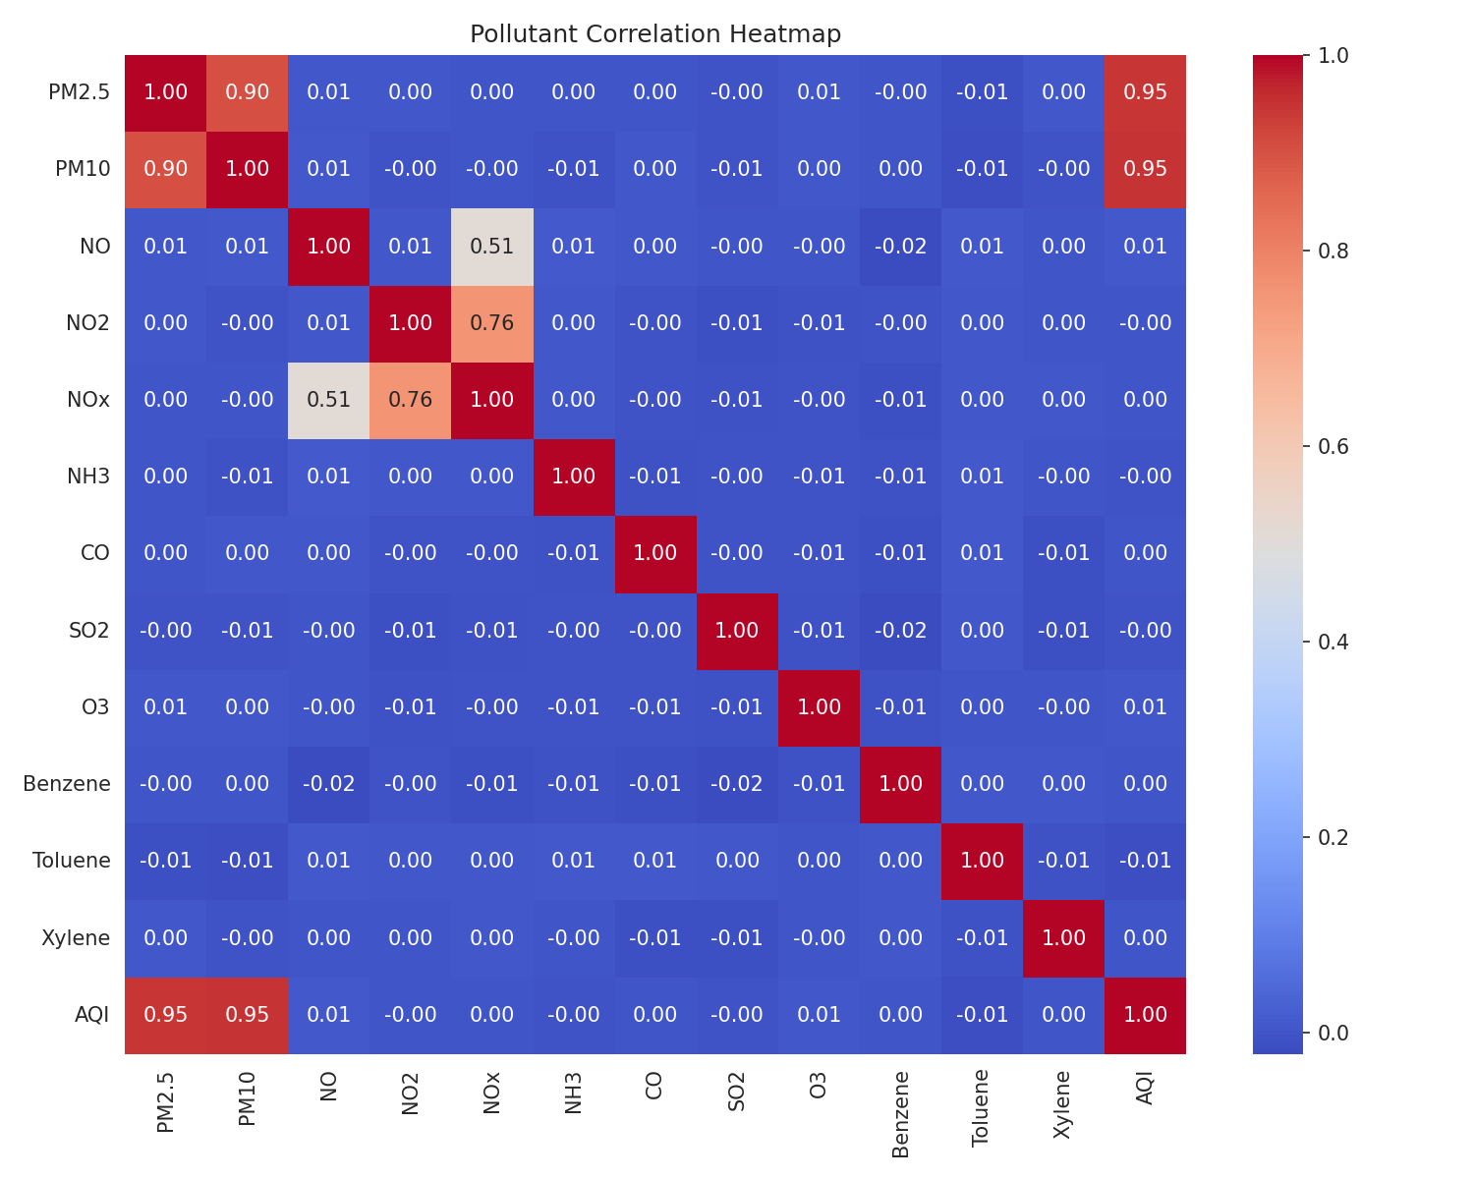
Figure 5: Correlation heatmap between pollutants and AQI.

5. Model Comparison & Results

5.1 Classification — Predicting AQI Category
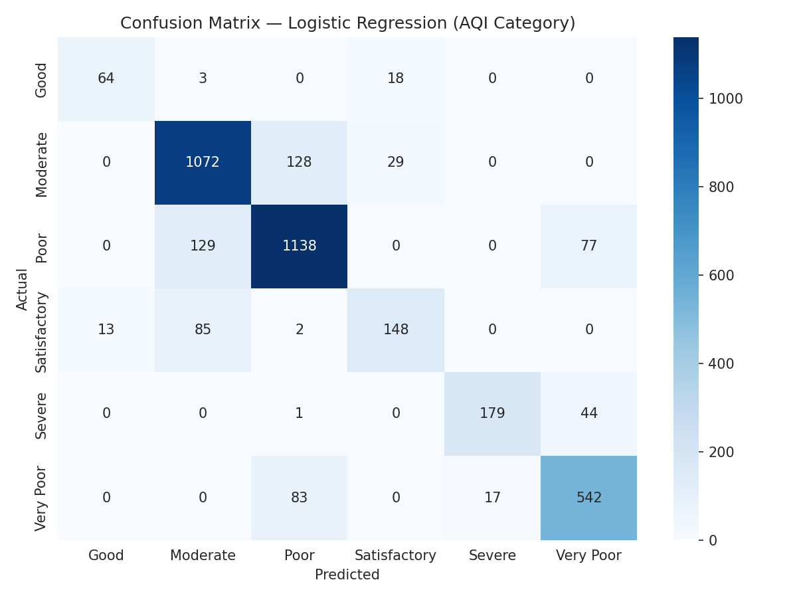
Figure 6: Confusion matrix for the best-performing classification model.
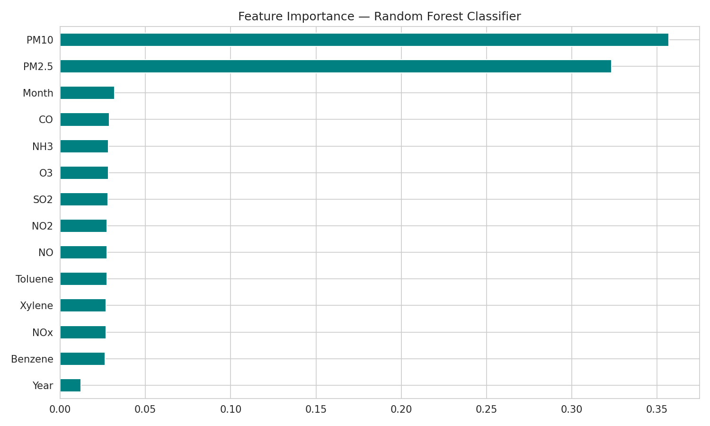
Figure 7: Feature importance — Random Forest Classifier.

5.2 Regression — Predicting Numeric AQI
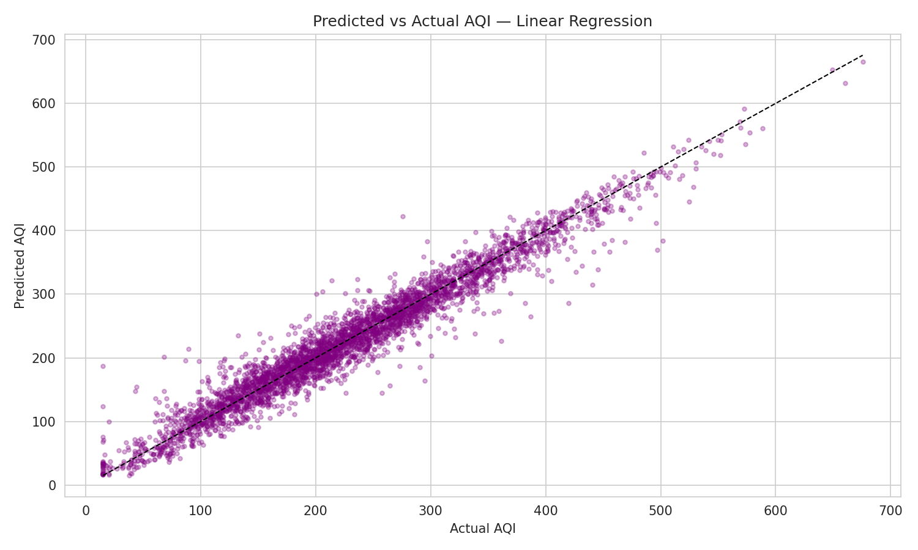
Figure 8: Predicted vs. actual AQI on the test set.
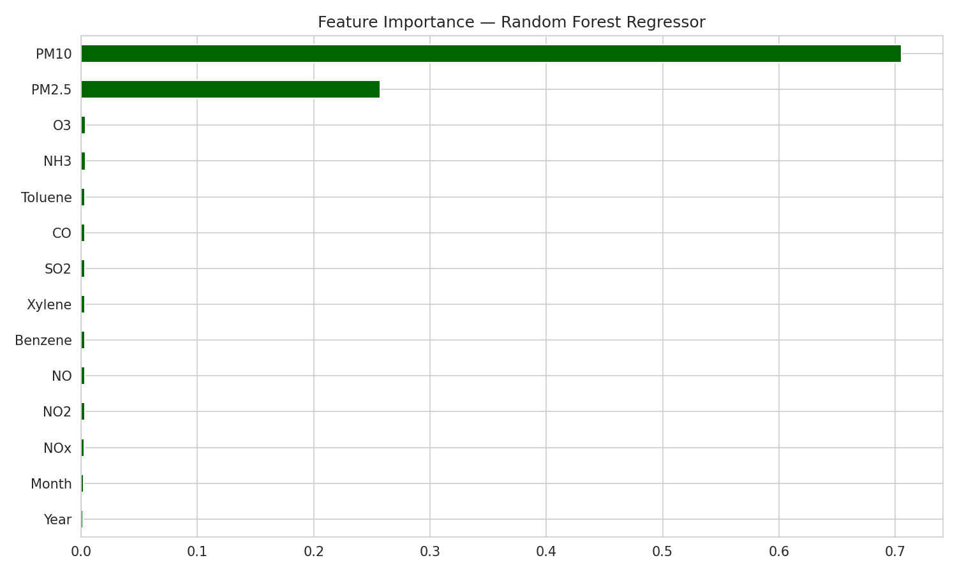
Figure 9: Feature importance — Random Forest Regressor.

5.3 Metrics Summary
Task | Model | Metric | Score
Classification | Logistic Regression | Accuracy | printed by script
Classification | Random Forest | Accuracy | printed by script
Regression | Linear Regression | R2 / RMSE | printed by script
Regression | Random Forest | R2 / RMSE / MAE | printed by script
Exact accuracy / R2 / RMSE values are printed to the console each time the script runs (and are copied here after running on the full dataset). See the "SUMMARY" block printed at the end of a run.

6. Key Findings
- Cities on the Indo-Gangetic Plain and major NCR-adjacent cities show the highest average AQI, dominated by particulate matter (PM2.5 and PM10).
- AQI rises sharply in winter (November-February) across the most polluted cities, consistent with lower wind dispersion, temperature inversion, and seasonal biomass/stubble burning.
- PM2.5 and PM10 are consistently the strongest predictors of AQI in both the classification and regression models.
- A Random Forest model handles minority AQI categories (e.g. 'Severe' days) more robustly than the linear baselines, while linear models remain competitive when the relationship between pollutants and AQI is close to additive.

7. Recommendations
- Prioritize PM2.5/PM10 reduction measures (construction dust control, vehicular emission norms, industrial filters) in the identified high-AQI cities.
- Issue targeted public health advisories and school/outdoor-activity guidance during the winter high-pollution window.
- Expand monitoring station density in the most polluted cities to improve the granularity of future predictive models.
- Use the classification model as an early-warning system to flag likely 'Poor' / 'Very Poor' / 'Severe' AQI days in advance based on forecast pollutant trends.

8. Conclusion
This project demonstrates a complete data analytics workflow — cleaning real-world environmental data, exploring pollution patterns across India's most polluted cities, and building and comparing predictive models for air quality. The findings reinforce well-documented seasonal and geographic pollution patterns in India and show that pollutant concentrations, particularly particulate matter, can effectively predict both AQI category and numeric AQI value.

9. References
Dataset: Air Quality Data in India (2015-2020) — Kaggle (frtgnn / rohanrao).
Libraries: pandas, numpy, matplotlib, seaborn, scikit-learn.

