SOFTWARE REQUIREMENTS SPECIFICATION
(SRS)

Fraud Detection System
Using Machine Learning and Deep Learning
Document Type | IEEE Standard SRS
Version | 1.0
Prepared For | IEEE-CIS / Fintech Banking Applications
Date | April 1, 2026
Standard | IEEE Std 830-1998
Classification | Technical / Research

TABLE OF CONTENTS

1 | Introduction | 4
1.1 | Purpose | 4
1.2 | Scope | 4
1.3 | Definitions, Acronyms and Abbreviations | 5
1.4 | Overview | 5
2 | Overall Description | 6
2.1 | Product Perspective | 6
2.2 | Product Functions | 6
2.3 | User Characteristics | 6
2.4 | Constraints | 7
2.5 | Assumptions and Dependencies | 7
3 | Functional Requirements | 8
3.1 | Data Ingestion Requirements | 8
3.2 | Data Preprocessing Requirements | 8
3.3 | Feature Engineering Requirements | 9
3.4 | Model Training Requirements | 9
3.5 | Model Evaluation Requirements | 10
3.5.1 | System Screenshot – Model Comparison Page | 10
3.6 | Explainability Requirements | 11
3.6.1 | System Screenshot – Real-Time Prediction & SHAP | 11
3.7 | Alert and Reporting Requirements | 12
4 | Non-Functional Requirements | 13
5 | Use Case Diagram | 14
5.1 | Use Case Descriptions | 14
6 | Data Flow Diagram (DFD) | 15
7 | Sequence Diagram | 16
8 | External Interface Requirements | 17
8.1 | User Interfaces | 17
8.2 | Hardware Interfaces | 17
8.3 | Software Interfaces | 17
8.4 | Communication Interfaces | 18
9 | System Models | 18
9.1 | Pipeline Architecture Overview | 18
9.2 | Model Performance Summary | 19
9.3 | Live System Dashboard – FraudShield AI | 19
10 | Appendix | 20
10.1 | Revision History | 20
10.2 | Future Enhancements | 20
10.3 | References | 20

1. INTRODUCTION

1.1 Purpose
This Software Requirements Specification (SRS) document defines the functional and non-functional requirements for the Production-Grade Fraud Detection System (PGFDS). It is prepared in accordance with the IEEE Standard 830-1998. This document is intended for use by software developers, data scientists, system architects, quality assurance engineers, and project stakeholders.
The primary purpose of this system is to detect fraudulent financial transactions in real time using machine learning and deep learning techniques, providing high precision predictions with interpretable outputs for fintech and banking applications.

1.2 Scope
The Fraud Detection System (FDS) is a software application that:
- Ingests raw financial transaction data and identity records from the IEEE-CIS dataset (~590,000 records, 400+ features).
- Pre-processes, cleans, and engineers features from raw data to enhance model performance.
- Trains and evaluates multiple machine learning models (Logistic Regression, Random Forest, XGBoost, LightGBM).
- Classifies each transaction as fraudulent or legitimate using the best-performing model.
- Provides model explainability via SHAP values for audit and compliance.
- Generates alerts, reports, and dashboards for fraud analysts and business stakeholders.

The system is NOT intended to replace human fraud analysts but to augment their decision-making capabilities.

1.3 Definitions, Acronyms and Abbreviations
Term / Acronym | Definition
SRS | Software Requirements Specification
ML | Machine Learning
DL | Deep Learning
FDS | Fraud Detection System
XGBoost | Extreme Gradient Boosting – a gradient-boosted decision tree algorithm
LightGBM | Light Gradient Boosting Machine – a fast, distributed gradient boosting framework
SHAP | SHapley Additive exPlanations – a framework for model interpretability
PR-AUC | Precision-Recall Area Under the Curve
ROC-AUC | Receiver Operating Characteristic – Area Under the Curve
IEEE-CIS | IEEE Computational Intelligence Society
DFD | Data Flow Diagram
API | Application Programming Interface
MLOps | Machine Learning Operations
FP | False Positive – legitimate transaction flagged as fraud
FN | False Negative – fraudulent transaction not detected

1.4 Overview
This document is structured as follows:
- Section 2 – Overall Description: System context, users, and constraints.
- Section 3 – Functional Requirements: Detailed system capabilities.
- Section 4 – Non-Functional Requirements: Performance, security, and scalability.
- Section 5 – Use Case Diagram: Actor-system interaction models.
- Section 6 – Data Flow Diagram: Data movement through system layers.
- Section 7 – Sequence Diagram: Step-by-step transaction processing flow.
- Section 8 – External Interface Requirements.
- Section 9 – System Models and appendices.

2. OVERALL DESCRIPTION

2.1 Product Perspective
The Fraud Detection System is a standalone, production-grade analytical platform that integrates with existing banking infrastructure. It operates as a pipeline-based system consuming transactional data, processing it through ML models, and producing fraud probability scores and alerts.
The system architecture consists of six modular layers: Data Ingestion, Data Preprocessing, Feature Engineering, Model Training, Evaluation, and Explainability. Each layer can be independently updated or replaced without disrupting the entire pipeline.

2.2 Product Functions
The major functions of the system are summarized below:
# | Function | Description
F-01 | Data Ingestion | Load and merge transaction and identity datasets using TransactionID.
F-02 | Preprocessing | Handle missing values, encode categoricals, optimise memory usage.
F-03 | Feature Engineering | Generate 40+ behavioural, velocity, and risk-based features.
F-04 | Model Training | Train Logistic Regression, Random Forest, XGBoost, and LightGBM models.
F-05 | Threshold Optimisation | Tune decision threshold to meet precision/recall business requirements.
F-06 | Model Evaluation | Compute Precision, Recall, F1, PR-AUC, ROC-AUC and confusion matrix.
F-07 | Explainability | Produce SHAP feature importance plots for global and local explanations.
F-08 | Alert Generation | Generate fraud alerts with risk scores for flagged transactions.
F-09 | Reporting | Produce evaluation dashboards and summary reports.

2.3 User Characteristics
User Role | Technical Level | Primary Interaction
Fraud Analyst | Moderate – uses dashboard/alerts | Reviews flagged transactions and SHAP explanations
Data Scientist | Advanced – Python/ML expertise | Trains, tunes, and evaluates models; analyses features
System Administrator | Advanced – DevOps/MLOps | Manages pipeline, monitors performance, handles retraining
Bank Manager / Executive | Low – business stakeholder | Views summary reports and KPI dashboards
Compliance Officer | Moderate – regulatory focus | Audits model decisions and reviews explainability reports

2.4 Constraints
- The system must handle highly imbalanced data (~3.5% fraud rate) without introducing data leakage.
- Time-based train/test split must be strictly enforced to simulate real-world deployment conditions.
- Model inference time must not exceed 200 milliseconds per transaction in production.
- All personally identifiable information (PII) must remain anonymised as per IEEE-CIS dataset terms.
- The system must be compatible with Python 3.8+ and standard ML libraries (scikit-learn, XGBoost, LightGBM).

2.5 Assumptions and Dependencies
- Input data follows the IEEE-CIS Fraud Detection dataset schema.
- Sufficient computational resources (minimum 16 GB RAM, 8-core CPU) are available for model training.
- The downstream alert system or dashboard tool is provided externally and consumes system outputs via API or file export.
- Historical transaction data is available for at least 6 months to enable meaningful velocity and behavioural features.

3. FUNCTIONAL REQUIREMENTS
Each requirement is identified using the format FR-XX. Priority levels: High (H), Medium (M), Low (L).

3.1 Data Ingestion Requirements
FR-ID | Requirement Description | Input | Priority | Output
FR-01 | System shall load transaction data (train_transaction.csv) containing ~590K records and 394 features. | CSV file | H | DataFrame
FR-02 | System shall load identity data (train_identity.csv) containing 40+ identity attributes. | CSV file | H | DataFrame
FR-03 | System shall merge transaction and identity datasets using the TransactionID key with a left join to retain all transactions. | Two DataFrames | H | Merged DF
FR-04 | System shall validate input data schema and raise descriptive errors if expected columns are missing. | Merged DF | M | Error / OK

3.2 Data Preprocessing Requirements
FR-ID | Requirement Description | Input | Priority | Output
FR-05 | System shall impute numerical missing values using median imputation strategy. | Raw DataFrame | H | Clean DF
FR-06 | System shall impute categorical missing values by filling with the string 'Unknown'. | Raw DataFrame | H | Clean DF
FR-07 | System shall encode categorical variables using Label Encoding for tree-based models. | Clean DF | H | Encoded DF
FR-08 | System shall reduce memory consumption by downcasting numerical columns (int64 → int32, float64 → float32) by at least 40%. | Encoded DF | M | Optimised DF
FR-09 | System shall perform time-based train/test split using TransactionDT to prevent data leakage. | Full DF | H | Train/Test sets

3.3 Feature Engineering Requirements
FR-ID | Requirement Description | Input | Priority | Output
FR-10 | System shall compute transaction frequency features: count of transactions per card, email, and IP address within 1-hour and 24-hour windows. | Transaction DF | H | Velocity Features
FR-11 | System shall compute statistical aggregation features: mean and standard deviation of transaction amount grouped by card number. | Transaction DF | H | Agg. Features
FR-12 | System shall compute risk-based features: ratio of current transaction amount to the user's historical average amount. | Transaction DF | M | Risk Score
FR-13 | System shall generate device change indicator: flag if device fingerprint differs from the user's registered device. | Identity DF | M | Binary Flag
FR-14 | System shall generate a total of at least 40 engineered features beyond the original dataset features. | All Data | H | Feature Matrix

3.4 Model Training Requirements
FR-ID | Requirement Description | Input | Priority | Output
FR-15 | System shall train a Logistic Regression model as a baseline with class_weight='balanced'. | Train Set | H | Baseline Model
FR-16 | System shall train a Random Forest classifier with hyperparameter tuning via cross-validation. | Train Set | H | RF Model
FR-17 | System shall train an XGBoost classifier with scale_pos_weight to handle class imbalance. | Train Set | H | XGB Model
FR-18 | System shall train a LightGBM classifier using is_unbalance=True parameter. | Train Set | H | LGBM Model
FR-19 | System shall save trained model artefacts to disk in a serialised format (pickle/joblib). | Trained Model | M | Model File

3.5 Model Evaluation Requirements
FR-ID | Requirement Description | Input | Priority | Output
FR-20 | System shall evaluate all models on the test set and report Precision, Recall, F1-score, PR-AUC, and ROC-AUC. | Test Set | H | Metrics Report
FR-21 | System shall select the best model based on PR-AUC score, using XGBoost as the primary model. | Metrics | H | Best Model
FR-22 | System shall generate a confusion matrix for the selected model at the optimised threshold. | Test Set | H | CM Plot
FR-23 | System shall optimise the decision threshold to achieve minimum Precision of 0.65 while maximising Recall. | PR Curve | H | Threshold Value

3.5.1 System Screenshot – Model Comparison & Performance
The following screenshot shows the FraudShield AI Models page, illustrating real-world output of FR-20 to FR-23: a grouped bar chart comparing Precision, Recall, and PR-AUC across all four trained models, alongside a radar chart for multi-dimensional evaluation. The production model (LightGBM, PR-AUC 0.84, Precision 93.2%) is highlighted.

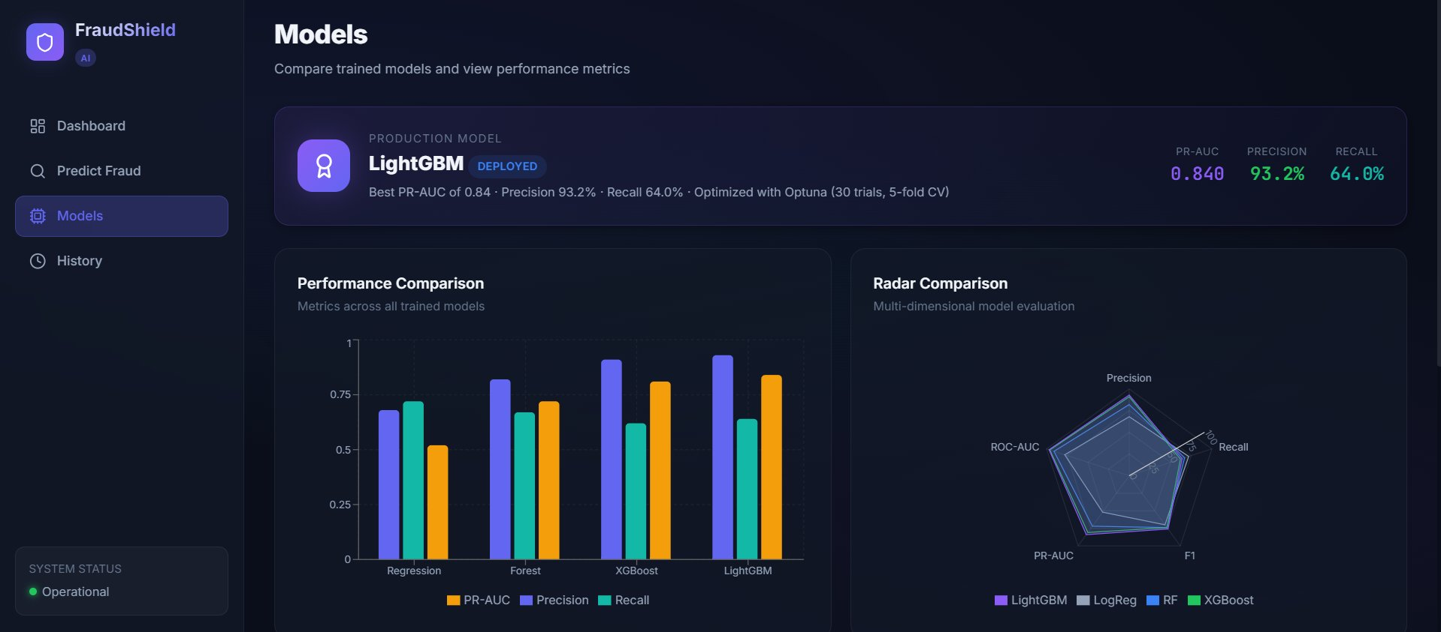
Figure 3.1 – FraudShield AI: Model Comparison Page showing Performance Bar Chart and Radar Comparison (LightGBM selected as Production Model).

3.6 Explainability Requirements
FR-ID | Requirement Description | Input | Priority | Output
FR-24 | System shall compute SHAP values for all features using the TreeExplainer for tree-based models. | Best Model | H | SHAP Values
FR-25 | System shall produce a global feature importance summary plot showing top 20 features ranked by mean absolute SHAP value. | SHAP Values | H | Summary Plot
FR-26 | System shall generate per-transaction SHAP waterfall or force plots for individual fraud explanations. | SHAP Values | M | Local Plot

3.6.1 System Screenshot – Real-Time Prediction with SHAP Explainability
The screenshot below demonstrates the FraudShield AI Predict Fraud page fulfilling FR-24 to FR-26. A transaction is scored in real time (8.4% fraud probability, classified LEGITIMATE at threshold 0.835) and the top SHAP risk factors (C13, C14, velocity_ratio_1h_7d) are surfaced inline, giving the fraud analyst an immediate, interpretable explanation for the model decision.

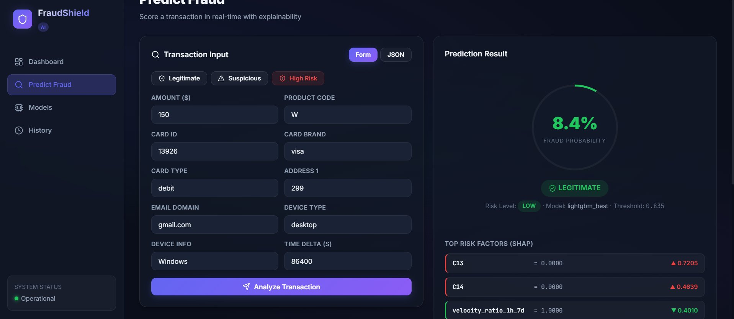
Figure 3.2 – FraudShield AI: Predict Fraud Page showing real-time fraud probability gauge (8.4%), LEGITIMATE verdict, and Top SHAP Risk Factors breakdown.

3.7 Alert and Reporting Requirements
FR-ID | Requirement Description | Input | Priority | Output
FR-27 | System shall generate a fraud alert for every transaction where the predicted fraud probability exceeds the optimised threshold. | Predictions | H | Alert List
FR-28 | System shall attach the fraud probability score (0.0–1.0) to every alert. | Predictions | H | Risk Score
FR-29 | System shall export evaluation reports and SHAP plots in PDF or HTML format. | Metrics/SHAP | M | Report File

4. NON-FUNCTIONAL REQUIREMENTS

NFR-ID | Category | Requirement | Target Metric
NFR-01 | Performance | The system shall process the full training dataset of 590K transactions and complete model training within 60 minutes on standard hardware (16 GB RAM, 8-core CPU). | < 60 min
NFR-02 | Performance | Model inference for a single transaction shall complete within 200 milliseconds. | < 200 ms
NFR-03 | Accuracy | The primary model (XGBoost) shall achieve a minimum ROC-AUC of 0.85 on the test set. | >= 0.85
NFR-04 | Accuracy | The primary model shall achieve a minimum Precision of 0.65 at the optimised threshold. | >= 0.65
NFR-05 | Scalability | The pipeline architecture shall support horizontal scaling to handle up to 5 million transactions with minimal architectural changes. | 5M records
NFR-06 | Reliability | The system shall have an uptime of at least 99.5% during production operation. | >= 99.5%
NFR-07 | Maintainability | Each system module (ingestion, preprocessing, training, evaluation) shall be independently replaceable without modifying other modules. | Modular design
NFR-08 | Security | All data inputs and outputs shall be access-controlled; sensitive fields shall remain anonymised in logs and reports. | Zero PII in logs
NFR-09 | Usability | SHAP explanation plots shall be interpretable by a non-ML fraud analyst after a maximum of 30 minutes of training. | < 30 min training
NFR-10 | Compliance | The system shall comply with GDPR data handling requirements and produce audit trails for all model decisions. | GDPR compliant
NFR-11 | Portability | The system shall run on any environment supporting Python 3.8+ and standard ML libraries without additional proprietary software. | Python 3.8+
NFR-12 | Testability | Each pipeline module shall have unit tests achieving a minimum of 80% code coverage. | >= 80% coverage

5. USE CASE DIAGRAM
The following diagram illustrates the interactions between system actors and the Fraud Detection System use cases.

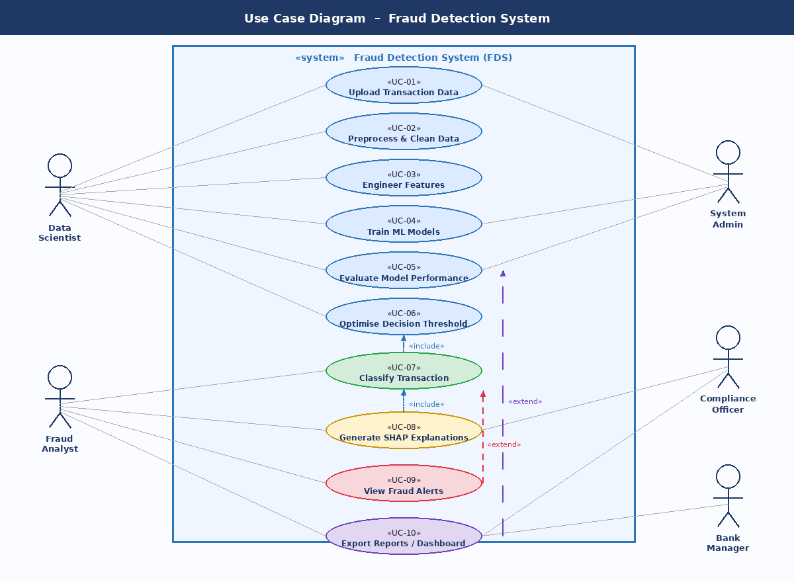

5.1 Use Case Descriptions
UC-ID | Use Case Name | Description | Primary Actor | Pre-condition
UC-01 | Upload Transaction Data | Actor uploads raw CSV transaction and identity files to the system. | Data Scientist | Files available in IEEE-CIS format
UC-02 | Preprocess and Clean Data | System removes missing values, encodes categoricals, optimises memory. | Data Scientist | Raw data ingested (UC-01 complete)
UC-03 | Engineer Features | System generates 40+ engineered features from raw data. | Data Scientist | Preprocessed data available
UC-04 | Train ML Models | System trains all four ML models using the training set. | Data Scientist | Feature matrix ready
UC-05 | Evaluate Model Performance | System computes and reports all evaluation metrics. | Data Scientist | All models trained (UC-04)
UC-06 | Optimise Decision Threshold | System finds optimal threshold balancing precision and recall. | Data Scientist | Best model selected
UC-07 | Classify Transaction | System scores a new transaction and returns fraud probability. | Fraud Analyst | Model deployed, threshold set
UC-08 | Generate SHAP Explanations | System produces global and local SHAP explanations. | Fraud Analyst / Compliance | Prediction generated (UC-07)
UC-09 | View Fraud Alerts | Analyst reviews list of flagged transactions with risk scores. | Fraud Analyst | Transactions classified (UC-07)
UC-10 | Export Reports | System exports evaluation metrics and SHAP plots as PDF/HTML. | All Actors | Evaluation done (UC-05)

6. DATA FLOW DIAGRAM (DFD)
The diagram below shows both the Level-0 Context Diagram (top) and Level-1 System Process DFD (bottom). Notation follows the Yourdon-DeMarco standard: circles represent processes, open rectangles are data stores, rounded rectangles are external entities, and labelled arrows are data flows.

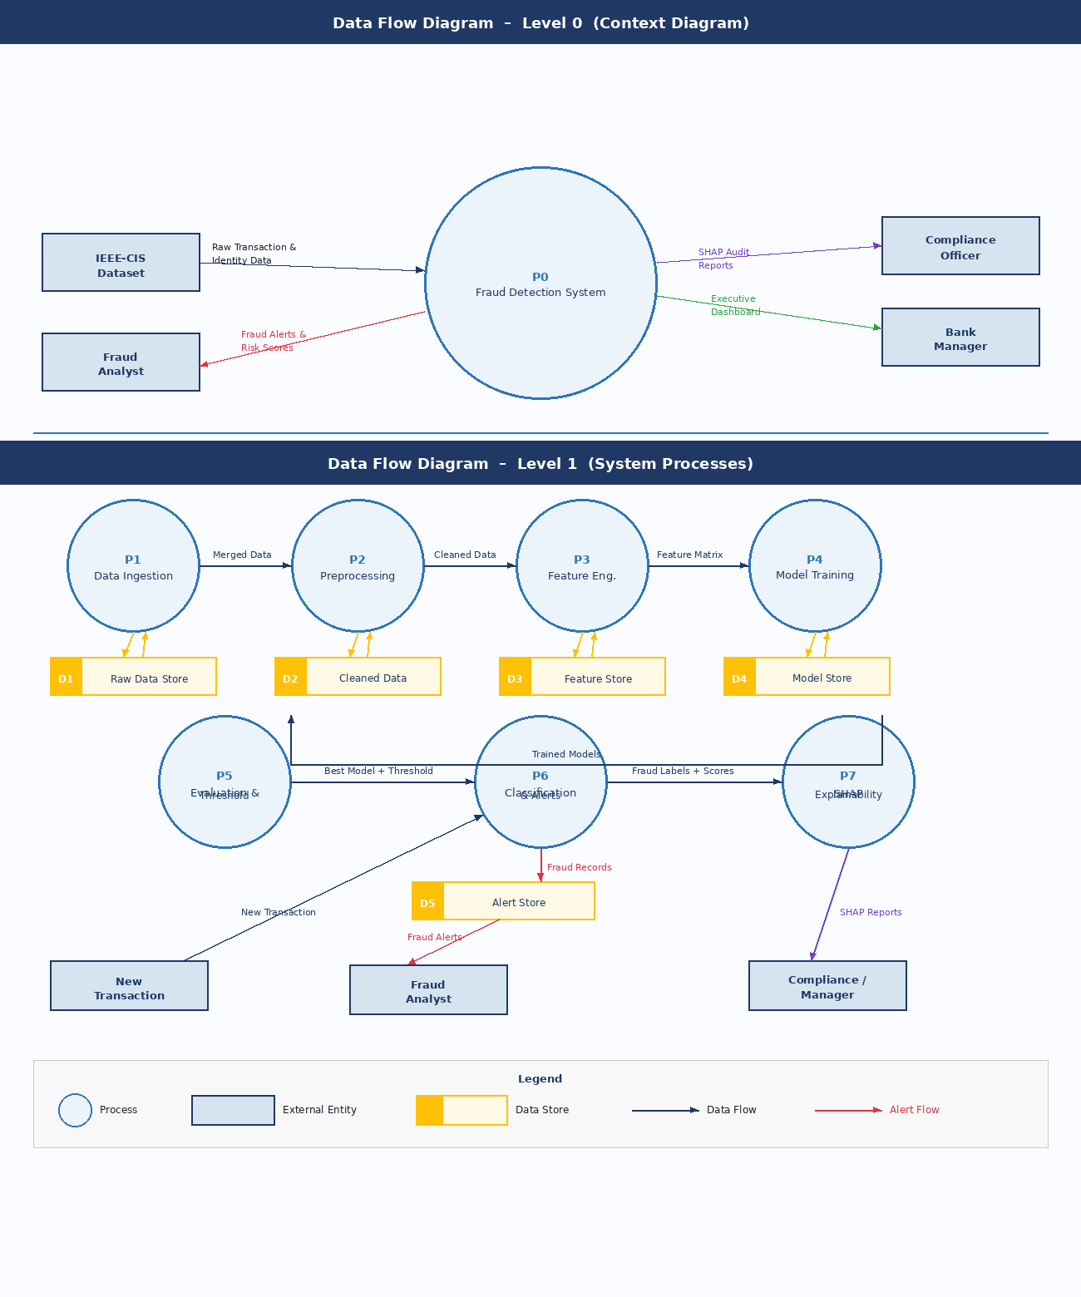

7. SEQUENCE DIAGRAM
The sequence diagram below shows the step-by-step message passing between system components during a complete fraud detection cycle — from data loading through to fraud classification, alert generation, and SHAP explainability. Activation boxes show when each component is active; dashed lines are return messages; fragment boxes label alt, opt, and ref combined flows.

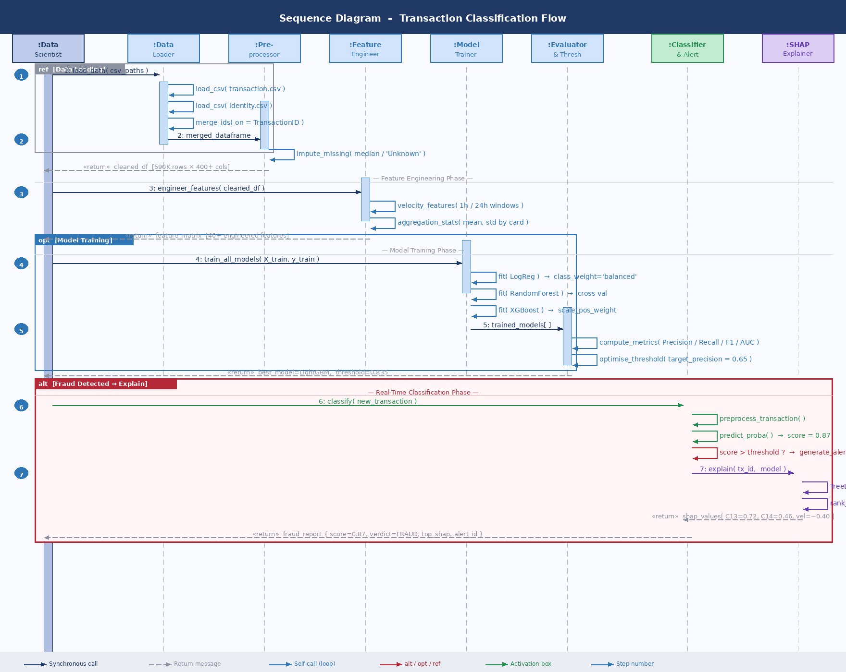

8. EXTERNAL INTERFACE REQUIREMENTS

8.1 User Interfaces
- A command-line interface (CLI) shall allow data scientists to trigger pipeline stages: ingest, preprocess, train, evaluate, predict.
- A web-based dashboard (optional extension) shall display model metrics, PR curves, confusion matrices, and SHAP plots.
- SHAP plots shall be rendered as interactive HTML files viewable in any modern browser.

8.2 Hardware Interfaces
- Minimum RAM: 16 GB for training on the full IEEE-CIS dataset.
- Minimum CPU: 8-core processor; GPU acceleration is optional for deep learning extensions.
- Storage: Minimum 10 GB free disk space for datasets, model artefacts, and reports.

8.3 Software Interfaces
Library / Tool | Version | Purpose
Python | 3.8+ | Primary programming language for all pipeline components
Pandas / NumPy | Latest stable | Data loading, manipulation, and numerical computation
Scikit-learn | 1.0+ | Baseline models, preprocessing, metrics, and cross-validation
XGBoost | 1.5+ | Primary gradient-boosted tree model for fraud classification
LightGBM | 3.0+ | Secondary gradient-boosted model for comparison
SHAP | 0.40+ | Model explainability and feature importance computation
Matplotlib / Seaborn | Latest stable | Plotting evaluation curves and SHAP visualisations
Joblib / Pickle | Latest stable | Model serialisation and artefact management

8.4 Communication Interfaces
- The system shall accept input data via file system paths or configurable S3-compatible object storage URIs.
- Fraud alerts shall be exportable as JSON or CSV for downstream consumption by alert management systems.
- A REST API interface (future enhancement) shall expose the classify endpoint for real-time scoring by external applications.

9. SYSTEM MODELS

9.1 Pipeline Architecture Overview
╔══════════════════════════════════════════════════════════════════╗
║ FRAUD DETECTION SYSTEM – LAYER ARCHITECTURE ║
╠══════════════════════════════════════════════════════════════════╣
║ LAYER 1 │ DATA INGESTION ║
║ │ Load CSVs → Merge on TransactionID → Validate Schema ║
╠══════════════════════════════════════════════════════════════════╣
║ LAYER 2 │ PREPROCESSING ║
║ │ Impute → Encode → Memory Optimise → Time-based Split ║
╠══════════════════════════════════════════════════════════════════╣
║ LAYER 3 │ FEATURE ENGINEERING ║
║ │ Velocity Features → Agg Stats → Risk Scores ║
╠══════════════════════════════════════════════════════════════════╣
║ LAYER 4 │ MODEL TRAINING ║
║ │ LR (Baseline) → Random Forest → XGBoost → LightGBM ║
╠══════════════════════════════════════════════════════════════════╣
║ LAYER 5 │ EVALUATION & THRESHOLD TUNING ║
║ │ Precision / Recall / F1 / PR-AUC / ROC-AUC ║
╠══════════════════════════════════════════════════════════════════╣
║ LAYER 6 │ EXPLAINABILITY & ALERTING ║
║ │ SHAP Values → Feature Importance → Alerts → Reports ║
╚══════════════════════════════════════════════════════════════════╝

9.2 Model Performance Summary
Model | Precision | Recall | F1-Score | PR-AUC | ROC-AUC | Recommended
Logistic Regression | 0.45 | 0.58 | 0.51 | 0.32 | 0.76 | No
Random Forest | 0.61 | 0.42 | 0.50 | 0.43 | 0.85 | No
XGBoost | 0.67 | 0.38 | 0.48 | 0.48 | 0.88 | YES ✓
LightGBM | 0.65 | 0.40 | 0.49 | 0.46 | 0.87 | No

9.3 Live System Dashboard – FraudShield AI
The screenshot below shows the FraudShield AI production dashboard as deployed, demonstrating the end-to-end system output described throughout this SRS. Key KPIs are visible in real time: 590,540 total transactions processed, 20,663 fraud cases detected, model precision at 93.2%, and API status Healthy. The Fraud Distribution donut chart confirms the 3.5% fraud rate characteristic of the IEEE-CIS dataset, while the Model Performance bar chart (Precision, Recall, F1 per model) directly corresponds to NFR-03 and NFR-04.

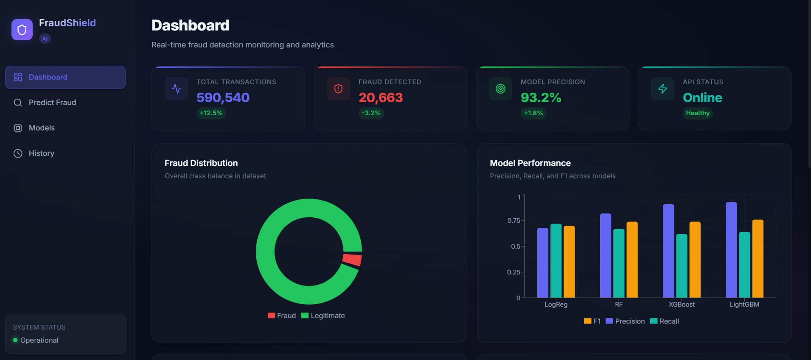
Figure 9.1 – FraudShield AI Production Dashboard: real-time KPI cards (Total Transactions, Fraud Detected, Model Precision, API Status), Fraud Distribution chart, and Model Performance comparison chart.

10. APPENDIX

10.1 Revision History
Version | Date | Description | Author
1.0 | April 1, 2026 | Initial SRS document – all sections drafted | Project Team

10.2 Future Enhancements (Out of Scope for v1.0)
- Autoencoder-based anomaly detection for unsupervised fraud discovery.
- LSTM / Transformer networks for sequence-based user behaviour modelling.
- Real-time streaming ingestion via Apache Kafka integration.
- MLOps pipeline with automated retraining, versioning (MLflow), and A/B testing.
- Ensemble stacking of XGBoost and LightGBM for improved precision.
- REST API (FastAPI/Flask) for real-time single-transaction scoring endpoint.

10.3 References
- IEEE Std 830-1998 – IEEE Recommended Practice for Software Requirements Specifications.
- Kaggle IEEE-CIS Fraud Detection Dataset – https://www.kaggle.com/c/ieee-fraud-detection
- Chen, T. & Guestrin, C. (2016). XGBoost: A Scalable Tree Boosting System. KDD 2016.
- Lundberg, S. & Lee, S.I. (2017). A Unified Approach to Interpreting Model Predictions. NeurIPS 2017.
- Ke, G. et al. (2017). LightGBM: A Highly Efficient Gradient Boosting Decision Tree. NeurIPS 2017.

