Project Design Phase
Solution Architecture

Date | 13 July 2026
Team ID
Project Name | Book A Doctor – Online Healthcare Appointment Booking Platform
Maximum Marks | 4 Marks

Solution Architecture:
Solution architecture is a complex process – with many sub-processes – that bridges the gap between business problems and technology solutions. Its goals are to:
- Find the best tech solution to solve existing business problems.
- Describe the structure, characteristics, behavior, and other aspects of the software to project stakeholders.
- Define features, development phases, and solution requirements.
- Provide specifications according to which the solution is defined, managed, and delivered.

Example - Solution Architecture Diagram:


Figure 1: Architecture and data flow of the voice patient diary sample application
Reference: https://aws.amazon.com/blogs/industries/voice-applications-in-clinical-research-powered-by-ai-on-aws-part-1-architecture-and-design-considerations/

Our Solution Architecture: Book A Doctor
The application follows a 3-tier MERN architecture: a React.js single-page front end, a Node.js/Express.js REST API layer with role-based middleware, and a MongoDB data store, with a separate file storage layer for uploaded documents.
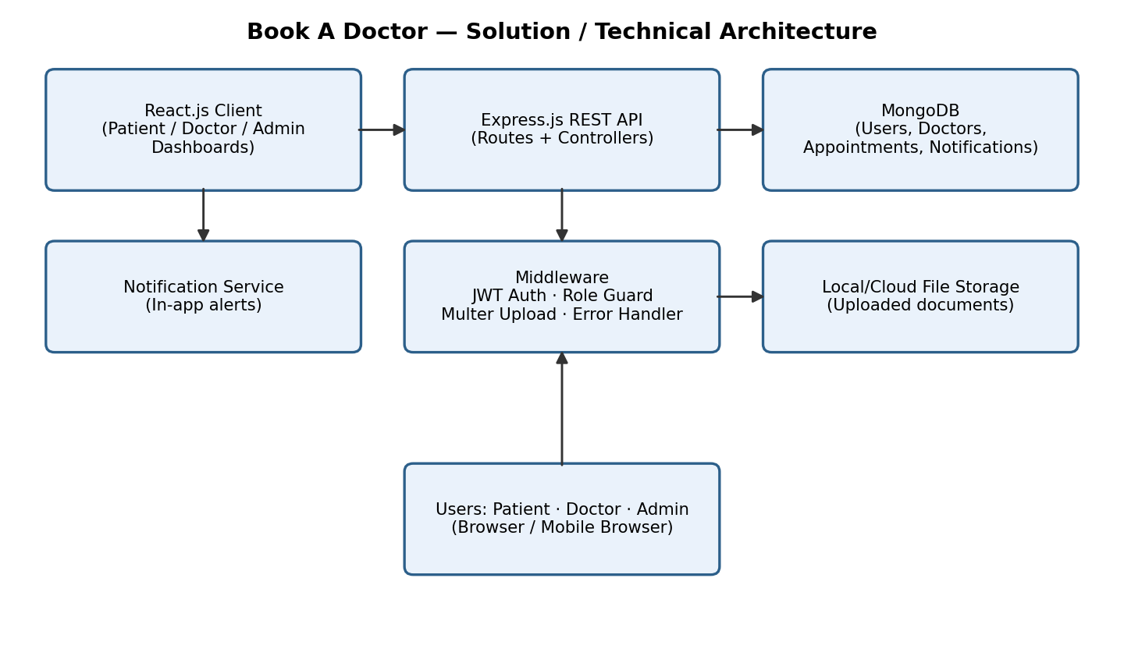
Figure: Architecture and data flow of the Book A Doctor application

Architecture Layers
Layer | Details
Presentation (Client) | React.js, React Router, Axios; pages for Login/Register, Doctor List/Profile, Patient Dashboard, Doctor Dashboard, Admin Dashboard, Notifications; AuthContext for session state.
Application (API) | Express.js routers (auth, doctors, appointments, notifications) mapped to controllers (authController, doctorController, appointmentController, notificationController).
Middleware | authMiddleware (JWT verification & role guard), uploadMiddleware (Multer for document uploads), errorMiddleware (centralized error handling).
Data (Database) | MongoDB via Mongoose models: User, Doctor, Appointment, Notification, with indexes on doctor/date/timeSlot and specialization for fast queries.
File Storage | Uploaded patient documents (reports/prescriptions) stored on disk (backend/uploads) in development; can be swapped for cloud object storage (e.g. S3) in production.
Security | JWT-based authentication, bcrypt password hashing, role-based access control for Patient/Doctor/Admin routes.

