Project Design Phase-II
Data Flow Diagram & User Stories

Date | 13 July 2026
Team ID
Project Name | Book A Doctor – Online Healthcare Appointment Booking Platform
Maximum Marks | 4 Marks

Data Flow Diagrams:
A Data Flow Diagram (DFD) is a traditional visual representation of the information flows within a system. A neat and clear DFD can depict the right amount of the system requirement graphically. It shows how data enters and leaves the system, what changes the information, and where data is stored.
Example: DFD Level 0 (Industry Standard)
Example: (Simplified)
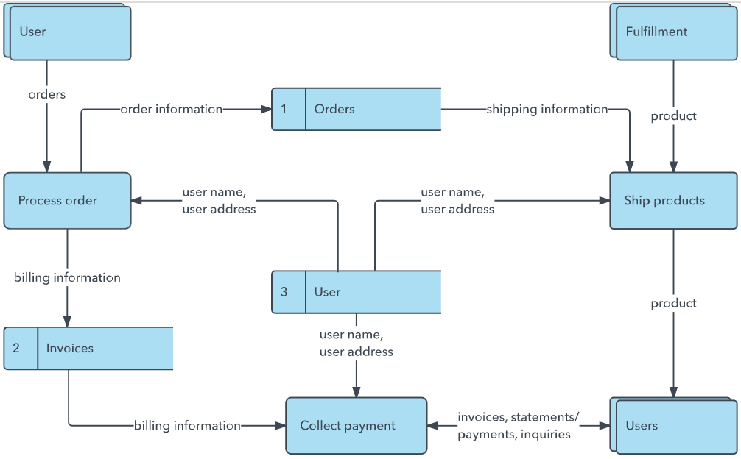


Our Data Flow Diagram (Level-0)
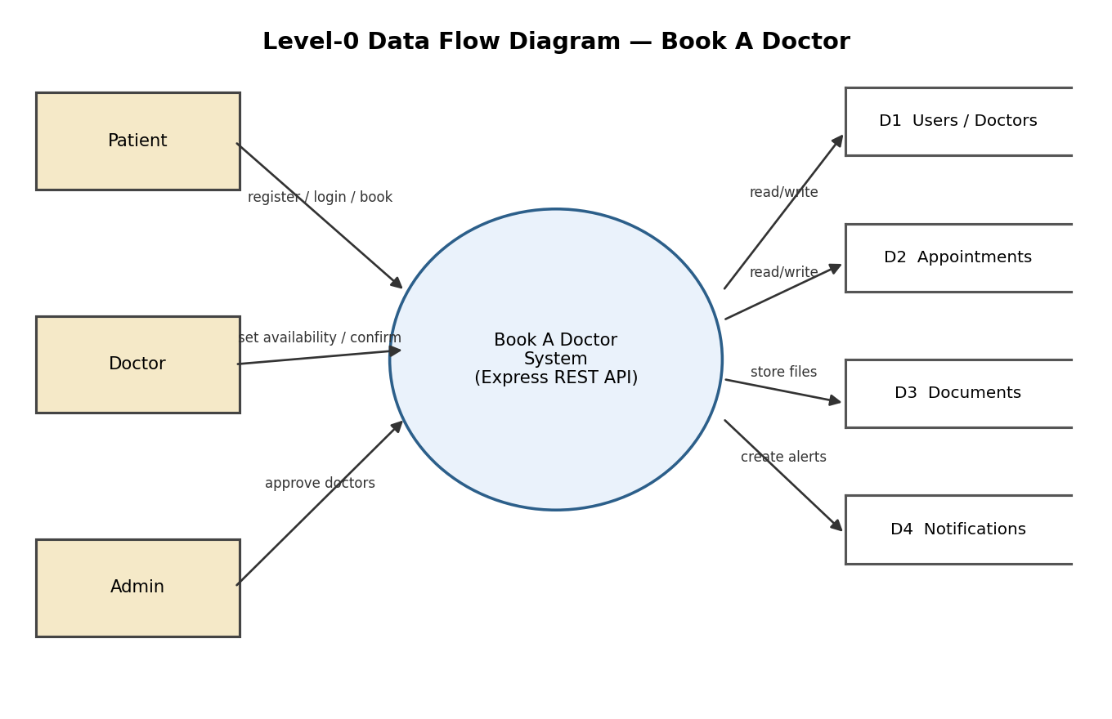

User Stories
Use the below template to list all the user stories for the product.
User Type | Functional Requirement (Epic) | User Story Number | User Story / Task | Acceptance criteria | Priority | Release
Patient | Registration | USN-1 | As a patient, I can register by entering my name, email, password and phone number. | I can log in immediately after successful registration | High | Sprint-1
Patient |  | USN-2 | As a patient, I receive a JWT token on successful login so I stay authenticated. | Token is stored and attached to subsequent API requests | High | Sprint-1
Patient | Doctor Discovery | USN-3 | As a patient, I can search and filter doctors by name or specialization. | Matching doctors are displayed with profile summary | High | Sprint-2
Patient |  | USN-4 | As a patient, I can view a doctor's full profile including fee, qualifications and availability. | Profile page loads doctor details and open time slots | High | Sprint-2
Patient | Appointment Booking | USN-5 | As a patient, I can book an appointment for an available date & time slot. | Appointment is created with status 'pending' and visible in my dashboard | High | Sprint-3
Patient |  | USN-6 | As a patient, I can upload a report/prescription document to my appointment. | Document appears in the appointment's document list | Medium | Sprint-3
Patient | Notifications | USN-7 | As a patient, I receive a notification when my appointment is confirmed, declined or completed. | Notification appears in my notification list | Medium | Sprint-4
Doctor | Doctor Profile | USN-8 | As a doctor, I can update my profile (specialization, qualifications, fee, availability). | Changes are reflected on my public profile | High | Sprint-2
Doctor | Appointment Management | USN-9 | As a doctor, I can view all appointments booked with me. | My dashboard lists appointments with patient details | High | Sprint-3
Doctor |  | USN-10 | As a doctor, I can confirm, decline, or mark an appointment as completed, and add consultation notes. | Appointment status updates and patient is notified | High | Sprint-3
Administrator | Doctor Governance | USN-11 | As an admin, I can view all registered doctors and approve or revoke their accounts. | Only approved doctors are visible/bookable by patients | High | Sprint-4
Administrator | Platform Oversight | USN-12 | As an admin, I can view all appointments across the platform. | Admin dashboard lists every appointment with status | Medium | Sprint-4

