**Remote Healthcare Monitoring System**

**Dataset description:**

The dataset comprises health readings collected from individuals across different age groups, including children, adults, and the elderly. Data was gathered using sensors that track body temperature and heart rate. Each record in the dataset captures an individual's age group, temperature, heart rate, and the associated health condition based on certain predefined thresholds. This collection of data points enables us to assess and identify health conditions such as fever, hypothermia, hypertension, and hypotension, all of which are categorized according to the guidelines provided by the World Health Organization.

The columns in this dataset are as follows:

1. Timestamp
2. Age
3. Temperature
4. BPM
5. Raw pulse sensor value
6. Condition
7. Status

**Dataset Collection:**

a. Instruments:

* Temperature Sensor (DS18B20): Gives a real-time temperature reading.
* Pulse Sensor (SEN-11574): Gives heart rate in beats per minute (BPM).
* ESP WROOM 32 Microcontroller
* ThingSpeak Cloud Platform: To store the data for our project.

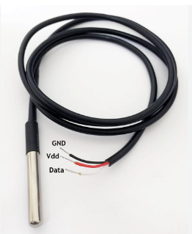 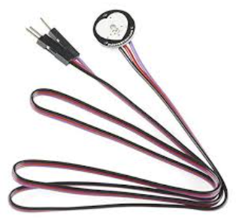

b. Surveys:

* Age Group Survey: We conducted surveys with different age groups—children, adults, and elderly people. This helped us understand how temperature and heart rate vary across ages and identify which health conditions commonly appear in each group.
* Common Health Conditions: From the survey, we discovered that the most common issues associated with temperature and heart rate were fever, hypothermia (low body temperature), hypotension (low blood pressure), and hypertension (high blood pressure).

c. Experiments and Interviews:

* Prototype Testing: We tested our setup on different people, including our hostel wardens, friends, and some children. During each test, we recorded temperature and heart rate readings and saved this data in Microsoft Excel.
* Interviews: After collecting the data, we spoke to each person to learn more about their health conditions and lifestyle. This helped us understand the reasons behind their readings and allowed us to make informed conclusions about certain health conditions.

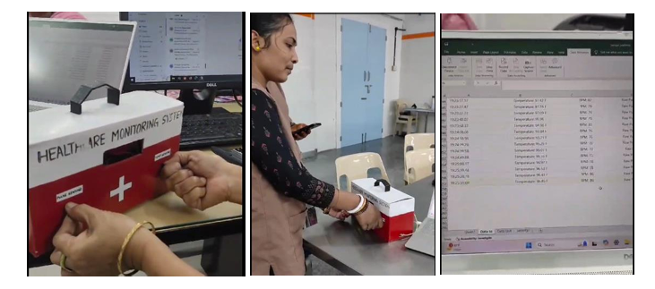

d. Archival Research for Threshold Determination:

* We referred to WHO to determine a temperature and a pulse threshold for all the different health conditions like Fever, hypothermia, hypertension, hypotension.
* Fever: Body temperature above 100.4°F.
* Hypothermia: Body temperature below 95°F.
* Hypertension: Blood pressure ≥ 80 mmHg.
* Hypotension: Blood pressure < 60 mmHg.

e. Data Storage and Access: From a thing speak channel used only for our project.

