Multimodal Fusion for Early Screening of Gestational Diabetes Mellitus and Fetal Macrosomia Using Digital Twins
R. Nirmalan, Assistant Professor (Sr.G)
G. A. Srivarsha
P. Sankari
Department of Artificial Intelligence and Data Science, Mepco Schlenk Engineering College, Sivakasi, India
Abstract — Gestational diabetes mellitus (GDM) and fetal macrosomia are usually identified after mid-pregnancy. This paper presents MDT-GEN, a maternal–fetal digital-twin framework for early risk assessment that combines booking-time prediction, a two-stage macrosomia pathway, and fetal abdominal circumference (AC) measurement. The GDM and macrosomia models use ten variables available at the first antenatal visit and exclude diagnostic glucose and delivery outcomes. On an internal held-out set of 4,698 women from one hospital, the GDM model achieved an area under the receiver operating characteristic curve (AUROC) of 0.712 (95% confidence interval [CI], 0.684–0.738), a Brier score of 0.071, and a calibration slope of 0.96. The macrosomia model achieved an AUROC of 0.639 (95% CI, 0.611–0.667) and had a calibration slope of 1.30. On 83 expert-referenced ultrasound sweeps from 42 held-out women, automated AC measurement had a mean absolute error of 10.7 mm (95% CI, 8.5–13.1) and a mean bias of −4.9 mm. Training on synthetic records did not generalize to real held-out records (AUROC, 0.504). A neural ordinary differential equation (ODE) trajectory model did not predict fasting glucose better than the cohort mean (R² = −2.20) and is presented for illustration only. Because the maternal and ultrasound cohorts are unlinked, modules were evaluated separately; external and prospective validation remain necessary.
Index Terms — Gestational diabetes mellitus, fetal macrosomia, digital twins, clinical prediction, fetal biometry.

I. Introduction
Gestational diabetes mellitus (GDM) is hyperglycaemia first recognised in pregnancy. It is diagnosed with the 75 g oral glucose tolerance test (OGTT), using the thresholds set by the International Association of Diabetes and Pregnancy Study Groups (IADPSG) [1]. The Hyperglycemia and Adverse Pregnancy Outcome (HAPO) study showed that adverse outcomes rise continuously with maternal glucose, including birthweight above the 90th centile [2]. Fetal macrosomia, commonly defined as birthweight ≥ 4000 g, raises the risk of shoulder dystocia, caesarean delivery and neonatal hypoglycaemia [3].
Both conditions are usually detected late. The OGTT is offered at 24–28 weeks, and suspected overgrowth is confirmed by third-trimester ultrasound biometry [13]. A risk estimate available at the first antenatal (booking) visit, around 12 weeks, could target earlier testing, lifestyle advice and growth surveillance at the women most likely to benefit.
Machine learning (ML) models for early GDM and macrosomia prediction are increasingly reported [4], [6], [7]. However, a recent systematic review found that few GDM models are externally validated, and that calibration is often poorly reported [5].
Three problems are common in this literature:
- Target leakage. Models that include OGTT glucose report near-perfect accuracy because the predictor is the diagnostic test itself.
- Uncalibrated probabilities. Re-weighting the rare class improves recall but inflates every predicted risk, so a displayed “40% risk” does not mean 40%.
- Unvalidated fusion. Maternal records and ultrasound images usually come from different cohorts, so a combined score cannot be validated.
Digital twins offer a natural frame for antenatal care. A patient-specific model starts from booking data and is updated as new measurements arrive [8], [9]. Continuous-time neural ordinary differential equations (Neural ODEs) [10] can represent physiological trajectories between visits. Generative models such as CTGAN [24] can produce synthetic cohorts for sharing. These components still need to be judged against data that can actually validate them.
This paper presents MDT-GEN, a multimodal maternal–fetal digital twin built around the principle that every displayed output is either validated on held-out data or explicitly labelled as unvalidated. The contributions are:
- Leakage-safe booking-visit models for GDM and macrosomia. The GDM model was well calibrated; the macrosomia model had a calibration slope of 1.30.
- A two-stage macrosomia pathway. The booking-model estimate is used as the pre-test probability, with caution because its calibration slope is 1.30.
- An automated abdominal circumference (AC) measurement pipeline for ACOUSLIC-AI blind-sweep ultrasound [18], [19], evaluated once on a subject-level held-out test set (42 women, 83 reference sweeps) and compared with the published results of the three ACOUSLIC-AI challenge winners.
- A held-out audit of the Neural ODE trajectory component. The audit shows that, with one glucose value per woman, the simulated glucose dynamics cannot be validated, so the trajectories are presented as illustrative.
Section II reviews related work. Section III describes the method, and Section IV the datasets. Section V reports results, Section VI the ablations, and Section VII the discussion. Section VIII concludes.

II. Related Works

A. GDM Diagnosis and Early Prediction
The IADPSG consensus defined OGTT glucose thresholds for GDM [1], building on the HAPO evidence of a continuous glucose–outcome relationship [2]. Current guidance offers testing at 24–28 weeks [3], [40].
Recent ML studies predict GDM before the OGTT from maternal characteristics and early laboratory values. Zaky et al. [4], for example, reported ML models for early GDM detection. Seifu et al. [5] pooled externally validated GDM models and found moderate discrimination, frequent miscalibration and incomplete reporting. MDT-GEN addresses these points directly: it excludes diagnostic glucose, reports calibration, and fixes decision thresholds before testing.

B. Macrosomia Prediction and Ultrasound Biometry
ML models for macrosomia have been developed at different stages of pregnancy. Liu et al. [6] showed that accuracy improves as later-pregnancy data become available. Wang et al. [7] built an explainable model for a Han Chinese cohort.
In clinical practice, macrosomia is suspected from third-trimester ultrasound. In a systematic review of 63 accuracy studies, Coomarasamy et al. [27] found that AC ≥ 36 cm and EFW ≥ 4000 g had similar accuracy for predicting birthweight > 4000 g, with summary ROC areas of 0.85 and 0.87. Positive results were better at ruling macrosomia in than negative results were at ruling it out.
EFW formulas include the AC-only Hadlock [16] and Campbell–Wilkin [17] equations and the four-parameter Hadlock model [38]. Fetal growth standards are given by INTERGROWTH-21st [11], [12] and ISUOG guidance [13]. Choi et al. [14] proposed simple median formulae for fetal biometry, including median AC (cm) ≈ GA (weeks) − 5. Sonographer interobserver limits of agreement for AC are about ±21 mm or ±9.1% of the mean [15], [18], which sets a practical benchmark for automated measurement.

C. Automated Abdominal Circumference Measurement
U-Net [21] and Attention U-Net [22] are standard architectures for medical image segmentation. Jang et al. [20] estimated AC automatically from standard-plane images. The ACOUSLIC-AI challenge [18], [19] moved the task to blind, operator-agnostic sweeps from low-resource settings. Each case has six sweeps of 140 frames at 0.28 mm/pixel, plus expert reference AC per sweep. The public training set (300 cases) comes from Sierra Leone; the hidden test set (282 cases) comes from two Tanzanian health units and a Dutch hospital [18]. The three winning entries used multi-model pipelines: A1 an ensemble of nine VGG-encoder U-Nets with a frame-suitability head, A2 a 2.5-D U-Net with a ConvNeXt-V2 encoder, and A3 five ResNet50 frame classifiers followed by nnU-Net [18]. Each selects one frame per case and needed 123–549 s per case on an RTX 2080 Ti GPU [18]. Ellipse perimeters are usually computed with Ramanujan’s approximation [23].

D. Digital Twins and Continuous-Time Models
Digital twins in medicine are patient-specific computational models updated with new data [8]. A scoping review found that most health digital twins remain at the prototype stage, and that their validation is often limited [9]. Neural ODEs [10] model latent dynamics in continuous time and naturally handle irregular visits, but learning their dynamics requires repeated measurements.

E. Synthetic Data and Privacy
CTGAN [24] models mixed-type tabular data with conditional generation and mode-specific normalisation. Synthetic records can still leak membership information [25]. Distance-to-closest-record (DCR) measures should therefore be paired with attack-based assessments [26].

F. Reporting and Evaluation Standards
TRIPOD+AI [33] and PROBAST+AI [34] set expectations for reporting prediction models and assessing their risk of bias. Calibration has been called the Achilles heel of predictive analytics [35]. Decision-curve analysis [36] and the Brier score [37] complement discrimination metrics. The base learners used here are random forest [28], XGBoost [29], CatBoost [30] and stacked generalisation [31], with explanations from SHAP [32].

III. Proposed Approach

A. Model Overview
MDT-GEN has five components. Fig. 1 shows how they connect.
- Booking-risk module. Stacked models for GDM and macrosomia, using ten booking predictors; GDM calibration was good, while macrosomia calibration was weaker.
- Two-stage macrosomia pathway. A Bayesian update of the booking risk using a published ultrasound criterion.
- Fetal biometry module. Attention U-Net segmentation of ACOUSLIC-AI sweeps, ellipse fitting and AC in millimetres.
- Trajectory module. A patient-conditioned Neural ODE that simulates fasting glucose, BMI and systolic blood pressure from week 12 to week 40.
- Synthetic-cohort module. CTGAN trained on the booking predictors, with a fidelity, utility and privacy audit.
The twin state is a late-fusion record. It holds the booking predictors, the validated risks and the latest fetal biometry. Because the maternal and ultrasound datasets are not linked, no learned fusion score is computed.

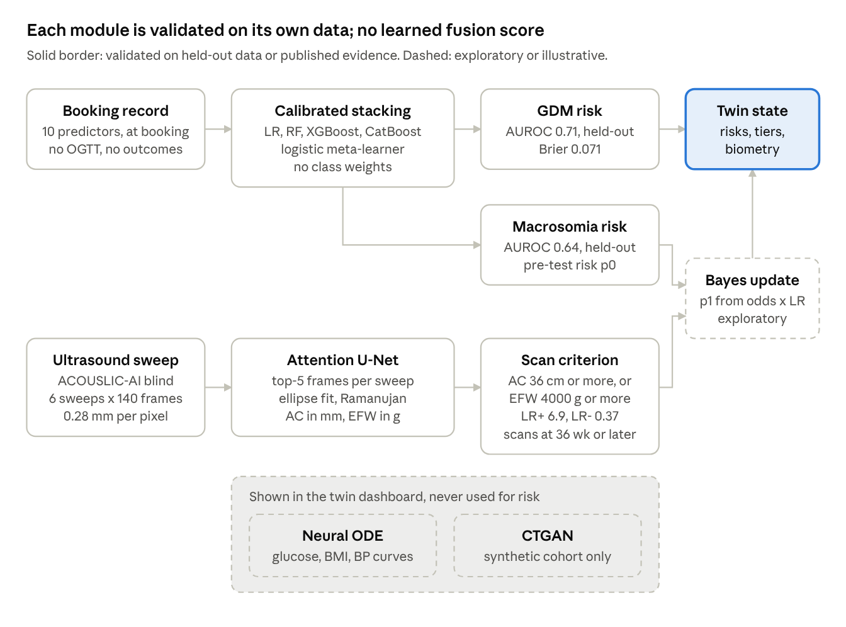
Fig. 1. MDT-GEN architecture · validated paths (solid) and exploratory or illustrative parts (dashed)

The booking record feeds both risk models. A late scan contributes only through a published criterion. The Neural ODE and CTGAN are displayed but never enter a risk estimate.

B. Feature Representation and Leakage Guards
Let the cohort be
$$D=\{\left(x_{n},y_{n}\right)\}_{n=1}^{N}$$
$$x_{n}∈R^{9}×E$$
where 𝓔 is the set of ethnicity categories and yₙ ∈ {0, 1} is the outcome. For GDM, y = 1 if GDM was diagnosed. For macrosomia, y = 1 if birthweight was ≥ 4000 g.
The ten predictors are all available at booking:
- maternal age
- gestational age at booking
- booking BMI
- gravidity
- parity
- number of previous caesarean sections
- Index of Multiple Deprivation (IMD) rank
- systolic blood pressure
- diastolic blood pressure
- ethnicity
Three groups of variables are excluded by an explicit guard in the code: OGTT glucose, the GDM diagnosis (when macrosomia is the outcome), and all delivery or neonatal variables.
Implausible values are set to missing before training:
- booking gestational age outside 4–42 weeks
- gravidity > 20
- systolic blood pressure outside 70–250 mmHg
- diastolic blood pressure outside 30–150 mmHg
Blood pressure was unrecorded for about 60% of women, so a missingness indicator is added for each blood-pressure variable. Within each training fold, numeric features are median-imputed and standardised, and ethnicity is one-hot encoded.

C. Calibrated Stacking Ensemble
Four base learners are trained: logistic regression, random forest [28], XGBoost [29] and CatBoost [30]. On the training set, 5-fold stratified cross-validation produces out-of-fold (OOF) probabilities p̂ⱼ(x) for base learner j = 1,…,4. A logistic meta-learner combines them [31]:
$$\hat{p}\left(x\right)=σ\left(β_{0}+\sum_{j=1}^{4}{β_{j}} {\hat{p}}_{j}\left(x\right)\right)$$
$$σ\left(u\right)=\frac{1}{1+e^{-u}}$$
The base learners are then refitted on the full training set. No class re-weighting is applied, but this alone does not guarantee calibrated probabilities.
Calibration is assessed by logistic recalibration on the held-out set. A slope b = 1 and an intercept a = 0 (estimated with the slope fixed at 1) indicate perfect calibration [35]:
$$logitP\left(y=1∣\hat{p}\right)=a+b logit\left(\hat{p}\right)$$
Overall accuracy is measured by the Brier score [37] and the scaled Brier score. A scaled Brier score above 0 means the model beats a constant prediction equal to the prevalence π:
$$BS=\frac{1}{N}\sum_{n=1}^{N}{{\left({\hat{p}}_{n}-y_{n}\right)}^{2}}$$
$$BS_{\text{scaled}}=1-\frac{BS}{π\left(1-π\right)}$$
The operating threshold τ is fixed before testing. It is the 80th percentile of the OOF stacked probabilities, so the top 20% of women at booking are flagged. Youden’s J on the OOF predictions is reported as a secondary threshold. Clinical usefulness is summarised by net benefit across thresholds [36]:
$$NB\left(p_{t}\right)=\frac{TP}{N}-\frac{FP}{N}⋅\frac{p_{t}}{1-p_{t}}$$

D. Two-Stage Macrosomia Pathway
Stage 1 is the booking model estimate for macrosomia, p₀ = p̂(x). Its mean prediction matches prevalence, but the calibration slope (1.30) indicates that individual probabilities remain imperfectly calibrated.
Stage 2 applies a published ultrasound criterion to a third-trimester scan [27]:
- If HC, BPD and FL are available, the four-parameter Hadlock EFW [38] is used, with the criterion EFW ≥ 4000 g (LR⁺ = 5.7, LR⁻ = 0.48).
- Otherwise, the criterion is AC ≥ 36 cm (LR⁺ = 6.9, LR⁻ = 0.37).
Only one criterion is applied, because AC and EFW are strongly correlated. The criterion is applied only to scans at ≥ 36 weeks. This is a conservative project rule, because the pooled studies evaluated prediction of birthweight close to delivery.
The post-test probability follows from Bayes’ rule in odds form:
$$\frac{p_{1}}{1-p_{1}}=\frac{p_{0}}{1-p_{0}}×LR$$
$$p_{1}=\frac{{\text{odds}}_{0}⋅LR}{1+{\text{odds}}_{0}⋅LR}$$
This combination assumes that the published likelihood ratios transfer to this population and do not depend on the booking predictors. It is therefore reported as exploratory.
The pathway assigns three tiers:
- High: the Stage 2 criterion is positive.
- Moderate: Stage 1 flags the woman (top 20% of booking risk) and Stage 2 is not positive. A growth scan is advised.
- Low: neither.
The median AC for gestational age from Choi et al. [14] (ACₘₑd = GA − 5 cm, valid for 20–40 weeks) is shown as descriptive context only.

E. Fetal Abdominal Circumference Biometry
The segmentation network is an Attention U-Net [22] with 7.86 M parameters. It has five encoder levels (32–512 channels), additive attention gates on the skip connections, and a single-channel output. Inputs are grayscale frames resized to 320 × 416.
Training uses annotated frames plus a random 20% of empty frames per case, with flips, rotation (±15°), scaling, gamma, contrast and noise augmentation. The loss is binary cross-entropy plus soft Dice. AdamW (learning rate 3 × 10⁻⁴, weight decay 10⁻⁴) with cosine annealing runs for 50 epochs at batch size 16 with mixed precision on one NVIDIA T4 GPU. The checkpoint with the best validation Dice (0.924, epoch 24) is kept. The frame-selection rule below was fixed before training and was not tuned on the test set.
For one sweep of F = 140 frames, each frame i yields a probability map Pᵢ. Thresholding at 0.5 and keeping the largest connected component (≥ 2,000 pixels) gives a mask Mᵢ. The frame confidence is the mean probability inside the mask:
ci=1Miu∈Mi​Piu
The five most confident frames are kept. For each one, the probability map is resized to the original 562 × 744 resolution and a least-squares ellipse is fitted to the outer contour. With full axis lengths w and h (in pixels) and pixel spacing s read from the image header, the semi-axes are a = s·w/2 and b = s·h/2. The perimeter follows Ramanujan’s first approximation [23]:
$$AC_{i}=π\left[ 3\left(a+b\right)-\sqrt{\left(3a+b\right)\left(a+3b\right)} \right]$$
The sweep AC is the median of the five ACᵢ values.
For single frames, the AC-only Hadlock EFW (AC in cm) [16] is also reported:
$$ln\left(EFW_{g}\right)=2.695+0.253 AC-0.00275 AC^{2}$$

F. Continuous-Time Trajectory Simulation
An encoder maps the booking predictors to a latent vector h ∈ ℝ³². A projector sets the initial state z(t₀) = g(x, h), where z holds fasting glucose (mmol/L), BMI (kg/m²) and systolic blood pressure (mmHg). The dynamics are rate-bounded:
$$\frac{dz}{dt}=r⊙tanh\left(f_{θ}\left(z\left(t\right), t/40, h\right)\right)$$
$$r=\left(0.08, 0.25, 0.50\right) \text{per week}$$
The system is integrated with fourth-order Runge–Kutta from week 12 to week 40. During training, the initial state is fitted to the observed values. The cohort has a single glucose value per woman (the fasting OGTT value), so the slope of each trajectory has no direct supervision. Section V-E tests this.

G. Synthetic Cohort Generation
CTGAN [24] is trained on the ten booking predictors and the GDM label. It uses mode-specific normalisation and PacGAN discrimination (pac = 10). The synthetic data are assessed for correlation fidelity and train-synthetic-test-real (TSTR) utility. Privacy is not formally tested here; distance-based checks and membership-inference attacks [25], [26] are left to future work. Synthetic records are not used to train the clinical models.

H. Algorithms
Algorithm 1 — Training the booking models
- Load the fixed 80/20 split. Apply the leakage guard and the data-quality rules.
- For each fold k = 1,…,5: fit the preprocessor on the training folds, train the four base learners, and store OOF probabilities.
- Fit the logistic meta-learner on the OOF probability matrix.
- Set τ to the 80th percentile of the OOF stacked probabilities.
- Refit the preprocessor and base learners on all training data.
- Score the held-out set once. Report discrimination, calibration, Brier score, net benefit and SHAP, with 1,000 bootstrap resamples.
Algorithm 2 — Two-stage macrosomia inference
- Compute p₀ with the booking model. Flag the woman if p₀ ≥ τ.
- If a scan at ≥ 36 weeks is available, select the EFW criterion (if HC, BPD and FL are present) or the AC criterion, and obtain the matching LR.
- Compute p₁ with the odds-form Bayes rule.
- Assign the tier (High, Moderate or Low) and report p₀, p₁ and the criterion used.

IV. Dataset Description
Three datasets are used, each for the component it can validate: a maternity cohort for the booking models, ACOUSLIC-AI for AC measurement, and a synthetic longitudinal cohort for the Neural ODE method benchmark.

A. Maternal Cohort (St Mary’s Hospital GDM Dataset)
The maternal data are the anonymised electronic health records described by Jeyaparam and Agha-Jaffar [41]. This retrospective observational study used CERNER records for pregnancies monitored at St Mary’s Hospital, London, from April 2016 to November 2019. The initial search identified 26,063 patients. The dataset includes postcode, height, weight, booking BMI, self-reported ethnicity, parity, whether a 75-g oral glucose tolerance test (OGTT) was offered, and glucose measurements at 0 and 120 minutes after the glucose load. Other recorded variables include mode of delivery, estimated total blood loss, gestational age, neonatal birthweight, special care baby unit (SCBU) admission, length of stay after delivery, fetal sex, and stillbirth. The dataset documentation states that records missing one or more key variables were removed without imputation during the original preparation. Unit inconsistencies were corrected, and significant outliers were adjusted or excluded when original records could not be reviewed.
Following the source-level preparation, records without a GDM outcome were excluded for this analysis, leaving 23,490 women and 48 variables. The cohort is split once into training (80%) and test (20%) sets, stratified by GDM with seed 42. The same split is used for every booking-model experiment.
Table I summarises the cohort. Booking gestational age exceeded 12 weeks for about 23% of women, so the ≤ 12-week subgroup is reported separately. Fasting OGTT glucose was recorded for 72% of women overall: 99.9% of women with GDM but only about 70% of those without. Its missingness is therefore informative, which is one more reason to exclude it.
TABLE I
Maternal cohort: split and outcome prevalence
Split | Women | GDM, n (%) | Birthweight ≥ 4000 g, n (%) | LGA (birthweight centile ≥ 90), %
Training | 18,792 | 1,483 (7.89) | 1,506 (8.01) | —
Test | 4,698 | 371 (7.90) | 375 (7.98) | 11.88
Total | 23,490 | 1,854 (7.89) | 1,881 (8.01) | —
TABLE II
Missingness of booking predictors (whole cohort)
Predictor | Missing (%) | Handling
Diastolic blood pressure | 65.3 | median imputation + missingness flag
Systolic blood pressure | 58.9 | median imputation + missingness flag
Gestational age at booking | 9.1 | median imputation; out-of-range values set to missing
Age, BMI, gravidity, parity, previous caesarean sections, IMD rank, ethnicity | < 1 | median imputation (numeric); one-hot encoding (ethnicity)

B. ACOUSLIC-AI Blind-Sweep Ultrasound
ACOUSLIC-AI v1.1 [18], [19] provides 300 training cases from 281 subjects. Each case is one stacked volume of six blind sweeps × 140 frames, giving 840 frames of 744 × 562 pixels at 0.28 mm/pixel. Frame masks mark the fetal abdomen in optimal (label 1) and suboptimal (label 2) planes.
The circumference file gives an expert reference AC for 553 sweeps (1–6 per case; median 229.5 mm, range 140.9–350.6 mm). AC accuracy is evaluated only on cases not used to train the segmentation model. Subjects (women) were split 70/15/15 with seed 42, so no woman appears in more than one set: 207 training cases (197 women, 386 reference sweeps), 45 validation cases (42 women, 84 sweeps) and 48 test cases (42 women, 83 sweeps). Validation selects the checkpoint only, and the test set is scored once (Section V-F).

C. Synthetic Longitudinal Pregnancy Cohort
The maternal cohort has a single measurement per woman, so Neural ODE dynamics cannot be learned from it. To test the method itself, we use Pinto et al.’s synthetic low-risk pregnancy dataset [39] and its data descriptor [38]. The dataset is associated with Grupo de Investigação em Engenharia e Computação Inteligente para a Inovação e o Desenvolvimento. Version 1.0 contains 5,000 synthetic patient records representing longitudinal low-risk pregnancy trajectories. It has 162 variables in a wide format, covering preconception where applicable, antenatal consultations, trimester-specific assessments, delivery outcomes, puerperium, and early postnatal follow-up. Variable names encode the relevant clinical timepoints. For the benchmark, maternal weight is forecast at withheld third-trimester visits using first- and second-trimester observations, with 4,000 records for training and 1,000 for testing.
TABLE III
Summary of datasets and their role
Property | St Mary’s GDM Dataset | ACOUSLIC-AI v1.1 | Synthetic pregnancy cohort
Type | Real EHR, tabular | Real ultrasound sweeps | Synthetic, longitudinal
Size | 26,063 initially identified; 23,490 analyzed | 300 cases, 281 subjects | 5,000 synthetic records; 162 variables
Used for | GDM and macrosomia booking models; CTGAN; Neural ODE glucose audit | AC segmentation and agreement | Neural ODE method benchmark
Outcome or label | GDM; birthweight ≥ 4000 g | Abdomen mask; reference AC (mm) | Weight at later visits (kg)
Access | Figshare [41] | Zenodo [19] | Zenodo [39]
The maternal and ultrasound datasets come from different populations and cannot be linked at patient level. This is why MDT-GEN validates each module separately and computes no learned fusion score.

V. Experiments and Results
On 4,698 held-out women, the GDM model was well calibrated (slope 0.96). The macrosomia model matched the cohort prevalence on average but had a calibration slope of 1.30.

A. Experimental Setup
All booking-model experiments use the fixed split in Section IV-A. Thresholds and the meta-learner are fitted on out-of-fold training predictions, and the test set is scored once. Confidence intervals (CIs) come from 1,000 bootstrap resamples of the test set. Table IV lists the configuration. The code is in models/train_validated_booking_models.py.
TABLE IV
Configuration of the booking models
Item | Setting
Logistic regression | L2, max 2,000 iterations, no class weights
Random forest | 300 trees, depth 8, min. 20 samples per leaf
XGBoost | 300 trees, depth 3, learning rate 0.03, subsample 0.8, column sample 0.8
CatBoost | 400 iterations, depth 4, learning rate 0.03
Stacking | 5-fold stratified OOF probabilities → logistic meta-learner
Decision threshold | 80th percentile of OOF stacked risk (top 20% flagged)
Uncertainty | 1,000 bootstrap resamples; seed 42
Software | Python 3.13.7, scikit-learn 1.8.0, XGBoost 3.3.0, CatBoost 1.2.10

B. GDM Prediction at Booking
Table V shows held-out performance. All five GDM models are calibrated (intercept ≈ 0, slope 0.91–1.26). The stacking ensemble reaches an AUROC of 0.712 (95% CI 0.684–0.738) and an AUPRC of 0.166, against a prevalence of 0.079. Plain logistic regression performs similarly, with an AUROC of 0.714.

TABLE V
GDM: held-out performance (n = 4,698; 371 GDM)
Model | AUROC (95% CI) | AUPRC (95% CI) | Brier | Scaled Brier | Cal. intercept | Cal. slope | OOF AUROC
Logistic regression | 0.714 (0.686–0.742) | 0.171 (0.146–0.204) | 0.070 | 0.042 | 0.00 | 0.93 | 0.719
Random forest | 0.700 (0.673–0.726) | 0.158 (0.133–0.189) | 0.070 | 0.035 | 0.00 | 1.26 | 0.708
XGBoost | 0.704 (0.677–0.730) | 0.158 (0.135–0.190) | 0.070 | 0.036 | 0.01 | 0.91 | 0.713
CatBoost | 0.707 (0.680–0.734) | 0.158 (0.135–0.187) | 0.070 | 0.037 | 0.02 | 0.98 | 0.715
Stacking ensemble | 0.712 (0.684–0.738) | 0.166 (0.141–0.198) | 0.071 | 0.030 | 0.00 | 0.96 | 0.719

At the top-20% threshold (τ = 0.096), the model flags 20.0% of women. It detects 42.9% of GDM cases with a specificity of 82.0%, a PPV of 17.0% and an NPV of 94.4%. At the Youden threshold (τ = 0.063), sensitivity is 73.6% and specificity 59.6%.
The decision curve shows net benefit above both “test all” and “test none” for threshold probabilities between about 4% and 18%. In women booked at ≤ 12 weeks (n = 3,195), the AUROC is 0.711 (95% CI, 0.682–0.740) and the Brier score is 0.075.
Fig. 2 shows the ROC, precision–recall and decile calibration curves for all five models.

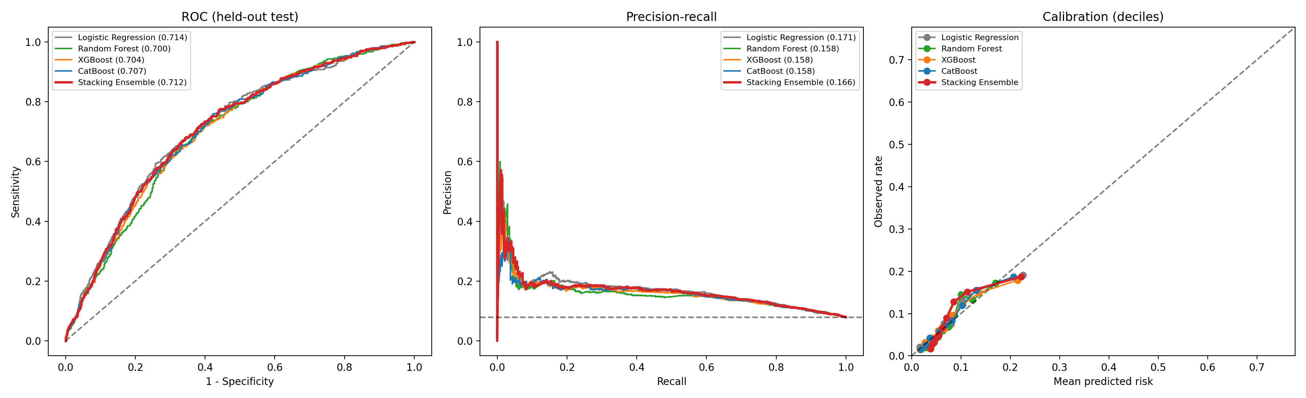
Fig. 2. GDM booking models on the held-out test set: ROC (left), precision–recall (centre) and decile calibration (right)

C. Macrosomia Prediction at Booking
Table VI shows that booking data predict birthweight ≥ 4000 g only modestly. The stacking AUROC is 0.639 (95% CI, 0.611–0.667), with an AUPRC of 0.124 against a prevalence of 0.080. The mean predicted risk matches the observed prevalence, but the calibration slope is 1.30.

TABLE VI
Macrosomia (birthweight ≥ 4000 g): held-out performance (n = 4,698; 375 cases)
Model | AUROC (95% CI) | AUPRC (95% CI) | Brier | Scaled Brier | Cal. intercept | Cal. slope | OOF AUROC
Logistic regression | 0.629 (0.602–0.657) | 0.122 (0.106–0.147) | 0.072 | 0.015 | 0.00 | 0.98 | 0.627
Random forest | 0.634 (0.605–0.662) | 0.124 (0.106–0.148) | 0.072 | 0.015 | 0.00 | 1.50 | 0.618
XGBoost | 0.633 (0.606–0.661) | 0.124 (0.106–0.149) | 0.072 | 0.016 | 0.01 | 1.01 | 0.626
CatBoost | 0.640 (0.612–0.667) | 0.123 (0.106–0.148) | 0.072 | 0.017 | 0.01 | 1.17 | 0.627
Stacking ensemble | 0.639 (0.611–0.667) | 0.124 (0.108–0.148) | 0.072 | 0.016 | 0.01 | 1.30 | 0.631

At the top-20% threshold (τ = 0.099), 19.2% of women are flagged. Sensitivity is 30.9%, specificity 81.9%, PPV 12.9% and NPV 93.2%. Net benefit exceeds both default strategies only for thresholds of about 5–15%. In women booked at ≤ 12 weeks, the AUROC is 0.625 (95% CI, 0.592–0.662).
This modest discrimination is the empirical reason for the two-stage design. The booking-model estimate serves as an exploratory pre-test probability; the model’s calibration slope is 1.30. Most of the discrimination is expected from the late ultrasound criterion (summary AUROC about 0.85 for AC ≥ 36 cm [27]).
For illustration only, a woman with a booking-model estimate p₀ = 10% and a positive AC criterion has p₁ = 43.4%; with a negative criterion, p₁ = 3.9%. The pathway has not been validated end to end.
Fig. 3 shows the corresponding curves for macrosomia, and Fig. 4 compares the decision curves of the two stacking models. Both give net benefit over “treat all” and “treat none” only at low threshold probabilities, below about 15–20%.

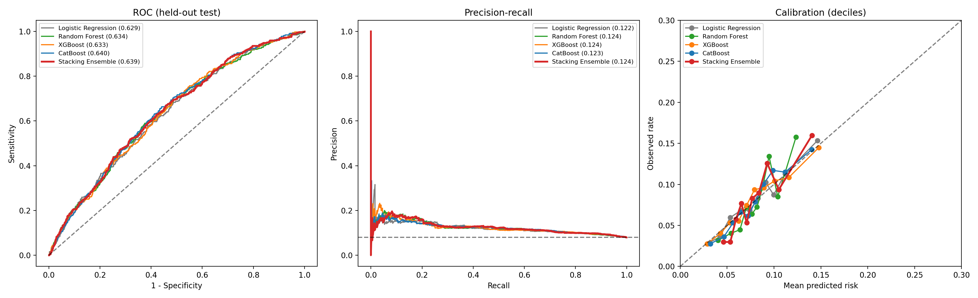
Fig. 3. Macrosomia booking models on the held-out test set: ROC (left), precision–recall (centre) and decile calibration (right)

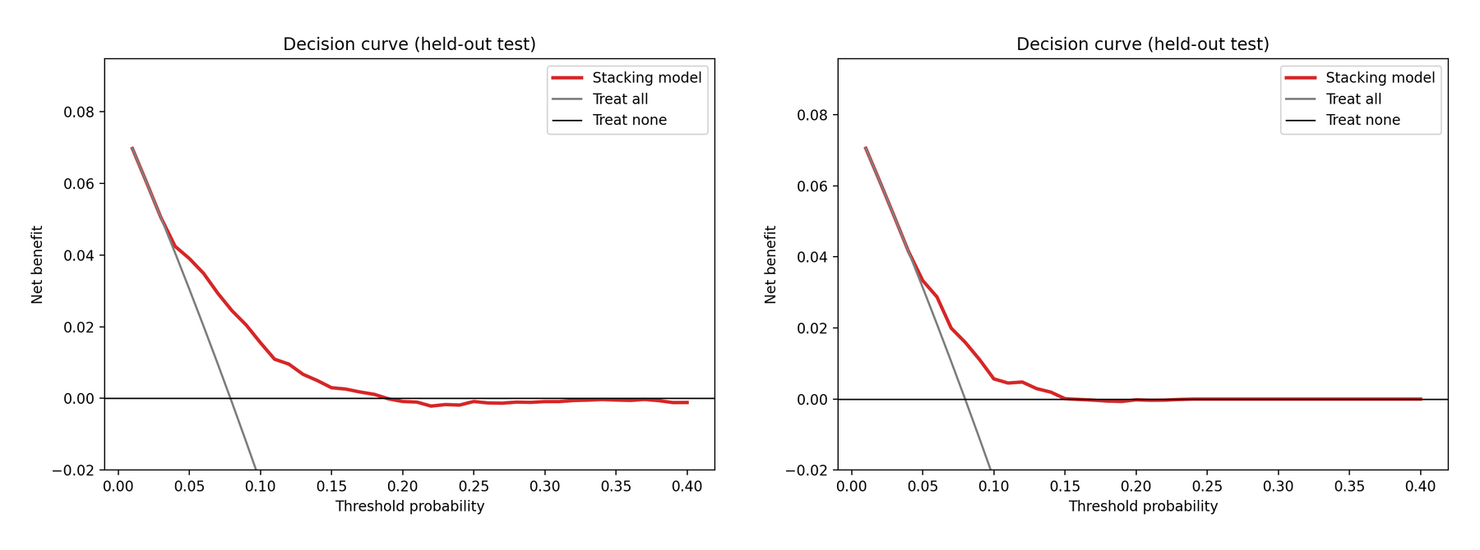
Fig. 4. Decision curves of the stacking models on the held-out test set: (a) GDM, (b) macrosomia

D. Explainability
Table VII lists the predictors with the largest mean |SHAP| values for the CatBoost base learner on the test set [32], and Fig. 5 shows the full SHAP summaries.

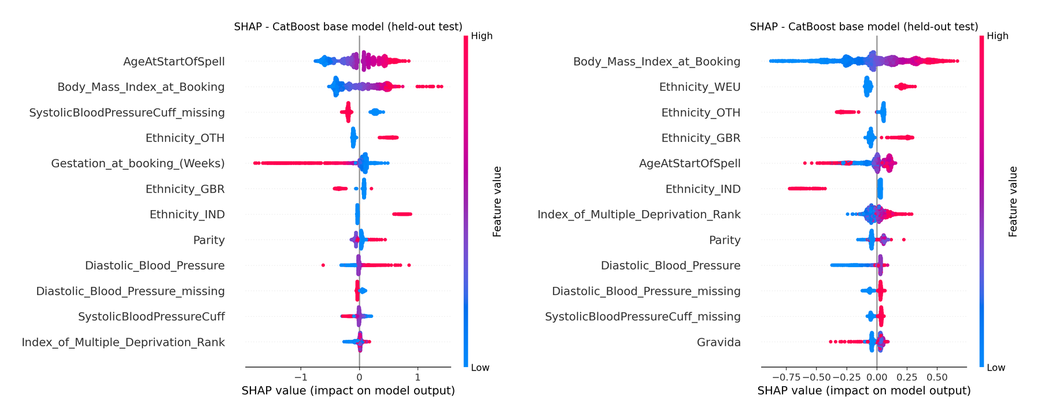
Fig. 5. SHAP summary of the CatBoost base learner on the held-out test set: (a) GDM, (b) macrosomia. Each point is one woman; colour shows the feature value

TABLE VII
Top predictors by mean |SHAP| (CatBoost, test set)
Rank | GDM | Mean abs. SHAP | Macrosomia | Mean abs. SHAP
1 | Maternal age | 0.316 | Booking BMI | 0.214
2 | Booking BMI | 0.303 | Ethnicity: Western European | 0.112
3 | Systolic BP not recorded | 0.225 | Ethnicity: Other | 0.088
4 | Ethnicity: Other | 0.170 | Ethnicity: British | 0.087
5 | Gestational age at booking | 0.146 | Maternal age | 0.081
6 | Ethnicity: British | 0.131 | Ethnicity: Indian | 0.054
Age and booking BMI had the largest mean absolute SHAP values for GDM; booking BMI ranked first for macrosomia [40].
Whether systolic blood pressure was recorded ranks third for GDM. This probably reflects recording practice, not physiology, and is discussed as a limitation.

E. Neural ODE Glucose Audit
The Neural ODE was evaluated on the one quantity with real ground truth: fasting OGTT glucose in held-out women who had an OGTT (n = 3,354; mean 4.35 mmol/L, SD 0.53). The OGTT week is not recorded, so the simulated curve was read at weeks 24, 26 and 28, the window recommended by NICE NG3 [40]. The model received booking predictors only, as on the dashboard.
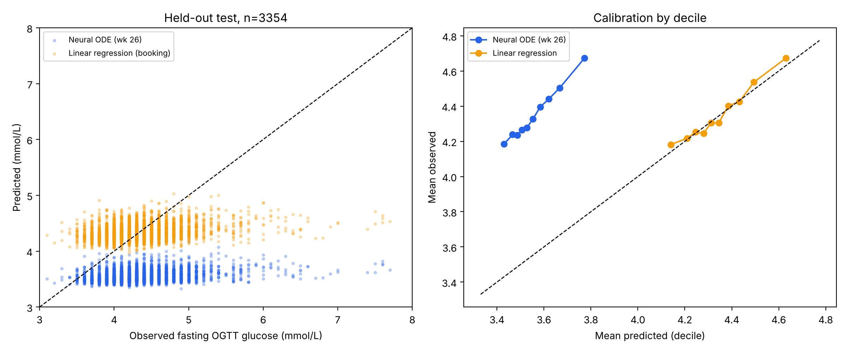
Fig. 6. Neural ODE glucose audit on held-out women with an OGTT: R² for predicting fasting OGTT glucose from the training mean, a linear model, and the Neural ODE read at weeks 12, 24, 26 and 28
The initial state (week 12) is about as informative as a linear regression on the same predictors: R² 0.057 vs 0.079, MAE 0.356 vs 0.344 mmol/L. The simulated trajectory then falls by 0.84 mmol/L from week 12 to week 26. At the OGTT window this gives MAE 0.80 mmol/L and R² −2.20 (95% CI −2.51 to −1.91), far worse than predicting the cohort mean.
With one glucose value per woman, the slope of the trajectory is never supervised. The model’s per-week GDM “risk” output (AUROC 0.70) has no time-specific ground truth and was removed. The trajectories are therefore presented as illustrative only.
On the synthetic longitudinal cohort [39], the same architecture forecasts withheld third-trimester weight with an MAE of 0.87 kg. Last observation carried forward gives 5.72 kg and linear extrapolation 3.15 kg. This supports the method when repeated measurements exist, not the clinical trajectories in this cohort.

F. Abdominal Circumference Agreement (held-out ACOUSLIC-AI cases)
AC agreement is computed on the 48 test cases (Section IV-B) after training is complete, using the same metric definitions as fetal/evaluate_ac_accuracy.py. The frozen pipeline runs unchanged on every test sweep that has an expert reference and reads pixel spacing from each image header. Each predicted sweep AC is compared with the reference.
Detection failures (a reference exists but no abdomen is found) are counted separately. Confidence intervals come from a cluster bootstrap over subjects. Published sonographer variability is shown for context, not used as a formal equivalence margin.
TABLE VIII
AC agreement on the subject-level held-out test set (48 cases, 42 women; 95% CI from cluster bootstrap over women, 2,000 resamples)
Metric (per sweep) | Value (95% CI)
Held-out cases / women / reference sweeps | 48 / 42 / 83
Detection failures, n (%) | 0 (0.0)
Mean absolute error (mm) | 10.7 (8.5–13.1)
Median absolute error (mm) | 8.1 (5.0–10.3)
RMSE (mm) | 14.6 (11.7–17.5)
Bias, predicted − reference (mm) | −4.9 (−8.0 to −2.2)
95% limits of agreement (mm) | −32.0 to +22.3
Proportional bias slope | −0.032 (−0.089 to 0.028)
Normalised absolute error | 0.045 (0.036–0.055)
Within ±8.8% of reference AC (%) | 83.1 (74.2–91.8)
Within ±10 mm (%) | 60.2 (49.4–70.9)
Per case (mean of sweeps, n = 48): MAE / bias (mm) | 8.8 / −6.5
Segmentation Dice, annotated test frames | 0.925
False-positive rate on empty test frames (%) | 23.0
Table VIII and Fig. 7 show the results. An abdomen was found in every test sweep. Test Dice (0.925) matched validation Dice (0.924), so the checkpoint did not overfit the validation set. Agreement does not depend on fetal size (proportional bias slope −0.03, CI includes 0), and the median error (8.1 mm) is lower than the mean because a few sweeps have large errors. Five of 83 sweeps, from five women, differed by more than 25 mm (largest −53 mm). The model slightly underestimates AC on average. 23% of empty frames gave a false-positive mask. Choosing the five most confident frames limits the effect on the AC value, but per-frame overlays shown on the dashboard can include these false positives.
An earlier figure of 7.14 mm on 36 sweeps came from cases that also selected the checkpoint, and seven of them came from women in the training set. It is superseded by the result above.

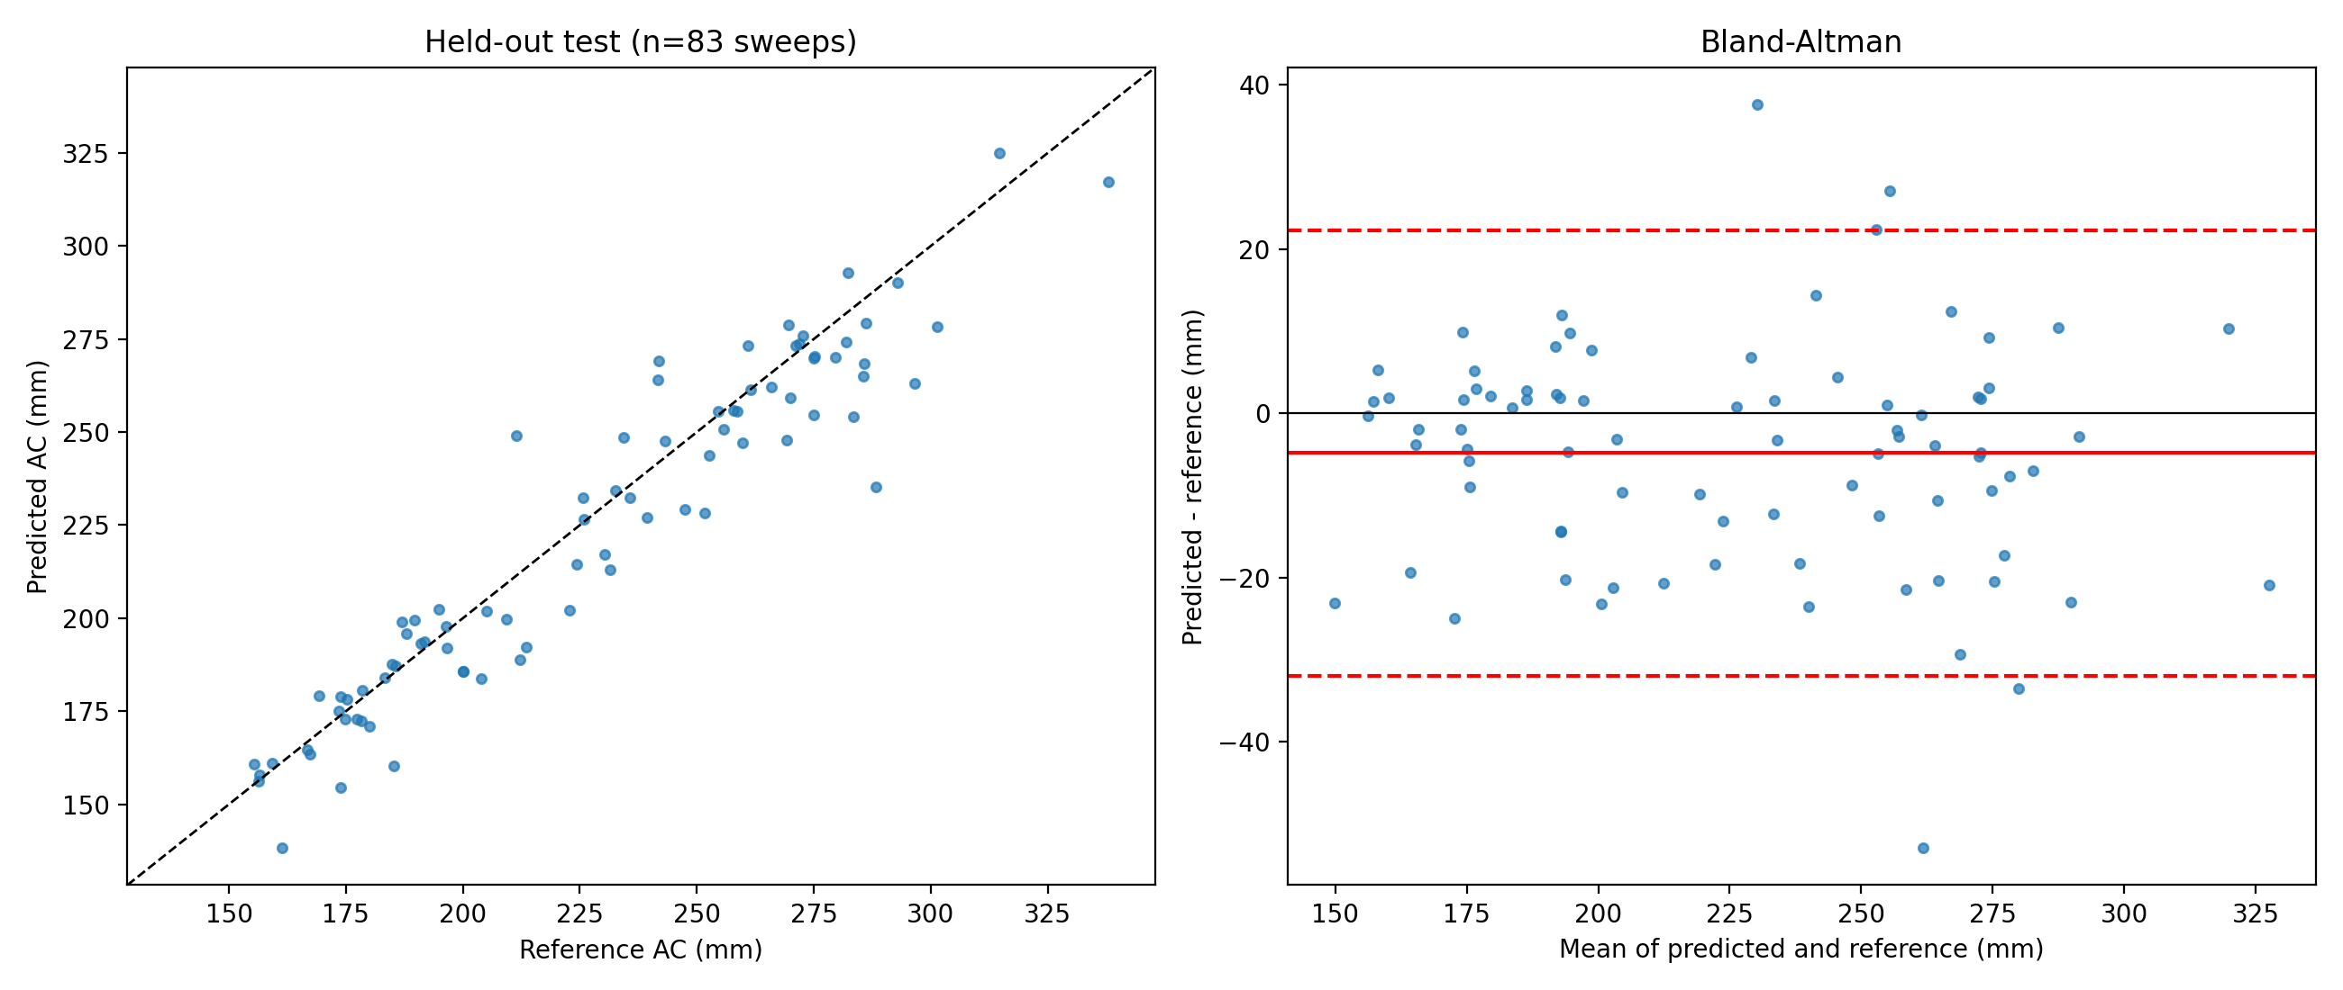
Fig. 7. AC agreement on the subject-level held-out test set (83 sweeps, 42 women): predicted vs reference (left) and Bland–Altman plot with bias and 95% limits of agreement (right)

G. Comparison with the ACOUSLIC-AI Challenge Winners
Table IX places our biometry module beside the three top-ranked entries of the ACOUSLIC-AI challenge (A1–A3), using the figures published in the challenge report [18]. The challenge task differs from ours. Each challenge algorithm selects one frame per case, and its AC is compared with the reference of the sweep that frame came from. If that sweep has no reference, the case receives the worst score (NAE = 1). Our pipeline measures every sweep and compares it with that sweep’s reference. The challenge NAE uses the same formula as ours, |AC_{ref} − AC_{pred}| / max(AC_{ref}, AC_{pred}) [18].

TABLE IX
Our Attention U-Net vs the top three ACOUSLIC-AI entries (challenge figures from [18])
Method | Network | Test data | NAE, mean (median) | Signed AC error, mean ± SD (mm) | Dice | Time per case
A1 (1st) | 9 × U-Net, VGG encoder, suitability head | 282 hidden cases (Tanzania, Netherlands) | 0.16 (0.04) | −9.69 ± 11.99 | 0.94ᵃ | 549 sᶜ
A2 (2nd) | 2.5-D U-Net, ConvNeXt-V2 encoder | same | 0.16 (0.03) | −1.43 ± 10.38 | 0.94ᵃ | 123 sᶜ
A3 (3rd) | 5 × ResNet50 + nnU-Net | same | 0.21 (0.05) | −9.78 ± 11.12 | 0.94ᵃ | 125 sᶜ
Ours | 1 × Attention U-Net, 7.86 M parameters | 48 cases / 42 women, Sierra Leone, subject-level hold-out | 0.045 (0.033) | −4.87 ± 13.84 | 0.925ᵇ | ≈ 17 sᵈ
ᵃ Dice on the annotated frame nearest to the selected frame. ᵇ Mean Dice over all annotated test frames. ᶜ RTX 2080 Ti [18]. ᵈ Tesla T4, including image loading and frame-level evaluation (806 s for 48 cases). Challenge NAE is per case, with cases lacking a reference in the selected sweep scored 1. Our NAE is per sweep (n = 83).

Three points follow from Table IX. First, a single Attention U-Net with top-5 frame averaging reaches a median NAE (0.033) in the same range as the winners (0.03–0.05), at roughly one-seventh to one-thirtieth of their reported run time, although on a different GPU. Its mean NAE is lower mainly because it never measures a sweep without a reference, so it avoids the NAE = 1 penalty that inflates the challenge means.
Second, our errors are more spread out. The SD of our signed error (13.8 mm) is larger than that of A1–A3 (10.4–12.0 mm). Our limits of agreement (±27.1 mm, ±11.8%) are wider than the ±21 mm and ±9.1% sonographer interobserver limits [15], [18]. Against blind-sweep reference values on the Dutch cohort, A2 achieved ±18.3 mm with an average absolute difference of 6.8 mm, against our 10.7 mm on the Sierra Leone hold-out [18]. Our bias (−4.9 mm) lies between A2 (−1.4 mm) and A1/A3 (about −9.7 mm).
Third, our test set is easier. It comes from the same Sierra Leone health units and annotators as the training data, while the challenge test set came from new sites with more expert annotators. Table IX is therefore a reference comparison, not a ranking. A fair head-to-head would require submitting the model to the challenge’s hidden test set.

H. Synthetic Cohort Audit
CTGAN trained on the ten booking predictors and the GDM label reproduced pairwise correlations with a mean absolute difference of 0.061. A GDM model trained only on synthetic data and tested on real held-out women (TSTR) reached an AUROC of 0.504, essentially chance, compared with 0.699 for real-data training. Adding synthetic rows to real data lowered the AUROC to 0.601.
The synthetic cohort is used only for internal demonstration, not for model training or external sharing. Its privacy has not been tested by attack [25], [26], so it is not released.

VI. Ablation Study
Three design choices change the results substantially: excluding OGTT glucose, not re-weighting classes, and defining macrosomia by absolute birthweight. Ensembling changes them very little.

A. Diagnostic Leakage
An earlier version of the pipeline added fasting and 2-hour OGTT glucose to the same booking predictors. It reached a held-out AUROC of 1.000, against 0.704 for the leakage-safe ensemble in that version.
The near-perfect score is not predictive skill. OGTT glucose defines the GDM label, so including it reproduces the diagnosis instead of anticipating it. It is also recorded mainly in women already selected for testing. All results in Section V therefore exclude OGTT glucose.

B. Class Weighting vs Calibration
The same stacking ensemble was retrained with balanced class weights, as in the original pipeline (Table X, Fig. 8). Ranking is unchanged, but every probability is inflated about five-fold. The weighted model’s Brier score is worse than a constant prediction at the prevalence.

TABLE X
Effect of class weighting on the GDM stacking ensemble (held-out)
Configuration | AUROC | Brier | Scaled Brier | Cal. intercept | Cal. slope | Mean predicted vs observed
Balanced class weights (original) | 0.714 | 0.216 | −1.968 | −2.47 | 0.93 | 43.9% vs 7.9%
No class weights (proposed) | 0.712 | 0.071 | +0.030 | 0.00 | 0.96 | 7.9% vs 7.9%

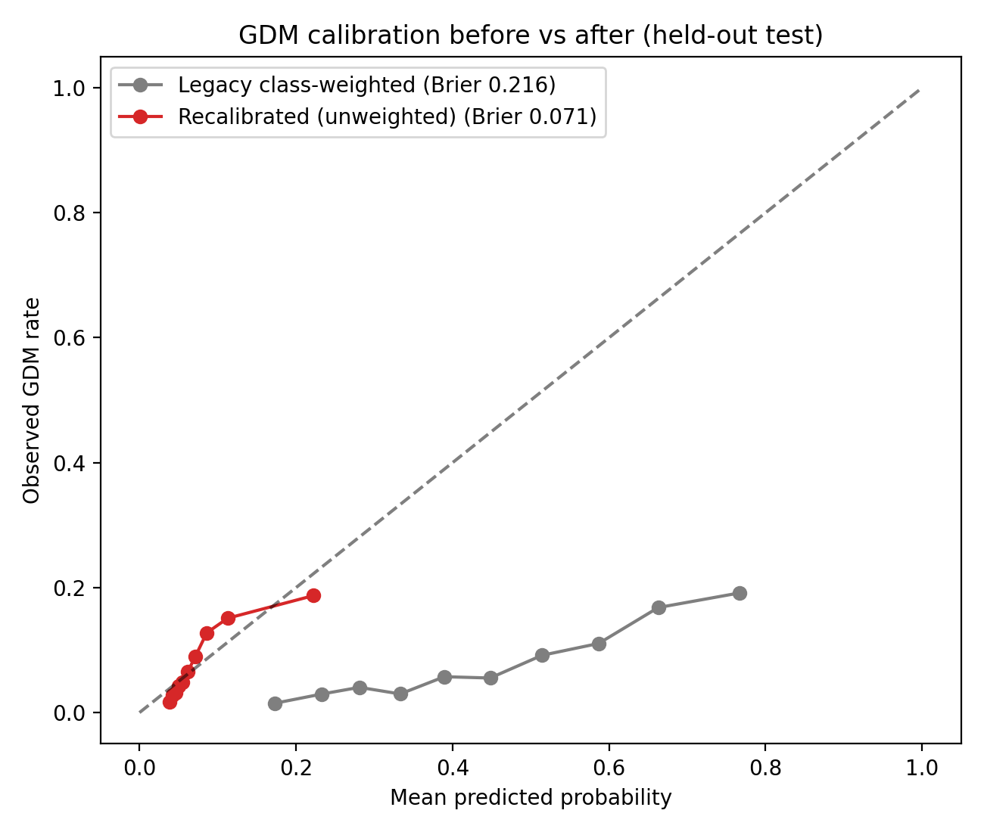
Fig. 8. GDM calibration on the held-out test set before (class-weighted, Brier 0.216) and after (unweighted, Brier 0.071) recalibration
For a dashboard that shows a percentage to clinicians, the unweighted model is the only one whose numbers can be read literally. Sensitivity is recovered by choosing a threshold on OOF predictions, not by distorting the probabilities.

C. Base Learners vs Stacking
Across both outcomes, the stacking ensemble’s AUROC is within 0.004 of the best single base learner. Logistic regression alone reaches 0.714 for GDM and 0.629 for macrosomia (Tables V and VI).
With ten mostly linear predictors, additional model capacity adds little. The ensemble is kept for robustness and continuity with earlier work. A logistic model would be an equally defensible, more transparent choice.

D. Outcome Definition for Macrosomia
Replacing the absolute threshold (birthweight ≥ 4000 g) with large-for-gestational-age (LGA, birthweight centile ≥ 90; test prevalence 11.9%) lowers the stacking AUROC from 0.639 to 0.561 (95% CI, 0.537–0.586). The calibration slope also worsens, from 1.30 to 1.42.
Booking predictors carry more information about absolute size, which partly tracks maternal BMI and ethnicity, than about size relative to gestational age. The primary outcome is therefore birthweight ≥ 4000 g.

E. Synthetic Augmentation
Adding CTGAN rows to the real training data lowered the GDM AUROC from 0.699 to 0.601 (Section V-H). An earlier variant labelled synthetic rows with the real model’s own predictions (pseudo-labelling). This adds no outcome information and was retired. The clinical models are trained on real data only.

VII. Discussion
A useful digital twin for antenatal screening depends less on model complexity than on keeping each output tied to evidence that can support it.

A. Interpreting the Core Findings
The GDM booking model reaches an AUROC of 0.71 with good calibration.
The top-20% flag finds 43% of GDM cases at about twice the base-rate PPV. That suits targeted early testing, not diagnosis. The universal OGTT at 24–28 weeks remains the diagnostic standard [1], [40].
The macrosomia booking model is weaker (AUROC 0.64). This matches the finding by Liu et al. [6] that accuracy improves as later-pregnancy information becomes available.

B. Why Calibration Matters for a Digital Twin
A digital twin shows numbers to clinicians, so a probability must mean what it says. Class re-weighting, common in imbalanced-data pipelines, left the GDM ranking intact but shifted the mean predicted risk from 7.9% to 43.9% (Table X). Every woman would have appeared high-risk.
Re-training without weights and choosing the threshold on out-of-fold data fixed this without loss of discrimination. We recommend that antenatal prediction studies report calibration slope, calibration intercept and scaled Brier score alongside AUROC, as TRIPOD+AI requires [33].

C. The Two-Stage Design as Honest Fusion
The maternal and ultrasound data come from different cohorts, so a learned fusion model could not be validated. MDT-GEN combines a booking-model estimate with published likelihood ratios; the macrosomia model’s calibration slope of 1.30 warrants caution, and the combined pathway remains exploratory.
Each part has separate evidence: the booking model was tested on 4,698 women, and the ultrasound criterion comes from published studies. The combined pathway is exploratory because the likelihood ratios may not transfer to this population or account for the macrosomia model’s calibration slope of 1.30.
The design also mirrors clinical workflow. Women at higher booking risk are prioritised for growth scans, and a positive late scan raises the estimated risk sharply. In the worked example, a 10% booking risk rose to 43% after a positive AC criterion.

D. What the Neural ODE Can and Cannot Show
The Neural ODE audit is a cautionary result. A model trained with a single glucose value per woman produced trajectories that looked smooth and physiological in the dashboard, yet predicted held-out OGTT glucose worse than a constant (R² −2.2).
The architecture itself is sound: on synthetic longitudinal data it forecast later weight with 0.87 kg error. The limitation is the data. A continuous-time twin needs repeated measurements, such as home glucose monitoring or serial antenatal visits, before its trajectories can be called forecasts.

E. Comparison with Existing Approaches
For biometry, the ACOUSLIC-AI winners [18] show that blind-sweep AC can approach sonographer agreement with large ensembles. Our results suggest that a single lightweight network gives a similar median error and is much faster, which matters for phone-connected probes in low-resource clinics. However, its wider error spread and in-distribution test set mean it should be treated as a screening aid until externally tested.
Many early GDM prediction studies report high accuracy when glucose measurements are included. Our ablation shows the same effect (AUROC 1.000) and explains why it does not reflect early prediction.
Leakage-safe booking-stage models generally show moderate discrimination [4], [5]. Our results are consistent with this, and we also report calibration and net benefit. Exact comparison is limited by differences in cohorts, predictors and outcome definitions.

F. Limitations
- Single-centre, internal validation. All booking results come from one London hospital (2016–2019) with a random split. External and temporal validation are needed before clinical use [34].
- Booking timing. About 23% of women booked after 12 weeks. Results for the ≤ 12-week subgroup are similar, but true first-trimester performance needs confirmation.
- Missing and informative predictors. Blood pressure was missing for about 60% of women, and its missingness ranked among the top GDM predictors. This likely reflects recording practice and may not transfer to other sites.
- Unlinked modalities. Fusion of booking risk and ultrasound uses published likelihood ratios that are not validated in this population. The criterion is applied only at ≥ 36 weeks.
- AC accuracy and range. The test set is small (42 women) and comes from one low-resource blind-sweep programme. Its largest reference AC is 338 mm, so no test fetus reached the 360 mm macrosomia criterion, and the criterion’s sensitivity with automated AC is untested. The −4.9 mm bias, if it persists at large AC, would make the automated criterion slightly conservative.
- Trajectories. The Neural ODE trajectories are illustrative. The synthetic cohort is unsuitable for training (TSTR AUROC 0.50), and its privacy has not yet been tested by attack.

G. Future Work
- Validate the booking models externally in Indian and other multi-ethnic cohorts.
- Collect linked booking, third-trimester ultrasound and birthweight data so that the two-stage pathway can be validated end to end.
- Train the Neural ODE on serial glucose and weight measurements.
- Add membership-inference testing to the synthetic-data audit.
- Extend the biometry module to head circumference and femur length, so that a four-parameter EFW can be computed automatically.

VIII. Conclusion
MDT-GEN is a maternal–fetal digital twin for early screening of GDM and macrosomia in which every displayed output is either validated or labelled as unvalidated.
Using only ten predictors available at booking, the calibrated GDM model reached an AUROC of 0.712 and a Brier score of 0.071 on 4,698 held-out women. Its predicted risks match observed rates, so the percentages shown to clinicians can be read literally.
Booking data alone screen for macrosomia only modestly (AUROC 0.639; calibration slope 1.30). MDT-GEN demonstrates a two-stage pathway that combines this booking-model estimate with a published late-pregnancy ultrasound criterion; the combined probability is exploratory and has not been validated end to end. On ACOUSLIC-AI blind sweeps, automated AC measurement had a mean absolute error of 10.7 mm on a subject-level hold-out of 42 women. Its median error was comparable to challenge entries, but its limits of agreement were wider; cross-study differences prevent ranking.
The audits also showed where the evidence stops. Diagnostic glucose produced illusory accuracy. Class re-weighting inflated risks five-fold. The Neural ODE trajectories, smooth as they looked, could not be validated without repeated measurements.
These findings point to the next steps: external validation, linked booking–ultrasound–outcome cohorts, and longitudinal monitoring data. With these, the twin’s trajectories could move from illustration to forecast.

References
- International Association of Diabetes and Pregnancy Study Groups Consensus Panel, “International association of diabetes and pregnancy study groups recommendations on the diagnosis and classification of hyperglycemia in pregnancy,” Diabetes Care, vol. 33, no. 3, pp. 676–682, 2010. doi:10.2337/dc09-1848
- HAPO Study Cooperative Research Group, “Hyperglycemia and adverse pregnancy outcomes,” N. Engl. J. Med., vol. 358, pp. 1991–2002, 2008. doi:10.1056/NEJMoa0707943
- American Diabetes Association Professional Practice Committee, “Management of diabetes in pregnancy: Standards of Care in Diabetes—2026,” Diabetes Care, vol. 49, suppl. 1, pp. S321–S338, 2026. doi:10.2337/dc26-S015
- H. Zaky, E. Fthenou, L. Srour, et al., “Machine learning based model for the early detection of gestational diabetes mellitus,” BMC Med. Inform. Decis. Mak., vol. 25, p. 130, 2025. doi:10.1186/s12911-025-02947-3
- B. L. Seifu, Y. Belsti, N. B. Yimer, R. F. Goldstein, J. Enticott, and H. Teede, “Externally validated risk prediction models for gestational diabetes mellitus: a systematic review and meta-analysis,” Acta Obstet. Gynecol. Scand., vol. 105, pp. 1918–1931, 2026. doi:10.1111/aogs.70300
- Q. Liu, S. Zhu, M. Zhao, et al., “Machine learning approaches for predicting fetal macrosomia at different stages of pregnancy: a retrospective study in China,” BMC Pregnancy Childbirth, vol. 25, p. 140, 2025. doi:10.1186/s12884-025-07239-2
- J. Wang, X. Wang, Y. Yu, et al., “Development and validation of an explainable machine learning-based risk prediction model for macrosomia in Han Chinese women with singleton cephalic pregnancies,” Sci. Rep., 2026, online ahead of print. doi:10.1038/s41598-026-65628-9
- B. Björnsson, C. Borrebaeck, N. Elander, et al., “Digital twins to personalize medicine,” Genome Med., vol. 12, p. 4, 2020. doi:10.1186/s13073-019-0701-3
- E. Katsoulakis, Q. Wang, H. Wu, et al., “Digital twins for health: a scoping review,” npj Digit. Med., vol. 7, p. 77, 2024. doi:10.1038/s41746-024-01073-0
- R. T. Q. Chen, Y. Rubanova, J. Bettencourt, and D. Duvenaud, “Neural ordinary differential equations,” in Adv. Neural Inf. Process. Syst. 31, 2018, pp. 6571–6583. Available: https://proceedings.neurips.cc/paper_files/paper/2018/hash/69386f6bb1dfed68692a24c8686939b9-Abstract.html
- A. T. Papageorghiou, E. O. Ohuma, D. G. Altman, et al., “International standards for fetal growth based on serial ultrasound measurements: the Fetal Growth Longitudinal Study of the INTERGROWTH-21st Project,” Lancet, vol. 384, no. 9946, pp. 869–879, 2014. doi:10.1016/S0140-6736(14)61490-2
- J. Stirnemann, J. Villar, L. J. Salomon, et al., “International estimated fetal weight standards of the INTERGROWTH-21st Project,” Ultrasound Obstet. Gynecol., vol. 49, no. 4, pp. 478–486, 2017. doi:10.1002/uog.17347
- L. J. Salomon, Z. Alfirevic, F. Da Silva Costa, et al., “ISUOG Practice Guidelines: ultrasound assessment of fetal biometry and growth,” Ultrasound Obstet. Gynecol., vol. 53, no. 6, pp. 715–723, 2019. doi:10.1002/uog.20272
- H. Y. Choi, J. H. Kim, J. Y. Park, E. Y. Jung, J. H. No, K. J. Oh, and J.-S. Hong, “Simple mathematical formulae for estimation of median values of fetal biometry at each gestational age,” Obstet. Gynecol. Sci., vol. 59, no. 2, pp. 91–96, 2016. doi:10.5468/ogs.2016.59.2.91
- I. Sarris, C. Ioannou, P. Chamberlain, et al., “Intra- and interobserver variability in fetal ultrasound measurements,” Ultrasound Obstet. Gynecol., vol. 39, no. 3, pp. 266–273, 2012. doi:10.1002/uog.10082
- F. P. Hadlock, R. B. Harrist, R. J. Carpenter, R. L. Deter, and S. K. Park, “Sonographic estimation of fetal weight: the value of femur length in addition to head and abdomen measurements,” Radiology, vol. 150, no. 2, pp. 535–540, 1984. doi:10.1148/radiology.150.2.6691115
- S. Campbell and D. Wilkin, “Ultrasonic measurement of fetal abdomen circumference in the estimation of fetal weight,” Br. J. Obstet. Gynaecol., vol. 82, no. 9, pp. 689–697, 1975. doi:10.1111/j.1471-0528.1975.tb00708.x
- M. S. Sappia, C. L. de Korte, B. van Ginneken, et al., “ACOUSLIC-AI challenge report: fetal abdominal circumference measurement on blind-sweep ultrasound data from low-income countries,” Med. Image Anal., vol. 105, p. 103640, 2025. doi:10.1016/j.media.2025.103640
- M. S. Sappia, “ACOUSLIC-AI: Abdominal Circumference Operator-agnostic UltraSound measurement in Low-Income Countries using Artificial Intelligence,” dataset v1.1, Zenodo, 2024. doi:10.5281/zenodo.12697994
- J. Jang, Y. Park, B. Kim, S. M. Lee, J.-Y. Kwon, and J. K. Seo, “Automatic estimation of fetal abdominal circumference from ultrasound images,” IEEE J. Biomed. Health Inform., vol. 22, no. 5, pp. 1512–1520, 2018. doi:10.1109/JBHI.2017.2776116
- O. Ronneberger, P. Fischer, and T. Brox, “U-Net: convolutional networks for biomedical image segmentation,” in Proc. MICCAI, 2015, pp. 234–241. doi:10.1007/978-3-319-24574-4_28
- O. Oktay, J. Schlemper, L. Le Folgoc, et al., “Attention U-Net: learning where to look for the pancreas,” arXiv:1804.03999, 2018. Available: https://arxiv.org/abs/1804.03999
- S. Ramanujan, “Modular equations and approximations to π,” Q. J. Math., vol. 45, pp. 350–372, 1914. Available: https://ramanujan.sirinudi.org/Volumes/published/ram06.pdf
- L. Xu, M. Skoularidou, A. Cuesta-Infante, and K. Veeramachaneni, “Modeling tabular data using conditional GAN,” in Adv. Neural Inf. Process. Syst. 32, 2019, pp. 7335–7345. Available: https://proceedings.neurips.cc/paper/2019/hash/562d3d0897e2c8f7b3c1e33f53e8dc1c-Abstract.html
- Z. Zhang, C. Yan, and B. A. Malin, “Membership inference attacks against synthetic health data,” J. Biomed. Inform., vol. 125, p. 103977, 2022. doi:10.1016/j.jbi.2021.103977
- B. Kaabachi, J. Despraz, T. Meurers, et al., “A scoping review of privacy and utility metrics in medical synthetic data,” npj Digit. Med., vol. 8, p. 60, 2025. doi:10.1038/s41746-024-01359-3
- A. Coomarasamy, M. Connock, J. Thornton, and K. S. Khan, “Accuracy of ultrasound biometry in the prediction of macrosomia: a systematic quantitative review,” BJOG, vol. 112, no. 11, pp. 1461–1466, 2005. doi:10.1111/j.1471-0528.2005.00702.x
- L. Breiman, “Random forests,” Mach. Learn., vol. 45, no. 1, pp. 5–32, 2001. doi:10.1023/A:1010933404324
- T. Chen and C. Guestrin, “XGBoost: a scalable tree boosting system,” in Proc. 22nd ACM SIGKDD, 2016, pp. 785–794. doi:10.1145/2939672.2939785
- L. Prokhorenkova, G. Gusev, A. Vorobev, A. V. Dorogush, and A. Gulin, “CatBoost: unbiased boosting with categorical features,” in Adv. Neural Inf. Process. Syst. 31, 2018, pp. 6638–6648. Available: https://proceedings.neurips.cc/paper/2018/hash/14491b756b3a51daac41c24863285549-Abstract.html
- D. H. Wolpert, “Stacked generalization,” Neural Netw., vol. 5, no. 2, pp. 241–259, 1992. doi:10.1016/S0893-6080(05)80023-1
- S. M. Lundberg and S.-I. Lee, “A unified approach to interpreting model predictions,” in Adv. Neural Inf. Process. Syst. 30, 2017, pp. 4765–4774. Available: https://proceedings.neurips.cc/paper/2017/hash/8a20a8621978632d76c43dfd28b67767-Abstract.html
- G. S. Collins, K. G. M. Moons, P. Dhiman, et al., “TRIPOD+AI statement: updated guidance for reporting clinical prediction models that use regression or machine learning methods,” BMJ, vol. 385, p. e078378, 2024. doi:10.1136/bmj-2023-078378
- K. G. M. Moons, J. A. A. Damen, T. Kaul, et al., “PROBAST+AI: an updated quality, risk of bias, and applicability assessment tool for prediction models using regression or artificial intelligence methods,” BMJ, vol. 388, p. e082505, 2025. doi:10.1136/bmj-2024-082505
- B. Van Calster, D. J. McLernon, M. van Smeden, L. Wynants, and E. W. Steyerberg, “Calibration: the Achilles heel of predictive analytics,” BMC Med., vol. 17, p. 230, 2019. doi:10.1186/s12916-019-1466-7
- A. J. Vickers and E. B. Elkin, “Decision curve analysis: a novel method for evaluating prediction models,” Med. Decis. Making, vol. 26, no. 6, pp. 565–574, 2006. doi:10.1177/0272989X06295361
- F. P. Hadlock, R. B. Harrist, R. S. Sharman, R. L. Deter, and S. K. Park, “Estimation of fetal weight with the use of head, body, and femur measurements—a prospective study,” Am. J. Obstet. Gynecol., vol. 151, no. 3, pp. 333–337, 1985. doi:10.1016/0002-9378(85)90298-4
- G. Pinto, V. Crista, R. Silva, et al., “Large language models for generating longitudinal synthetic data in low-risk pregnancy care,” Data Brief, vol. 67, p. 112933, 2026. doi:10.1016/j.dib.2026.112933
[39] G. Pinto, V. Crista, A. R. Jesus Silva, F. Andrade Bernardi, R. Almeida, B. Costa, J. Souza, A. Freitas, G. Marreiros, and L. Conceição, “Low-Risk Synthetic Patient Level Pregnancy Trajectories,” dataset, version 1.0, Zenodo, 2026. doi:10.5281/zenodo.19472146
[40] National Institute for Health and Care Excellence, “Diabetes in pregnancy: management from preconception to the postnatal period,” NICE guideline NG3, 2015 (updated 2020). Available: https://www.nice.org.uk/guidance/ng3
[41] S. Jeyaparam and A. Agha-Jaffar, “GDM Dataset,” Figshare, 2023. doi: 10.6084/m9.figshare.21806472.v1

