Oops:1.class>constructor>method>psvm>obj creation

Classs:blueprint

Obj:entity

To get close into real world java integrate with oops

========================================================================

1.ABSTRACTION:

Abstraction will hide the unwated data from users

Can be done with abstract classes and interface

##COFFEE MACHINE EXAMPLE

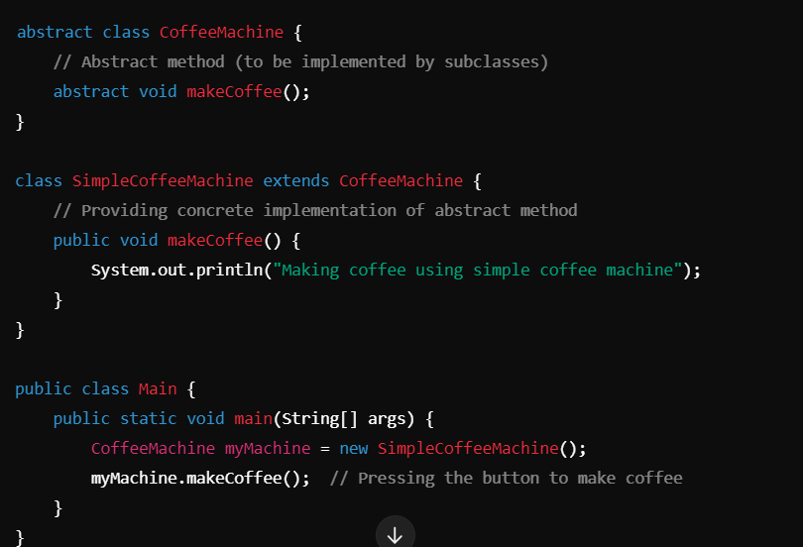

1.create anstract class

2.create a class user interactie that extends abstract class

3.main class

4.obj creation to call user class

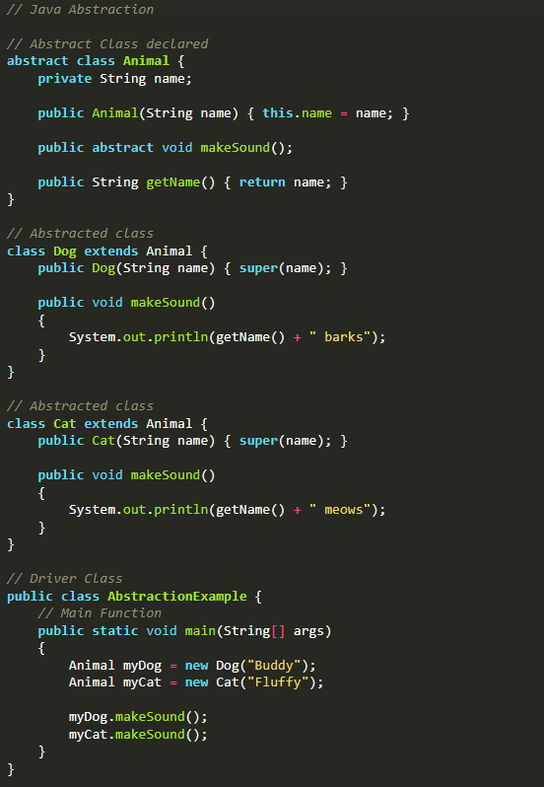

Using interface:

When a common spcial is shared among clases this anbstarction is used

Using interface we can do multiple inheritence

Tells what to do not how to do

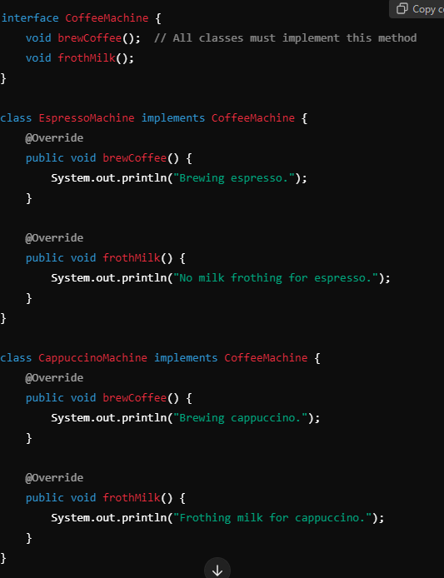

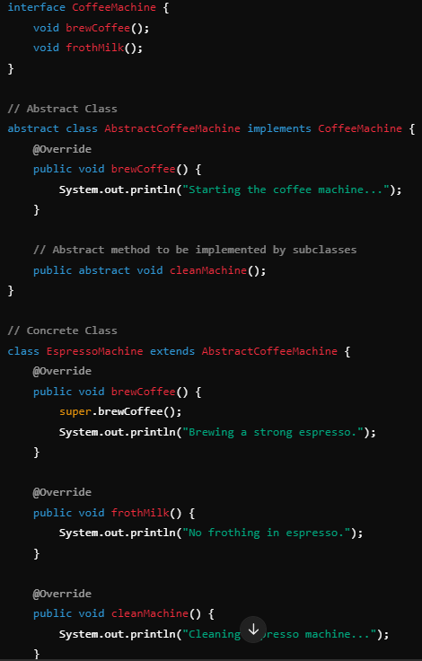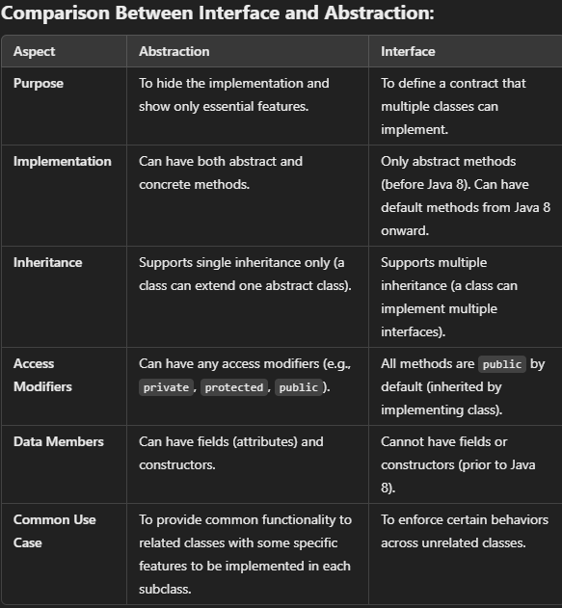

##encapsulation:  
giving security

Protect data

Private keywords are used

Getter setter methods

Ex: bank recheck ad changing amount

When a account holder came to withdraw money in encapsulation first allow him to check his name if check done then next stage of processs this validation is dne at encapsulation secured data

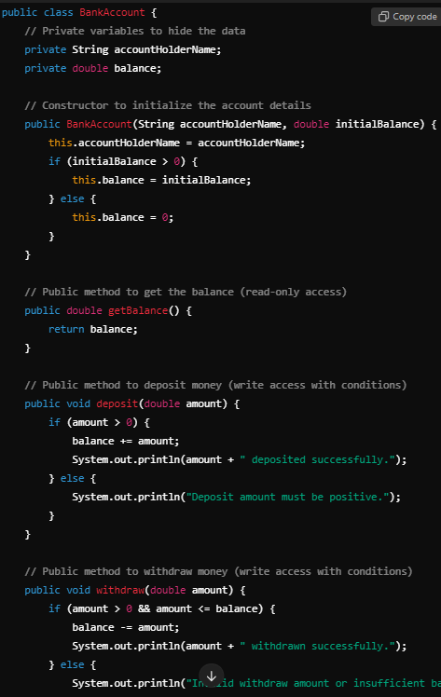

##inheritence:

Accepting data from parent class (base) to derived class(child)

Using extend keyword

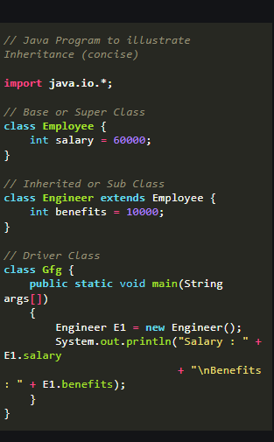

1. Single Inheritance

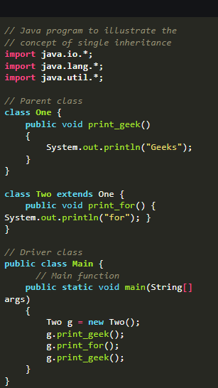

1. Multilevel Inheritance

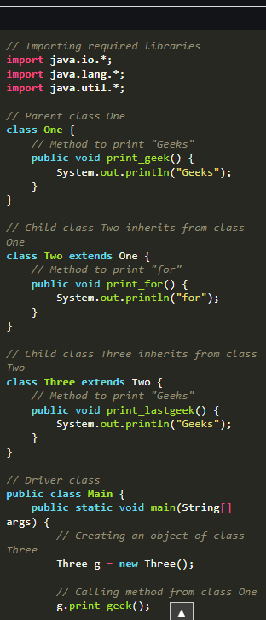

1. Hierarchical Inheritance
2. Multiple Inheritance

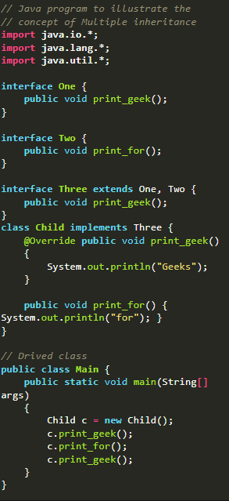

1. Hybrid Inheritance

#####polymorphism

Having many form

Ability to ddispaly message in many forms

**Real-life Illustration of Polymorphism in Java**: A person can have different characteristics at the same time. Like a man at the same time is a father, a husband, and an employee. So the same person possesses different behaviors in different situations. This is called polymorphism.

Typr:

1,compile time

Known as static and also method overloading or operator overloading

Overloading:’same functional name diff parameteds

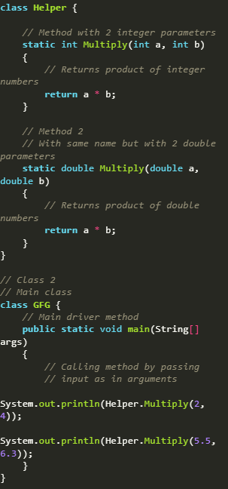

2.runtime

A methd is again declared in child which is already in parent class

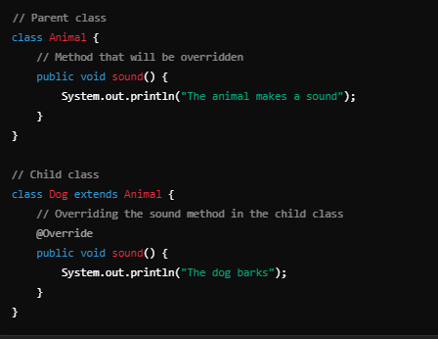

In this animal make a sound and also dog barks will be exeited as the child overrides prent that statement also prints!!!