|  |  |
| --- | --- |
| **HOPE -1**  **GRADE 11**    **EXERCISE FOR FITNESS**  **Quarter 1 Week 7 Module 1**   |  | | --- | | **Most Essential Learning Competencies:**  **…Self-assesses health-related fitness (HRF).Status, barriers to physical activity assessment participation and one’s diet.**  **…Sets Frequency Intensity Time Type (FITT) goals based on training principles to achieve and/or maintain healthrelated fitness (HRF).**  **…Engages in moderate to vigorous physical activities (MVPAs) for at least 60 minutes most days of the week in a variety of settings in- and out-of school.**  **…Observes personal safety protocol to avoid dehydration, overexertion, hypo- and hyperthermia during MVPA participation.** | |

**HOW TO USE THIS MODULE**

|  |
| --- |
| Before starting the module, I want you to set aside other **tasks**that will disturb you while enjoying the lessons. Read the simple instructions below to successfully enjoy the objectives of this kt. *I Have fun!*   1. Follow carefully all the contents and instructions indicated in every page of this module. 2. *Write on your notebook the concepts about the lessons.* ***Writing enhances learning****, that is important to develop and keep in mind.* 3. Perform all the provided activities in the module. 4. Let your facilitator/ guardian assess your answers using the answer key card. 5. Analyze conceptually the post-test and apply what you have learned. 6. Enjoy studying! |

**PARTS OF THE MODULE**

* **Expectations** – These are what you will be able to know after completing

the lessons in the module.

* **Pre-test** – This will measure your prior knowledge and the concepts to be mastered throughout the lesson.
* **Looking Back to your Lesson** – This section will measure what learnings and skills did you understand from the previous lesson.
* **Brief Introduction** – This section will give you an overview of the lesson.
* **Activities** – This is a set of activities you will perform with a partner.
* **Remember** – This section summarizes the concepts and applications of the lessons.
* **Check your Understanding** – It will verify how you learned from the lesson.
* **Post-test** – This will measure how much you have learned from the entire module.

# PRE-TEST

Multiple Choice: Choose the letter of the best answer.

1. Observe all posted equipment instructions and warnings before engaging to workout.
   * 1. Most of the time
     2. Depending on the situation
     3. Sometimes
     4. None of the above
2. What will you do if someone is using a piece of equipment that you will use?
   * 1. Workout between his sets
     2. Ask politely if you can “work in between their sets
     3. Change your program
     4. Start with other equipment
3. What is the proper etiquette when using equipment while others are waiting?
   * 1. Change your program
     2. Put all equipment away
     3. Allow others to work in between your sets
     4. All of the above
4. What is ALWAYS required on days that we go to work out?
   * 1. proper athletic clothing
     2. cell phones C. food and drinks

D. none of the above

1. The proper time to wipe down a machine is: A. before your workout
   * 1. after your workout
     2. during workout
     3. both before and after workout
2. It is the set of conventional rules of personal behavior in polite society, usually in the form of an ethical code that delineates the expected and accepted social behaviors that accord with the conventions and norms observed by a society, a social class, or a social group.
   1. Rules B. Regulations C. Etiquettes D. Morals
3. Which of the following is not considered as proper etiquette inside the fitness venue?
   1. Avoid dropping weights; avoid banging weight stacks on machines
   2. Use cardio equipment properly C. Do not bounce balls in the facility.

D. Exercise in walking areas

1. Is gym etiquette is none other than respect?
   1. Yes B. No C. Maybe D. Sometimes
   2. No
2. When using cardio equipment, please do not exceed the _____________.
   1. 45 minute time limit
   2. 30 minute time limit
   3. 2 hour time limit
   4. 1 hour time limit
3. Limit grunting and yelling during exercise. Is this considered as proper etiquette in use of facilities and equipment?
   1. Yes B. Yes C. Maybe D. Sometimes
   2. No

***Great, you finished answering the questions. You may request your facilitator to check your work. Congratulations and keep on learning!***

# HOPE-1

**LESSON 8: Gym Etiquette, Etiquette in Using Sport and Recreational Venues**

|  |
| --- |
| **EXPECTATIONS**  This module will help you to:  • Demonstrate understanding about proper etiquette and safety in the use of facilities and equipment |

# LOOKING BACK TO YOUR LESSON

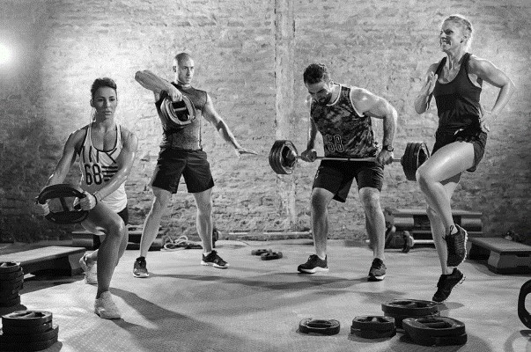Ensuring that you are performing safely is one of the most important factors when taking part in any physical activity. Injuries can lead to physical and work-related disability and can place a considerable financial burden on the injured person. In recent years, high school sports participation has risen significantly, and as a result, the frequency of injuries to teenagers has increased.

Guide Questions:

1. How do you exercise inside the gym facility?
2. Are you aware of proper etiquettes and safety measures inside the fitness facility?
3. What do you think are the proper etiquettes and safety measures in the use of facilities and equipment?

# BRIEF INTRODUCTION

What Is Etiquette? Etiquette is the set of conventional rules of personal behavior in polite society, usually in the form of an ethical code that delineates the expected and accepted social behaviors that accord with the conventions and norms observed by a society, a social class, or a social group. In practical speaking, gym etiquette is none other than respect. That's right, respect. Respect for the equipment, others, and yourself in the gym. Everybody's there for the same reason, and nobody wants to be distracted or held up. Do yourself and others a favor and follow these simple, easy, and for the most part down-right obvious rules.

## Fitness Etiquettes Uphold the rules of the facility

* Read, understand, and follow all rules, expectations, and posted signs
* Observe all posted equipment instructions and warnings
* If there is a piece of equipment you do not know how to use, don’t assume you know how to use it and ask for assistance

## Using a piece of equipment someone else is using

• Ask if you can “work in between their sets” – if they say no, please be patient and wait o When “working in” allow the other person to use the equipment after each set and re-set all equipment adjustments back to where they were before you started o You cannot claim a piece of equipment by setting a towel or water bottle on it or next to it.

## When using equipment while others are waiting

* Allow others to work in between your sets
* Do not rest on the equipment; it is better to walk around to accelerate your recovery
* When using cardio equipment, please do not exceed the 45 minute time limit
* Wipe down all equipment following each set with the provided pre-moistened wipes then discard the wipes appropriately
* When done with a piece of equipment, wipe down the equipment with the provided pre-moistened wipes then discard the wipes appropriately
* Take all extra personal equipment with you – includes water bottles, towels, weight belts, etc.
* Put all equipment away – rack free weights in their designated location, return cable accessories to the stand, dumbbells and kettle bells, jump ropes, and stretch cords returned to the appropriate rack, stability balls, balance balls, and foam rollers are to be wiped down, then returned to the storage area.

## Being aware of the exercise areas

* Stay clear of free weight areas when in use
* Do not exercise in walking areas – gray floor pathways and in front of water fountains, water and ice machine, wall-mounted wipes containers and trash/recycle receptacles
* Do not stand in front of dumbbell rack
* Before using a wall-mounted mirror, look around to make sure you are not in someone else’s space

## Avoiding excess noise

* Keep in mind this is a public place
* Avoid excess chatter while in the exercise areas
* Limit cell phone use that stops you from exercising
* Limit grunting and yelling during exercise; the use of profanity while exercising is not acceptable
* Avoid dropping weights; avoid banging weight stacks on machines
* Use cardio equipment properly
* Do not bounce balls in the facility – basketballs are for the basketball courts
* Remember that loud or constant noises can annoy other facility users

## Wearing proper attire

* Wear workout clothes and athletic shoes in the exercise areas (jeans are not appropriate)
* Refrain from working out without a shirt (or in just a sports bra) and athletic shoes

## Practicing good hygiene

* Avoid offensive body odors – bath regularly and use deodorant
* Wipe down equipment after use
* Reduce spreading germ
* Wash hands after using the restroom
* Wash hands after sneezing or coughing into your hand
* Wash hands after your workout
* This is a smoke-free facility, refrain from smoking near the facility entrance

# ACTIVITIES

Write the word DO if the picture resemblance proper etiquette in a fitness facility while write the word DON’T if not.

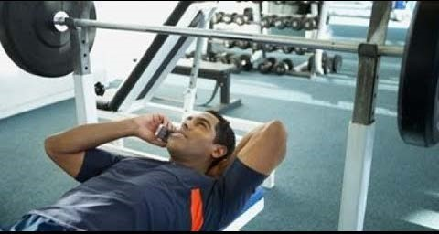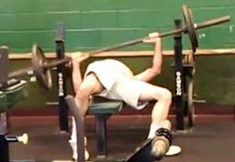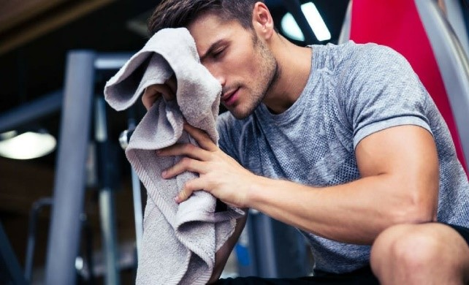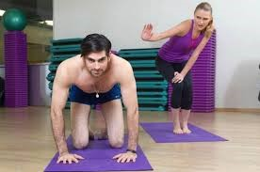

**Tiktok Challenge.**

Film at least 3 good etiquette in a fitness facility at your home through TikTok platform. Be resourceful. Enjoy filming and use the hashtag #BeResponsible #BeFIt

# REMEMBER

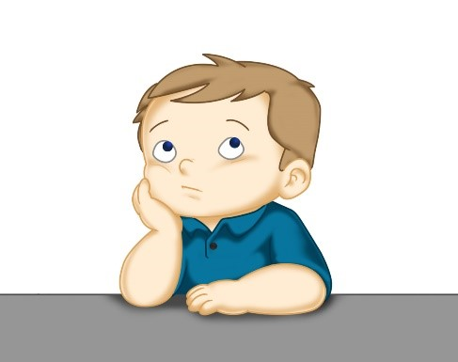

What is the importance of gym etiquette, etiquette in using sport and recreational

venues?

# CHECKING YOUR UNDERSTANDING

1. What are the fitness etiquettes?
2. How important these fitness etiquettes in our daily lives?
3. What are the benefits of fitness etiquettes during training and sports activities?
4. What value can you learned in this lesson?

# REFLECTIVE LEARNING SHEET

1. These are the common fitness etiquettes…

•

•

•

1. These are the rules of the facility that must uphold …

•

•

•

1. These are the importance of fitness etiquettes…

•

•

•

## POST TEST

**Test I.** Identify the following statements whether it’s true or false. Write TRUE if the statement is correct and FALSE, if not,

1. Do not exercise in walking areas – gray floor pathways and in front of water fountains, water and ice machine, wall-mounted wipes containers and trash/recycle receptacles.
2. Limit grunting and yelling during exercise; the use of profanity while exercising is acceptable.
3. Wear workout clothes and athletic shoes in the exercise areas (jeans are not appropriate)
4. You can smoke anywhere at any part of the fitness center.
5. Clean / wipe all used materials after using.

**Test II.** Multiple Choice

Read the statements carefully. Choose the correct answer in the given situation.

1. Choose the most appropriate response after you've lost a sports game:
   1. Verbally assault the referee
   2. Throw your equipment at the other team
   3. Just walk off the field in anger
   4. Shake hands with the other team's players
2. Which of the following is an example of poor etiquette in a fitness center:
   1. Not using the shower stall to change clothes while others are waiting to use it to shower
   2. Talking on the phone away from the main exercise area
   3. Wiping away your sweat with a towel off of a machine
   4. Returning dumbbells to the wrong spot on the rack
3. What is ALWAYS required on days that we go to workout?
   1. proper athletic clothing
   2. cell phones C. food and drinks

D. none of the above

1. Before you even walk into the gym, what should you make sure to avoid wearing for a work out?
   1. perfumes and colognes
   2. sweating gym clothes
   3. dirty sneakers
   4. all of the above
2. The proper time to wipe down a machine is:

A. before your workout B. after your workout

* 1. during workout
  2. both before and after workout

**END OF 8th WEEK \*\*\*\*\*\*\*\*\*\*\*\*\***

## *References*

Facility Rules and Regulations, Fitness Center Etiquette (2011), Retrieved from <http://students.umw.edu/campusrec/files/2011/10/Fitness-Center-Rules-and-Regulations.pdf>