Creating a folder intrestcl> Creating an empty file with name internsctl.sh, then the chmod +xinternsctl.sh command is used to make a script or executable file named "internsctl.sh" executable in a Unix-like operating system.

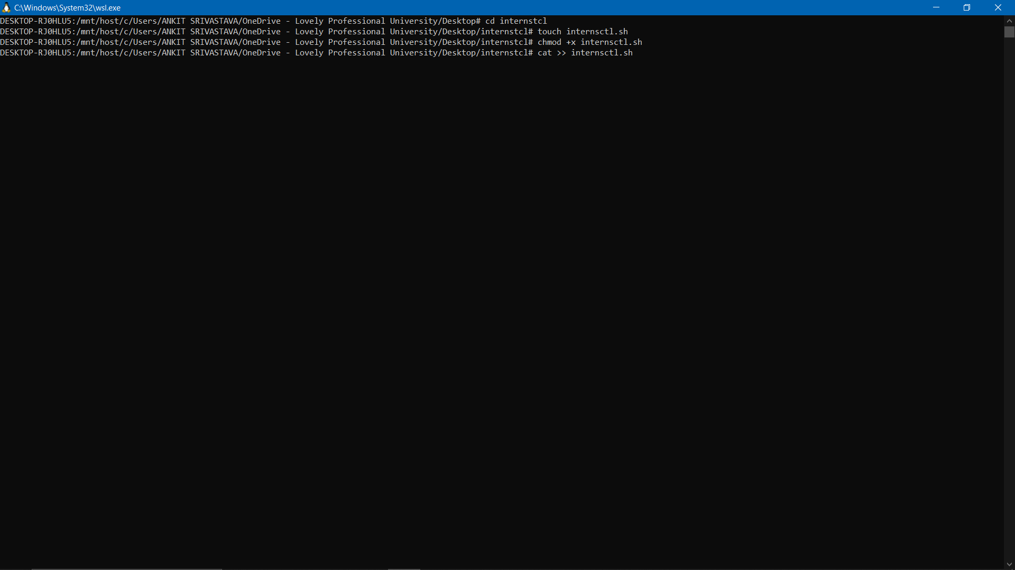

Writing bash script in internsctl.sh for my custom command

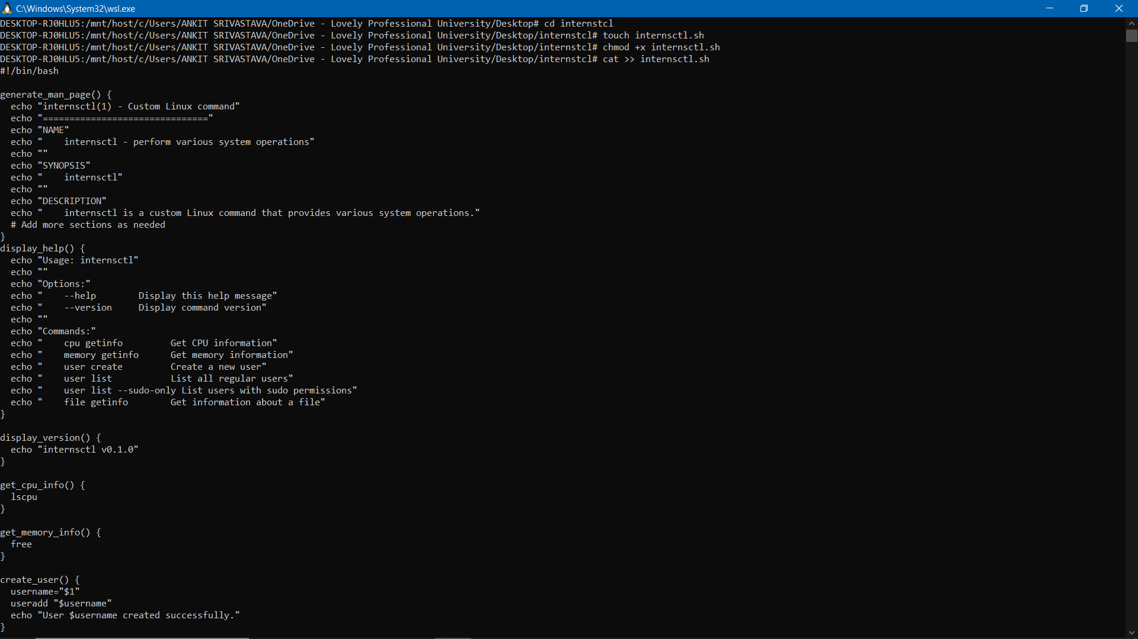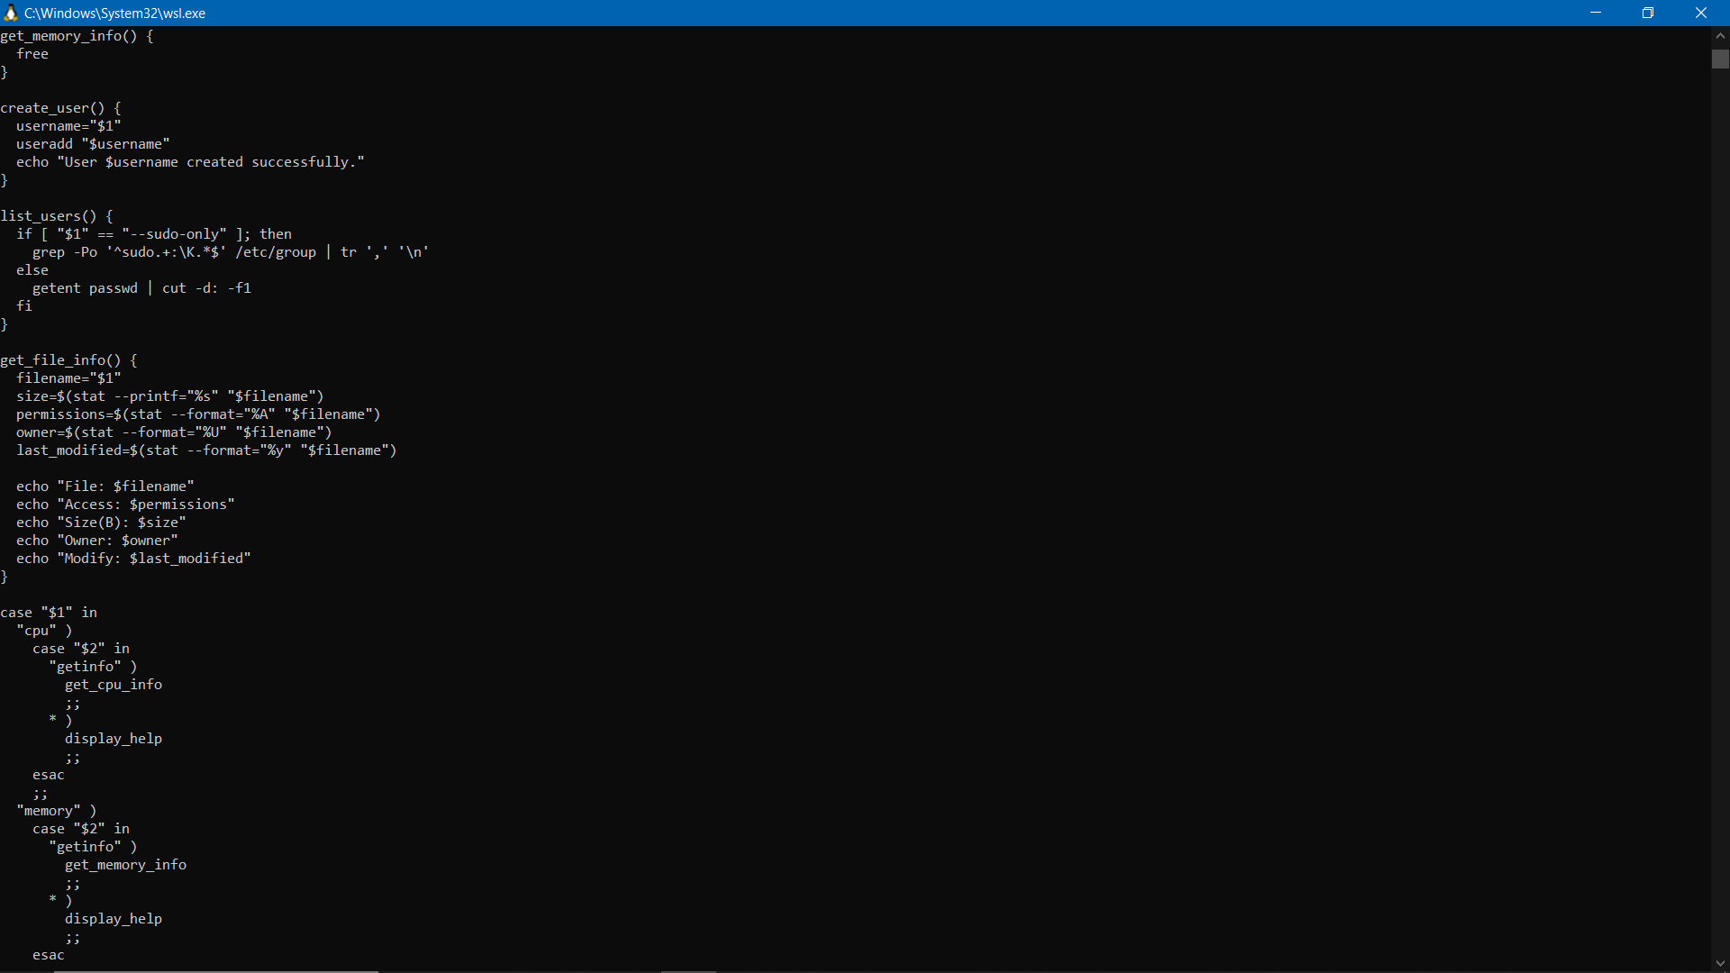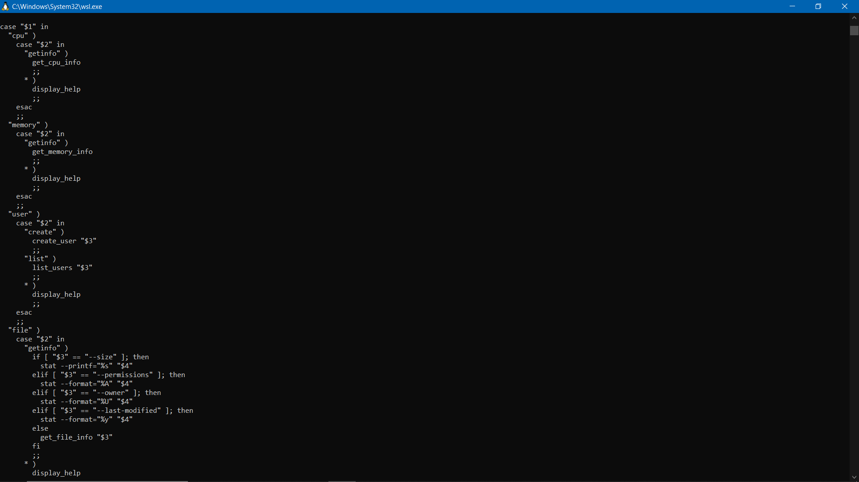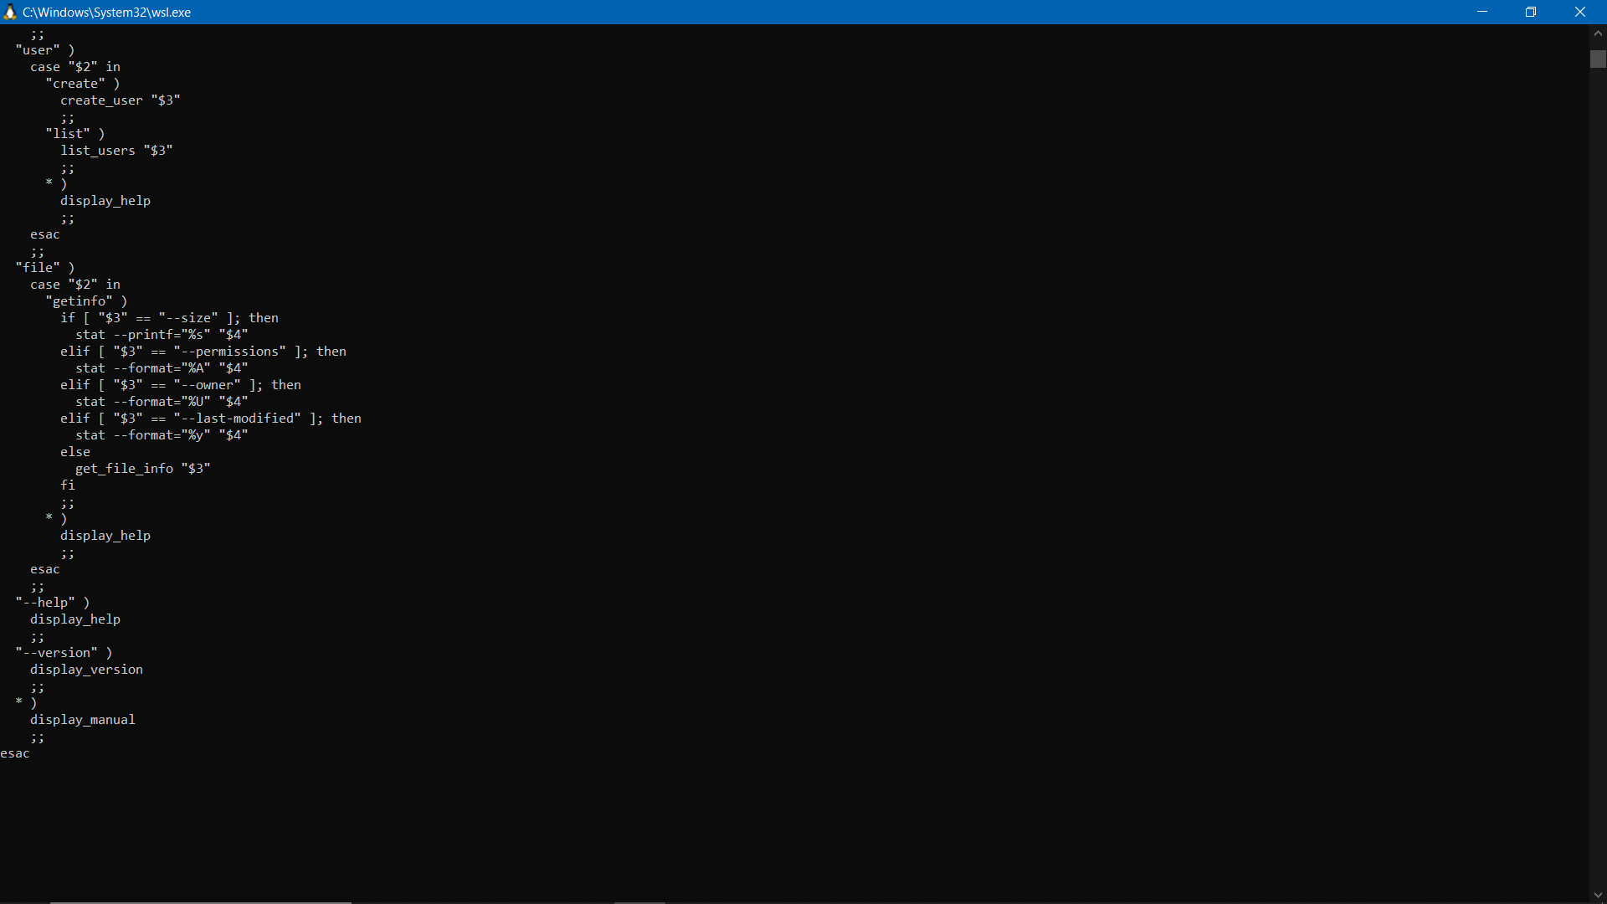

Screenshots of commands with output:

Section A

1. Version command:

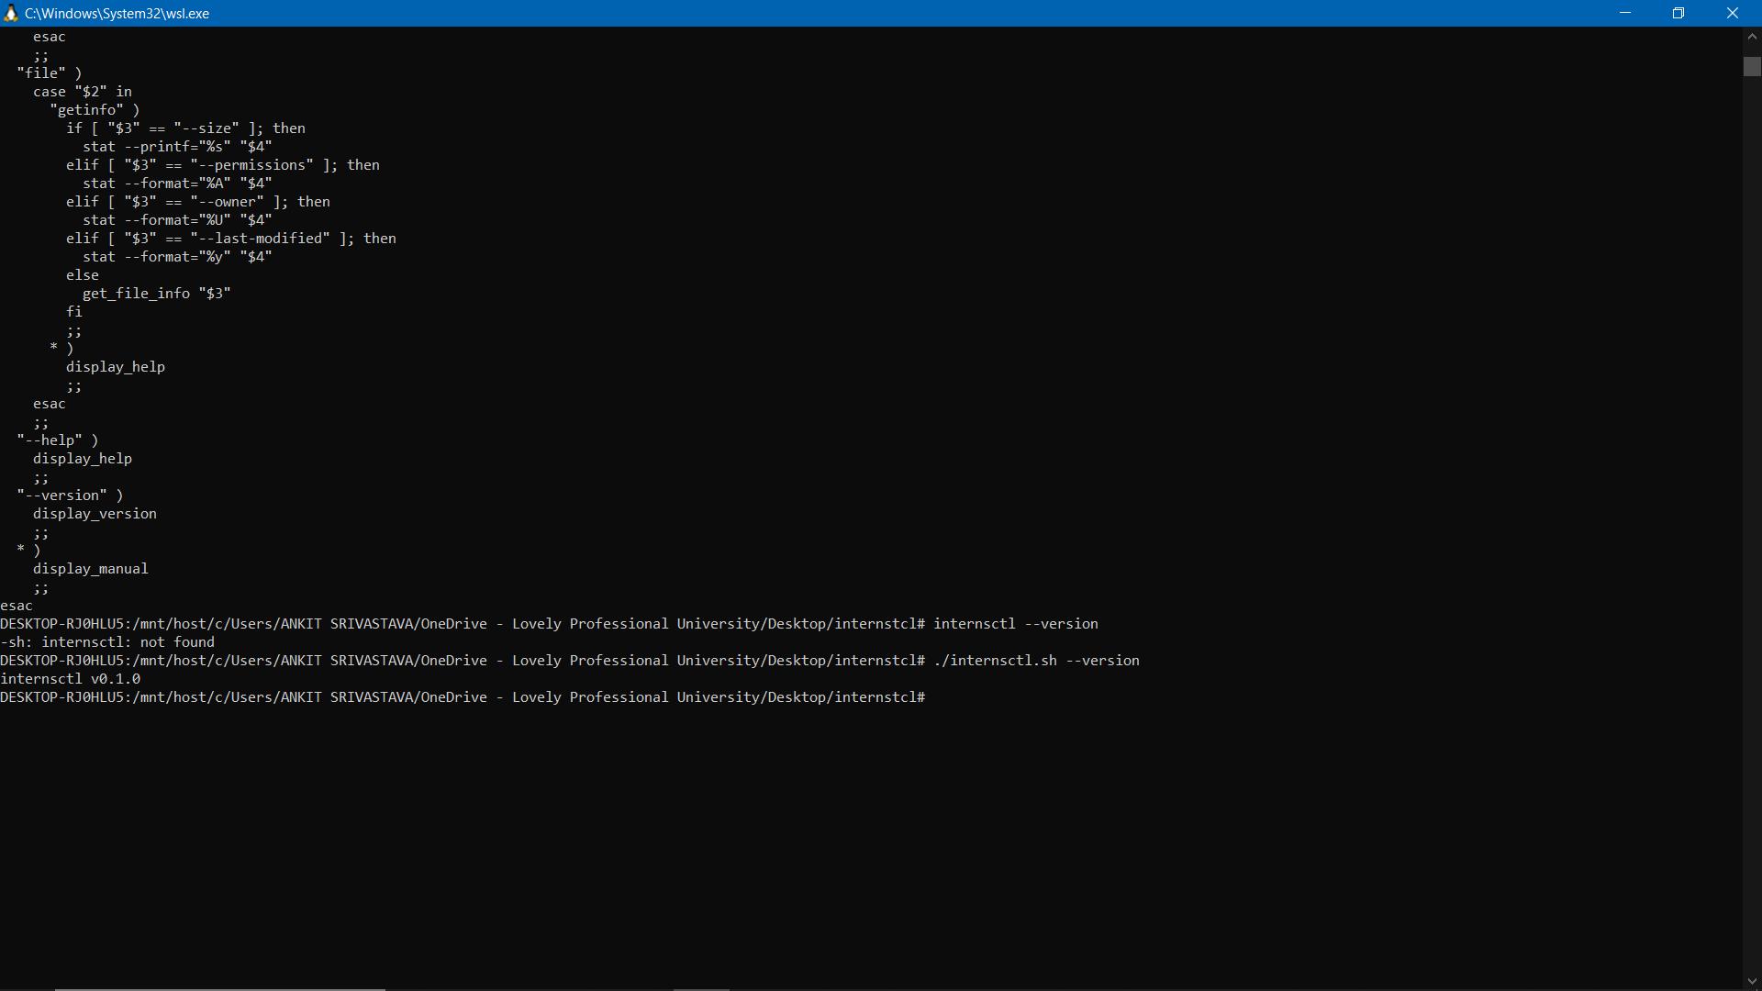

1. Help command:

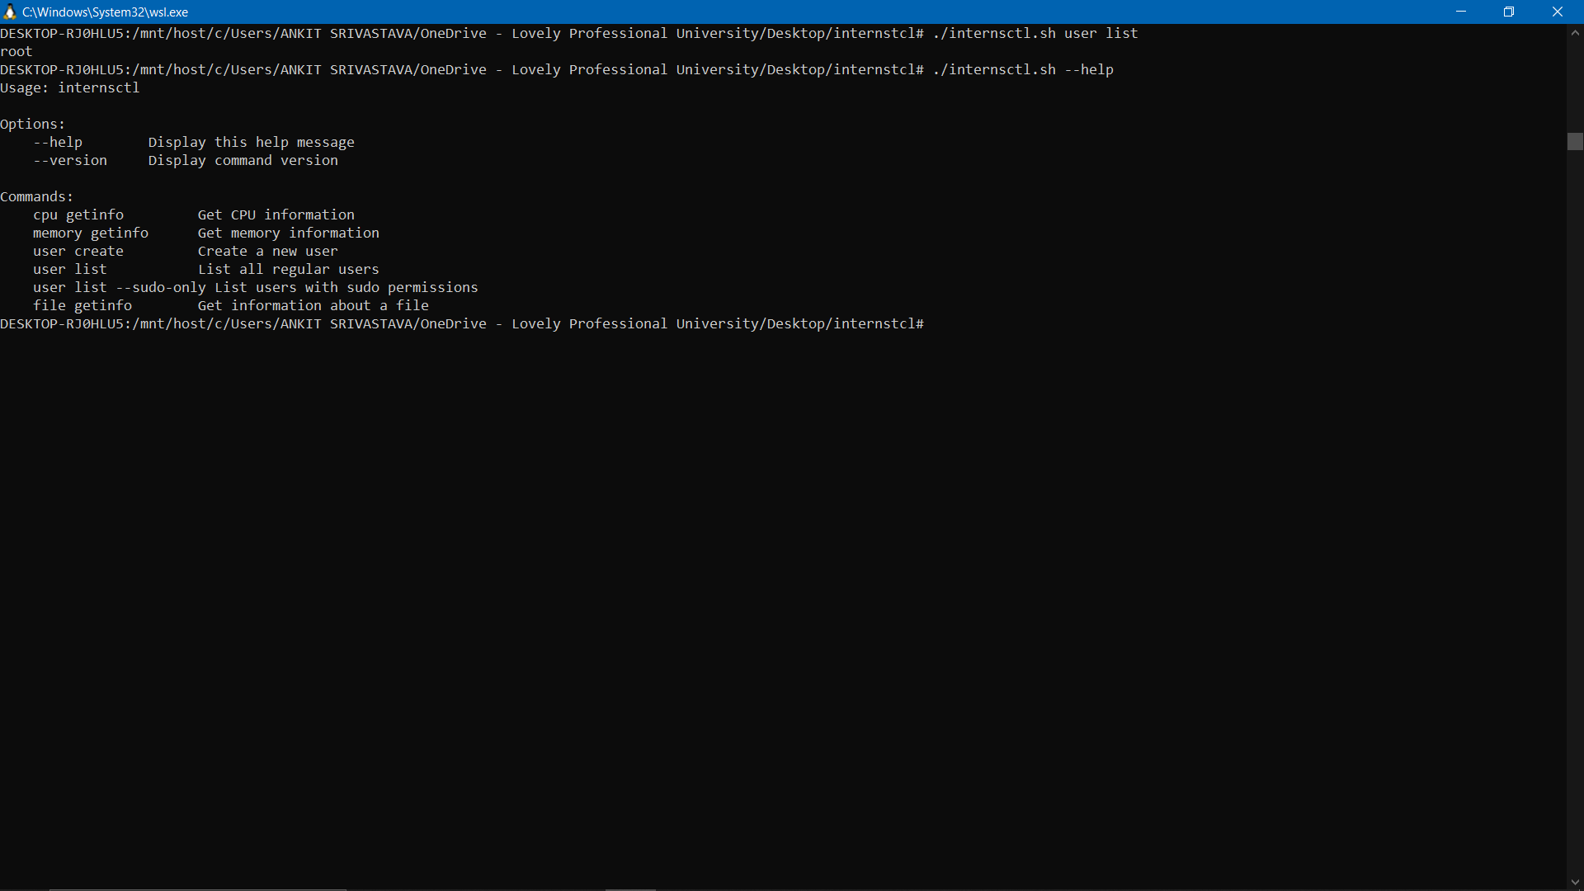

Section B

Part 1.

1. Cpu getinfo command:

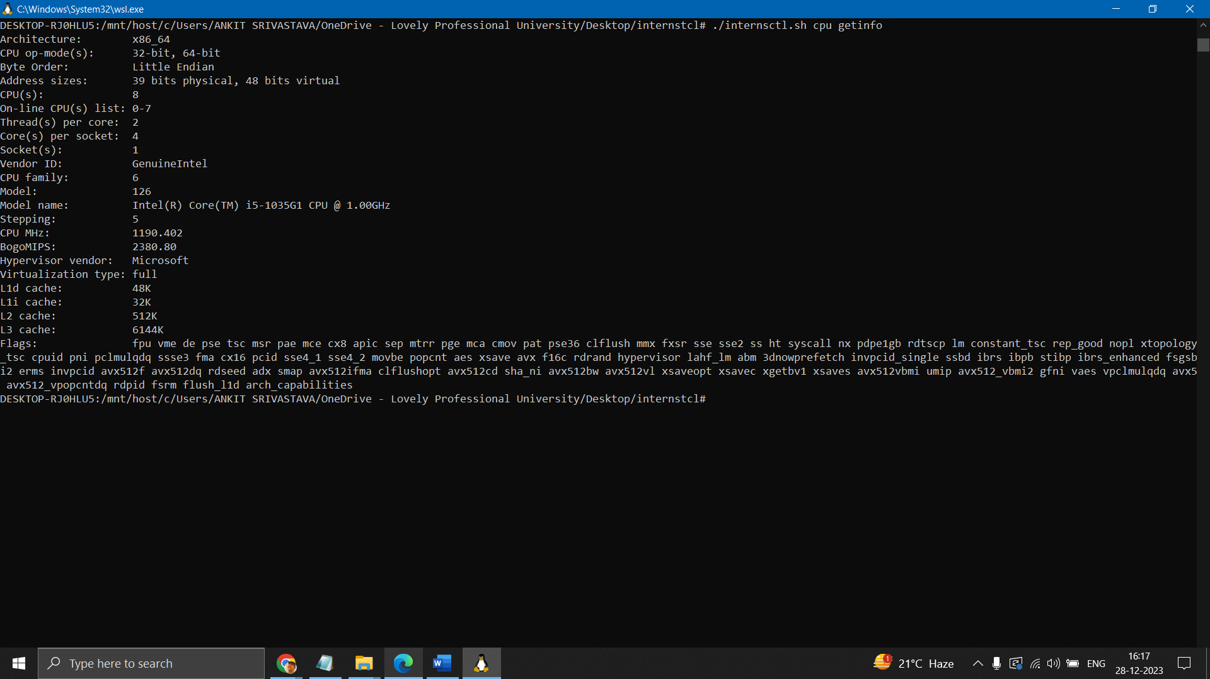

1. Memory getinfo command:

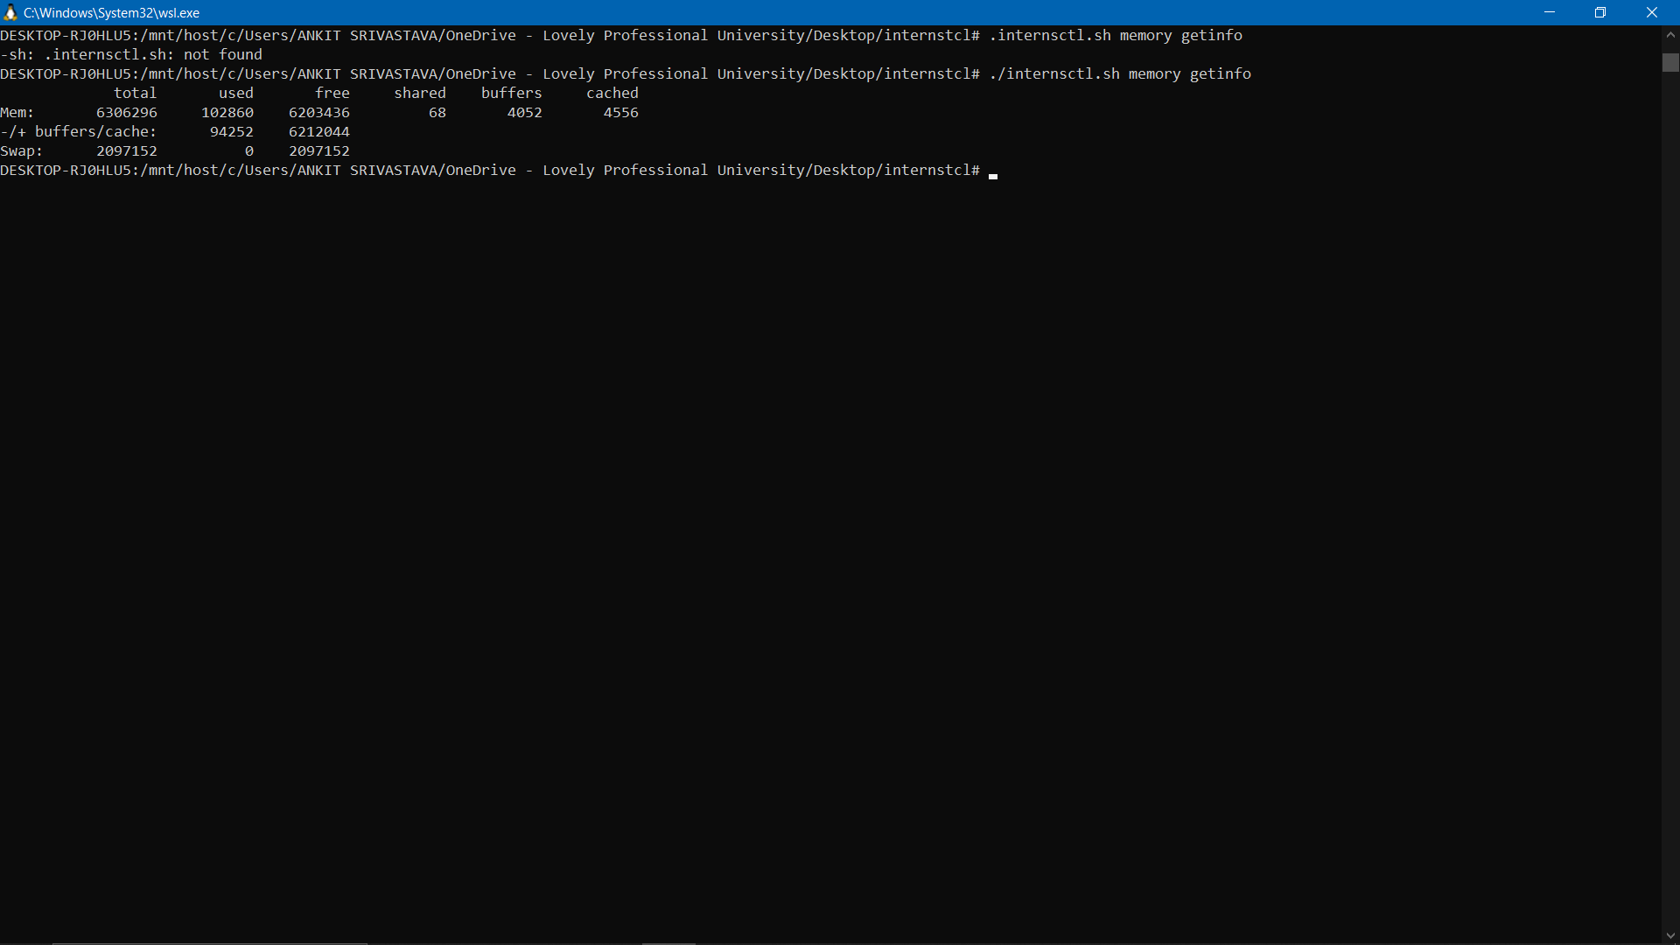

Part 2:

1. User create command: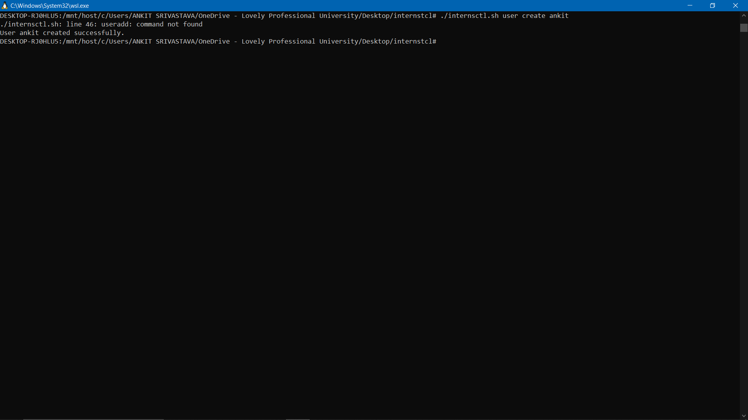
2. User list command: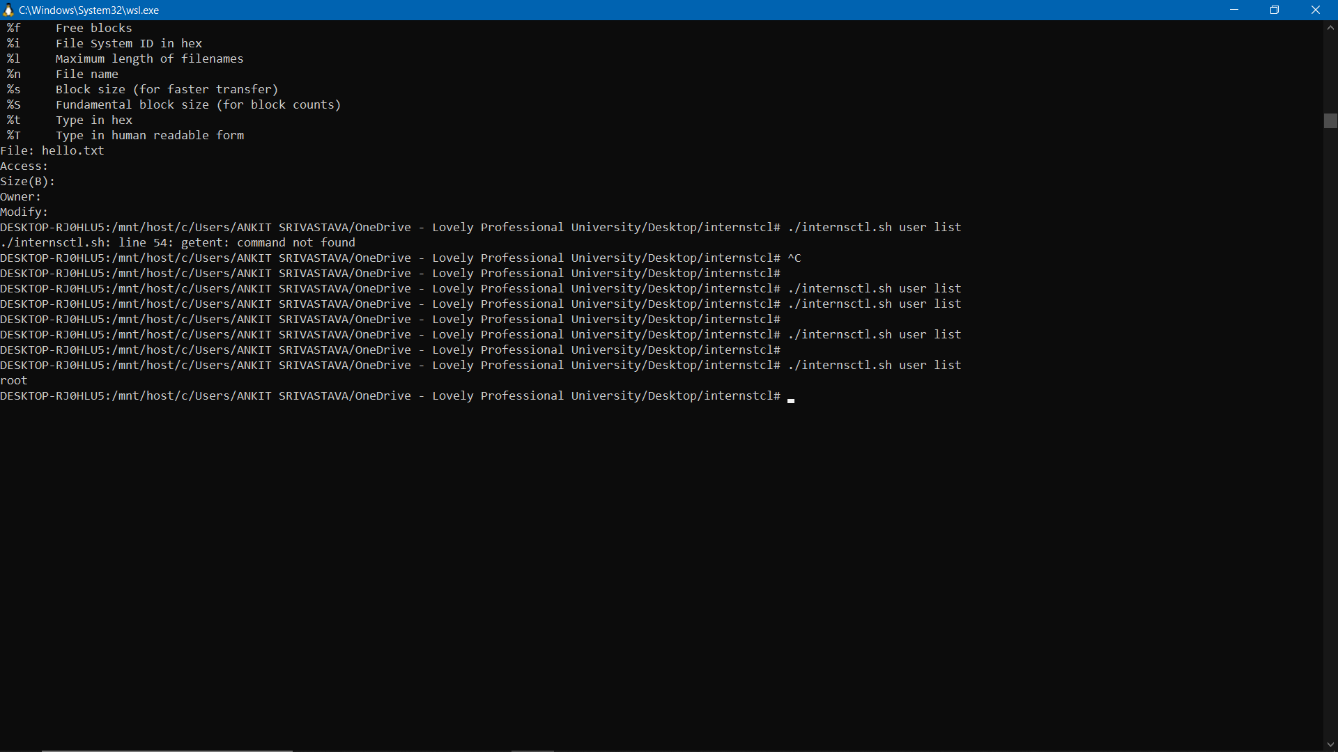

Part 3:

1. File getinfo command:

