STILL-IN-SESSION
Session Management using Servlets

Jakarta Servlets + Embedded Tomcat Web Application

Submitted by
Ananya Chandra
Registration No: 25MCA1065

1. AIM
To develop a minimal web application "Still-In-Session" using Jakarta Servlets that demonstrates HTTP session management — creating, using, and destroying sessions. The application shows how a server maintains user state across multiple HTTP requests using the HttpSession API.

2. TOOLS & TECHNOLOGIES
Component | Technology
Language | Java 17
Servlet API | Jakarta Servlet 6.0
Server | Apache Tomcat 10.1.19 (Embedded via Gretty)
Build Tool | Gradle 8.13
Frontend | HTML

3. THEORY

3.1 What is a Session?
HTTP is a stateless protocol — each request is independent with no memory of previous requests. A session is a mechanism to maintain state (user data) across multiple HTTP requests from the same client. The server creates a unique session ID and sends it to the client (usually via a cookie). The client sends this ID back with every subsequent request, allowing the server to identify the user.

3.2 Key HttpSession Methods
Method | Purpose
request.getSession() | Creates new session or returns existing one
request.getSession(false) | Returns existing session only; returns null if none exists
session.setAttribute(key, val) | Stores a value in the session
session.getAttribute(key) | Retrieves a value from the session
session.invalidate() | Destroys the session and all stored data
session.getId() | Returns the unique session identifier

4. PROCEDURE
1. Set up a Gradle project with the Gretty plugin (for embedded Tomcat) and Jakarta Servlet API dependency.
2. Created login.html — a simple HTML form with a username input field that sends a POST request to /login.
3. Created LoginServlet.java — reads the username from the form, creates an HTTP session using request.getSession(), stores the username using session.setAttribute("user", username), and redirects to /welcome.
4. Created WelcomeServlet.java — retrieves the existing session using request.getSession(false), reads the username using session.getAttribute("user"), and displays "Welcome, username!" with the session ID. If no session exists, displays "Session expired".
5. Created LogoutServlet.java — retrieves the existing session and calls session.invalidate() to destroy it, then displays a logout confirmation message with a link back to the login page.
6. Configured web.xml with servlet mappings: /login → LoginServlet, /welcome → WelcomeServlet, /logout → LogoutServlet.
7. Tested the complete session lifecycle: Login → Welcome (session active) → Logout (session destroyed).

5. SOURCE CODE

5.1 login.html (Login Form)
<!DOCTYPE html>
<html>
<head>
<title>Login Page</title>
</head>
<body>
<h2>Login Page</h2>
<!-- Simple login form that sends POST request to LoginServlet -->
<form method="POST" action="login">
<label for="username">Enter Username:</label><br><br>
<input type="text" id="username" name="username" required><br><br>
<input type="submit" value="Login">
</form>
</body>
</html>

5.2 LoginServlet.java (Session Creation)
package com.session;
import java.io.IOException;
import jakarta.servlet.ServletException;
import jakarta.servlet.http.HttpServlet;
import jakarta.servlet.http.HttpServletRequest;
import jakarta.servlet.http.HttpServletResponse;
import jakarta.servlet.http.HttpSession;
/**
* LoginServlet - Handles user login and creates a new HTTP session.
*
* When the user submits the login form, this servlet:
* 1. Reads the username from the form
* 2. Creates a new HTTP session
* 3. Stores the username in the session
* 4. Redirects to the WelcomeServlet
*/
public class LoginServlet extends HttpServlet {
@Override
protected void doPost(HttpServletRequest request, HttpServletResponse response)
throws ServletException, IOException {
// Step 1: Read the username from the login form
String username = request.getParameter("username");
// Step 2: Create a new session (or get existing one)
// getSession() creates a new session if one doesn't exist
HttpSession session = request.getSession();
// Step 3: Store the username in the session as an attribute
session.setAttribute("user", username);
// Step 4: Redirect the user to the welcome page
response.sendRedirect("welcome");
}
}

5.3 WelcomeServlet.java (Session Reading)
package com.session;
import java.io.IOException;
import java.io.PrintWriter;
import jakarta.servlet.ServletException;
import jakarta.servlet.http.HttpServlet;
import jakarta.servlet.http.HttpServletRequest;
import jakarta.servlet.http.HttpServletResponse;
import jakarta.servlet.http.HttpSession;
/**
* WelcomeServlet - Reads session data and displays a welcome message.
*
* This servlet checks if a valid session exists:
* - If yes: displays the welcome message with the username
* - If no: shows a "Session expired" message
*/
public class WelcomeServlet extends HttpServlet {
@Override
protected void doGet(HttpServletRequest request, HttpServletResponse response)
throws ServletException, IOException {
response.setContentType("text/html");
PrintWriter out = response.getWriter();
// getSession(false) returns the existing session, but does NOT create a new one
// Returns null if no session exists
HttpSession session = request.getSession(false);
if (session != null) {
// Session exists - read the username stored during login
String username = (String) session.getAttribute("user");
out.println("<html><body>");
out.println("<h2>Welcome, " + username + "!</h2>");
out.println("<p>Your session ID: " + session.getId() + "</p>");
out.println("<a href='logout'>Logout</a>");
out.println("</body></html>");
} else {
// No session found - user hasn't logged in or session expired
out.println("<html><body>");
out.println("<h2>Session expired. Please login again.</h2>");
out.println("<a href='login.html'>Login</a>");
out.println("</body></html>");
}
out.close();
}
}

5.4 LogoutServlet.java (Session Invalidation)
package com.session;
import java.io.IOException;
import java.io.PrintWriter;
import jakarta.servlet.ServletException;
import jakarta.servlet.http.HttpServlet;
import jakarta.servlet.http.HttpServletRequest;
import jakarta.servlet.http.HttpServletResponse;
import jakarta.servlet.http.HttpSession;
/**
* LogoutServlet - Invalidates the session and logs the user out.
*
* This servlet:
* 1. Gets the existing session
* 2. Invalidates (destroys) it
* 3. Shows a logout confirmation message
*/
public class LogoutServlet extends HttpServlet {
@Override
protected void doGet(HttpServletRequest request, HttpServletResponse response)
throws ServletException, IOException {
response.setContentType("text/html");
PrintWriter out = response.getWriter();
// Get the existing session (don't create a new one)
HttpSession session = request.getSession(false);
if (session != null) {
// Invalidate the session - this destroys all session data
session.invalidate();
}
// Display logout confirmation
out.println("<html><body>");
out.println("<h2>You have been logged out successfully.</h2>");
out.println("<a href='login.html'>Login Again</a>");
out.println("</body></html>");
out.close();
}
}

5.5 web.xml (Servlet Mappings)
<?xml version="1.0" encoding="UTF-8"?>
<web-app xmlns="https://jakarta.ee/xml/ns/jakartaee"
xmlns:xsi="http://www.w3.org/2001/XMLSchema-instance"
xsi:schemaLocation="https://jakarta.ee/xml/ns/jakartaee
https://jakarta.ee/xml/ns/jakartaee/web-app_6_0.xsd"
version="6.0">
<display-name>Session Management Demo</display-name>
<!-- Welcome file - shown when accessing the root URL -->
<welcome-file-list>
<welcome-file>login.html</welcome-file>
</welcome-file-list>
<!-- LoginServlet mapping -->
<servlet>
<servlet-name>LoginServlet</servlet-name>
<servlet-class>com.session.LoginServlet</servlet-class>
</servlet>
<servlet-mapping>
<servlet-name>LoginServlet</servlet-name>
<url-pattern>/login</url-pattern>
</servlet-mapping>
<!-- WelcomeServlet mapping -->
<servlet>
<servlet-name>WelcomeServlet</servlet-name>
<servlet-class>com.session.WelcomeServlet</servlet-class>
</servlet>
<servlet-mapping>
<servlet-name>WelcomeServlet</servlet-name>
<url-pattern>/welcome</url-pattern>
</servlet-mapping>
<!-- LogoutServlet mapping -->
<servlet>
<servlet-name>LogoutServlet</servlet-name>
<servlet-class>com.session.LogoutServlet</servlet-class>
</servlet>
<servlet-mapping>
<servlet-name>LogoutServlet</servlet-name>
<url-pattern>/logout</url-pattern>
</servlet-mapping>
</web-app>

6. OUTPUT SCREENSHOTS

6.1 Login Page
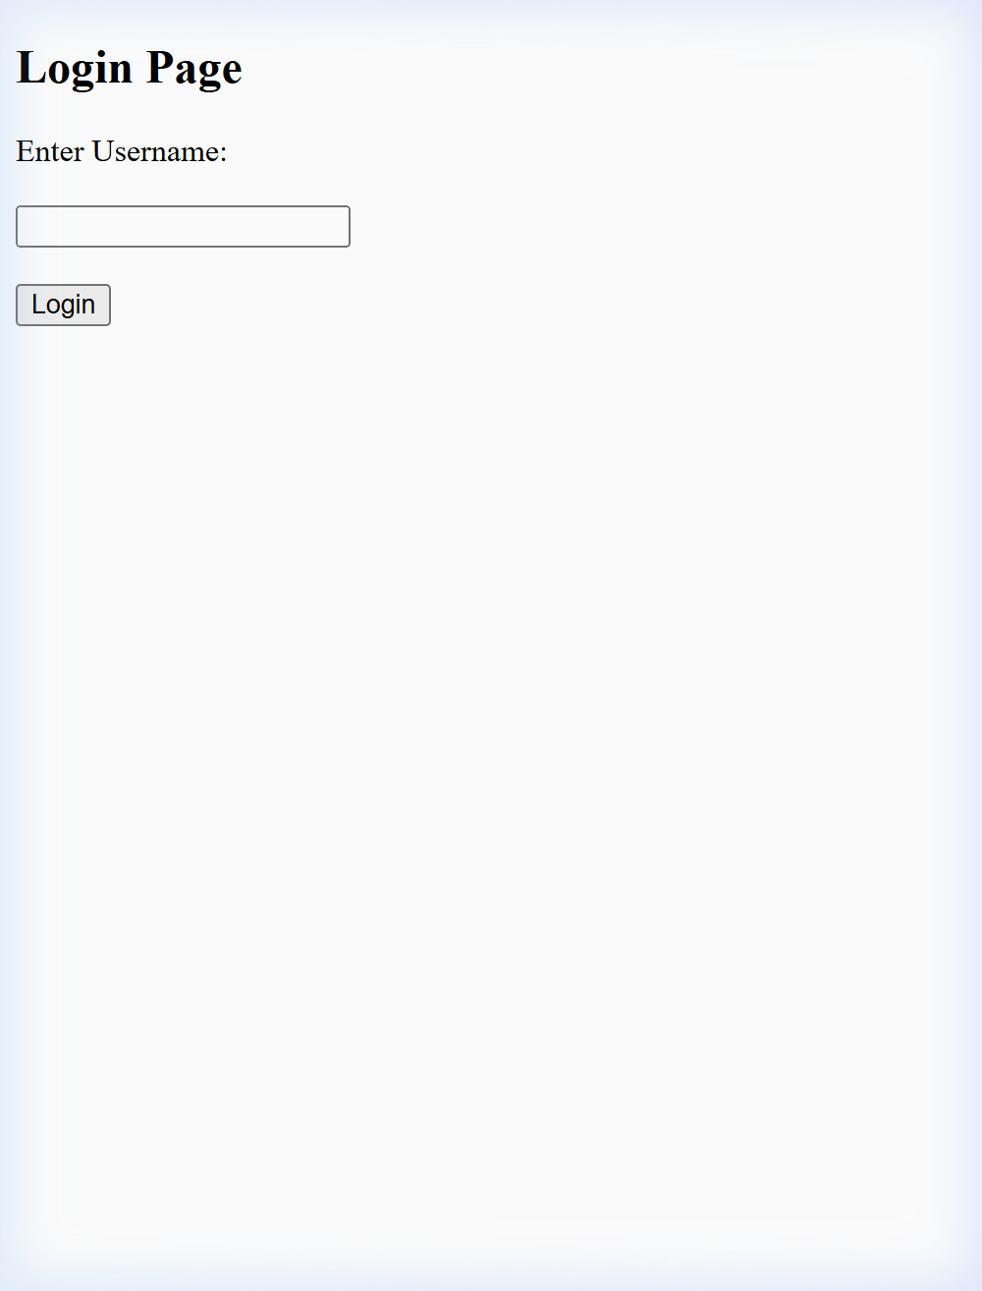
Figure 1: Login Page with Username Input

6.2 Welcome Page (Session Active)
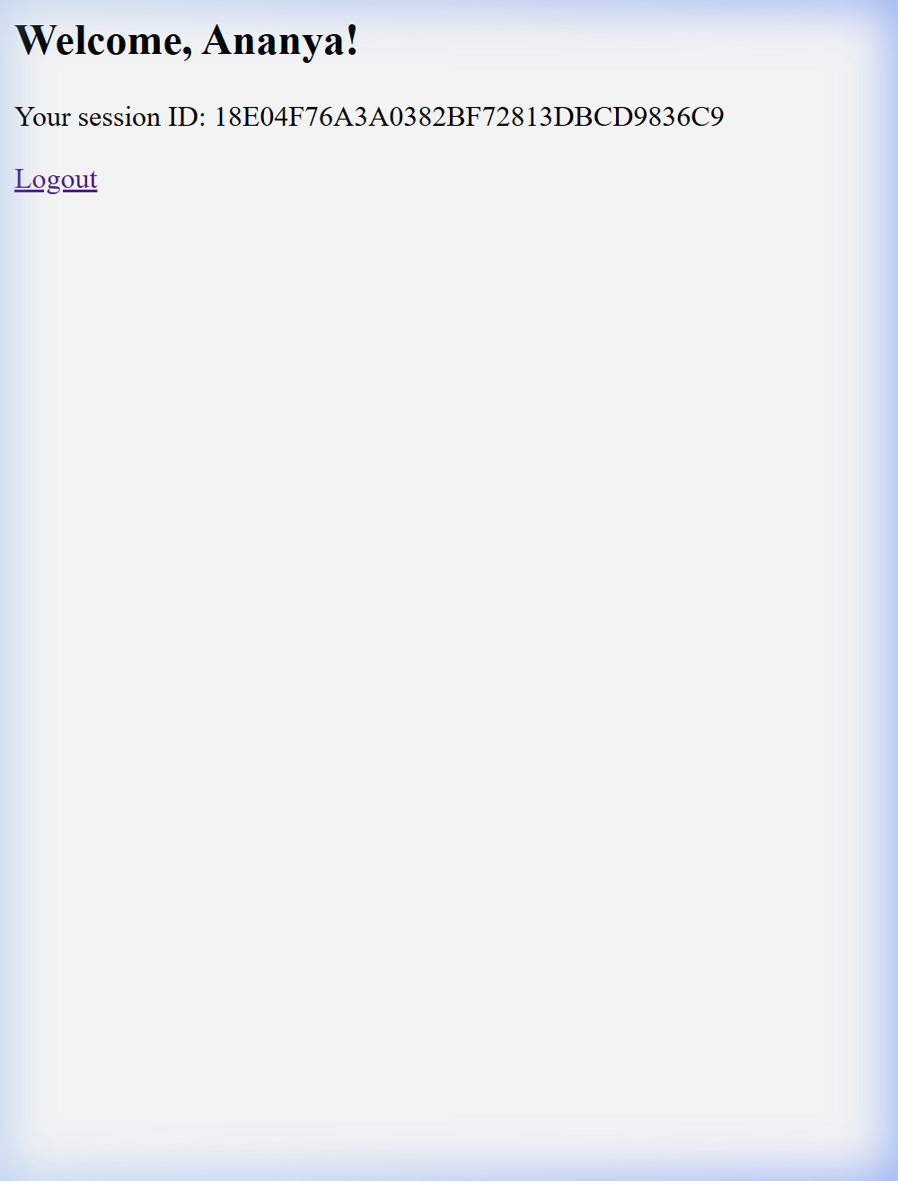
Figure 2: Welcome Page Displaying Session Data

6.3 Logout Page (Session Destroyed)
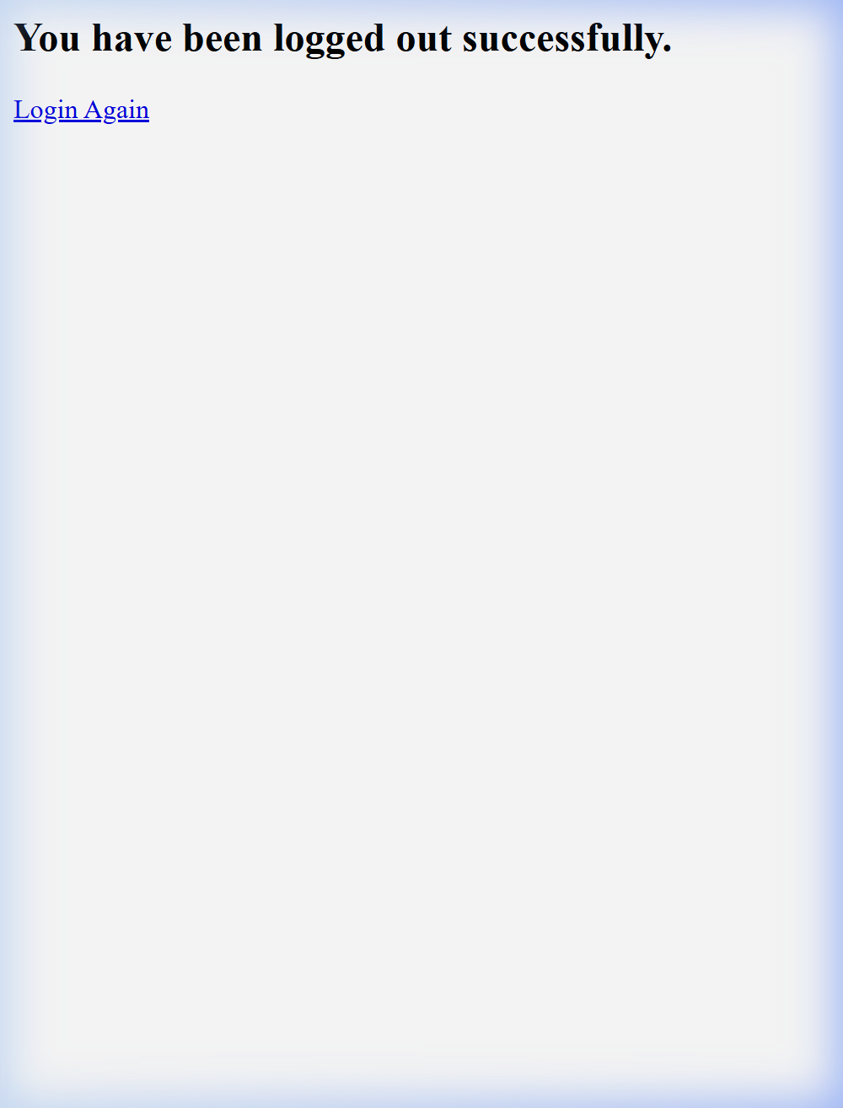
Figure 3: Logout Confirmation After Session Invalidation

7. CONCLUSION
The "Still-In-Session" application was successfully developed using Jakarta Servlets and deployed on an embedded Tomcat 10 server. It demonstrates the complete HTTP session lifecycle — creating a session on login, storing and retrieving user data across requests, and destroying the session on logout. The application illustrates how Java Servlets use the HttpSession API to maintain state in the inherently stateless HTTP protocol, which is a fundamental concept in web application development.

