STILL-IN-SESSION
HTTP Session Management Demo

Java Jakarta Servlets Application

Submitted by
Ananya Chandra
Registration No: 25MCA1065

1. AIM
To develop a minimal web application "Still-In-Session" using Jakarta Servlets that demonstrates the complete lifecycle of HTTP Session Management, including session creation, attribute storage, attribute retrieval, and session invalidation across multiple requests.

2. TOOLS & TECHNOLOGIES
Component | Technology
Language | Java 17
Web API | Jakarta Servlet 6.0
Server | Embedded Tomcat 10.1.19
Frontend | HTML5
Build Tool | Gradle (Gretty Plugin)

3. PROCEDURE
1. Set up Gradle project with the Gretty plugin for embedded Tomcat 10 and Jakarta Servlet API 6.0.
2. Created a simple HTML login form (login.html) to capture a username and POST it to the server.
3. Developed LoginServlet.java handles the POST request, retrieves the username parameter, creates a new HTTP session (request.getSession()), stores the username as a session attribute, and redirects.
4. Developed WelcomeServlet.java retrieves the existing session (request.getSession(false)), reads the username attribute, and renders a dynamic welcome page showing the Session ID.
5. Developed LogoutServlet.java retrieves the existing session, calls session.invalidate() to destroy all session data, and displays a logout confirmation.
6. Configured web.xml deployment descriptor to map URL patterns (/login, /welcome, /logout) to their respective servlet classes.
7. Tested the complete flow (Login -> Welcome -> Logout) locally on embedded Tomcat.

4. KEY SESSION METHODS USED
Method | Purpose
request.getSession() | Creates a new session or retrieves an existing one.
request.getSession(false) | Retrieves existing session only (returns null if none exists).
session.setAttribute("key", value) | Stores an object within the session state.
session.getAttribute("key") | Retrieves a previously stored object from the session.
session.invalidate() | Destroys the session and unbinds all its objects.
session.getId() | Returns a string containing the unique identifier assigned to this session.

5. SOURCE CODE

5.1 LoginServlet.java (Session Creation)
package com.session;
import java.io.IOException;
import jakarta.servlet.ServletException;
import jakarta.servlet.http.HttpServlet;
import jakarta.servlet.http.HttpServletRequest;
import jakarta.servlet.http.HttpServletResponse;
import jakarta.servlet.http.HttpSession;
/**
* LoginServlet - Handles user login and creates a new HTTP session.
*
* When the user submits the login form, this servlet:
* 1. Reads the username from the form
* 2. Creates a new HTTP session
* 3. Stores the username in the session
* 4. Redirects to the WelcomeServlet
*/
public class LoginServlet extends HttpServlet {
@Override
protected void doPost(HttpServletRequest request, HttpServletResponse response)
throws ServletException, IOException {
// Step 1: Read the username from the login form
String username = request.getParameter("username");
// Step 2: Create a new session (or get existing one)
// getSession() creates a new session if one doesn't exist
HttpSession session = request.getSession();
// Step 3: Store the username in the session as an attribute
session.setAttribute("user", username);
// Step 4: Redirect the user to the welcome page
response.sendRedirect("welcome");
}
}

5.2 WelcomeServlet.java (Session Usage)
package com.session;
import java.io.IOException;
import java.io.PrintWriter;
import jakarta.servlet.ServletException;
import jakarta.servlet.http.HttpServlet;
import jakarta.servlet.http.HttpServletRequest;
import jakarta.servlet.http.HttpServletResponse;
import jakarta.servlet.http.HttpSession;
/**
* WelcomeServlet - Reads session data and displays a welcome message.
*
* This servlet checks if a valid session exists:
* - If yes: displays the welcome message with the username
* - If no: shows a "Session expired" message
*/
public class WelcomeServlet extends HttpServlet {
@Override
protected void doGet(HttpServletRequest request, HttpServletResponse response)
throws ServletException, IOException {
response.setContentType("text/html");
PrintWriter out = response.getWriter();
// getSession(false) returns the existing session, but does NOT create a new one
// Returns null if no session exists
HttpSession session = request.getSession(false);
if (session != null) {
// Session exists - read the username stored during login
String username = (String) session.getAttribute("user");
out.println("<html><body>");
out.println("<h2>Welcome, " + username + "!</h2>");
out.println("<p>Your session ID: " + session.getId() + "</p>");
out.println("<a href='logout'>Logout</a>");
out.println("</body></html>");
} else {
// No session found - user hasn't logged in or session expired
out.println("<html><body>");
out.println("<h2>Session expired. Please login again.</h2>");
out.println("<a href='login.html'>Login</a>");
out.println("</body></html>");
}
out.close();
}
}

5.3 LogoutServlet.java (Session Invalidation)
package com.session;
import java.io.IOException;
import java.io.PrintWriter;
import jakarta.servlet.ServletException;
import jakarta.servlet.http.HttpServlet;
import jakarta.servlet.http.HttpServletRequest;
import jakarta.servlet.http.HttpServletResponse;
import jakarta.servlet.http.HttpSession;
/**
* LogoutServlet - Invalidates the session and logs the user out.
*
* This servlet:
* 1. Gets the existing session
* 2. Invalidates (destroys) it
* 3. Shows a logout confirmation message
*/
public class LogoutServlet extends HttpServlet {
@Override
protected void doGet(HttpServletRequest request, HttpServletResponse response)
throws ServletException, IOException {
response.setContentType("text/html");
PrintWriter out = response.getWriter();
// Get the existing session (don't create a new one)
HttpSession session = request.getSession(false);
if (session != null) {
// Invalidate the session - this destroys all session data
session.invalidate();
}
// Display logout confirmation
out.println("<html><body>");
out.println("<h2>You have been logged out successfully.</h2>");
out.println("<a href='login.html'>Login Again</a>");
out.println("</body></html>");
out.close();
}
}

6. OUTPUT SCREENSHOTS

6.1 Login Page (/SessionDemo/)
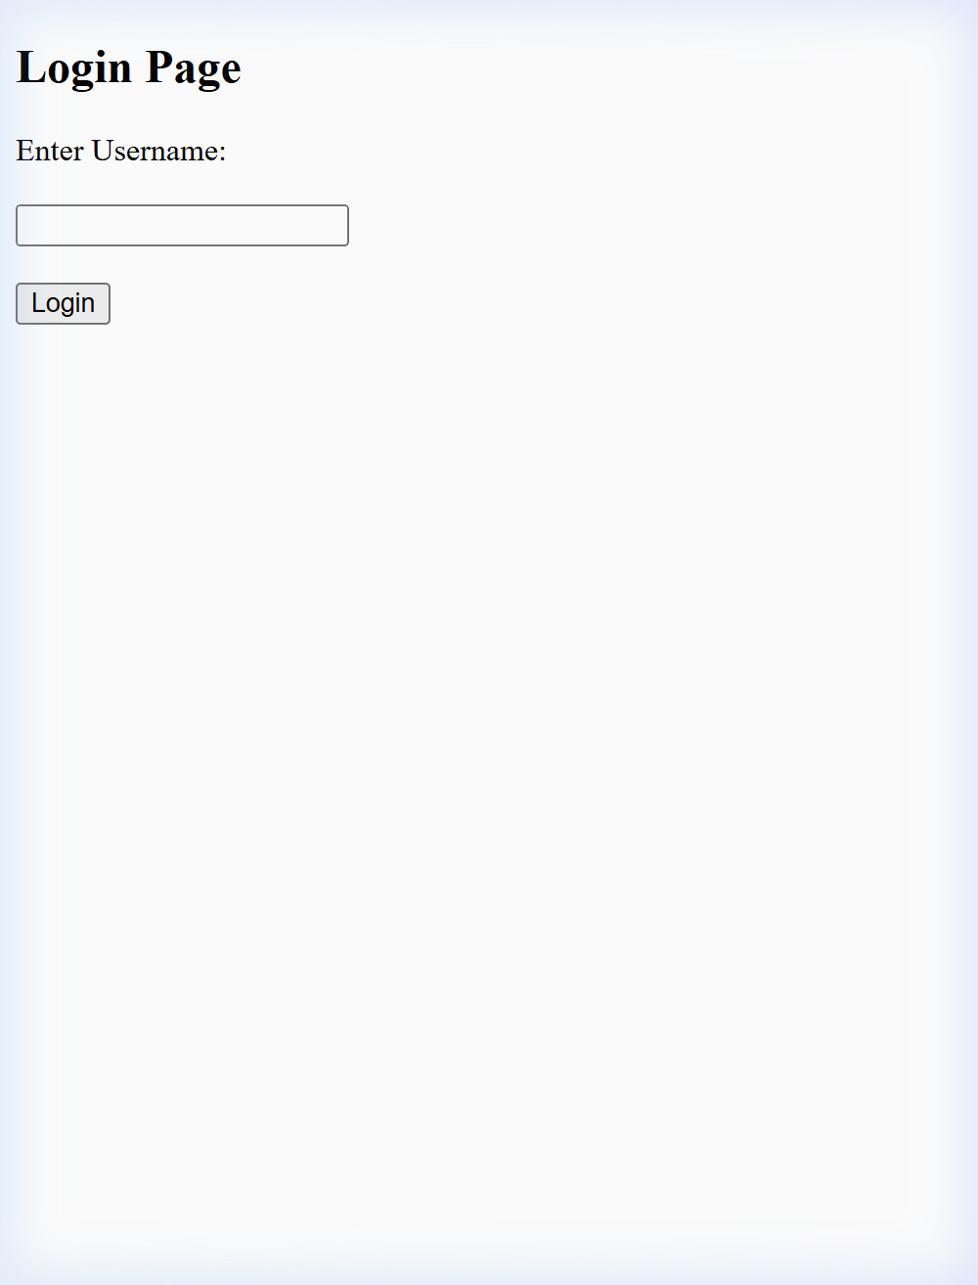
Figure 1: HTML Login Form taking username input.

6.2 Welcome Page (/welcome)
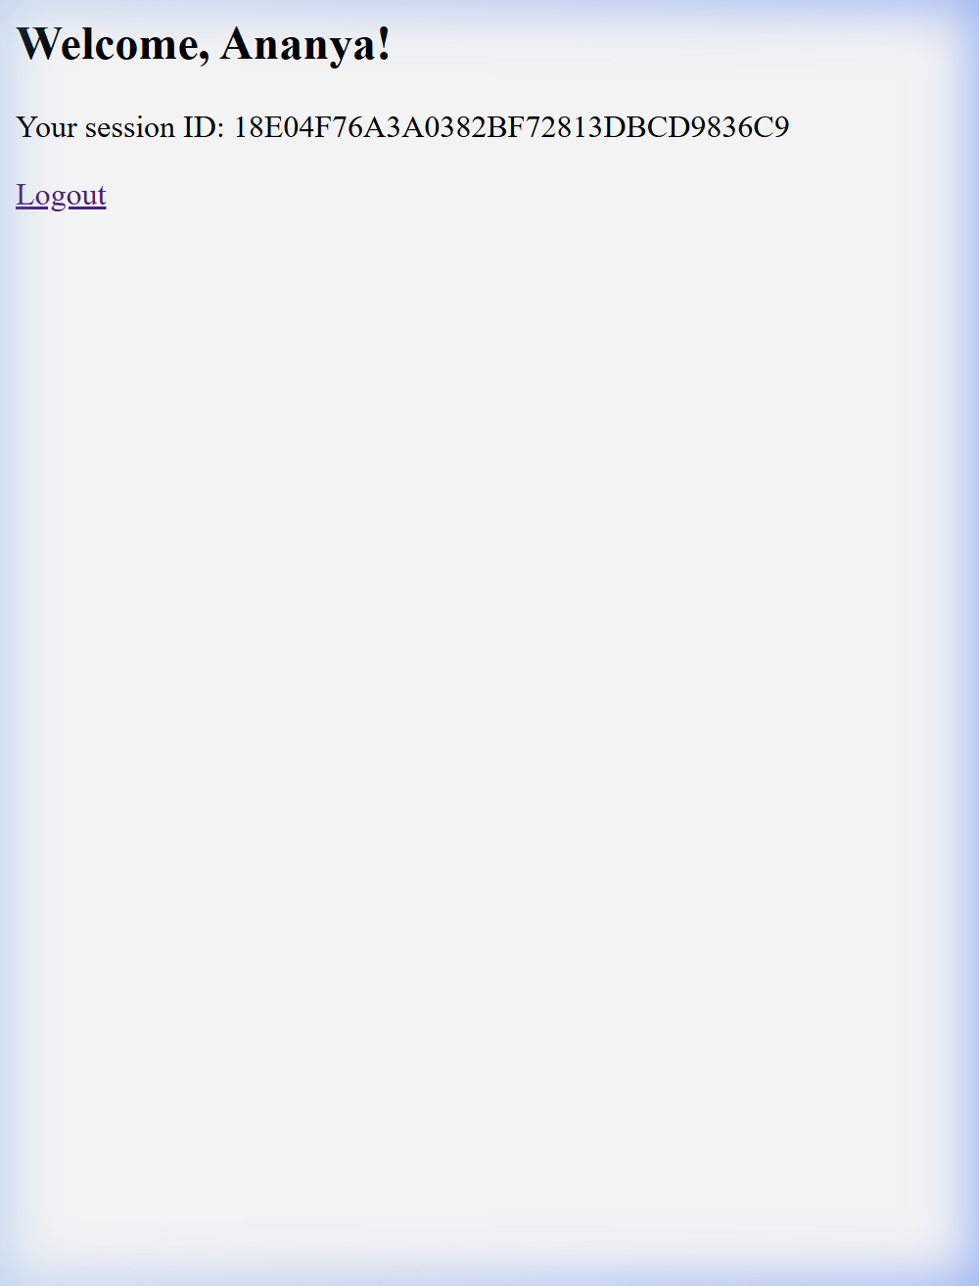
Figure 2: Dynamic Welcome page showing retrieved username and active Session ID.

6.3 Logout Page (/logout)

Figure 3: Confirmation page after session.invalidate() was called.

7. CONCLUSION
The "Still-In-Session" application was successfully implemented and tested on an embedded Tomcat server. It clearly demonstrated the ability of HTTP Sessions to overcome the stateless nature of the HTTP protocol by persisting user-specific data (username) across consecutive page requests, and properly clearing that data upon logout. The project met all functional requirements for a servlet-based session management lab.

