EX. NO: 1a
SETTING UP PYTHON ENVIRONMENT AND LIBRARIES – JUPYTER NOTEBOOK
AIM:
To install Python, configure Jupyter Notebook, understand the notebook environment, execute Python programs, create Markdown cells, install and verify the core data-analytics libraries (NumPy, Pandas, Matplotlib, Seaborn), and load the sales dataset into the notebook environment for Data Analytics applications.
ALGORITHM:
- Download Python from the official Python website (www.python.org).
- Run the Python installer, select "Add Python to PATH", and complete the installation.
- Verify that Python is installed successfully using the version command.
- Open Command Prompt and install Jupyter Notebook using pip.
- Install the data-analytics libraries NumPy, Pandas, Matplotlib and Seaborn using pip.
- Launch Jupyter Notebook to open the Notebook Dashboard.
- Create a new Python 3 notebook from the dashboard and rename it.
- Create Code cells and Markdown cells in the notebook.
- Execute the cells using Shift + Enter and observe the output.
- Import the installed libraries and verify their versions.
- Load the sales dataset into a Pandas DataFrame and display it.
- Plot a simple graph to confirm that the visualisation library is working.
- Save the notebook and observe the output.
PROGRAM:
Step 1: Verifying the Python installation
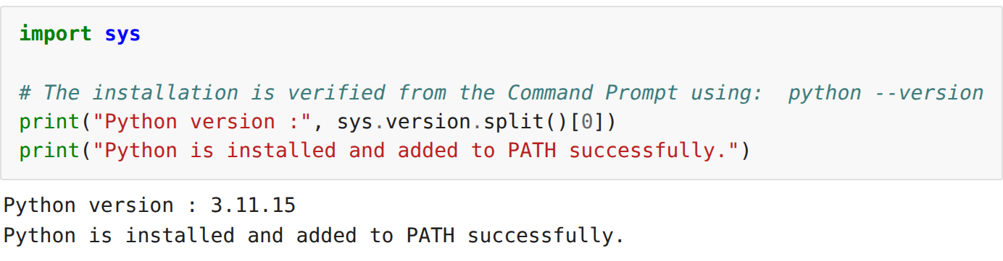
Step 2: Installing the required libraries
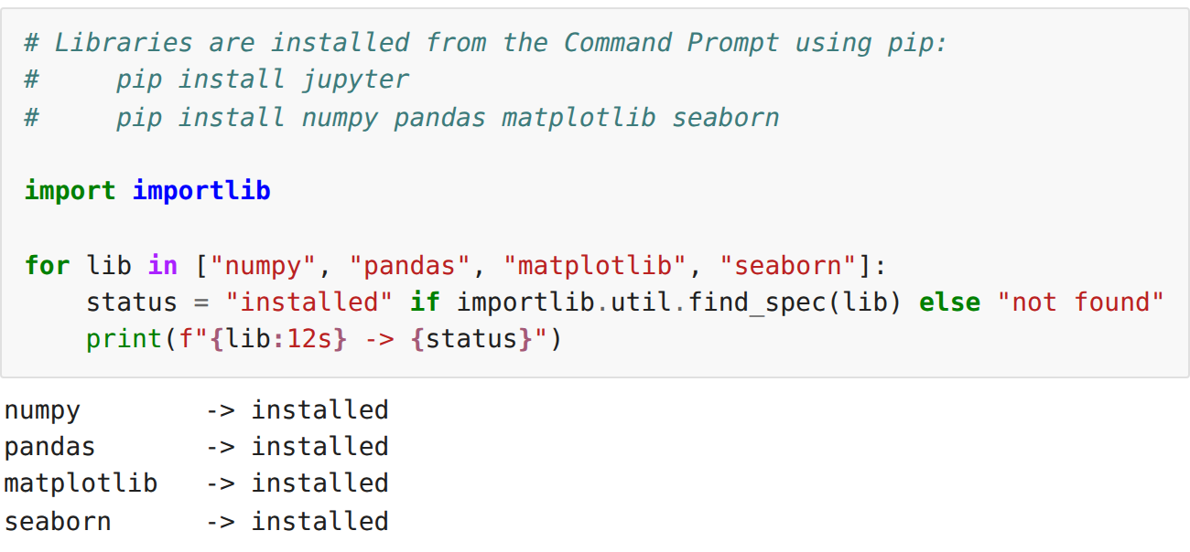
Step 3: Importing the libraries and verifying their versions
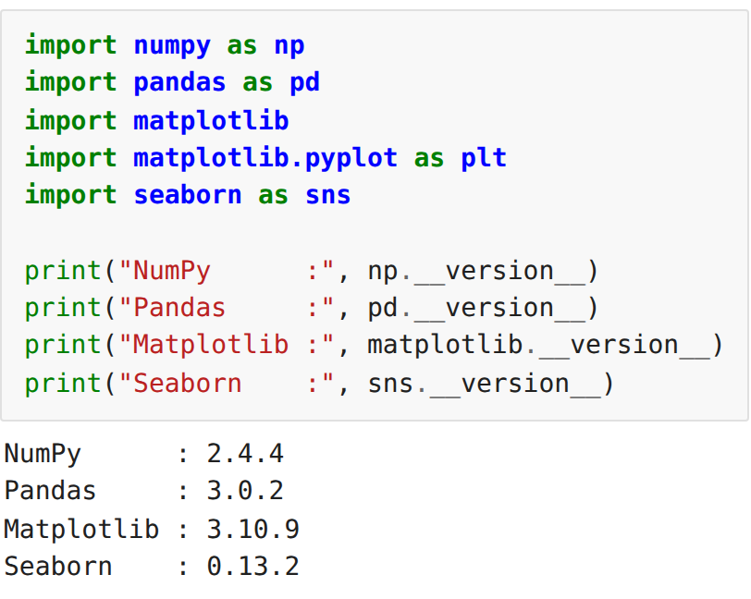
Step 4: Executing a basic Python program in a Code cell
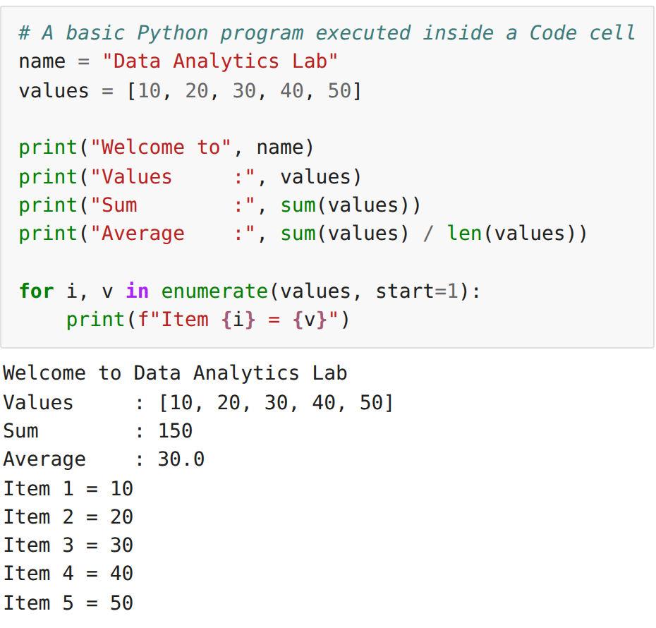
Step 5: Creating a Markdown cell
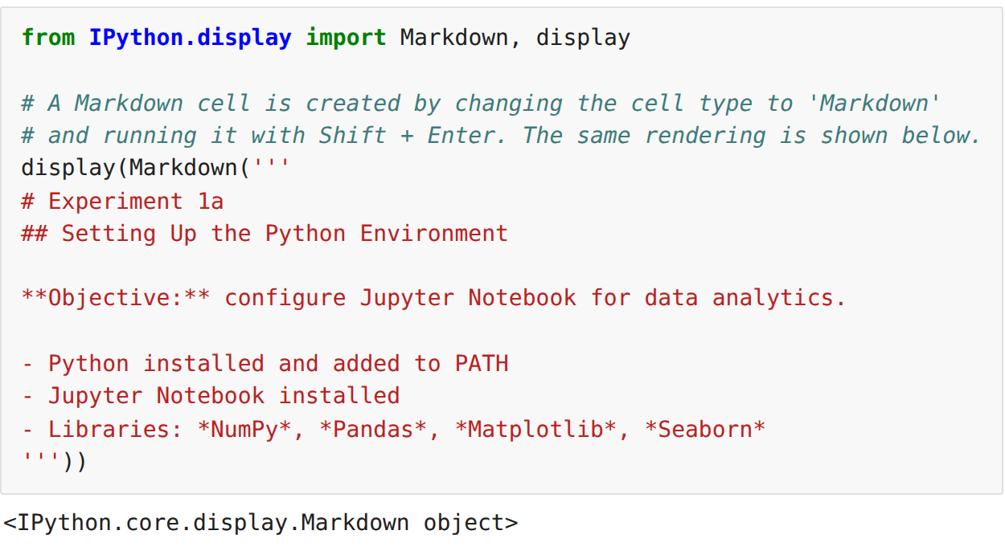
Step 6: Loading the sales dataset into the notebook
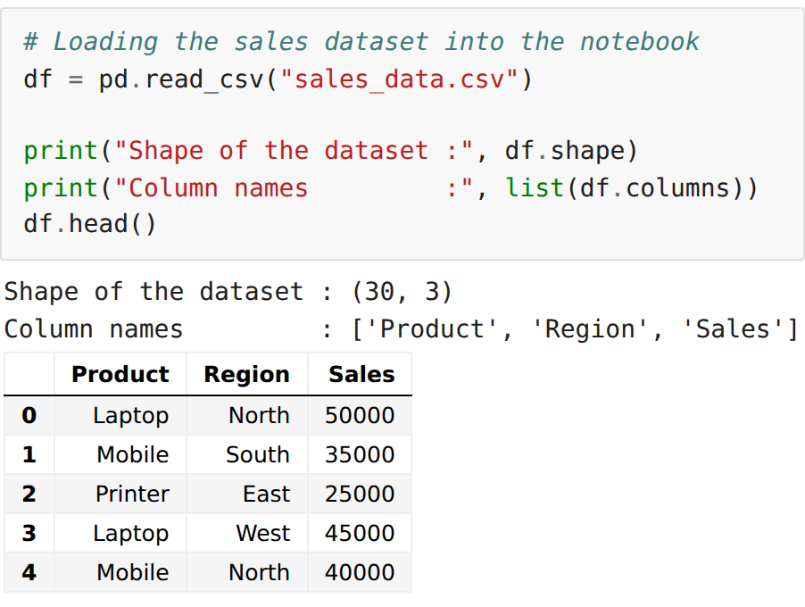
Step 7: Verifying Matplotlib with a simple plot
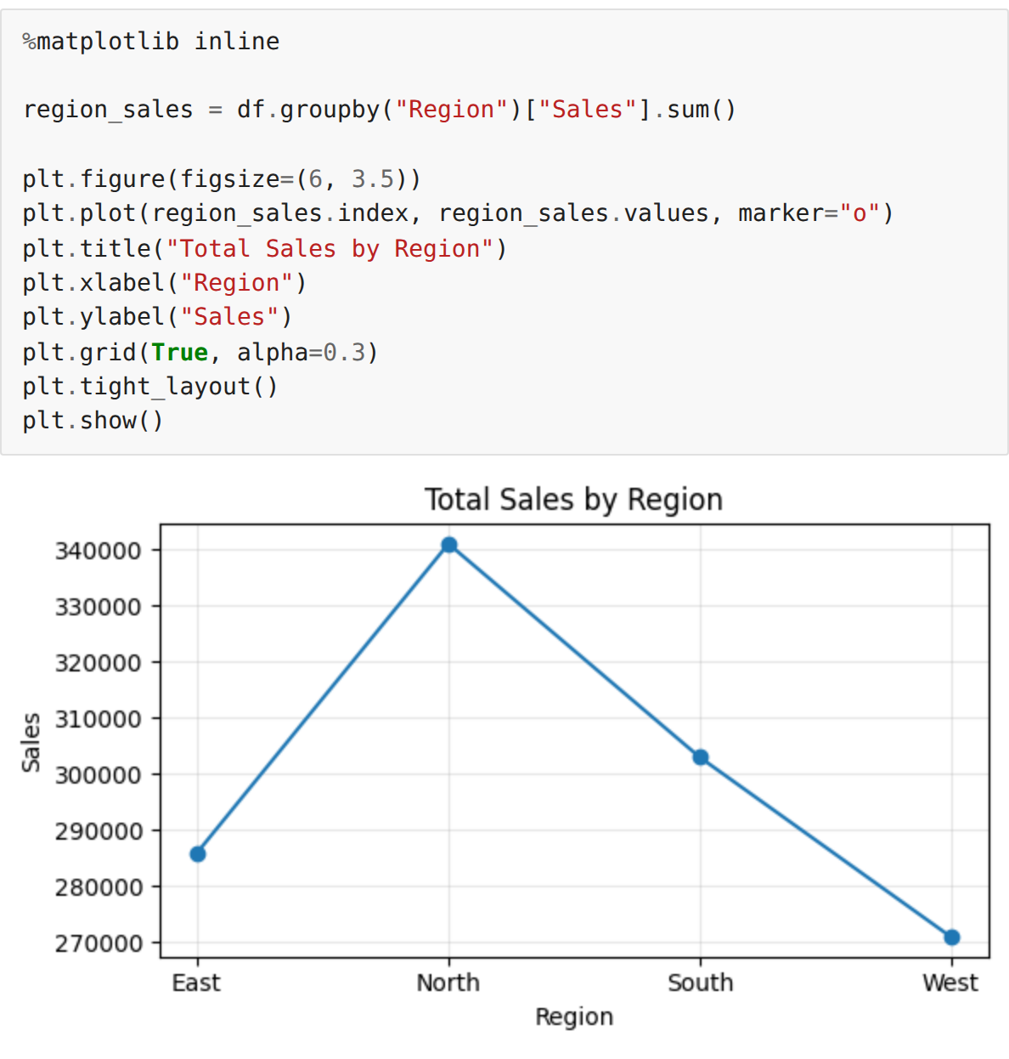
RESULT:
Thus the Python environment was set up successfully, Jupyter Notebook was configured, the required data-analytics libraries were installed and verified, Code and Markdown cells were created and executed, and the sales dataset was loaded and plotted successfully.

