EX. NO: 1b
EXPLORATORY DATA ANALYSIS – DATA SCIENCE FRAMEWORKS (CRISP-DM, SEMMA, KDD)
AIM:
To study the three standard data science process frameworks — CRISP-DM, SEMMA and KDD — and to apply the phases of each framework practically on the sales dataset using Python, so as to understand how a data analytics problem is carried out from business understanding to interpretation of results.
ALGORITHM:
- Study the six phases of CRISP-DM: Business Understanding, Data Understanding, Data Preparation, Modeling, Evaluation and Deployment.
- Study the five stages of SEMMA: Sample, Explore, Modify, Model and Assess.
- Study the five steps of KDD: Selection, Pre-processing, Transformation, Data Mining and Interpretation/Evaluation.
- Import the required libraries and load the sales dataset.
- Apply the CRISP-DM phases: state the business objective, understand the data using info() and describe(), prepare the data, build a simple model and evaluate it.
- Apply the SEMMA stages: sample the data, explore it using grouping, modify it by adding derived columns, model it and assess the result.
- Apply the KDD steps: select the relevant attributes, pre-process, transform, mine the data for patterns and interpret the discovered knowledge.
- Compare the three frameworks and tabulate their phases side by side.
- Observe and record the output of each phase.
PROGRAM:
Step 1: Importing libraries and loading the dataset
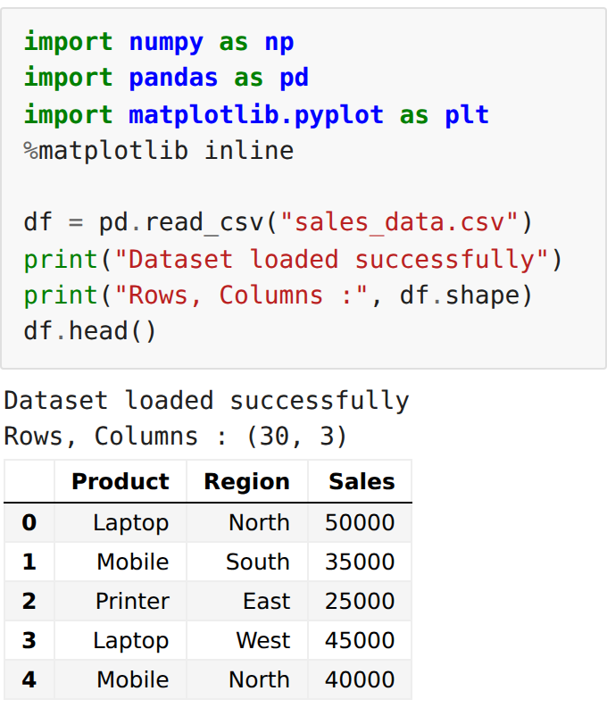
CRISP-DM Phase 1 & 2: Business Understanding and Data Understanding
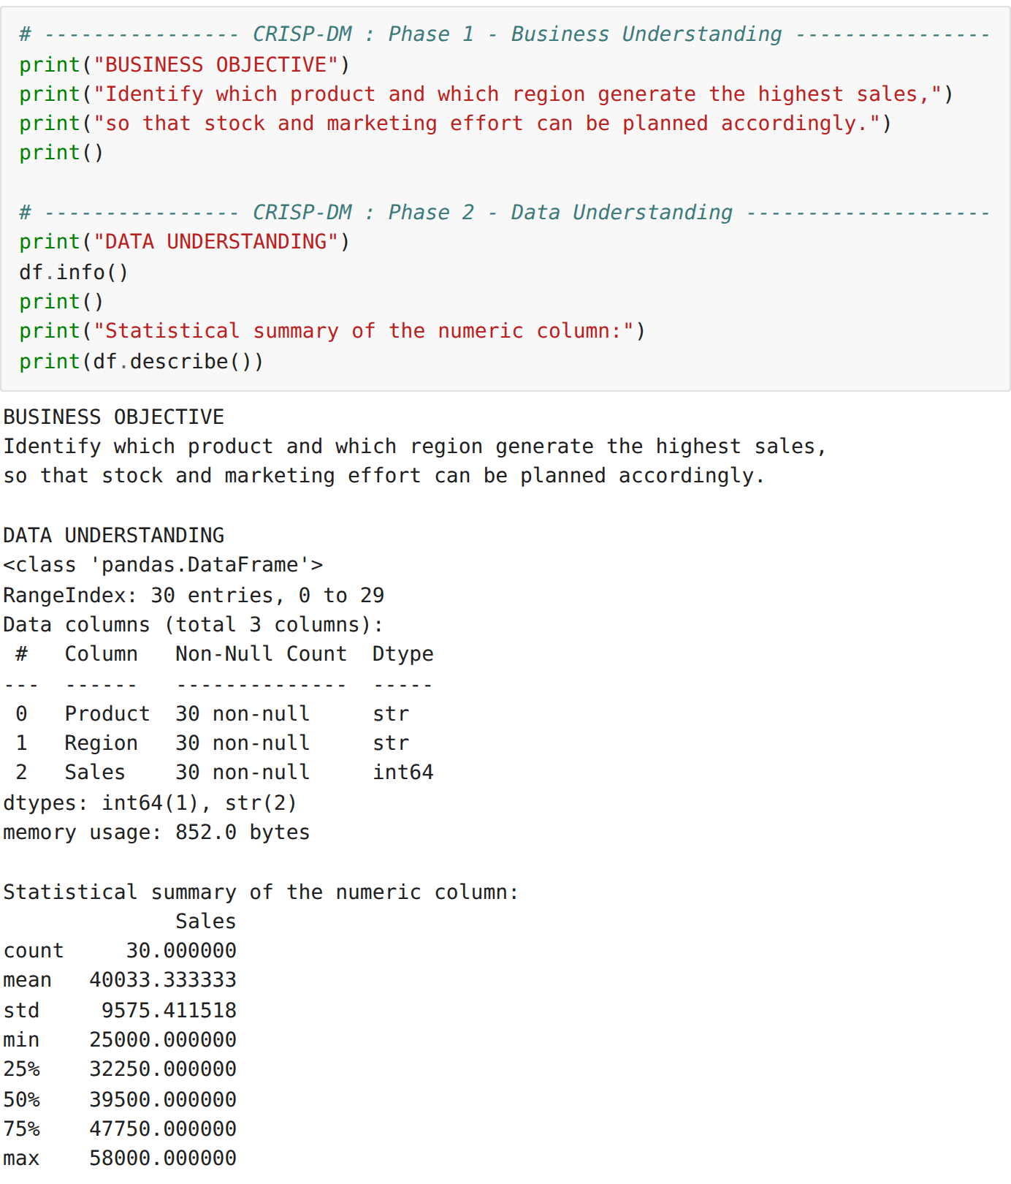
CRISP-DM Phase 3: Data Preparation
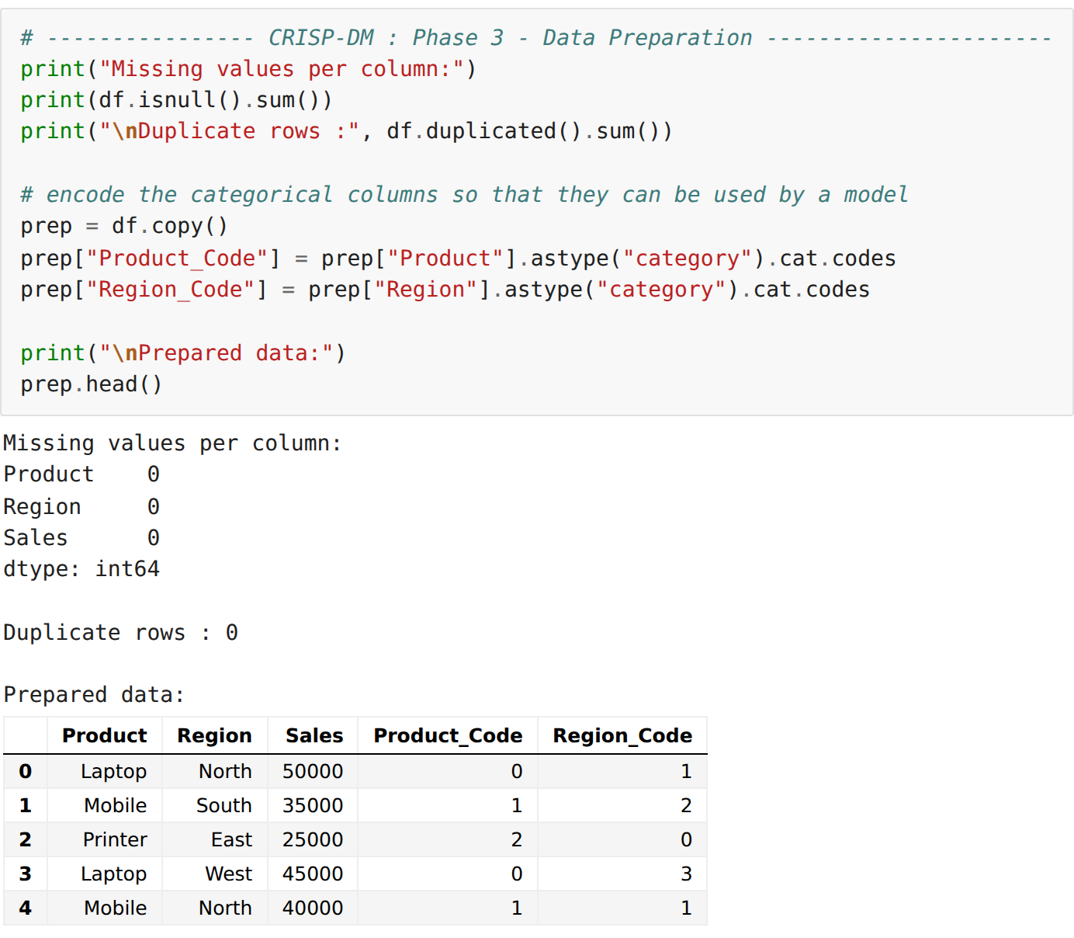
CRISP-DM Phase 4 & 5: Modeling and Evaluation
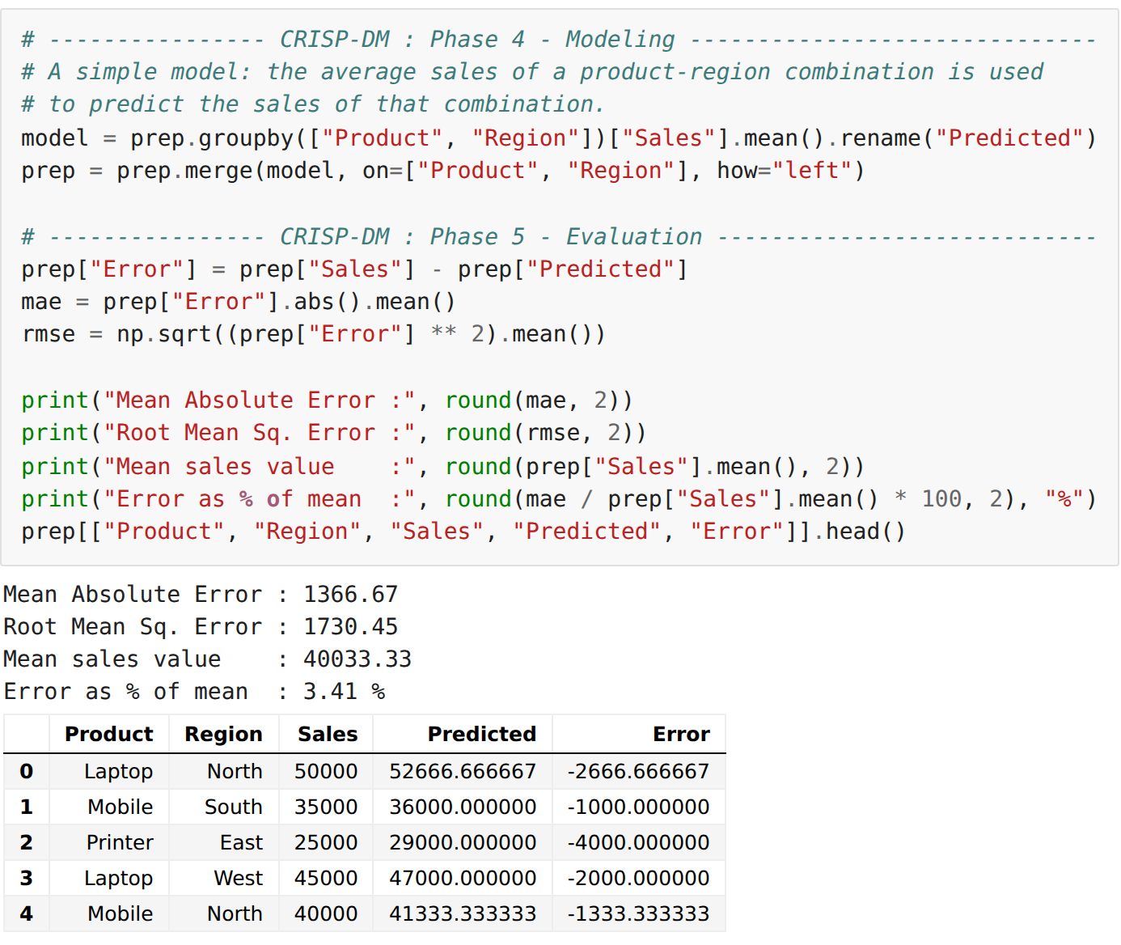
CRISP-DM Phase 6: Deployment
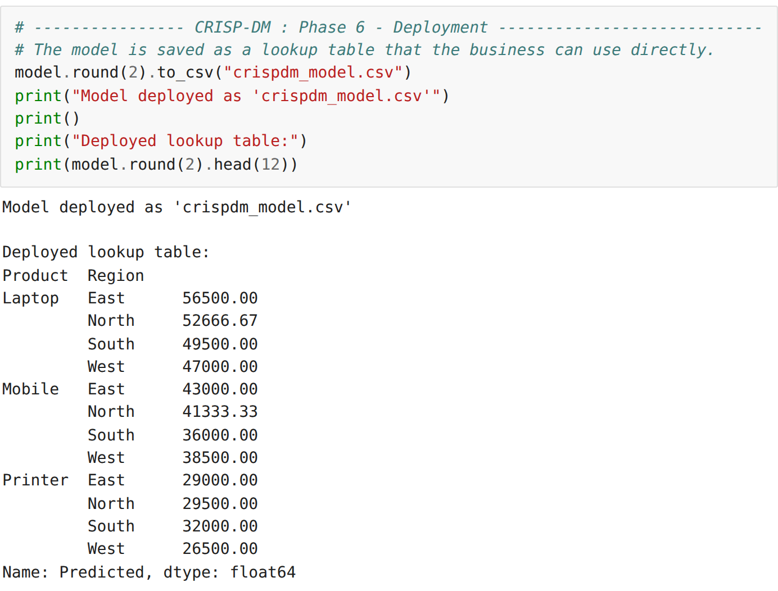
SEMMA: Sample and Explore
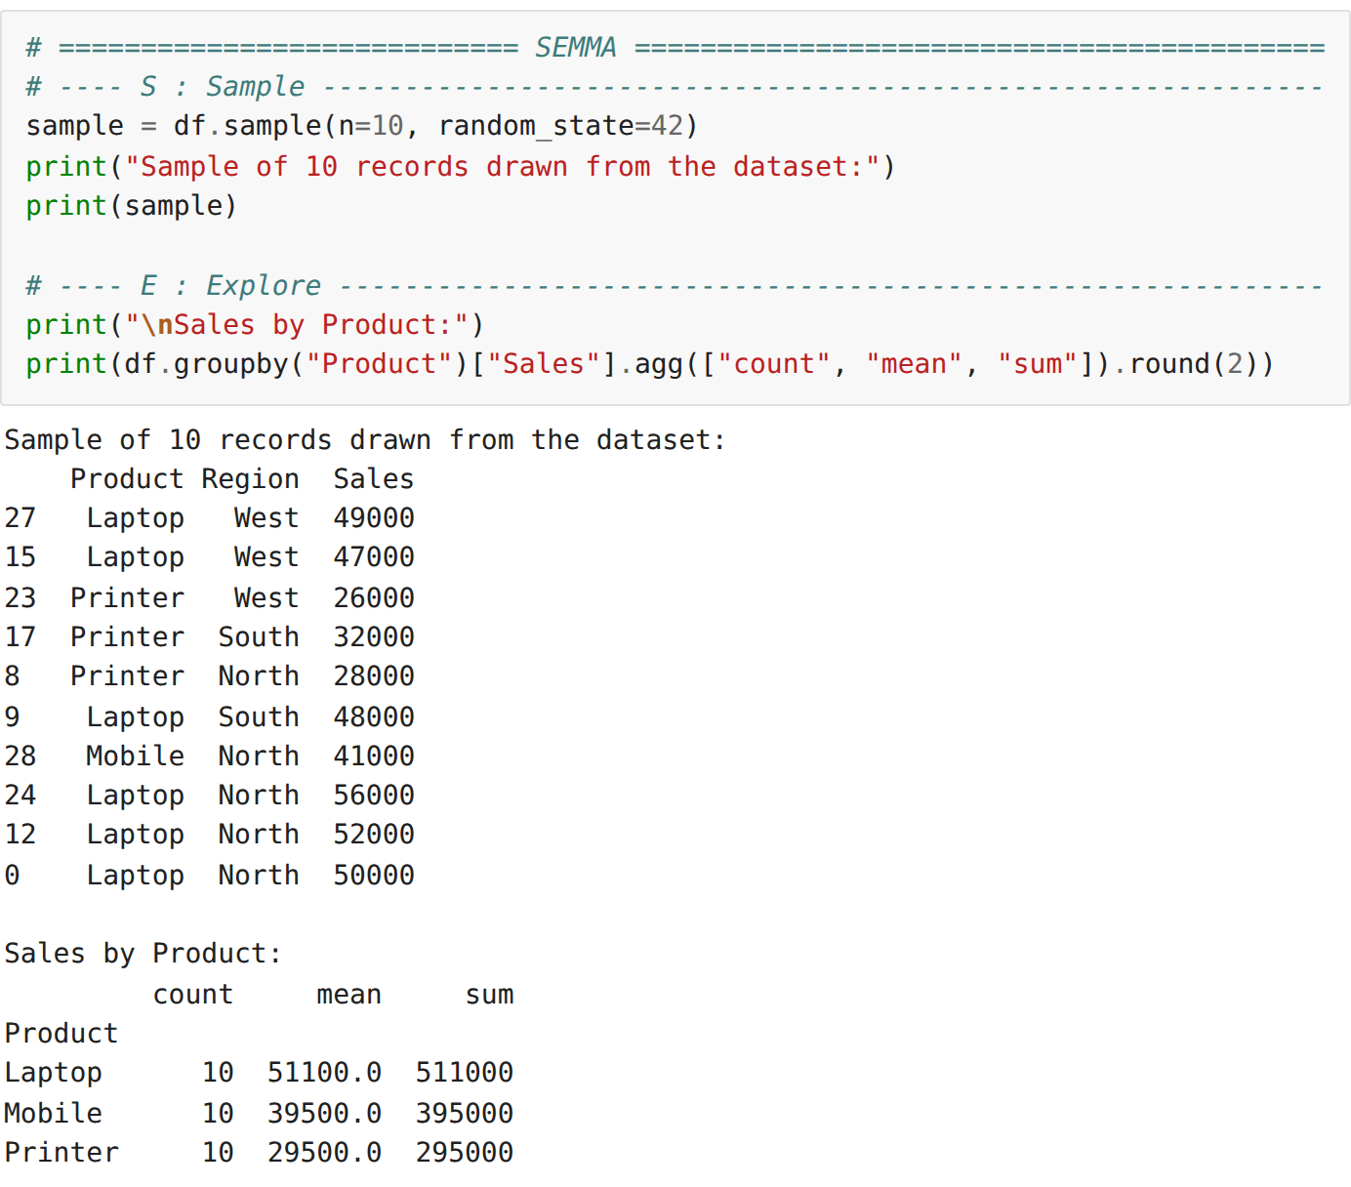
SEMMA: Modify, Model and Assess
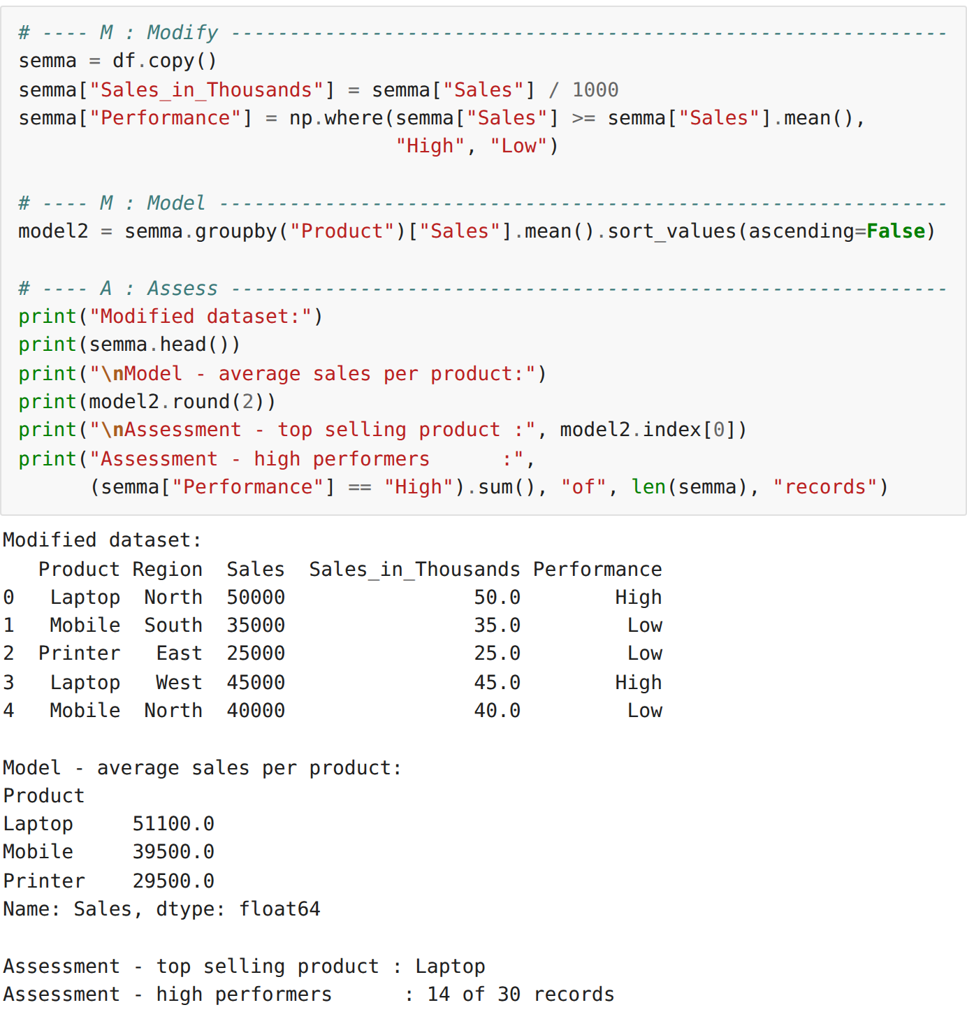
KDD: Selection, Pre-processing and Transformation
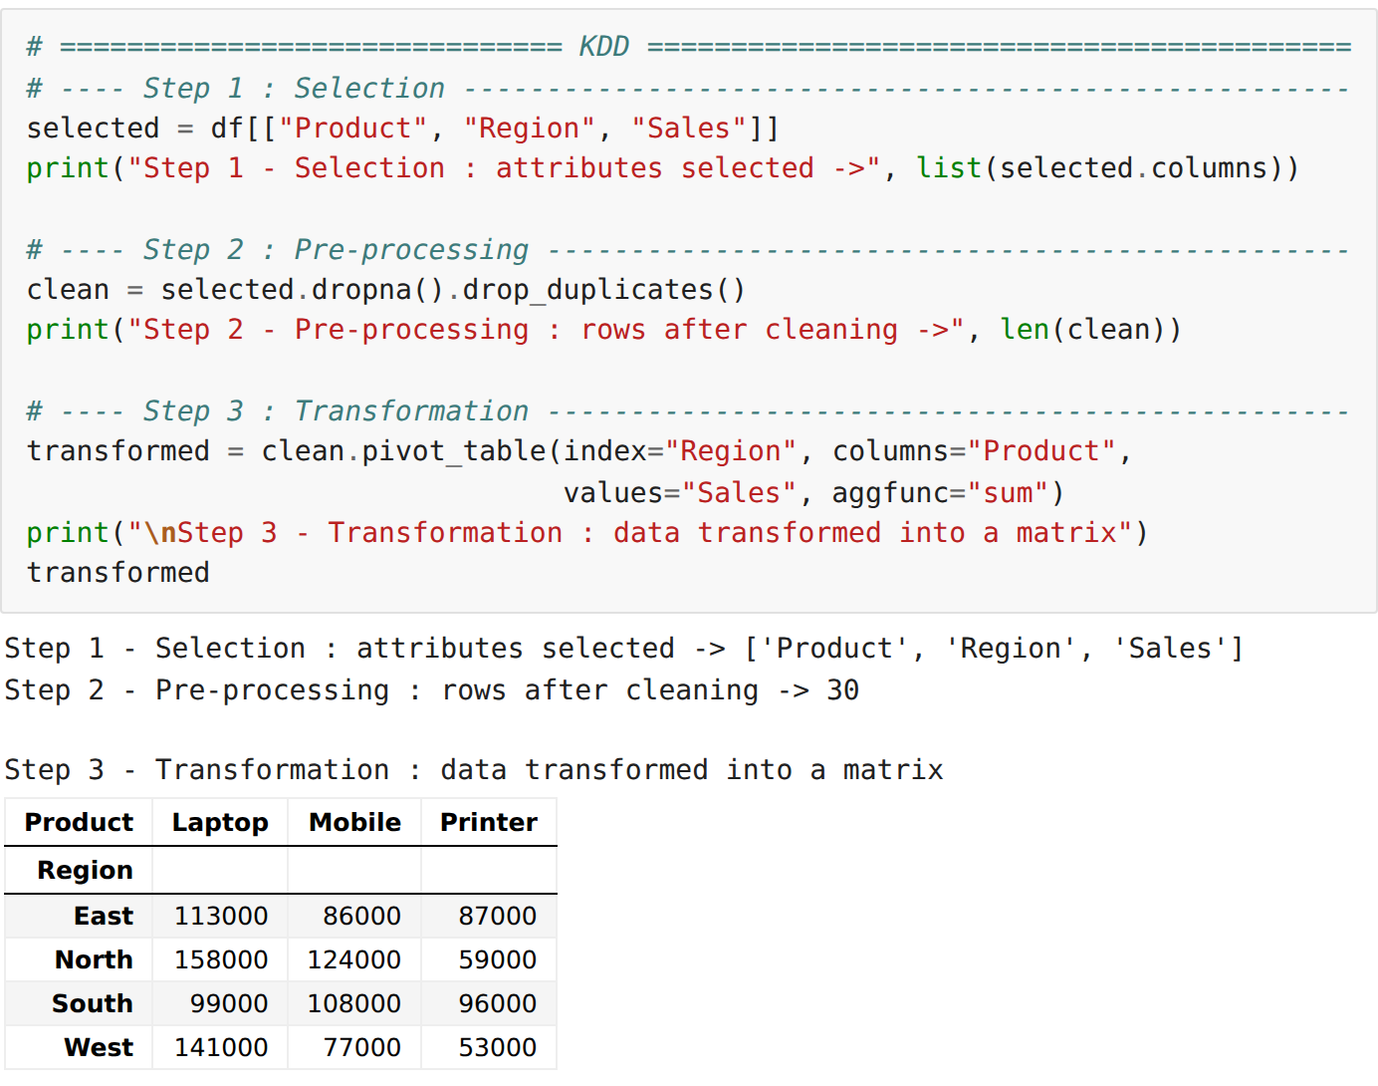
KDD: Data Mining and Interpretation
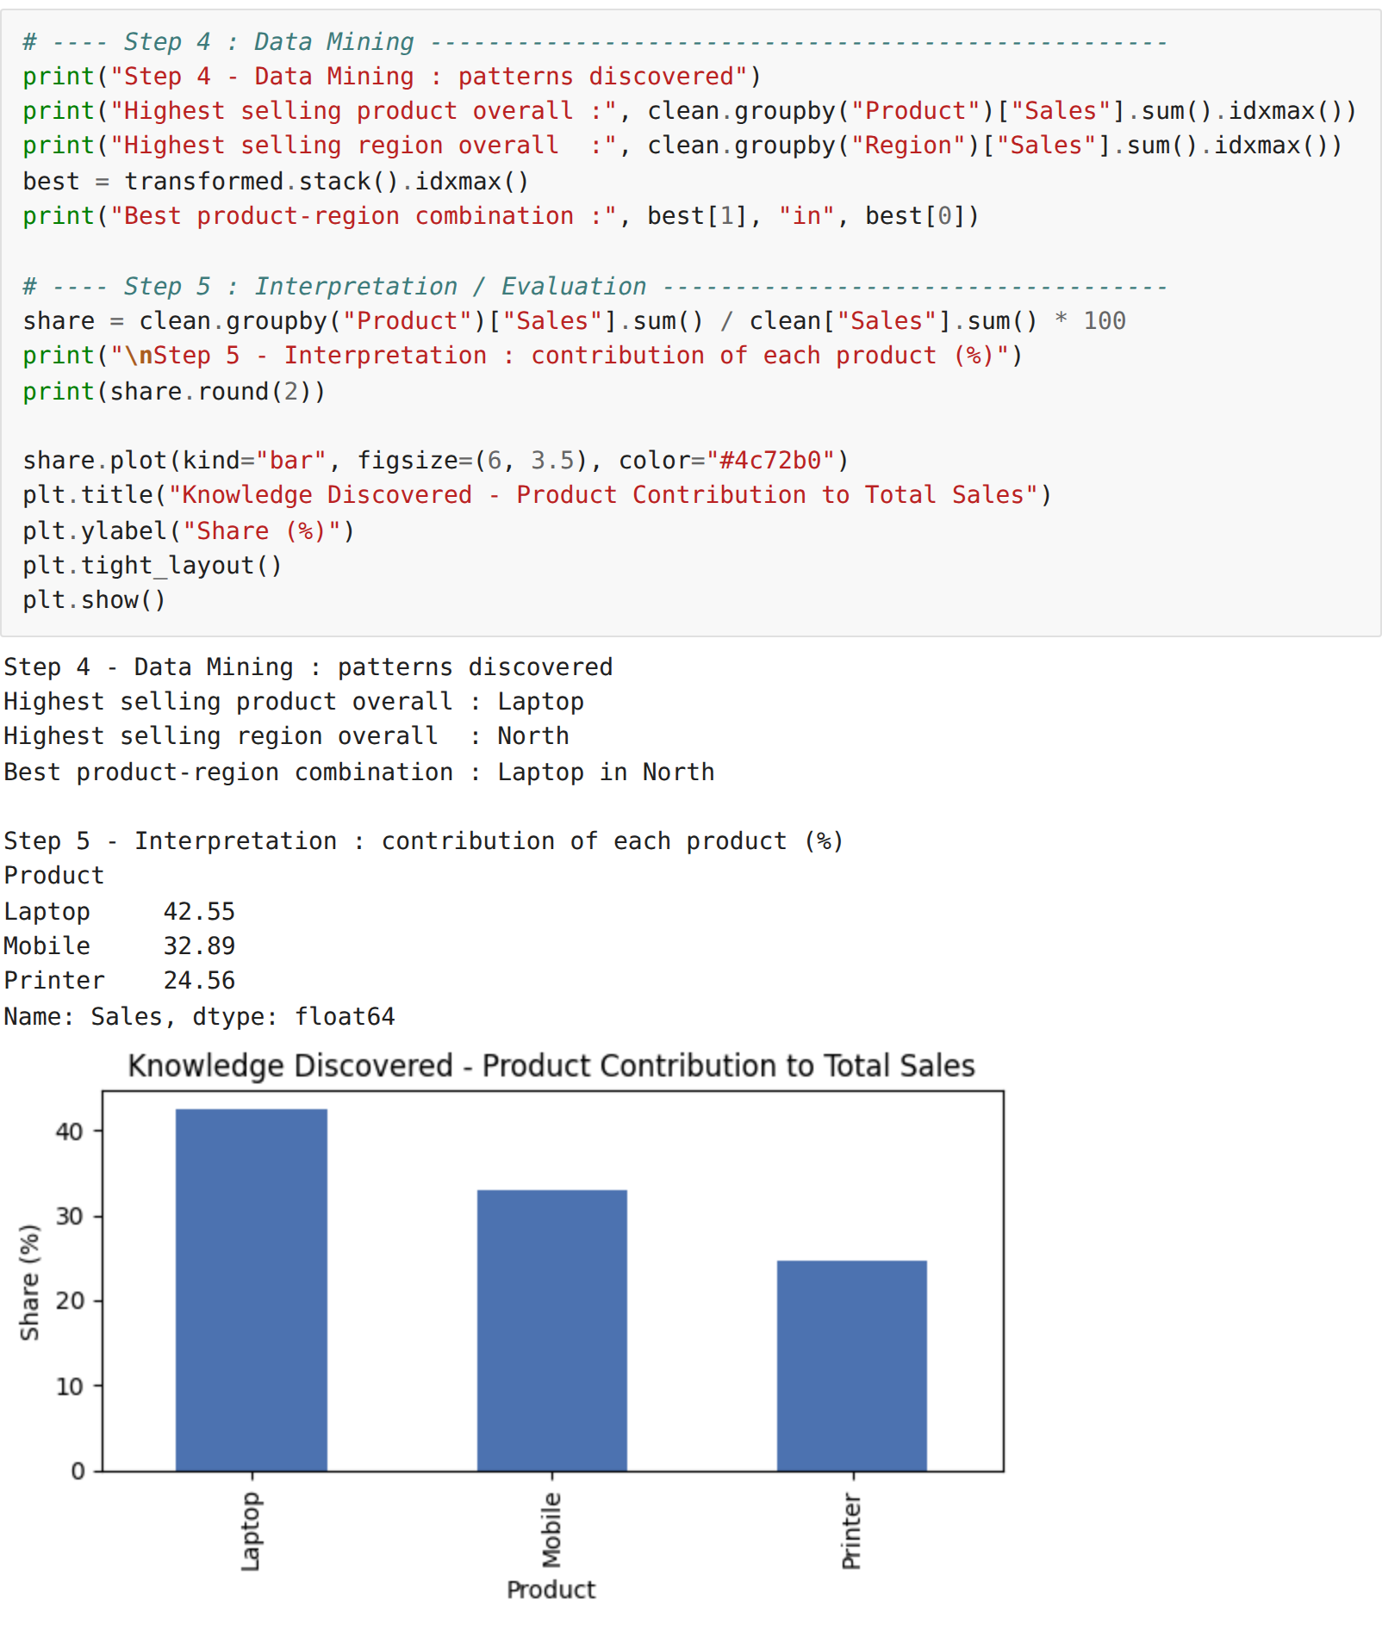
Comparison of the three frameworks
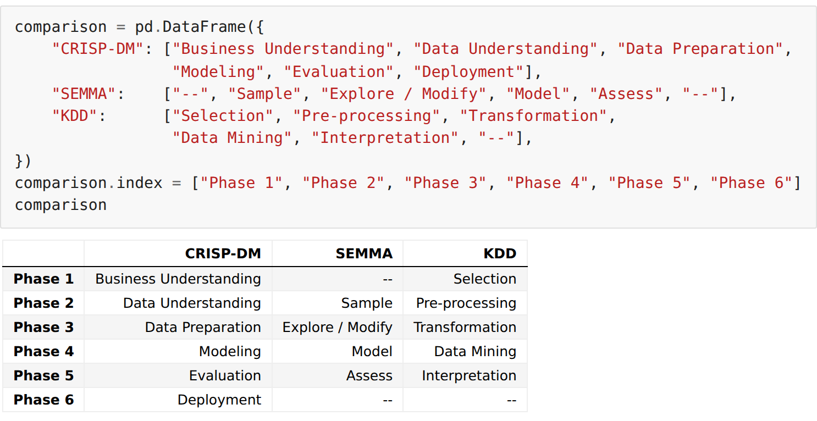
RESULT:
Thus the CRISP-DM, SEMMA and KDD data science frameworks were studied and each of their phases was applied successfully on the sales dataset, and the outputs were verified.

