EX. NO: 2
EXPLORATORY DATA ANALYSIS (EDA) – DATA IMPORT AND EXPORT
AIM:
To import the sales dataset into a Pandas DataFrame from different sources and with different read options, and to export the same data into various file formats such as CSV, Excel, JSON, HTML and text, and to verify the exported files by reading them back into the notebook.
ALGORITHM:
- Import the required libraries — Pandas, NumPy and the os module.
- Import the sales dataset from the CSV file using the read_csv() function.
- Display the imported data and check its shape, columns and data types.
- Import the data again using read options such as usecols, nrows, index_col and dtype.
- Create a DataFrame directly from a Python dictionary and from a list of lists.
- Export the DataFrame to a CSV file using to_csv().
- Export the DataFrame to an Excel workbook using to_excel().
- Export the DataFrame to a JSON file using to_json().
- Export the DataFrame to HTML and to a plain text file.
- List the exported files in the working directory using the os module.
- Read every exported file back into the notebook to verify the export.
- Observe and record the output.
PROGRAM:
Step 1: Importing the libraries and importing the dataset from a CSV file
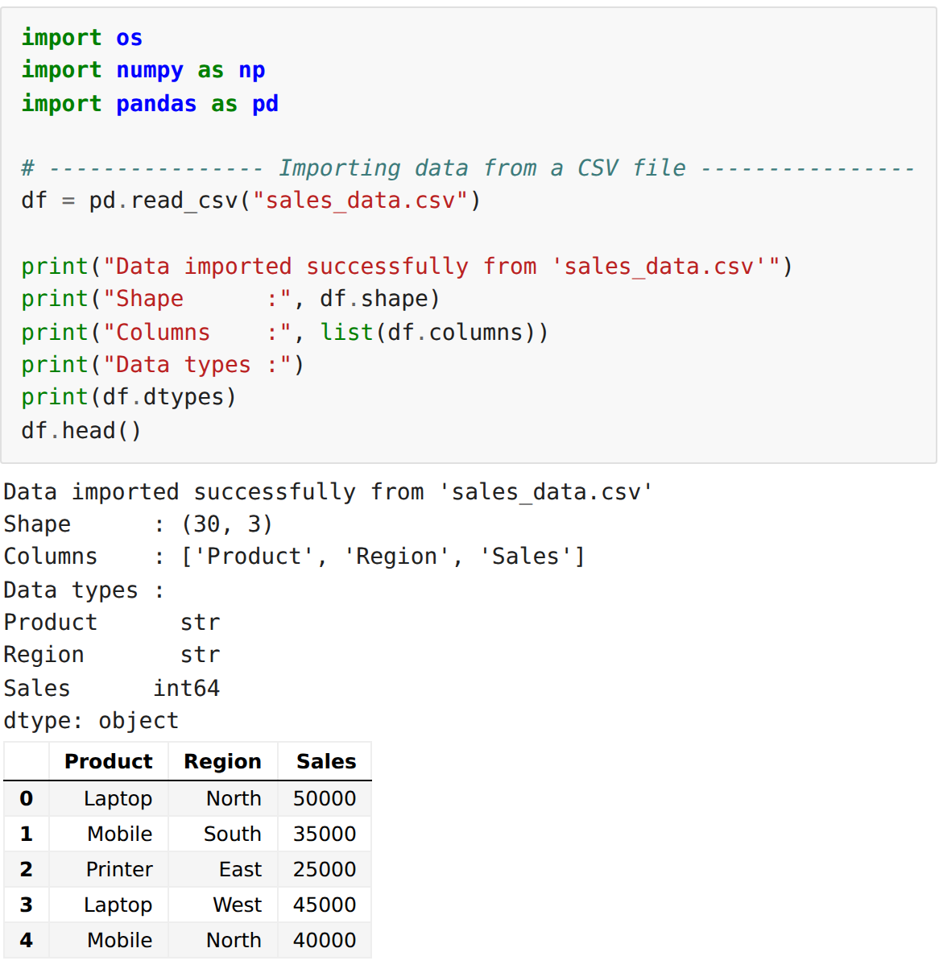
Step 2: Importing with read options (usecols, nrows, index_col, dtype)
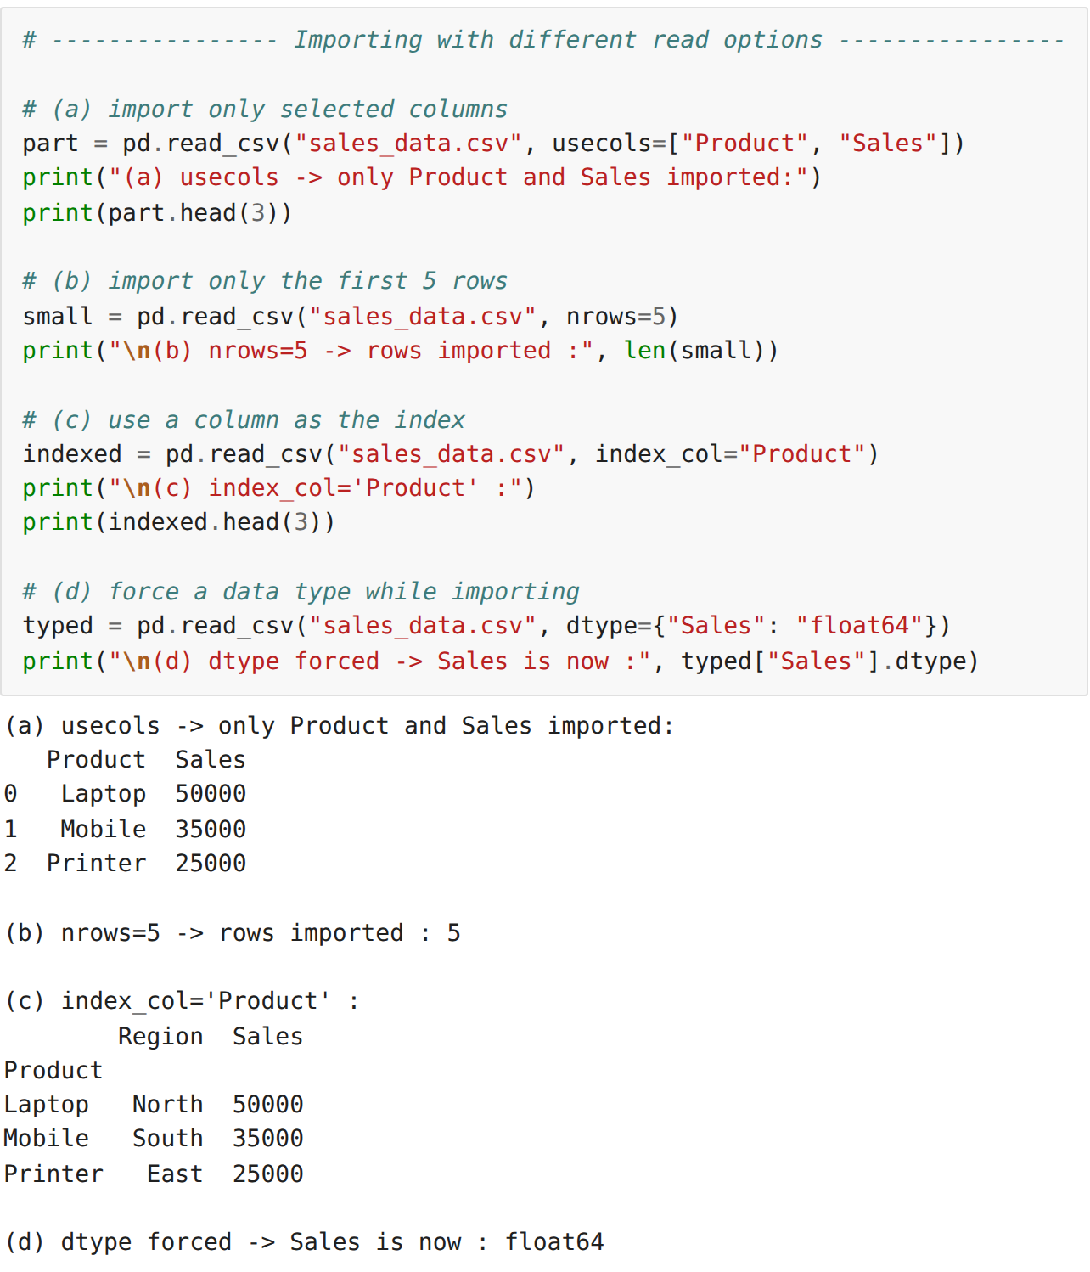
Step 3: Importing data from a Python dictionary and from a list of lists
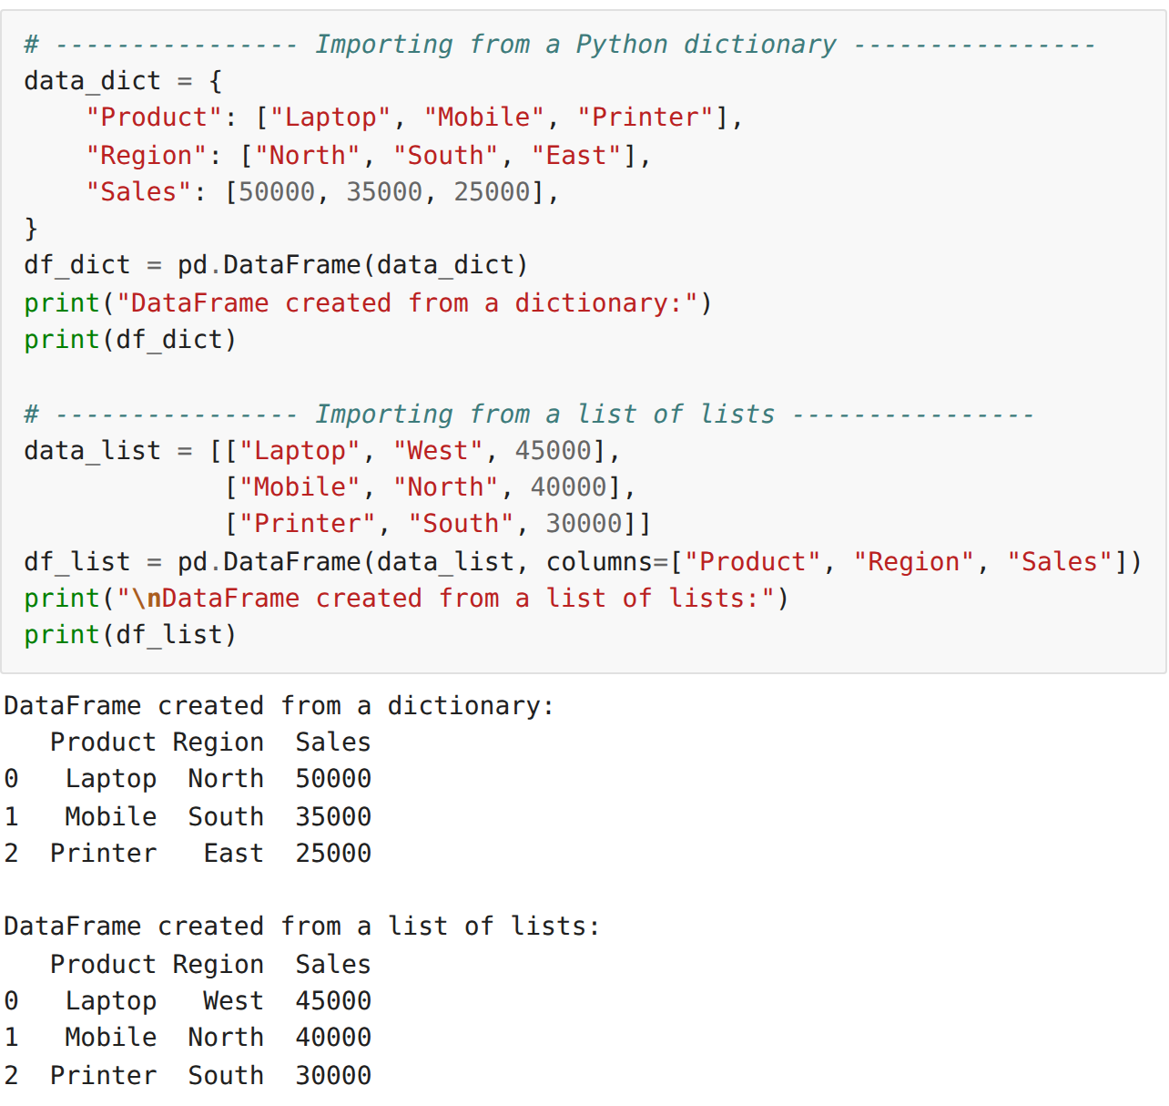
Step 4: Exporting the data to a CSV file
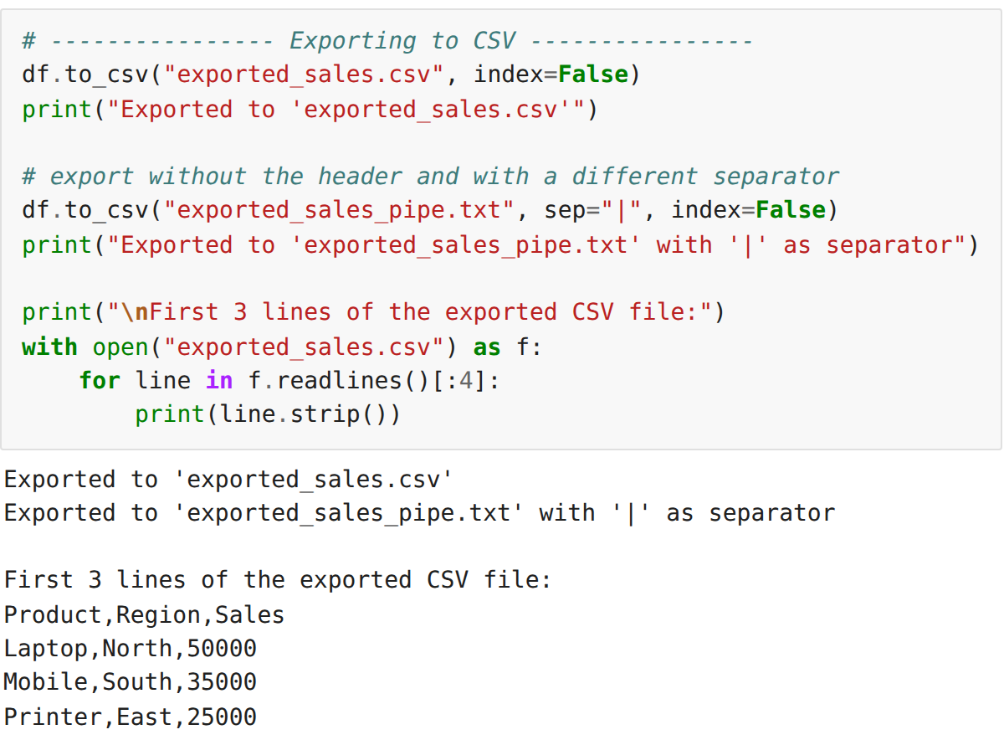
Step 5: Exporting the data to an Excel workbook
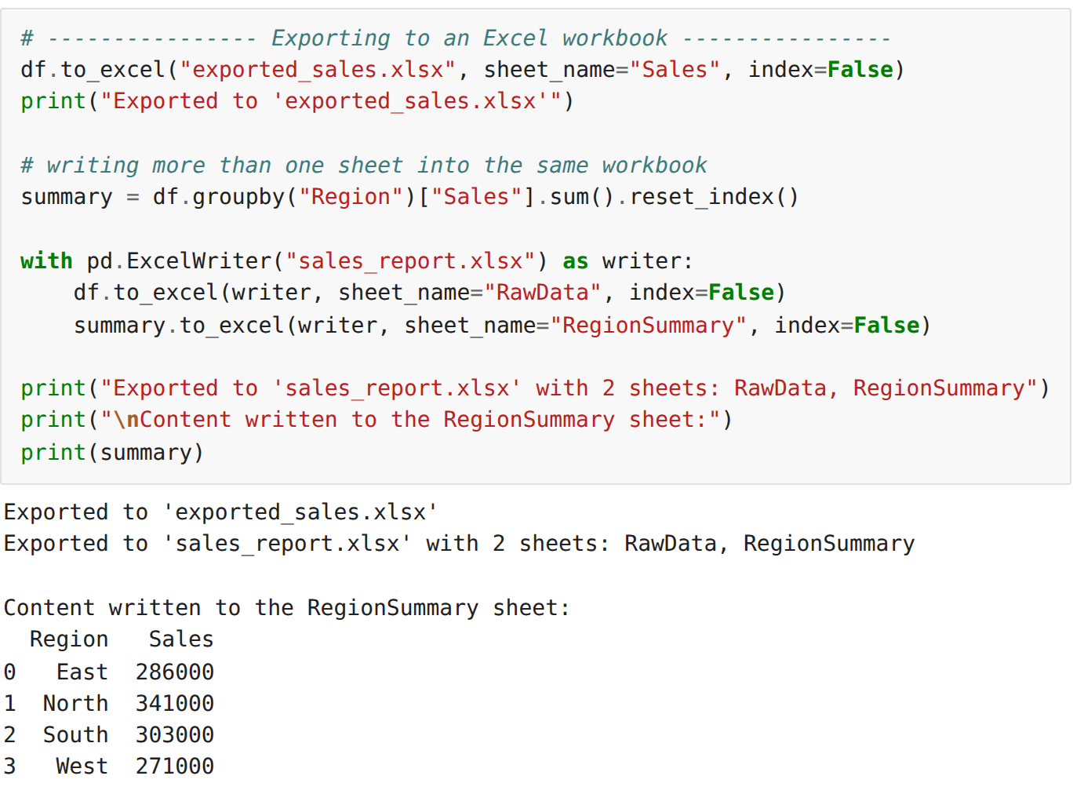
Step 6: Exporting the data to a JSON file
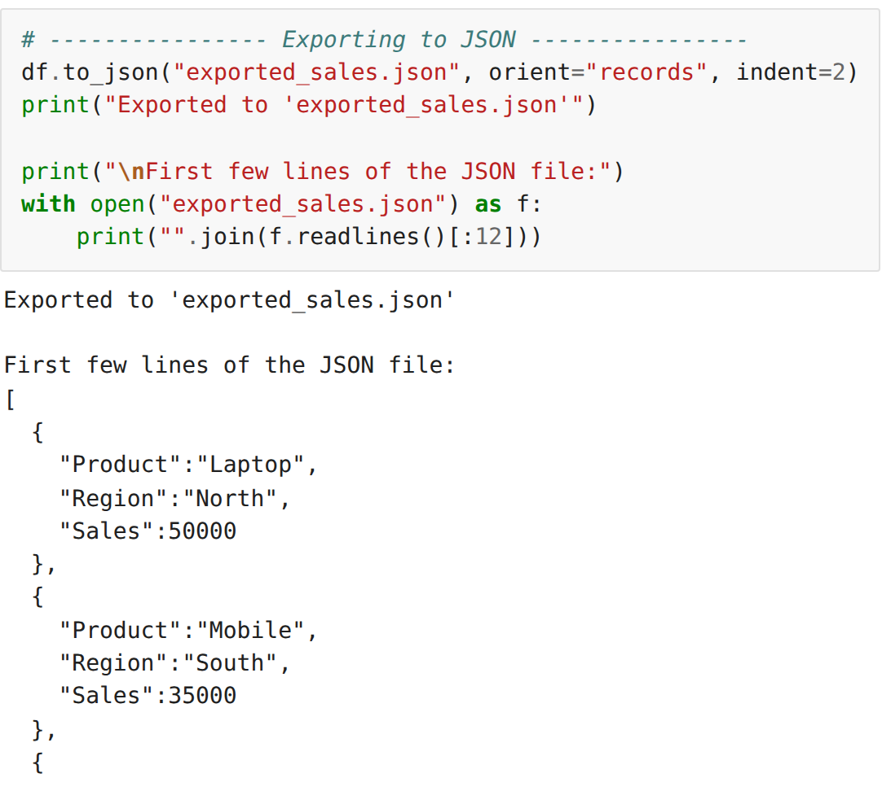
Step 7: Exporting the data to HTML and to a text file
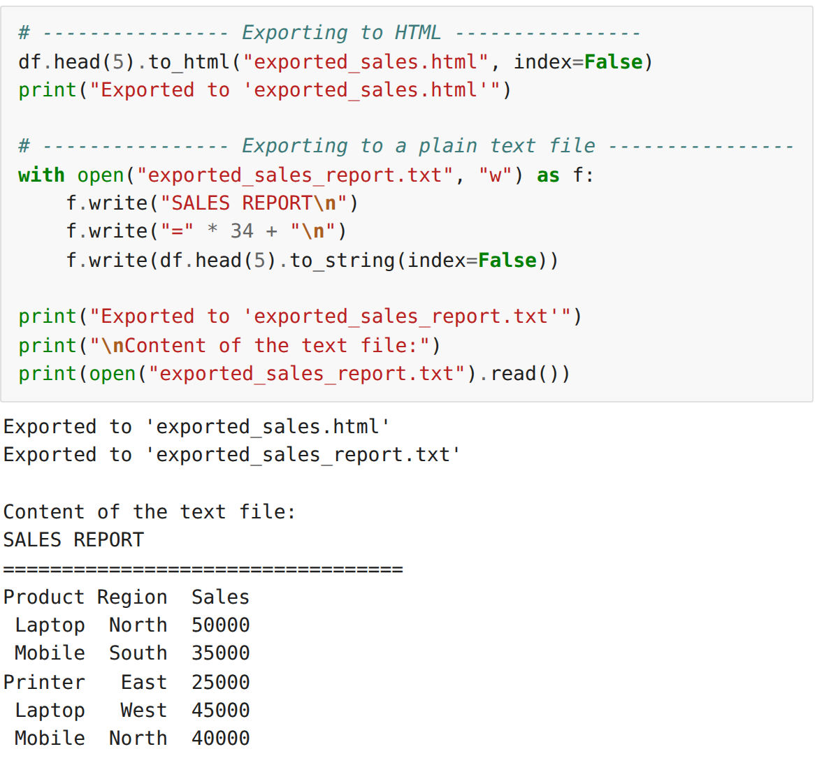
Step 8: Listing the exported files in the working directory
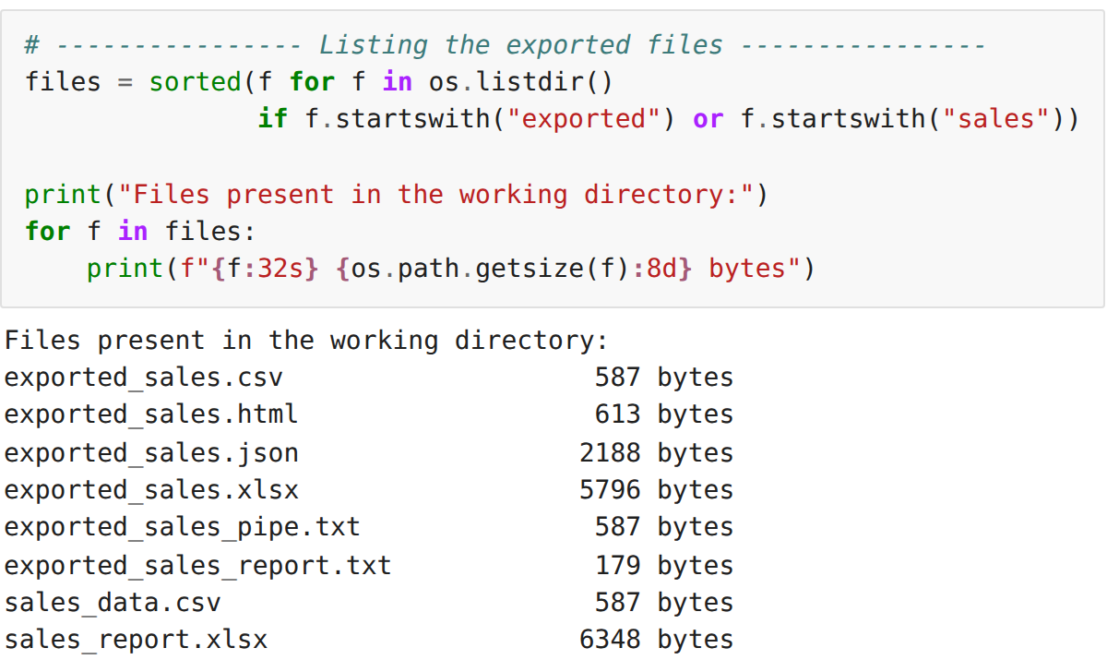
Step 9: Reading the exported files back to verify the export
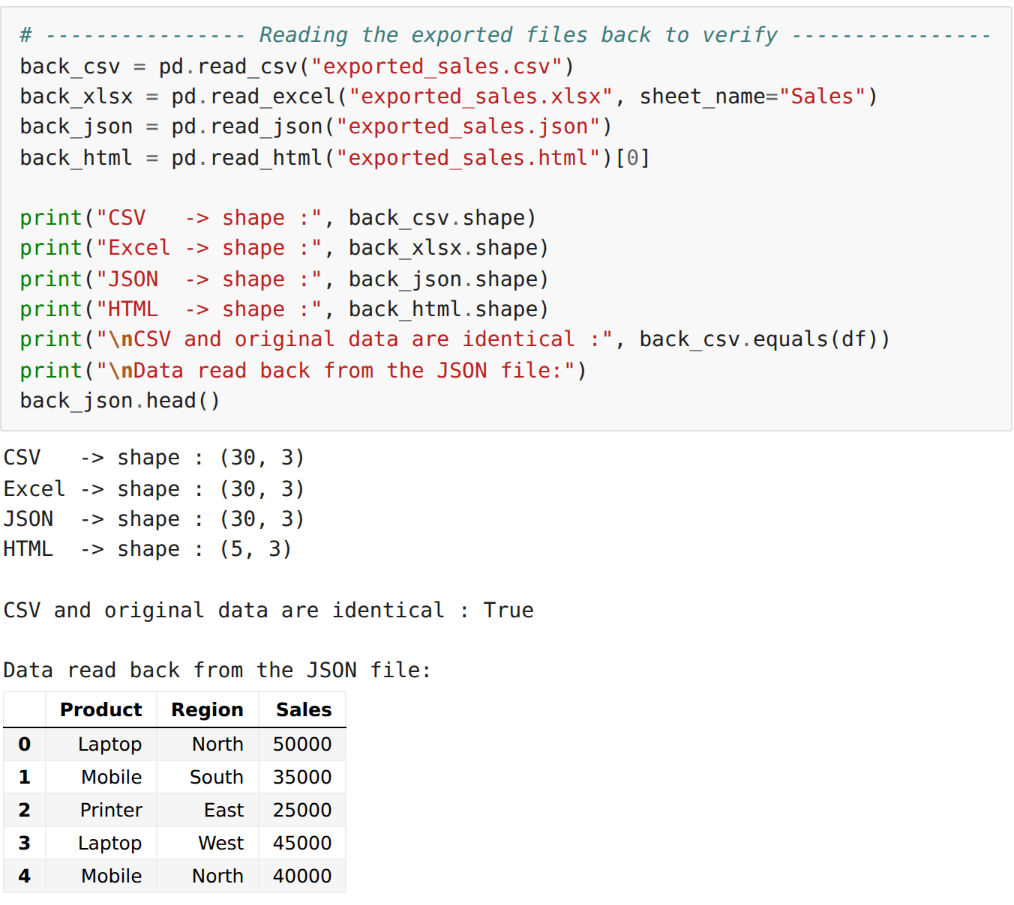
RESULT:
Thus the sales dataset was imported into the notebook from different sources and with different read options, exported successfully into CSV, Excel, JSON, HTML and text formats, and the exported files were read back and verified.

