EX. NO: 3
EXPLORATORY DATA ANALYSIS (EDA) – DATA CLEANING AND DATA TRANSFORMATION
AIM:
To perform data cleaning operations on the sales dataset — handling missing values, removing duplicate records, correcting inconsistent text entries, fixing data types and detecting outliers — and to perform data transformation operations such as normalisation, standardisation, binning, encoding of categorical variables and creation of derived columns.
ALGORITHM:
- Import the required libraries and load the sales dataset.
- Create a working copy of the dataset and introduce missing values, duplicate rows and inconsistent text entries so that the cleaning operations can be demonstrated.
- Inspect the data quality using isnull(), duplicated() and dtypes.
- Handle the missing values using fillna() with the mean and using dropna().
- Remove the duplicate records using drop_duplicates().
- Clean the inconsistent text entries using strip() and str.title().
- Rename the columns and convert the columns to the correct data types.
- Detect the outliers using the Inter-Quartile Range (IQR) method.
- Transform the data using Min-Max normalisation and Z-score standardisation.
- Convert the continuous Sales column into categories using binning with cut().
- Encode the categorical columns using label encoding and one-hot encoding.
- Create a derived column using the apply() function.
- Display the final cleaned and transformed dataset and observe the output.
PROGRAM:
Step 1: Loading the dataset and creating a raw copy with data-quality problems
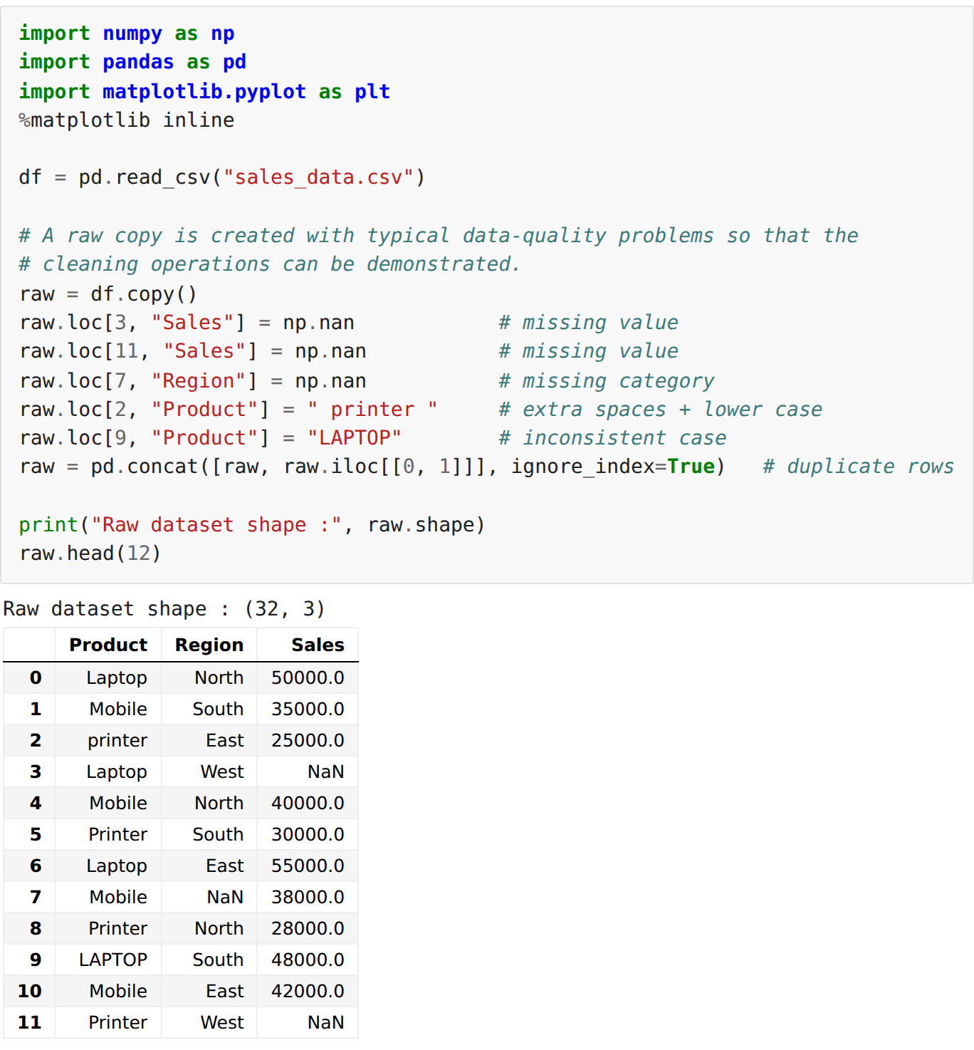
Step 2: Inspecting the data quality
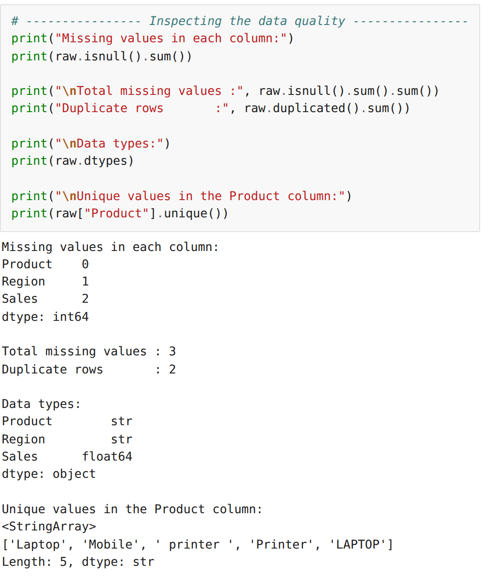
Step 3: Handling the missing values
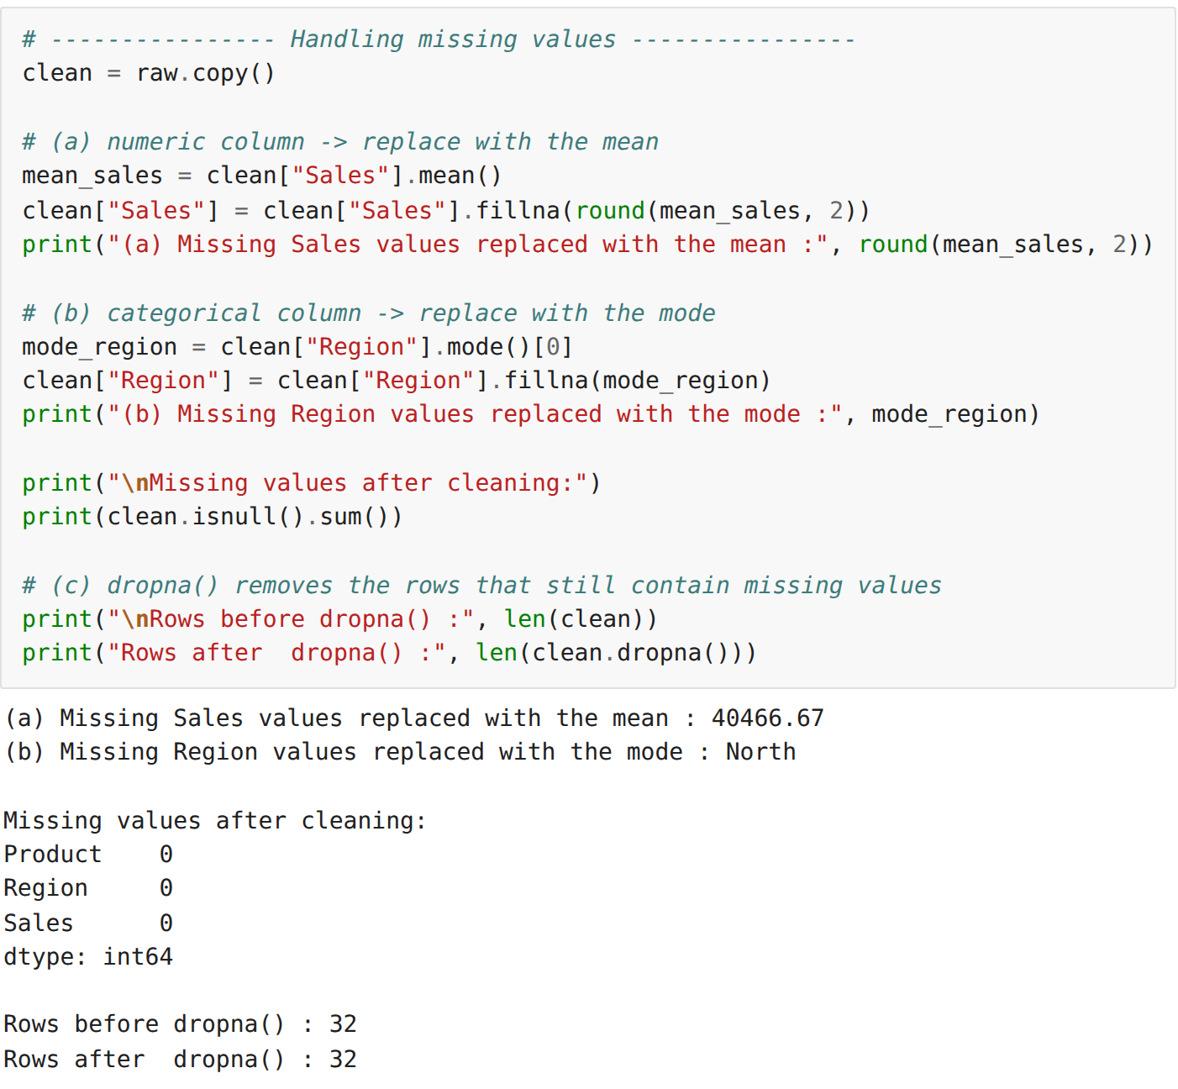
Step 4: Removing the duplicate records
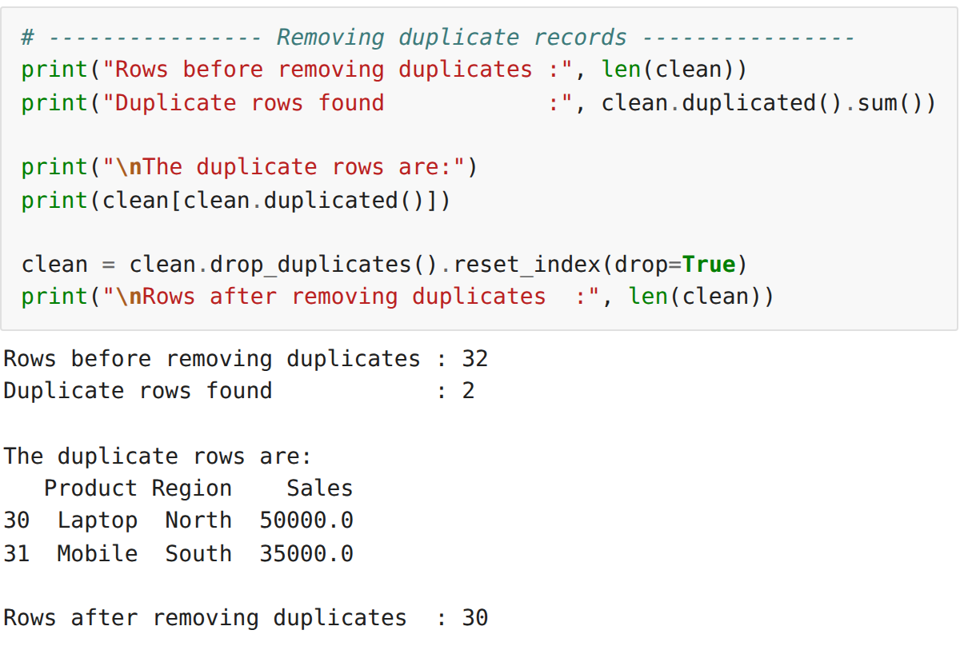
Step 5: Cleaning inconsistent text entries
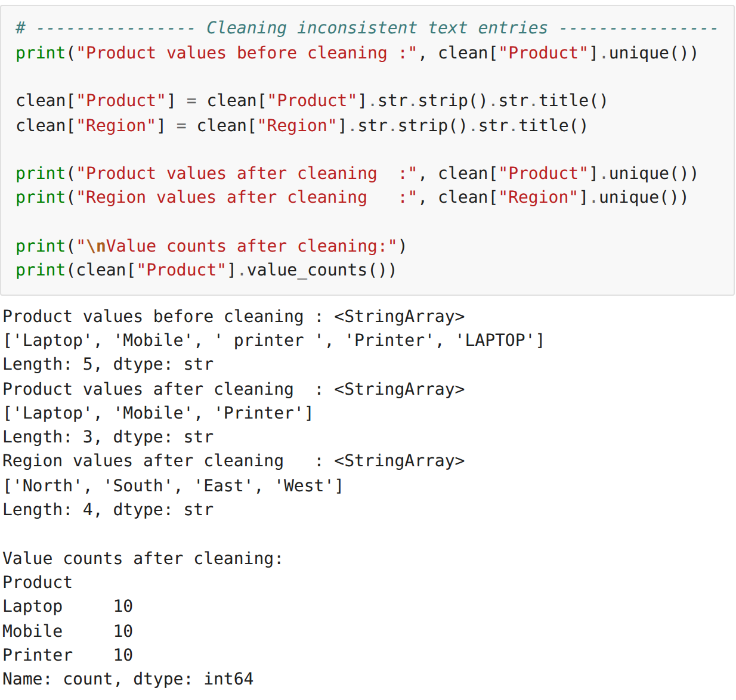
Step 6: Renaming columns and correcting the data types
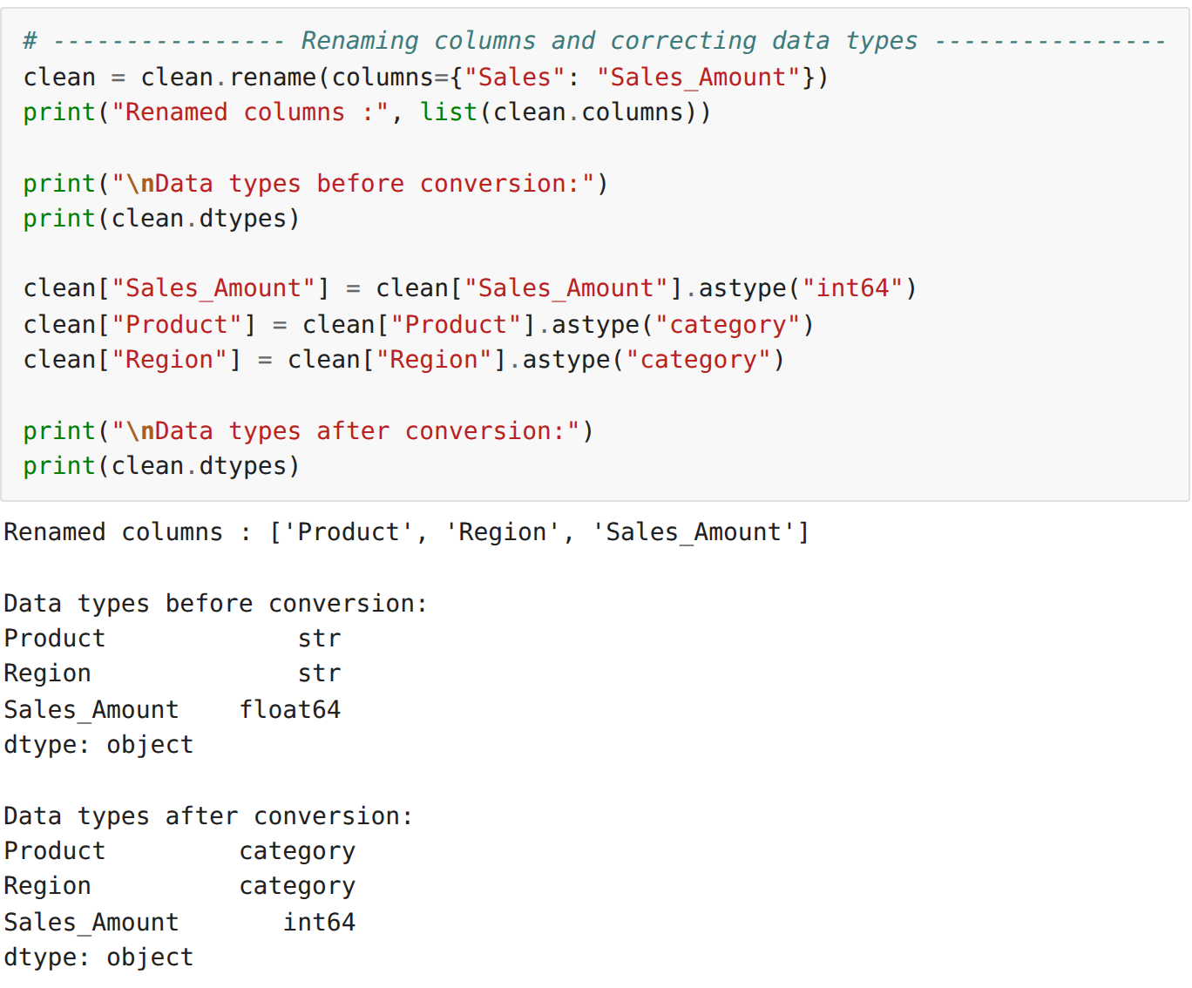
Step 7: Detecting outliers using the IQR method
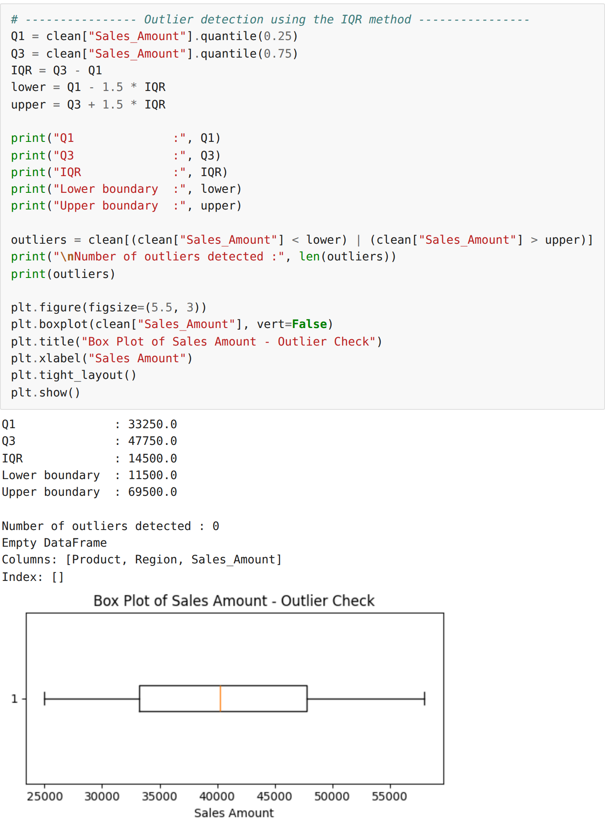
Step 8: Min-Max normalisation and Z-score standardisation
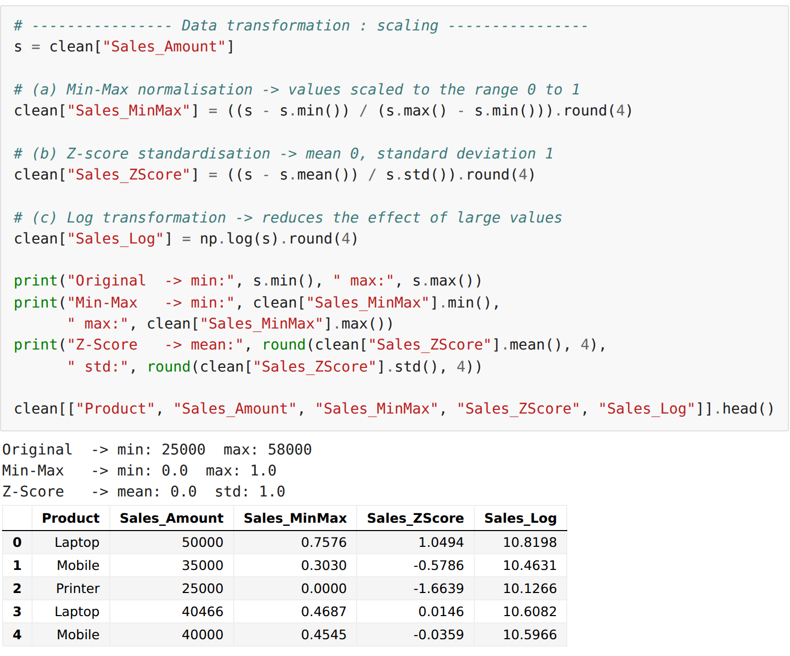
Step 9: Binning the continuous Sales column into categories
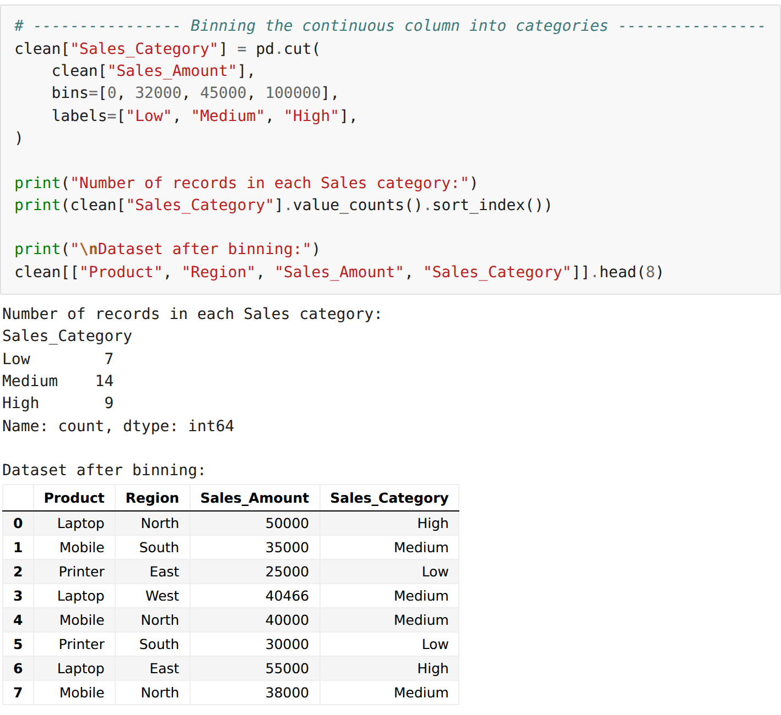
Step 10: Label encoding and one-hot encoding of categorical columns
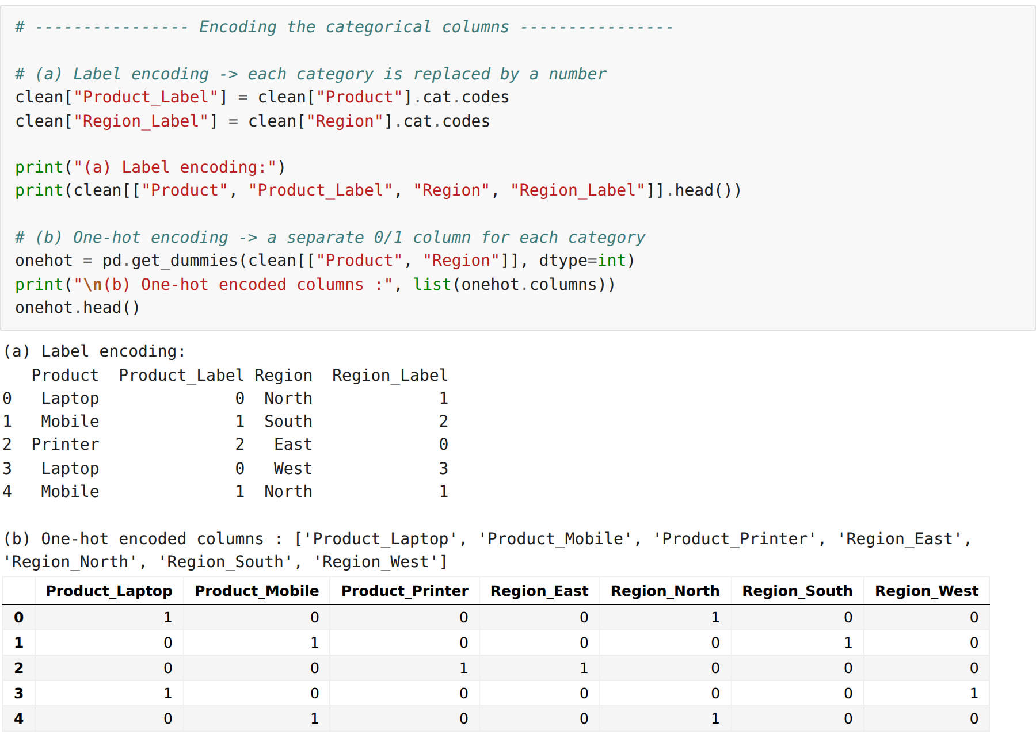
Step 11: Creating a derived column using apply()
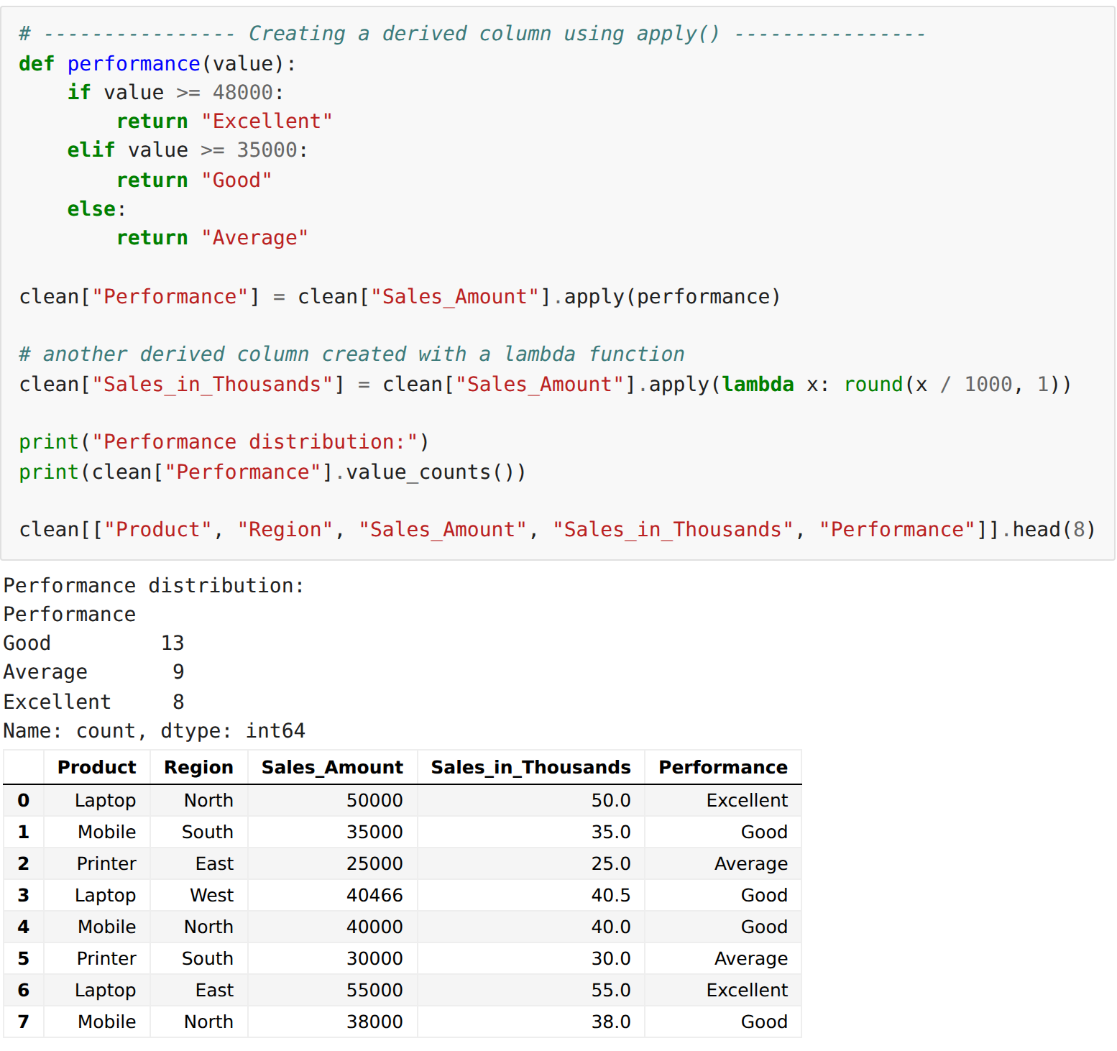
Step 12: The final cleaned and transformed dataset
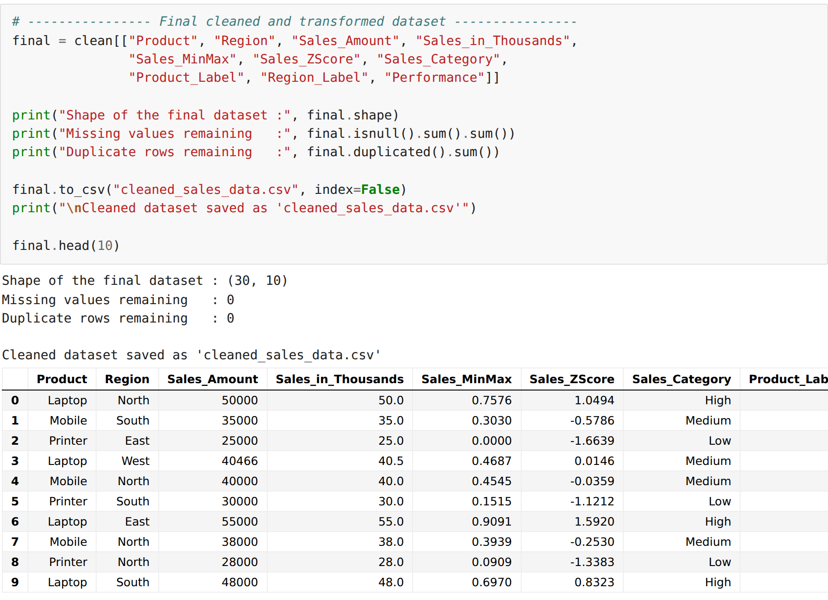
RESULT:
Thus the data cleaning operations — handling missing values, removing duplicates, correcting inconsistent entries, fixing data types and detecting outliers — and the data transformation operations — normalisation, standardisation, binning, encoding and creation of derived columns — were performed successfully on the sales dataset and the output was verified.

