EX. NO: 4a
EXPLORATORY DATA ANALYSIS (EDA) – DATA INSPECTION, FILTERING, STATISTICAL ANALYSIS AND CORRELATION
AIM:
To inspect the structure and contents of the sales dataset, to filter the records using different conditional and indexing techniques, to perform descriptive statistical analysis on the data, and to compute and visualise the correlation between the attributes of the dataset.
ALGORITHM:
- Import the required libraries — Pandas, NumPy, Matplotlib and Seaborn — and load the sales dataset.
- Inspect the data using head(), tail(), shape, columns, dtypes, info() and describe().
- Check the dataset for missing values and duplicate records.
- Filter the records using single and multiple boolean conditions.
- Filter the records using isin(), between() and the query() method.
- Select rows and columns using the loc[] and iloc[] indexers and sort the data.
- Perform statistical analysis — mean, median, mode, standard deviation, variance, minimum, maximum, range and quartiles.
- Group the data by Product and by Region and apply aggregate functions.
- Convert the categorical columns into numeric codes so that correlation can be computed.
- Compute the correlation matrix using the corr() function.
- Build a Product-versus-Region matrix and compute the correlation between the products.
- Visualise the correlation matrix using a heatmap and interpret the result.
PROGRAM:
Step 1: Loading the dataset and inspecting it
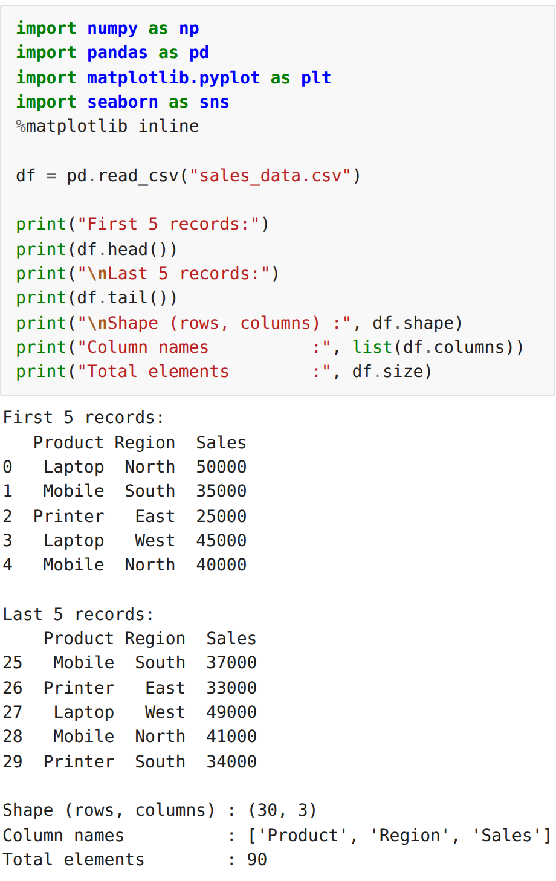
Step 2: Inspecting the structure with info() and describe()
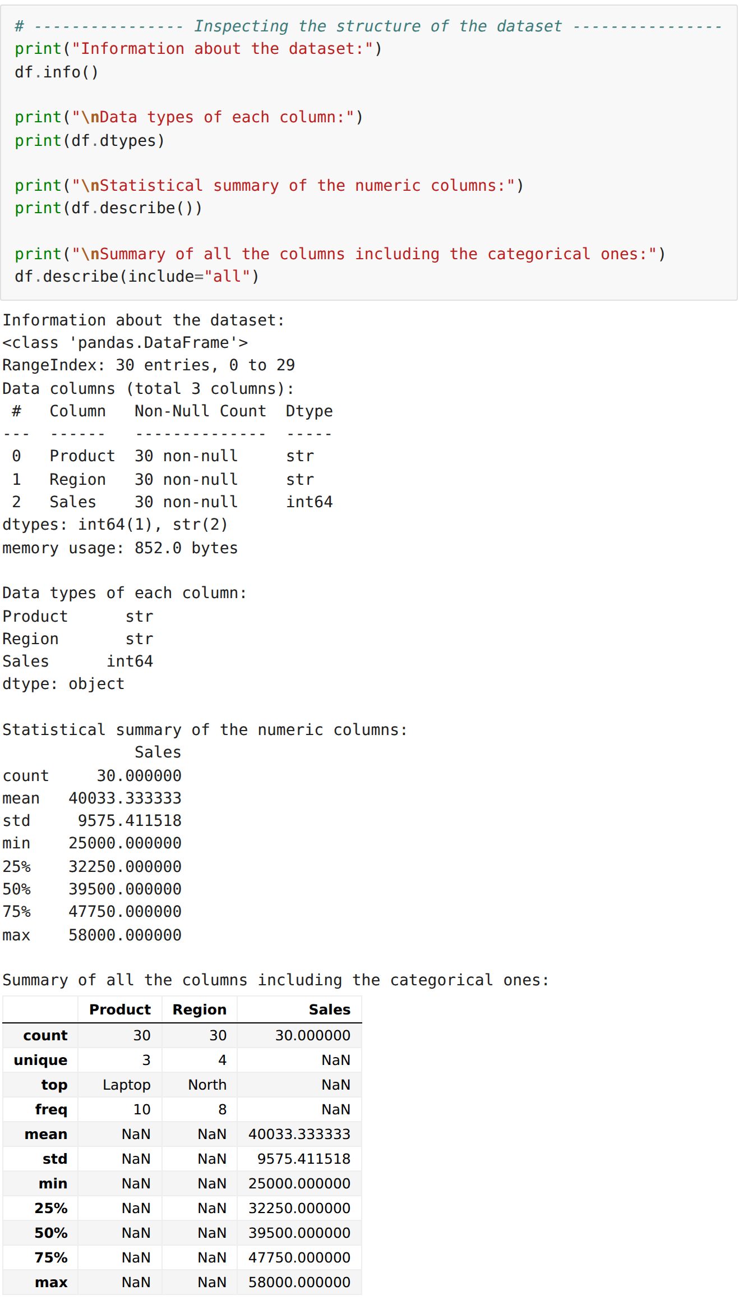
Step 3: Checking for missing values and duplicates
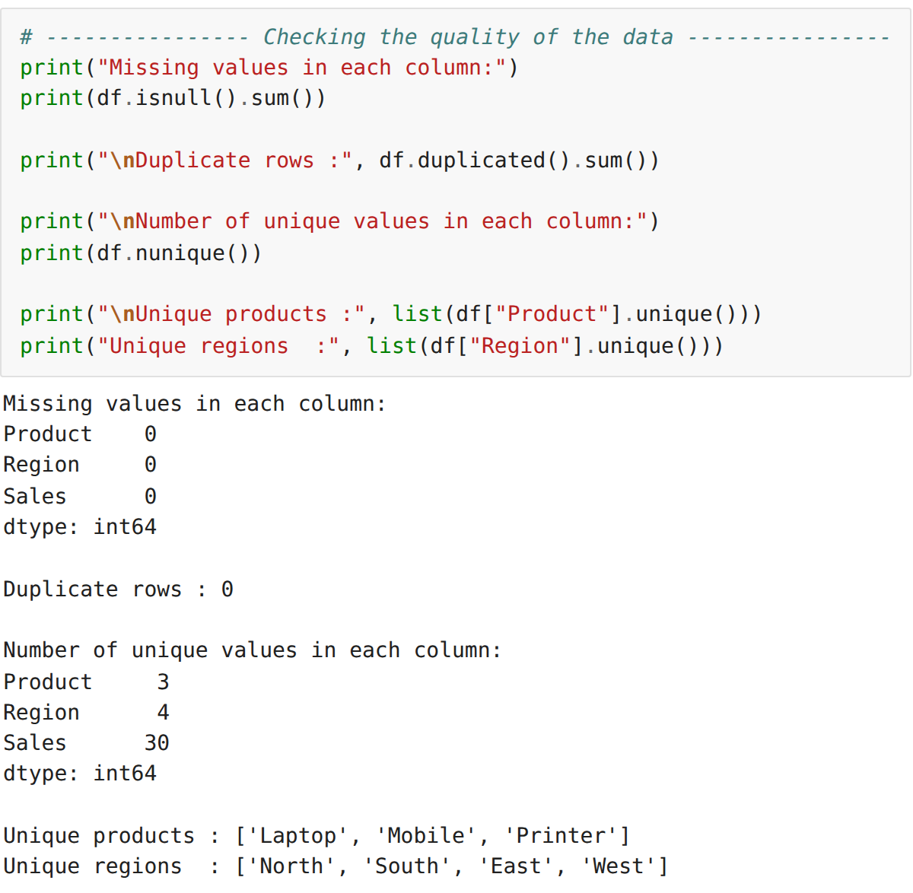
Step 4: Filtering the records using boolean conditions
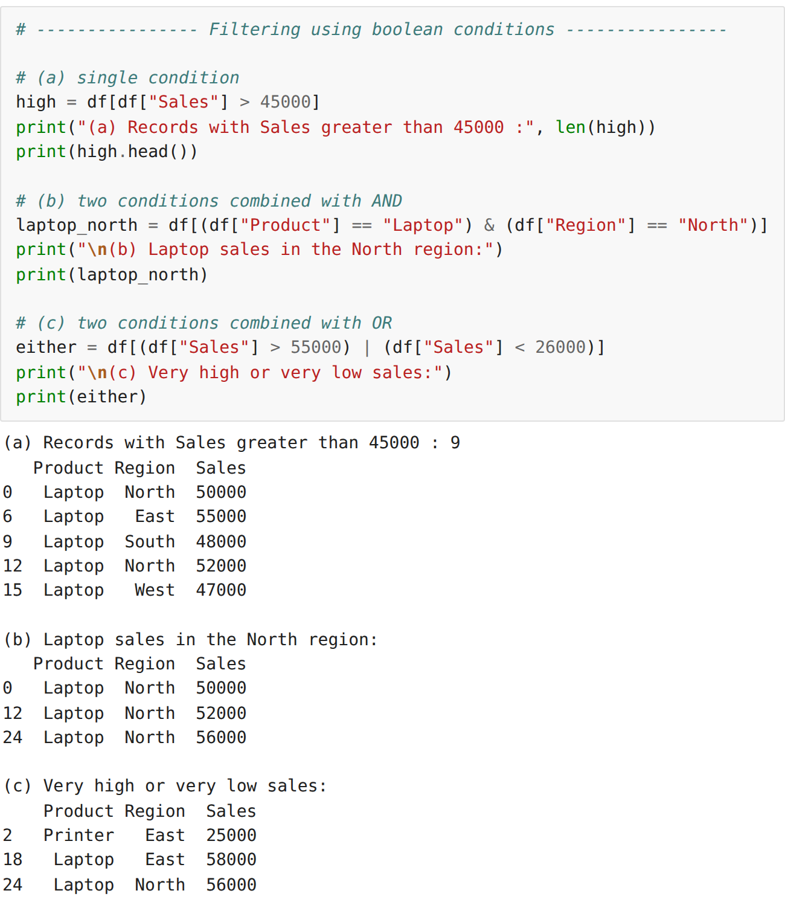
Step 5: Filtering using isin(), between() and query()
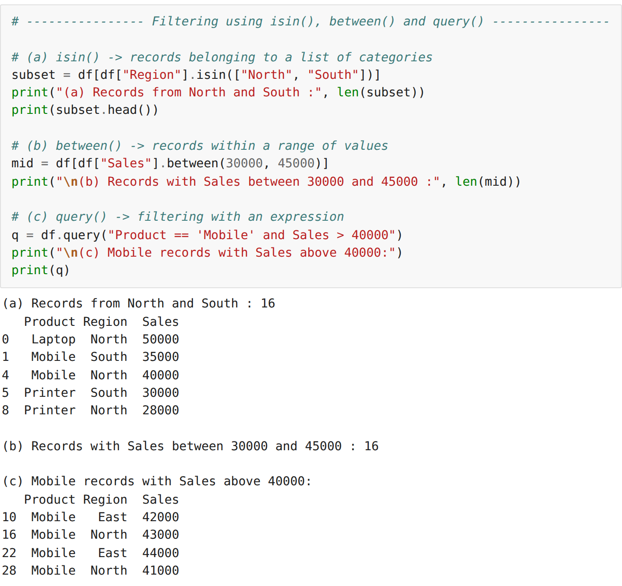
Step 6: Selecting data using loc[] and iloc[] and sorting
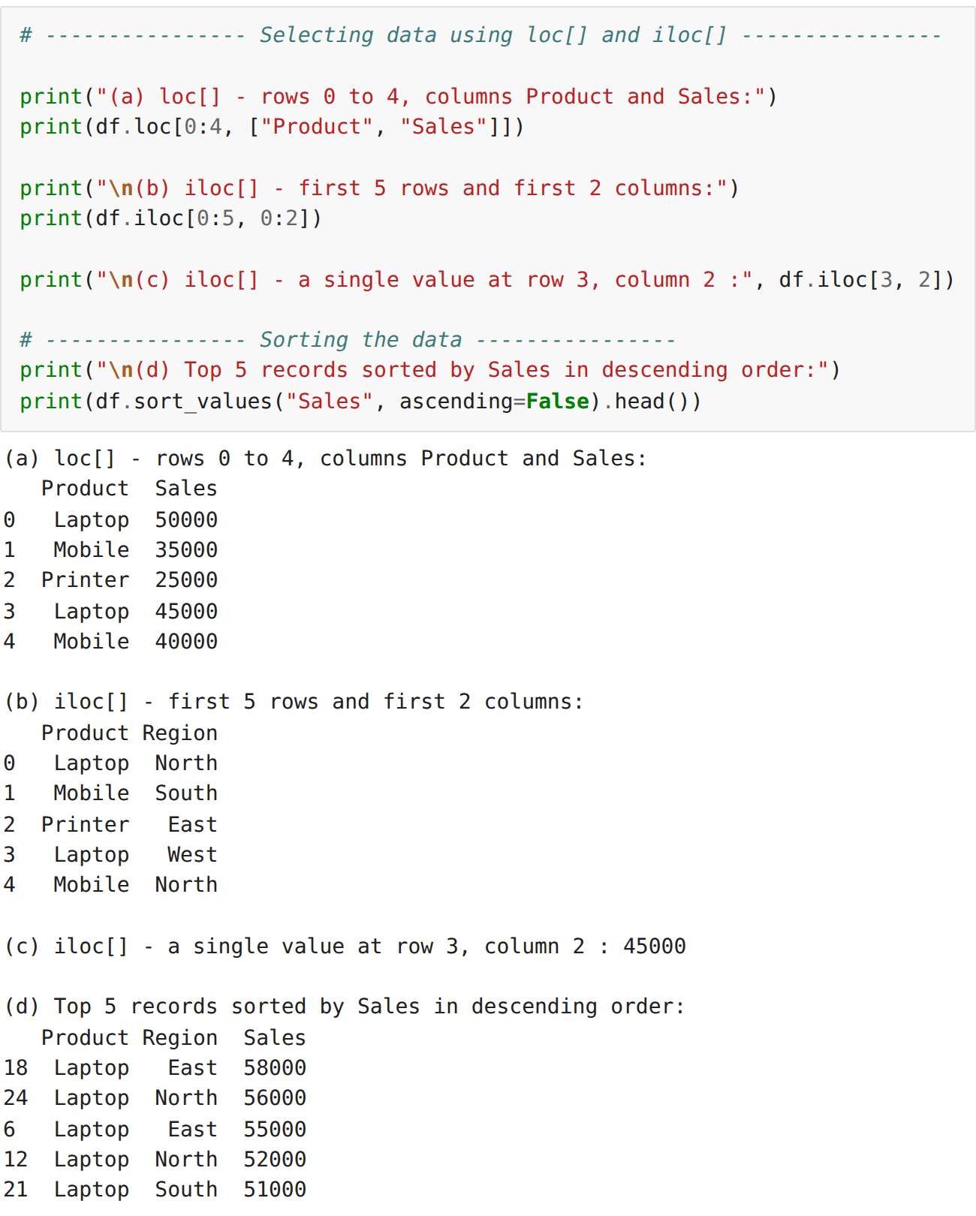
Step 7: Descriptive statistical analysis
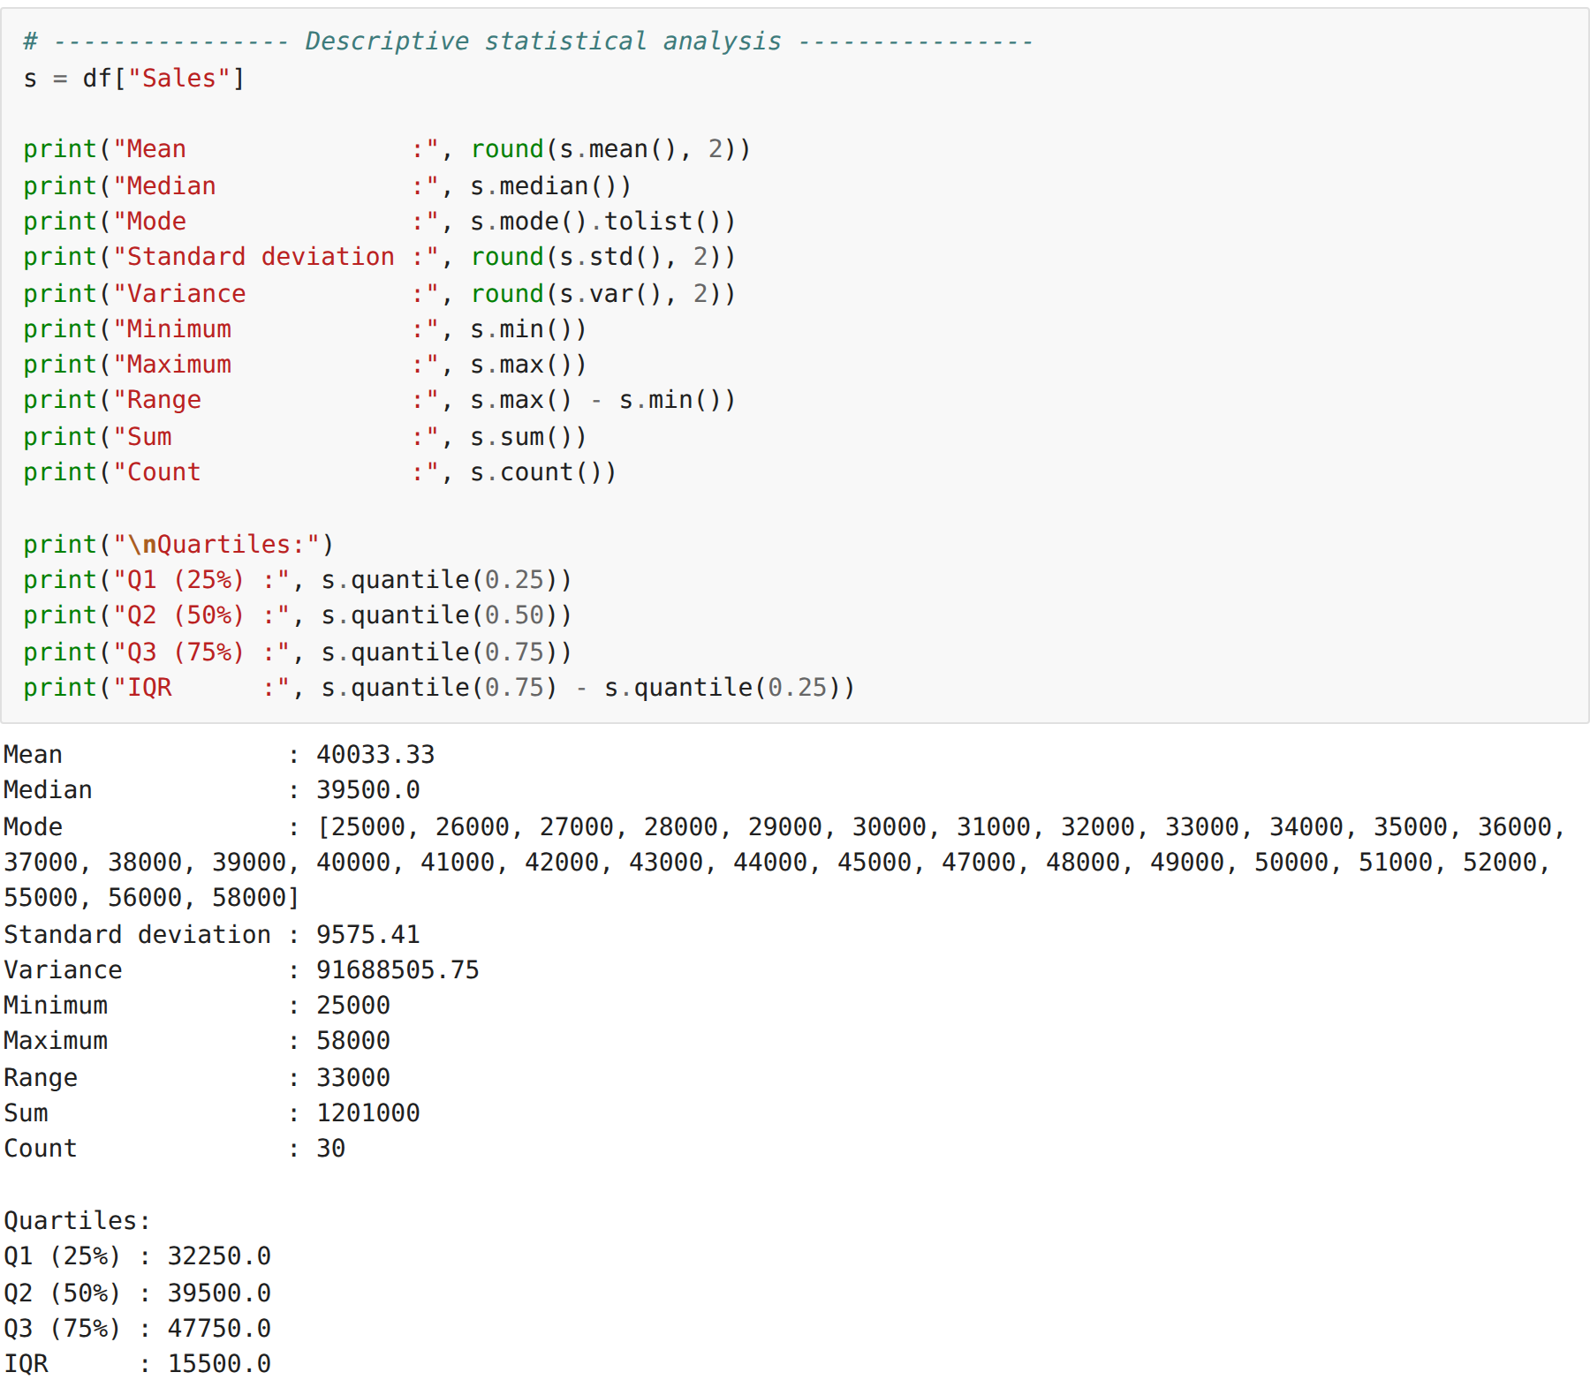
Step 8: Grouping the data and applying aggregate functions
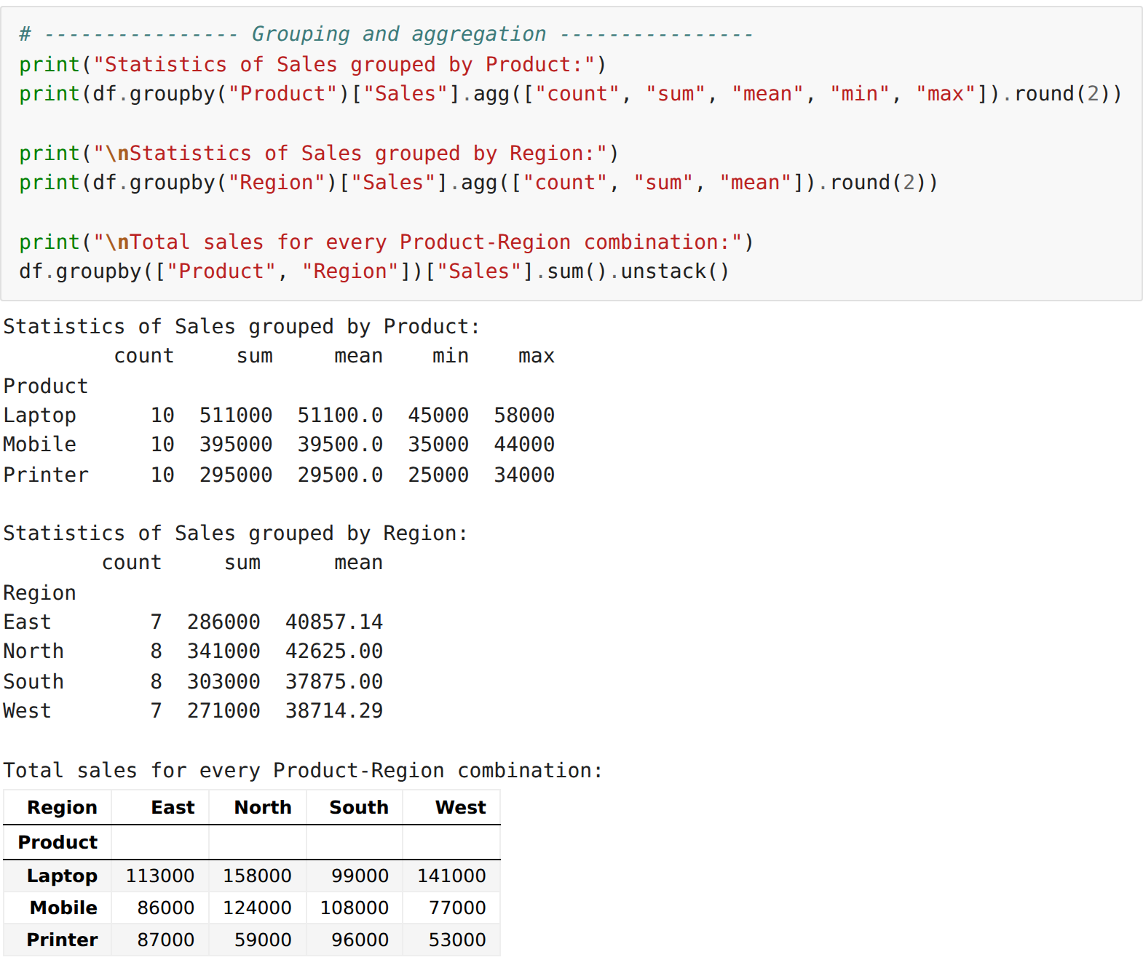
Step 9: Encoding the categorical columns and computing the correlation matrix
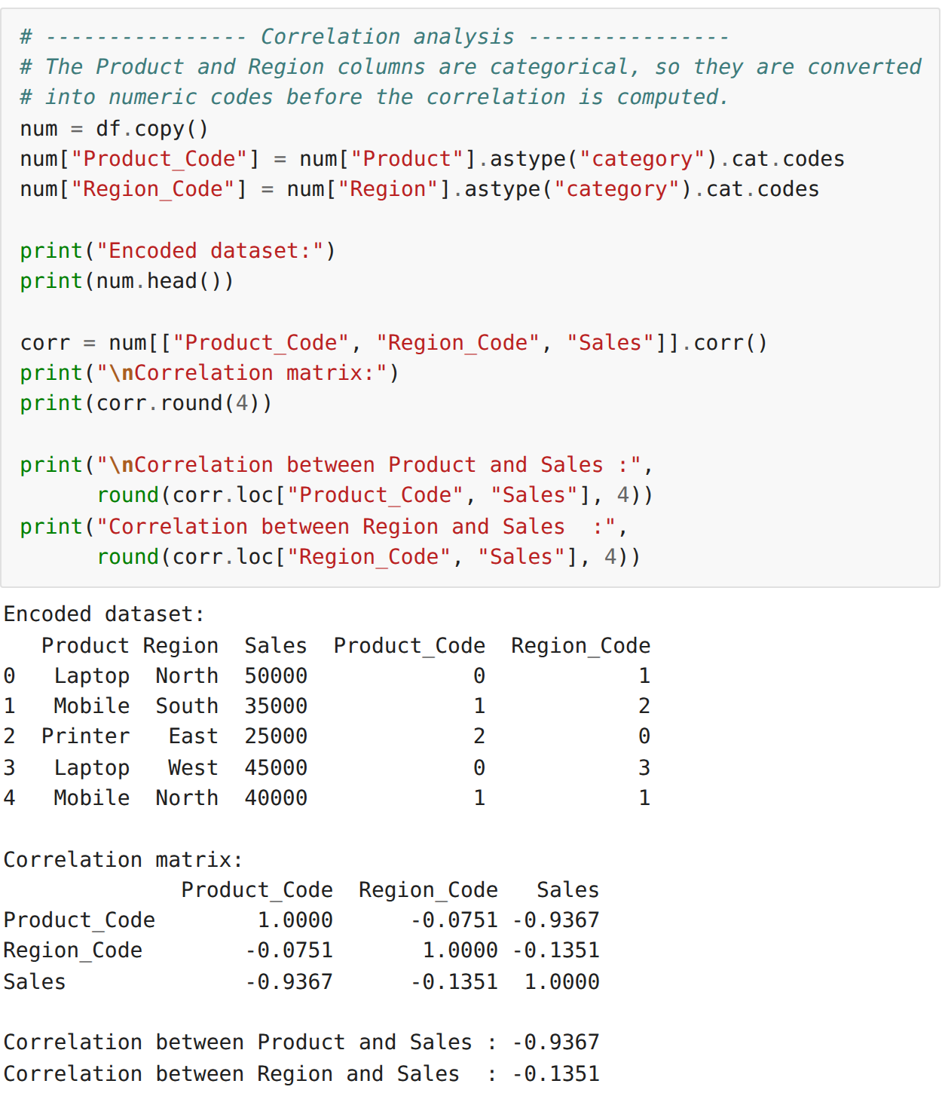
Step 10: Correlation between the products across the regions
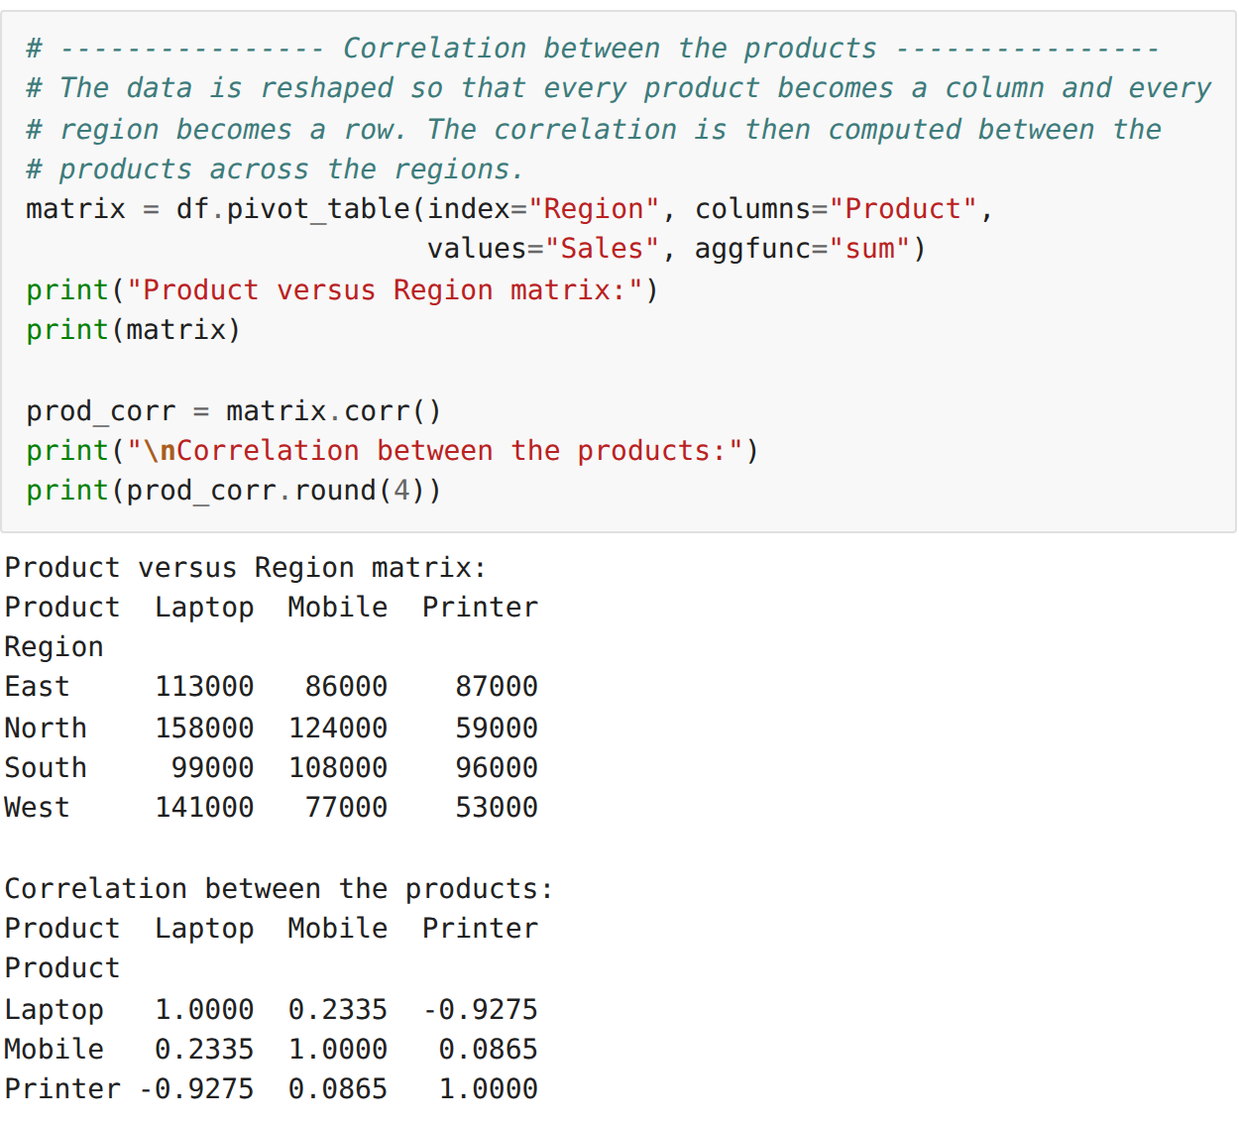
Step 11: Visualising the correlation using a heatmap
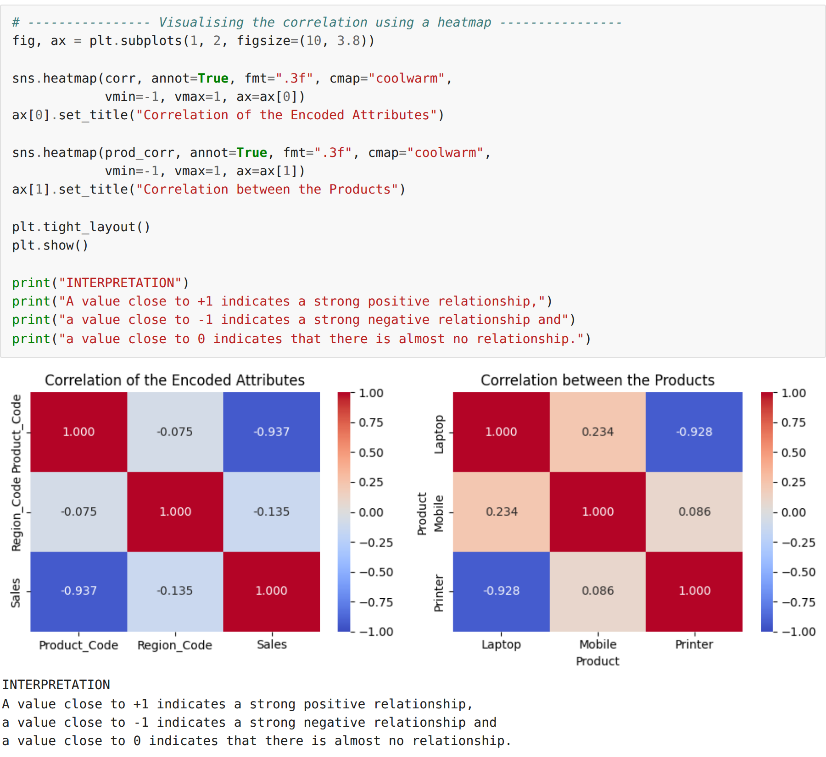
RESULT:
Thus the sales dataset was inspected, filtered using various conditions and indexing methods, analysed statistically, and the correlation between its attributes was computed and visualised successfully.

