EX. NO: 4b
EXPLORATORY DATA ANALYSIS (EDA) – DATA INSPECTION, FILTERING, STATISTICAL ANALYSIS AND CORRELATION
AIM:
To perform advanced exploratory data analysis on the sales dataset — inspecting the data using value_counts() and memory usage, filtering with nlargest(), group-wise conditions and cross-tabulation, computing advanced descriptive measures such as skewness, kurtosis and standard error, and comparing the Pearson, Spearman and Kendall correlation coefficients along with their significance.
ALGORITHM:
- Import the required libraries including the stats module of SciPy and load the dataset.
- Inspect the dataset using sample(), nunique(), value_counts() and memory_usage().
- Filter the records using nlargest(), nsmallest() and group-wise filtering.
- Filter the data using a variable inside the query() method.
- Build a cross-tabulation and a pivot table of Product against Region.
- Compute the advanced descriptive measures — skewness, kurtosis, standard error, coefficient of variation and the Inter-Quartile Range.
- Compute the group-wise descriptive statistics using describe() on a grouped object.
- Compute the covariance matrix of the numeric attributes.
- Compute the Pearson, Spearman and Kendall correlation coefficients and compare them.
- Test the significance of the correlation using the pearsonr() function of SciPy.
- Visualise the correlation using a heatmap and a pair-wise scatter plot.
- Interpret the results and record the output.
PROGRAM:
Step 1: Loading the dataset and inspecting it
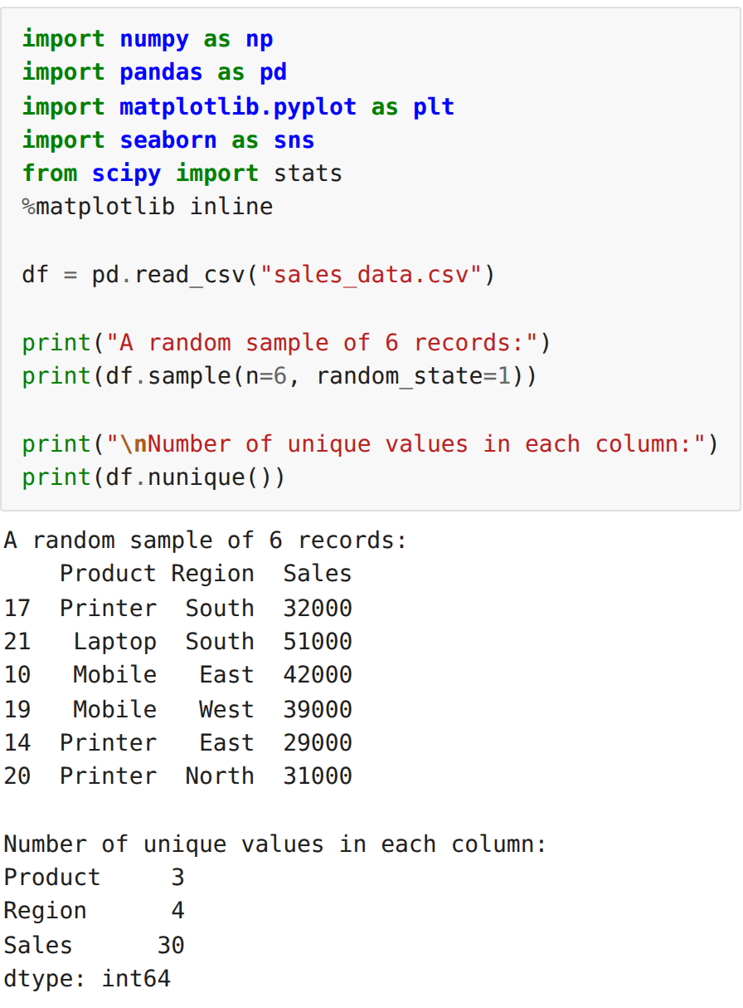
Step 2: Inspecting the distribution of the categories and the memory usage
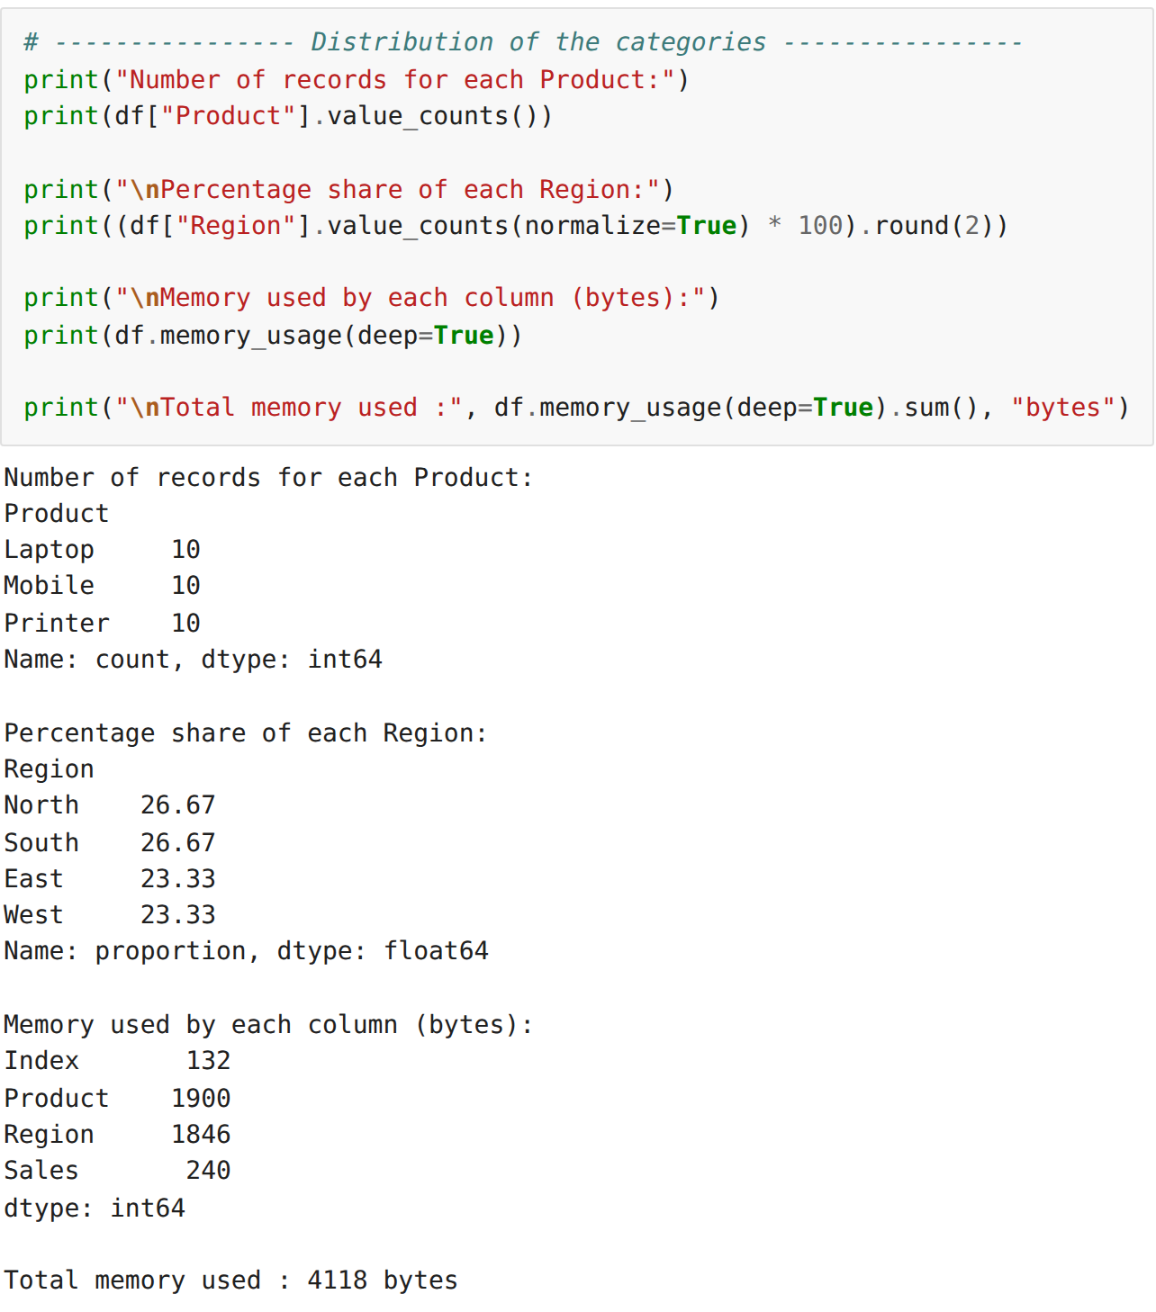
Step 3: Filtering using nlargest() and nsmallest()
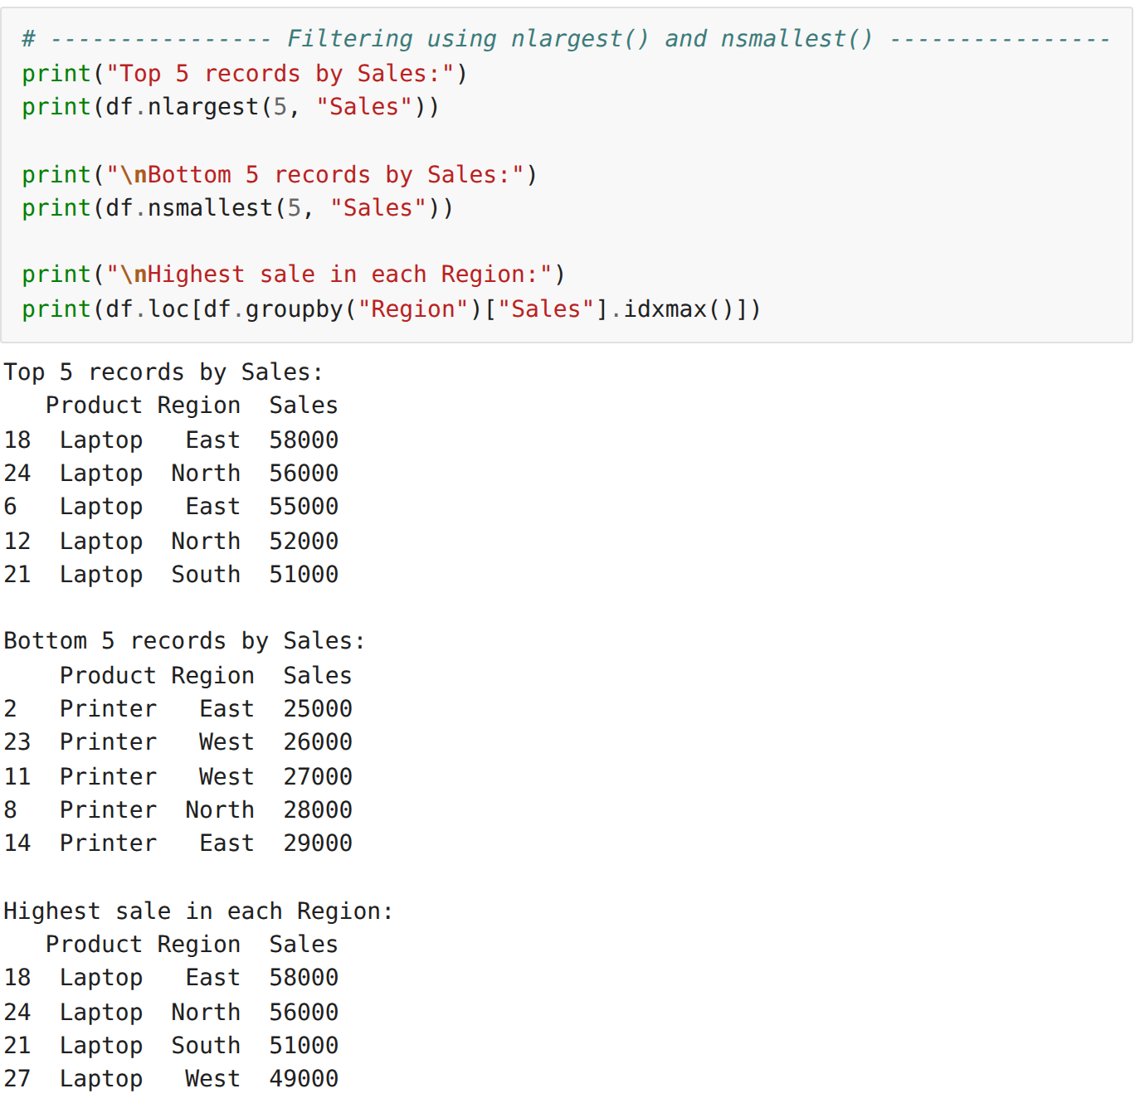
Step 4: Group-wise filtering and filtering with a variable in query()
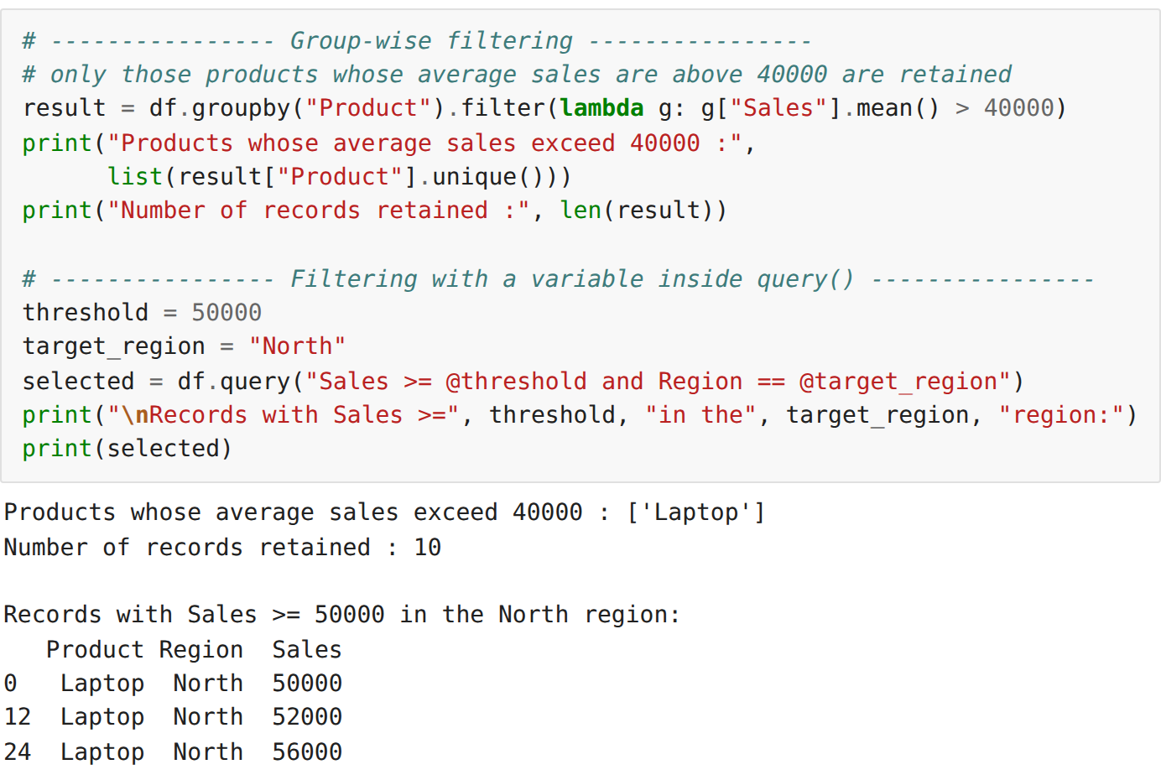
Step 5: Cross-tabulation and pivot table
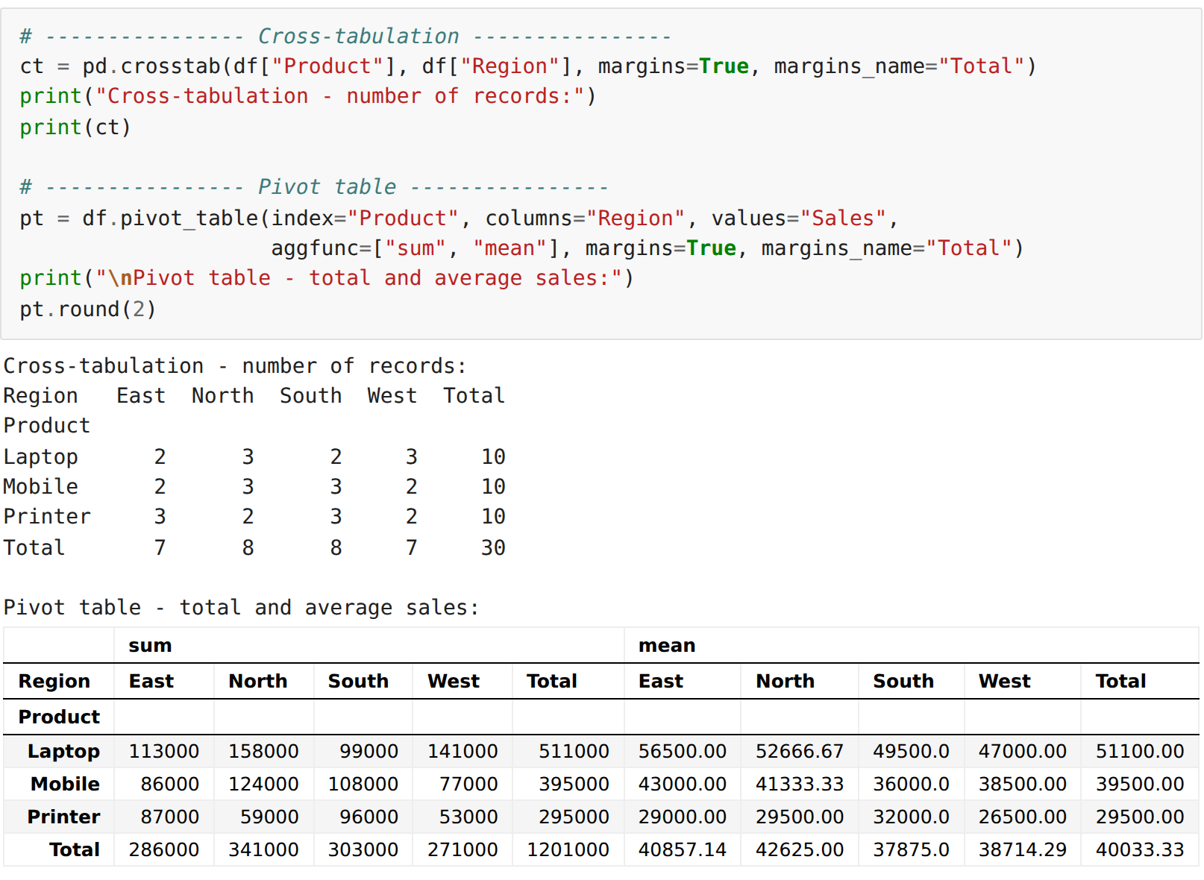
Step 6: Advanced descriptive statistical measures
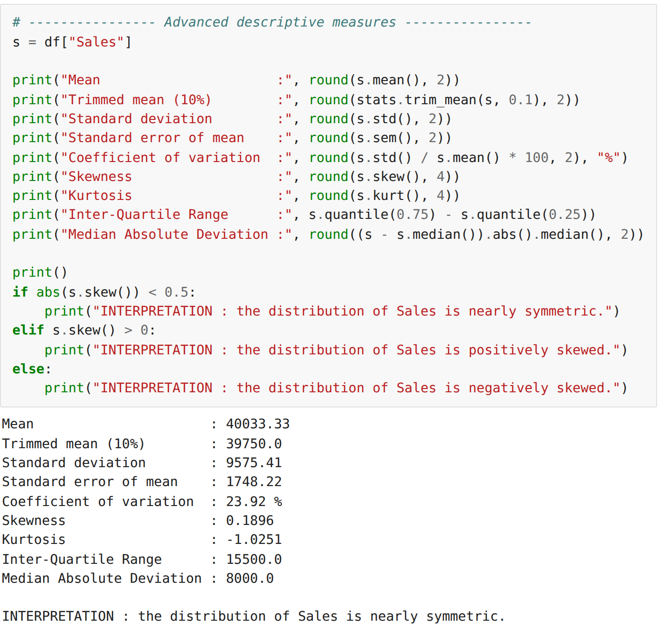
Step 7: Group-wise descriptive statistics
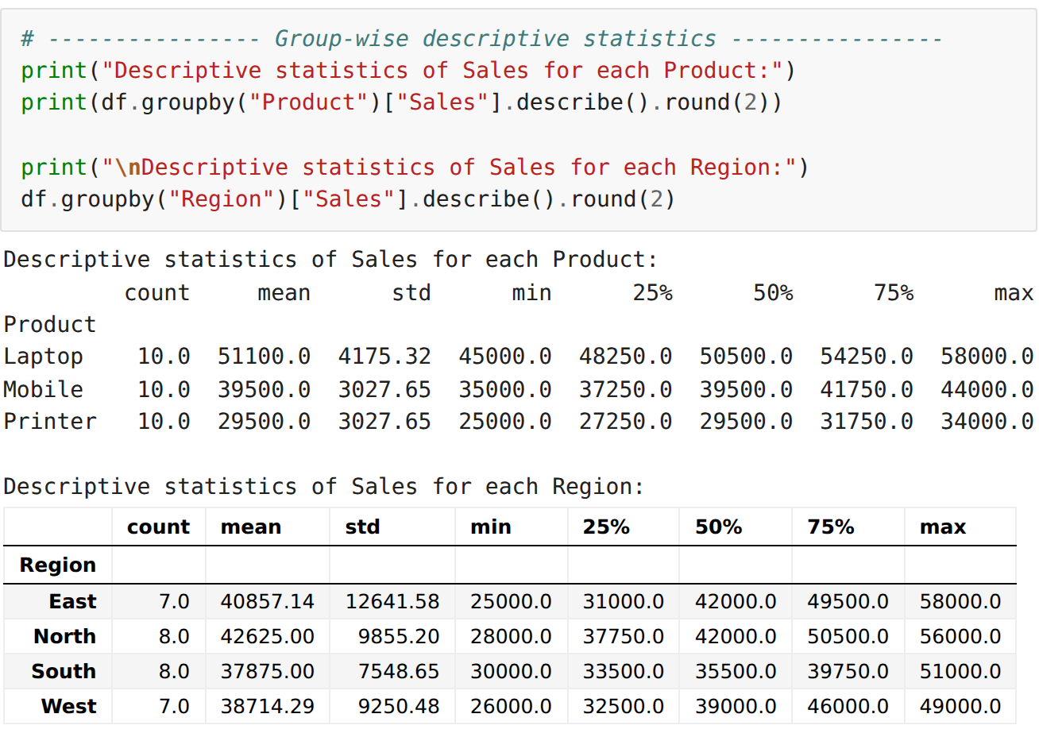
Step 8: Building the numeric feature set and computing the covariance matrix
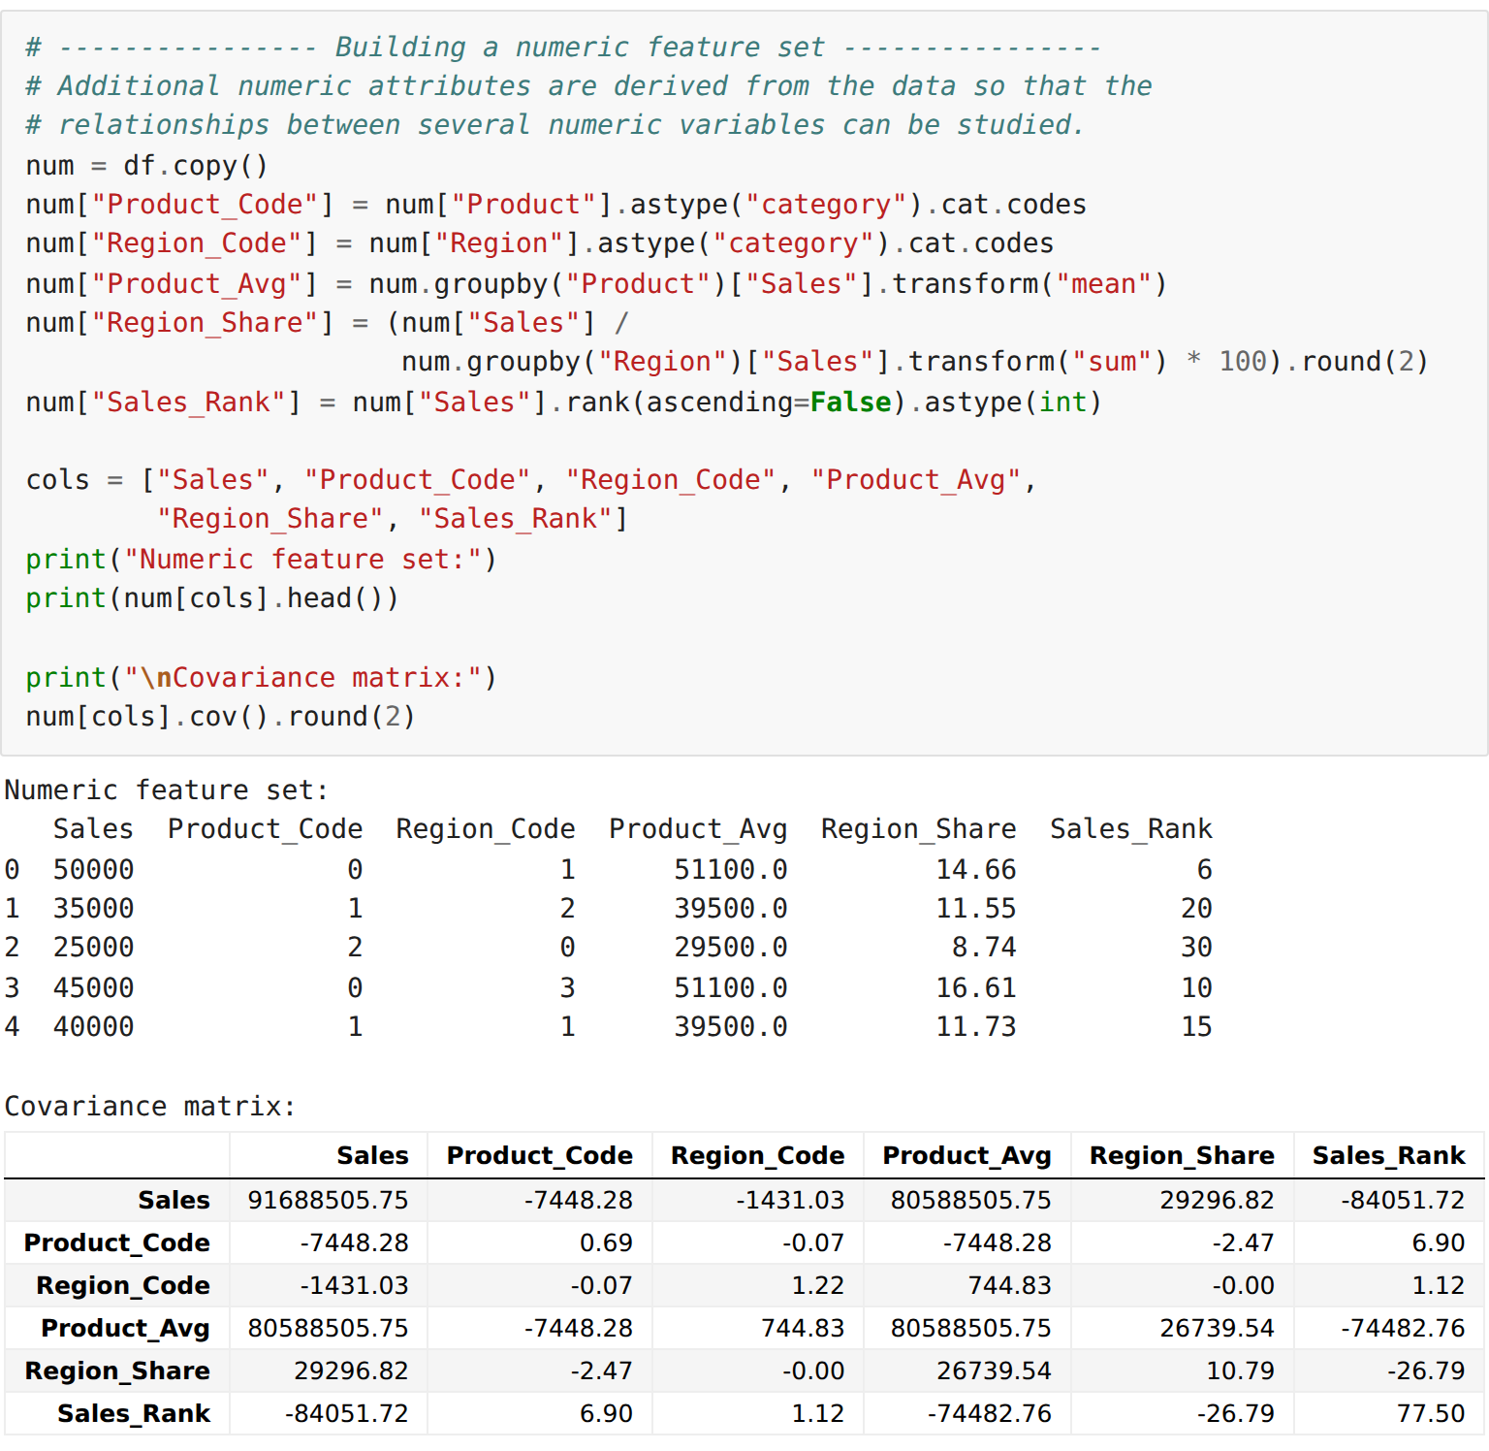
Step 9: Pearson, Spearman and Kendall correlation coefficients
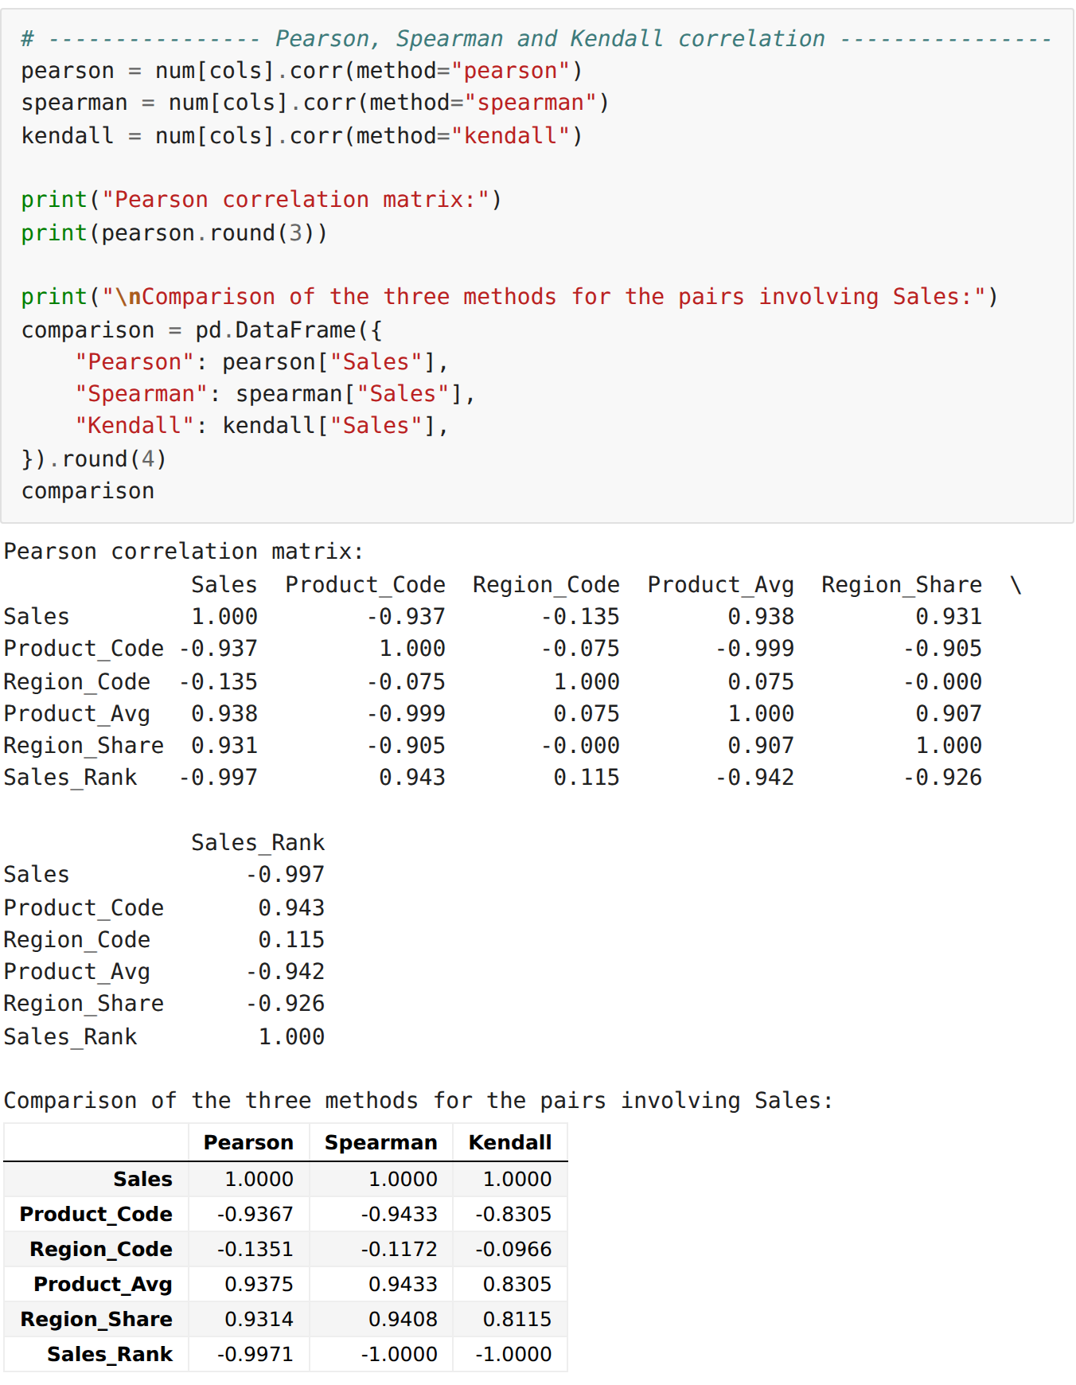
Step 10: Testing the significance of the correlation
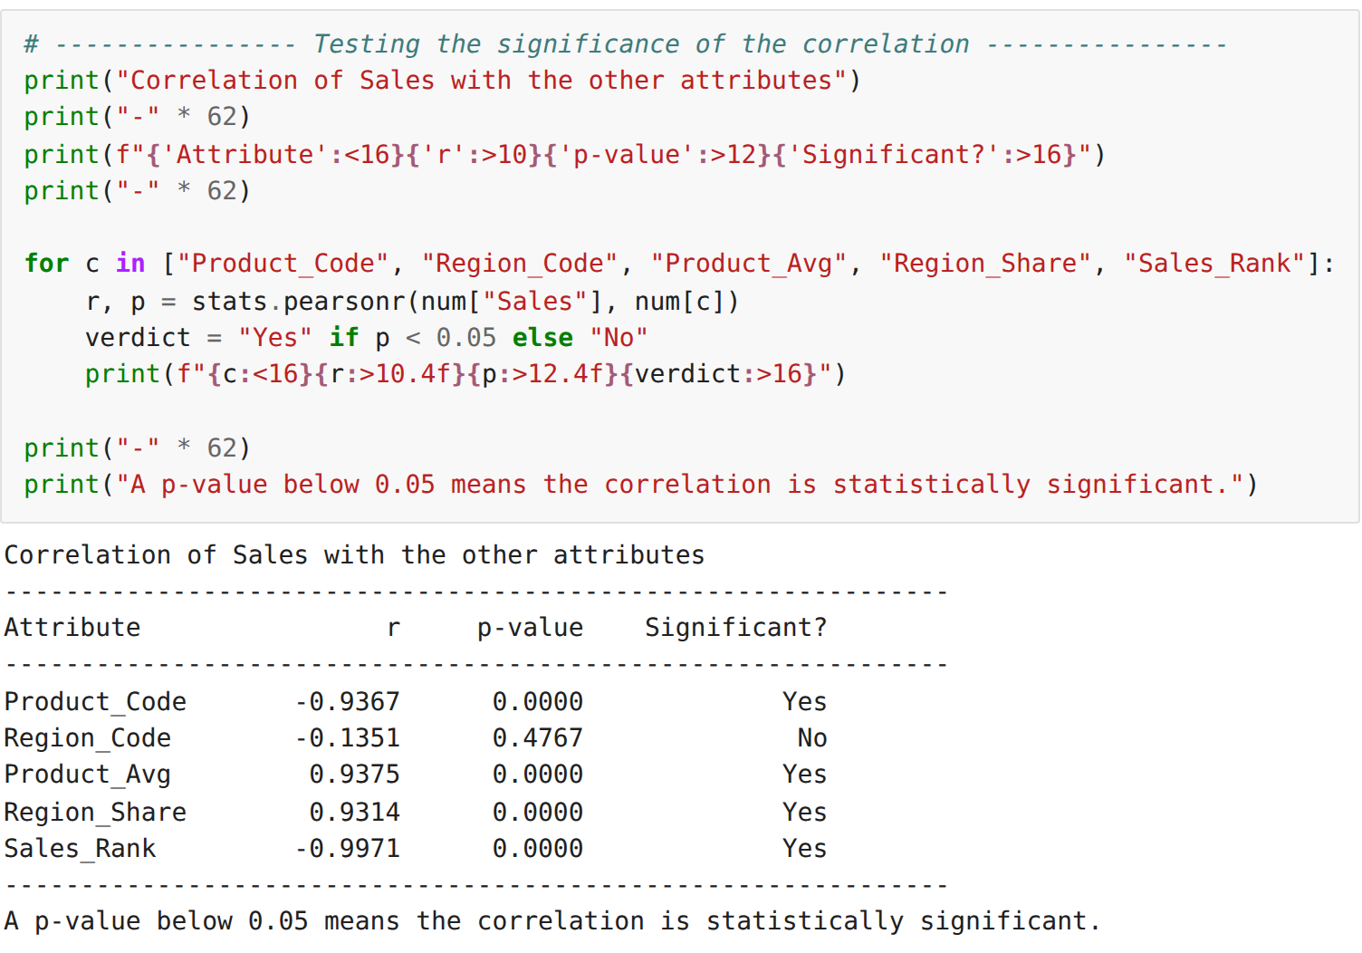
Step 11: Visualising the correlation using a heatmap
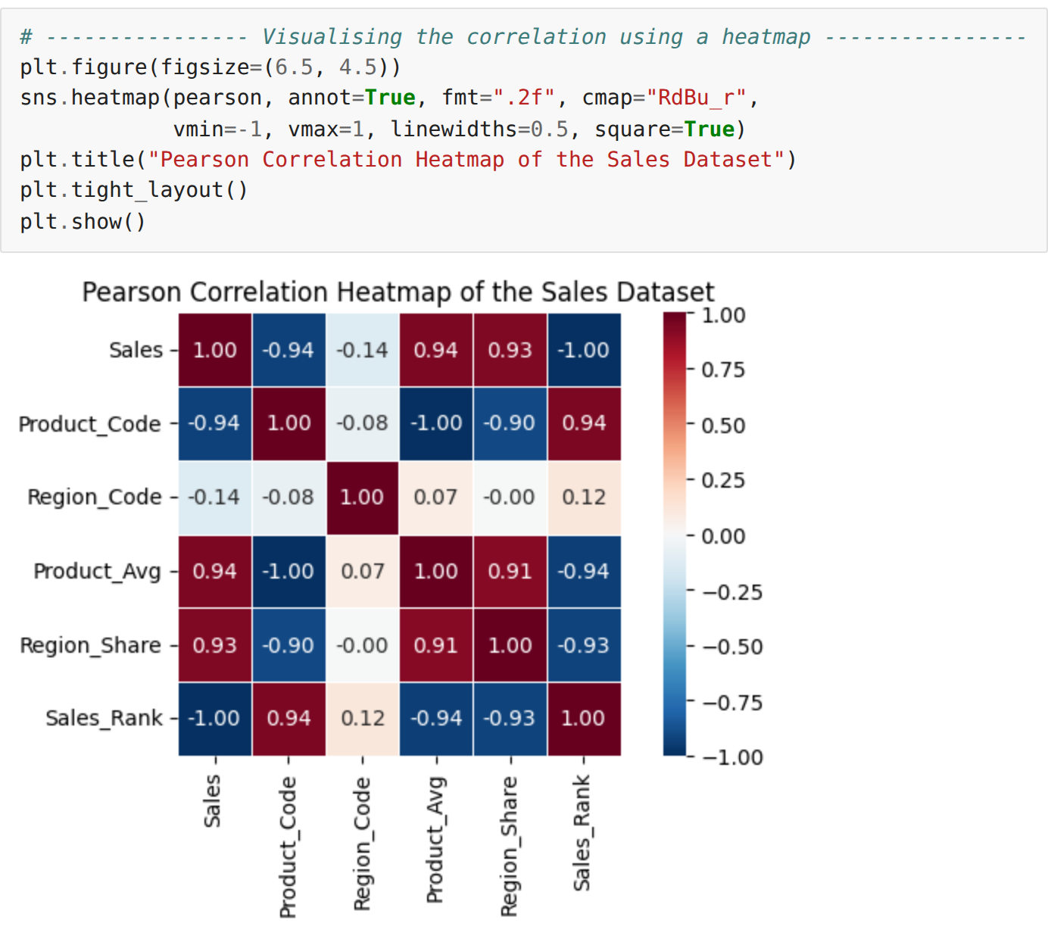
Step 12: Pair-wise scatter plot of the numeric attributes
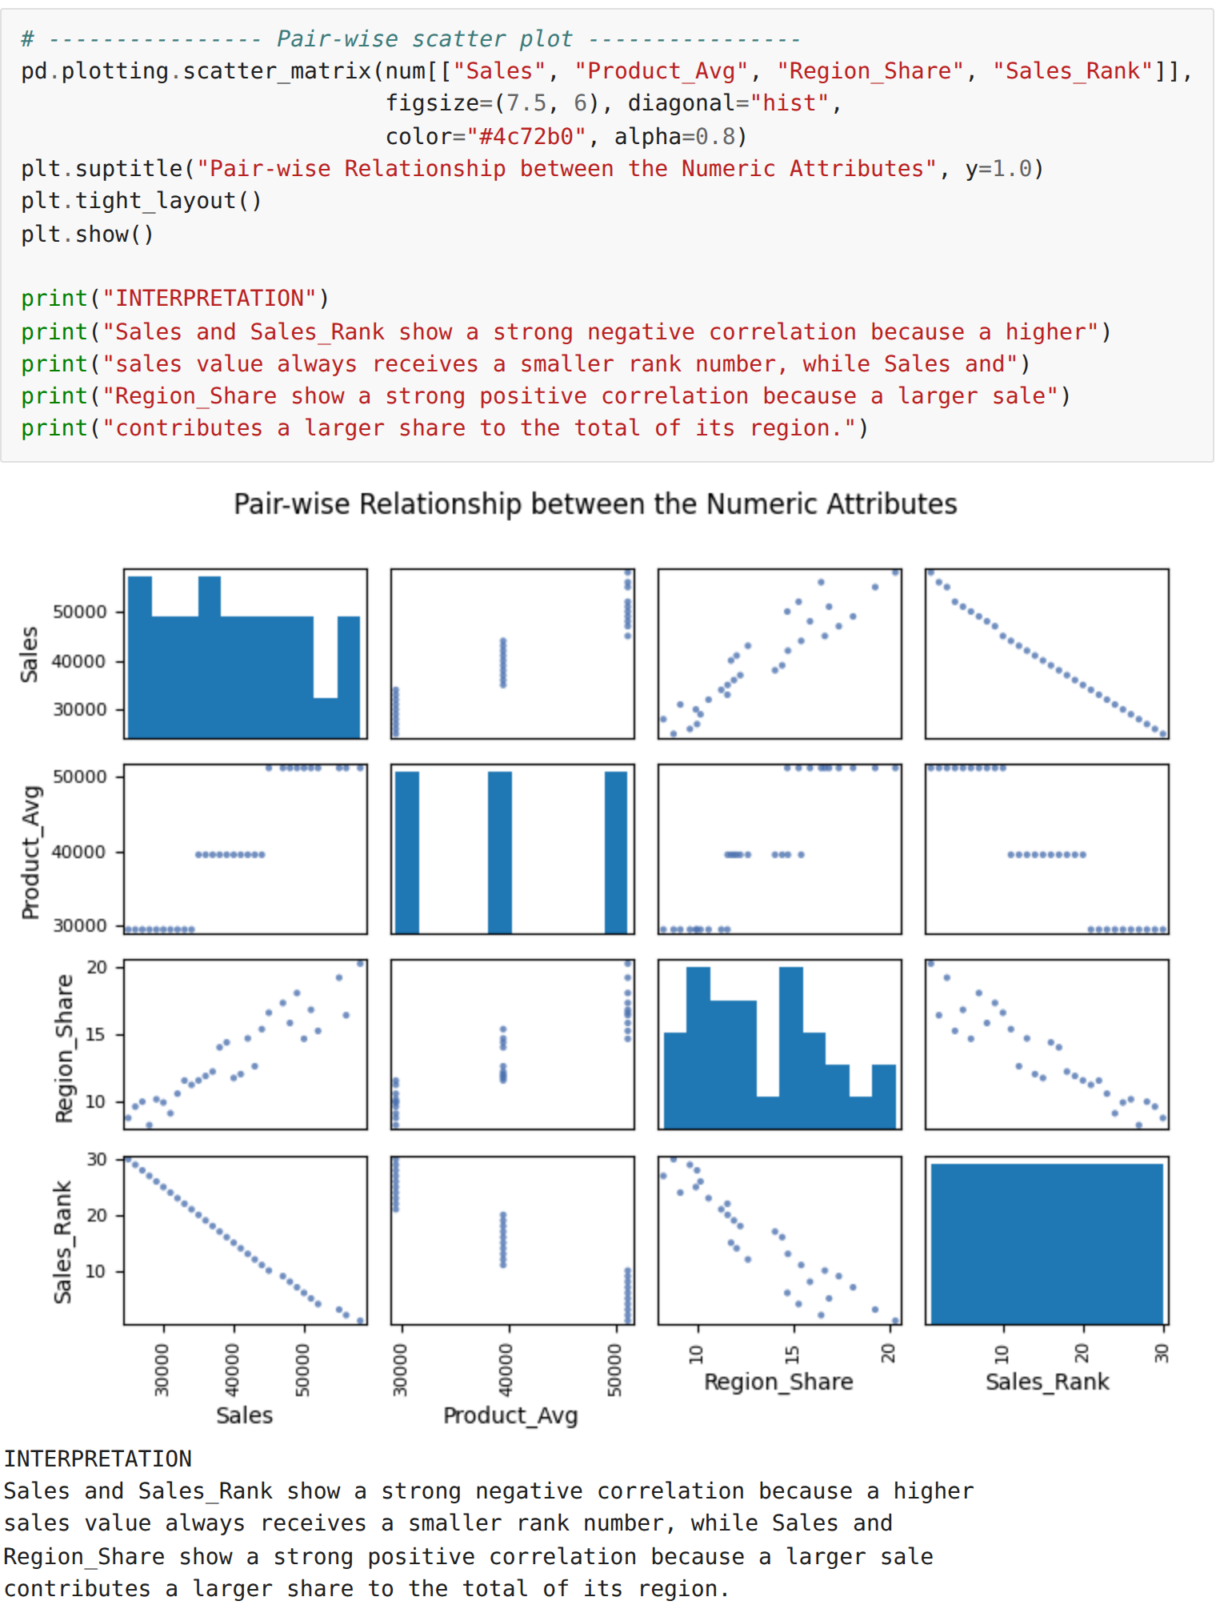
RESULT:
Thus advanced data inspection, filtering, statistical analysis and correlation analysis were carried out on the sales dataset, the Pearson, Spearman and Kendall coefficients were compared, their significance was tested and the results were visualised successfully.

