Experiment 9: Implement a Basic Reinforcement Learning Model (Q-Learning)
Aim
To implement a basic reinforcement learning model using the Q-Learning algorithm to learn the optimal actions for reaching a target state using a reward matrix and a Q-table.
Algorithm
- Start.
- Import the NumPy library.
- Define the reward matrix representing the rewards for moving between states.
- Initialize the Q-table with zeros.
- Set the discount factor \(\gamma = 0.8\) and the number of training episodes to 1000.
- Randomly select an initial state.
- Identify the possible actions from the current state using the reward matrix.
- Randomly select one of the available actions.
- Determine the next state based on the selected action.
- Update the Q-table using the Q-Learning update equation:
\[ Q(s,a)=R(s,a)+\gamma\max_{a'}Q(s',a') \]
- Continue until the target state (state 5) is reached.
- Repeat the training process for 1000 episodes.
- Display the final Q-table.
- Stop
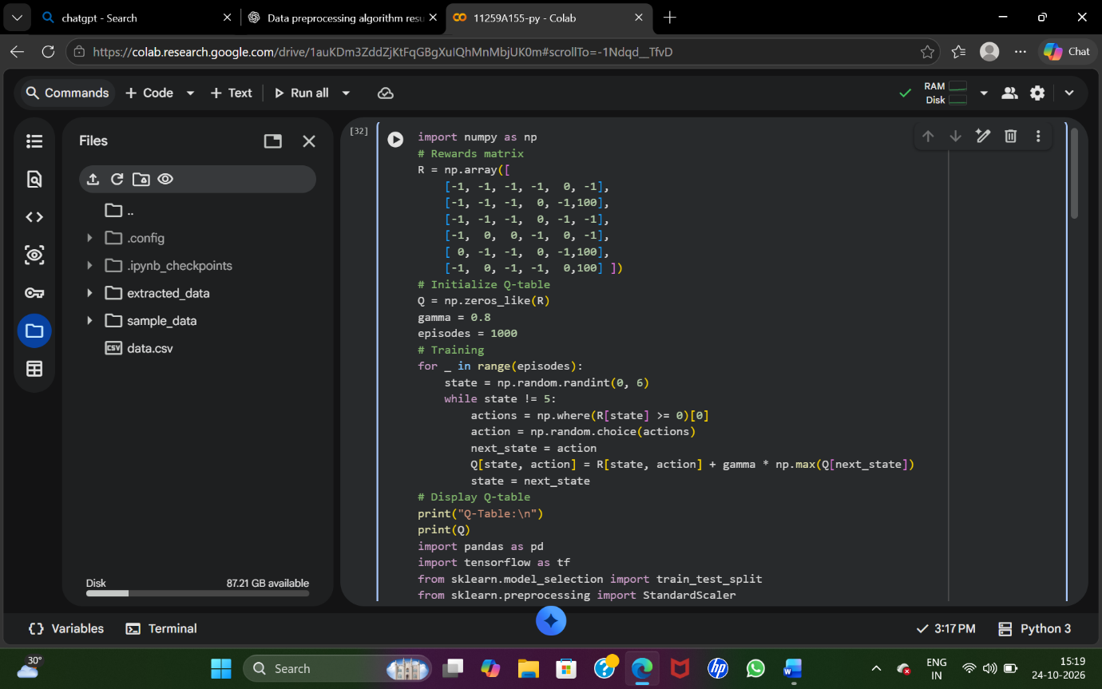
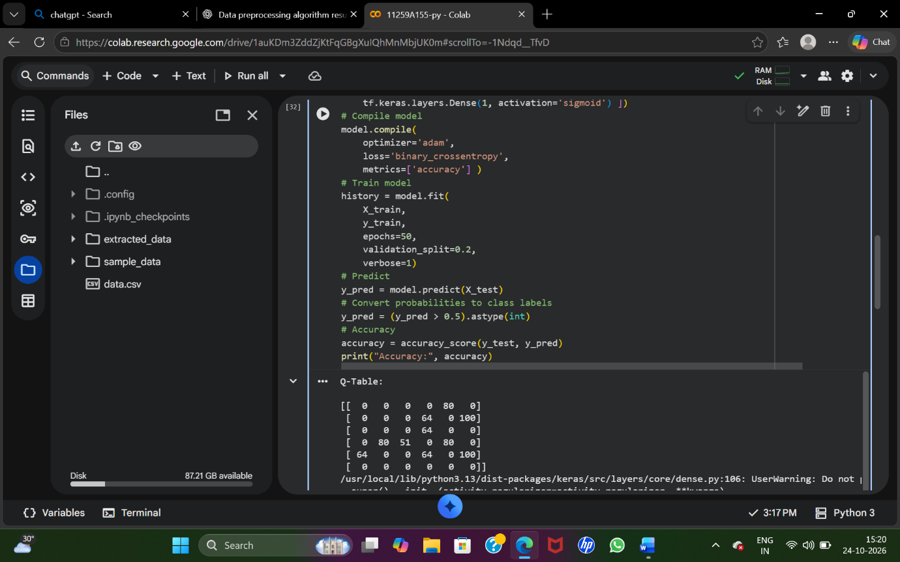
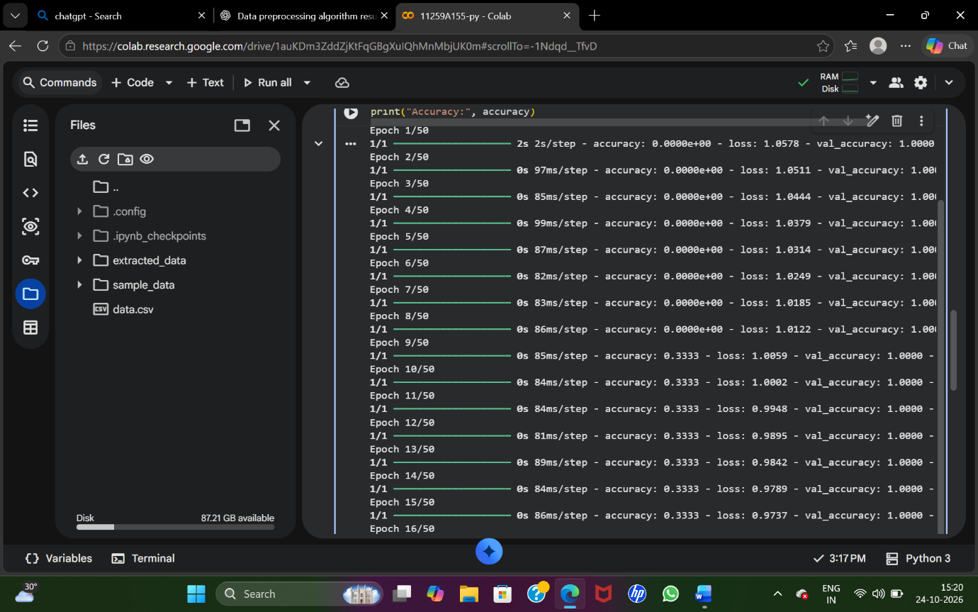
Result
Thus, the Q-Learning reinforcement learning model was implemented successfully. The agent learned state-action values through repeated interaction with the reward matrix, and the learned values were displayed in the Q-table.

