Program 1: Data Preprocessing
1. Aim
To preprocess a dataset by checking for missing values, filling missing numerical values with their mean, selecting numerical columns, and normalizing the data using StandardScaler.
Algorithm
- Start.
- Import the required libraries: pandas and StandardScaler from sklearn.preprocessing.
- Load the dataset from data.csv.
- Display the first five rows of the original dataset.
- Check and display the number of missing values in each column.
- Fill missing numerical values with the mean of their respective columns.
- Select the columns Hours_Studied, Attendance, Assignments, and Marks.
- Create a StandardScaler object.
- Apply standardization to the selected numerical columns.
- Convert the normalized data into a Pandas DataFrame.
- Display the first five rows of the normalized dataset.
- Stop.
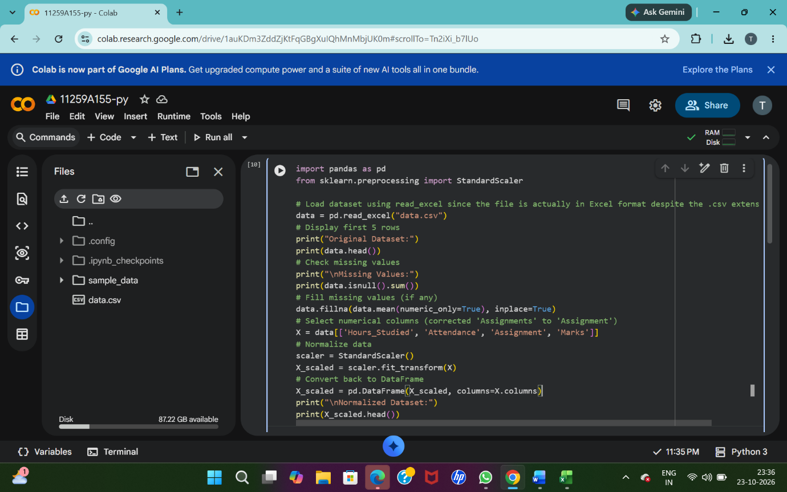
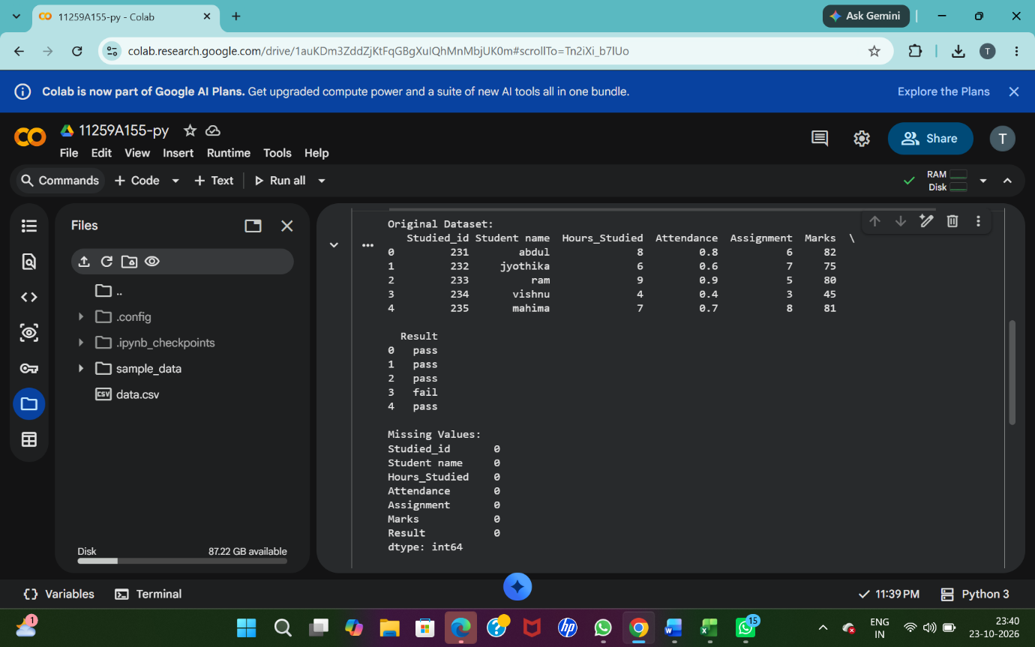
4. Result
The exact output depends on the contents of data.csv. The following is an illustrative output assuming the dataset contains suitable student records.

