Ex.No. 3: Implement Linear Regression
Aim
To implement a Linear Regression algorithm to predict students' marks based on the number of hours studied and evaluate the model using Mean Squared Error (MSE) and R² score.
Algorithm
- Start.
- Import the required libraries: Pandas, Matplotlib, train_test_split, LinearRegression, and evaluation metrics.
- Load the dataset from data.csv.
- Select Hours_Studied as the input feature and Marks as the target variable.
- Split the dataset into 80% training data and 20% testing data.
- Create a Linear Regression model.
- Train the model using the training dataset.
- Predict students' marks using the testing dataset.
- Evaluate the model using Mean Squared Error and R² score.
- Display the predicted marks.
- Plot the actual data points and the regression line.
- Stop.
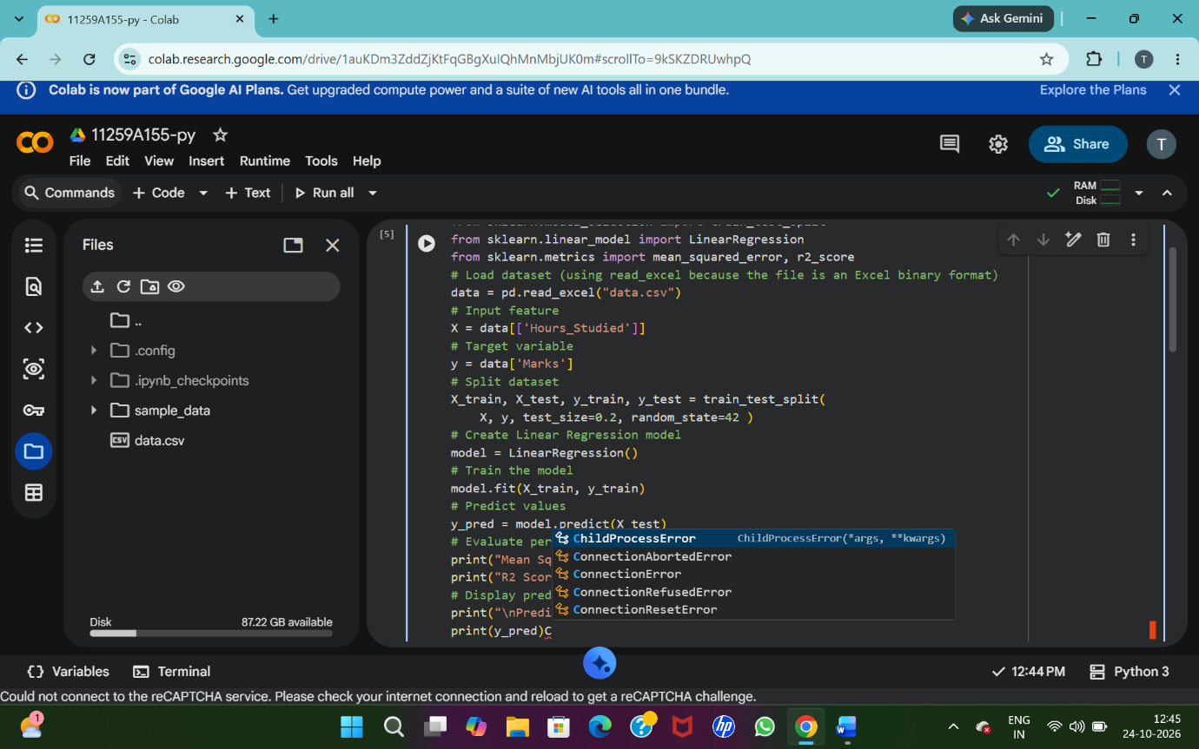
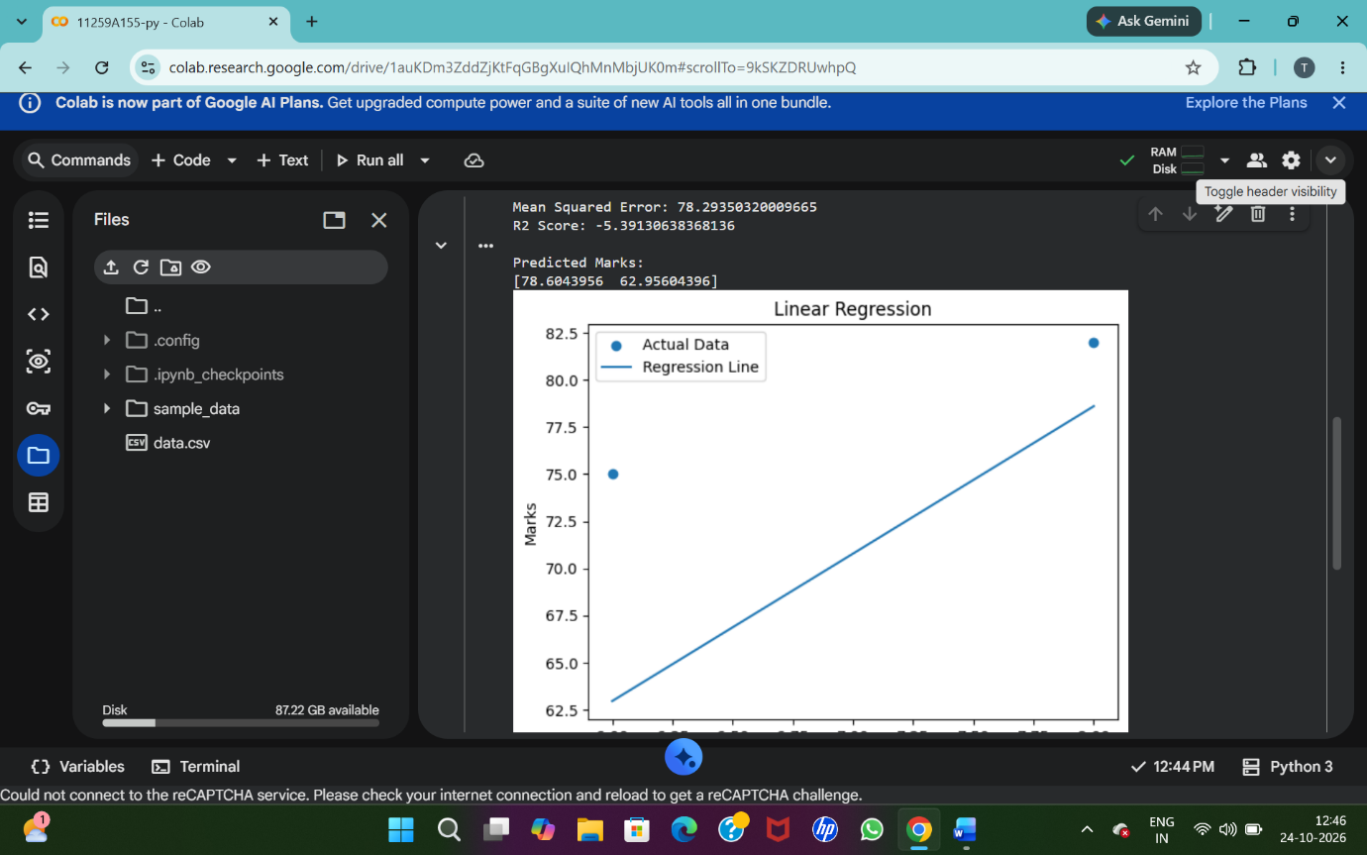
Result
Thus, the Linear Regression algorithm was implemented successfully to predict students' marks based on their study hours. The model's performance was evaluated using Mean Squared Error and R² score, and the actual data and regression line were plotted.

