EX.NO. 4(A): Implement Classification Model Using KNN and Compute Evaluation Metrics
Aim
To implement the K-Nearest Neighbors (KNN) classification algorithm to predict students' results based on hours studied, attendance, and assignments, and evaluate the model using accuracy, confusion matrix, and classification report.
Algorithm
- Start.
- Import the required libraries: Pandas, train_test_split, KNeighborsClassifier, and evaluation metrics.
- Load the dataset from data.csv.
- Select Hours_Studied, Attendance, and Assignments as input features.
- Select Result as the target variable.
- Split the dataset into 80% training data and 20% testing data.
- Create a KNN classifier with n_neighbors=3.
- Train the model using the training dataset.
- Predict the results for the testing dataset.
- Calculate and display the accuracy score.
- Display the confusion matrix.
- Display the classification report containing precision, recall, and F1-score.
- Stop.
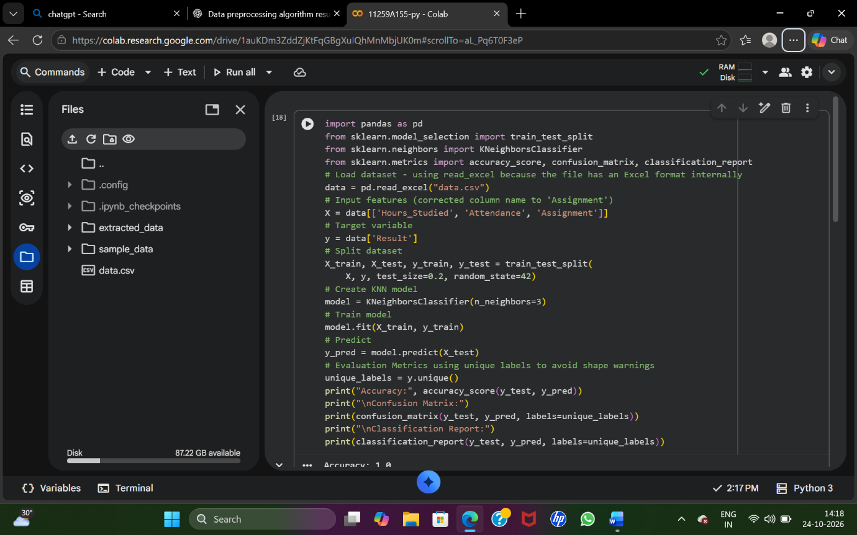
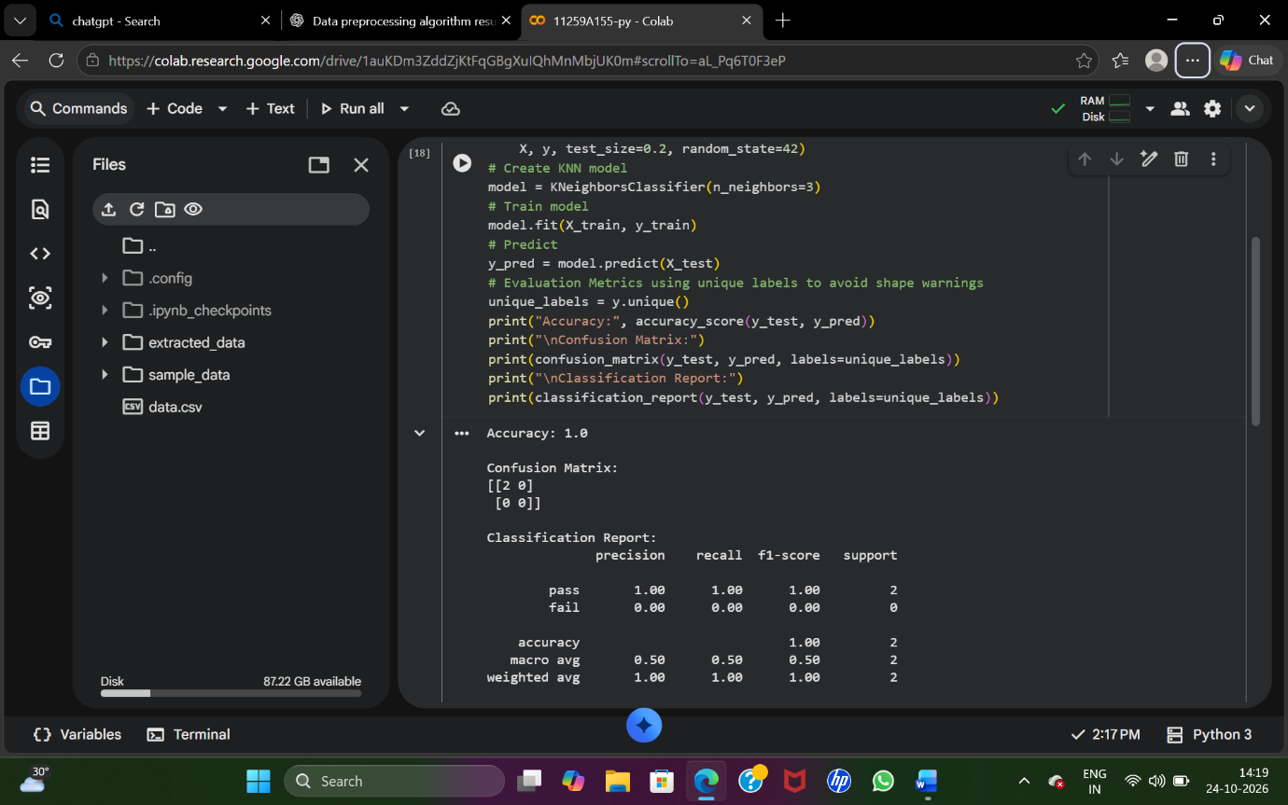
Result
Thus, the KNN classification model was implemented successfully, and its performance was evaluated using accuracy, confusion matrix, precision, recall, and F1-score.
EX.NO. 4(B): Implement Classification Model Using SVM and Compute Evaluation Metrics
Aim
To implement a Support Vector Machine (SVM) classification algorithm using a linear kernel to predict students' results based on hours studied, attendance, and assignments, and evaluate its performance using accuracy, confusion matrix, and classification report.
Algorithm
- Start.
- Import the required libraries: Pandas, train_test_split, SVC, and evaluation metrics.
- Load the dataset from data.csv.
- Select Hours_Studied, Attendance, and Assignments as input features.
- Select Result as the target variable.
- Split the dataset into 80% training data and 20% testing data.
- Create an SVM classifier using SVC(kernel='linear').
- Train the model using the training dataset.
- Predict the results for the testing dataset.
- Calculate and display the accuracy score.
- Display the confusion matrix.
- Display the classification report containing precision, recall, and F1-score.
- Stop
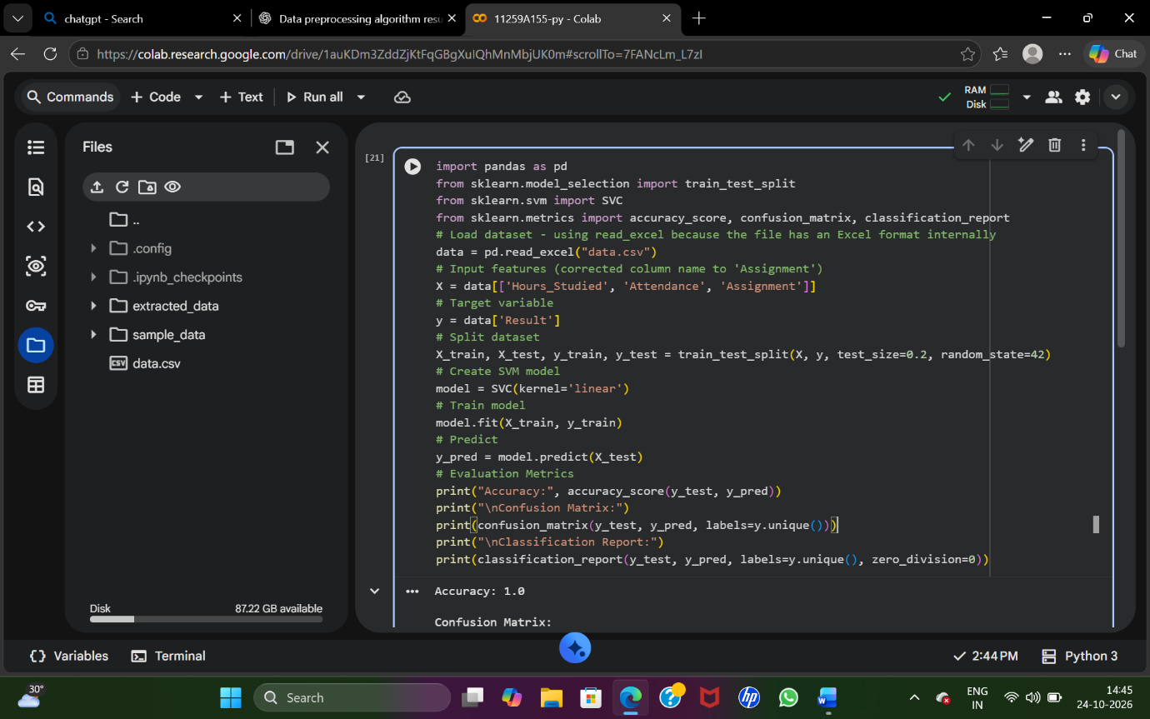
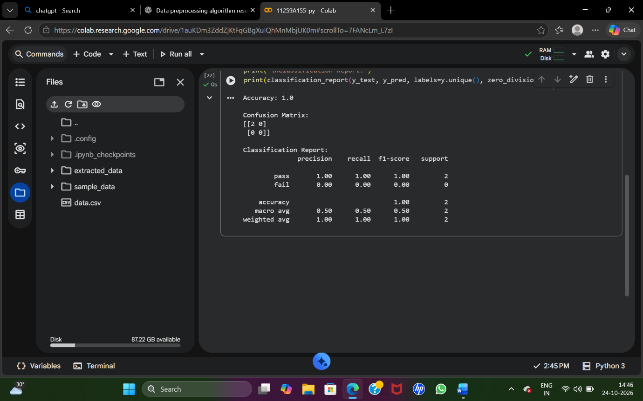
Result
Thus, the SVM classification model with a linear kernel was implemented successfully, and its performance was evaluated using accuracy, confusion matrix, precision, recall, and F1-score.

