Ex No. 5: Implement K-Means Clustering
Aim
To implement the K-Means clustering algorithm to group students based on their hours studied and marks into three clusters and visualize the clusters along with their centroids.
Algorithm
- Start.
- Import the required libraries: Pandas, Matplotlib, and KMeans from sklearn.cluster.
- Load the dataset from data.csv.
- Select Hours_Studied and Marks as input features.
- Create a K-Means clustering model with three clusters (n_clusters=3).
- Fit the model to the selected data.
- Obtain the cluster labels for each data point.
- Add the cluster labels as a new column named Cluster in the dataset.
- Display the clustered dataset.
- Plot the data points using different colors for each cluster.
- Plot the cluster centroids using an X-shaped marker.
- Add axis labels, a title, and a legend to the graph.
- Display the graph.
- Stop.
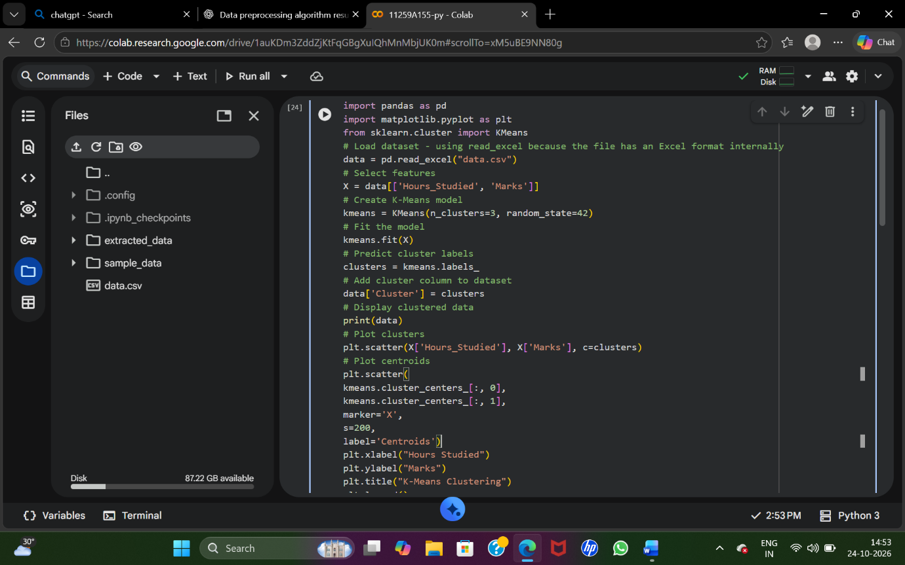
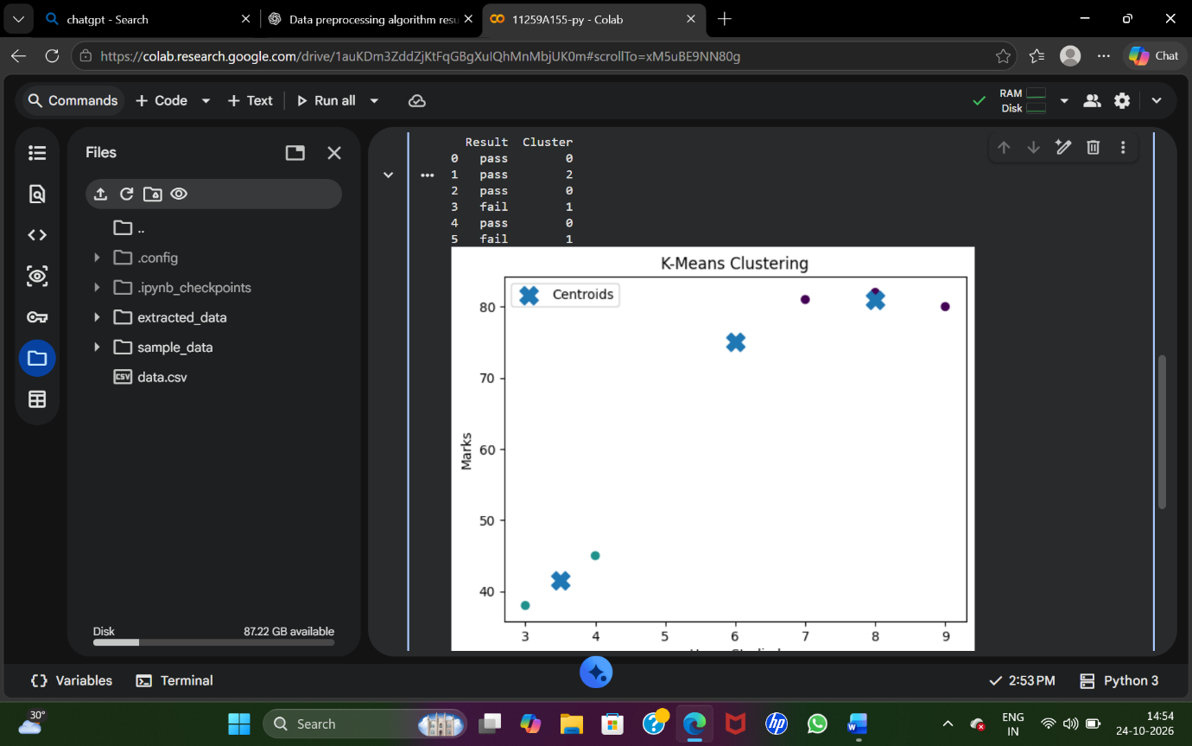
Output
Thus, the K-Means clustering algorithm was implemented successfully to group students into three clusters based on their hours studied and marks. The clustered data and centroids were visualized using a scatter plot.

