Experiment 6: Implement Hierarchical Clustering
Aim
To implement the Hierarchical Clustering algorithm to group students based on their hours studied and marks into three clusters, and visualize the results using a dendrogram and a scatter plot.
Algorithm
- Start.
- Import the required libraries: Pandas, Matplotlib, dendrogram, linkage, and AgglomerativeClustering.
- Load the dataset from data.csv.
- Select Hours_Studied and Marks as input features.
- Create a linkage matrix using the Ward linkage method.
- Plot the dendrogram to visualize the hierarchical relationships between data points.
- Create an Agglomerative Clustering model with three clusters.
- Apply the model to the selected data and predict cluster labels.
- Add the cluster labels to the dataset as a new column named Cluster.
- Display the clustered dataset.
- Plot a scatter plot showing the three clusters using different colors.
- Display the graph.
- Stop.
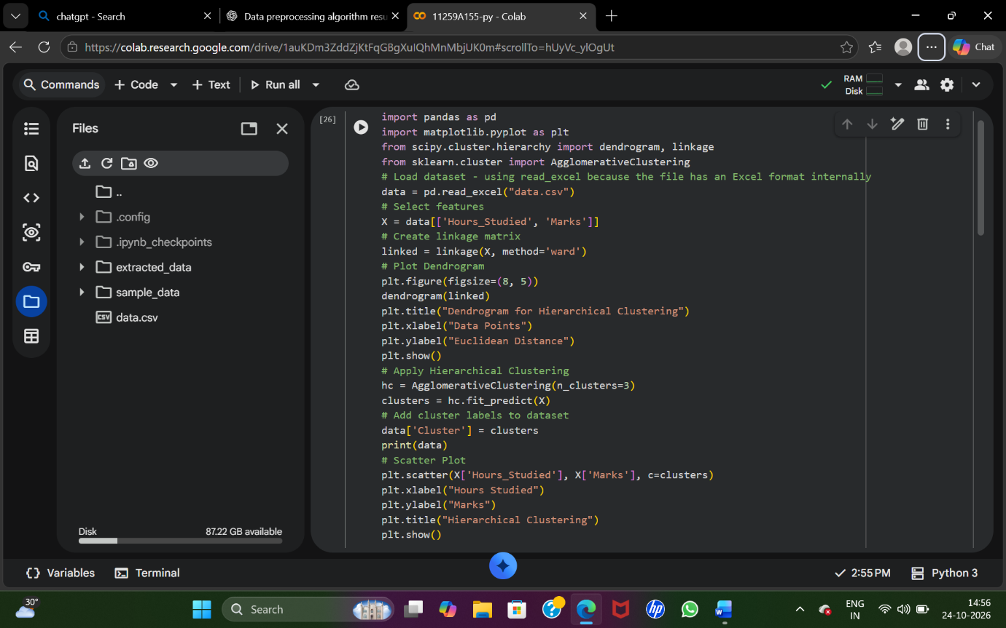
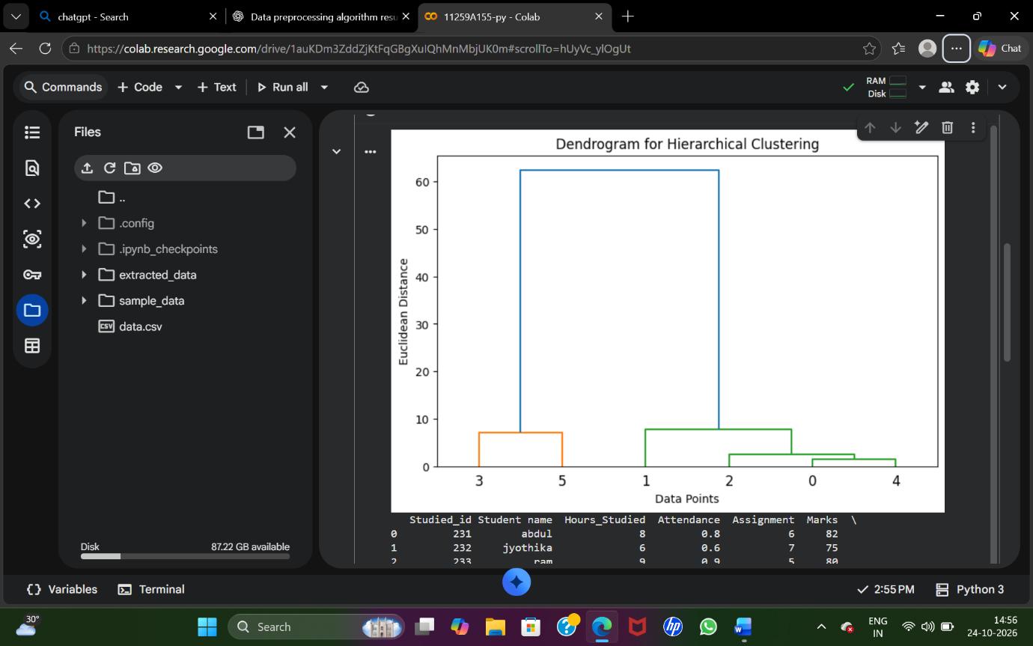
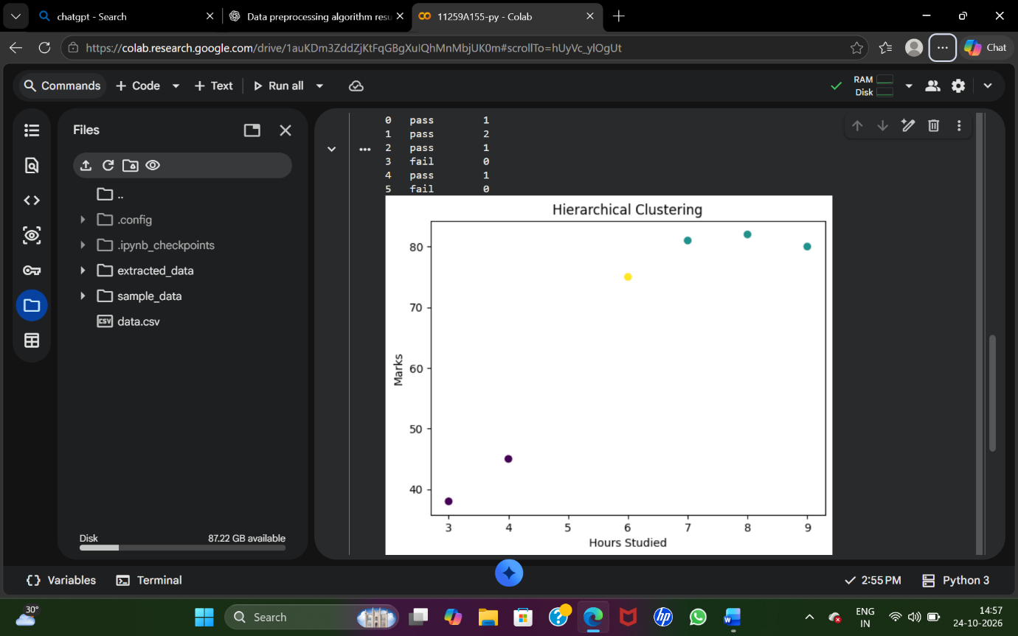
Result
Thus, the Hierarchical Clustering algorithm was implemented successfully using Ward linkage and Agglomerative Clustering. The hierarchical relationships were visualized using a dendrogram, and the final three clusters were displayed using a scatter plot.

