Experiment 7: Implement Random Forest and Analyze Performance
Aim
To implement the Random Forest classification algorithm to predict students' results based on hours studied, attendance, and assignments, and analyze its performance using accuracy, confusion matrix, classification report, and feature importance visualization.
Algorithm
- Start.
- Import the required libraries: Pandas, train_test_split, RandomForestClassifier, evaluation metrics, and Matplotlib.
- Load the dataset from data.csv.
- Select Hours_Studied, Attendance, and Assignments as input features.
- Select Result as the target variable.
- Split the dataset into 80% training data and 20% testing data using train_test_split().
- Create a Random Forest classifier with 100 decision trees and random_state=42.
- Train the model using the training dataset.
- Predict the results for the testing dataset.
- Calculate and display the accuracy score.
- Display the confusion matrix and classification report.
- Extract the feature importance values from the trained model.
- Plot a bar graph showing the importance of each feature.
- Display the graph.
- Stop.
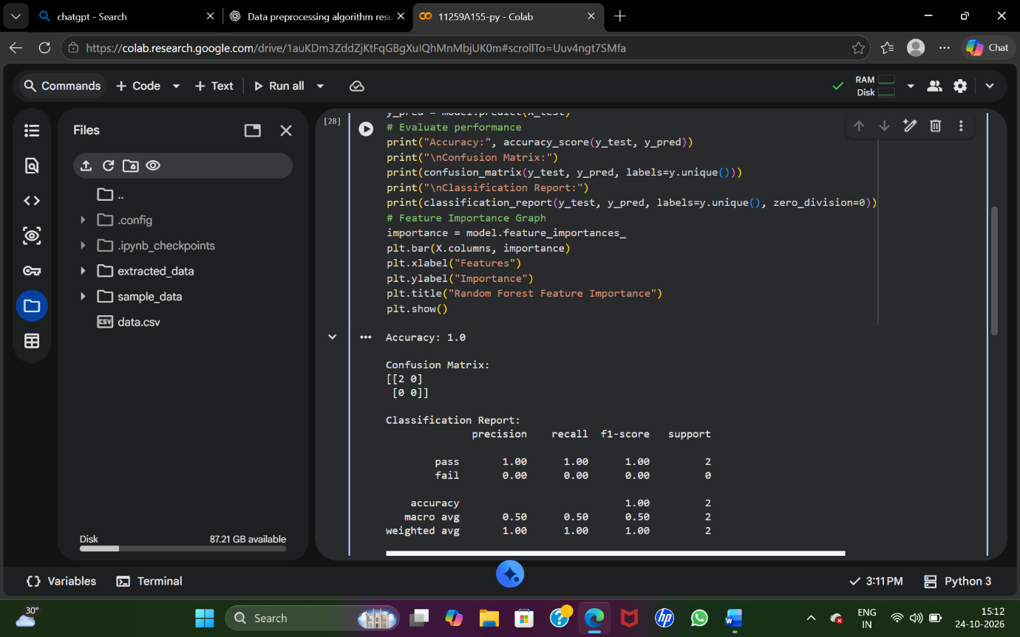
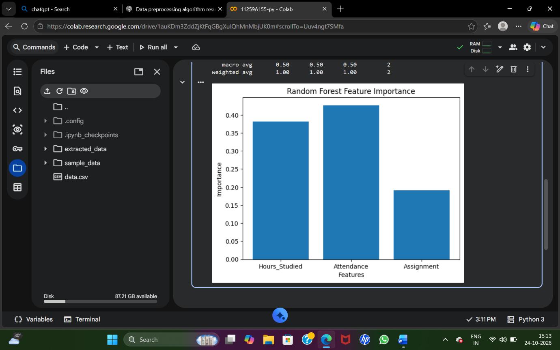
Result
Thus, the Random Forest classification algorithm was implemented successfully to predict students' results. Its performance was analyzed using accuracy, confusion matrix, precision, recall, and F1-score. Feature importance was also visualized using a bar graph.

