Experiment 8: Implement Boosting Technique (AdaBoost) and Analyze Performance
Aim
To implement the AdaBoost classification algorithm to predict students' results based on hours studied, attendance, and assignments, and analyze its performance using accuracy, confusion matrix, classification report, and feature importance visualization.
Algorithm
- Start.
- Import the required libraries: Pandas, Matplotlib, train_test_split, AdaBoostClassifier, and evaluation metrics.
- Load the dataset from data.csv.
- Select Hours_Studied, Attendance, and Assignments as input features.
- Select Result as the target variable.
- Split the dataset into 80% training data and 20% testing data.
- Create an AdaBoost classifier with 50 estimators.
- Train the model using the training dataset.
- Predict the results for the testing dataset.
- Calculate and display the accuracy score.
- Display the confusion matrix and classification report.
- Extract the feature importance values.
- Plot a bar graph showing the importance of each feature.
- Display the graph.
- Stop.
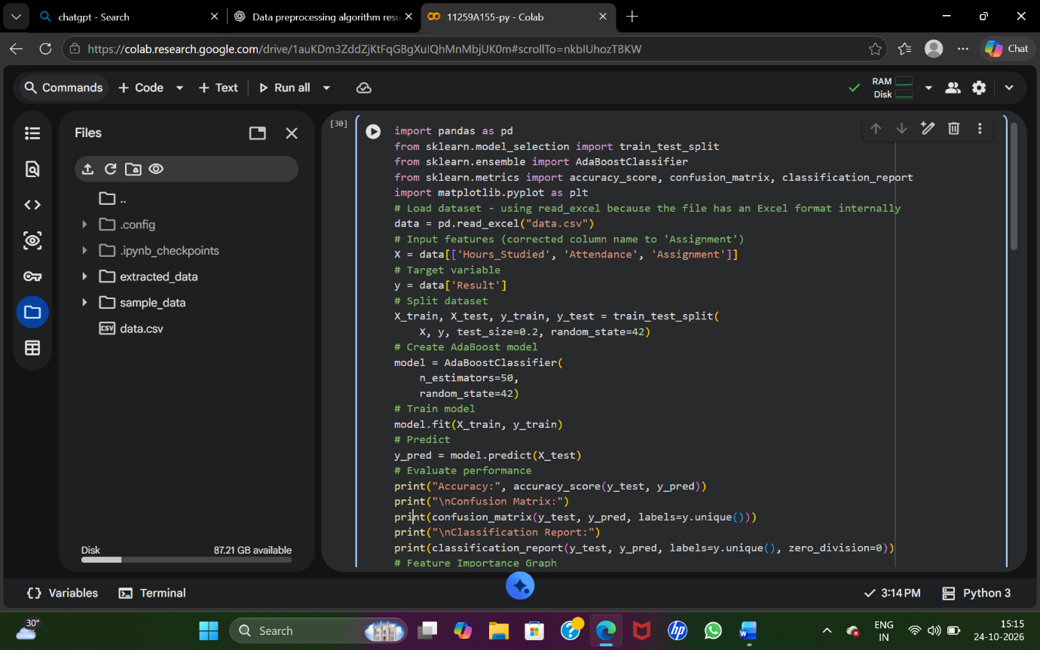
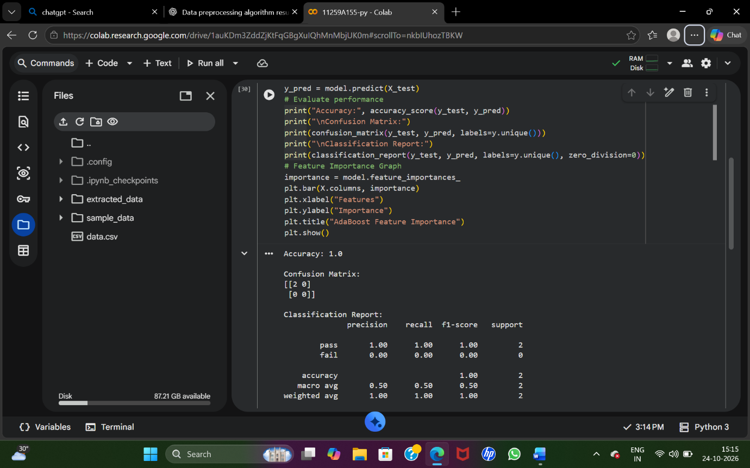
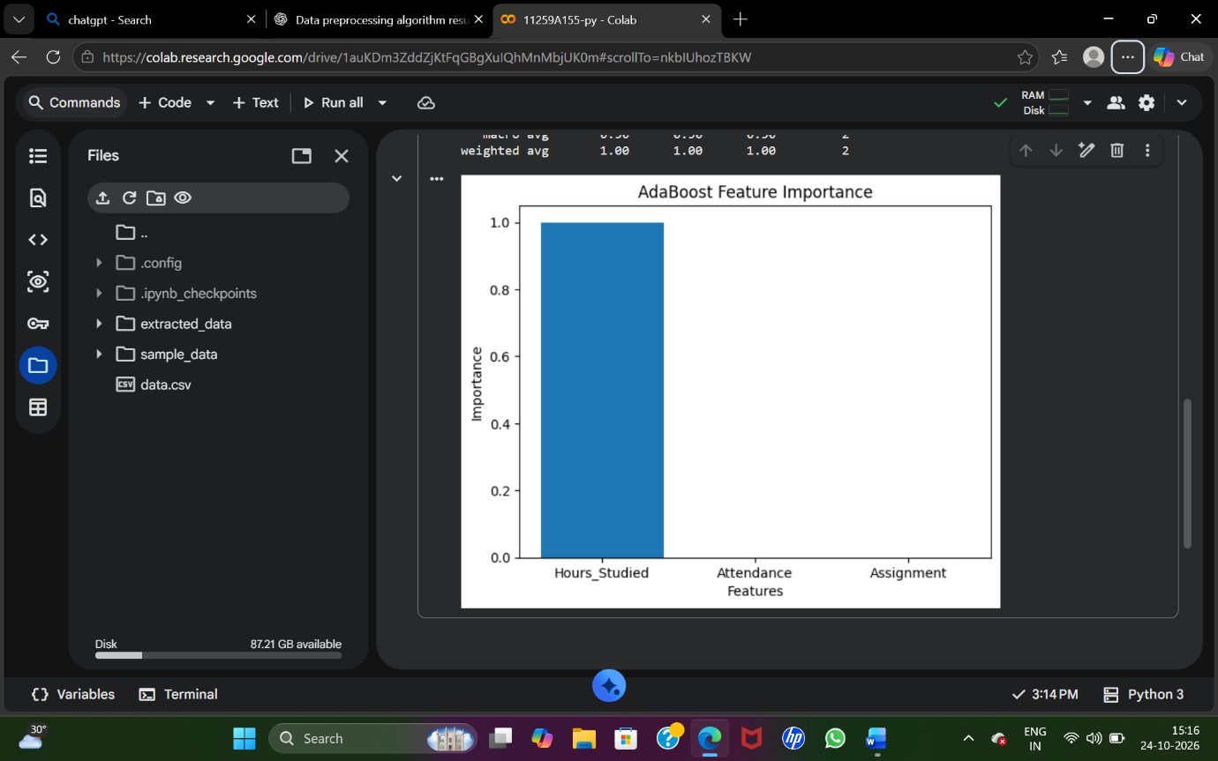
Result
Thus, the AdaBoost classification algorithm was implemented successfully. Its performance was analyzed using accuracy, confusion matrix, precision, recall, and F1-score, and feature importance was visualized using a bar graph.

