A. Creating Arrays
Aim
To write a Python program using the NumPy library to create and display different types of arrays, such as 1D arrays, 2D arrays, zeros, ones, identity matrices, and range of numbers.
Algorithm
- Start the program.
- Import the NumPy library as np.
- Create a 1D array using np.array().
- Create a 2D array using np.array().
- Create a zero matrix using np.zeros().
- Create a matrix of ones using np.ones().
- Create an identity matrix using np.eye().
- Generate a sequence of numbers using np.arange().
- Display all the arrays using the print() function.
- Stop the program.
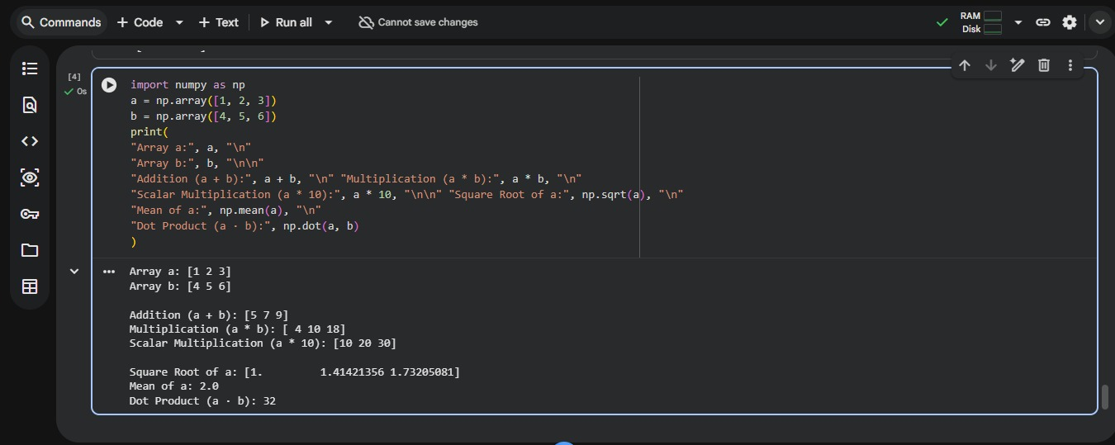
Result
Thus, the Python program to create and display different types of NumPy arrays was successfully executed.
B. Array Operations
Aim
To write a Python program using NumPy to perform array operations such as addition, multiplication, scalar multiplication, square root, mean, and dot product.
Algorithm
- Start the program.
- Import the NumPy library as np.
- Create two arrays, a = [1, 2, 3] and b = [4, 5, 6].
- Display both arrays.
- Perform element-wise addition using a + b.
- Perform element-wise multiplication using a * b.
- Perform scalar multiplication using a * 10.
- Calculate the square root of array a using np.sqrt().
- Calculate the mean of array a using np.mean().
- Calculate the dot product of arrays a and b using np.dot().
- Display all the results.
- Stop the program.
Result
Thus, the Python program to perform various NumPy array operations, including addition, multiplication, scalar multiplication, square root, mean, and dot product, was successfully executed.
C. Indexing and Slicing
Aim
To write a Python program using NumPy to access individual elements, extract rows and columns, and obtain a sub-matrix from a two-dimensional array using indexing and slicing.
Algorithm
- Start the program.
- Import the NumPy library as np.
- Create a 3×3 matrix containing the elements 10 to 90.
- Display the matrix.
- Access the element at index [1, 2] using matrix[1, 2].
- Extract the first row using matrix[0, :].
- Extract the second column using matrix[:, 1].
- Extract the top-left 2×2 sub-matrix using matrix[0:2, 0:2].
- Display all the extracted elements and sub-matrices.
- Stop the program.
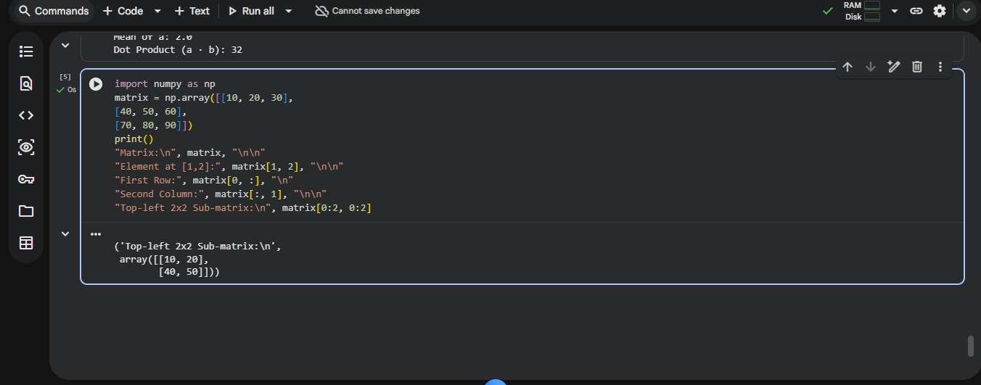
Result
Thus, the Python program to perform indexing and slicing operations on a NumPy matrix was successfully executed, and the required elements, row, column, and sub-matrix were obtained.

