A. Creating DataFrames
Aim
To write a Python program using the Pandas library to create a DataFrame from a dictionary and display the first few rows, data types, non-null values, and statistical summary.
Algorithm
- Start the program.
- Import the Pandas library as pd.
- Create a dictionary containing Name, Age, and City.
- Convert the dictionary into a DataFrame using pd.DataFrame().
- Display the first five rows using df.head().
- Display the DataFrame information using df.info().
- Display the statistical summary using df.describe().
- Stop the program.
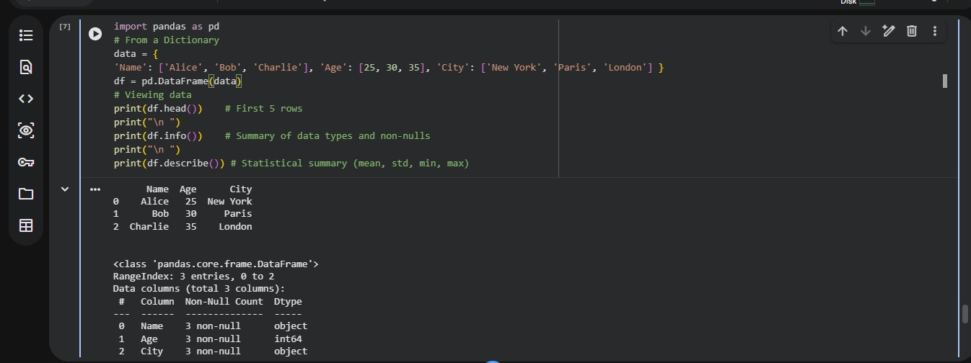
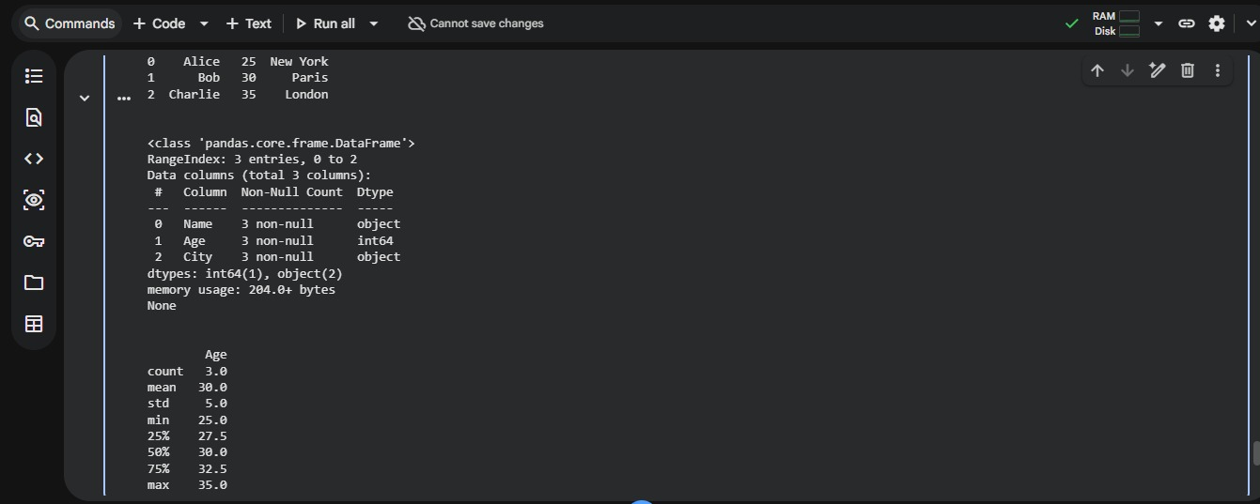
Result
Thus, the Python program to create a Pandas DataFrame and display its contents, data types, and statistical summary was successfully executed.
B. Selection and Filtering
Aim
To write a Python program using Pandas to select specific columns, filter rows based on conditions, and access data using iloc and loc.
Algorithm
- Start the program.
- Import the Pandas library as pd.
- Use the DataFrame created in Program A.
- Select the Age column using df['Age'].
- Filter rows where Age is greater than 25.
- Access the first row using df.iloc[0].
- Access the Name value at index 0 using df.loc[0, 'Name'].
- Display the selected column, filtered rows, and accessed values.
- Stop the program.
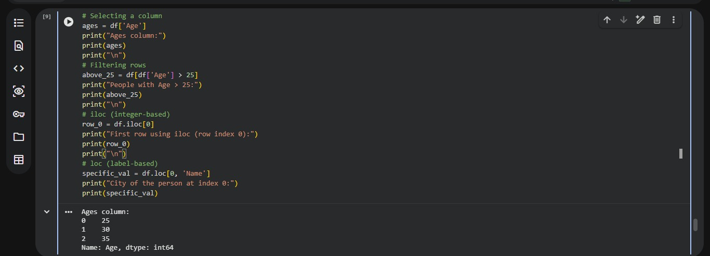
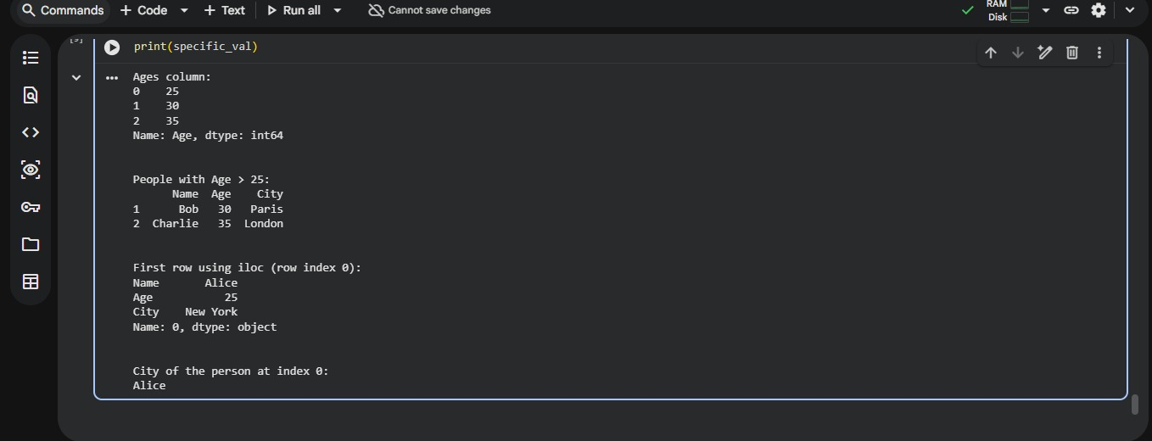
Result
Thus, the Python program to select columns, filter rows, and access DataFrame elements using iloc and loc was successfully executed.
Note: In your code, the statement df.loc[0, 'Name'] retrieves Alice, not the city. To retrieve the city, use df.loc[0, 'City'].
C. Data Cleaning (Handling Missing Values)
Aim
To write a Python program using Pandas and NumPy to identify and handle missing values in a DataFrame by dropping rows, filling missing values with zero, and replacing missing Age values with the column mean.
Algorithm
- Start the program.
- Import the Pandas library as pd and the NumPy library as np.
- Create a dictionary containing Name, Age, and City, with some missing values represented by np.nan.
- Convert the dictionary into a DataFrame using pd.DataFrame().
- Display the original DataFrame.
- Identify missing values in each column using df.isnull().sum().
- Remove rows containing missing values using df.dropna().
- Fill all missing values with zero using df.fillna(0).
- Create a copy of the original DataFrame.
- Calculate the mean of the Age column and replace missing Age values with the mean.
- Display the results of each cleaning operation.
- Stop the program.
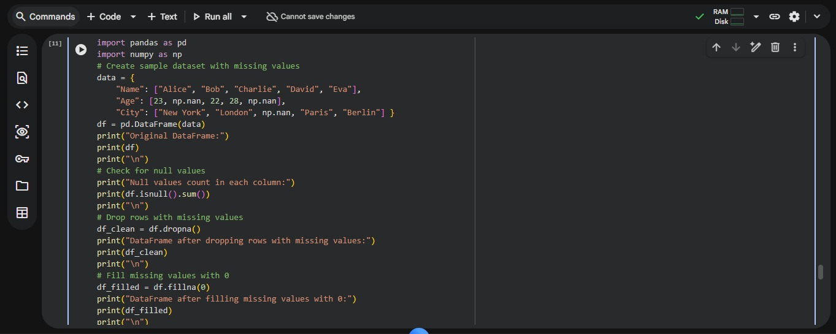
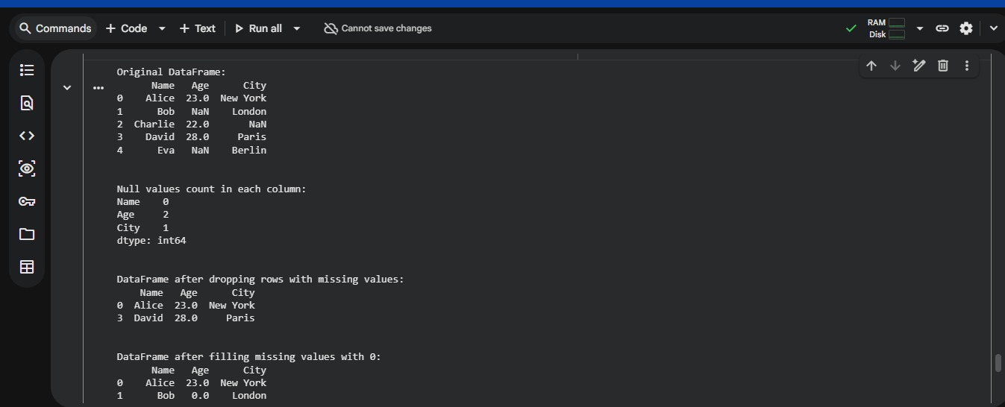
Result
Thus, the Python program to identify and handle missing values in a Pandas DataFrame using isnull(), dropna(), and fillna() was successfully executed.

