Data Splitting
Aim
To split the dataset into training and testing sets, where 80% of the data is used for training and 20% is used for testing, using the train_test_split() function.
Algorithm
- Start.
- Import the required libraries: pandas and train_test_split.
- Load the dataset from data.csv.
- Select the input features: Hours_Studied, Attendance, and Assignments.
- Select the target variable Result.
- Split the dataset into 80% training data and 20% testing data using train_test_split().
- Set random_state=42 to ensure reproducible results.
- Display the training and testing datasets.
- Display the number of training and testing samples.
- Stop.
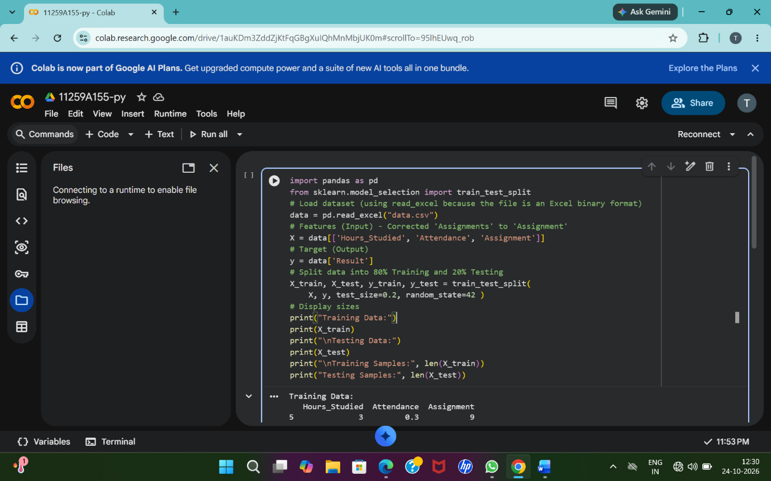
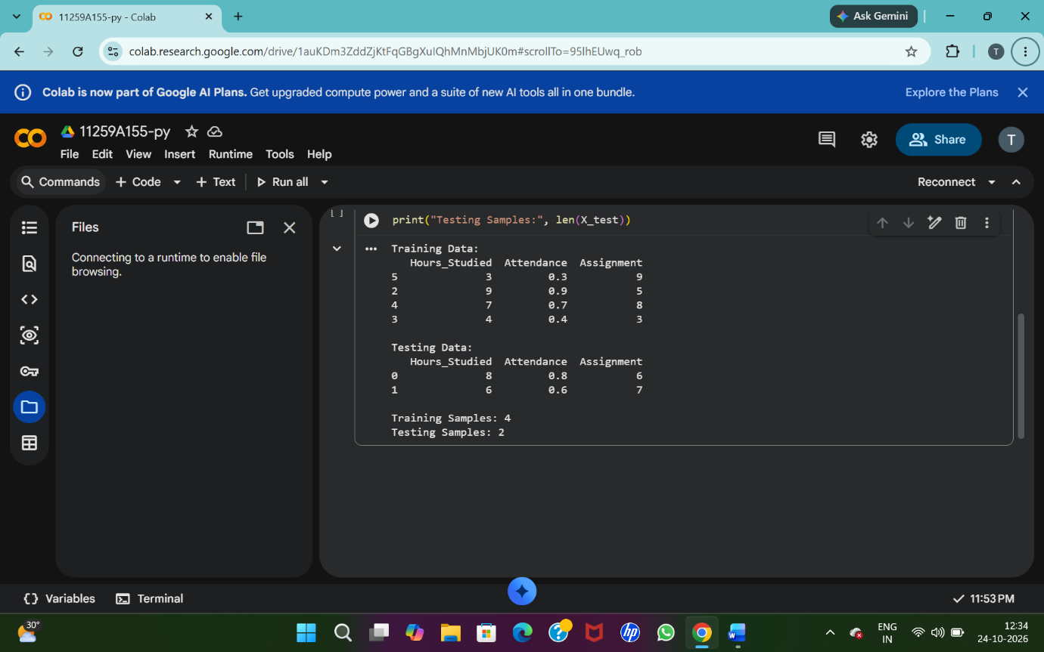
Result
The dataset was successfully split into training and testing sets using an 80:20 ratio.
Cross-Validation
Aim
To split the dataset into training and testing sets and evaluate a K-Nearest Neighbors (KNN) classifier using 5-fold cross-validation.
Algorithm
- Start.
- Import pandas, train_test_split, cross_val_score, and KNeighborsClassifier.
- Load the dataset from data.csv.
- Select the input features: Hours_Studied, Attendance, and Assignments.
- Select Result as the target variable.
- Split the dataset into 80% training data and 20% testing data.
- Display the sizes of the training and testing datasets.
- Create a KNN classifier with n_neighbors=3.
- Perform 5-fold cross-validation using cross_val_score().
- Display the accuracy scores obtained from the five folds.
- Calculate and display the average accuracy.
- Stop.
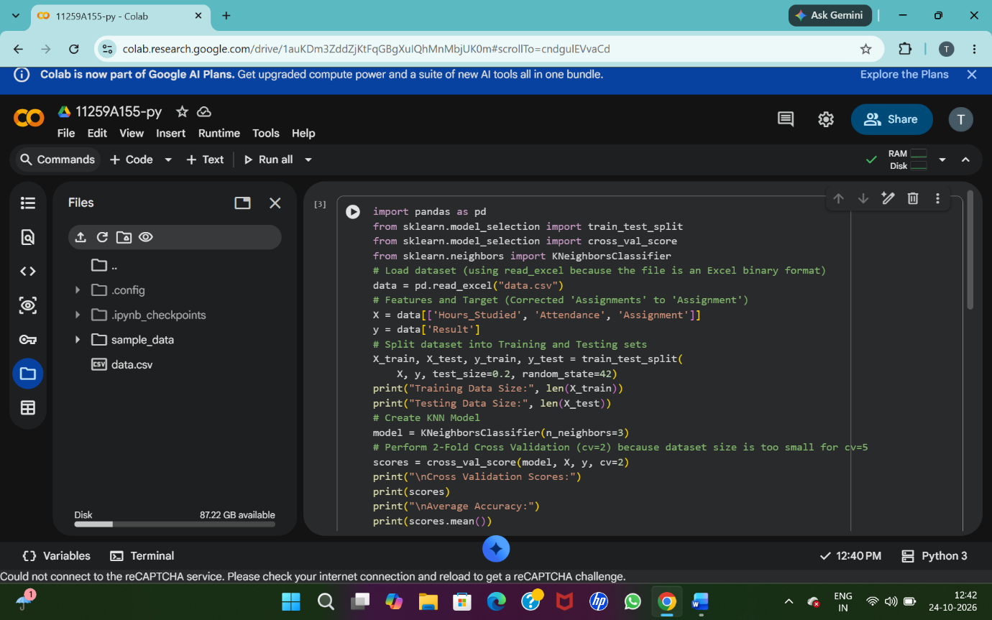
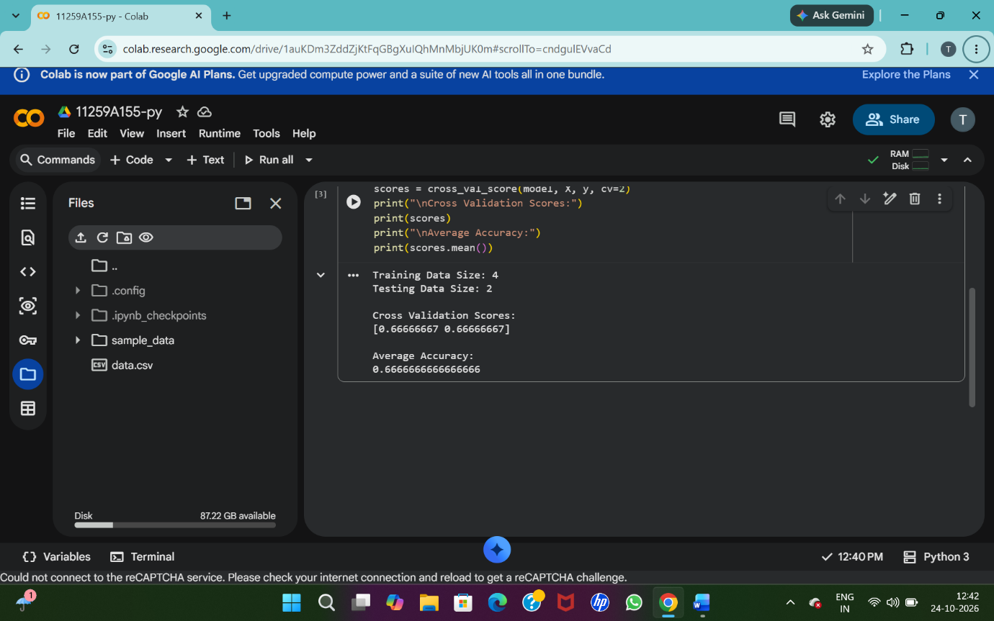
Result
The dataset was successfully split into training and testing sets, and the KNN classifier was evaluated using 5-fold cross-validation.

