1. Objective
This report demonstrates seven distinct SQL query patterns using two structured, related tables. Each section records the query objective, the SQL statement, and the output returned by the execution shown in the supplied screenshots.

2. Dataset and table structure
The practice database contains student details in the students table and subject-level exam results in the performance table. The tables are related through student_id.
Table | Purpose | Key fields
students | Student profile and enrollment information | student_id (primary key), name, department, city, enrollment_date
performance | Marks and exam information for each student and subject | performance_id (primary key), student_id (foreign key), subject, marks, status, exam_date

3. Table creation and sample data
The following statements create both tables and populate them with six student records and ten performance records.
CREATE TABLE students (
student_id INTEGER PRIMARY KEY,
name TEXT NOT NULL,
department TEXT,
city TEXT,
enrollment_date TEXT
);
CREATE TABLE performance (
performance_id INTEGER PRIMARY KEY,
student_id INTEGER,
subject TEXT,
marks INTEGER,
status TEXT,
exam_date TEXT,
FOREIGN KEY (student_id) REFERENCES students(student_id)
);
INSERT INTO students VALUES
(1, 'Arun', 'CSE', 'Chennai', '2025-01-10'),
(2, 'Priya', 'ECE', 'Chennai', '2025-02-15'),
(3, 'Karthik', 'CSE', 'Bangalore', '2025-03-20'),
(4, 'Divya', 'IT', 'Chennai', '2025-04-05'),
(5, 'Rahul', 'ECE', NULL, '2025-05-12'),
(6, 'Meena', 'IT', 'Coimbatore', '2025-06-18');
INSERT INTO performance VALUES
(1, 1, 'SQL', 85, 'Pass', '2025-06-10'),
(2, 1, 'Python', 92, 'Pass', '2025-06-15'),
(3, 2, 'SQL', 78, 'Pass', '2025-06-10'),
(4, 2, 'Python', 65, 'Pass', '2025-06-15'),
(5, 3, 'SQL', 45, 'Fail', '2025-06-10'),
(6, 3, 'Python', 55, 'Pass', '2025-06-15'),
(7, 4, 'SQL', 95, 'Pass', '2025-06-10'),
(8, 4, 'Python', 88, 'Pass', '2025-06-15'),
(9, 5, 'SQL', 72, 'Pass', '2025-06-10'),
(10, 6, 'Python', 81, 'Pass', '2025-06-15');
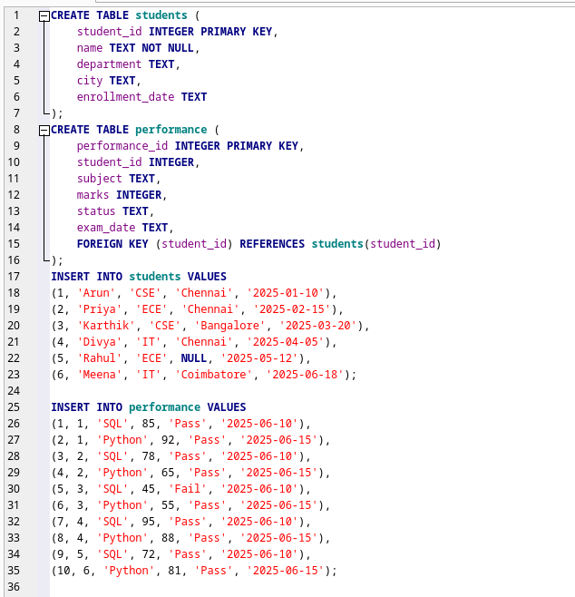
Figure 1. Table creation and sample data entered in the SQLite editor.

4. Query implementations and outputs

4.1 Filtering with multiple conditions
Objective: Return students in the CSE department whose city value is not missing.
SELECT name, department, city
FROM students
WHERE department = 'CSE' AND city IS NOT NULL;
name | department | city
Arun | CSE | Chennai
Karthik | CSE | Bangalore

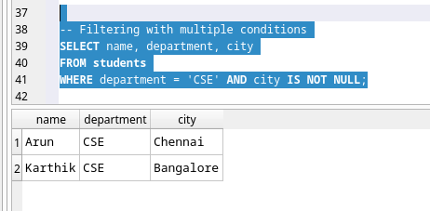
Figure 2. Executed filtering query and result.

4.2 Sorting and limiting results
Objective: Retrieve the three highest marks across all subjects.
SELECT s.name, p.marks, p.subject
FROM performance p
JOIN students s ON s.student_id = p.student_id
ORDER BY p.marks DESC
LIMIT 3;
name | marks | subject
Divya | 95 | SQL
Arun | 92 | Python
Divya | 88 | Python

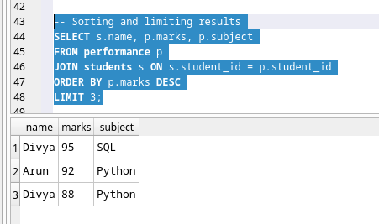
Figure 3. Executed sorting and limiting query and result.

4.3 Aggregation with grouping
Objective: Calculate the number of attempts and average marks for each subject.
SELECT subject, COUNT(*) AS attempts,
ROUND(AVG(marks), 2) AS average_marks
FROM performance
GROUP BY subject;
subject | attempts | average_marks
Python | 5 | 76.2
SQL | 5 | 75.0

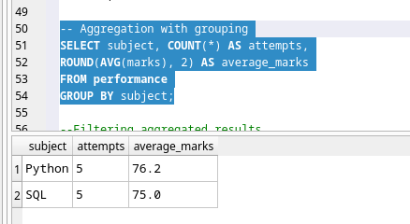
Figure 4. Executed aggregation and grouping query and result.

4.4 Filtering aggregated results with HAVING
Objective: Return subjects whose average marks are at least 75.
SELECT subject, COUNT(*) AS attempts,
ROUND(AVG(marks), 2) AS average_marks
FROM performance
GROUP BY subject
HAVING AVG(marks) >= 75;
subject | attempts | average_marks
Python | 5 | 76.2
SQL | 5 | 75.0

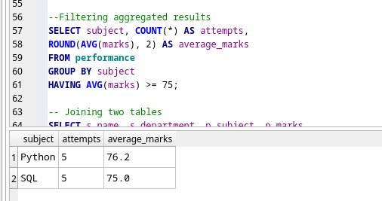
Figure 5. Executed HAVING query and result.

4.5 Joining two tables
Objective: Combine student details with each student's subject and marks.
SELECT s.name, s.department, p.subject, p.marks
FROM students s
INNER JOIN performance p
ON s.student_id = p.student_id
ORDER BY s.student_id, p.performance_id;
name | department | subject | marks
Arun | CSE | SQL | 85
Arun | CSE | Python | 92
Priya | ECE | SQL | 78
Priya | ECE | Python | 65
Karthik | CSE | SQL | 45
Karthik | CSE | Python | 55
Divya | IT | SQL | 95
Divya | IT | Python | 88
Rahul | ECE | SQL | 72
Meena | IT | Python | 81

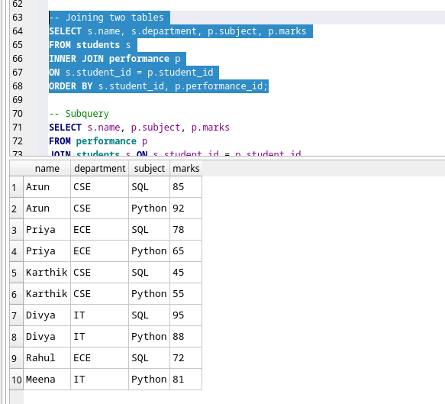
Figure 6. Executed INNER JOIN query and result.

4.6 Subquery
Objective: Find individual subject results with marks above the overall average across all performance records.
SELECT s.name, p.subject, p.marks
FROM performance p
JOIN students s ON s.student_id = p.student_id
WHERE p.marks > (
SELECT AVG(marks)
FROM performance
)
ORDER BY p.marks DESC;
name | subject | marks
Divya | SQL | 95
Arun | Python | 92
Divya | Python | 88
Arun | SQL | 85
Meena | Python | 81
Priya | SQL | 78

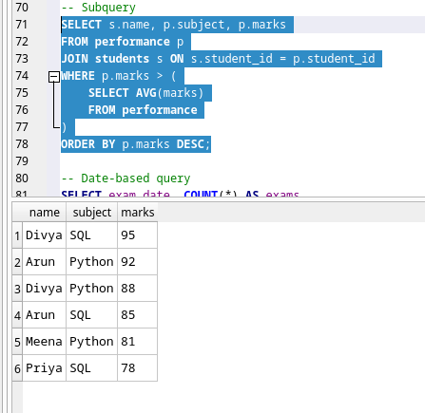
Figure 7. Executed subquery and result.

4.7 Date-based query
Objective: Group exam records by exam date and calculate the average marks for each date in the selected range.
SELECT exam_date, COUNT(*) AS exams,
ROUND(AVG(marks), 2) AS average_marks
FROM performance
WHERE exam_date BETWEEN '2025-06-10' AND '2025-06-15'
GROUP BY exam_date
ORDER BY exam_date;
exam_date | exams | average_marks
2025-06-10 | 5 | 75.0
2025-06-15 | 5 | 76.2

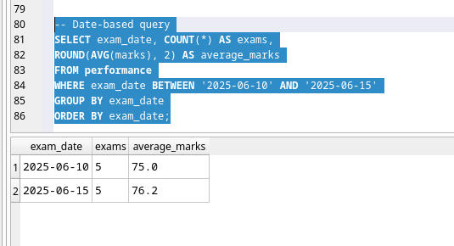
Figure 8. Executed date-based query and result.

