1. Objective
This report demonstrates seven distinct SQL query patterns using a small e-commerce sample dataset in SQLite. Each section contains the query objective, SQL statement, and expected output based on the sample records defined for this practice task.

2. Dataset structure
Table | Purpose | Key fields
orders | Order-level records | order_id, order_date, customer_id, product_name, category, quantity, unit_price, total_amount, payment_method, order_status, city
products | Product reference records | product_id, product_name, category

The orders table contains eight sample rows. The products table contains five product records. The sample intentionally includes missing values, an invalid date, a negative quantity, and inconsistent category capitalization to support data-quality practice.

3. Table creation and sample data
CREATE TABLE orders (
order_id INTEGER,
order_date TEXT,
customer_id INTEGER,
product_name TEXT,
category TEXT,
quantity INTEGER,
unit_price REAL,
total_amount REAL,
payment_method TEXT,
order_status TEXT,
city TEXT
);
CREATE TABLE products (
product_id INTEGER PRIMARY KEY,
product_name TEXT,
category TEXT
);
INSERT INTO orders VALUES
(101, '2026-01-05', 1, 'Laptop', 'Electronics', 1, 50000, 50000, 'UPI', 'Delivered', 'Chennai'),
(102, '2026-01-08', 2, 'Headphones', 'Electronics', 2, 1500, 3000, 'Card', 'Delivered', 'Bangalore'),
(103, '2026-01-12', 3, 'T-Shirt', 'Clothing', 3, 500, 1500, 'UPI', 'Pending', 'Chennai'),
(104, '2026-01-15', 1, 'Laptop', 'electronics', 1, 50000, 50000, 'Card', 'Delivered', 'Chennai'),
(105, '2026-02-02', 4, 'Shoes', 'Clothing', 2, 2000, 4000, 'Cash', 'Cancelled', 'Coimbatore'),
(106, '2026-02-10', 5, 'Headphones', 'Electronics', NULL, 1500, NULL, NULL, 'Pending', NULL),
(107, 'invalid-date', 6, 'Watch', 'Accessories', -1, 2500, -2500, 'UPI', 'Delivered', 'Chennai'),
(108, '2026-02-15', 7, 'T-Shirt', 'Clothing', 2, 500, 1000, 'Card', 'Delivered', 'Bangalore');
INSERT INTO products VALUES
(1, 'Laptop', 'Electronics'),
(2, 'Headphones', 'Electronics'),
(3, 'T-Shirt', 'Clothing'),
(4, 'Shoes', 'Clothing'),
(5, 'Watch', 'Accessories');
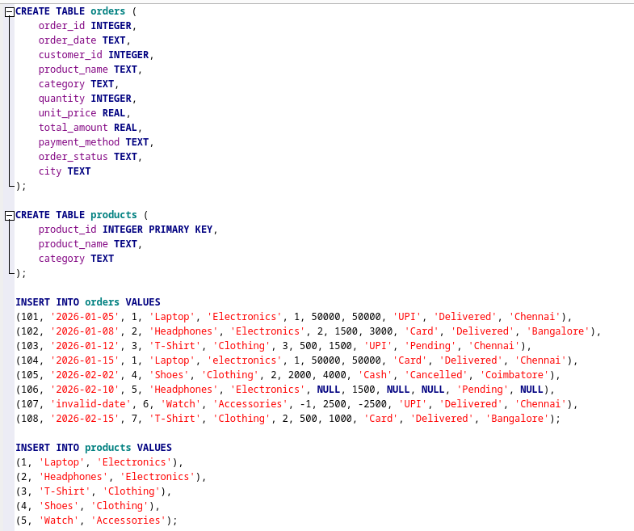

4. Query implementations and outputs

4.1 Filtering with multiple conditions
Objective: Return delivered orders with a total amount greater than 3,000.
SELECT order_id, product_name, total_amount, city
FROM orders
WHERE order_status = 'Delivered'
AND total_amount > 3000;

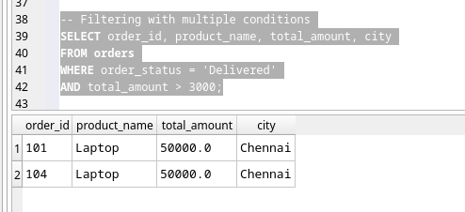

4.2 Sorting and limiting results
Objective: Retrieve the three highest order amounts.
SELECT order_id, product_name, total_amount
FROM orders
ORDER BY total_amount DESC
LIMIT 3;

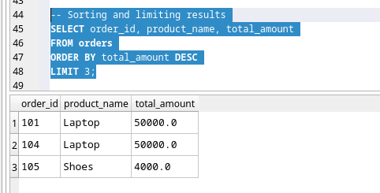

4.3 Aggregation with grouping
Objective: Count orders and calculate revenue by category. NULL amounts are ignored by SUM.
SELECT category, COUNT(*) AS total_orders,
ROUND(SUM(total_amount), 2) AS total_revenue
FROM orders
GROUP BY category;

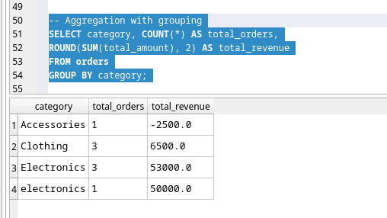

4.4 Filtering aggregated results with HAVING
Objective: Return categories with at least two orders.
SELECT category, COUNT(*) AS total_orders,
ROUND(AVG(total_amount), 2) AS average_amount
FROM orders
GROUP BY category
HAVING COUNT(*) >= 2;
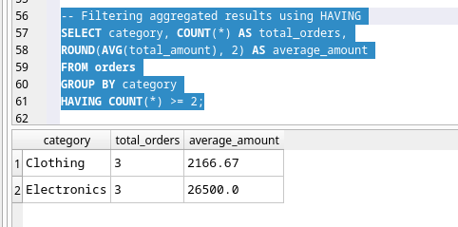

4.5 Joining two tables
Objective: Combine order records with their matching product reference data.
SELECT o.order_id, o.product_name, p.category,
o.quantity, o.total_amount
FROM orders o
INNER JOIN products p
ON o.product_name = p.product_name
ORDER BY o.order_id;
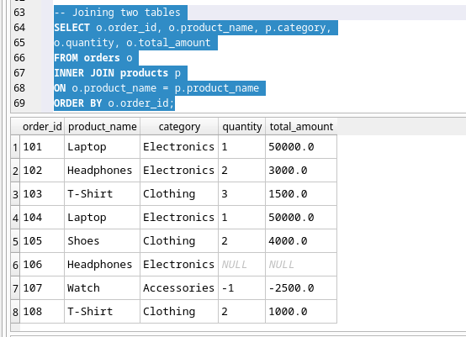

4.6 Subquery
Objective: Find orders with a total amount above the average non-NULL total amount.
SELECT order_id, product_name, total_amount
FROM orders
WHERE total_amount > (
SELECT AVG(total_amount)
FROM orders
)
ORDER BY total_amount DESC;
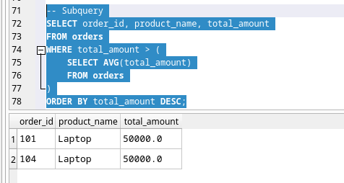

4.7 Date-based query
Objective: Summarize orders by day for January 2026. Invalid dates do not match the range.
SELECT date(order_date) AS order_date,
COUNT(*) AS total_orders,
ROUND(SUM(total_amount), 2) AS daily_revenue
FROM orders
WHERE date(order_date) BETWEEN '2026-01-01' AND '2026-01-31'
GROUP BY date(order_date)
ORDER BY order_date;

