**Reg no: 11908974**

**Roll no: A23**

**1 ScatterPlot**

import matplotlib.pyplot as plt

import requests

from pandas.io.json import json_normalize

URL = "https://api.covid19india.org/data.json"

data = requests.get(url=URL).json()

covid19_df = json_normalize(data['statewise'])

active=covid19_df['active'][0]

confirmed=covid19_df['confirmed'][0]

deltaconfirmed=covid19_df['deltaconfirmed'][0]

deaths=covid19_df['deaths'][0]

deltadeaths=covid19_df['deltadeaths'][0]

recovered=covid19_df['recovered'][0]

deltarecovered=covid19_df['deltarecovered'][0]

# x-axis values

x = ['act','conf','dconf','de','dde','rec','drec']

# y-axis values

y = [active,confirmed,deltaconfirmed,deaths,deltadeaths,recovered,deltarecovered]

# plotting points as a scatter plot

plt.scatter(x, y, label= "stars", color= "green",

marker= "*", s=30)

# x-axis label

plt.xlabel('x - axis')

# frequency label

plt.ylabel('y - axis')

# plot title

plt.title('My scatter plot!')

# showing legend

plt.legend()

# function to show the plot

plt.show()

print('act = Total Active Cases')

print('cnf = Total Confirmed cases')

print('dconf = Total Deltaconfirmed cases')

print('de = Total Deaths')

print('dde = Total Deltadeaths')

print('rec = Total Recovered')

print('drec = Total Deltarecovered')

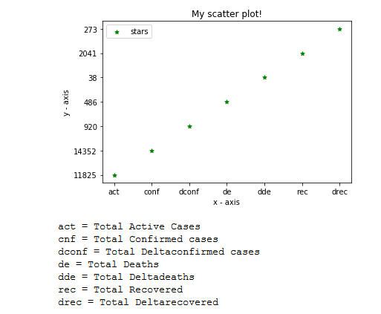

# Num of death state wise : line plot

**import matplotlib.pyplot as plt**

**import requests**

**import numpy as np**

**from pandas.io.json import json_normalize**

**URL = "https://api.covid19india.org/data.json"**

**data = requests.get(url=URL).json()**

**covid19_df = json_normalize(data['statewise'])**

**statename=[]**

**ideath=[]**

**for i in covid19_df['statecode'][1:]:**

**statename.append(i)**

**for i in covid19_df['deaths'][1:]:**

**ideath.append(i)**

**plt.figure(figsize = (12, 7))**

**plt.plot(statename, ideath)**

**plt.show()**

**import itertools**

**for (a,b) in zip(covid19_dfnew['statecode'], covid19_dfnew['state']):**

**print(a , ' = ' , b)**

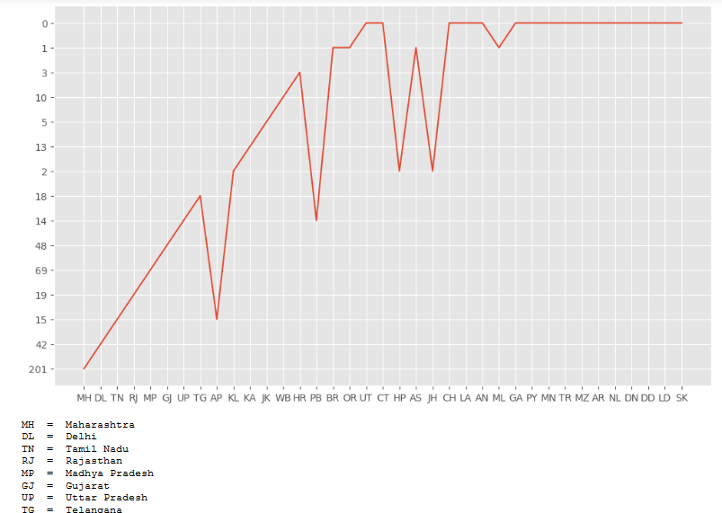

# Area Plot:-

**import matplotlib.pyplot as plt**

**import requests**

**from pandas.io.json import json_normalize**

**URL = "https://api.covid19india.org/data.json"**

**data = requests.get(url=URL).json()**

**covid19_df = json_normalize(data['statewise'])**

**covid19_dfnew=covid19_df.drop(covid19_df.index[[0]])**

**count=[1,2,3,4,5,6,7,8,9,10,11,12,13,14,15,16,17,18,19,20,21,22,23,24,25,26,27,28,29,30,31,32,33,34,35,36,37]**

**active =covid19_dfnew['active']**

**confirmed=covid19_dfnew['confirmed']**

**recovered =covid19_dfnew['recovered']**

**deaths = covid19_dfnew['deaths']**

**plt.figure(figsize = (12, 7))**

**plt.plot([],[],color='m', label='active', linewidth=5)**

**plt.plot([],[],color='c', label='confirmed', linewidth=5)**

**plt.plot([],[],color='r', label='recovered', linewidth=5)**

**plt.plot([],[],color='k', label='deaths', linewidth=5)**

**plt.stackplot(count, active,confirmed,recovered,deaths, colors=['m','c','r','k'])**

**plt.xlabel('x')**

**plt.ylabel('y')**

**plt.title('Stack Plot')**

**plt.legend()**

**plt.show()**

