**EE5311 - Digital IC Design**

**Assignment 3 – Full Adder**

**Member 1: Srivenkat A(EE18B038)  
Member 2: Hemanth Ram G K(EE18B132)  
Member 3: Sidesh S(EE18B032)**

## Full Adder - 1(Cout-1x + Sum-3x)

## Member - 1

## 

## Schematic

## Layout

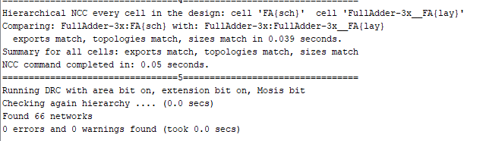 **DRC LVS Clean Screenshot**

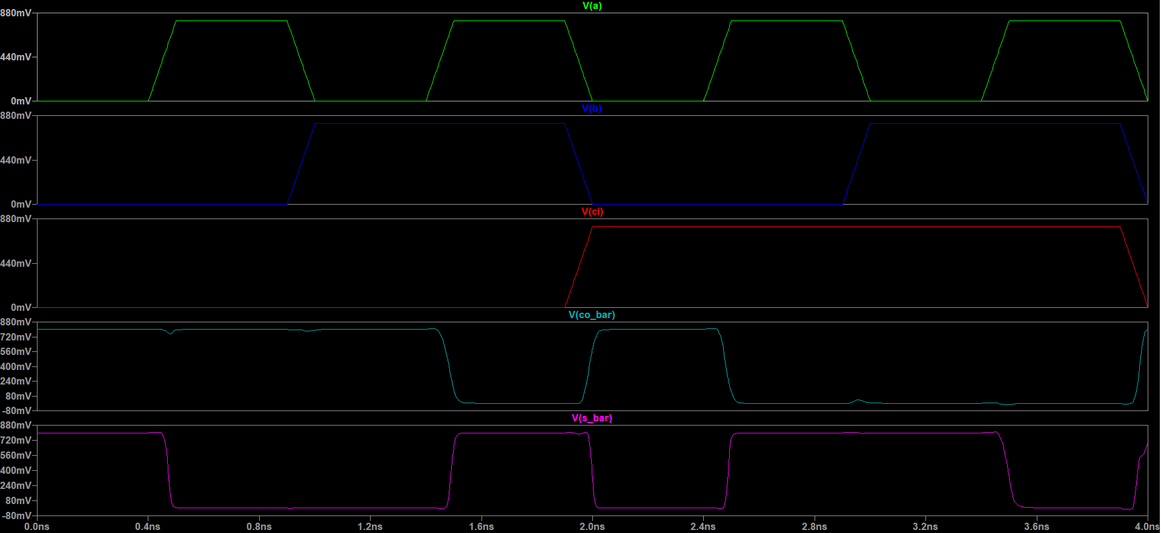 **Functionality Spice Simulation**

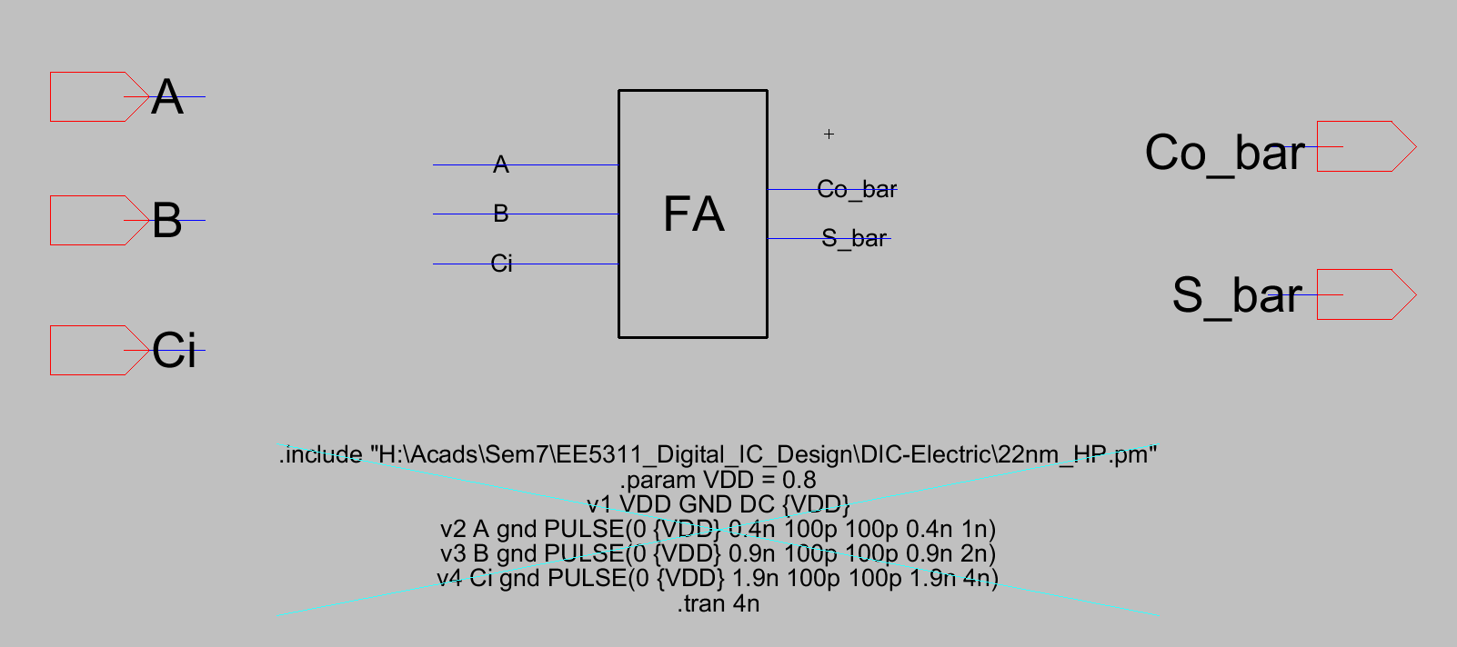

**Functionality Simulation Testbench**

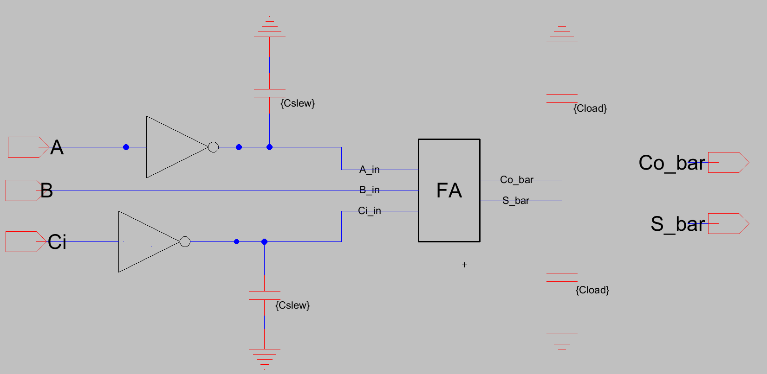 **Delay Testbench**

**Output Delay Table**

|  |  |  |  |  |
| --- | --- | --- | --- | --- |
| **Parameters** | | | **Output Delay - Sum** | **Input Slew(Sin) - A** |
| **step** | **Cload** | **Cslew** | **Output Delay** | **Input Slew** |
| 1 | 1.00E-14 | 1.00E-14 | 1.74E-10 | 7.37E-11 |
| 2 | 6.00E-14 | 1.00E-14 | 8.59E-10 | 7.36E-11 |
| 3 | 1.10E-13 | 1.00E-14 | 1.54E-09 | 7.36E-11 |
| 4 | 1.60E-13 | 1.00E-14 | 2.23E-09 | 7.36E-11 |
| 5 | 2.10E-13 | 1.00E-14 | 2.91E-09 | 7.36E-11 |
| 6 | 2.60E-13 | 1.00E-14 | 3.60E-09 | 7.36E-11 |
| 7 | 3.10E-13 | 1.00E-14 | 4.28E-09 | 7.36E-11 |
| 8 | 3.60E-13 | 1.00E-14 | 4.97E-09 | 7.36E-11 |
| 9 | 4.10E-13 | 1.00E-14 | 5.65E-09 | 7.36E-11 |
| 10 | 4.60E-13 | 1.00E-14 | 6.34E-09 | 7.36E-11 |
| 11 | 5.00E-13 | 1.00E-14 | 6.88E-09 | 7.36E-11 |
| 12 | 1.00E-14 | 2.00E-14 | 1.84E-10 | 1.05E-10 |
| 13 | 6.00E-14 | 2.00E-14 | 8.69E-10 | 1.05E-10 |
| 14 | 1.10E-13 | 2.00E-14 | 1.55E-09 | 1.05E-10 |
| 15 | 1.60E-13 | 2.00E-14 | 2.24E-09 | 1.05E-10 |
| 16 | 2.10E-13 | 2.00E-14 | 2.92E-09 | 1.05E-10 |
| 17 | 2.60E-13 | 2.00E-14 | 3.61E-09 | 1.05E-10 |
| 18 | 3.10E-13 | 2.00E-14 | 4.29E-09 | 1.05E-10 |
| 19 | 3.60E-13 | 2.00E-14 | 4.98E-09 | 1.05E-10 |
| 20 | 4.10E-13 | 2.00E-14 | 5.66E-09 | 1.05E-10 |
| 21 | 4.60E-13 | 2.00E-14 | 6.35E-09 | 1.05E-10 |
| 22 | 5.00E-13 | 2.00E-14 | 6.89E-09 | 1.05E-10 |
| 23 | 1.00E-14 | 3.00E-14 | 1.94E-10 | 1.36E-10 |
| 24 | 6.00E-14 | 3.00E-14 | 8.80E-10 | 1.36E-10 |
| 25 | 1.10E-13 | 3.00E-14 | 1.57E-09 | 1.36E-10 |
| 26 | 1.60E-13 | 3.00E-14 | 2.25E-09 | 1.36E-10 |
| 27 | 2.10E-13 | 3.00E-14 | 2.93E-09 | 1.36E-10 |
| 28 | 2.60E-13 | 3.00E-14 | 3.62E-09 | 1.36E-10 |
| 29 | 3.10E-13 | 3.00E-14 | 4.30E-09 | 1.36E-10 |
| 30 | 3.60E-13 | 3.00E-14 | 4.99E-09 | 1.36E-10 |
| 31 | 4.10E-13 | 3.00E-14 | 5.67E-09 | 1.36E-10 |
| 32 | 4.60E-13 | 3.00E-14 | 6.36E-09 | 1.36E-10 |
| 33 | 5.00E-13 | 3.00E-14 | 6.90E-09 | 1.36E-10 |
| 34 | 1.00E-14 | 4.00E-14 | 2.04E-10 | 1.69E-10 |
| 35 | 6.00E-14 | 4.00E-14 | 8.92E-10 | 1.69E-10 |
| 36 | 1.10E-13 | 4.00E-14 | 1.58E-09 | 1.69E-10 |
| 37 | 1.60E-13 | 4.00E-14 | 2.26E-09 | 1.69E-10 |
| 38 | 2.10E-13 | 4.00E-14 | 2.95E-09 | 1.69E-10 |
| 39 | 2.60E-13 | 4.00E-14 | 3.63E-09 | 1.69E-10 |
| 40 | 3.10E-13 | 4.00E-14 | 4.31E-09 | 1.69E-10 |
| 41 | 3.60E-13 | 4.00E-14 | 5.00E-09 | 1.69E-10 |
| 42 | 4.10E-13 | 4.00E-14 | 5.68E-09 | 1.69E-10 |
| 43 | 4.60E-13 | 4.00E-14 | 6.37E-09 | 1.69E-10 |
| 44 | 5.00E-13 | 4.00E-14 | 6.92E-09 | 1.69E-10 |
| 45 | 1.00E-14 | 5.00E-14 | 2.13E-10 | 2.04E-10 |
| 46 | 6.00E-14 | 5.00E-14 | 9.03E-10 | 2.04E-10 |
| 47 | 1.10E-13 | 5.00E-14 | 1.59E-09 | 2.04E-10 |
| 48 | 1.60E-13 | 5.00E-14 | 2.27E-09 | 2.04E-10 |
| 49 | 2.10E-13 | 5.00E-14 | 2.96E-09 | 2.04E-10 |
| 50 | 2.60E-13 | 5.00E-14 | 3.64E-09 | 2.04E-10 |
| 51 | 3.10E-13 | 5.00E-14 | 4.33E-09 | 2.04E-10 |
| 52 | 3.60E-13 | 5.00E-14 | 5.01E-09 | 2.04E-10 |
| 53 | 4.10E-13 | 5.00E-14 | 5.70E-09 | 2.04E-10 |
| 54 | 4.60E-13 | 5.00E-14 | 6.38E-09 | 2.04E-10 |
| 55 | 5.00E-13 | 5.00E-14 | 6.93E-09 | 2.04E-10 |
| 56 | 1.00E-14 | 6.00E-14 | 2.22E-10 | 2.39E-10 |
| 57 | 6.00E-14 | 6.00E-14 | 9.15E-10 | 2.39E-10 |
| 58 | 1.10E-13 | 6.00E-14 | 1.60E-09 | 2.39E-10 |
| 59 | 1.60E-13 | 6.00E-14 | 2.28E-09 | 2.39E-10 |
| 60 | 2.10E-13 | 6.00E-14 | 2.97E-09 | 2.39E-10 |
| 61 | 2.60E-13 | 6.00E-14 | 3.65E-09 | 2.39E-10 |
| 62 | 3.10E-13 | 6.00E-14 | 4.34E-09 | 2.39E-10 |
| 63 | 3.60E-13 | 6.00E-14 | 5.02E-09 | 2.39E-10 |
| 64 | 4.10E-13 | 6.00E-14 | 5.71E-09 | 2.39E-10 |
| 65 | 4.60E-13 | 6.00E-14 | 6.39E-09 | 2.39E-10 |
| 66 | 5.00E-13 | 6.00E-14 | 6.94E-09 | 2.39E-10 |
| 67 | 1.00E-14 | 7.00E-14 | 2.31E-10 | 2.75E-10 |
| 68 | 6.00E-14 | 7.00E-14 | 9.26E-10 | 2.74E-10 |
| 69 | 1.10E-13 | 7.00E-14 | 1.61E-09 | 2.74E-10 |
| 70 | 1.60E-13 | 7.00E-14 | 2.30E-09 | 2.74E-10 |
| 71 | 2.10E-13 | 7.00E-14 | 2.98E-09 | 2.74E-10 |
| 72 | 2.60E-13 | 7.00E-14 | 3.67E-09 | 2.74E-10 |
| 73 | 3.10E-13 | 7.00E-14 | 4.35E-09 | 2.74E-10 |
| 74 | 3.60E-13 | 7.00E-14 | 5.03E-09 | 2.74E-10 |
| 75 | 4.10E-13 | 7.00E-14 | 5.72E-09 | 2.74E-10 |
| 76 | 4.60E-13 | 7.00E-14 | 6.40E-09 | 2.74E-10 |
| 77 | 5.00E-13 | 7.00E-14 | 6.95E-09 | 2.74E-10 |
| 78 | 1.00E-14 | 8.00E-14 | 2.39E-10 | 3.10E-10 |
| 79 | 6.00E-14 | 8.00E-14 | 9.38E-10 | 3.10E-10 |
| 80 | 1.10E-13 | 8.00E-14 | 1.62E-09 | 3.10E-10 |
| 81 | 1.60E-13 | 8.00E-14 | 2.31E-09 | 3.10E-10 |
| 82 | 2.10E-13 | 8.00E-14 | 2.99E-09 | 3.10E-10 |
| 83 | 2.60E-13 | 8.00E-14 | 3.68E-09 | 3.10E-10 |
| 84 | 3.10E-13 | 8.00E-14 | 4.36E-09 | 3.10E-10 |
| 85 | 3.60E-13 | 8.00E-14 | 5.05E-09 | 3.10E-10 |
| 86 | 4.10E-13 | 8.00E-14 | 5.73E-09 | 3.10E-10 |
| 87 | 4.60E-13 | 8.00E-14 | 6.42E-09 | 3.10E-10 |
| 88 | 5.00E-13 | 8.00E-14 | 6.96E-09 | 3.10E-10 |
| 89 | 1.00E-14 | 9.00E-14 | 2.47E-10 | 3.46E-10 |
| 90 | 6.00E-14 | 9.00E-14 | 9.49E-10 | 3.46E-10 |
| 91 | 1.10E-13 | 9.00E-14 | 1.63E-09 | 3.46E-10 |
| 92 | 1.60E-13 | 9.00E-14 | 2.32E-09 | 3.46E-10 |
| 93 | 2.10E-13 | 9.00E-14 | 3.00E-09 | 3.46E-10 |
| 94 | 2.60E-13 | 9.00E-14 | 3.69E-09 | 3.46E-10 |
| 95 | 3.10E-13 | 9.00E-14 | 4.37E-09 | 3.46E-10 |
| 96 | 3.60E-13 | 9.00E-14 | 5.06E-09 | 3.46E-10 |
| 97 | 4.10E-13 | 9.00E-14 | 5.74E-09 | 3.46E-10 |
| 98 | 4.60E-13 | 9.00E-14 | 6.43E-09 | 3.46E-10 |
| 99 | 5.00E-13 | 9.00E-14 | 6.97E-09 | 3.46E-10 |
| 100 | 1.00E-14 | 1.00E-13 | 2.55E-10 | 3.83E-10 |
| 101 | 6.00E-14 | 1.00E-13 | 9.60E-10 | 3.82E-10 |
| 102 | 1.10E-13 | 1.00E-13 | 1.65E-09 | 3.82E-10 |
| 103 | 1.60E-13 | 1.00E-13 | 2.33E-09 | 3.82E-10 |
| 104 | 2.10E-13 | 1.00E-13 | 3.02E-09 | 3.82E-10 |
| 105 | 2.60E-13 | 1.00E-13 | 3.70E-09 | 3.82E-10 |
| 106 | 3.10E-13 | 1.00E-13 | 4.39E-09 | 3.82E-10 |
| 107 | 3.60E-13 | 1.00E-13 | 5.07E-09 | 3.82E-10 |
| 108 | 4.10E-13 | 1.00E-13 | 5.75E-09 | 3.82E-10 |
| 109 | 4.60E-13 | 1.00E-13 | 6.44E-09 | 3.82E-10 |
| 110 | 5.00E-13 | 1.00E-13 | 6.99E-09 | 3.82E-10 |
| 111 | 1.00E-14 | 1.10E-13 | 2.62E-10 | 4.20E-10 |
| 112 | 6.00E-14 | 1.10E-13 | 9.71E-10 | 4.19E-10 |
| 113 | 1.10E-13 | 1.10E-13 | 1.66E-09 | 4.19E-10 |
| 114 | 1.60E-13 | 1.10E-13 | 2.34E-09 | 4.19E-10 |
| 115 | 2.10E-13 | 1.10E-13 | 3.03E-09 | 4.19E-10 |
| 116 | 2.60E-13 | 1.10E-13 | 3.71E-09 | 4.19E-10 |
| 117 | 3.10E-13 | 1.10E-13 | 4.40E-09 | 4.19E-10 |
| 118 | 3.60E-13 | 1.10E-13 | 5.08E-09 | 4.19E-10 |
| 119 | 4.10E-13 | 1.10E-13 | 5.77E-09 | 4.19E-10 |
| 120 | 4.60E-13 | 1.10E-13 | 6.45E-09 | 4.19E-10 |
| 121 | 5.00E-13 | 1.10E-13 | 7.00E-09 | 4.19E-10 |
| 122 | 1.00E-14 | 1.20E-13 | 2.70E-10 | 4.56E-10 |
| 123 | 6.00E-14 | 1.20E-13 | 9.83E-10 | 4.56E-10 |
| 124 | 1.10E-13 | 1.20E-13 | 1.67E-09 | 4.56E-10 |
| 125 | 1.60E-13 | 1.20E-13 | 2.35E-09 | 4.56E-10 |
| 126 | 2.10E-13 | 1.20E-13 | 3.04E-09 | 4.56E-10 |
| 127 | 2.60E-13 | 1.20E-13 | 3.72E-09 | 4.56E-10 |
| 128 | 3.10E-13 | 1.20E-13 | 4.41E-09 | 4.56E-10 |
| 129 | 3.60E-13 | 1.20E-13 | 5.09E-09 | 4.56E-10 |
| 130 | 4.10E-13 | 1.20E-13 | 5.78E-09 | 4.56E-10 |
| 131 | 4.60E-13 | 1.20E-13 | 6.46E-09 | 4.56E-10 |
| 132 | 5.00E-13 | 1.20E-13 | 7.01E-09 | 4.56E-10 |
| 133 | 1.00E-14 | 1.30E-13 | 2.76E-10 | 4.93E-10 |
| 134 | 6.00E-14 | 1.30E-13 | 9.93E-10 | 4.92E-10 |
| 135 | 1.10E-13 | 1.30E-13 | 1.68E-09 | 4.92E-10 |
| 136 | 1.60E-13 | 1.30E-13 | 2.37E-09 | 4.92E-10 |
| 137 | 2.10E-13 | 1.30E-13 | 3.05E-09 | 4.92E-10 |
| 138 | 2.60E-13 | 1.30E-13 | 3.74E-09 | 4.92E-10 |
| 139 | 3.10E-13 | 1.30E-13 | 4.42E-09 | 4.92E-10 |
| 140 | 3.60E-13 | 1.30E-13 | 5.11E-09 | 4.92E-10 |
| 141 | 4.10E-13 | 1.30E-13 | 5.79E-09 | 4.92E-10 |
| 142 | 4.60E-13 | 1.30E-13 | 6.47E-09 | 4.92E-10 |
| 143 | 5.00E-13 | 1.30E-13 | 7.02E-09 | 4.92E-10 |
| 144 | 1.00E-14 | 1.40E-13 | 2.83E-10 | 5.30E-10 |
| 145 | 6.00E-14 | 1.40E-13 | 1.00E-09 | 5.30E-10 |
| 146 | 1.10E-13 | 1.40E-13 | 1.69E-09 | 5.30E-10 |
| 147 | 1.60E-13 | 1.40E-13 | 2.38E-09 | 5.29E-10 |
| 148 | 2.10E-13 | 1.40E-13 | 3.06E-09 | 5.29E-10 |
| 149 | 2.60E-13 | 1.40E-13 | 3.75E-09 | 5.29E-10 |
| 150 | 3.10E-13 | 1.40E-13 | 4.43E-09 | 5.29E-10 |
| 151 | 3.60E-13 | 1.40E-13 | 5.12E-09 | 5.29E-10 |
| 152 | 4.10E-13 | 1.40E-13 | 5.80E-09 | 5.29E-10 |
| 153 | 4.60E-13 | 1.40E-13 | 6.49E-09 | 5.29E-10 |
| 154 | 5.00E-13 | 1.40E-13 | 7.03E-09 | 5.29E-10 |
| 155 | 1.00E-14 | 1.50E-13 | 2.90E-10 | 5.67E-10 |
| 156 | 6.00E-14 | 1.50E-13 | 1.01E-09 | 5.67E-10 |
| 157 | 1.10E-13 | 1.50E-13 | 1.70E-09 | 5.67E-10 |
| 158 | 1.60E-13 | 1.50E-13 | 2.39E-09 | 5.67E-10 |
| 159 | 2.10E-13 | 1.50E-13 | 3.07E-09 | 5.67E-10 |
| 160 | 2.60E-13 | 1.50E-13 | 3.76E-09 | 5.67E-10 |
| 161 | 3.10E-13 | 1.50E-13 | 4.44E-09 | 5.67E-10 |
| 162 | 3.60E-13 | 1.50E-13 | 5.13E-09 | 5.67E-10 |
| 163 | 4.10E-13 | 1.50E-13 | 5.81E-09 | 5.67E-10 |
| 164 | 4.60E-13 | 1.50E-13 | 6.50E-09 | 5.67E-10 |
| 165 | 5.00E-13 | 1.50E-13 | 7.05E-09 | 5.67E-10 |
| 166 | 1.00E-14 | 1.60E-13 | 2.96E-10 | 6.04E-10 |
| 167 | 6.00E-14 | 1.60E-13 | 1.03E-09 | 6.04E-10 |
| 168 | 1.10E-13 | 1.60E-13 | 1.72E-09 | 6.04E-10 |
| 169 | 1.60E-13 | 1.60E-13 | 2.40E-09 | 6.04E-10 |
| 170 | 2.10E-13 | 1.60E-13 | 3.09E-09 | 6.04E-10 |
| 171 | 2.60E-13 | 1.60E-13 | 3.77E-09 | 6.04E-10 |
| 172 | 3.10E-13 | 1.60E-13 | 4.46E-09 | 6.04E-10 |
| 173 | 3.60E-13 | 1.60E-13 | 5.14E-09 | 6.04E-10 |
| 174 | 4.10E-13 | 1.60E-13 | 5.82E-09 | 6.04E-10 |
| 175 | 4.60E-13 | 1.60E-13 | 6.51E-09 | 6.04E-10 |
| 176 | 5.00E-13 | 1.60E-13 | 7.06E-09 | 6.04E-10 |
| 177 | 1.00E-14 | 1.70E-13 | 3.02E-10 | 6.42E-10 |
| 178 | 6.00E-14 | 1.70E-13 | 1.04E-09 | 6.41E-10 |
| 179 | 1.10E-13 | 1.70E-13 | 1.73E-09 | 6.41E-10 |
| 180 | 1.60E-13 | 1.70E-13 | 2.41E-09 | 6.41E-10 |
| 181 | 2.10E-13 | 1.70E-13 | 3.10E-09 | 6.41E-10 |
| 182 | 2.60E-13 | 1.70E-13 | 3.78E-09 | 6.41E-10 |
| 183 | 3.10E-13 | 1.70E-13 | 4.47E-09 | 6.42E-10 |
| 184 | 3.60E-13 | 1.70E-13 | 5.15E-09 | 6.42E-10 |
| 185 | 4.10E-13 | 1.70E-13 | 5.84E-09 | 6.41E-10 |
| 186 | 4.60E-13 | 1.70E-13 | 6.52E-09 | 6.41E-10 |
| 187 | 5.00E-13 | 1.70E-13 | 7.07E-09 | 6.41E-10 |
| 188 | 1.00E-14 | 1.80E-13 | 3.08E-10 | 6.79E-10 |
| 189 | 6.00E-14 | 1.80E-13 | 1.05E-09 | 6.78E-10 |
| 190 | 1.10E-13 | 1.80E-13 | 1.74E-09 | 6.78E-10 |
| 191 | 1.60E-13 | 1.80E-13 | 2.42E-09 | 6.78E-10 |
| 192 | 2.10E-13 | 1.80E-13 | 3.11E-09 | 6.79E-10 |
| 193 | 2.60E-13 | 1.80E-13 | 3.79E-09 | 6.79E-10 |
| 194 | 3.10E-13 | 1.80E-13 | 4.48E-09 | 6.78E-10 |
| 195 | 3.60E-13 | 1.80E-13 | 5.16E-09 | 6.78E-10 |
| 196 | 4.10E-13 | 1.80E-13 | 5.85E-09 | 6.78E-10 |
| 197 | 4.60E-13 | 1.80E-13 | 6.53E-09 | 6.78E-10 |
| 198 | 5.00E-13 | 1.80E-13 | 7.08E-09 | 6.78E-10 |
| 199 | 1.00E-14 | 1.90E-13 | 3.14E-10 | 7.16E-10 |
| 200 | 6.00E-14 | 1.90E-13 | 1.06E-09 | 7.15E-10 |
| 201 | 1.10E-13 | 1.90E-13 | 1.75E-09 | 7.15E-10 |
| 202 | 1.60E-13 | 1.90E-13 | 2.44E-09 | 7.15E-10 |
| 203 | 2.10E-13 | 1.90E-13 | 3.12E-09 | 7.15E-10 |
| 204 | 2.60E-13 | 1.90E-13 | 3.81E-09 | 7.15E-10 |
| 205 | 3.10E-13 | 1.90E-13 | 4.49E-09 | 7.16E-10 |
| 206 | 3.60E-13 | 1.90E-13 | 5.18E-09 | 7.16E-10 |
| 207 | 4.10E-13 | 1.90E-13 | 5.86E-09 | 7.16E-10 |
| 208 | 4.60E-13 | 1.90E-13 | 6.54E-09 | 7.16E-10 |
| 209 | 5.00E-13 | 1.90E-13 | 7.09E-09 | 7.16E-10 |
| 210 | 1.00E-14 | 2.00E-13 | 3.20E-10 | 7.53E-10 |
| 211 | 6.00E-14 | 2.00E-13 | 1.07E-09 | 7.53E-10 |
| 212 | 1.10E-13 | 2.00E-13 | 1.76E-09 | 7.52E-10 |
| 213 | 1.60E-13 | 2.00E-13 | 2.45E-09 | 7.52E-10 |
| 214 | 2.10E-13 | 2.00E-13 | 3.13E-09 | 7.52E-10 |
| 215 | 2.60E-13 | 2.00E-13 | 3.82E-09 | 7.53E-10 |
| 216 | 3.10E-13 | 2.00E-13 | 4.50E-09 | 7.53E-10 |
| 217 | 3.60E-13 | 2.00E-13 | 5.19E-09 | 7.53E-10 |
| 218 | 4.10E-13 | 2.00E-13 | 5.87E-09 | 7.53E-10 |
| 219 | 4.60E-13 | 2.00E-13 | 6.56E-09 | 7.53E-10 |
| 220 | 5.00E-13 | 2.00E-13 | 7.10E-09 | 7.53E-10 |

**Output Delay Plot (Delay vs Cload vs Sin)**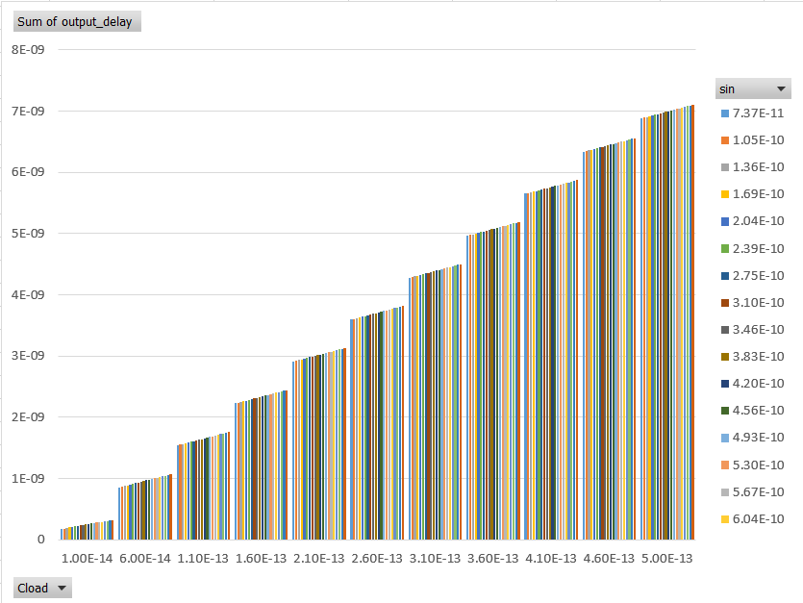

**Output Slew Table**

|  |  |  |  |  |
| --- | --- | --- | --- | --- |
| **Parameters** | | | **Output Delay - Sum** | **Input Slew(Sin) - A** |
| **step** | **Cload** | **Cslew** | **Output Delay** | **Input Slew** |
| 1 | 1.00E-14 | 1.00E-14 | 1.74E-10 | 7.37E-11 |
| 2 | 6.00E-14 | 1.00E-14 | 8.59E-10 | 7.36E-11 |
| 3 | 1.10E-13 | 1.00E-14 | 1.54E-09 | 7.36E-11 |
| 4 | 1.60E-13 | 1.00E-14 | 2.23E-09 | 7.36E-11 |
| 5 | 2.10E-13 | 1.00E-14 | 2.91E-09 | 7.36E-11 |
| 6 | 2.60E-13 | 1.00E-14 | 3.60E-09 | 7.36E-11 |
| 7 | 3.10E-13 | 1.00E-14 | 4.28E-09 | 7.36E-11 |
| 8 | 3.60E-13 | 1.00E-14 | 4.97E-09 | 7.36E-11 |
| 9 | 4.10E-13 | 1.00E-14 | 5.65E-09 | 7.36E-11 |
| 10 | 4.60E-13 | 1.00E-14 | 6.34E-09 | 7.36E-11 |
| 11 | 5.00E-13 | 1.00E-14 | 6.88E-09 | 7.36E-11 |
| 12 | 1.00E-14 | 2.00E-14 | 1.84E-10 | 1.05E-10 |
| 13 | 6.00E-14 | 2.00E-14 | 8.69E-10 | 1.05E-10 |
| 14 | 1.10E-13 | 2.00E-14 | 1.55E-09 | 1.05E-10 |
| 15 | 1.60E-13 | 2.00E-14 | 2.24E-09 | 1.05E-10 |
| 16 | 2.10E-13 | 2.00E-14 | 2.92E-09 | 1.05E-10 |
| 17 | 2.60E-13 | 2.00E-14 | 3.61E-09 | 1.05E-10 |
| 18 | 3.10E-13 | 2.00E-14 | 4.29E-09 | 1.05E-10 |
| 19 | 3.60E-13 | 2.00E-14 | 4.98E-09 | 1.05E-10 |
| 20 | 4.10E-13 | 2.00E-14 | 5.66E-09 | 1.05E-10 |
| 21 | 4.60E-13 | 2.00E-14 | 6.35E-09 | 1.05E-10 |
| 22 | 5.00E-13 | 2.00E-14 | 6.89E-09 | 1.05E-10 |
| 23 | 1.00E-14 | 3.00E-14 | 1.94E-10 | 1.36E-10 |
| 24 | 6.00E-14 | 3.00E-14 | 8.80E-10 | 1.36E-10 |
| 25 | 1.10E-13 | 3.00E-14 | 1.57E-09 | 1.36E-10 |
| 26 | 1.60E-13 | 3.00E-14 | 2.25E-09 | 1.36E-10 |
| 27 | 2.10E-13 | 3.00E-14 | 2.93E-09 | 1.36E-10 |
| 28 | 2.60E-13 | 3.00E-14 | 3.62E-09 | 1.36E-10 |
| 29 | 3.10E-13 | 3.00E-14 | 4.30E-09 | 1.36E-10 |
| 30 | 3.60E-13 | 3.00E-14 | 4.99E-09 | 1.36E-10 |
| 31 | 4.10E-13 | 3.00E-14 | 5.67E-09 | 1.36E-10 |
| 32 | 4.60E-13 | 3.00E-14 | 6.36E-09 | 1.36E-10 |
| 33 | 5.00E-13 | 3.00E-14 | 6.90E-09 | 1.36E-10 |
| 34 | 1.00E-14 | 4.00E-14 | 2.04E-10 | 1.69E-10 |
| 35 | 6.00E-14 | 4.00E-14 | 8.92E-10 | 1.69E-10 |
| 36 | 1.10E-13 | 4.00E-14 | 1.58E-09 | 1.69E-10 |
| 37 | 1.60E-13 | 4.00E-14 | 2.26E-09 | 1.69E-10 |
| 38 | 2.10E-13 | 4.00E-14 | 2.95E-09 | 1.69E-10 |
| 39 | 2.60E-13 | 4.00E-14 | 3.63E-09 | 1.69E-10 |
| 40 | 3.10E-13 | 4.00E-14 | 4.31E-09 | 1.69E-10 |
| 41 | 3.60E-13 | 4.00E-14 | 5.00E-09 | 1.69E-10 |
| 42 | 4.10E-13 | 4.00E-14 | 5.68E-09 | 1.69E-10 |
| 43 | 4.60E-13 | 4.00E-14 | 6.37E-09 | 1.69E-10 |
| 44 | 5.00E-13 | 4.00E-14 | 6.92E-09 | 1.69E-10 |
| 45 | 1.00E-14 | 5.00E-14 | 2.13E-10 | 2.04E-10 |
| 46 | 6.00E-14 | 5.00E-14 | 9.03E-10 | 2.04E-10 |
| 47 | 1.10E-13 | 5.00E-14 | 1.59E-09 | 2.04E-10 |
| 48 | 1.60E-13 | 5.00E-14 | 2.27E-09 | 2.04E-10 |
| 49 | 2.10E-13 | 5.00E-14 | 2.96E-09 | 2.04E-10 |
| 50 | 2.60E-13 | 5.00E-14 | 3.64E-09 | 2.04E-10 |
| 51 | 3.10E-13 | 5.00E-14 | 4.33E-09 | 2.04E-10 |
| 52 | 3.60E-13 | 5.00E-14 | 5.01E-09 | 2.04E-10 |
| 53 | 4.10E-13 | 5.00E-14 | 5.70E-09 | 2.04E-10 |
| 54 | 4.60E-13 | 5.00E-14 | 6.38E-09 | 2.04E-10 |
| 55 | 5.00E-13 | 5.00E-14 | 6.93E-09 | 2.04E-10 |
| 56 | 1.00E-14 | 6.00E-14 | 2.22E-10 | 2.39E-10 |
| 57 | 6.00E-14 | 6.00E-14 | 9.15E-10 | 2.39E-10 |
| 58 | 1.10E-13 | 6.00E-14 | 1.60E-09 | 2.39E-10 |
| 59 | 1.60E-13 | 6.00E-14 | 2.28E-09 | 2.39E-10 |
| 60 | 2.10E-13 | 6.00E-14 | 2.97E-09 | 2.39E-10 |
| 61 | 2.60E-13 | 6.00E-14 | 3.65E-09 | 2.39E-10 |
| 62 | 3.10E-13 | 6.00E-14 | 4.34E-09 | 2.39E-10 |
| 63 | 3.60E-13 | 6.00E-14 | 5.02E-09 | 2.39E-10 |
| 64 | 4.10E-13 | 6.00E-14 | 5.71E-09 | 2.39E-10 |
| 65 | 4.60E-13 | 6.00E-14 | 6.39E-09 | 2.39E-10 |
| 66 | 5.00E-13 | 6.00E-14 | 6.94E-09 | 2.39E-10 |
| 67 | 1.00E-14 | 7.00E-14 | 2.31E-10 | 2.75E-10 |
| 68 | 6.00E-14 | 7.00E-14 | 9.26E-10 | 2.74E-10 |
| 69 | 1.10E-13 | 7.00E-14 | 1.61E-09 | 2.74E-10 |
| 70 | 1.60E-13 | 7.00E-14 | 2.30E-09 | 2.74E-10 |
| 71 | 2.10E-13 | 7.00E-14 | 2.98E-09 | 2.74E-10 |
| 72 | 2.60E-13 | 7.00E-14 | 3.67E-09 | 2.74E-10 |
| 73 | 3.10E-13 | 7.00E-14 | 4.35E-09 | 2.74E-10 |
| 74 | 3.60E-13 | 7.00E-14 | 5.03E-09 | 2.74E-10 |
| 75 | 4.10E-13 | 7.00E-14 | 5.72E-09 | 2.74E-10 |
| 76 | 4.60E-13 | 7.00E-14 | 6.40E-09 | 2.74E-10 |
| 77 | 5.00E-13 | 7.00E-14 | 6.95E-09 | 2.74E-10 |
| 78 | 1.00E-14 | 8.00E-14 | 2.39E-10 | 3.10E-10 |
| 79 | 6.00E-14 | 8.00E-14 | 9.38E-10 | 3.10E-10 |
| 80 | 1.10E-13 | 8.00E-14 | 1.62E-09 | 3.10E-10 |
| 81 | 1.60E-13 | 8.00E-14 | 2.31E-09 | 3.10E-10 |
| 82 | 2.10E-13 | 8.00E-14 | 2.99E-09 | 3.10E-10 |
| 83 | 2.60E-13 | 8.00E-14 | 3.68E-09 | 3.10E-10 |
| 84 | 3.10E-13 | 8.00E-14 | 4.36E-09 | 3.10E-10 |
| 85 | 3.60E-13 | 8.00E-14 | 5.05E-09 | 3.10E-10 |
| 86 | 4.10E-13 | 8.00E-14 | 5.73E-09 | 3.10E-10 |
| 87 | 4.60E-13 | 8.00E-14 | 6.42E-09 | 3.10E-10 |
| 88 | 5.00E-13 | 8.00E-14 | 6.96E-09 | 3.10E-10 |
| 89 | 1.00E-14 | 9.00E-14 | 2.47E-10 | 3.46E-10 |
| 90 | 6.00E-14 | 9.00E-14 | 9.49E-10 | 3.46E-10 |
| 91 | 1.10E-13 | 9.00E-14 | 1.63E-09 | 3.46E-10 |
| 92 | 1.60E-13 | 9.00E-14 | 2.32E-09 | 3.46E-10 |
| 93 | 2.10E-13 | 9.00E-14 | 3.00E-09 | 3.46E-10 |
| 94 | 2.60E-13 | 9.00E-14 | 3.69E-09 | 3.46E-10 |
| 95 | 3.10E-13 | 9.00E-14 | 4.37E-09 | 3.46E-10 |
| 96 | 3.60E-13 | 9.00E-14 | 5.06E-09 | 3.46E-10 |
| 97 | 4.10E-13 | 9.00E-14 | 5.74E-09 | 3.46E-10 |
| 98 | 4.60E-13 | 9.00E-14 | 6.43E-09 | 3.46E-10 |
| 99 | 5.00E-13 | 9.00E-14 | 6.97E-09 | 3.46E-10 |
| 100 | 1.00E-14 | 1.00E-13 | 2.55E-10 | 3.83E-10 |
| 101 | 6.00E-14 | 1.00E-13 | 9.60E-10 | 3.82E-10 |
| 102 | 1.10E-13 | 1.00E-13 | 1.65E-09 | 3.82E-10 |
| 103 | 1.60E-13 | 1.00E-13 | 2.33E-09 | 3.82E-10 |
| 104 | 2.10E-13 | 1.00E-13 | 3.02E-09 | 3.82E-10 |
| 105 | 2.60E-13 | 1.00E-13 | 3.70E-09 | 3.82E-10 |
| 106 | 3.10E-13 | 1.00E-13 | 4.39E-09 | 3.82E-10 |
| 107 | 3.60E-13 | 1.00E-13 | 5.07E-09 | 3.82E-10 |
| 108 | 4.10E-13 | 1.00E-13 | 5.75E-09 | 3.82E-10 |
| 109 | 4.60E-13 | 1.00E-13 | 6.44E-09 | 3.82E-10 |
| 110 | 5.00E-13 | 1.00E-13 | 6.99E-09 | 3.82E-10 |
| 111 | 1.00E-14 | 1.10E-13 | 2.62E-10 | 4.20E-10 |
| 112 | 6.00E-14 | 1.10E-13 | 9.71E-10 | 4.19E-10 |
| 113 | 1.10E-13 | 1.10E-13 | 1.66E-09 | 4.19E-10 |
| 114 | 1.60E-13 | 1.10E-13 | 2.34E-09 | 4.19E-10 |
| 115 | 2.10E-13 | 1.10E-13 | 3.03E-09 | 4.19E-10 |
| 116 | 2.60E-13 | 1.10E-13 | 3.71E-09 | 4.19E-10 |
| 117 | 3.10E-13 | 1.10E-13 | 4.40E-09 | 4.19E-10 |
| 118 | 3.60E-13 | 1.10E-13 | 5.08E-09 | 4.19E-10 |
| 119 | 4.10E-13 | 1.10E-13 | 5.77E-09 | 4.19E-10 |
| 120 | 4.60E-13 | 1.10E-13 | 6.45E-09 | 4.19E-10 |
| 121 | 5.00E-13 | 1.10E-13 | 7.00E-09 | 4.19E-10 |
| 122 | 1.00E-14 | 1.20E-13 | 2.70E-10 | 4.56E-10 |
| 123 | 6.00E-14 | 1.20E-13 | 9.83E-10 | 4.56E-10 |
| 124 | 1.10E-13 | 1.20E-13 | 1.67E-09 | 4.56E-10 |
| 125 | 1.60E-13 | 1.20E-13 | 2.35E-09 | 4.56E-10 |
| 126 | 2.10E-13 | 1.20E-13 | 3.04E-09 | 4.56E-10 |
| 127 | 2.60E-13 | 1.20E-13 | 3.72E-09 | 4.56E-10 |
| 128 | 3.10E-13 | 1.20E-13 | 4.41E-09 | 4.56E-10 |
| 129 | 3.60E-13 | 1.20E-13 | 5.09E-09 | 4.56E-10 |
| 130 | 4.10E-13 | 1.20E-13 | 5.78E-09 | 4.56E-10 |
| 131 | 4.60E-13 | 1.20E-13 | 6.46E-09 | 4.56E-10 |
| 132 | 5.00E-13 | 1.20E-13 | 7.01E-09 | 4.56E-10 |
| 133 | 1.00E-14 | 1.30E-13 | 2.76E-10 | 4.93E-10 |
| 134 | 6.00E-14 | 1.30E-13 | 9.93E-10 | 4.92E-10 |
| 135 | 1.10E-13 | 1.30E-13 | 1.68E-09 | 4.92E-10 |
| 136 | 1.60E-13 | 1.30E-13 | 2.37E-09 | 4.92E-10 |
| 137 | 2.10E-13 | 1.30E-13 | 3.05E-09 | 4.92E-10 |
| 138 | 2.60E-13 | 1.30E-13 | 3.74E-09 | 4.92E-10 |
| 139 | 3.10E-13 | 1.30E-13 | 4.42E-09 | 4.92E-10 |
| 140 | 3.60E-13 | 1.30E-13 | 5.11E-09 | 4.92E-10 |
| 141 | 4.10E-13 | 1.30E-13 | 5.79E-09 | 4.92E-10 |
| 142 | 4.60E-13 | 1.30E-13 | 6.47E-09 | 4.92E-10 |
| 143 | 5.00E-13 | 1.30E-13 | 7.02E-09 | 4.92E-10 |
| 144 | 1.00E-14 | 1.40E-13 | 2.83E-10 | 5.30E-10 |
| 145 | 6.00E-14 | 1.40E-13 | 1.00E-09 | 5.30E-10 |
| 146 | 1.10E-13 | 1.40E-13 | 1.69E-09 | 5.30E-10 |
| 147 | 1.60E-13 | 1.40E-13 | 2.38E-09 | 5.29E-10 |
| 148 | 2.10E-13 | 1.40E-13 | 3.06E-09 | 5.29E-10 |
| 149 | 2.60E-13 | 1.40E-13 | 3.75E-09 | 5.29E-10 |
| 150 | 3.10E-13 | 1.40E-13 | 4.43E-09 | 5.29E-10 |
| 151 | 3.60E-13 | 1.40E-13 | 5.12E-09 | 5.29E-10 |
| 152 | 4.10E-13 | 1.40E-13 | 5.80E-09 | 5.29E-10 |
| 153 | 4.60E-13 | 1.40E-13 | 6.49E-09 | 5.29E-10 |
| 154 | 5.00E-13 | 1.40E-13 | 7.03E-09 | 5.29E-10 |
| 155 | 1.00E-14 | 1.50E-13 | 2.90E-10 | 5.67E-10 |
| 156 | 6.00E-14 | 1.50E-13 | 1.01E-09 | 5.67E-10 |
| 157 | 1.10E-13 | 1.50E-13 | 1.70E-09 | 5.67E-10 |
| 158 | 1.60E-13 | 1.50E-13 | 2.39E-09 | 5.67E-10 |
| 159 | 2.10E-13 | 1.50E-13 | 3.07E-09 | 5.67E-10 |
| 160 | 2.60E-13 | 1.50E-13 | 3.76E-09 | 5.67E-10 |
| 161 | 3.10E-13 | 1.50E-13 | 4.44E-09 | 5.67E-10 |
| 162 | 3.60E-13 | 1.50E-13 | 5.13E-09 | 5.67E-10 |
| 163 | 4.10E-13 | 1.50E-13 | 5.81E-09 | 5.67E-10 |
| 164 | 4.60E-13 | 1.50E-13 | 6.50E-09 | 5.67E-10 |
| 165 | 5.00E-13 | 1.50E-13 | 7.05E-09 | 5.67E-10 |
| 166 | 1.00E-14 | 1.60E-13 | 2.96E-10 | 6.04E-10 |
| 167 | 6.00E-14 | 1.60E-13 | 1.03E-09 | 6.04E-10 |
| 168 | 1.10E-13 | 1.60E-13 | 1.72E-09 | 6.04E-10 |
| 169 | 1.60E-13 | 1.60E-13 | 2.40E-09 | 6.04E-10 |
| 170 | 2.10E-13 | 1.60E-13 | 3.09E-09 | 6.04E-10 |
| 171 | 2.60E-13 | 1.60E-13 | 3.77E-09 | 6.04E-10 |
| 172 | 3.10E-13 | 1.60E-13 | 4.46E-09 | 6.04E-10 |
| 173 | 3.60E-13 | 1.60E-13 | 5.14E-09 | 6.04E-10 |
| 174 | 4.10E-13 | 1.60E-13 | 5.82E-09 | 6.04E-10 |
| 175 | 4.60E-13 | 1.60E-13 | 6.51E-09 | 6.04E-10 |
| 176 | 5.00E-13 | 1.60E-13 | 7.06E-09 | 6.04E-10 |
| 177 | 1.00E-14 | 1.70E-13 | 3.02E-10 | 6.42E-10 |
| 178 | 6.00E-14 | 1.70E-13 | 1.04E-09 | 6.41E-10 |
| 179 | 1.10E-13 | 1.70E-13 | 1.73E-09 | 6.41E-10 |
| 180 | 1.60E-13 | 1.70E-13 | 2.41E-09 | 6.41E-10 |
| 181 | 2.10E-13 | 1.70E-13 | 3.10E-09 | 6.41E-10 |
| 182 | 2.60E-13 | 1.70E-13 | 3.78E-09 | 6.41E-10 |
| 183 | 3.10E-13 | 1.70E-13 | 4.47E-09 | 6.42E-10 |
| 184 | 3.60E-13 | 1.70E-13 | 5.15E-09 | 6.42E-10 |
| 185 | 4.10E-13 | 1.70E-13 | 5.84E-09 | 6.41E-10 |
| 186 | 4.60E-13 | 1.70E-13 | 6.52E-09 | 6.41E-10 |
| 187 | 5.00E-13 | 1.70E-13 | 7.07E-09 | 6.41E-10 |
| 188 | 1.00E-14 | 1.80E-13 | 3.08E-10 | 6.79E-10 |
| 189 | 6.00E-14 | 1.80E-13 | 1.05E-09 | 6.78E-10 |
| 190 | 1.10E-13 | 1.80E-13 | 1.74E-09 | 6.78E-10 |
| 191 | 1.60E-13 | 1.80E-13 | 2.42E-09 | 6.78E-10 |
| 192 | 2.10E-13 | 1.80E-13 | 3.11E-09 | 6.79E-10 |
| 193 | 2.60E-13 | 1.80E-13 | 3.79E-09 | 6.79E-10 |
| 194 | 3.10E-13 | 1.80E-13 | 4.48E-09 | 6.78E-10 |
| 195 | 3.60E-13 | 1.80E-13 | 5.16E-09 | 6.78E-10 |
| 196 | 4.10E-13 | 1.80E-13 | 5.85E-09 | 6.78E-10 |
| 197 | 4.60E-13 | 1.80E-13 | 6.53E-09 | 6.78E-10 |
| 198 | 5.00E-13 | 1.80E-13 | 7.08E-09 | 6.78E-10 |
| 199 | 1.00E-14 | 1.90E-13 | 3.14E-10 | 7.16E-10 |
| 200 | 6.00E-14 | 1.90E-13 | 1.06E-09 | 7.15E-10 |
| 201 | 1.10E-13 | 1.90E-13 | 1.75E-09 | 7.15E-10 |
| 202 | 1.60E-13 | 1.90E-13 | 2.44E-09 | 7.15E-10 |
| 203 | 2.10E-13 | 1.90E-13 | 3.12E-09 | 7.15E-10 |
| 204 | 2.60E-13 | 1.90E-13 | 3.81E-09 | 7.15E-10 |
| 205 | 3.10E-13 | 1.90E-13 | 4.49E-09 | 7.16E-10 |
| 206 | 3.60E-13 | 1.90E-13 | 5.18E-09 | 7.16E-10 |
| 207 | 4.10E-13 | 1.90E-13 | 5.86E-09 | 7.16E-10 |
| 208 | 4.60E-13 | 1.90E-13 | 6.54E-09 | 7.16E-10 |
| 209 | 5.00E-13 | 1.90E-13 | 7.09E-09 | 7.16E-10 |
| 210 | 1.00E-14 | 2.00E-13 | 3.20E-10 | 7.53E-10 |
| 211 | 6.00E-14 | 2.00E-13 | 1.07E-09 | 7.53E-10 |
| 212 | 1.10E-13 | 2.00E-13 | 1.76E-09 | 7.52E-10 |
| 213 | 1.60E-13 | 2.00E-13 | 2.45E-09 | 7.52E-10 |
| 214 | 2.10E-13 | 2.00E-13 | 3.13E-09 | 7.52E-10 |
| 215 | 2.60E-13 | 2.00E-13 | 3.82E-09 | 7.53E-10 |
| 216 | 3.10E-13 | 2.00E-13 | 4.50E-09 | 7.53E-10 |
| 217 | 3.60E-13 | 2.00E-13 | 5.19E-09 | 7.53E-10 |
| 218 | 4.10E-13 | 2.00E-13 | 5.87E-09 | 7.53E-10 |
| 219 | 4.60E-13 | 2.00E-13 | 6.56E-09 | 7.53E-10 |
| 220 | 5.00E-13 | 2.00E-13 | 7.10E-09 | 7.53E-10 |

**Output Slew Plot (Slew vs Cload vs Sin)**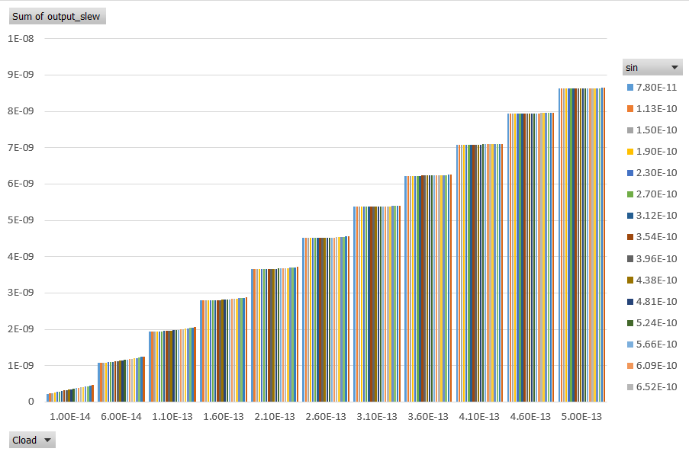

## Full Adder - 2(Cout-2x + Sum-1x)

## Member - 2

## 

## Schematic

## Layout

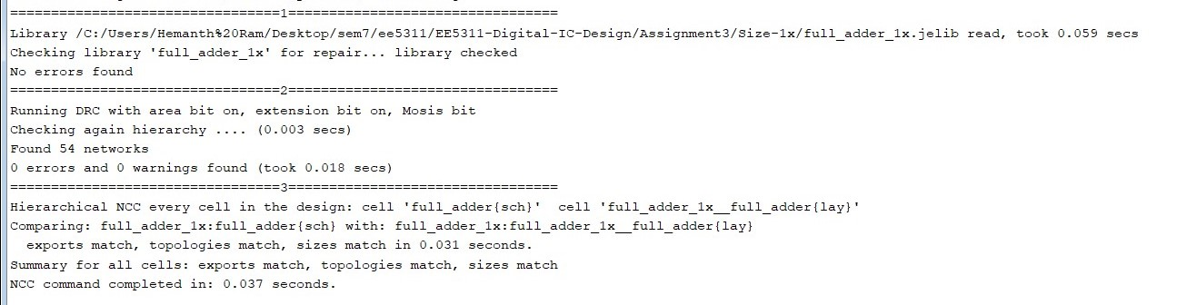 **DRC LVS Clean Screenshot**

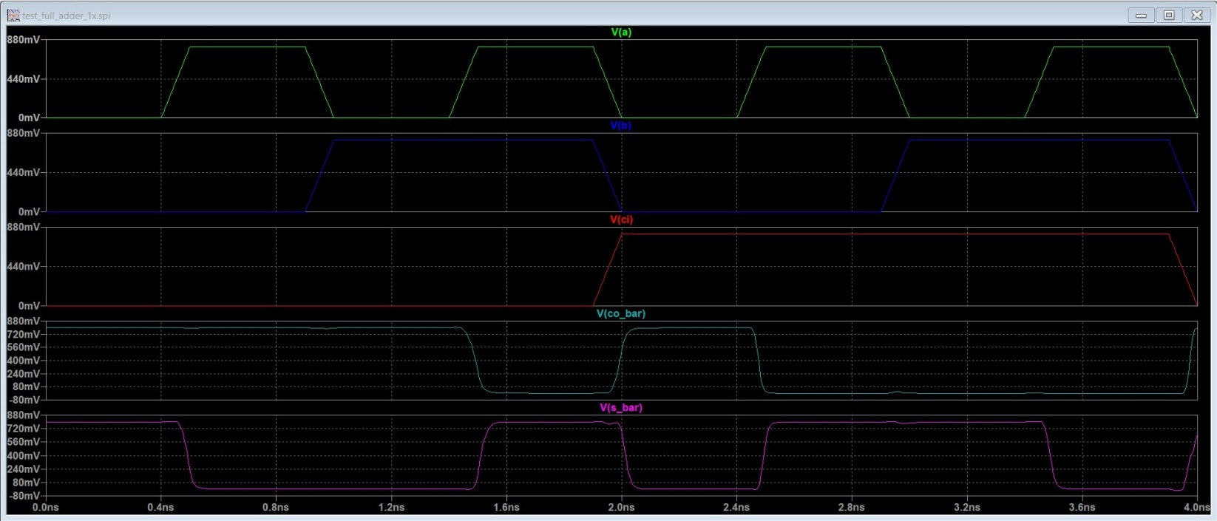 **Functionality Spice Simulation**

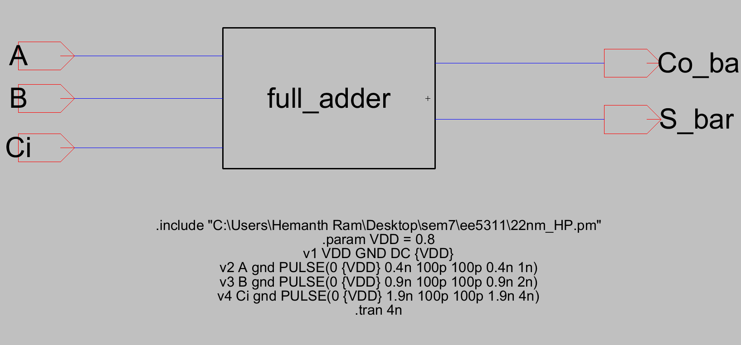

**Functionality Simulation Testbench**

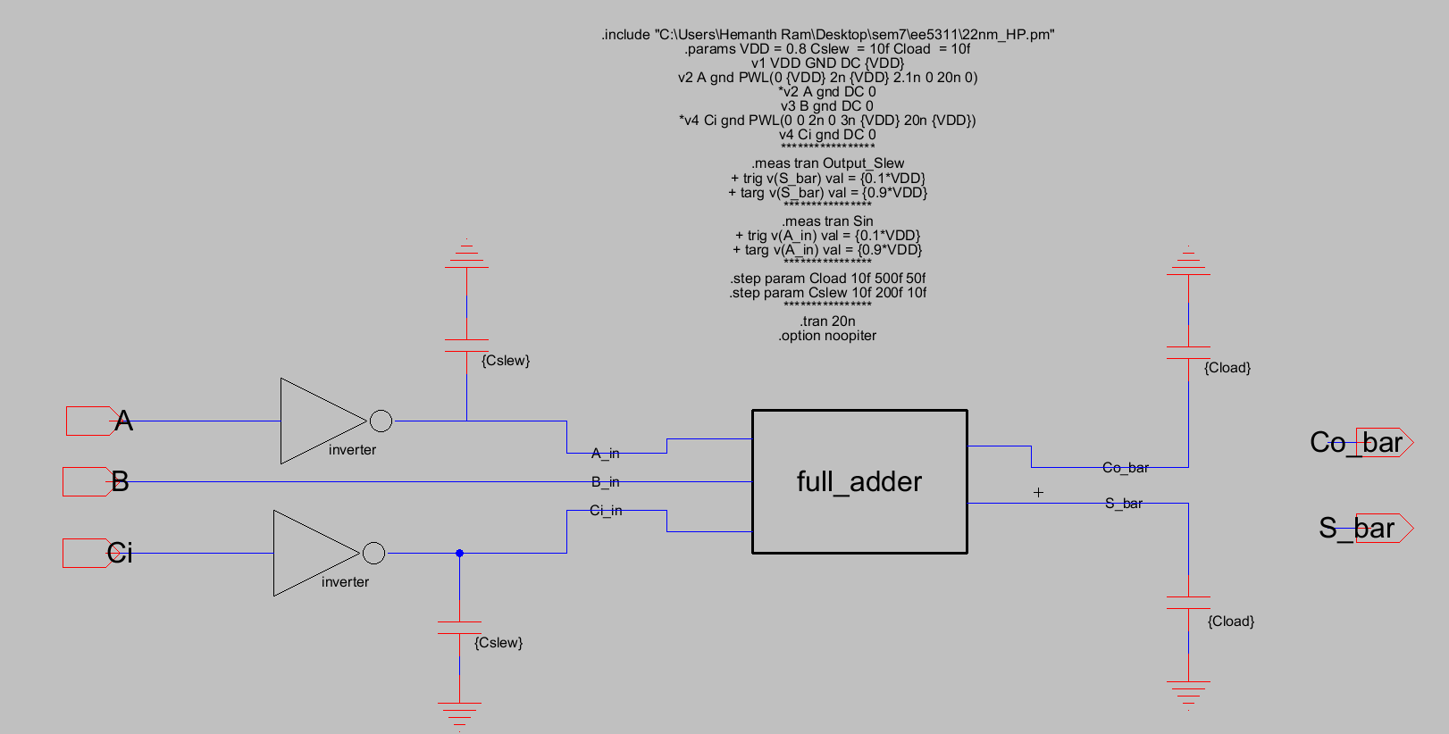 **Delay Testbench**

**Output Delay Table**

|  |  |  |  |  |
| --- | --- | --- | --- | --- |
| **Parameters** | | | **Output Delay - Sum** | **Input Slew(Sin) - A** |
| **step** | **Cload** | **Cslew** | **Output Delay** | **Input Slew** |
| 1 | 1.00E-14 | 1.00E-14 | 2.19E-10 | 1.13E-10 |
| 2 | 6.00E-14 | 1.00E-14 | 1.14E-09 | 1.12E-10 |
| 3 | 1.10E-13 | 1.00E-14 | 2.06E-09 | 1.12E-10 |
| 4 | 1.60E-13 | 1.00E-14 | 2.99E-09 | 1.12E-10 |
| 5 | 2.10E-13 | 1.00E-14 | 3.91E-09 | 1.12E-10 |
| 6 | 2.60E-13 | 1.00E-14 | 4.83E-09 | 1.12E-10 |
| 7 | 3.10E-13 | 1.00E-14 | 5.76E-09 | 1.12E-10 |
| 8 | 3.60E-13 | 1.00E-14 | 6.68E-09 | 1.12E-10 |
| 9 | 4.10E-13 | 1.00E-14 | 7.60E-09 | 1.12E-10 |
| 10 | 4.60E-13 | 1.00E-14 | 8.53E-09 | 1.12E-10 |
| 11 | 5.00E-13 | 1.00E-14 | 9.26E-09 | 1.12E-10 |
| 12 | 1.00E-14 | 2.00E-14 | 2.21E-10 | 1.81E-10 |
| 13 | 6.00E-14 | 2.00E-14 | 1.14E-09 | 1.79E-10 |
| 14 | 1.10E-13 | 2.00E-14 | 2.06E-09 | 1.79E-10 |
| 15 | 1.60E-13 | 2.00E-14 | 2.98E-09 | 1.79E-10 |
| 16 | 2.10E-13 | 2.00E-14 | 3.91E-09 | 1.79E-10 |
| 17 | 2.60E-13 | 2.00E-14 | 4.83E-09 | 1.79E-10 |
| 18 | 3.10E-13 | 2.00E-14 | 5.76E-09 | 1.79E-10 |
| 19 | 3.60E-13 | 2.00E-14 | 6.68E-09 | 1.79E-10 |
| 20 | 4.10E-13 | 2.00E-14 | 7.60E-09 | 1.79E-10 |
| 21 | 4.60E-13 | 2.00E-14 | 8.53E-09 | 1.79E-10 |
| 22 | 5.00E-13 | 2.00E-14 | 9.26E-09 | 1.79E-10 |
| 23 | 1.00E-14 | 3.00E-14 | 2.22E-10 | 2.53E-10 |
| 24 | 6.00E-14 | 3.00E-14 | 1.14E-09 | 2.52E-10 |
| 25 | 1.10E-13 | 3.00E-14 | 2.06E-09 | 2.52E-10 |
| 26 | 1.60E-13 | 3.00E-14 | 2.99E-09 | 2.52E-10 |
| 27 | 2.10E-13 | 3.00E-14 | 3.91E-09 | 2.52E-10 |
| 28 | 2.60E-13 | 3.00E-14 | 4.83E-09 | 2.52E-10 |
| 29 | 3.10E-13 | 3.00E-14 | 5.76E-09 | 2.52E-10 |
| 30 | 3.60E-13 | 3.00E-14 | 6.68E-09 | 2.52E-10 |
| 31 | 4.10E-13 | 3.00E-14 | 7.60E-09 | 2.52E-10 |
| 32 | 4.60E-13 | 3.00E-14 | 8.53E-09 | 2.52E-10 |
| 33 | 5.00E-13 | 3.00E-14 | 9.26E-09 | 2.52E-10 |
| 34 | 1.00E-14 | 4.00E-14 | 2.24E-10 | 3.26E-10 |
| 35 | 6.00E-14 | 4.00E-14 | 1.14E-09 | 3.25E-10 |
| 36 | 1.10E-13 | 4.00E-14 | 2.06E-09 | 3.24E-10 |
| 37 | 1.60E-13 | 4.00E-14 | 2.99E-09 | 3.24E-10 |
| 38 | 2.10E-13 | 4.00E-14 | 3.91E-09 | 3.24E-10 |
| 39 | 2.60E-13 | 4.00E-14 | 4.84E-09 | 3.24E-10 |
| 40 | 3.10E-13 | 4.00E-14 | 5.76E-09 | 3.24E-10 |
| 41 | 3.60E-13 | 4.00E-14 | 6.68E-09 | 3.24E-10 |
| 42 | 4.10E-13 | 4.00E-14 | 7.60E-09 | 3.24E-10 |
| 43 | 4.60E-13 | 4.00E-14 | 8.53E-09 | 3.24E-10 |
| 44 | 5.00E-13 | 4.00E-14 | 9.26E-09 | 3.24E-10 |
| 45 | 1.00E-14 | 5.00E-14 | 2.26E-10 | 4.00E-10 |
| 46 | 6.00E-14 | 5.00E-14 | 1.14E-09 | 3.99E-10 |
| 47 | 1.10E-13 | 5.00E-14 | 2.06E-09 | 3.99E-10 |
| 48 | 1.60E-13 | 5.00E-14 | 2.99E-09 | 3.99E-10 |
| 49 | 2.10E-13 | 5.00E-14 | 3.91E-09 | 3.99E-10 |
| 50 | 2.60E-13 | 5.00E-14 | 4.83E-09 | 3.99E-10 |
| 51 | 3.10E-13 | 5.00E-14 | 5.76E-09 | 3.99E-10 |
| 52 | 3.60E-13 | 5.00E-14 | 6.68E-09 | 3.99E-10 |
| 53 | 4.10E-13 | 5.00E-14 | 7.61E-09 | 3.99E-10 |
| 54 | 4.60E-13 | 5.00E-14 | 8.53E-09 | 3.99E-10 |
| 55 | 5.00E-13 | 5.00E-14 | 9.26E-09 | 3.99E-10 |
| 56 | 1.00E-14 | 6.00E-14 | 2.28E-10 | 4.75E-10 |
| 57 | 6.00E-14 | 6.00E-14 | 1.14E-09 | 4.74E-10 |
| 58 | 1.10E-13 | 6.00E-14 | 2.06E-09 | 4.74E-10 |
| 59 | 1.60E-13 | 6.00E-14 | 2.99E-09 | 4.74E-10 |
| 60 | 2.10E-13 | 6.00E-14 | 3.91E-09 | 4.74E-10 |
| 61 | 2.60E-13 | 6.00E-14 | 4.83E-09 | 4.74E-10 |
| 62 | 3.10E-13 | 6.00E-14 | 5.76E-09 | 4.74E-10 |
| 63 | 3.60E-13 | 6.00E-14 | 6.68E-09 | 4.74E-10 |
| 64 | 4.10E-13 | 6.00E-14 | 7.60E-09 | 4.74E-10 |
| 65 | 4.60E-13 | 6.00E-14 | 8.53E-09 | 4.74E-10 |
| 66 | 5.00E-13 | 6.00E-14 | 9.27E-09 | 4.74E-10 |
| 67 | 1.00E-14 | 7.00E-14 | 2.30E-10 | 5.51E-10 |
| 68 | 6.00E-14 | 7.00E-14 | 1.14E-09 | 5.50E-10 |
| 69 | 1.10E-13 | 7.00E-14 | 2.06E-09 | 5.50E-10 |
| 70 | 1.60E-13 | 7.00E-14 | 2.99E-09 | 5.50E-10 |
| 71 | 2.10E-13 | 7.00E-14 | 3.91E-09 | 5.49E-10 |
| 72 | 2.60E-13 | 7.00E-14 | 4.83E-09 | 5.49E-10 |
| 73 | 3.10E-13 | 7.00E-14 | 5.76E-09 | 5.49E-10 |
| 74 | 3.60E-13 | 7.00E-14 | 6.68E-09 | 5.49E-10 |
| 75 | 4.10E-13 | 7.00E-14 | 7.60E-09 | 5.49E-10 |
| 76 | 4.60E-13 | 7.00E-14 | 8.53E-09 | 5.49E-10 |
| 77 | 5.00E-13 | 7.00E-14 | 9.27E-09 | 5.49E-10 |
| 78 | 1.00E-14 | 8.00E-14 | 2.33E-10 | 6.27E-10 |
| 79 | 6.00E-14 | 8.00E-14 | 1.14E-09 | 6.26E-10 |
| 80 | 1.10E-13 | 8.00E-14 | 2.07E-09 | 6.26E-10 |
| 81 | 1.60E-13 | 8.00E-14 | 2.99E-09 | 6.25E-10 |
| 82 | 2.10E-13 | 8.00E-14 | 3.91E-09 | 6.25E-10 |
| 83 | 2.60E-13 | 8.00E-14 | 4.83E-09 | 6.25E-10 |
| 84 | 3.10E-13 | 8.00E-14 | 5.76E-09 | 6.25E-10 |
| 85 | 3.60E-13 | 8.00E-14 | 6.68E-09 | 6.25E-10 |
| 86 | 4.10E-13 | 8.00E-14 | 7.61E-09 | 6.25E-10 |
| 87 | 4.60E-13 | 8.00E-14 | 8.53E-09 | 6.25E-10 |
| 88 | 5.00E-13 | 8.00E-14 | 9.27E-09 | 6.25E-10 |
| 89 | 1.00E-14 | 9.00E-14 | 2.35E-10 | 7.03E-10 |
| 90 | 6.00E-14 | 9.00E-14 | 1.15E-09 | 7.02E-10 |
| 91 | 1.10E-13 | 9.00E-14 | 2.06E-09 | 7.02E-10 |
| 92 | 1.60E-13 | 9.00E-14 | 2.99E-09 | 7.02E-10 |
| 93 | 2.10E-13 | 9.00E-14 | 3.91E-09 | 7.02E-10 |
| 94 | 2.60E-13 | 9.00E-14 | 4.83E-09 | 7.01E-10 |
| 95 | 3.10E-13 | 9.00E-14 | 5.76E-09 | 7.01E-10 |
| 96 | 3.60E-13 | 9.00E-14 | 6.68E-09 | 7.02E-10 |
| 97 | 4.10E-13 | 9.00E-14 | 7.60E-09 | 7.02E-10 |
| 98 | 4.60E-13 | 9.00E-14 | 8.53E-09 | 7.02E-10 |
| 99 | 5.00E-13 | 9.00E-14 | 9.26E-09 | 7.02E-10 |
| 100 | 1.00E-14 | 1.00E-13 | 2.38E-10 | 7.79E-10 |
| 101 | 6.00E-14 | 1.00E-13 | 1.15E-09 | 7.78E-10 |
| 102 | 1.10E-13 | 1.00E-13 | 2.07E-09 | 7.78E-10 |
| 103 | 1.60E-13 | 1.00E-13 | 2.99E-09 | 7.78E-10 |
| 104 | 2.10E-13 | 1.00E-13 | 3.91E-09 | 7.78E-10 |
| 105 | 2.60E-13 | 1.00E-13 | 4.83E-09 | 7.78E-10 |
| 106 | 3.10E-13 | 1.00E-13 | 5.76E-09 | 7.78E-10 |
| 107 | 3.60E-13 | 1.00E-13 | 6.68E-09 | 7.78E-10 |
| 108 | 4.10E-13 | 1.00E-13 | 7.61E-09 | 7.78E-10 |
| 109 | 4.60E-13 | 1.00E-13 | 8.53E-09 | 7.78E-10 |
| 110 | 5.00E-13 | 1.00E-13 | 9.26E-09 | 7.78E-10 |
| 111 | 1.00E-14 | 1.10E-13 | 2.41E-10 | 8.55E-10 |
| 112 | 6.00E-14 | 1.10E-13 | 1.15E-09 | 8.55E-10 |
| 113 | 1.10E-13 | 1.10E-13 | 2.07E-09 | 8.54E-10 |
| 114 | 1.60E-13 | 1.10E-13 | 2.99E-09 | 8.54E-10 |
| 115 | 2.10E-13 | 1.10E-13 | 3.91E-09 | 8.54E-10 |
| 116 | 2.60E-13 | 1.10E-13 | 4.83E-09 | 8.54E-10 |
| 117 | 3.10E-13 | 1.10E-13 | 5.76E-09 | 8.54E-10 |
| 118 | 3.60E-13 | 1.10E-13 | 6.68E-09 | 8.54E-10 |
| 119 | 4.10E-13 | 1.10E-13 | 7.61E-09 | 8.54E-10 |
| 120 | 4.60E-13 | 1.10E-13 | 8.53E-09 | 8.54E-10 |
| 121 | 5.00E-13 | 1.10E-13 | 9.27E-09 | 8.54E-10 |
| 122 | 1.00E-14 | 1.20E-13 | 2.44E-10 | 9.31E-10 |
| 123 | 6.00E-14 | 1.20E-13 | 1.15E-09 | 9.31E-10 |
| 124 | 1.10E-13 | 1.20E-13 | 2.07E-09 | 9.30E-10 |
| 125 | 1.60E-13 | 1.20E-13 | 2.99E-09 | 9.30E-10 |
| 126 | 2.10E-13 | 1.20E-13 | 3.91E-09 | 9.30E-10 |
| 127 | 2.60E-13 | 1.20E-13 | 4.83E-09 | 9.30E-10 |
| 128 | 3.10E-13 | 1.20E-13 | 5.76E-09 | 9.30E-10 |
| 129 | 3.60E-13 | 1.20E-13 | 6.68E-09 | 9.30E-10 |
| 130 | 4.10E-13 | 1.20E-13 | 7.60E-09 | 9.30E-10 |
| 131 | 4.60E-13 | 1.20E-13 | 8.53E-09 | 9.30E-10 |
| 132 | 5.00E-13 | 1.20E-13 | 9.27E-09 | 9.30E-10 |
| 133 | 1.00E-14 | 1.30E-13 | 2.46E-10 | 1.01E-09 |
| 134 | 6.00E-14 | 1.30E-13 | 1.15E-09 | 1.01E-09 |
| 135 | 1.10E-13 | 1.30E-13 | 2.07E-09 | 1.01E-09 |
| 136 | 1.60E-13 | 1.30E-13 | 2.99E-09 | 1.01E-09 |
| 137 | 2.10E-13 | 1.30E-13 | 3.91E-09 | 1.01E-09 |
| 138 | 2.60E-13 | 1.30E-13 | 4.84E-09 | 1.01E-09 |
| 139 | 3.10E-13 | 1.30E-13 | 5.76E-09 | 1.01E-09 |
| 140 | 3.60E-13 | 1.30E-13 | 6.68E-09 | 1.01E-09 |
| 141 | 4.10E-13 | 1.30E-13 | 7.60E-09 | 1.01E-09 |
| 142 | 4.60E-13 | 1.30E-13 | 8.53E-09 | 1.01E-09 |
| 143 | 5.00E-13 | 1.30E-13 | 9.26E-09 | 1.01E-09 |
| 144 | 1.00E-14 | 1.40E-13 | 2.49E-10 | 1.08E-09 |
| 145 | 6.00E-14 | 1.40E-13 | 1.15E-09 | 1.08E-09 |
| 146 | 1.10E-13 | 1.40E-13 | 2.07E-09 | 1.08E-09 |
| 147 | 1.60E-13 | 1.40E-13 | 2.99E-09 | 1.08E-09 |
| 148 | 2.10E-13 | 1.40E-13 | 3.91E-09 | 1.08E-09 |
| 149 | 2.60E-13 | 1.40E-13 | 4.84E-09 | 1.08E-09 |
| 150 | 3.10E-13 | 1.40E-13 | 5.76E-09 | 1.08E-09 |
| 151 | 3.60E-13 | 1.40E-13 | 6.68E-09 | 1.08E-09 |
| 152 | 4.10E-13 | 1.40E-13 | 7.61E-09 | 1.08E-09 |
| 153 | 4.60E-13 | 1.40E-13 | 8.53E-09 | 1.08E-09 |
| 154 | 5.00E-13 | 1.40E-13 | 9.27E-09 | 1.08E-09 |
| 155 | 1.00E-14 | 1.50E-13 | 2.52E-10 | 1.16E-09 |
| 156 | 6.00E-14 | 1.50E-13 | 1.15E-09 | 1.16E-09 |
| 157 | 1.10E-13 | 1.50E-13 | 2.07E-09 | 1.16E-09 |
| 158 | 1.60E-13 | 1.50E-13 | 2.99E-09 | 1.16E-09 |
| 159 | 2.10E-13 | 1.50E-13 | 3.91E-09 | 1.16E-09 |
| 160 | 2.60E-13 | 1.50E-13 | 4.84E-09 | 1.16E-09 |
| 161 | 3.10E-13 | 1.50E-13 | 5.76E-09 | 1.16E-09 |
| 162 | 3.60E-13 | 1.50E-13 | 6.68E-09 | 1.16E-09 |
| 163 | 4.10E-13 | 1.50E-13 | 7.60E-09 | 1.16E-09 |
| 164 | 4.60E-13 | 1.50E-13 | 8.53E-09 | 1.16E-09 |
| 165 | 5.00E-13 | 1.50E-13 | 9.26E-09 | 1.16E-09 |
| 166 | 1.00E-14 | 1.60E-13 | 2.55E-10 | 1.23E-09 |
| 167 | 6.00E-14 | 1.60E-13 | 1.16E-09 | 1.24E-09 |
| 168 | 1.10E-13 | 1.60E-13 | 2.07E-09 | 1.23E-09 |
| 169 | 1.60E-13 | 1.60E-13 | 2.99E-09 | 1.23E-09 |
| 170 | 2.10E-13 | 1.60E-13 | 3.91E-09 | 1.23E-09 |
| 171 | 2.60E-13 | 1.60E-13 | 4.84E-09 | 1.23E-09 |
| 172 | 3.10E-13 | 1.60E-13 | 5.76E-09 | 1.23E-09 |
| 173 | 3.60E-13 | 1.60E-13 | 6.68E-09 | 1.23E-09 |
| 174 | 4.10E-13 | 1.60E-13 | 7.61E-09 | 1.23E-09 |
| 175 | 4.60E-13 | 1.60E-13 | 8.53E-09 | 1.23E-09 |
| 176 | 5.00E-13 | 1.60E-13 | 9.27E-09 | 1.23E-09 |
| 177 | 1.00E-14 | 1.70E-13 | 2.57E-10 | 1.31E-09 |
| 178 | 6.00E-14 | 1.70E-13 | 1.16E-09 | 1.31E-09 |
| 179 | 1.10E-13 | 1.70E-13 | 2.08E-09 | 1.31E-09 |
| 180 | 1.60E-13 | 1.70E-13 | 2.99E-09 | 1.31E-09 |
| 181 | 2.10E-13 | 1.70E-13 | 3.92E-09 | 1.31E-09 |
| 182 | 2.60E-13 | 1.70E-13 | 4.84E-09 | 1.31E-09 |
| 183 | 3.10E-13 | 1.70E-13 | 5.76E-09 | 1.31E-09 |
| 184 | 3.60E-13 | 1.70E-13 | 6.68E-09 | 1.31E-09 |
| 185 | 4.10E-13 | 1.70E-13 | 7.61E-09 | 1.31E-09 |
| 186 | 4.60E-13 | 1.70E-13 | 8.53E-09 | 1.31E-09 |
| 187 | 5.00E-13 | 1.70E-13 | 9.27E-09 | 1.31E-09 |
| 188 | 1.00E-14 | 1.80E-13 | 2.60E-10 | 1.39E-09 |
| 189 | 6.00E-14 | 1.80E-13 | 1.16E-09 | 1.39E-09 |
| 190 | 1.10E-13 | 1.80E-13 | 2.08E-09 | 1.39E-09 |
| 191 | 1.60E-13 | 1.80E-13 | 3.00E-09 | 1.39E-09 |
| 192 | 2.10E-13 | 1.80E-13 | 3.92E-09 | 1.39E-09 |
| 193 | 2.60E-13 | 1.80E-13 | 4.84E-09 | 1.39E-09 |
| 194 | 3.10E-13 | 1.80E-13 | 5.76E-09 | 1.39E-09 |
| 195 | 3.60E-13 | 1.80E-13 | 6.68E-09 | 1.39E-09 |
| 196 | 4.10E-13 | 1.80E-13 | 7.61E-09 | 1.39E-09 |
| 197 | 4.60E-13 | 1.80E-13 | 8.53E-09 | 1.39E-09 |
| 198 | 5.00E-13 | 1.80E-13 | 9.26E-09 | 1.39E-09 |
| 199 | 1.00E-14 | 1.90E-13 | 2.64E-10 | 1.46E-09 |
| 200 | 6.00E-14 | 1.90E-13 | 1.16E-09 | 1.46E-09 |
| 201 | 1.10E-13 | 1.90E-13 | 2.08E-09 | 1.46E-09 |
| 202 | 1.60E-13 | 1.90E-13 | 3.00E-09 | 1.46E-09 |
| 203 | 2.10E-13 | 1.90E-13 | 3.92E-09 | 1.46E-09 |
| 204 | 2.60E-13 | 1.90E-13 | 4.84E-09 | 1.46E-09 |
| 205 | 3.10E-13 | 1.90E-13 | 5.76E-09 | 1.46E-09 |
| 206 | 3.60E-13 | 1.90E-13 | 6.68E-09 | 1.46E-09 |
| 207 | 4.10E-13 | 1.90E-13 | 7.61E-09 | 1.46E-09 |
| 208 | 4.60E-13 | 1.90E-13 | 8.53E-09 | 1.46E-09 |
| 209 | 5.00E-13 | 1.90E-13 | 9.27E-09 | 1.46E-09 |
| 210 | 1.00E-14 | 2.00E-13 | 2.66E-10 | 1.54E-09 |
| 211 | 6.00E-14 | 2.00E-13 | 1.16E-09 | 1.54E-09 |
| 212 | 1.10E-13 | 2.00E-13 | 2.08E-09 | 1.54E-09 |
| 213 | 1.60E-13 | 2.00E-13 | 3.00E-09 | 1.54E-09 |
| 214 | 2.10E-13 | 2.00E-13 | 3.92E-09 | 1.54E-09 |
| 215 | 2.60E-13 | 2.00E-13 | 4.84E-09 | 1.54E-09 |
| 216 | 3.10E-13 | 2.00E-13 | 5.76E-09 | 1.54E-09 |
| 217 | 3.60E-13 | 2.00E-13 | 6.68E-09 | 1.54E-09 |
| 218 | 4.10E-13 | 2.00E-13 | 7.60E-09 | 1.54E-09 |
| 219 | 4.60E-13 | 2.00E-13 | 8.53E-09 | 1.54E-09 |
| 220 | 5.00E-13 | 2.00E-13 | 9.26E-09 | 1.54E-09 |

**Output Delay Plot (Delay vs Cload vs Sin)**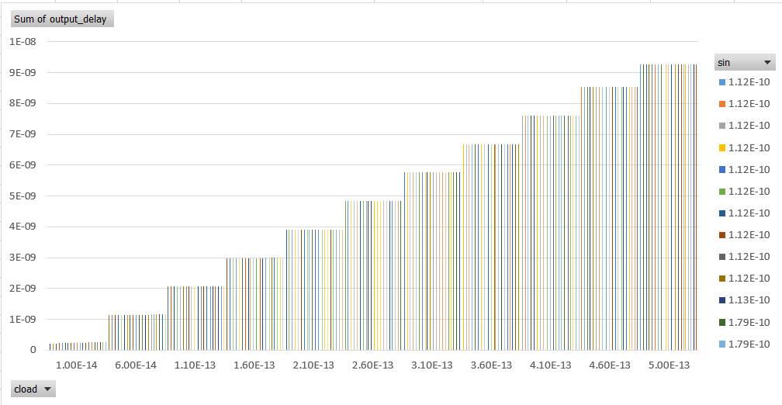

**Output Slew Table**

|  |  |  |  |  |
| --- | --- | --- | --- | --- |
| **Parameters** | | | **Output Slew - Cout** | **Input Slew(Sin) - Ci** |
| **step** | **Cload** | **Cslew** | **Output Slew** | **Input Slew** |
| 1 | 1.00E-14 | 1.00E-14 | 1.88E-10 | 3.40E-10 |
| 2 | 6.00E-14 | 1.00E-14 | 5.62E-10 | 3.39E-10 |
| 3 | 1.10E-13 | 1.00E-14 | 9.74E-10 | 3.38E-10 |
| 4 | 1.60E-13 | 1.00E-14 | 1.40E-09 | 3.38E-10 |
| 5 | 2.10E-13 | 1.00E-14 | 1.82E-09 | 3.38E-10 |
| 6 | 2.60E-13 | 1.00E-14 | 2.25E-09 | 3.38E-10 |
| 7 | 3.10E-13 | 1.00E-14 | 2.68E-09 | 3.38E-10 |
| 8 | 3.60E-13 | 1.00E-14 | 3.11E-09 | 3.38E-10 |
| 9 | 4.10E-13 | 1.00E-14 | 3.53E-09 | 3.38E-10 |
| 10 | 4.60E-13 | 1.00E-14 | 3.97E-09 | 3.38E-10 |
| 11 | 5.00E-13 | 1.00E-14 | 4.31E-09 | 3.38E-10 |
| 12 | 1.00E-14 | 2.00E-14 | 2.08E-10 | 4.13E-10 |
| 13 | 6.00E-14 | 2.00E-14 | 5.78E-10 | 4.13E-10 |
| 14 | 1.10E-13 | 2.00E-14 | 9.85E-10 | 4.12E-10 |
| 15 | 1.60E-13 | 2.00E-14 | 1.40E-09 | 4.12E-10 |
| 16 | 2.10E-13 | 2.00E-14 | 1.83E-09 | 4.12E-10 |
| 17 | 2.60E-13 | 2.00E-14 | 2.25E-09 | 4.12E-10 |
| 18 | 3.10E-13 | 2.00E-14 | 2.68E-09 | 4.12E-10 |
| 19 | 3.60E-13 | 2.00E-14 | 3.11E-09 | 4.12E-10 |
| 20 | 4.10E-13 | 2.00E-14 | 3.54E-09 | 4.12E-10 |
| 21 | 4.60E-13 | 2.00E-14 | 3.97E-09 | 4.12E-10 |
| 22 | 5.00E-13 | 2.00E-14 | 4.31E-09 | 4.12E-10 |
| 23 | 1.00E-14 | 3.00E-14 | 2.22E-10 | 4.78E-10 |
| 24 | 6.00E-14 | 3.00E-14 | 5.96E-10 | 4.78E-10 |
| 25 | 1.10E-13 | 3.00E-14 | 9.98E-10 | 4.77E-10 |
| 26 | 1.60E-13 | 3.00E-14 | 1.41E-09 | 4.77E-10 |
| 27 | 2.10E-13 | 3.00E-14 | 1.83E-09 | 4.77E-10 |
| 28 | 2.60E-13 | 3.00E-14 | 2.26E-09 | 4.77E-10 |
| 29 | 3.10E-13 | 3.00E-14 | 2.68E-09 | 4.77E-10 |
| 30 | 3.60E-13 | 3.00E-14 | 3.11E-09 | 4.77E-10 |
| 31 | 4.10E-13 | 3.00E-14 | 3.54E-09 | 4.77E-10 |
| 32 | 4.60E-13 | 3.00E-14 | 3.97E-09 | 4.77E-10 |
| 33 | 5.00E-13 | 3.00E-14 | 4.31E-09 | 4.77E-10 |
| 34 | 1.00E-14 | 4.00E-14 | 2.38E-10 | 5.44E-10 |
| 35 | 6.00E-14 | 4.00E-14 | 6.15E-10 | 5.44E-10 |
| 36 | 1.10E-13 | 4.00E-14 | 1.01E-09 | 5.44E-10 |
| 37 | 1.60E-13 | 4.00E-14 | 1.43E-09 | 5.44E-10 |
| 38 | 2.10E-13 | 4.00E-14 | 1.84E-09 | 5.43E-10 |
| 39 | 2.60E-13 | 4.00E-14 | 2.27E-09 | 5.43E-10 |
| 40 | 3.10E-13 | 4.00E-14 | 2.69E-09 | 5.43E-10 |
| 41 | 3.60E-13 | 4.00E-14 | 3.12E-09 | 5.43E-10 |
| 42 | 4.10E-13 | 4.00E-14 | 3.54E-09 | 5.43E-10 |
| 43 | 4.60E-13 | 4.00E-14 | 3.97E-09 | 5.43E-10 |
| 44 | 5.00E-13 | 4.00E-14 | 4.31E-09 | 5.43E-10 |
| 45 | 1.00E-14 | 5.00E-14 | 2.53E-10 | 6.12E-10 |
| 46 | 6.00E-14 | 5.00E-14 | 6.36E-10 | 6.13E-10 |
| 47 | 1.10E-13 | 5.00E-14 | 1.03E-09 | 6.13E-10 |
| 48 | 1.60E-13 | 5.00E-14 | 1.44E-09 | 6.12E-10 |
| 49 | 2.10E-13 | 5.00E-14 | 1.86E-09 | 6.12E-10 |
| 50 | 2.60E-13 | 5.00E-14 | 2.28E-09 | 6.12E-10 |
| 51 | 3.10E-13 | 5.00E-14 | 2.70E-09 | 6.12E-10 |
| 52 | 3.60E-13 | 5.00E-14 | 3.12E-09 | 6.12E-10 |
| 53 | 4.10E-13 | 5.00E-14 | 3.55E-09 | 6.12E-10 |
| 54 | 4.60E-13 | 5.00E-14 | 3.97E-09 | 6.12E-10 |
| 55 | 5.00E-13 | 5.00E-14 | 4.31E-09 | 6.12E-10 |
| 56 | 1.00E-14 | 6.00E-14 | 2.69E-10 | 6.84E-10 |
| 57 | 6.00E-14 | 6.00E-14 | 6.59E-10 | 6.85E-10 |
| 58 | 1.10E-13 | 6.00E-14 | 1.05E-09 | 6.85E-10 |
| 59 | 1.60E-13 | 6.00E-14 | 1.46E-09 | 6.84E-10 |
| 60 | 2.10E-13 | 6.00E-14 | 1.87E-09 | 6.84E-10 |
| 61 | 2.60E-13 | 6.00E-14 | 2.29E-09 | 6.84E-10 |
| 62 | 3.10E-13 | 6.00E-14 | 2.71E-09 | 6.84E-10 |
| 63 | 3.60E-13 | 6.00E-14 | 3.13E-09 | 6.84E-10 |
| 64 | 4.10E-13 | 6.00E-14 | 3.56E-09 | 6.84E-10 |
| 65 | 4.60E-13 | 6.00E-14 | 3.98E-09 | 6.84E-10 |
| 66 | 5.00E-13 | 6.00E-14 | 4.32E-09 | 6.84E-10 |
| 67 | 1.00E-14 | 7.00E-14 | 2.86E-10 | 7.58E-10 |
| 68 | 6.00E-14 | 7.00E-14 | 6.84E-10 | 7.59E-10 |
| 69 | 1.10E-13 | 7.00E-14 | 1.08E-09 | 7.59E-10 |
| 70 | 1.60E-13 | 7.00E-14 | 1.48E-09 | 7.59E-10 |
| 71 | 2.10E-13 | 7.00E-14 | 1.89E-09 | 7.58E-10 |
| 72 | 2.60E-13 | 7.00E-14 | 2.31E-09 | 7.58E-10 |
| 73 | 3.10E-13 | 7.00E-14 | 2.72E-09 | 7.58E-10 |
| 74 | 3.60E-13 | 7.00E-14 | 3.15E-09 | 7.58E-10 |
| 75 | 4.10E-13 | 7.00E-14 | 3.57E-09 | 7.58E-10 |
| 76 | 4.60E-13 | 7.00E-14 | 3.99E-09 | 7.58E-10 |
| 77 | 5.00E-13 | 7.00E-14 | 4.33E-09 | 7.58E-10 |
| 78 | 1.00E-14 | 8.00E-14 | 3.05E-10 | 8.33E-10 |
| 79 | 6.00E-14 | 8.00E-14 | 7.09E-10 | 8.36E-10 |
| 80 | 1.10E-13 | 8.00E-14 | 1.10E-09 | 8.35E-10 |
| 81 | 1.60E-13 | 8.00E-14 | 1.50E-09 | 8.35E-10 |
| 82 | 2.10E-13 | 8.00E-14 | 1.91E-09 | 8.35E-10 |
| 83 | 2.60E-13 | 8.00E-14 | 2.32E-09 | 8.35E-10 |
| 84 | 3.10E-13 | 8.00E-14 | 2.74E-09 | 8.34E-10 |
| 85 | 3.60E-13 | 8.00E-14 | 3.16E-09 | 8.34E-10 |
| 86 | 4.10E-13 | 8.00E-14 | 3.58E-09 | 8.34E-10 |
| 87 | 4.60E-13 | 8.00E-14 | 4.00E-09 | 8.34E-10 |
| 88 | 5.00E-13 | 8.00E-14 | 4.34E-09 | 8.34E-10 |
| 89 | 1.00E-14 | 9.00E-14 | 3.24E-10 | 9.11E-10 |
| 90 | 6.00E-14 | 9.00E-14 | 7.35E-10 | 9.13E-10 |
| 91 | 1.10E-13 | 9.00E-14 | 1.13E-09 | 9.13E-10 |
| 92 | 1.60E-13 | 9.00E-14 | 1.52E-09 | 9.13E-10 |
| 93 | 2.10E-13 | 9.00E-14 | 1.93E-09 | 9.12E-10 |
| 94 | 2.60E-13 | 9.00E-14 | 2.34E-09 | 9.12E-10 |
| 95 | 3.10E-13 | 9.00E-14 | 2.75E-09 | 9.12E-10 |
| 96 | 3.60E-13 | 9.00E-14 | 3.17E-09 | 9.12E-10 |
| 97 | 4.10E-13 | 9.00E-14 | 3.59E-09 | 9.12E-10 |
| 98 | 4.60E-13 | 9.00E-14 | 4.01E-09 | 9.12E-10 |
| 99 | 5.00E-13 | 9.00E-14 | 4.35E-09 | 9.12E-10 |
| 100 | 1.00E-14 | 1.00E-13 | 3.47E-10 | 9.90E-10 |
| 101 | 6.00E-14 | 1.00E-13 | 7.62E-10 | 9.92E-10 |
| 102 | 1.10E-13 | 1.00E-13 | 1.15E-09 | 9.92E-10 |
| 103 | 1.60E-13 | 1.00E-13 | 1.55E-09 | 9.91E-10 |
| 104 | 2.10E-13 | 1.00E-13 | 1.95E-09 | 9.91E-10 |
| 105 | 2.60E-13 | 1.00E-13 | 2.36E-09 | 9.91E-10 |
| 106 | 3.10E-13 | 1.00E-13 | 2.77E-09 | 9.91E-10 |
| 107 | 3.60E-13 | 1.00E-13 | 3.19E-09 | 9.91E-10 |
| 108 | 4.10E-13 | 1.00E-13 | 3.60E-09 | 9.91E-10 |
| 109 | 4.60E-13 | 1.00E-13 | 4.03E-09 | 9.91E-10 |
| 110 | 5.00E-13 | 1.00E-13 | 4.36E-09 | 9.91E-10 |
| 111 | 1.00E-14 | 1.10E-13 | 3.68E-10 | 1.07E-09 |
| 112 | 6.00E-14 | 1.10E-13 | 7.88E-10 | 1.07E-09 |
| 113 | 1.10E-13 | 1.10E-13 | 1.18E-09 | 1.07E-09 |
| 114 | 1.60E-13 | 1.10E-13 | 1.57E-09 | 1.07E-09 |
| 115 | 2.10E-13 | 1.10E-13 | 1.97E-09 | 1.07E-09 |
| 116 | 2.60E-13 | 1.10E-13 | 2.38E-09 | 1.07E-09 |
| 117 | 3.10E-13 | 1.10E-13 | 2.79E-09 | 1.07E-09 |
| 118 | 3.60E-13 | 1.10E-13 | 3.21E-09 | 1.07E-09 |
| 119 | 4.10E-13 | 1.10E-13 | 3.62E-09 | 1.07E-09 |
| 120 | 4.60E-13 | 1.10E-13 | 4.04E-09 | 1.07E-09 |
| 121 | 5.00E-13 | 1.10E-13 | 4.37E-09 | 1.07E-09 |
| 122 | 1.00E-14 | 1.20E-13 | 3.90E-10 | 1.15E-09 |
| 123 | 6.00E-14 | 1.20E-13 | 8.14E-10 | 1.15E-09 |
| 124 | 1.10E-13 | 1.20E-13 | 1.21E-09 | 1.15E-09 |
| 125 | 1.60E-13 | 1.20E-13 | 1.60E-09 | 1.15E-09 |
| 126 | 2.10E-13 | 1.20E-13 | 2.00E-09 | 1.15E-09 |
| 127 | 2.60E-13 | 1.20E-13 | 2.40E-09 | 1.15E-09 |
| 128 | 3.10E-13 | 1.20E-13 | 2.81E-09 | 1.15E-09 |
| 129 | 3.60E-13 | 1.20E-13 | 3.22E-09 | 1.15E-09 |
| 130 | 4.10E-13 | 1.20E-13 | 3.64E-09 | 1.15E-09 |
| 131 | 4.60E-13 | 1.20E-13 | 4.06E-09 | 1.15E-09 |
| 132 | 5.00E-13 | 1.20E-13 | 4.39E-09 | 1.15E-09 |
| 133 | 1.00E-14 | 1.30E-13 | 4.12E-10 | 1.23E-09 |
| 134 | 6.00E-14 | 1.30E-13 | 8.41E-10 | 1.23E-09 |
| 135 | 1.10E-13 | 1.30E-13 | 1.23E-09 | 1.23E-09 |
| 136 | 1.60E-13 | 1.30E-13 | 1.62E-09 | 1.23E-09 |
| 137 | 2.10E-13 | 1.30E-13 | 2.02E-09 | 1.23E-09 |
| 138 | 2.60E-13 | 1.30E-13 | 2.42E-09 | 1.23E-09 |
| 139 | 3.10E-13 | 1.30E-13 | 2.83E-09 | 1.23E-09 |
| 140 | 3.60E-13 | 1.30E-13 | 3.24E-09 | 1.23E-09 |
| 141 | 4.10E-13 | 1.30E-13 | 3.65E-09 | 1.23E-09 |
| 142 | 4.60E-13 | 1.30E-13 | 4.07E-09 | 1.23E-09 |
| 143 | 5.00E-13 | 1.30E-13 | 4.40E-09 | 1.23E-09 |
| 144 | 1.00E-14 | 1.40E-13 | 4.33E-10 | 1.31E-09 |
| 145 | 6.00E-14 | 1.40E-13 | 8.67E-10 | 1.32E-09 |
| 146 | 1.10E-13 | 1.40E-13 | 1.26E-09 | 1.32E-09 |
| 147 | 1.60E-13 | 1.40E-13 | 1.65E-09 | 1.32E-09 |
| 148 | 2.10E-13 | 1.40E-13 | 2.05E-09 | 1.32E-09 |
| 149 | 2.60E-13 | 1.40E-13 | 2.45E-09 | 1.32E-09 |
| 150 | 3.10E-13 | 1.40E-13 | 2.85E-09 | 1.32E-09 |
| 151 | 3.60E-13 | 1.40E-13 | 3.26E-09 | 1.32E-09 |
| 152 | 4.10E-13 | 1.40E-13 | 3.67E-09 | 1.32E-09 |
| 153 | 4.60E-13 | 1.40E-13 | 4.09E-09 | 1.32E-09 |
| 154 | 5.00E-13 | 1.40E-13 | 4.42E-09 | 1.32E-09 |
| 155 | 1.00E-14 | 1.50E-13 | 4.55E-10 | 1.40E-09 |
| 156 | 6.00E-14 | 1.50E-13 | 8.93E-10 | 1.40E-09 |
| 157 | 1.10E-13 | 1.50E-13 | 1.29E-09 | 1.40E-09 |
| 158 | 1.60E-13 | 1.50E-13 | 1.68E-09 | 1.40E-09 |
| 159 | 2.10E-13 | 1.50E-13 | 2.07E-09 | 1.40E-09 |
| 160 | 2.60E-13 | 1.50E-13 | 2.47E-09 | 1.40E-09 |
| 161 | 3.10E-13 | 1.50E-13 | 2.87E-09 | 1.40E-09 |
| 162 | 3.60E-13 | 1.50E-13 | 3.28E-09 | 1.40E-09 |
| 163 | 4.10E-13 | 1.50E-13 | 3.69E-09 | 1.40E-09 |
| 164 | 4.60E-13 | 1.50E-13 | 4.11E-09 | 1.40E-09 |
| 165 | 5.00E-13 | 1.50E-13 | 4.44E-09 | 1.40E-09 |
| 166 | 1.00E-14 | 1.60E-13 | 4.77E-10 | 1.48E-09 |
| 167 | 6.00E-14 | 1.60E-13 | 9.19E-10 | 1.48E-09 |
| 168 | 1.10E-13 | 1.60E-13 | 1.31E-09 | 1.48E-09 |
| 169 | 1.60E-13 | 1.60E-13 | 1.70E-09 | 1.48E-09 |
| 170 | 2.10E-13 | 1.60E-13 | 2.10E-09 | 1.48E-09 |
| 171 | 2.60E-13 | 1.60E-13 | 2.49E-09 | 1.48E-09 |
| 172 | 3.10E-13 | 1.60E-13 | 2.90E-09 | 1.48E-09 |
| 173 | 3.60E-13 | 1.60E-13 | 3.30E-09 | 1.48E-09 |
| 174 | 4.10E-13 | 1.60E-13 | 3.71E-09 | 1.48E-09 |
| 175 | 4.60E-13 | 1.60E-13 | 4.13E-09 | 1.48E-09 |
| 176 | 5.00E-13 | 1.60E-13 | 4.46E-09 | 1.48E-09 |
| 177 | 1.00E-14 | 1.70E-13 | 4.98E-10 | 1.56E-09 |
| 178 | 6.00E-14 | 1.70E-13 | 9.44E-10 | 1.56E-09 |
| 179 | 1.10E-13 | 1.70E-13 | 1.34E-09 | 1.57E-09 |
| 180 | 1.60E-13 | 1.70E-13 | 1.73E-09 | 1.57E-09 |
| 181 | 2.10E-13 | 1.70E-13 | 2.12E-09 | 1.56E-09 |
| 182 | 2.60E-13 | 1.70E-13 | 2.52E-09 | 1.56E-09 |
| 183 | 3.10E-13 | 1.70E-13 | 2.92E-09 | 1.56E-09 |
| 184 | 3.60E-13 | 1.70E-13 | 3.33E-09 | 1.56E-09 |
| 185 | 4.10E-13 | 1.70E-13 | 3.73E-09 | 1.56E-09 |
| 186 | 4.60E-13 | 1.70E-13 | 4.15E-09 | 1.56E-09 |
| 187 | 5.00E-13 | 1.70E-13 | 4.48E-09 | 1.56E-09 |
| 188 | 1.00E-14 | 1.80E-13 | 5.20E-10 | 1.65E-09 |
| 189 | 6.00E-14 | 1.80E-13 | 9.70E-10 | 1.65E-09 |
| 190 | 1.10E-13 | 1.80E-13 | 1.37E-09 | 1.65E-09 |
| 191 | 1.60E-13 | 1.80E-13 | 1.76E-09 | 1.65E-09 |
| 192 | 2.10E-13 | 1.80E-13 | 2.15E-09 | 1.65E-09 |
| 193 | 2.60E-13 | 1.80E-13 | 2.54E-09 | 1.65E-09 |
| 194 | 3.10E-13 | 1.80E-13 | 2.94E-09 | 1.65E-09 |
| 195 | 3.60E-13 | 1.80E-13 | 3.35E-09 | 1.65E-09 |
| 196 | 4.10E-13 | 1.80E-13 | 3.76E-09 | 1.65E-09 |
| 197 | 4.60E-13 | 1.80E-13 | 4.17E-09 | 1.65E-09 |
| 198 | 5.00E-13 | 1.80E-13 | 4.49E-09 | 1.65E-09 |
| 199 | 1.00E-14 | 1.90E-13 | 5.42E-10 | 1.73E-09 |
| 200 | 6.00E-14 | 1.90E-13 | 9.95E-10 | 1.73E-09 |
| 201 | 1.10E-13 | 1.90E-13 | 1.39E-09 | 1.73E-09 |
| 202 | 1.60E-13 | 1.90E-13 | 1.79E-09 | 1.73E-09 |
| 203 | 2.10E-13 | 1.90E-13 | 2.18E-09 | 1.73E-09 |
| 204 | 2.60E-13 | 1.90E-13 | 2.57E-09 | 1.73E-09 |
| 205 | 3.10E-13 | 1.90E-13 | 2.97E-09 | 1.73E-09 |
| 206 | 3.60E-13 | 1.90E-13 | 3.37E-09 | 1.73E-09 |
| 207 | 4.10E-13 | 1.90E-13 | 3.78E-09 | 1.73E-09 |
| 208 | 4.60E-13 | 1.90E-13 | 4.18E-09 | 1.73E-09 |
| 209 | 5.00E-13 | 1.90E-13 | 4.51E-09 | 1.73E-09 |
| 210 | 1.00E-14 | 2.00E-13 | 5.63E-10 | 1.82E-09 |
| 211 | 6.00E-14 | 2.00E-13 | 1.02E-09 | 1.82E-09 |
| 212 | 1.10E-13 | 2.00E-13 | 1.42E-09 | 1.82E-09 |
| 213 | 1.60E-13 | 2.00E-13 | 1.81E-09 | 1.82E-09 |
| 214 | 2.10E-13 | 2.00E-13 | 2.20E-09 | 1.82E-09 |
| 215 | 2.60E-13 | 2.00E-13 | 2.60E-09 | 1.82E-09 |
| 216 | 3.10E-13 | 2.00E-13 | 2.99E-09 | 1.82E-09 |
| 217 | 3.60E-13 | 2.00E-13 | 3.39E-09 | 1.82E-09 |
| 218 | 4.10E-13 | 2.00E-13 | 3.80E-09 | 1.82E-09 |
| 219 | 4.60E-13 | 2.00E-13 | 4.21E-09 | 1.82E-09 |
| 220 | 5.00E-13 | 2.00E-13 | 4.53E-09 | 1.82E-09 |

**Output Slew Plot (Slew vs Cload vs Sin)**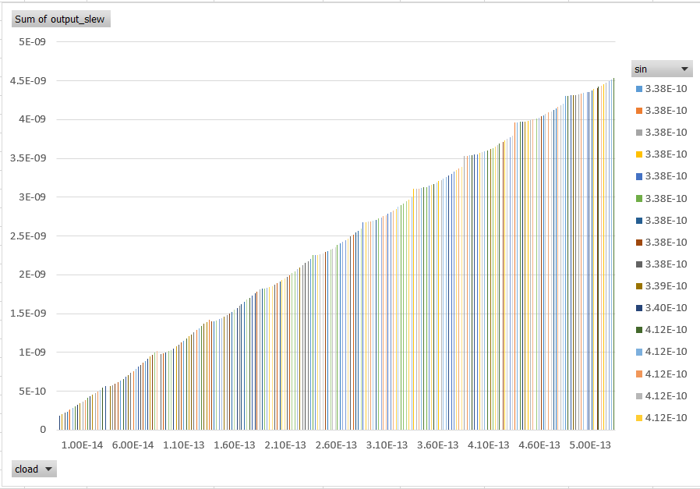

## Full Adder - 3(Cout-3x + Sum-2x)

## Member - 3

## 

## Schematic

## Layout

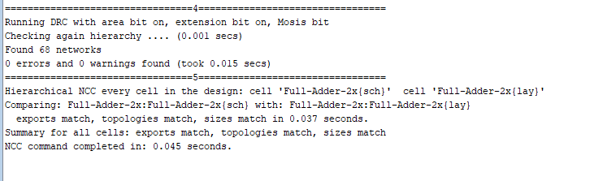 **DRC LVS Clean Screenshot**

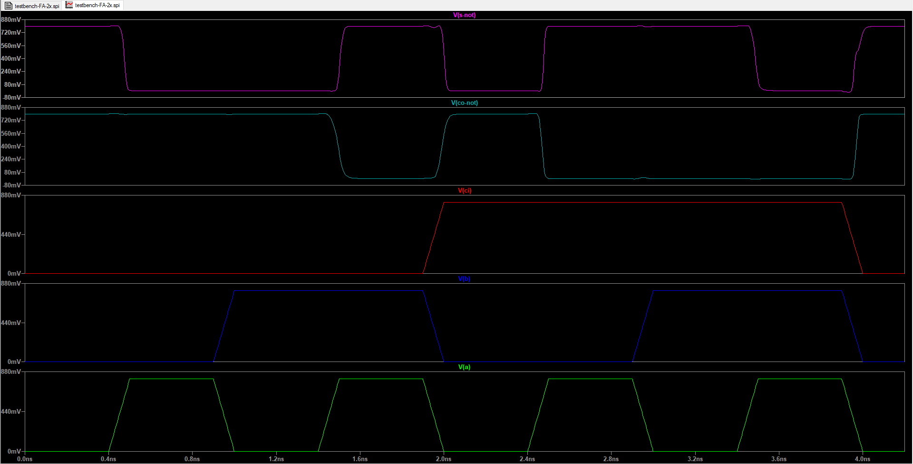 **Functionality Spice Simulation**

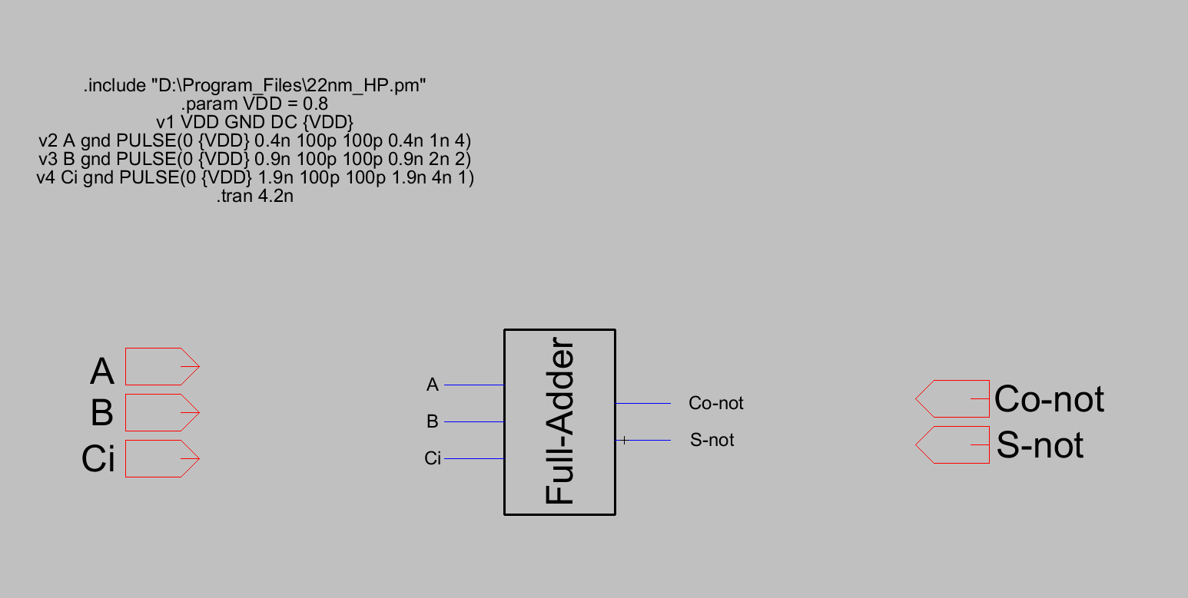

**Functionality Simulation Testbench**

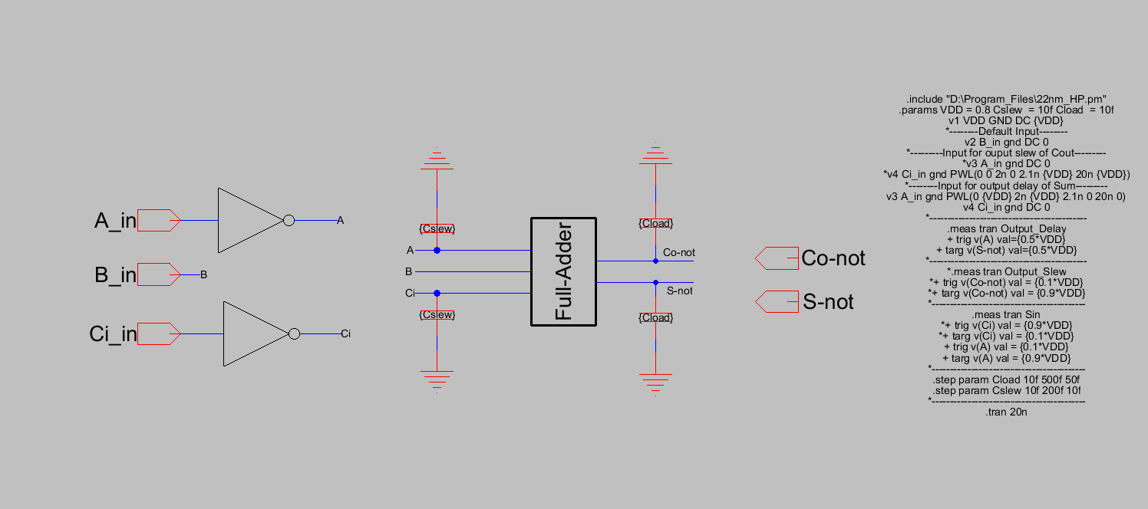 **Delay Testbench**

**Output Delay Table**

|  |  |  |  |  |
| --- | --- | --- | --- | --- |
| **Parameters** | | | **Output Delay - Sum** | **Input Slew(Sin) - A** |
| **step** | **Cload** | **Cslew** | **Output Delay** | **Input Slew** |
| 1 | 1.00E-14 | 1.00E-14 | 1.08E-10 | 7.39E-11 |
| 2 | 6.00E-14 | 1.00E-14 | 4.97E-10 | 7.46E-11 |
| 3 | 1.10E-13 | 1.00E-14 | 8.86E-10 | 7.46E-11 |
| 4 | 1.60E-13 | 1.00E-14 | 1.28E-09 | 7.46E-11 |
| 5 | 2.10E-13 | 1.00E-14 | 1.66E-09 | 7.46E-11 |
| 6 | 2.60E-13 | 1.00E-14 | 2.05E-09 | 7.46E-11 |
| 7 | 3.10E-13 | 1.00E-14 | 2.44E-09 | 7.46E-11 |
| 8 | 3.60E-13 | 1.00E-14 | 2.83E-09 | 7.46E-11 |
| 9 | 4.10E-13 | 1.00E-14 | 3.22E-09 | 7.46E-11 |
| 10 | 4.60E-13 | 1.00E-14 | 3.61E-09 | 7.46E-11 |
| 11 | 5.00E-13 | 1.00E-14 | 3.92E-09 | 7.46E-11 |
| 12 | 1.00E-14 | 2.00E-14 | 1.16E-10 | 1.06E-10 |
| 13 | 6.00E-14 | 2.00E-14 | 5.07E-10 | 1.06E-10 |
| 14 | 1.10E-13 | 2.00E-14 | 8.96E-10 | 1.05E-10 |
| 15 | 1.60E-13 | 2.00E-14 | 1.29E-09 | 1.05E-10 |
| 16 | 2.10E-13 | 2.00E-14 | 1.68E-09 | 1.05E-10 |
| 17 | 2.60E-13 | 2.00E-14 | 2.06E-09 | 1.05E-10 |
| 18 | 3.10E-13 | 2.00E-14 | 2.45E-09 | 1.05E-10 |
| 19 | 3.60E-13 | 2.00E-14 | 2.84E-09 | 1.05E-10 |
| 20 | 4.10E-13 | 2.00E-14 | 3.23E-09 | 1.05E-10 |
| 21 | 4.60E-13 | 2.00E-14 | 3.62E-09 | 1.05E-10 |
| 22 | 5.00E-13 | 2.00E-14 | 3.93E-09 | 1.05E-10 |
| 23 | 1.00E-14 | 3.00E-14 | 1.23E-10 | 1.37E-10 |
| 24 | 6.00E-14 | 3.00E-14 | 5.17E-10 | 1.37E-10 |
| 25 | 1.10E-13 | 3.00E-14 | 9.07E-10 | 1.37E-10 |
| 26 | 1.60E-13 | 3.00E-14 | 1.30E-09 | 1.37E-10 |
| 27 | 2.10E-13 | 3.00E-14 | 1.69E-09 | 1.37E-10 |
| 28 | 2.60E-13 | 3.00E-14 | 2.08E-09 | 1.37E-10 |
| 29 | 3.10E-13 | 3.00E-14 | 2.46E-09 | 1.37E-10 |
| 30 | 3.60E-13 | 3.00E-14 | 2.85E-09 | 1.37E-10 |
| 31 | 4.10E-13 | 3.00E-14 | 3.24E-09 | 1.37E-10 |
| 32 | 4.60E-13 | 3.00E-14 | 3.63E-09 | 1.37E-10 |
| 33 | 5.00E-13 | 3.00E-14 | 3.94E-09 | 1.37E-10 |
| 34 | 1.00E-14 | 4.00E-14 | 1.30E-10 | 1.70E-10 |
| 35 | 6.00E-14 | 4.00E-14 | 5.28E-10 | 1.70E-10 |
| 36 | 1.10E-13 | 4.00E-14 | 9.18E-10 | 1.70E-10 |
| 37 | 1.60E-13 | 4.00E-14 | 1.31E-09 | 1.70E-10 |
| 38 | 2.10E-13 | 4.00E-14 | 1.70E-09 | 1.70E-10 |
| 39 | 2.60E-13 | 4.00E-14 | 2.09E-09 | 1.70E-10 |
| 40 | 3.10E-13 | 4.00E-14 | 2.48E-09 | 1.70E-10 |
| 41 | 3.60E-13 | 4.00E-14 | 2.87E-09 | 1.70E-10 |
| 42 | 4.10E-13 | 4.00E-14 | 3.25E-09 | 1.70E-10 |
| 43 | 4.60E-13 | 4.00E-14 | 3.64E-09 | 1.70E-10 |
| 44 | 5.00E-13 | 4.00E-14 | 3.96E-09 | 1.70E-10 |
| 45 | 1.00E-14 | 5.00E-14 | 1.37E-10 | 2.06E-10 |
| 46 | 6.00E-14 | 5.00E-14 | 5.38E-10 | 2.05E-10 |
| 47 | 1.10E-13 | 5.00E-14 | 9.29E-10 | 2.05E-10 |
| 48 | 1.60E-13 | 5.00E-14 | 1.32E-09 | 2.05E-10 |
| 49 | 2.10E-13 | 5.00E-14 | 1.71E-09 | 2.05E-10 |
| 50 | 2.60E-13 | 5.00E-14 | 2.10E-09 | 2.05E-10 |
| 51 | 3.10E-13 | 5.00E-14 | 2.49E-09 | 2.05E-10 |
| 52 | 3.60E-13 | 5.00E-14 | 2.88E-09 | 2.05E-10 |
| 53 | 4.10E-13 | 5.00E-14 | 3.27E-09 | 2.05E-10 |
| 54 | 4.60E-13 | 5.00E-14 | 3.66E-09 | 2.05E-10 |
| 55 | 5.00E-13 | 5.00E-14 | 3.97E-09 | 2.05E-10 |
| 56 | 1.00E-14 | 6.00E-14 | 1.43E-10 | 2.41E-10 |
| 57 | 6.00E-14 | 6.00E-14 | 5.49E-10 | 2.40E-10 |
| 58 | 1.10E-13 | 6.00E-14 | 9.40E-10 | 2.40E-10 |
| 59 | 1.60E-13 | 6.00E-14 | 1.33E-09 | 2.40E-10 |
| 60 | 2.10E-13 | 6.00E-14 | 1.72E-09 | 2.40E-10 |
| 61 | 2.60E-13 | 6.00E-14 | 2.11E-09 | 2.40E-10 |
| 62 | 3.10E-13 | 6.00E-14 | 2.50E-09 | 2.40E-10 |
| 63 | 3.60E-13 | 6.00E-14 | 2.89E-09 | 2.40E-10 |
| 64 | 4.10E-13 | 6.00E-14 | 3.28E-09 | 2.40E-10 |
| 65 | 4.60E-13 | 6.00E-14 | 3.67E-09 | 2.40E-10 |
| 66 | 5.00E-13 | 6.00E-14 | 3.98E-09 | 2.40E-10 |
| 67 | 1.00E-14 | 7.00E-14 | 1.49E-10 | 2.76E-10 |
| 68 | 6.00E-14 | 7.00E-14 | 5.59E-10 | 2.76E-10 |
| 69 | 1.10E-13 | 7.00E-14 | 9.51E-10 | 2.76E-10 |
| 70 | 1.60E-13 | 7.00E-14 | 1.34E-09 | 2.75E-10 |
| 71 | 2.10E-13 | 7.00E-14 | 1.73E-09 | 2.75E-10 |
| 72 | 2.60E-13 | 7.00E-14 | 2.12E-09 | 2.75E-10 |
| 73 | 3.10E-13 | 7.00E-14 | 2.51E-09 | 2.75E-10 |
| 74 | 3.60E-13 | 7.00E-14 | 2.90E-09 | 2.75E-10 |
| 75 | 4.10E-13 | 7.00E-14 | 3.29E-09 | 2.75E-10 |
| 76 | 4.60E-13 | 7.00E-14 | 3.68E-09 | 2.75E-10 |
| 77 | 5.00E-13 | 7.00E-14 | 3.99E-09 | 2.75E-10 |
| 78 | 1.00E-14 | 8.00E-14 | 1.54E-10 | 3.12E-10 |
| 79 | 6.00E-14 | 8.00E-14 | 5.68E-10 | 3.11E-10 |
| 80 | 1.10E-13 | 8.00E-14 | 9.62E-10 | 3.11E-10 |
| 81 | 1.60E-13 | 8.00E-14 | 1.35E-09 | 3.11E-10 |
| 82 | 2.10E-13 | 8.00E-14 | 1.74E-09 | 3.11E-10 |
| 83 | 2.60E-13 | 8.00E-14 | 2.13E-09 | 3.11E-10 |
| 84 | 3.10E-13 | 8.00E-14 | 2.52E-09 | 3.11E-10 |
| 85 | 3.60E-13 | 8.00E-14 | 2.91E-09 | 3.11E-10 |
| 86 | 4.10E-13 | 8.00E-14 | 3.30E-09 | 3.11E-10 |
| 87 | 4.60E-13 | 8.00E-14 | 3.69E-09 | 3.11E-10 |
| 88 | 5.00E-13 | 8.00E-14 | 4.00E-09 | 3.11E-10 |
| 89 | 1.00E-14 | 9.00E-14 | 1.59E-10 | 3.48E-10 |
| 90 | 6.00E-14 | 9.00E-14 | 5.78E-10 | 3.47E-10 |
| 91 | 1.10E-13 | 9.00E-14 | 9.72E-10 | 3.47E-10 |
| 92 | 1.60E-13 | 9.00E-14 | 1.36E-09 | 3.47E-10 |
| 93 | 2.10E-13 | 9.00E-14 | 1.75E-09 | 3.47E-10 |
| 94 | 2.60E-13 | 9.00E-14 | 2.14E-09 | 3.47E-10 |
| 95 | 3.10E-13 | 9.00E-14 | 2.53E-09 | 3.47E-10 |
| 96 | 3.60E-13 | 9.00E-14 | 2.92E-09 | 3.47E-10 |
| 97 | 4.10E-13 | 9.00E-14 | 3.31E-09 | 3.47E-10 |
| 98 | 4.60E-13 | 9.00E-14 | 3.70E-09 | 3.47E-10 |
| 99 | 5.00E-13 | 9.00E-14 | 4.01E-09 | 3.47E-10 |
| 100 | 1.00E-14 | 1.00E-13 | 1.64E-10 | 3.84E-10 |
| 101 | 6.00E-14 | 1.00E-13 | 5.87E-10 | 3.84E-10 |
| 102 | 1.10E-13 | 1.00E-13 | 9.83E-10 | 3.84E-10 |
| 103 | 1.60E-13 | 1.00E-13 | 1.37E-09 | 3.84E-10 |
| 104 | 2.10E-13 | 1.00E-13 | 1.76E-09 | 3.84E-10 |
| 105 | 2.60E-13 | 1.00E-13 | 2.15E-09 | 3.84E-10 |
| 106 | 3.10E-13 | 1.00E-13 | 2.54E-09 | 3.84E-10 |
| 107 | 3.60E-13 | 1.00E-13 | 2.93E-09 | 3.83E-10 |
| 108 | 4.10E-13 | 1.00E-13 | 3.32E-09 | 3.83E-10 |
| 109 | 4.60E-13 | 1.00E-13 | 3.71E-09 | 3.83E-10 |
| 110 | 5.00E-13 | 1.00E-13 | 4.02E-09 | 3.83E-10 |
| 111 | 1.00E-14 | 1.10E-13 | 1.68E-10 | 4.21E-10 |
| 112 | 6.00E-14 | 1.10E-13 | 5.96E-10 | 4.20E-10 |
| 113 | 1.10E-13 | 1.10E-13 | 9.93E-10 | 4.20E-10 |
| 114 | 1.60E-13 | 1.10E-13 | 1.39E-09 | 4.20E-10 |
| 115 | 2.10E-13 | 1.10E-13 | 1.78E-09 | 4.20E-10 |
| 116 | 2.60E-13 | 1.10E-13 | 2.17E-09 | 4.20E-10 |
| 117 | 3.10E-13 | 1.10E-13 | 2.56E-09 | 4.20E-10 |
| 118 | 3.60E-13 | 1.10E-13 | 2.95E-09 | 4.20E-10 |
| 119 | 4.10E-13 | 1.10E-13 | 3.33E-09 | 4.20E-10 |
| 120 | 4.60E-13 | 1.10E-13 | 3.72E-09 | 4.20E-10 |
| 121 | 5.00E-13 | 1.10E-13 | 4.04E-09 | 4.20E-10 |
| 122 | 1.00E-14 | 1.20E-13 | 1.73E-10 | 4.57E-10 |
| 123 | 6.00E-14 | 1.20E-13 | 6.05E-10 | 4.57E-10 |
| 124 | 1.10E-13 | 1.20E-13 | 1.00E-09 | 4.57E-10 |
| 125 | 1.60E-13 | 1.20E-13 | 1.40E-09 | 4.57E-10 |
| 126 | 2.10E-13 | 1.20E-13 | 1.79E-09 | 4.57E-10 |
| 127 | 2.60E-13 | 1.20E-13 | 2.18E-09 | 4.57E-10 |
| 128 | 3.10E-13 | 1.20E-13 | 2.57E-09 | 4.57E-10 |
| 129 | 3.60E-13 | 1.20E-13 | 2.96E-09 | 4.57E-10 |
| 130 | 4.10E-13 | 1.20E-13 | 3.35E-09 | 4.57E-10 |
| 131 | 4.60E-13 | 1.20E-13 | 3.74E-09 | 4.57E-10 |
| 132 | 5.00E-13 | 1.20E-13 | 4.05E-09 | 4.57E-10 |
| 133 | 1.00E-14 | 1.30E-13 | 1.76E-10 | 4.94E-10 |
| 134 | 6.00E-14 | 1.30E-13 | 6.13E-10 | 4.94E-10 |
| 135 | 1.10E-13 | 1.30E-13 | 1.01E-09 | 4.94E-10 |
| 136 | 1.60E-13 | 1.30E-13 | 1.41E-09 | 4.94E-10 |
| 137 | 2.10E-13 | 1.30E-13 | 1.80E-09 | 4.93E-10 |
| 138 | 2.60E-13 | 1.30E-13 | 2.19E-09 | 4.93E-10 |
| 139 | 3.10E-13 | 1.30E-13 | 2.58E-09 | 4.93E-10 |
| 140 | 3.60E-13 | 1.30E-13 | 2.97E-09 | 4.93E-10 |
| 141 | 4.10E-13 | 1.30E-13 | 3.36E-09 | 4.93E-10 |
| 142 | 4.60E-13 | 1.30E-13 | 3.75E-09 | 4.93E-10 |
| 143 | 5.00E-13 | 1.30E-13 | 4.06E-09 | 4.93E-10 |
| 144 | 1.00E-14 | 1.40E-13 | 1.80E-10 | 5.31E-10 |
| 145 | 6.00E-14 | 1.40E-13 | 6.22E-10 | 5.31E-10 |
| 146 | 1.10E-13 | 1.40E-13 | 1.02E-09 | 5.31E-10 |
| 147 | 1.60E-13 | 1.40E-13 | 1.42E-09 | 5.31E-10 |
| 148 | 2.10E-13 | 1.40E-13 | 1.81E-09 | 5.31E-10 |
| 149 | 2.60E-13 | 1.40E-13 | 2.20E-09 | 5.31E-10 |
| 150 | 3.10E-13 | 1.40E-13 | 2.59E-09 | 5.31E-10 |
| 151 | 3.60E-13 | 1.40E-13 | 2.98E-09 | 5.31E-10 |
| 152 | 4.10E-13 | 1.40E-13 | 3.37E-09 | 5.31E-10 |
| 153 | 4.60E-13 | 1.40E-13 | 3.76E-09 | 5.31E-10 |
| 154 | 5.00E-13 | 1.40E-13 | 4.07E-09 | 5.31E-10 |
| 155 | 1.00E-14 | 1.50E-13 | 1.84E-10 | 5.68E-10 |
| 156 | 6.00E-14 | 1.50E-13 | 6.30E-10 | 5.68E-10 |
| 157 | 1.10E-13 | 1.50E-13 | 1.03E-09 | 5.68E-10 |
| 158 | 1.60E-13 | 1.50E-13 | 1.43E-09 | 5.68E-10 |
| 159 | 2.10E-13 | 1.50E-13 | 1.82E-09 | 5.68E-10 |
| 160 | 2.60E-13 | 1.50E-13 | 2.21E-09 | 5.68E-10 |
| 161 | 3.10E-13 | 1.50E-13 | 2.60E-09 | 5.68E-10 |
| 162 | 3.60E-13 | 1.50E-13 | 2.99E-09 | 5.68E-10 |
| 163 | 4.10E-13 | 1.50E-13 | 3.38E-09 | 5.68E-10 |
| 164 | 4.60E-13 | 1.50E-13 | 3.77E-09 | 5.68E-10 |
| 165 | 5.00E-13 | 1.50E-13 | 4.08E-09 | 5.68E-10 |
| 166 | 1.00E-14 | 1.60E-13 | 1.87E-10 | 6.05E-10 |
| 167 | 6.00E-14 | 1.60E-13 | 6.38E-10 | 6.06E-10 |
| 168 | 1.10E-13 | 1.60E-13 | 1.04E-09 | 6.05E-10 |
| 169 | 1.60E-13 | 1.60E-13 | 1.44E-09 | 6.05E-10 |
| 170 | 2.10E-13 | 1.60E-13 | 1.83E-09 | 6.05E-10 |
| 171 | 2.60E-13 | 1.60E-13 | 2.22E-09 | 6.05E-10 |
| 172 | 3.10E-13 | 1.60E-13 | 2.61E-09 | 6.05E-10 |
| 173 | 3.60E-13 | 1.60E-13 | 3.00E-09 | 6.05E-10 |
| 174 | 4.10E-13 | 1.60E-13 | 3.39E-09 | 6.05E-10 |
| 175 | 4.60E-13 | 1.60E-13 | 3.78E-09 | 6.05E-10 |
| 176 | 5.00E-13 | 1.60E-13 | 4.09E-09 | 6.05E-10 |
| 177 | 1.00E-14 | 1.70E-13 | 1.90E-10 | 6.43E-10 |
| 178 | 6.00E-14 | 1.70E-13 | 6.46E-10 | 6.43E-10 |
| 179 | 1.10E-13 | 1.70E-13 | 1.05E-09 | 6.42E-10 |
| 180 | 1.60E-13 | 1.70E-13 | 1.45E-09 | 6.42E-10 |
| 181 | 2.10E-13 | 1.70E-13 | 1.84E-09 | 6.42E-10 |
| 182 | 2.60E-13 | 1.70E-13 | 2.23E-09 | 6.42E-10 |
| 183 | 3.10E-13 | 1.70E-13 | 2.62E-09 | 6.42E-10 |
| 184 | 3.60E-13 | 1.70E-13 | 3.01E-09 | 6.42E-10 |
| 185 | 4.10E-13 | 1.70E-13 | 3.40E-09 | 6.42E-10 |
| 186 | 4.60E-13 | 1.70E-13 | 3.79E-09 | 6.42E-10 |
| 187 | 5.00E-13 | 1.70E-13 | 4.10E-09 | 6.42E-10 |
| 188 | 1.00E-14 | 1.80E-13 | 1.93E-10 | 6.80E-10 |
| 189 | 6.00E-14 | 1.80E-13 | 6.53E-10 | 6.80E-10 |
| 190 | 1.10E-13 | 1.80E-13 | 1.06E-09 | 6.80E-10 |
| 191 | 1.60E-13 | 1.80E-13 | 1.46E-09 | 6.79E-10 |
| 192 | 2.10E-13 | 1.80E-13 | 1.85E-09 | 6.79E-10 |
| 193 | 2.60E-13 | 1.80E-13 | 2.24E-09 | 6.79E-10 |
| 194 | 3.10E-13 | 1.80E-13 | 2.63E-09 | 6.79E-10 |
| 195 | 3.60E-13 | 1.80E-13 | 3.02E-09 | 6.79E-10 |
| 196 | 4.10E-13 | 1.80E-13 | 3.41E-09 | 6.79E-10 |
| 197 | 4.60E-13 | 1.80E-13 | 3.80E-09 | 6.79E-10 |
| 198 | 5.00E-13 | 1.80E-13 | 4.12E-09 | 6.79E-10 |
| 199 | 1.00E-14 | 1.90E-13 | 1.96E-10 | 7.17E-10 |
| 200 | 6.00E-14 | 1.90E-13 | 6.61E-10 | 7.17E-10 |
| 201 | 1.10E-13 | 1.90E-13 | 1.07E-09 | 7.17E-10 |
| 202 | 1.60E-13 | 1.90E-13 | 1.47E-09 | 7.17E-10 |
| 203 | 2.10E-13 | 1.90E-13 | 1.86E-09 | 7.17E-10 |
| 204 | 2.60E-13 | 1.90E-13 | 2.25E-09 | 7.16E-10 |
| 205 | 3.10E-13 | 1.90E-13 | 2.64E-09 | 7.16E-10 |
| 206 | 3.60E-13 | 1.90E-13 | 3.03E-09 | 7.16E-10 |
| 207 | 4.10E-13 | 1.90E-13 | 3.42E-09 | 7.16E-10 |
| 208 | 4.60E-13 | 1.90E-13 | 3.81E-09 | 7.16E-10 |
| 209 | 5.00E-13 | 1.90E-13 | 4.13E-09 | 7.16E-10 |
| 210 | 1.00E-14 | 2.00E-13 | 1.99E-10 | 7.54E-10 |
| 211 | 6.00E-14 | 2.00E-13 | 6.68E-10 | 7.54E-10 |
| 212 | 1.10E-13 | 2.00E-13 | 1.08E-09 | 7.54E-10 |
| 213 | 1.60E-13 | 2.00E-13 | 1.48E-09 | 7.54E-10 |
| 214 | 2.10E-13 | 2.00E-13 | 1.87E-09 | 7.54E-10 |
| 215 | 2.60E-13 | 2.00E-13 | 2.26E-09 | 7.54E-10 |
| 216 | 3.10E-13 | 2.00E-13 | 2.65E-09 | 7.54E-10 |
| 217 | 3.60E-13 | 2.00E-13 | 3.05E-09 | 7.54E-10 |
| 218 | 4.10E-13 | 2.00E-13 | 3.44E-09 | 7.54E-10 |
| 219 | 4.60E-13 | 2.00E-13 | 3.83E-09 | 7.54E-10 |
| 220 | 5.00E-13 | 2.00E-13 | 4.14E-09 | 7.54E-10 |

**Output Delay Plot (Delay vs Cload vs Sin)**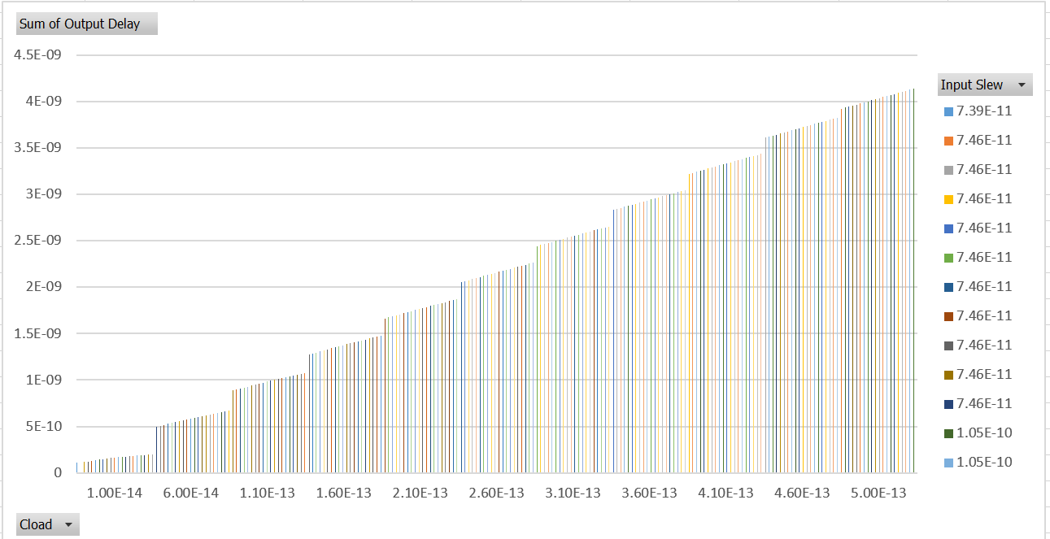

**Output Slew Table**

|  |  |  |  |  |
| --- | --- | --- | --- | --- |
| **Parameters** | | | **Output Slew - Cout** | **Input Slew(Sin) - Ci** |
| **step** | **Cload** | **Cslew** | **Output Slew** | **Input Slew** |
| 1 | 1.00E-14 | 1.00E-14 | 8.26E-11 | 7.71E-11 |
| 2 | 6.00E-14 | 1.00E-14 | 3.48E-10 | 7.60E-11 |
| 3 | 1.10E-13 | 1.00E-14 | 6.23E-10 | 7.59E-11 |
| 4 | 1.60E-13 | 1.00E-14 | 9.00E-10 | 7.59E-11 |
| 5 | 2.10E-13 | 1.00E-14 | 1.18E-09 | 7.58E-11 |
| 6 | 2.60E-13 | 1.00E-14 | 1.46E-09 | 7.58E-11 |
| 7 | 3.10E-13 | 1.00E-14 | 1.73E-09 | 7.58E-11 |
| 8 | 3.60E-13 | 1.00E-14 | 2.01E-09 | 7.58E-11 |
| 9 | 4.10E-13 | 1.00E-14 | 2.29E-09 | 7.58E-11 |
| 10 | 4.60E-13 | 1.00E-14 | 2.57E-09 | 7.58E-11 |
| 11 | 5.00E-13 | 1.00E-14 | 2.79E-09 | 7.58E-11 |
| 12 | 1.00E-14 | 2.00E-14 | 9.77E-11 | 1.12E-10 |
| 13 | 6.00E-14 | 2.00E-14 | 3.55E-10 | 1.11E-10 |
| 14 | 1.10E-13 | 2.00E-14 | 6.26E-10 | 1.11E-10 |
| 15 | 1.60E-13 | 2.00E-14 | 9.02E-10 | 1.11E-10 |
| 16 | 2.10E-13 | 2.00E-14 | 1.18E-09 | 1.11E-10 |
| 17 | 2.60E-13 | 2.00E-14 | 1.46E-09 | 1.11E-10 |
| 18 | 3.10E-13 | 2.00E-14 | 1.73E-09 | 1.11E-10 |
| 19 | 3.60E-13 | 2.00E-14 | 2.01E-09 | 1.11E-10 |
| 20 | 4.10E-13 | 2.00E-14 | 2.29E-09 | 1.11E-10 |
| 21 | 4.60E-13 | 2.00E-14 | 2.57E-09 | 1.11E-10 |
| 22 | 5.00E-13 | 2.00E-14 | 2.79E-09 | 1.11E-10 |
| 23 | 1.00E-14 | 3.00E-14 | 1.10E-10 | 1.50E-10 |
| 24 | 6.00E-14 | 3.00E-14 | 3.63E-10 | 1.49E-10 |
| 25 | 1.10E-13 | 3.00E-14 | 6.32E-10 | 1.49E-10 |
| 26 | 1.60E-13 | 3.00E-14 | 9.05E-10 | 1.49E-10 |
| 27 | 2.10E-13 | 3.00E-14 | 1.18E-09 | 1.49E-10 |
| 28 | 2.60E-13 | 3.00E-14 | 1.46E-09 | 1.49E-10 |
| 29 | 3.10E-13 | 3.00E-14 | 1.73E-09 | 1.49E-10 |
| 30 | 3.60E-13 | 3.00E-14 | 2.01E-09 | 1.49E-10 |
| 31 | 4.10E-13 | 3.00E-14 | 2.29E-09 | 1.49E-10 |
| 32 | 4.60E-13 | 3.00E-14 | 2.57E-09 | 1.49E-10 |
| 33 | 5.00E-13 | 3.00E-14 | 2.79E-09 | 1.49E-10 |
| 34 | 1.00E-14 | 4.00E-14 | 1.23E-10 | 1.89E-10 |
| 35 | 6.00E-14 | 4.00E-14 | 3.74E-10 | 1.88E-10 |
| 36 | 1.10E-13 | 4.00E-14 | 6.39E-10 | 1.88E-10 |
| 37 | 1.60E-13 | 4.00E-14 | 9.11E-10 | 1.88E-10 |
| 38 | 2.10E-13 | 4.00E-14 | 1.18E-09 | 1.88E-10 |
| 39 | 2.60E-13 | 4.00E-14 | 1.46E-09 | 1.88E-10 |
| 40 | 3.10E-13 | 4.00E-14 | 1.74E-09 | 1.88E-10 |
| 41 | 3.60E-13 | 4.00E-14 | 2.01E-09 | 1.88E-10 |
| 42 | 4.10E-13 | 4.00E-14 | 2.29E-09 | 1.88E-10 |
| 43 | 4.60E-13 | 4.00E-14 | 2.57E-09 | 1.88E-10 |
| 44 | 5.00E-13 | 4.00E-14 | 2.79E-09 | 1.88E-10 |
| 45 | 1.00E-14 | 5.00E-14 | 1.34E-10 | 2.29E-10 |
| 46 | 6.00E-14 | 5.00E-14 | 3.85E-10 | 2.29E-10 |
| 47 | 1.10E-13 | 5.00E-14 | 6.48E-10 | 2.29E-10 |
| 48 | 1.60E-13 | 5.00E-14 | 9.17E-10 | 2.29E-10 |
| 49 | 2.10E-13 | 5.00E-14 | 1.19E-09 | 2.29E-10 |
| 50 | 2.60E-13 | 5.00E-14 | 1.46E-09 | 2.29E-10 |
| 51 | 3.10E-13 | 5.00E-14 | 1.74E-09 | 2.28E-10 |
| 52 | 3.60E-13 | 5.00E-14 | 2.02E-09 | 2.28E-10 |
| 53 | 4.10E-13 | 5.00E-14 | 2.29E-09 | 2.28E-10 |
| 54 | 4.60E-13 | 5.00E-14 | 2.57E-09 | 2.28E-10 |
| 55 | 5.00E-13 | 5.00E-14 | 2.79E-09 | 2.28E-10 |
| 56 | 1.00E-14 | 6.00E-14 | 1.46E-10 | 2.70E-10 |
| 57 | 6.00E-14 | 6.00E-14 | 3.97E-10 | 2.70E-10 |
| 58 | 1.10E-13 | 6.00E-14 | 6.58E-10 | 2.69E-10 |
| 59 | 1.60E-13 | 6.00E-14 | 9.25E-10 | 2.69E-10 |
| 60 | 2.10E-13 | 6.00E-14 | 1.20E-09 | 2.69E-10 |
| 61 | 2.60E-13 | 6.00E-14 | 1.47E-09 | 2.69E-10 |
| 62 | 3.10E-13 | 6.00E-14 | 1.74E-09 | 2.69E-10 |
| 63 | 3.60E-13 | 6.00E-14 | 2.02E-09 | 2.69E-10 |
| 64 | 4.10E-13 | 6.00E-14 | 2.30E-09 | 2.69E-10 |
| 65 | 4.60E-13 | 6.00E-14 | 2.57E-09 | 2.69E-10 |
| 66 | 5.00E-13 | 6.00E-14 | 2.79E-09 | 2.69E-10 |
| 67 | 1.00E-14 | 7.00E-14 | 1.58E-10 | 3.11E-10 |
| 68 | 6.00E-14 | 7.00E-14 | 4.10E-10 | 3.12E-10 |
| 69 | 1.10E-13 | 7.00E-14 | 6.68E-10 | 3.11E-10 |
| 70 | 1.60E-13 | 7.00E-14 | 9.33E-10 | 3.11E-10 |
| 71 | 2.10E-13 | 7.00E-14 | 1.20E-09 | 3.11E-10 |
| 72 | 2.60E-13 | 7.00E-14 | 1.47E-09 | 3.11E-10 |
| 73 | 3.10E-13 | 7.00E-14 | 1.75E-09 | 3.11E-10 |
| 74 | 3.60E-13 | 7.00E-14 | 2.02E-09 | 3.11E-10 |
| 75 | 4.10E-13 | 7.00E-14 | 2.30E-09 | 3.11E-10 |
| 76 | 4.60E-13 | 7.00E-14 | 2.57E-09 | 3.11E-10 |
| 77 | 5.00E-13 | 7.00E-14 | 2.80E-09 | 3.11E-10 |
| 78 | 1.00E-14 | 8.00E-14 | 1.68E-10 | 3.53E-10 |
| 79 | 6.00E-14 | 8.00E-14 | 4.23E-10 | 3.54E-10 |
| 80 | 1.10E-13 | 8.00E-14 | 6.79E-10 | 3.53E-10 |
| 81 | 1.60E-13 | 8.00E-14 | 9.43E-10 | 3.53E-10 |
| 82 | 2.10E-13 | 8.00E-14 | 1.21E-09 | 3.53E-10 |
| 83 | 2.60E-13 | 8.00E-14 | 1.48E-09 | 3.53E-10 |
| 84 | 3.10E-13 | 8.00E-14 | 1.75E-09 | 3.53E-10 |
| 85 | 3.60E-13 | 8.00E-14 | 2.03E-09 | 3.53E-10 |
| 86 | 4.10E-13 | 8.00E-14 | 2.30E-09 | 3.53E-10 |
| 87 | 4.60E-13 | 8.00E-14 | 2.58E-09 | 3.53E-10 |
| 88 | 5.00E-13 | 8.00E-14 | 2.80E-09 | 3.53E-10 |
| 89 | 1.00E-14 | 9.00E-14 | 1.78E-10 | 3.95E-10 |
| 90 | 6.00E-14 | 9.00E-14 | 4.36E-10 | 3.96E-10 |
| 91 | 1.10E-13 | 9.00E-14 | 6.91E-10 | 3.96E-10 |
| 92 | 1.60E-13 | 9.00E-14 | 9.53E-10 | 3.95E-10 |
| 93 | 2.10E-13 | 9.00E-14 | 1.22E-09 | 3.95E-10 |
| 94 | 2.60E-13 | 9.00E-14 | 1.49E-09 | 3.95E-10 |
| 95 | 3.10E-13 | 9.00E-14 | 1.76E-09 | 3.95E-10 |
| 96 | 3.60E-13 | 9.00E-14 | 2.03E-09 | 3.95E-10 |
| 97 | 4.10E-13 | 9.00E-14 | 2.31E-09 | 3.95E-10 |
| 98 | 4.60E-13 | 9.00E-14 | 2.58E-09 | 3.95E-10 |
| 99 | 5.00E-13 | 9.00E-14 | 2.80E-09 | 3.95E-10 |
| 100 | 1.00E-14 | 1.00E-13 | 1.91E-10 | 4.38E-10 |
| 101 | 6.00E-14 | 1.00E-13 | 4.49E-10 | 4.39E-10 |
| 102 | 1.10E-13 | 1.00E-13 | 7.03E-10 | 4.38E-10 |
| 103 | 1.60E-13 | 1.00E-13 | 9.63E-10 | 4.38E-10 |
| 104 | 2.10E-13 | 1.00E-13 | 1.23E-09 | 4.38E-10 |
| 105 | 2.60E-13 | 1.00E-13 | 1.50E-09 | 4.38E-10 |
| 106 | 3.10E-13 | 1.00E-13 | 1.77E-09 | 4.38E-10 |
| 107 | 3.60E-13 | 1.00E-13 | 2.04E-09 | 4.38E-10 |
| 108 | 4.10E-13 | 1.00E-13 | 2.31E-09 | 4.38E-10 |
| 109 | 4.60E-13 | 1.00E-13 | 2.58E-09 | 4.38E-10 |
| 110 | 5.00E-13 | 1.00E-13 | 2.81E-09 | 4.38E-10 |
| 111 | 1.00E-14 | 1.10E-13 | 2.01E-10 | 4.81E-10 |
| 112 | 6.00E-14 | 1.10E-13 | 4.62E-10 | 4.82E-10 |
| 113 | 1.10E-13 | 1.10E-13 | 7.15E-10 | 4.81E-10 |
| 114 | 1.60E-13 | 1.10E-13 | 9.74E-10 | 4.81E-10 |
| 115 | 2.10E-13 | 1.10E-13 | 1.24E-09 | 4.81E-10 |
| 116 | 2.60E-13 | 1.10E-13 | 1.51E-09 | 4.81E-10 |
| 117 | 3.10E-13 | 1.10E-13 | 1.78E-09 | 4.81E-10 |
| 118 | 3.60E-13 | 1.10E-13 | 2.05E-09 | 4.81E-10 |
| 119 | 4.10E-13 | 1.10E-13 | 2.32E-09 | 4.81E-10 |
| 120 | 4.60E-13 | 1.10E-13 | 2.59E-09 | 4.81E-10 |
| 121 | 5.00E-13 | 1.10E-13 | 2.81E-09 | 4.81E-10 |
| 122 | 1.00E-14 | 1.20E-13 | 2.11E-10 | 5.23E-10 |
| 123 | 6.00E-14 | 1.20E-13 | 4.75E-10 | 5.24E-10 |
| 124 | 1.10E-13 | 1.20E-13 | 7.28E-10 | 5.24E-10 |
| 125 | 1.60E-13 | 1.20E-13 | 9.85E-10 | 5.24E-10 |
| 126 | 2.10E-13 | 1.20E-13 | 1.25E-09 | 5.24E-10 |
| 127 | 2.60E-13 | 1.20E-13 | 1.51E-09 | 5.23E-10 |
| 128 | 3.10E-13 | 1.20E-13 | 1.78E-09 | 5.23E-10 |
| 129 | 3.60E-13 | 1.20E-13 | 2.05E-09 | 5.23E-10 |
| 130 | 4.10E-13 | 1.20E-13 | 2.32E-09 | 5.23E-10 |
| 131 | 4.60E-13 | 1.20E-13 | 2.60E-09 | 5.23E-10 |
| 132 | 5.00E-13 | 1.20E-13 | 2.81E-09 | 5.23E-10 |
| 133 | 1.00E-14 | 1.30E-13 | 2.22E-10 | 5.66E-10 |
| 134 | 6.00E-14 | 1.30E-13 | 4.88E-10 | 5.67E-10 |
| 135 | 1.10E-13 | 1.30E-13 | 7.41E-10 | 5.67E-10 |
| 136 | 1.60E-13 | 1.30E-13 | 9.97E-10 | 5.67E-10 |
| 137 | 2.10E-13 | 1.30E-13 | 1.26E-09 | 5.66E-10 |
| 138 | 2.60E-13 | 1.30E-13 | 1.52E-09 | 5.66E-10 |
| 139 | 3.10E-13 | 1.30E-13 | 1.79E-09 | 5.66E-10 |
| 140 | 3.60E-13 | 1.30E-13 | 2.06E-09 | 5.66E-10 |
| 141 | 4.10E-13 | 1.30E-13 | 2.33E-09 | 5.66E-10 |
| 142 | 4.60E-13 | 1.30E-13 | 2.60E-09 | 5.66E-10 |
| 143 | 5.00E-13 | 1.30E-13 | 2.82E-09 | 5.66E-10 |
| 144 | 1.00E-14 | 1.40E-13 | 2.33E-10 | 6.09E-10 |
| 145 | 6.00E-14 | 1.40E-13 | 5.01E-10 | 6.10E-10 |
| 146 | 1.10E-13 | 1.40E-13 | 7.53E-10 | 6.10E-10 |
| 147 | 1.60E-13 | 1.40E-13 | 1.01E-09 | 6.09E-10 |
| 148 | 2.10E-13 | 1.40E-13 | 1.27E-09 | 6.09E-10 |
| 149 | 2.60E-13 | 1.40E-13 | 1.53E-09 | 6.09E-10 |
| 150 | 3.10E-13 | 1.40E-13 | 1.80E-09 | 6.09E-10 |
| 151 | 3.60E-13 | 1.40E-13 | 2.07E-09 | 6.09E-10 |
| 152 | 4.10E-13 | 1.40E-13 | 2.34E-09 | 6.09E-10 |
| 153 | 4.60E-13 | 1.40E-13 | 2.61E-09 | 6.09E-10 |
| 154 | 5.00E-13 | 1.40E-13 | 2.83E-09 | 6.09E-10 |
| 155 | 1.00E-14 | 1.50E-13 | 2.43E-10 | 6.52E-10 |
| 156 | 6.00E-14 | 1.50E-13 | 5.14E-10 | 6.53E-10 |
| 157 | 1.10E-13 | 1.50E-13 | 7.67E-10 | 6.52E-10 |
| 158 | 1.60E-13 | 1.50E-13 | 1.02E-09 | 6.52E-10 |
| 159 | 2.10E-13 | 1.50E-13 | 1.28E-09 | 6.52E-10 |
| 160 | 2.60E-13 | 1.50E-13 | 1.54E-09 | 6.52E-10 |
| 161 | 3.10E-13 | 1.50E-13 | 1.81E-09 | 6.52E-10 |
| 162 | 3.60E-13 | 1.50E-13 | 2.08E-09 | 6.52E-10 |
| 163 | 4.10E-13 | 1.50E-13 | 2.35E-09 | 6.52E-10 |
| 164 | 4.60E-13 | 1.50E-13 | 2.62E-09 | 6.52E-10 |
| 165 | 5.00E-13 | 1.50E-13 | 2.83E-09 | 6.52E-10 |
| 166 | 1.00E-14 | 1.60E-13 | 2.54E-10 | 6.95E-10 |
| 167 | 6.00E-14 | 1.60E-13 | 5.27E-10 | 6.96E-10 |
| 168 | 1.10E-13 | 1.60E-13 | 7.79E-10 | 6.95E-10 |
| 169 | 1.60E-13 | 1.60E-13 | 1.03E-09 | 6.95E-10 |
| 170 | 2.10E-13 | 1.60E-13 | 1.29E-09 | 6.95E-10 |
| 171 | 2.60E-13 | 1.60E-13 | 1.55E-09 | 6.95E-10 |
| 172 | 3.10E-13 | 1.60E-13 | 1.82E-09 | 6.95E-10 |
| 173 | 3.60E-13 | 1.60E-13 | 2.09E-09 | 6.95E-10 |
| 174 | 4.10E-13 | 1.60E-13 | 2.35E-09 | 6.95E-10 |
| 175 | 4.60E-13 | 1.60E-13 | 2.62E-09 | 6.95E-10 |
| 176 | 5.00E-13 | 1.60E-13 | 2.84E-09 | 6.95E-10 |
| 177 | 1.00E-14 | 1.70E-13 | 2.65E-10 | 7.38E-10 |
| 178 | 6.00E-14 | 1.70E-13 | 5.39E-10 | 7.38E-10 |
| 179 | 1.10E-13 | 1.70E-13 | 7.92E-10 | 7.38E-10 |
| 180 | 1.60E-13 | 1.70E-13 | 1.05E-09 | 7.38E-10 |
| 181 | 2.10E-13 | 1.70E-13 | 1.30E-09 | 7.38E-10 |
| 182 | 2.60E-13 | 1.70E-13 | 1.56E-09 | 7.38E-10 |
| 183 | 3.10E-13 | 1.70E-13 | 1.83E-09 | 7.38E-10 |
| 184 | 3.60E-13 | 1.70E-13 | 2.09E-09 | 7.37E-10 |
| 185 | 4.10E-13 | 1.70E-13 | 2.36E-09 | 7.37E-10 |
| 186 | 4.60E-13 | 1.70E-13 | 2.63E-09 | 7.37E-10 |
| 187 | 5.00E-13 | 1.70E-13 | 2.85E-09 | 7.37E-10 |
| 188 | 1.00E-14 | 1.80E-13 | 2.75E-10 | 7.80E-10 |
| 189 | 6.00E-14 | 1.80E-13 | 5.52E-10 | 7.81E-10 |
| 190 | 1.10E-13 | 1.80E-13 | 8.06E-10 | 7.81E-10 |
| 191 | 1.60E-13 | 1.80E-13 | 1.06E-09 | 7.81E-10 |
| 192 | 2.10E-13 | 1.80E-13 | 1.32E-09 | 7.80E-10 |
| 193 | 2.60E-13 | 1.80E-13 | 1.58E-09 | 7.80E-10 |
| 194 | 3.10E-13 | 1.80E-13 | 1.84E-09 | 7.80E-10 |
| 195 | 3.60E-13 | 1.80E-13 | 2.11E-09 | 7.80E-10 |
| 196 | 4.10E-13 | 1.80E-13 | 2.37E-09 | 7.80E-10 |
| 197 | 4.60E-13 | 1.80E-13 | 2.64E-09 | 7.80E-10 |
| 198 | 5.00E-13 | 1.80E-13 | 2.85E-09 | 7.80E-10 |
| 199 | 1.00E-14 | 1.90E-13 | 2.85E-10 | 8.23E-10 |
| 200 | 6.00E-14 | 1.90E-13 | 5.65E-10 | 8.24E-10 |
| 201 | 1.10E-13 | 1.90E-13 | 8.19E-10 | 8.24E-10 |
| 202 | 1.60E-13 | 1.90E-13 | 1.07E-09 | 8.24E-10 |
| 203 | 2.10E-13 | 1.90E-13 | 1.33E-09 | 8.23E-10 |
| 204 | 2.60E-13 | 1.90E-13 | 1.59E-09 | 8.23E-10 |
| 205 | 3.10E-13 | 1.90E-13 | 1.85E-09 | 8.23E-10 |
| 206 | 3.60E-13 | 1.90E-13 | 2.11E-09 | 8.23E-10 |
| 207 | 4.10E-13 | 1.90E-13 | 2.38E-09 | 8.23E-10 |
| 208 | 4.60E-13 | 1.90E-13 | 2.65E-09 | 8.23E-10 |
| 209 | 5.00E-13 | 1.90E-13 | 2.86E-09 | 8.23E-10 |
| 210 | 1.00E-14 | 2.00E-13 | 2.96E-10 | 8.66E-10 |
| 211 | 6.00E-14 | 2.00E-13 | 5.77E-10 | 8.67E-10 |
| 212 | 1.10E-13 | 2.00E-13 | 8.32E-10 | 8.67E-10 |
| 213 | 1.60E-13 | 2.00E-13 | 1.09E-09 | 8.66E-10 |
| 214 | 2.10E-13 | 2.00E-13 | 1.34E-09 | 8.66E-10 |
| 215 | 2.60E-13 | 2.00E-13 | 1.60E-09 | 8.66E-10 |
| 216 | 3.10E-13 | 2.00E-13 | 1.86E-09 | 8.66E-10 |
| 217 | 3.60E-13 | 2.00E-13 | 2.12E-09 | 8.66E-10 |
| 218 | 4.10E-13 | 2.00E-13 | 2.39E-09 | 8.66E-10 |
| 219 | 4.60E-13 | 2.00E-13 | 2.66E-09 | 8.66E-10 |
| 220 | 5.00E-13 | 2.00E-13 | 2.87E-09 | 8.66E-10 |

**Output Slew Plot (Slew vs Cload vs Sin)**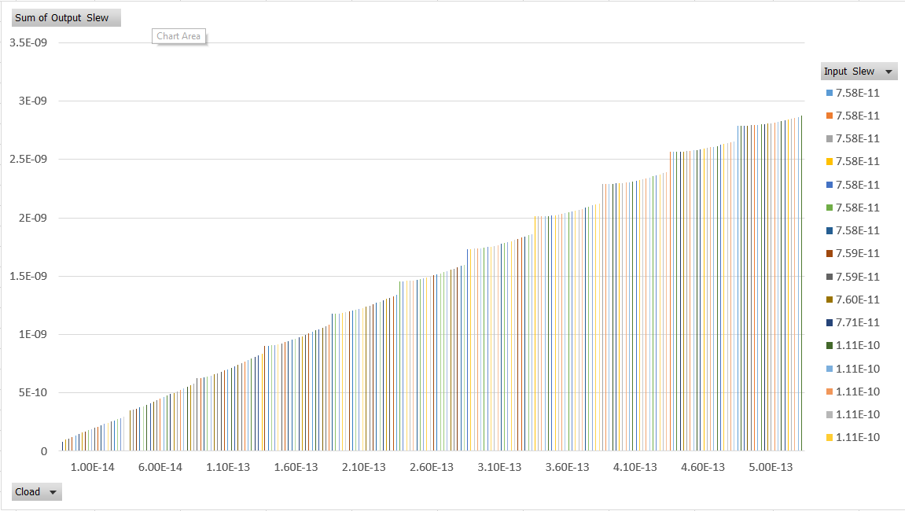

**--End--**