**EE5311 - Digital IC Design**

**Assignment 4 – Schematic of a signed 8-bit Carry Save Multiplier**

**Member 1: Srivenkat A(EE18B038)  
Member 2: Hemanth Ram G K(EE18B132)  
Member 3: Sidesh S(EE18B032)**

## Schematic of CSM

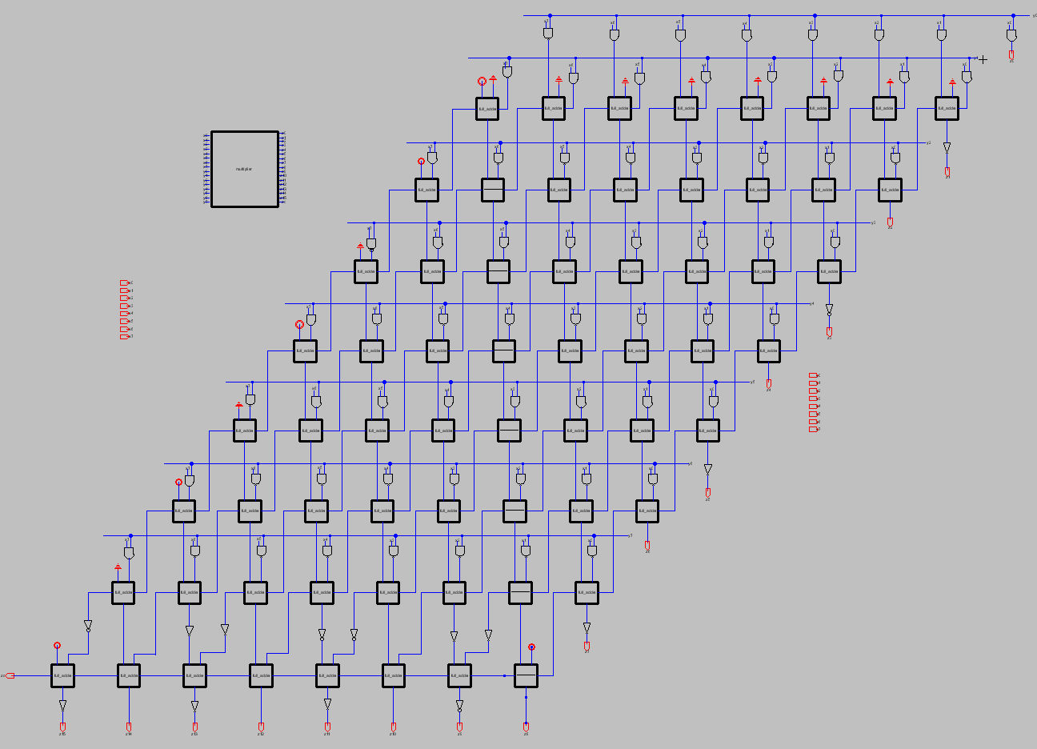

**Multiplier Testbench**

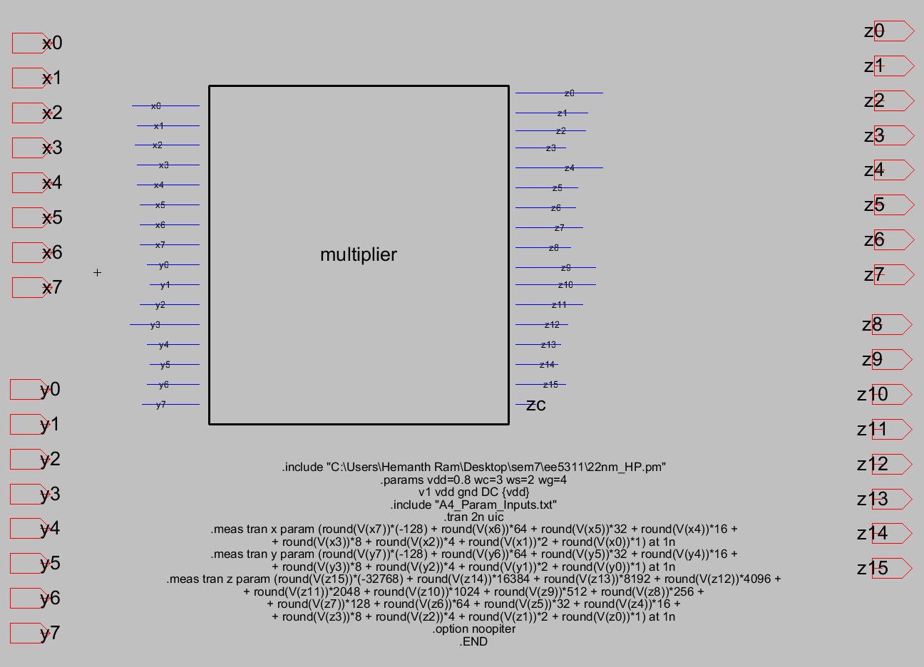

**Simulation output for 127 * -128**

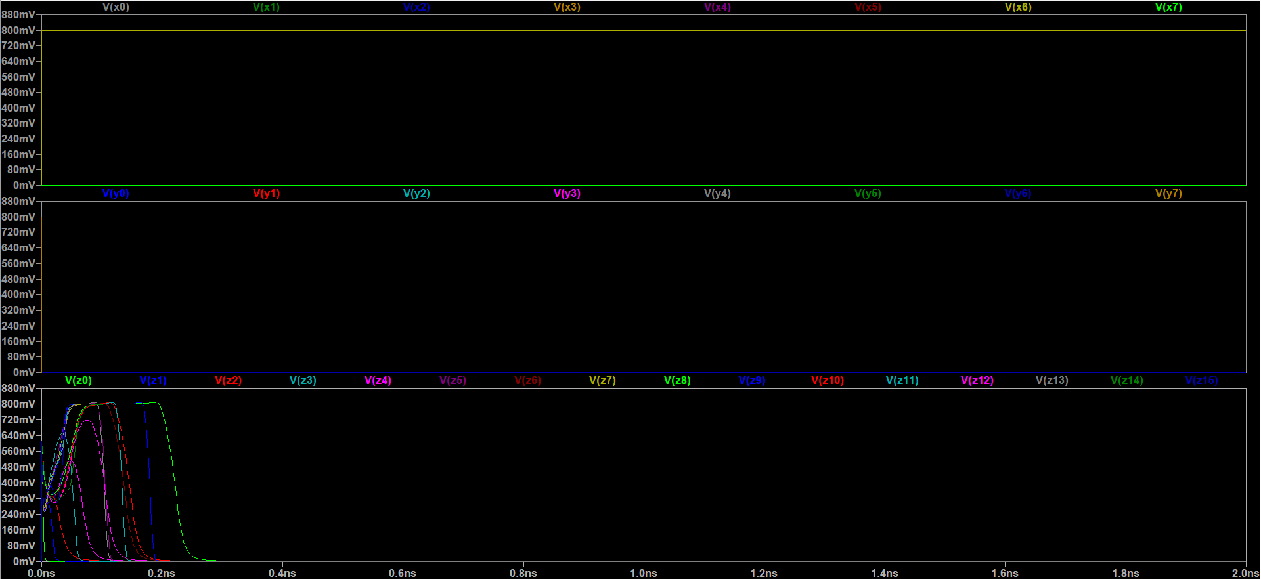

**Interpreted voltage values for 127 * -128**

**x: (round(v(x7))*(-128) + round(v(x6))*64 + round(v(x5))*32 + round(v(x4))*16 + round(v(x3))*8 + round(v(x2))*4 + round(v(x1))*2 + round(v(x0))*1)=127**

**y: (round(v(y7))*(-128) + round(v(y6))*64 + round(v(y5))*32 + round(v(y4))*16 + round(v(y3))*8 + round(v(y2))*4 + round(v(y1))*2 + round(v(y0))*1)=-128**

**z: (round(v(z15))*(-32768) + round(v(z14))*16384 + round(v(z13))*8192 + round(v(z12))*4096 + round(v(z11))*2048 + round(v(z10))*1024 + round(v(z9))*512 + round(v(z8))*256 + round(v(z7))*128 + round(v(z6))*64 + round(v(z5))*32 + round(v(z4))*16 + round(v(z3))*8 + round(v(z2))*4 + round(v(z1))*2 + round(v(z0))*1)=-16256**

**Interpreted voltage values for -128 * 127**

**x: (round(v(x7))*(-128) + round(v(x6))*64 + round(v(x5))*32 + round(v(x4))*16 + round(v(x3))*8 + round(v(x2))*4 + round(v(x1))*2 + round(v(x0))*1)=-128**

**y: (round(v(y7))*(-128) + round(v(y6))*64 + round(v(y5))*32 + round(v(y4))*16 + round(v(y3))*8 + round(v(y2))*4 + round(v(y1))*2 + round(v(y0))*1)=127**

**z: (round(v(z15))*(-32768) + round(v(z14))*16384 + round(v(z13))*8192 + round(v(z12))*4096 + round(v(z11))*2048 + round(v(z10))*1024 + round(v(z9))*512 + round(v(z8))*256 + round(v(z7))*128 + round(v(z6))*64 + round(v(z5))*32 + round(v(z4))*16 + round(v(z3))*8 + round(v(z2))*4 + round(v(z1))*2 + round(v(z0))*1)=-16256**

**Interpreted voltage values for 0 * 127**

**x: (round(v(x7))*(-128) + round(v(x6))*64 + round(v(x5))*32 + round(v(x4))*16 + round(v(x3))*8 + round(v(x2))*4 + round(v(x1))*2 + round(v(x0))*1)=0**

**y: (round(v(y7))*(-128) + round(v(y6))*64 + round(v(y5))*32 + round(v(y4))*16 + round(v(y3))*8 + round(v(y2))*4 + round(v(y1))*2 + round(v(y0))*1)=127**

**z: (round(v(z15))*(-32768) + round(v(z14))*16384 + round(v(z13))*8192 + round(v(z12))*4096 + round(v(z11))*2048 + round(v(z10))*1024 + round(v(z9))*512 + round(v(z8))*256 + round(v(z7))*128 + round(v(z6))*64 + round(v(z5))*32 + round(v(z4))*16 + round(v(z3))*8 + round(v(z2))*4 + round(v(z1))*2 + round(v(z0))*1)=0**

**Interpreted voltage values for -128 * 0**

**x: (round(v(x7))*(-128) + round(v(x6))*64 + round(v(x5))*32 + round(v(x4))*16 + round(v(x3))*8 + round(v(x2))*4 + round(v(x1))*2 + round(v(x0))*1)=-128**

**y: (round(v(y7))*(-128) + round(v(y6))*64 + round(v(y5))*32 + round(v(y4))*16 + round(v(y3))*8 + round(v(y2))*4 + round(v(y1))*2 + round(v(y0))*1)=0**

**z: (round(v(z15))*(-32768) + round(v(z14))*16384 + round(v(z13))*8192 + round(v(z12))*4096 + round(v(z11))*2048 + round(v(z10))*1024 + round(v(z9))*512 + round(v(z8))*256 + round(v(z7))*128 + round(v(z6))*64 + round(v(z5))*32 + round(v(z4))*16 + round(v(z3))*8 + round(v(z2))*4 + round(v(z1))*2 + round(v(z0))*1)=0**

**Interpreted voltage values for -12 * 13**

**x: (round(v(x7))*(-128) + round(v(x6))*64 + round(v(x5))*32 + round(v(x4))*16 + round(v(x3))*8 + round(v(x2))*4 + round(v(x1))*2 + round(v(x0))*1)=-12**

**y: (round(v(y7))*(-128) + round(v(y6))*64 + round(v(y5))*32 + round(v(y4))*16 + round(v(y3))*8 + round(v(y2))*4 + round(v(y1))*2 + round(v(y0))*1)=13**

**z: (round(v(z15))*(-32768) + round(v(z14))*16384 + round(v(z13))*8192 + round(v(z12))*4096 + round(v(z11))*2048 + round(v(z10))*1024 + round(v(z9))*512 + round(v(z8))*256 + round(v(z7))*128 + round(v(z6))*64 + round(v(z5))*32 + round(v(z4))*16 + round(v(z3))*8 + round(v(z2))*4 + round(v(z1))*2 + round(v(z0))*1)=-156**

**Interpreted voltage values for -1 * -1**

**x: (round(v(x7))*(-128) + round(v(x6))*64 + round(v(x5))*32 + round(v(x4))*16 + round(v(x3))*8 + round(v(x2))*4 + round(v(x1))*2 + round(v(x0))*1)=-1**

**y: (round(v(y7))*(-128) + round(v(y6))*64 + round(v(y5))*32 + round(v(y4))*16 + round(v(y3))*8 + round(v(y2))*4 + round(v(y1))*2 + round(v(y0))*1)=-1**

**z: (round(v(z15))*(-32768) + round(v(z14))*16384 + round(v(z13))*8192 + round(v(z12))*4096 + round(v(z11))*2048 + round(v(z10))*1024 + round(v(z9))*512 + round(v(z8))*256 + round(v(z7))*128 + round(v(z6))*64 + round(v(z5))*32 + round(v(z4))*16 + round(v(z3))*8 + round(v(z2))*4 + round(v(z1))*2 + round(v(z0))*1)=1**

**Interpreted voltage values for -128 * -128**

**x: (round(v(x7))*(-128) + round(v(x6))*64 + round(v(x5))*32 + round(v(x4))*16 + round(v(x3))*8 + round(v(x2))*4 + round(v(x1))*2 + round(v(x0))*1)=-128**

**y: (round(v(y7))*(-128) + round(v(y6))*64 + round(v(y5))*32 + round(v(y4))*16 + round(v(y3))*8 + round(v(y2))*4 + round(v(y1))*2 + round(v(y0))*1)=-128**

**z: (round(v(z15))*(-32768) + round(v(z14))*16384 + round(v(z13))*8192 + round(v(z12))*4096 + round(v(z11))*2048 + round(v(z10))*1024 + round(v(z9))*512 + round(v(z8))*256 + round(v(z7))*128 + round(v(z6))*64 + round(v(z5))*32 + round(v(z4))*16 + round(v(z3))*8 + round(v(z2))*4 + round(v(z1))*2 + round(v(z0))*1)=16384**

**Interpreted voltage values for 103 * -57**

**x: (round(v(x7))*(-128) + round(v(x6))*64 + round(v(x5))*32 + round(v(x4))*16 + round(v(x3))*8 + round(v(x2))*4 + round(v(x1))*2 + round(v(x0))*1)=103**

**y: (round(v(y7))*(-128) + round(v(y6))*64 + round(v(y5))*32 + round(v(y4))*16 + round(v(y3))*8 + round(v(y2))*4 + round(v(y1))*2 + round(v(y0))*1)=-57**

**z: (round(v(z15))*(-32768) + round(v(z14))*16384 + round(v(z13))*8192 + round(v(z12))*4096 + round(v(z11))*2048 + round(v(z10))*1024 + round(v(z9))*512 + round(v(z8))*256 + round(v(z7))*128 + round(v(z6))*64 + round(v(z5))*32 + round(v(z4))*16 + round(v(z3))*8 + round(v(z2))*4 + round(v(z1))*2 + round(v(z0))*1)=-5871**

**Interpreted voltage values for -50 * 50**

**x: (round(v(x7))*(-128) + round(v(x6))*64 + round(v(x5))*32 + round(v(x4))*16 + round(v(x3))*8 + round(v(x2))*4 + round(v(x1))*2 + round(v(x0))*1)=-50**

**y: (round(v(y7))*(-128) + round(v(y6))*64 + round(v(y5))*32 + round(v(y4))*16 + round(v(y3))*8 + round(v(y2))*4 + round(v(y1))*2 + round(v(y0))*1)=50**

**z: (round(v(z15))*(-32768) + round(v(z14))*16384 + round(v(z13))*8192 + round(v(z12))*4096 + round(v(z11))*2048 + round(v(z10))*1024 + round(v(z9))*512 + round(v(z8))*256 + round(v(z7))*128 + round(v(z6))*64 + round(v(z5))*32 + round(v(z4))*16 + round(v(z3))*8 + round(v(z2))*4 + round(v(z1))*2 + round(v(z0))*1)=-2500**

**Interpreted voltage values for 79 * 81**

**x: (round(v(x7))*(-128) + round(v(x6))*64 + round(v(x5))*32 + round(v(x4))*16 + round(v(x3))*8 + round(v(x2))*4 + round(v(x1))*2 + round(v(x0))*1)=79**

**y: (round(v(y7))*(-128) + round(v(y6))*64 + round(v(y5))*32 + round(v(y4))*16 + round(v(y3))*8 + round(v(y2))*4 + round(v(y1))*2 + round(v(y0))*1)=81**

**z: (round(v(z15))*(-32768) + round(v(z14))*16384 + round(v(z13))*8192 + round(v(z12))*4096 + round(v(z11))*2048 + round(v(z10))*1024 + round(v(z9))*512 + round(v(z8))*256 + round(v(z7))*128 + round(v(z6))*64 + round(v(z5))*32 + round(v(z4))*16 + round(v(z3))*8 + round(v(z2))*4 + round(v(z1))*2 + round(v(z0))*1)=6399**

**Critical Path of CSM modelled separately**

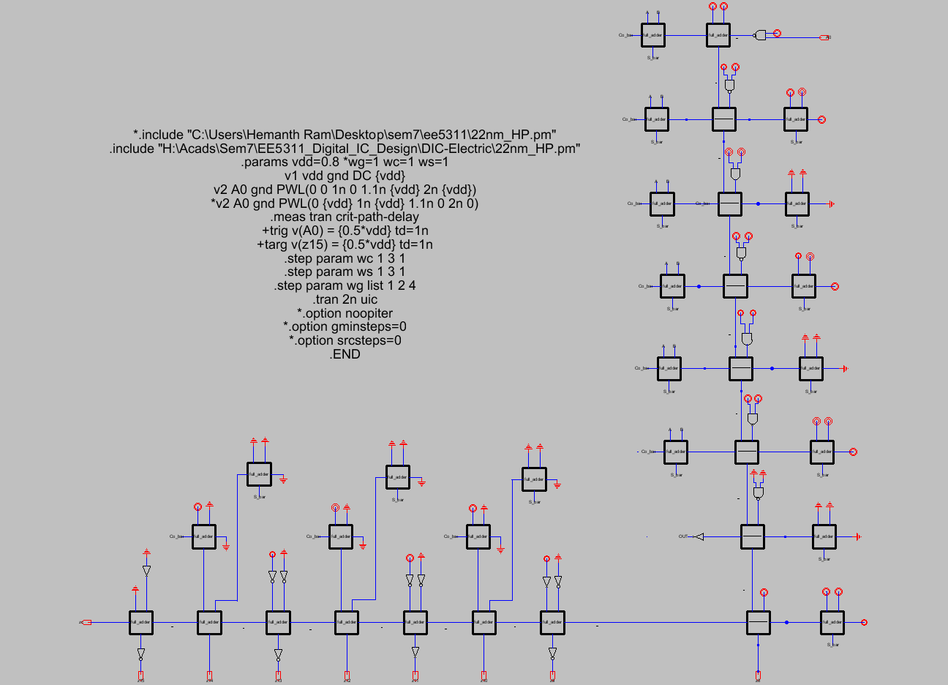

**Inputs to Full Adders in Critical Path**

1. Input Cin is closer than A, B to output and critical input is connected to Cin in every full adder.
2. For an edge in Cin, sum delay for different combinations of A, B in a Full Adder:

|  |  |  |
| --- | --- | --- |
| Inputs to (A,B ) \ Cin Edge Type | Rising | Falling |
| 00 | 28.5ps | 44.8ps |
| 01 | 41.1ps | 28.5ps |
| 10 | 38.8ps | 28.9ps |
| 11 | 75.6ps | 18.7ps |

So, for both rising edge in Cin, A=1, B=1 and for falling edge in Cin, A=0, B=0 for max delay in sum propagation

1. For an edge in Carry in, Full Adder should be in propagation stage for max delay. Delays for different combinations of A/B in Full Adder:

|  |  |  |
| --- | --- | --- |
| Inputs to (A, B) \ Cin Edge Type | Rising | Falling |
| 01 | 29.9ps | 10.6ps |
| 10 | 28.4ps | 10.5ps |

So, for rising/falling edge in Cin, A=0, B=1 for max delay in carry propagation

## Sizes of FA, NAND, AND and INV gates used are parameterised

**Schematic of Full Adder used**

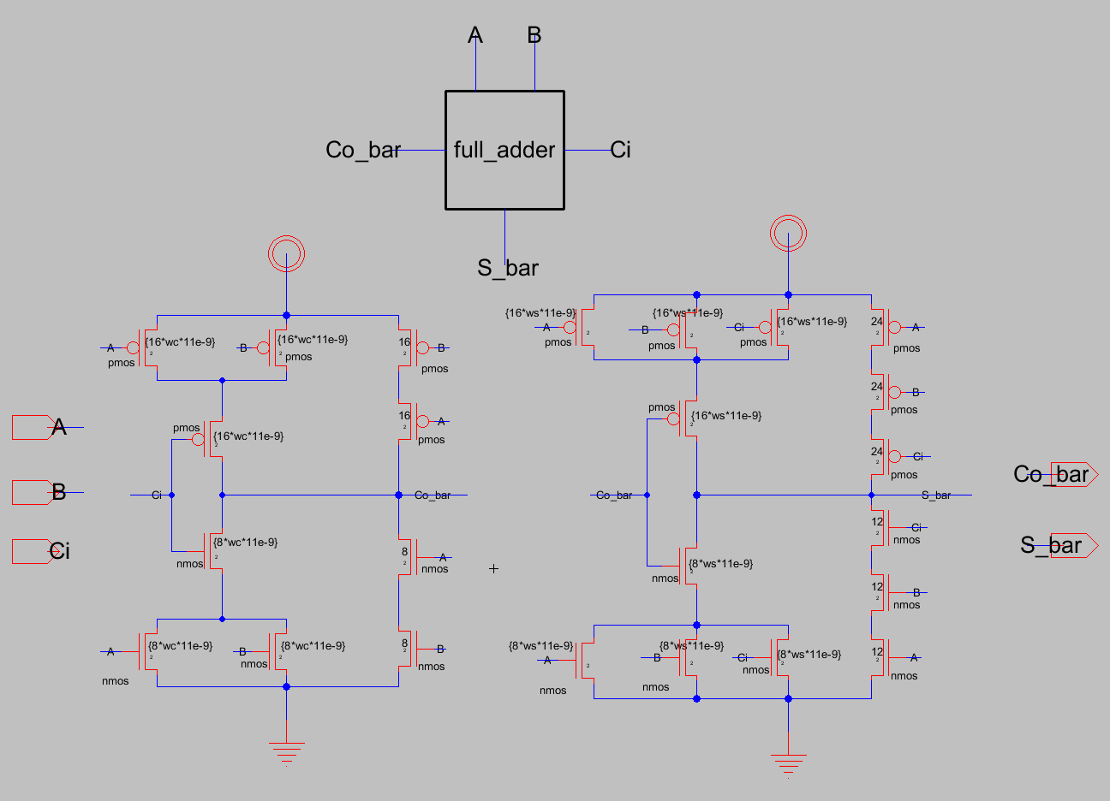

**Schematic of NAND gate used**

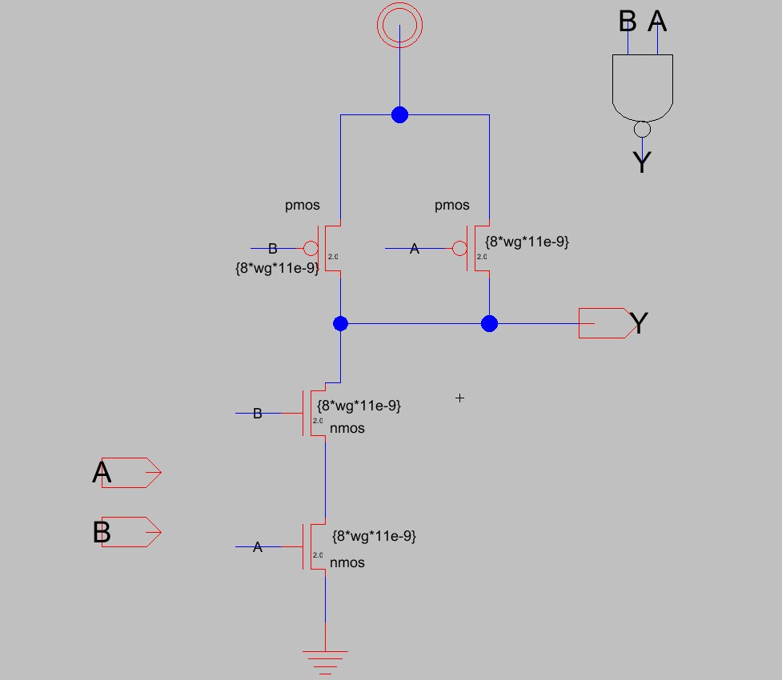

**Schematic of Inverter used**

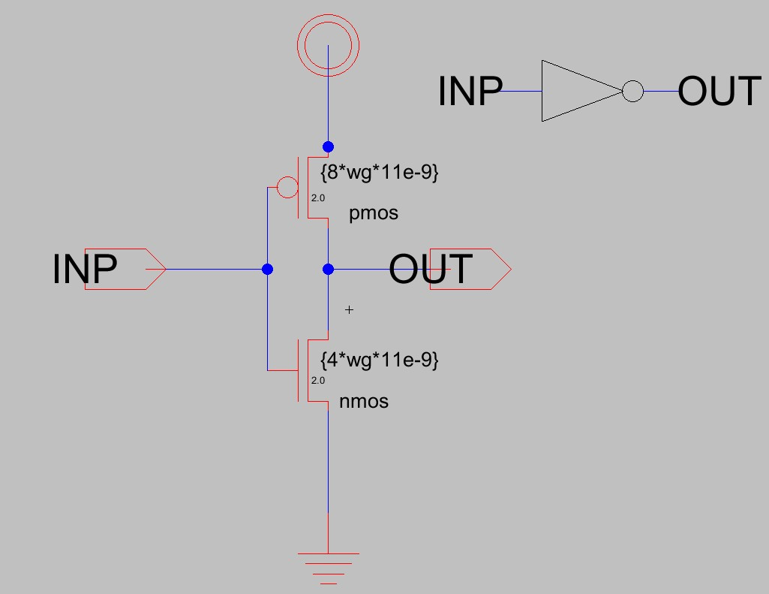

**Schematic of AND gate used**

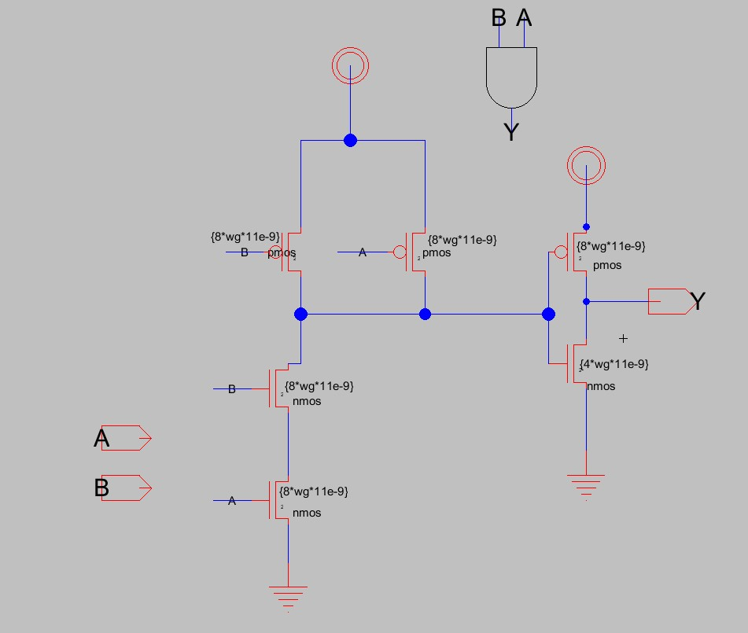

**Simulation of Critical Path Delay swept across possible gate size combinations**

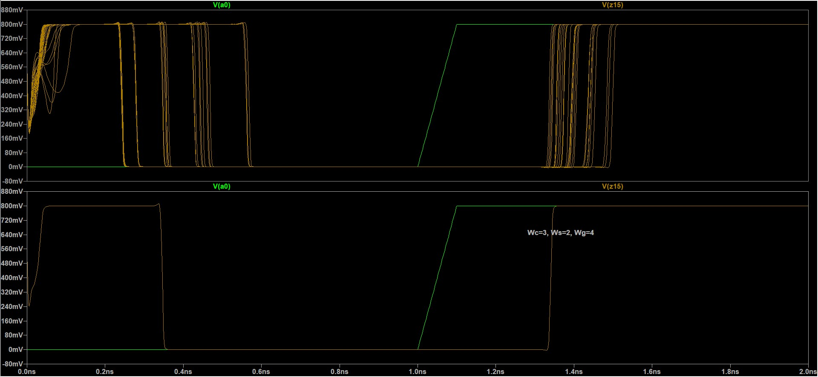

**Simulation of Vector Merge outputs for critical input**

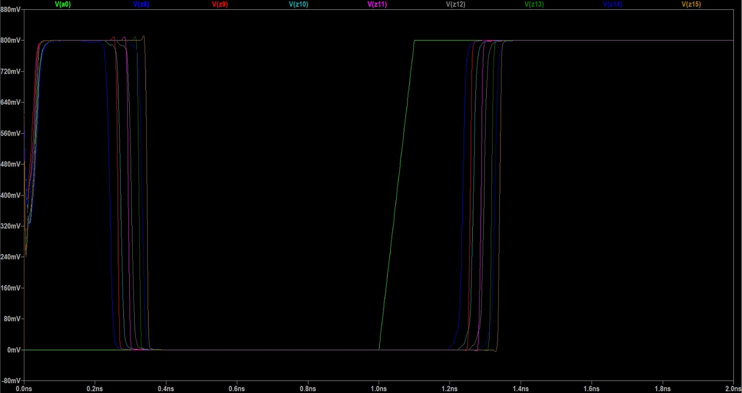

**Critical Path Delay tabulated across gate size combinations**

|  |  |  |  |  |  |  |
| --- | --- | --- | --- | --- | --- | --- |
| 1 | wc=1 | ws=1 | wg=1 | 3.92E-10 | 1.05E-09 | 1.44E-09 |
| 2 | wc=2 | ws=1 | wg=1 | 3.53E-10 | 1.05E-09 | 1.40E-09 |
| 3 | wc=3 | ws=1 | wg=1 | 3.56E-10 | 1.05E-09 | 1.41E-09 |
| 4 | wc=1 | ws=2 | wg=1 | 4.04E-10 | 1.05E-09 | 1.45E-09 |
| 5 | wc=2 | ws=2 | wg=1 | 3.24E-10 | 1.05E-09 | 1.37E-09 |
| 6 | wc=3 | ws=2 | wg=1 | 3.06E-10 | 1.05E-09 | 1.36E-09 |
| 7 | wc=1 | ws=3 | wg=1 | 4.49E-10 | 1.05E-09 | 1.50E-09 |
| 8 | wc=2 | ws=3 | wg=1 | 3.36E-10 | 1.05E-09 | 1.39E-09 |
| 9 | wc=3 | ws=3 | wg=1 | 3.06E-10 | 1.05E-09 | 1.36E-09 |
| 10 | wc=1 | ws=1 | wg=2 | 3.87E-10 | 1.05E-09 | 1.44E-09 |
| 11 | wc=2 | ws=1 | wg=2 | 3.46E-10 | 1.05E-09 | 1.40E-09 |
| 12 | wc=3 | ws=1 | wg=2 | 3.48E-10 | 1.05E-09 | 1.40E-09 |
| 13 | wc=1 | ws=2 | wg=2 | 3.96E-10 | 1.05E-09 | 1.45E-09 |
| 14 | wc=2 | ws=2 | wg=2 | 3.14E-10 | 1.05E-09 | 1.36E-09 |
| 15 | wc=3 | ws=2 | wg=2 | 2.96E-10 | 1.05E-09 | 1.35E-09 |
| 16 | wc=1 | ws=3 | wg=2 | 4.39E-10 | 1.05E-09 | 1.49E-09 |
| 17 | wc=2 | ws=3 | wg=2 | 3.25E-10 | 1.05E-09 | 1.37E-09 |
| 18 | wc=3 | ws=3 | wg=2 | 2.93E-10 | 1.05E-09 | 1.34E-09 |
| 19 | wc=1 | ws=1 | wg=4 | 3.86E-10 | 1.05E-09 | 1.44E-09 |
| 20 | wc=2 | ws=1 | wg=4 | 3.44E-10 | 1.05E-09 | 1.39E-09 |
| 21 | wc=3 | ws=1 | wg=4 | 3.45E-10 | 1.05E-09 | 1.40E-09 |
| 22 | wc=1 | ws=2 | wg=4 | 3.92E-10 | 1.05E-09 | 1.44E-09 |
| 23 | wc=2 | ws=2 | wg=4 | 3.10E-10 | 1.05E-09 | 1.36E-09 |
| 24 | wc=3 | ws=2 | wg=4 | 2.87E-10 | 1.05E-09 | 1.34E-09 |
| 25 | wc=1 | ws=3 | wg=4 | 4.34E-10 | 1.05E-09 | 1.48E-09 |
| 26 | wc=2 | ws=3 | wg=4 | 3.19E-10 | 1.05E-09 | 1.37E-09 |
| 27 | wc=3 | ws=3 | wg=4 | 2.87E-10 | 1.05E-09 | 1.34E-09 |

**Chosen Gate sizes**

**Full Adder:**

**Cout-bar: 3x**

**Sum-bar: 2x**

**Standard Cells:**

**NAND, AND, INV: 4x**

**--End--**