**SUBSCRIBERS GALORE; EXPLORING WORLD’S TOP YOUTUBE CHANNELS**

**INTRODUCTION**

HISTORY

**YouTube** is an American online video sharing and social media platform headquartered in ***San Bruno, California, United States***. Accessible worldwide,it was launched on February 14, 2005, by Steve Chen, Chad Hurley, and Jawed Karim. It is owned by Google and is the second most visited website in the world, after Google Search. YouTube has more than 2.5 billion monthly users, who collectively watch more than one billion hours of videos every day.As of May 2019, videos were being uploaded to the platform at a rate of more than 500 hours of content per minute.

YouTube allows users to upload videos, view them, rate them with likes and dislikes, share them, add videos to playlists, report, make comments on videos, and subscribe to other users. The slogan "Broadcast Yourself" used for several years and the reference to user profiles as "Channels" signifies the premise upon which the platform is based, of allowing anyone to operate a personal broadcasting station in resemblance to television with the extension of video on demand.

**Jawed Karim** (born October 28, 1979) is an American software engineer and Internet entrepreneur. He is a co-founder of YouTube and the first person to upload a video to the site.

**PROBLEM DEFINITION & DESIGN THINKING**

EMPATHY MAP

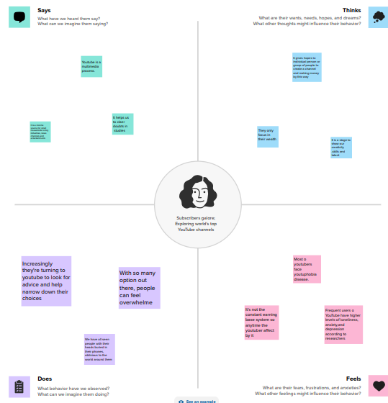

IDEATION & BRAINSTORMING MAP

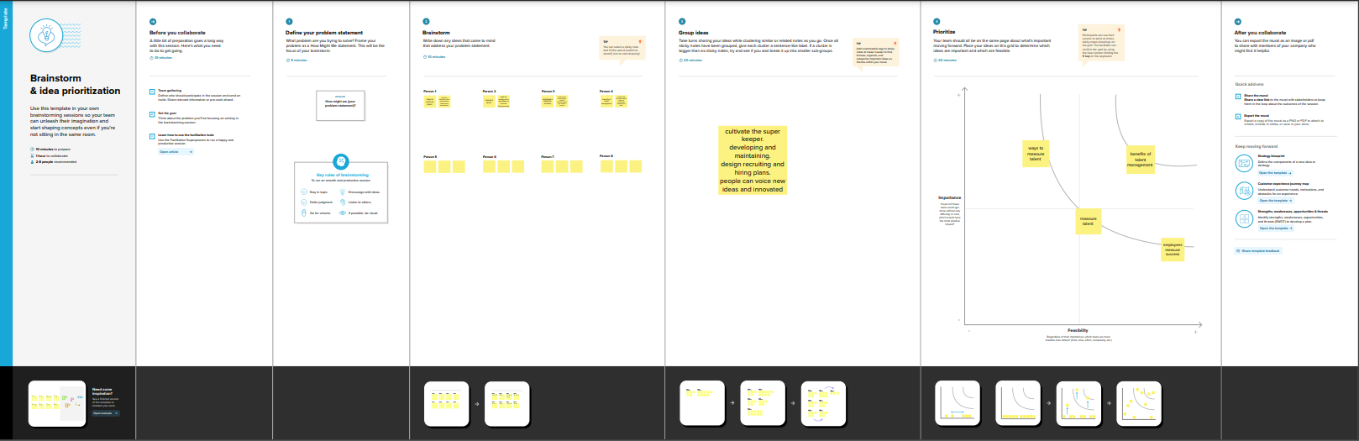

**RESULT**

Dashboard

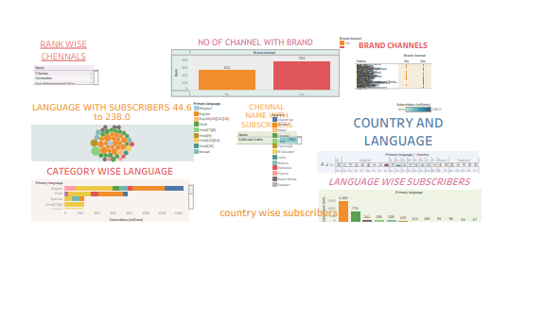

**Story**

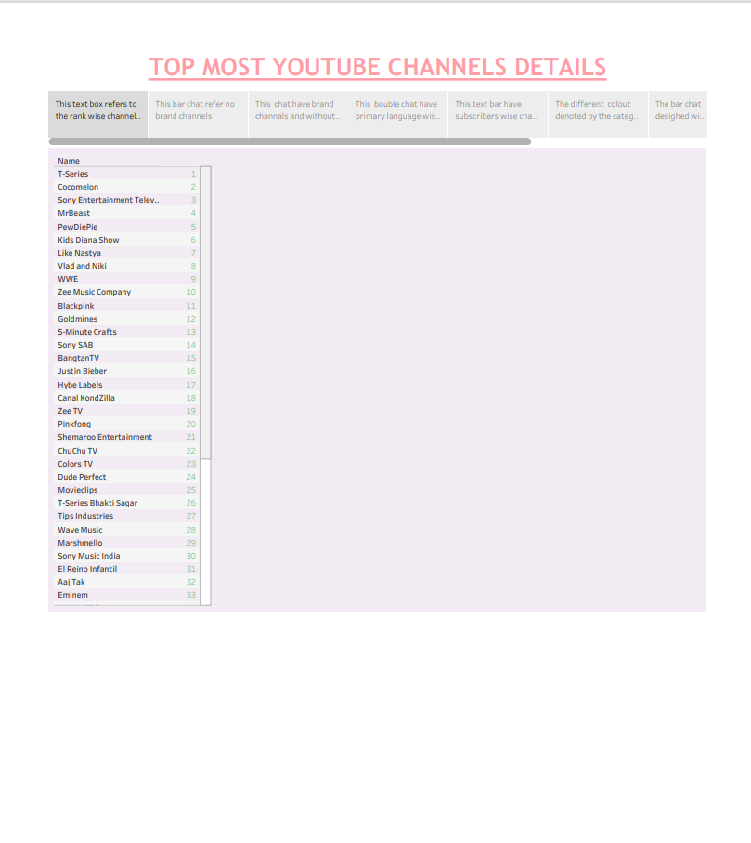

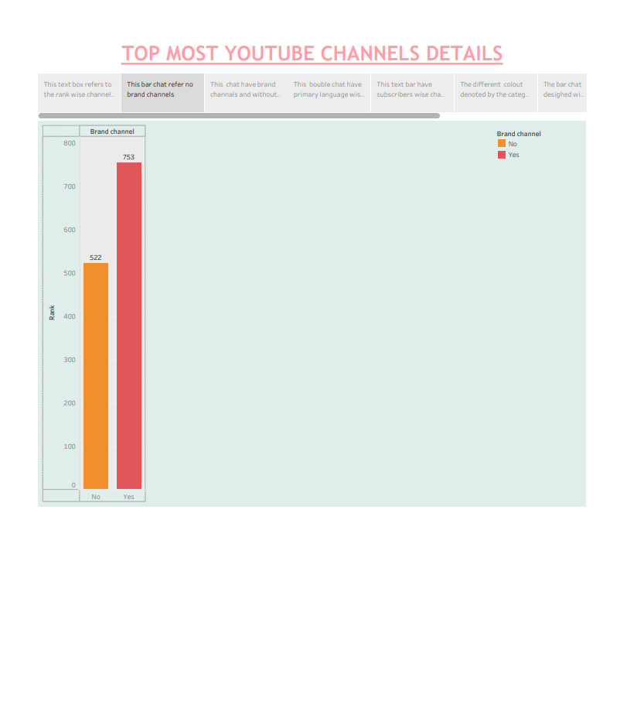

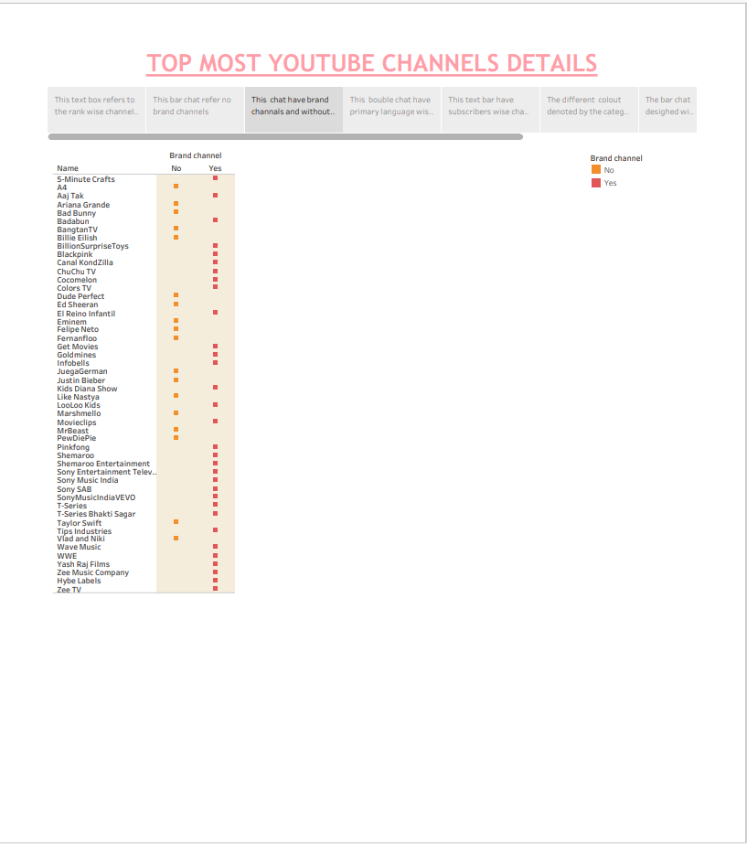

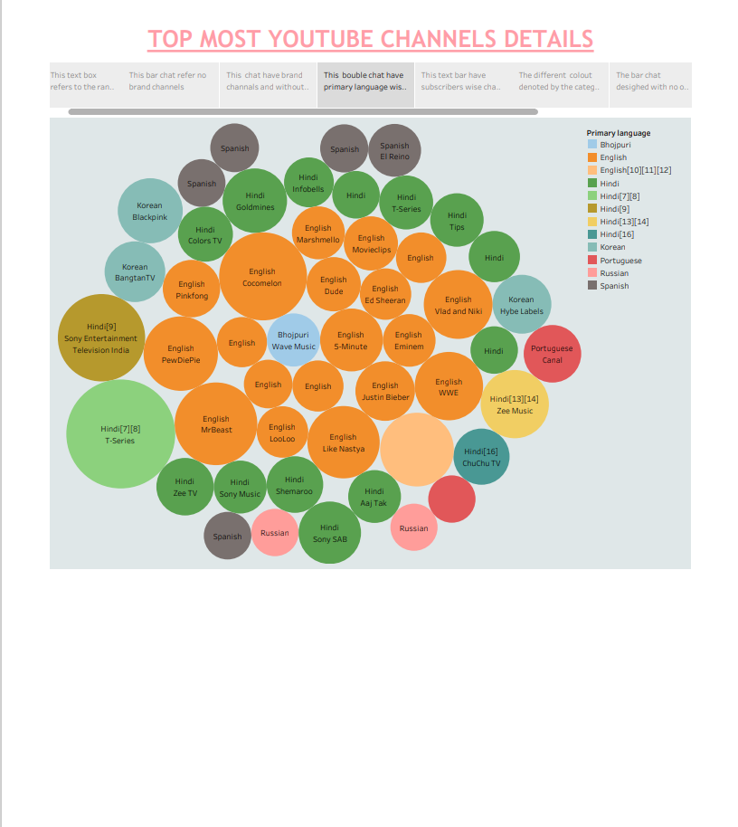

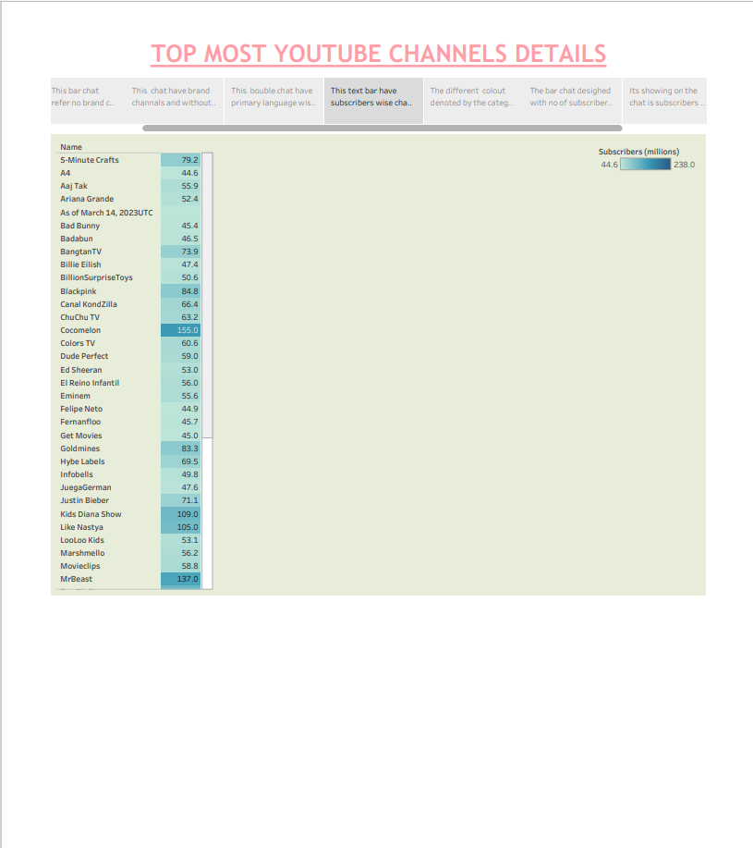

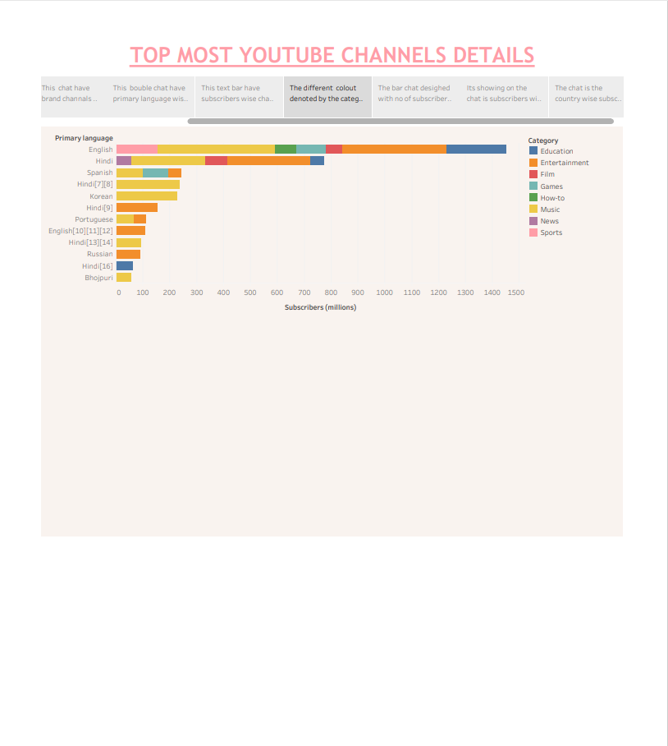

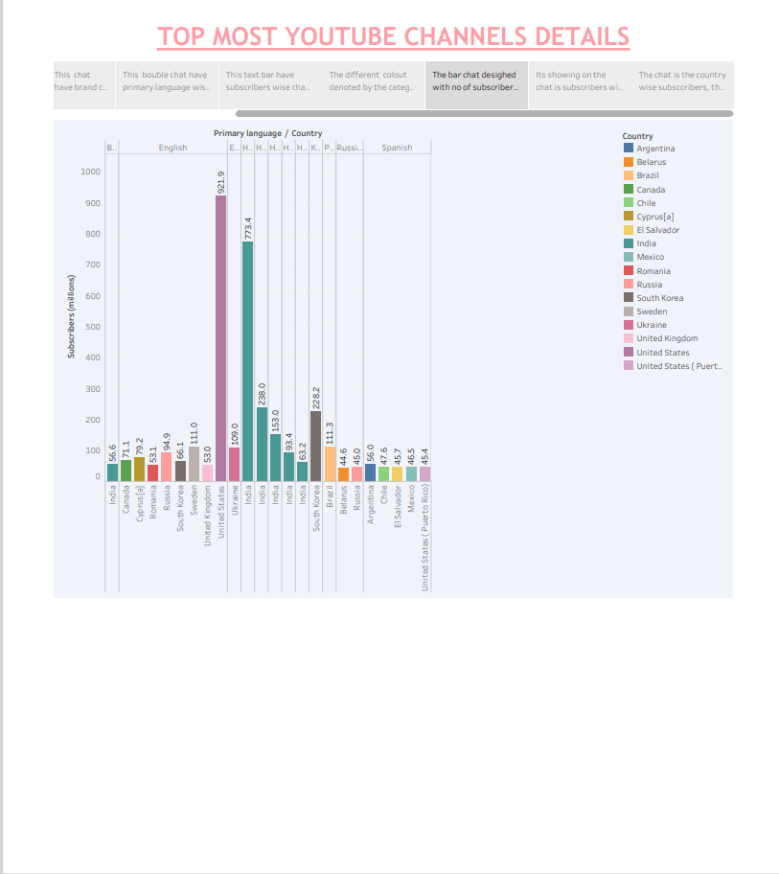

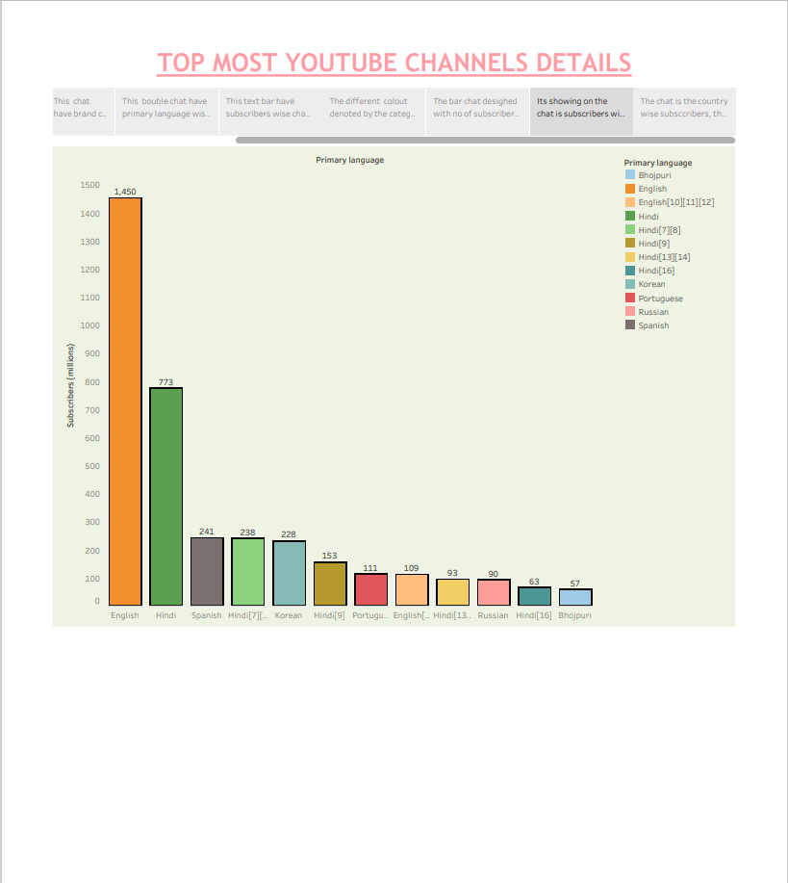

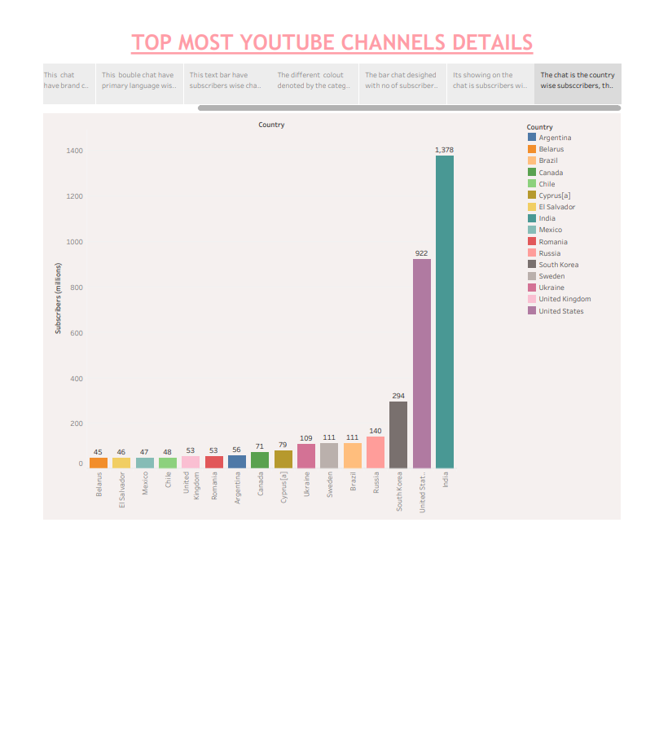**ADVANTAGE**

* [It gives you the opportunity to earn money through your videos](https://www.bing.com/ck/a?!&&p=43bc205da1af0489JmltdHM9MTY5Njk4MjQwMCZpZ3VpZD0zNGIzMjI1ZS1hZjFhLTY0ZDgtMWExYy0zMTEyYWVlZDY1NzkmaW5zaWQ9NTg2OQ&ptn=3&hsh=3&fclid=34b3225e-af1a-64d8-1a1c-3112aeed6579&psq=ADVANTAGE+OF+YOUTUBE&u=a1aHR0cHM6Ly9zbm9ibW9ua2V5LmNvbS90aGUtYWR2YW50YWdlcy1hbmQtZGlzYWR2YW50YWdlcy1vZi15b3V0dWJlLw&ntb=1).
* [It is easy to use for everyone, even if you don’t have any computer skills](https://www.bing.com/ck/a?!&&p=a4a6d0a4a96f3f57JmltdHM9MTY5Njk4MjQwMCZpZ3VpZD0zNGIzMjI1ZS1hZjFhLTY0ZDgtMWExYy0zMTEyYWVlZDY1NzkmaW5zaWQ9NTg3Mg&ptn=3&hsh=3&fclid=34b3225e-af1a-64d8-1a1c-3112aeed6579&psq=ADVANTAGE+OF+YOUTUBE&u=a1aHR0cHM6Ly9zbm9ibW9ua2V5LmNvbS90aGUtYWR2YW50YWdlcy1hbmQtZGlzYWR2YW50YWdlcy1vZi15b3V0dWJlLw&ntb=1) .
* [It is accessible from any device with an internet connection, including your computer, smart phone, and tablet](https://www.bing.com/ck/a?!&&p=88052afb92c8af56JmltdHM9MTY5Njk4MjQwMCZpZ3VpZD0zNGIzMjI1ZS1hZjFhLTY0ZDgtMWExYy0zMTEyYWVlZDY1NzkmaW5zaWQ9NTg3Ng&ptn=3&hsh=3&fclid=34b3225e-af1a-64d8-1a1c-3112aeed6579&psq=ADVANTAGE+OF+YOUTUBE&u=a1aHR0cHM6Ly93d3cuZWR1Y2JhLmNvbS9hZHZhbnRhZ2VzLWFuZC1kaXNhZHZhbnRhZ2VzLW9mLXlvdXR1YmUv&ntb=1).
* It is free to use, watch and upload videos.

**DISADVANTAGES**

* Misinformation: Videos posted on sites like YouTube are rarely vetted until much later and by then, the damage is already done.
* Increases expenses: YouTube can be addictive, and people may spend more money on data and devices to watch videos.
* Increases screen time: YouTube can be a time-consuming activity, and people may spend more time watching videos than doing other activities.
* Kills productivity: YouTube can be a distraction, and people may spend more time watching videos than working or studying.

**CONCLUSION**

You should**treat a YouTube content strategy** just like you would**treat a content strategy on any other** channel. Your**content needs to** be created**for a specific** audience you want to reach. The more you define your niche, the more your**content** will resonate with viewers. At this point, there are three main aspects you need to determine