**HULKSTORE APPLICATION**

The application has been started using IntelliJ IDEA.

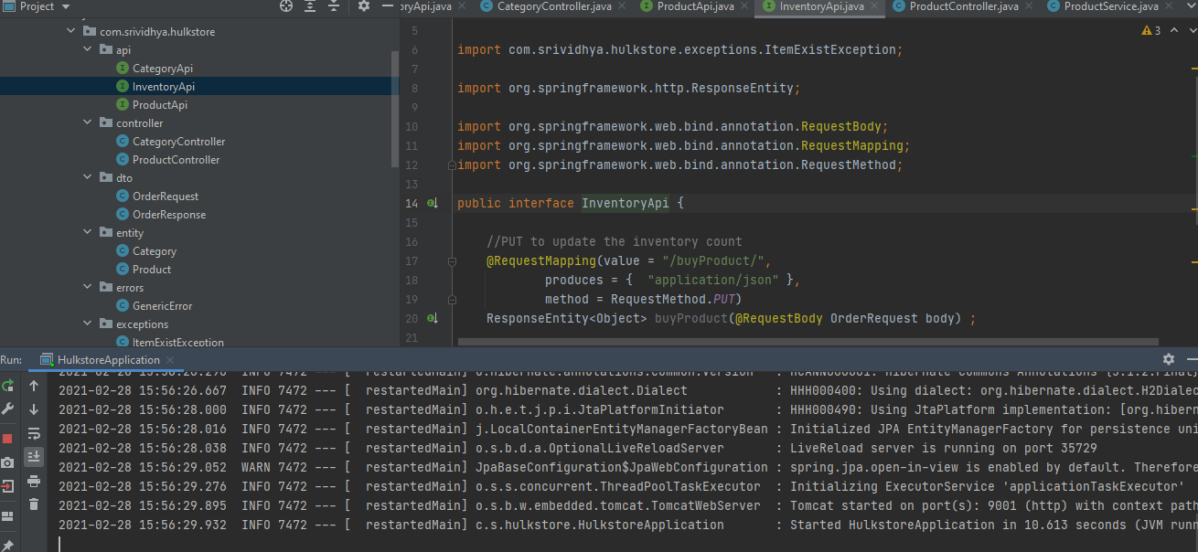

Testing my application in PostMan API tool.

TC_ID_01 : Category Creation – POST Method – SUCCES scenario

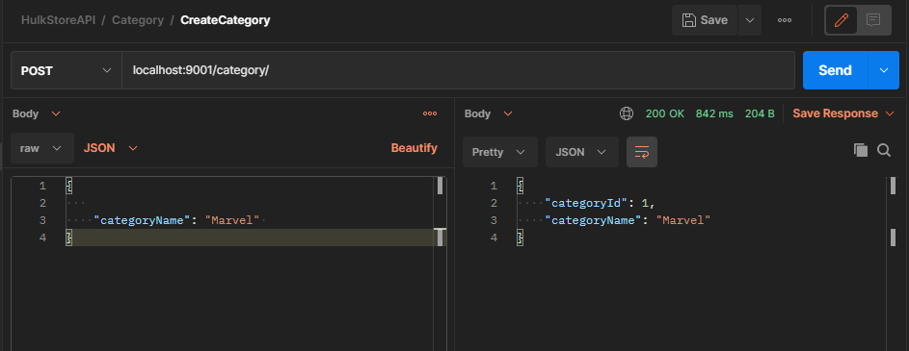

TC_ID_02 : Category Creation – POST – FAILURE – 409 CONFLICT

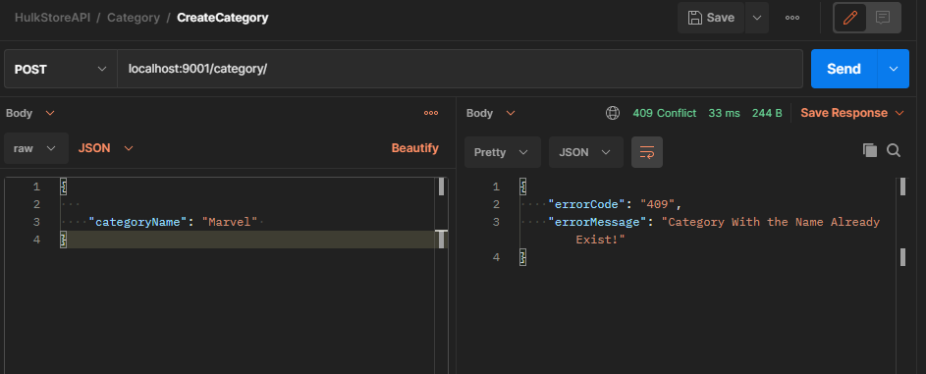

TC_ID_03 : Update Category – PUT method - SUCCESS – 200 OK

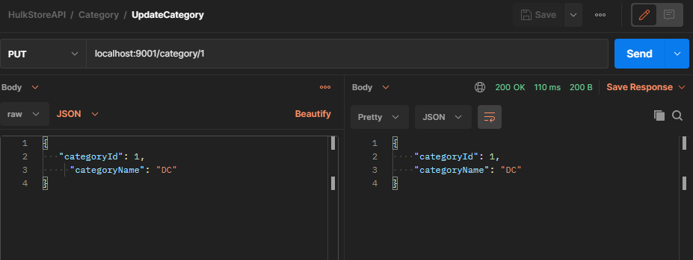

TC_ID_04 : PUT – FAILURE – 404 NOT FOUND

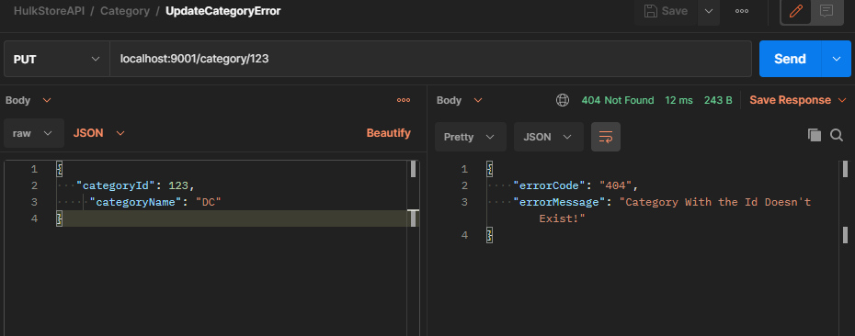

TC_ID_05 : Get All Category – SUCCESS – 200 OK

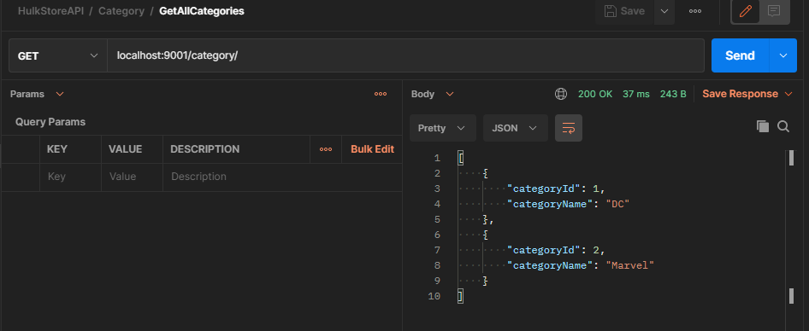

TC_ID_06 : Get category by Id – SUCCESS – 200 OK

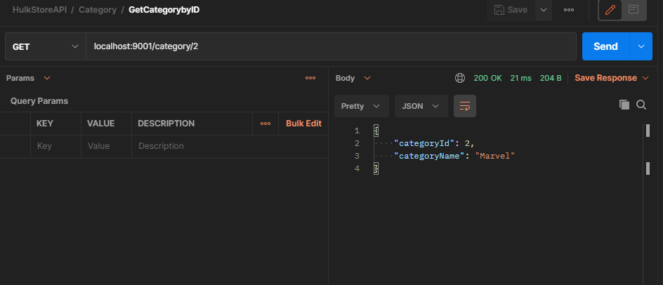

TC_ID_07 : Get Category by ID – FAILURE – 404 NOT FOUND

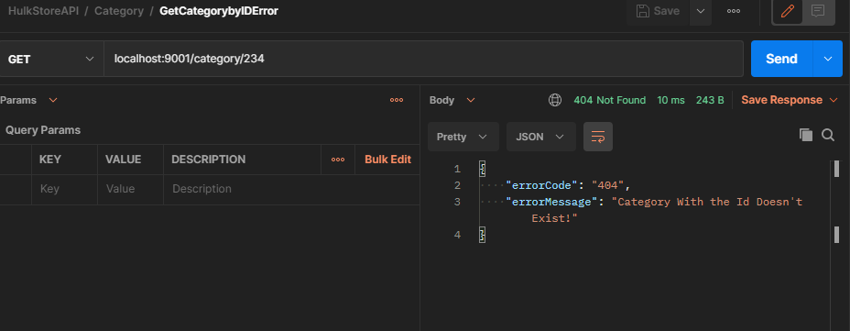

TC_ID_08 : Create Product – POST - SUCCESS – 200 OK

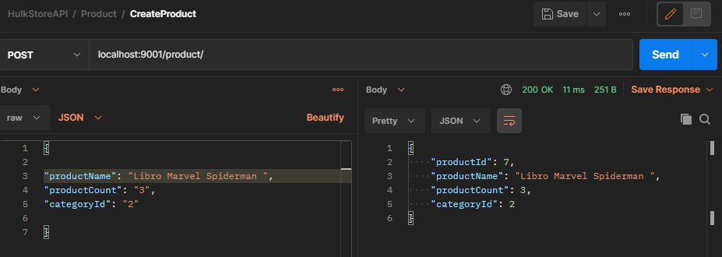

TC_ID_09 : Update Product – PUT – SUCCESS – 200 OK

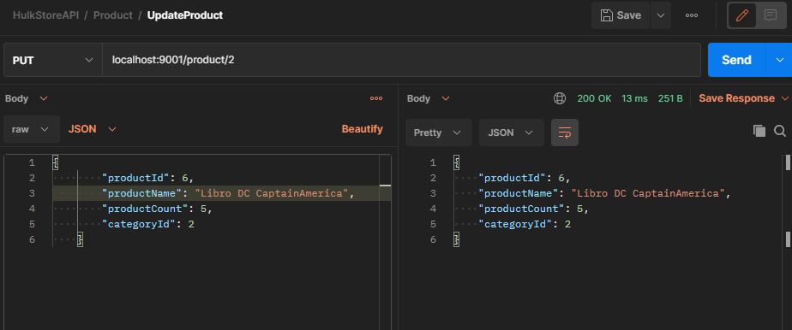

TC_ID_10 : Get All Product – GET – SUCCESS -200 OK

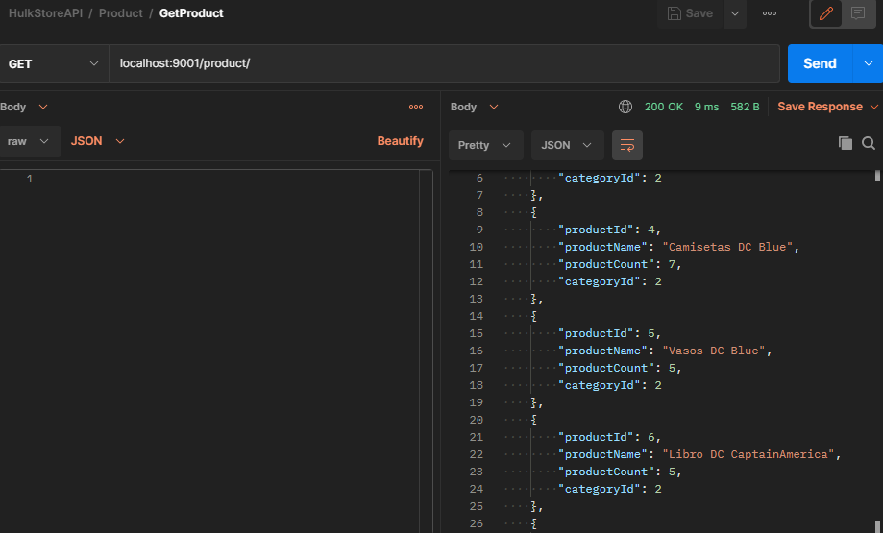

TC_ID_11 : Get Product by ID – GET – SUCCESS – 200 OK

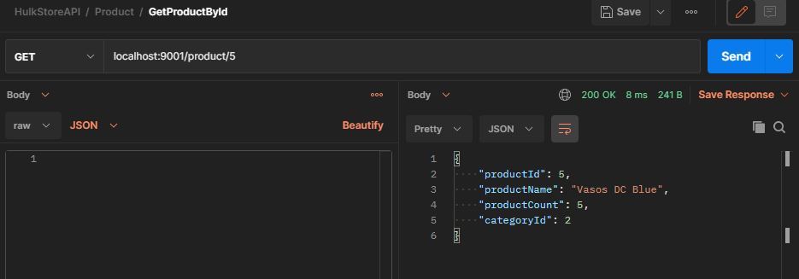

TC_ID_12 : Increase inventory count on adition of a Product – 200 OK - SUCCESS

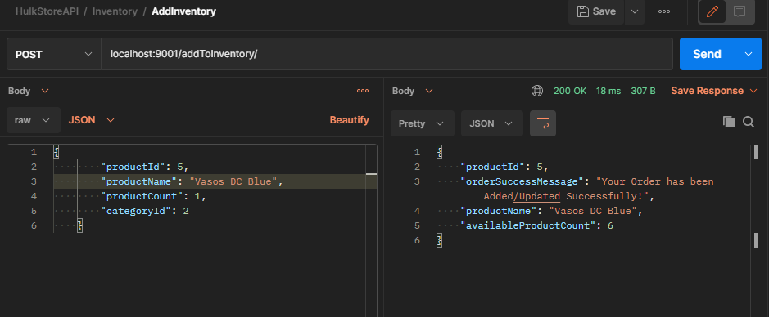

TC_ID_13 : Descrease in inventory count on reduction(selling) of a Product – 200 OK – SUCCESS

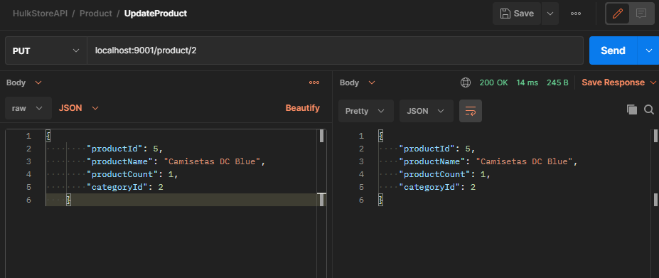

TC_ID_14 : Trying to order a producto which is not in stock – 404 NOT FOUND - FAILURE

