Grammar Rules used-
- A single-word sentence is valid only if that word is itself a conjugated verb.
- Only one subject is allowed in a sentence if conjunction “um” is not present
- Mixed subjects(one with “um” and one without “um”) are not allowed
- Subject is optional — Object + Verb sentences are permitted.
- Object is optional- Subject + verb permitted
- Person agreement must hold between subject and verb (1st / 2nd / 3rd).
- Number agreement must hold between subject and verb (singular / plural).
- Gender agreement must hold between subject and verb when applicable.
- Aytham (ஃ) subjects are supported as valid neutral subjects.
- Negation Bypass- Verbs ending in வில்லை bypass PNG agreement checks, since they are uninflected negative forms that work across all persons in colloquial Tamil.
- Interrogative Agreement Rule- Interrogative verb suffixes (ேனா, ாயா, ானா, ாளா, தா, ோமா, ீர்களா, ார்களா) are detected and their PNG is extracted just like declarative suffixes.
- Negative Interrogative Rule-Forms ending with வில்லையா are accepted universally.
- Single subject with “um” follows that subject
- Conjoined Agreement-
Lowest person dominates:
1+2, 1+3 → 1st person plural (வந்தோம்)
2+3 → 2nd person plural (வந்தீர்கள்)
3+3 → 3rd person plural (வந்தார்கள் / வந்தன)
- All the tenses are accepted
- Honorific subject agrees with honorific verb

Grammar Rules used-
- A single-word sentence is valid only if that word is itself a conjugated verb.
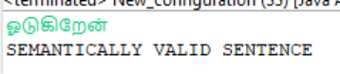
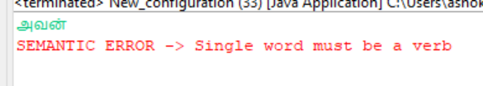

- Only one subject is allowed in a sentence if conjunction “um” is not present
- Mixed subjects(one with “um” and one without “um”) are not allowed

- Subject is optional — Object + Verb sentences are permitted.
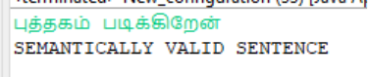

- Object is optional- Subject + verb permitted
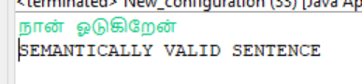

- Person agreement must hold between subject and verb (1st / 2nd / 3rd).
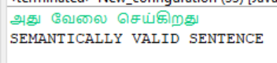
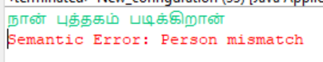
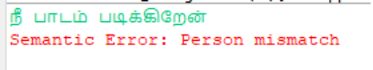

- Number agreement must hold between subject and verb (singular / plural).
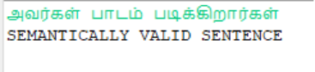
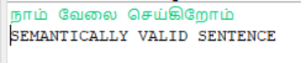
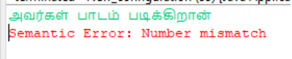
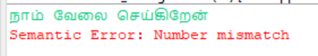
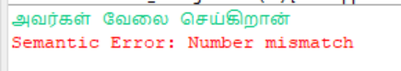

- Gender agreement must hold between subject and verb when applicable.
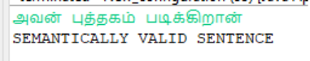
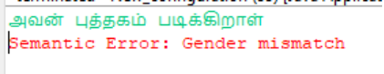
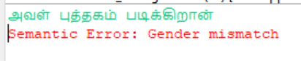
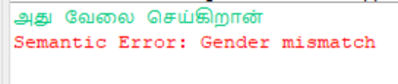

- Aytham (ஃ) subjects are supported as valid neutral subjects.
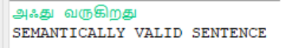
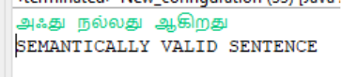
- Negation Bypass

Verbs ending in வில்லை bypass PNG agreement checks, since they are uninflected negative forms that work across all persons in colloquial Tamil.

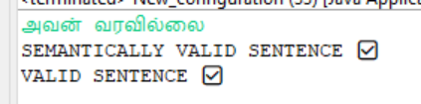
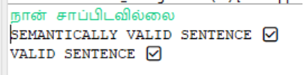
- Interrogative Agreement Rule
Interrogative verb suffixes (ேனா, ாயா, ானா, ாளா, தா, ோமா, ீர்களா, ார்களா) are detected and their PNG is extracted just like declarative suffixes.
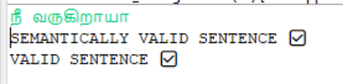
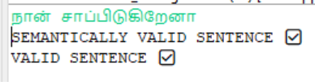
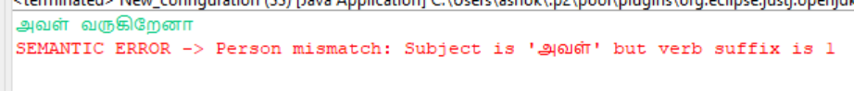
- Negative Interrogative Rule
Forms ending with வில்லையா are accepted universally.

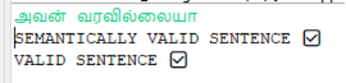
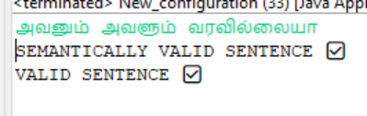
- Single subject with “um” follows that subject
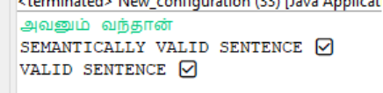

- Conjoined Agreement-
Lowest person dominates:
1+2, 1+3 → 1st person plural (வந்தோம்)
2+3 → 2nd person plural (வந்தீர்கள்)
3+3 → 3rd person plural (வந்தார்கள் / வந்தன)
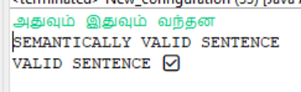
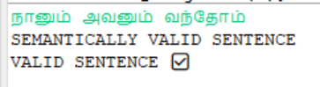
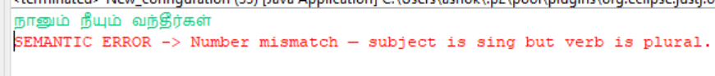

- All the tenses are accepted
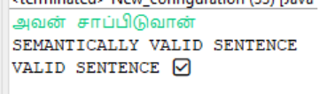
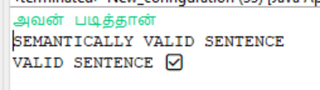
- Honorific subject agrees with honorific verb
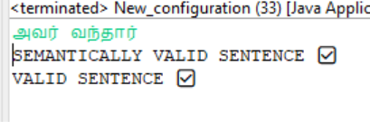

Addressing of lexical and syntactically errors:
Lexical Error:
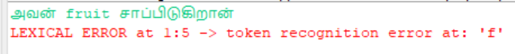
Syntax Error:
