Steps for UAT QA

Locations:

1. FS Location: \\nr5vfl02\RTOM-MEGA\GN16\FS
2. TC&TRD Latest: on email 25th March 
3. Excel sheet having Priority Scenarios (from BAs) & Priority TCs (based on above TC/TRD) 
4. Latest Mockups Location: \\nr5vfl02\RTOM-MEGA\GN16\FS\Loan\GN16_Latest Mock Ups_1st April\GN16_Latest Mock Ups
5. DSR daily update file .pptx as passed by Rao to be updated at day end for QA Summary.

Steps:

1. Go to the execution evidences folder:

\\nr5vfl02\RTOM-MEGA\GN16 UAT - NB & IF\Execution Evidence

1. Open the Cycle folder and then the date Folder (eg. Cycle 3, Date: 30th March)

\\nr5vfl02\RTOM-MEGA\GN16 UAT - NB & IF\Execution Evidence\Cycle 3

\\nr5vfl02\RTOM-MEGA\GN16 UAT - NB & IF\Execution Evidence\Cycle 3\30th March

1. Open each tester folder and copy all the .docx files into the main date folder (eg from 30th March\Balu, 30th March\Bhumika etc. to 30th March, so that all evidences for that date are together at the date folder.

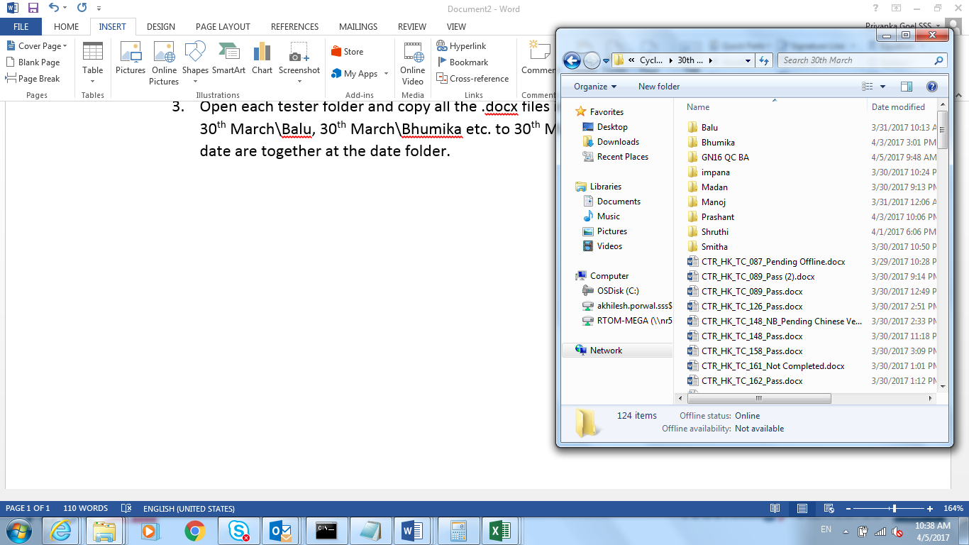

1. Open the command prompt and go to the shared drive (use the partition to which the shared drive is mapped – Z: in this case), and run the command:

DIR /B /A:-D *.docx > TestCaseFile<date>.csv

To copy all the .docx filenames in the .csv format.

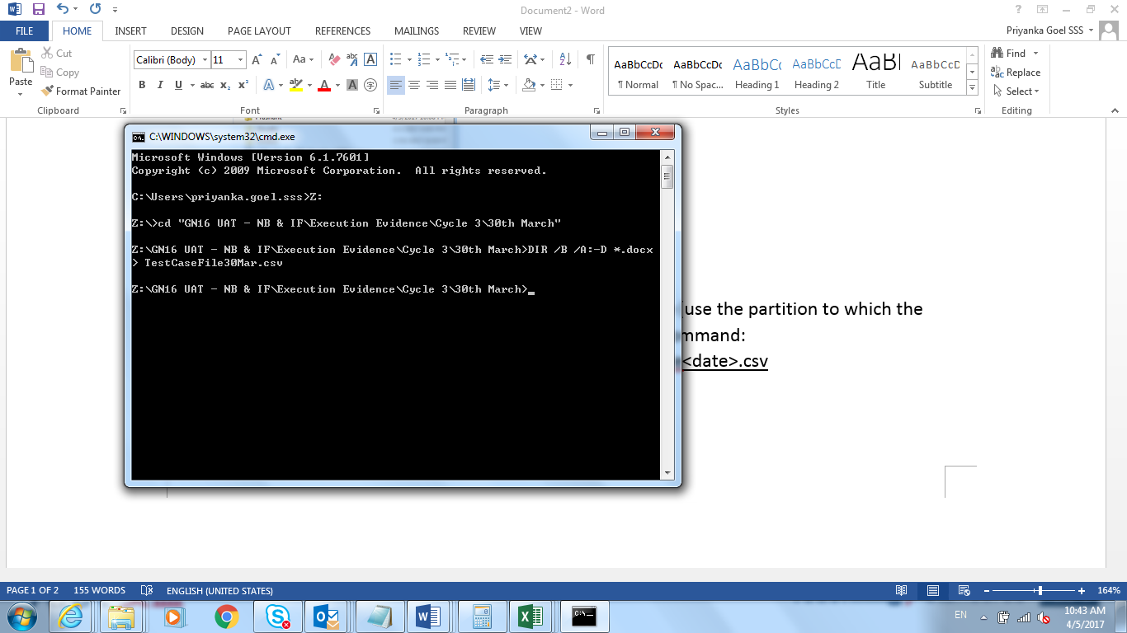

1. Once the file is created open it to copy the files, and paste in another excel sheet – Called C3 Priority cases (say in column F). Use find & Replace to remove all _Pass.docx or _PendingOffline.docx or _Fail.docx or any other extension to convert the filenames in “AAA_BB_CC_123” format.

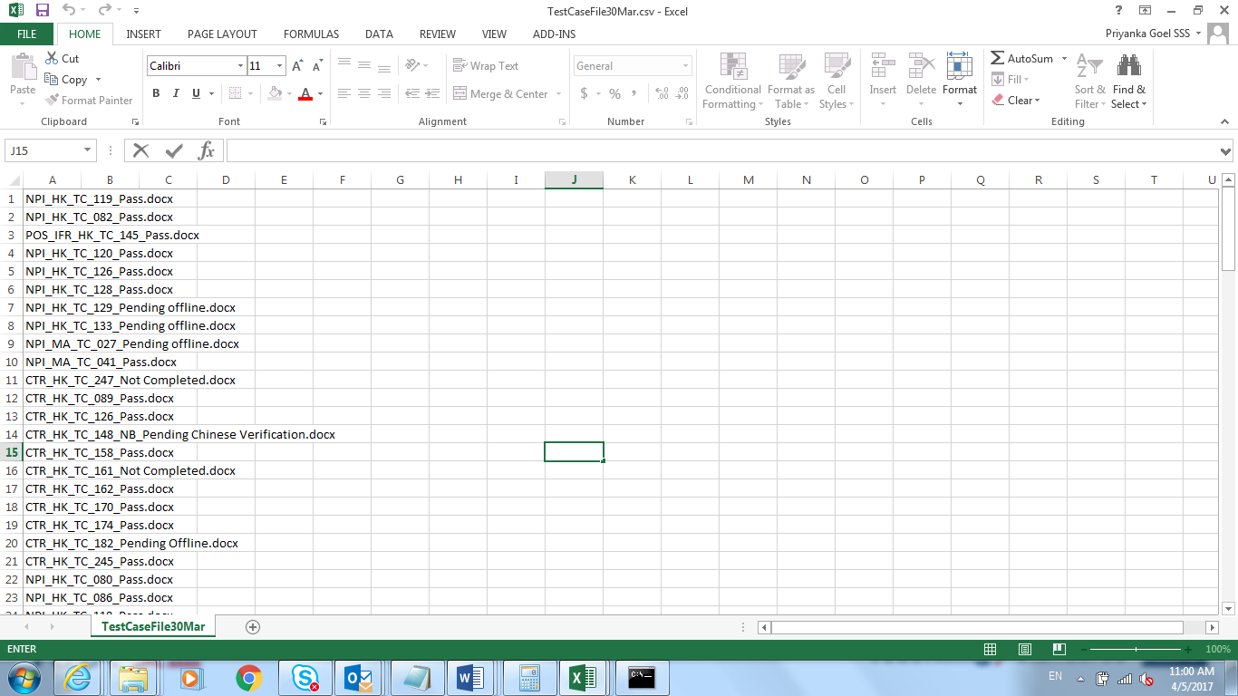

1. In another column ( paste all the priority test cases for that cycle from the priority excel sheet above (filter on Cycle 3, and select all resulting TCs).

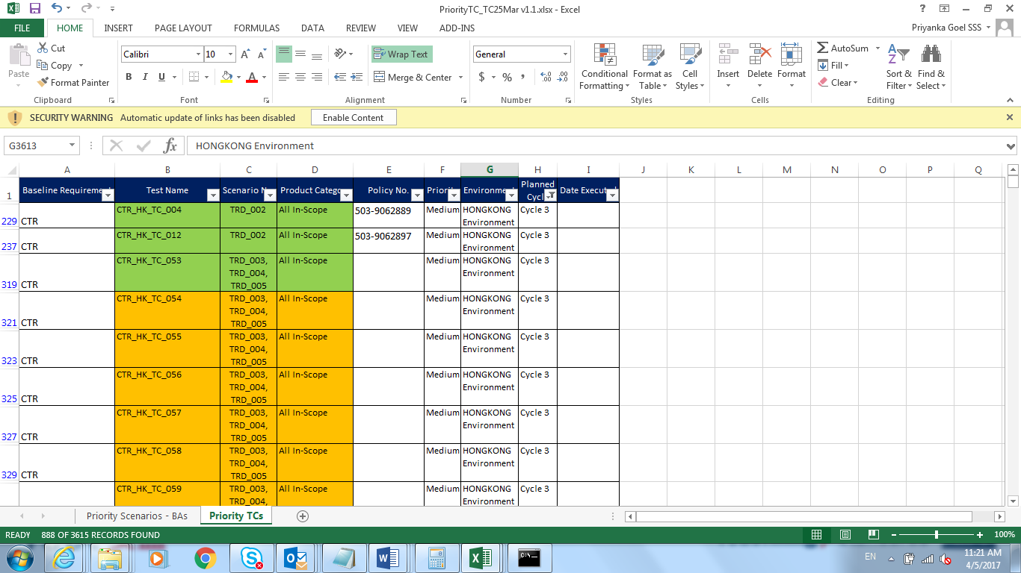

1. In a third column use this formula (drag the formula down to cover all cells till we have the priority cases/Column A cases) to choose only the priority TCs from Column A (those present in priority TCs column):

=IF(ISERROR(MATCH(F2,$G$2:$G$3071,0)),"",F2)

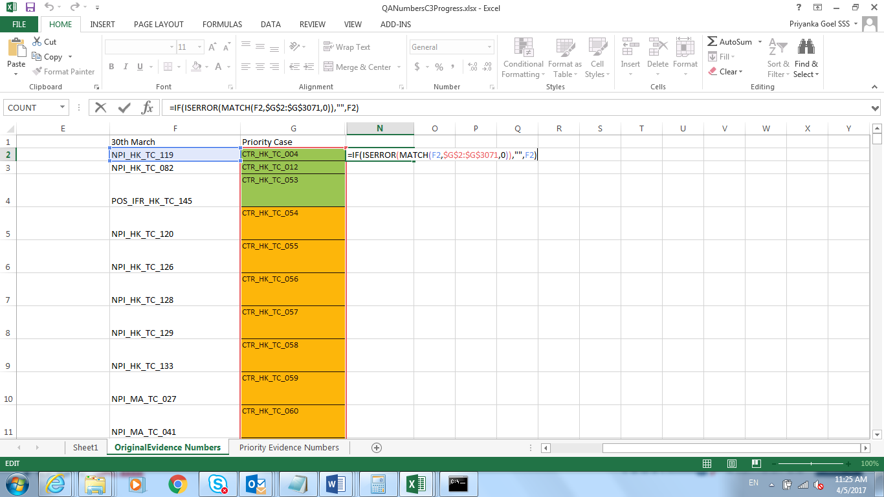

1. Copy all the resulting TC names (priority TCs from 30th March) in another sheet and paste values.
2. Create the QA Tracker for these TCs sorted above, to be shared with the BAs.

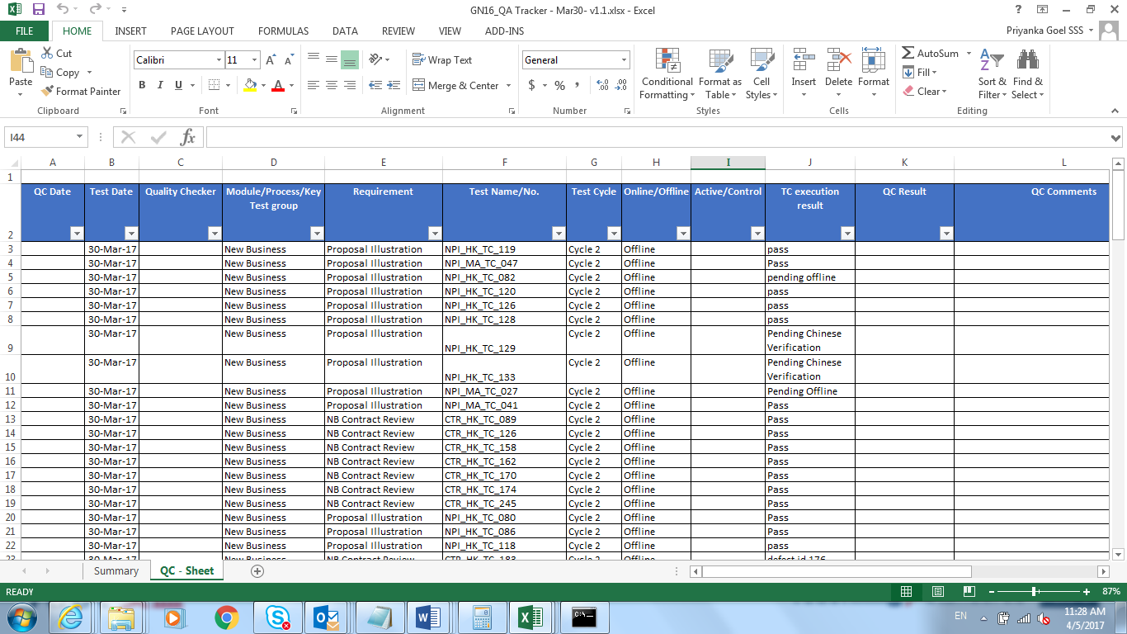

1. In the main Date folder(step 2 – 30th March in Cycle 3), create a folder – ‘GN16 QC BA’ and inside it copy the evidences of priority TCs.
2. Inside the ‘GN16 QC BA’ folder, create a ‘QC Tracker’ folder. Put the QA tracker sheet from Step 9 here.
3. Verify the evidences one by one, and keep updating the TC Execution Result column. In case any evidence is incorrect/needs clarification, remove it from this sheet (we will not pass it forward for BA verification unless we are sure it is a correct evidence).
4. For incorrect/needing clarification evidences, prepare another list for checking with offshore – if they need to provide additional info or update the evidence. Once these cases are ready, update the BA sheet in a newer version.
5. If you are not able to complete verification for all cases, just update the TC execution for those cases verified and add the remaining once done in a newer version. Target sending atleast some priority QA verification test cases every day.
6. Email for QA verification to BAs:

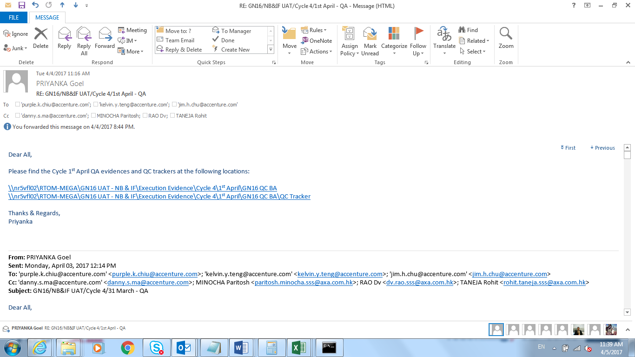

BAs who will verify(To): Purple< purple.k.chiu@accenture.com>

Jim< jim.h.chu@accenture.com>

Kelvin< kelvin.y.teng@accenture.com>

CC: Danny<danny.s.ma@accenture.com> , Paritosh, Rao, Rohit

Include hyperlink (as in the image) for 1. The ‘GN16 QC BA’ folder – location of priority evidences, 2. The ‘QC Tracker’ folder – Location of the QA tracker sheet for the BAs to fill.

1. Once BAs get back with the reply of verification (could be a lagged response, i.e., they may reply for an older date QA), please open their QA file, filter ‘QC Result’ column to filter only the non-Pass/Blank cases – could be a Fail or Clarification or Pending. Raise these issues with offshore to clarify/correct at urgency. Once we have a resolution/clarification/update about the progress, update the BAs with the same. Ensure timely communication with the BAs for their concerned raised.
2. Day end, update the QA Summary UAT Slide#5 of DSR pptx – 1. Test Date/Numbers (from the QA sheet we passed above), 2. Actual QA for the date depending on BA reply (skip blank- it means QC skipped), 3. QA pass/fail/fixed depending on BA reply above, 4. Check % = Actual QA/#of Test cases, 5. QC Fix% = #Fixed (by offshore or us)/#Fail – keep updating these numbers every time we have any comment from BA or any resolution from offshore, even if back dated. Send this to Rao before next day morning, CC Rohit.
3. Do the above every time a new Cycle/Date folder of evidence is available from offshore.