DEMO DOCUMENT.

There are two customers of the service User-1 and User-2.

User-1 wants to sell the following products:

1.MRI reports of 3rd grade ankle sprains.

2.MRI reports of meniscus tears.

3.MRI reports of ACL tears.

4.MRI reports of ATFL tears.

These health related documents/reports are very vital to an Orpthopadeacian who wants to study Injuries and rehabilitation. Let User-2 be the customer that wants to buy these reports from User-1.

But firstly User-1 needs to upload the data onto the Blockchain.

This is done by:

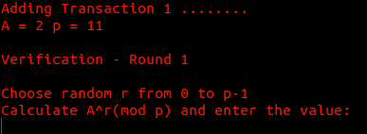

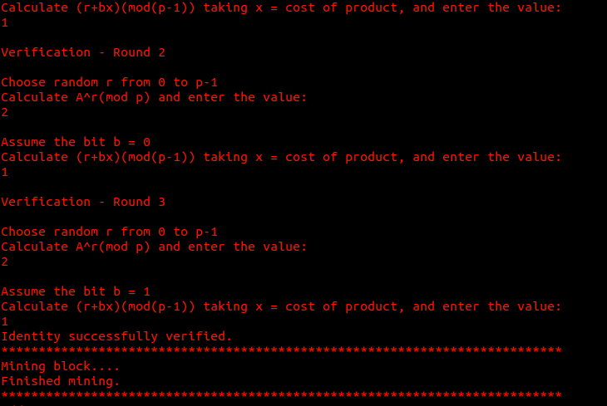Note that the verification process carries out the Zero Knowledge proof with the cost being the sensitive data and peers verifying in 3 rounds:

As soon as Identity is verified the user User-1 mines the block and claims the data.

And so he uploads all the data mentioned above in a similar manner and claims them.

The BlockChain details are hence as follows:

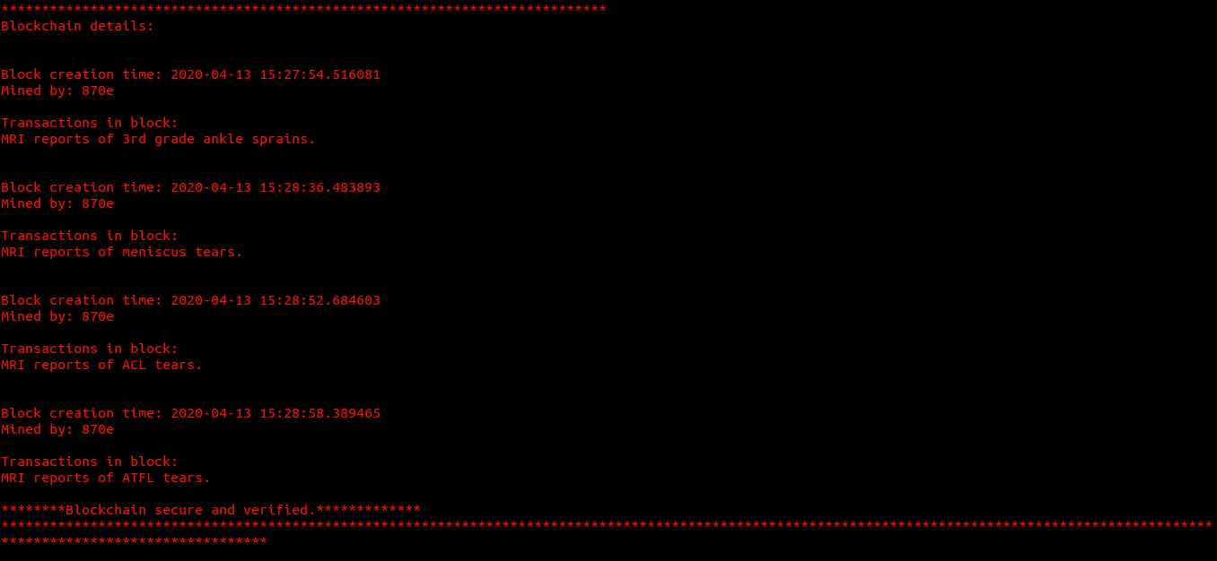

Next the buyer aka User-2 wants to buy the reports:

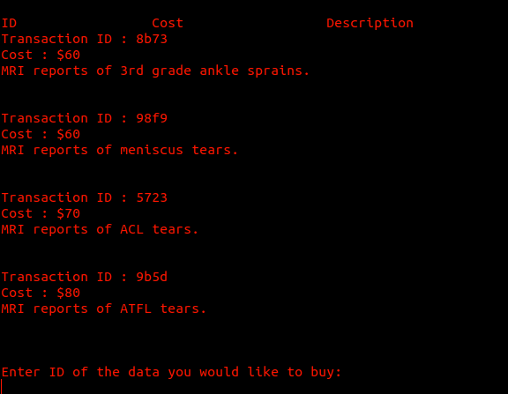

And the user buys Transaction ID : 8b73

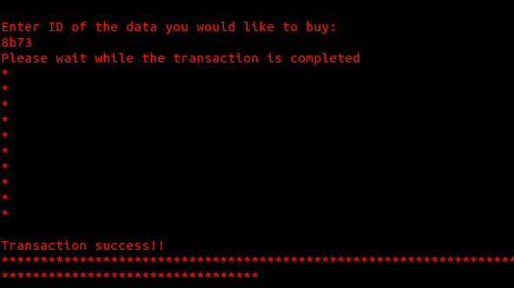

and the payment is carried out throught a secure gateway.

Lastly we view the user details of User-1 :

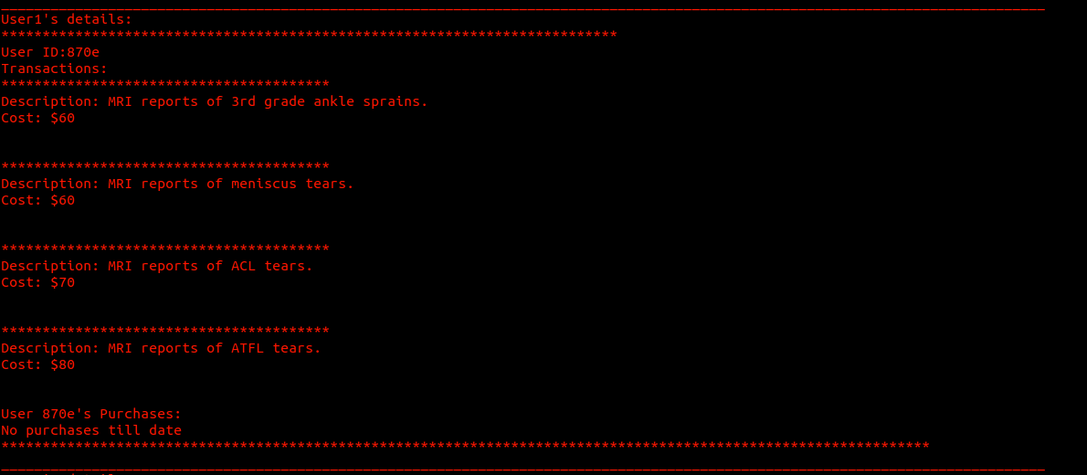

user details of User-2 :

