# **Assignment (15-08-2025)**

1.Reverse a given string without using built in functions.

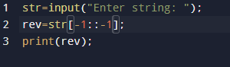**Program output:**

2. check if a string is palindrome or not.

**Program output:**

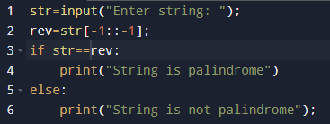

3.Count the num of vowels and constant in a string.

**Program output:**

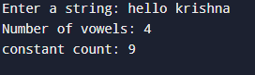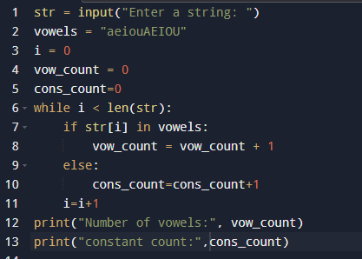

4.Remove all spaces from given string.

**Program output:**

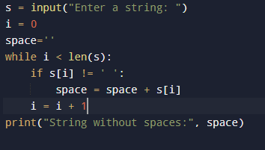

5.Count the frequency of each character in string.

**Program output:**

