# **ASSIGNMENT -1 [14-08-2025]**

Creating Table and Inserting values:

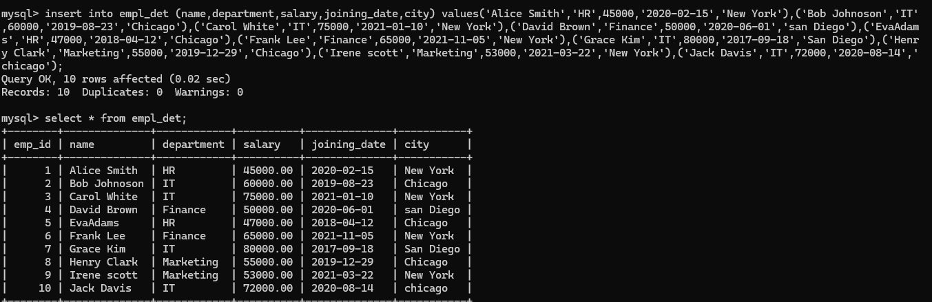

1. Show all employees who work in IT dept.

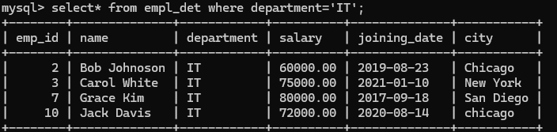

2 .Find emp whose salary >60000.

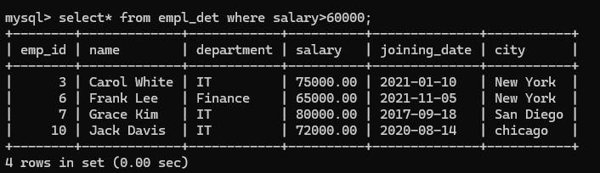

3.Get all emp who join after 1-1-2020.

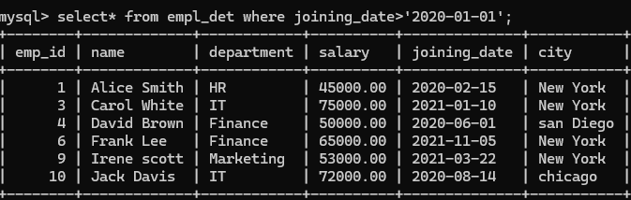

4.Total salary paid to emp in each dept.

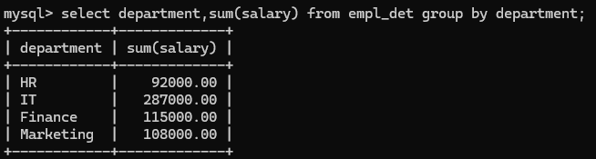

5.show the high paid employee in finance dept.

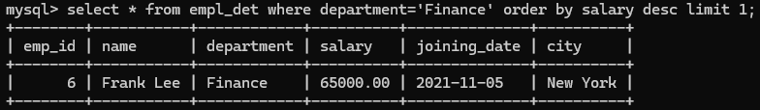

6. list employee who are from Chicago and salary>55000.

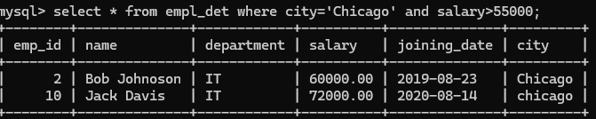

7. Find no.of employee in each city.

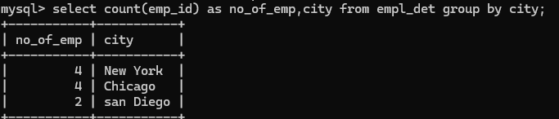

8. Show emp in the IT dept ordered by salary in desc order.

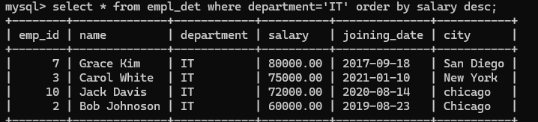

9. Display the avg salary of all employees.

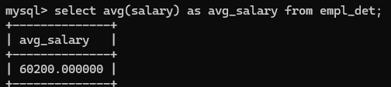

10. Get the details of the top 3 high pack.

