# **ASSIGNMENT(18-08-2025)**

Submitted by: A.Srividya

Roll Number: 23KQ5A0206 (EEE-A)

1. **To check Positive or negative of a given number.**

**Input program Output**

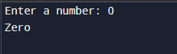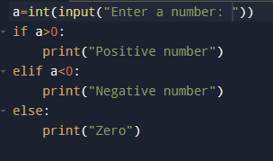

**2.To check the Even number or odd number of a given number.**

**Programm**  **Output**

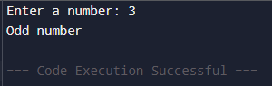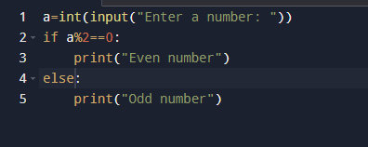

**3.To find the sum of natural numbers.**

