19-08-2025 Assignment

Submitted by : A.Srividya

Roll number:23KQ5A0206(EEE-A)

1. 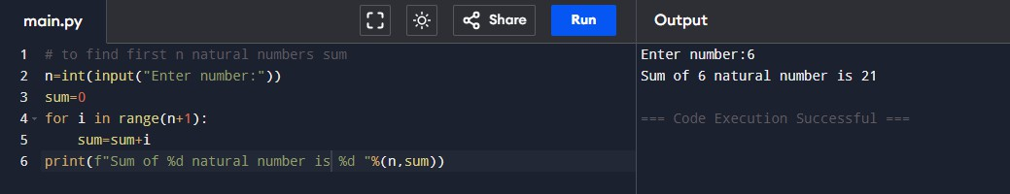**Write Python Programm to check the sum of first n natural numbers.**
2. 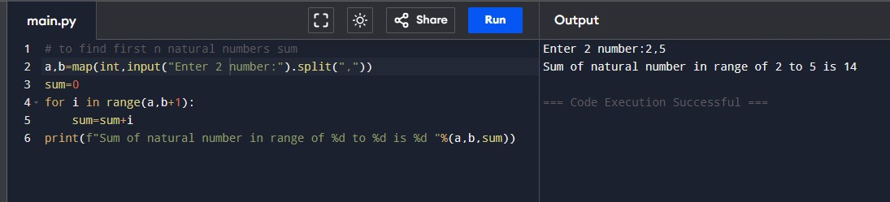**write python program to find sum of natural numbers with in given range.**
3. 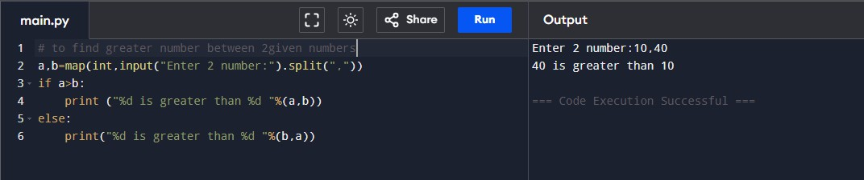**write a python program to check greatest number between 2 numbers.**